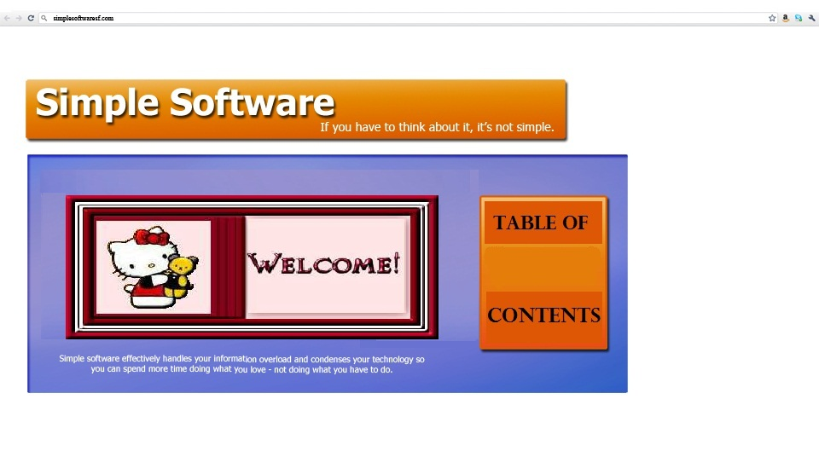section 1: Getting Started; Software Basics

***User Workspace & Applications***

*Part 1 –* The fundamentals of n*avigating and understanding the basics of your workspace*

1. How to access our software & workspace
2. Login on to your Sanrio Workspace
   1. Identifying “Username” & “Password”
   2. How to change your password
3. Simple ways of navigating through your workspace
4. Intro to work area – The Sanrio workspace screen
5. Hello Kitty Logo
6. Review of Helpdesk & Dashboard
7. Status bar location
8. Navigating your applications - Identify Modules & Processes

Lesson 1: “Workspace basics or (101)”

Accessing your Sanrio Workspace

### 1. How to access your Sanrio workspace.

Since your Sanrio Workspace resides online, you will access our software using most internet ready computer or mobile device. We suggest you download Firefox 5.0+ in order to enjoy the full experience.

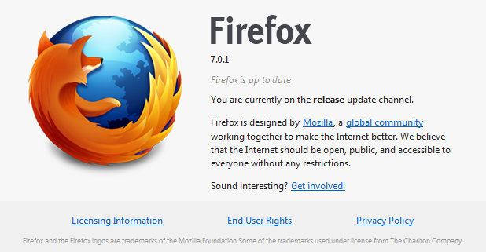

Note: *Your temporary password is your employee number which is located on your paystubs.* If you don’t have a Sanrio e-mail address, log in using the first initial of your first name, following your full last name. For instance, John Doe would login as “jdoe”.

Below is a screen shot demonstrating what you should see in your browser.

**Sanrio login site**

Type into the URL “<http://sanrio.simpsf.com>” and wait for page to load. Once the page has loaded you will see the Sanrio “Login” page.

If you entered the correct address, you will see a login screen like this:

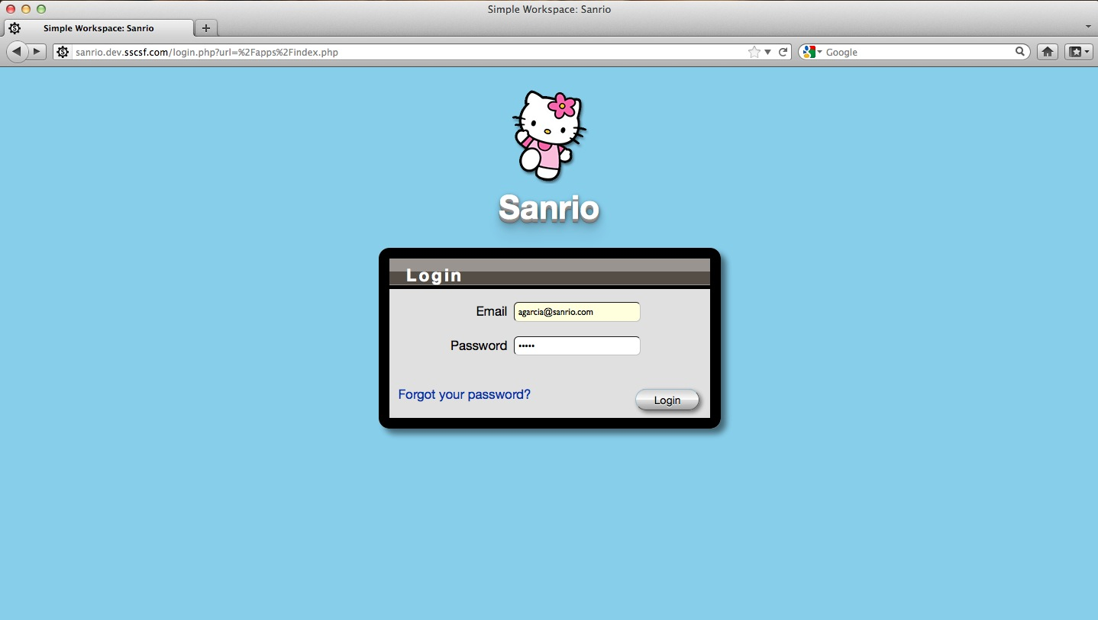

**Workspace URL:**

[**http://Sanrio.simpsf.com**](http://Sanrio.simpsf.com)

**& Now Login!**

### Logging On

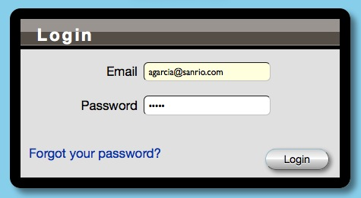

You will see a login screen that contains a space for you to enter your *Sanrio e-mail* and another blank space for you to *enter the password assigned to you.*

Login using your email address and password. For employees without an email address, login using your first initial + last name (John Doe would login as jdoe). Default passwords for Sanrio are your *employee number* located on your check stub.

### If you don’t have a Sanrio e-mail/password or you forgot the password to your “User Workspace”

Click on the link *“Forgot your password?”* link and it will guide you through the necessary steps to retrieve your correct password.

If you don’t have a Sanrio e-mail or password, use your first initial and last name

*For example; ppeterson*

Lesson 2: “Navigating your Workspace”

After logging in, you will see your company’s Workspace made by Simple Software, Inc.

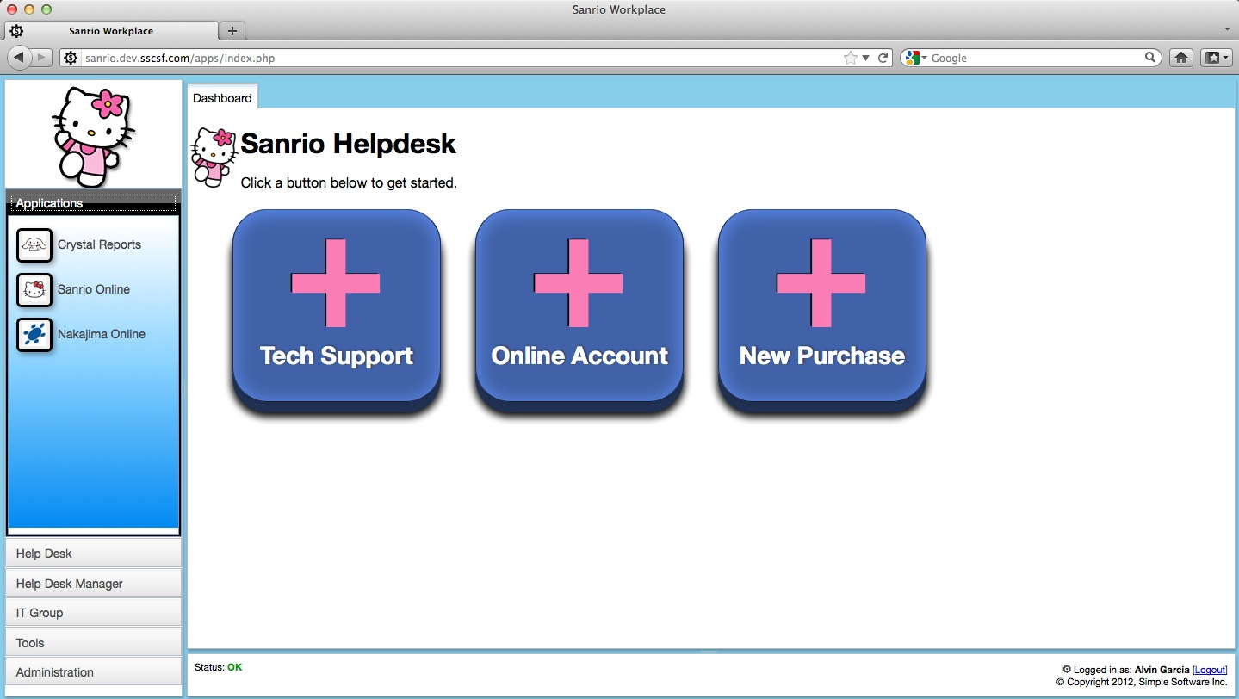

*Let’s quickly explore the different components of the screen shot in front of you.*

Application Layout (Your working parts!)

There are many parts that make up your Workspace. Our goal is to design a flexible interface that looks familiar to anyone that has used email.

We will go over these in detail but here is a quick reference:

1. Your Logo
2. Modules
3. Processes
4. Work Area
5. Tabs
6. Status Bar
7. Change your password
8. Logout

##### 

Overview of work area - Helpdesk shortcut buttons

To the right is your *“Work Area”,* currently displaying the ‘Sanrio Helpdesk’. The “Sanrio Helpdesk” dashboard contains shortcuts to various requests. Within the Helpdesk you can request:

* Tech Support
* Online Account
* New Purchase

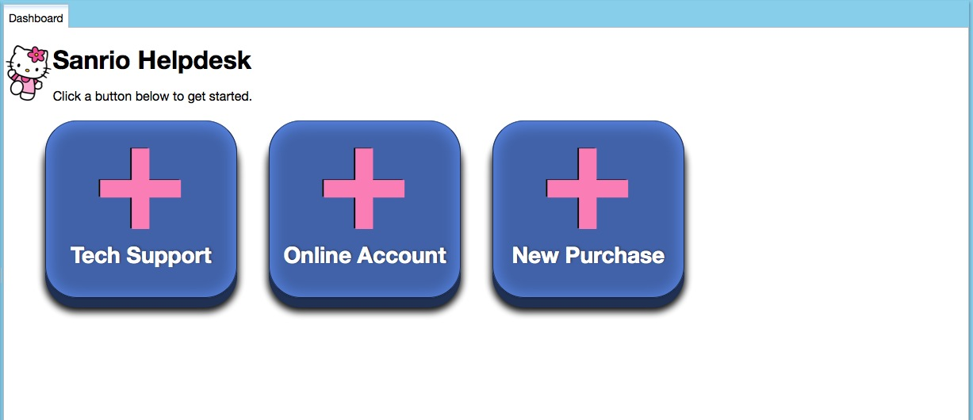

Note to reader: The Sanrio Help desk and how the buttons work will be explained later on in the Manual

To the bottom of the screen under your work area, you will see a “Logged in as” & a “Status” box.

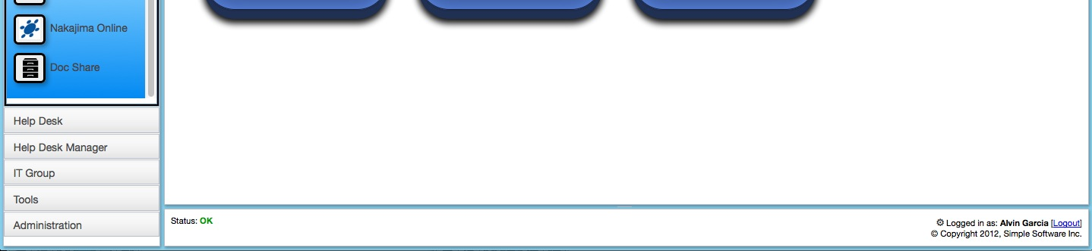

The status bar provides information such as:

* system status
* add, delete, update, relate to records
* person that is currently logged in

*The Status will be highlighted in green, alerting you of changes with work done in your workspace.*



.

Locate the ‘gear’ symbol and click on it in order to change your password.



One you click on the symbol above the “Change Password” dialogue will appear.

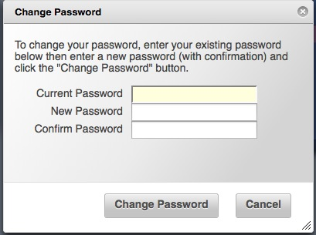

then…



After you change your password, log out and then log back in.

Navigating Applications – Review Applications in the workspace layout

##### Key Terms:

Dashboard: Is your work area

Tabs: Processes that get opened

##### Modules: Packages of “Applications” installed within your Sanrio Workspace.

##### Processes: Processes within Applications.

**Note: to reader:** Think of the modules below as a way of grouping similar processes. Think of modules as ‘folders for your applications’.

The screen shots below gives you an idea of where the *“Modules and Processes”* are located under the “Hello Kitty” logo.

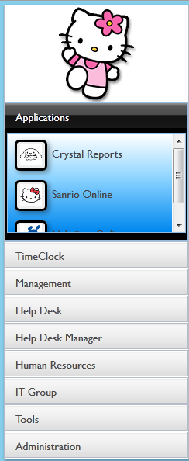

Sometimes referred to as “left navigation pane”

##### Your Logo



There are many ways of customizing your Workspace, and having your logo displayed is just one of them. Simply upload a new logo called logo.png and everyone that uses your Workspace will automatically see it!

To the left you will see a “Hello kitty” logo. Below the logo is a list of *Modules & Processes.*

##### Modules:

##### 

Modules are a helpful way of keeping similar tasks together as well as granting access to your apps. Below your “Hello kitty” logo is a list of modules, which can include;

* Applications
* Time Clock
* Management
* Help Desk
* Help Desk Manager
* Human Resources
* IT Group
* Tools
* Administration
* Help

##### Processes:

##### Processes:

Below is an example of different processes within the “Administration” module.

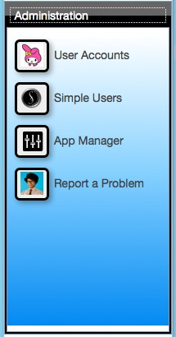

Only modules and processes you have been granted access to will appear in your workspace.

Processes are the applications that will help run your business. Under each module there are different buttons (processes) that pertain to that specific module. Only modules and processes you have been granted access to will appear in your workspace.

They can consist of:

* aApplications like Time Clock, Calendars, To Do List, CDR Mail, etc.;
* existing web applications;
* custom Tables;

**Note to reader -** You will also find Simple’s tools to manage and customize your application, or grant user access.**Lets take a closer look: Work Area located to the right on the Dashboard side**

##### Work Area:

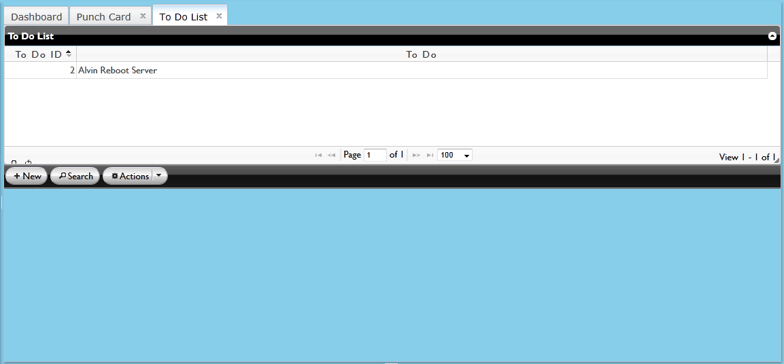

The work area of the application is where active processes will be running. You may identify the active process of your choice in order to get specific information by looking at the grid.

**Tabs**



If you select the process titled “To Do List”, a tab will open in your workspace. On the right there will be two tabs open. The first tab will read “Dashboard”; Next to it you will see any other processes you have opened. The “To Do List” tab will be bold because it is the active process.

Tabs give you quick access to switch tasks without losing any data.

The page is never reloaded!

You can switch back and forth just like a desktop application.

###### Multi-tasking online through Simple Software gives you an edge that most online applications can’t provide.