**SHAUNI RUETZ**

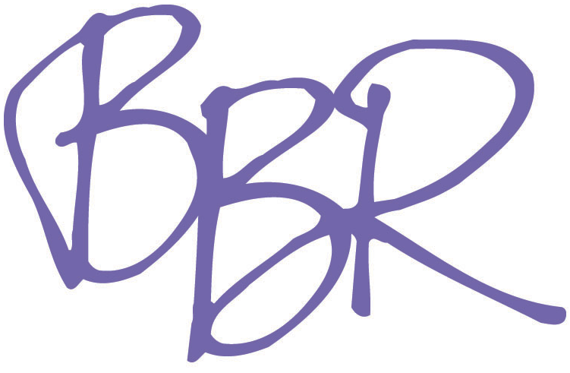

Brady, Brannon & Rich

323.852.9559

Bi-Coastal Theatrical/Legit

Jodie Bowman & Alisa Taylor

Height: 5’4”

Voice Type: Alto, Belt

[www.shauniruetz.com](http://www.shauniruetz.com)

**REGIONAL THEATRE**

Dogfight Rose Little Theatre of the Rockies

Aida Dance Captain/Ensemble Little Theatre of the Rockies

Little Shop of Horrors Crystal Little Theatre of the Rockies

**EDUCATIONAL THEATRE**

Once in a Lifetime Tapper/Dance Captain Univ. of Northern Colorado

Side Show The Bearded Lady Univ. of Northern Colorado

Oklahoma Gertie Cummings/US Aunt Eller Univ. of Northern Colorado

Legally Blonde Delta Nu Univ. of Northern Colorado

Mirada’s Nightmare Dancer Univ. of Northern Colorado

**WORKSHOPS**

Wings of Fire Emma Staged Reading (NY/DC)

The Imaginary A New Musical Lizzie Original Concept Release Album

The Imaginary A New Musical Lizzie Reading

Intro to Showbiz Instructor School of Diplomacy

**PERFORMANCES**

New York’s Got Talent: Season 2 Semi-Finalist Elektra Theater

Monday Night Live Musical Guest Elektra Theater

Rising Star Competition 2 Finalist Rise Bar

**EDUCATION AND TRAINING**

*Bachelor of Arts in Musical Theatre/Dance Minor at the University of Northern Colorado*

ACTING: Rhyn McLemore, Matthew Herrick, Tom McNalley, Ken Womble, David Grapes

VOICE: Ellen Lettrich, Matthew Herrick, Master class with touring cast of The Drowsy Chaperone

DANCE: 19 years Tap, Ballet, Jazz, Hip Hop

3 years Choreography: Monte Black, Christy Black

5 years Modern/Contemporary

2 years ACDA Dance Festival

Performance/Audition Workshops: Dave Clemmons, VP Boyle, Deidre Goodwin, Mike Ruckles, Victoria Morris, Michael Donovan, Natalie Weiss

Open Jar Insititue: Jeff Whiting, James Grey, Susan Stroman, Bob Cline, other various guests

Performance/Audition Workshop, Michael Cassara

2014 Jimmy Award Intern Camp Broadway, NY Van Kaplan

2011 Jimmy Award Winner Minskoff Theatre, NY

2011 Regional Best Actress Rochester Broadway Theatre League Bob Sagan

**SPECIAL SKILLS**

Human Spring