**SW Engineering CSC 648/848 Spring 2019**

“Stay”

**Team 02**

**Jaren Lynch**

**Chris Rosana**

**Monali Mirel Chuatico**

**Thanh Le**

**Shan Kwan Cho**

**Russelle Pineda**

**KaHo Lee**

**Milestone 4**

**History Table**

|  |  |
| --- | --- |
| **Progress** | **Date** |
| **First Draft** | **May 6, 2019** |

**Table of Contents**

## **1) Product summary (e.g. how would you market and sell your product – about ½ page)**

## **Name of the product**

* Explicit **itemized list of ALL major committed functions (your FINAL P1 functions for which you will be graded) your team shall actually deliver (and test for).** **This is your FINAL functional commitment e.g. failure to deliver on some of P1 functions results in reduced grade. Please write it in the list format (each item max 1-3 lines) so it is easy to check. List of functions to be written in regular English and not like specs. You can stay with the list recommended in M3**
* Say what is unique in your product (if anything)
* URL to your product accessible to instructors, on deployment server

**\*\*\* The list of final functions is used to grade your final project and will be checked on your final delivery for functionality and correct operation. Failure to deliver complete list of these committed functions will result in reduced grade for SE Product rubric. \*\*\*\***

**Name of Product: Stay**

**Priority 1:**

1. Unregistered user

1.1. Unregistered users shall be able to view the website.

1.2. Unregistered users shall be able to login or register.

1.3. Unregistered users shall be able to use searching tool to find housing types they are looking for.

1.4 Unregistered users can browse through different links. About, Contact and Posting links are located under search bar.

1.5 Unregistered users can use the filter button to filter different categories. Filter button located on top of page next to search bar.

1.6 Unregistered users can use the filter box to filter distance and price of housing. Filter box located on left hand side of page.

1. Registered user

2.1. Registered user shall be able to do anything unregistered user can do.

2.2. Registered users shall be able to upload a listing on the site.

2.3. Registered users shall be able to log out of their accounts.

1. Developers

3.1. Developers shall be able to edit the site.

3.2. Developers shall be able to view databases and maintain the server.

**Product URL:**

**2) Usability test plan – 2.5 pages max**

Select ONE major function (NOT login or registration) to be tested for usability. We recommend search or upload/post.

## **Write a usability test plan for this selected function. Please consult class material on developing usability test plan and questionnaire. This test plan is to contain separate sub-sections as below:**

- **Test objectives**: - what is being tested and why 0.5 page

- **Test description -**separate paragraphs each covering: System setup, starting point, who are the intended users, URL of the system to be tested ad what is to be measured (for M4 focus only on user satisfaction evaluation e.g Likert tests). Up to 1 page

-- **Usability** **Task description**: describe the task testers do before filling out the Likert questionnaire – a few lines (check class sldies)

- **Questionnaire**: Provide 3 Lickert scale questions getting user satisfaction after the above task has been performed, in a proper format as it is to be used by reviewer (check class slides) – 3/4 page

## **You can also ask your friends or team members to do this test (we suggest you wait for instructors to review your plans first).**

## **Usability Test Plan**

## - **Test objectives**:

## Our objective for this usability test is to ensure that user is able to use search for housing by housing type (house, apartment, studio).

1. Let the user filter the distance and price range of a posting in the filter box.
2. Let the user use the filter button on each category.
3. Let the user search with alphabetical text on search bar.
4. Let the user search with symbolic text on search bar (i.e. @, $, #).
5. Let the user search while in different page links.
6. Let the user search in each category of filter button.

- **Test description:**

This test plan's purpose is to ensure excellent user satisfaction! In order to achieve excellent user satisfaction, as the software engineers for this application, the application shall be tested to perform in its optimal condition. The application shall be tested on the filter box, filter button and the search bar.

The filter box shall work only as intended. It shall permit the user to type in keywords that will be used to filter the postings. Test the Distance text fields and the Price text fields. The posts shall update according to the filter input.

The filter button shall work only as intended. It shall call a drop down which presents different categories to filter the postings from. The posts shall update according to the filter category chosen. Each categories in the drop down shall be tested to make sure there is no bug in the filter button.

The search bar shall work only as intended as well. It shall permit the user to type in keywords that will be used to filter the postings. Test to see if numbers letters, and symbols are searchable. The search shall update the postings according to the keywords inputted into the search bar.

## - **Usability Task description**:

1. Find postings within the distance from SFSU.
2. Find postings within a certain zip code.
3. Find postings with price range within the range of $1000 to $2000 a month.
4. Search the postings for “apartment.”
5. Search the postings for “@$apartment.”
6. Search for postings while in Contact page.
7. Search for postings while the category of filter button is on House.

## - **Questionnaire**: <https://forms.gle/C7hnHLvmtnhbVwkm7>

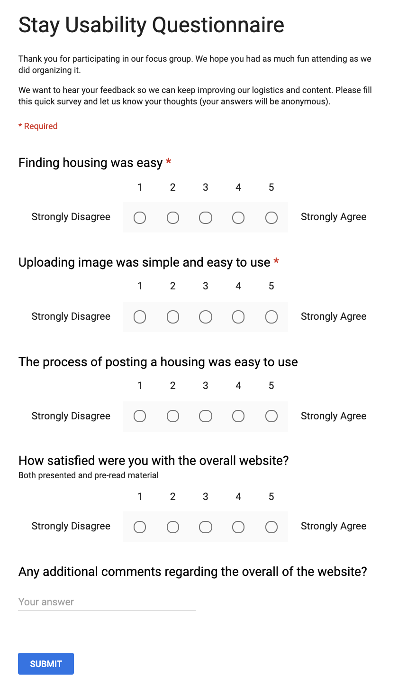

**3) QA test plan - max 2.5 pages**

For the same function you chose for the usability test, write a QA test plan (check class slides), as follows:

- **Test objectives**: - what is being tested

- **HW and SW setup** (including URL):

- **Feature to be tested**

- **QA Test plan**: 3 test cases and results of testing them on your system: appr. 1 page. Use tabular formats as in the class, see below

You must provide QA test plan in the format of the easy to read tabular form allowing easy reading and analysis by management e.g. like presented in the class slides on SW QA.

Suggested format for QA Test Plan Table: table columns are: test #; test title; test description; test input; expected correct output; test results (PASS or FAIL for each tested browser)

b) You also must perform the testing as per the plan above and record the results in a form above. Apply the above test on 2 browsers of different type and record it in the above QA test plan table

**Test objectives:**

Identify areas of weaknesses within our website when it comes to general usability.

**Hardware and Software Setup:**

Browsers:

Chrome Version 74.0.3729.131 or higher

Safari Version 12.1 or higher

Operating System:

Windows 10 or higher

Mac OS 10.9 or higher

|  |  |  |  |  |  |
| --- | --- | --- | --- | --- | --- |
| **Test#** | **Test Title** | **Test Description** | **Test input** | **Expected Correct Output** | **Test Results** |
| 1 | Search for housing by keyword or category | Users shall be able to search for housing using keyword or category | Category: House, Apartment, or Studio  Search bar: street, city, or zip code  Click button: Go | Search result should returned with search bar and few listings |  |
| 2 | Browse house listings | Users shall be able to browse house listings | Category: Housing Types  Search bar: empty  Click button: Go | Search result should returned all of the listings of houses | Google Chrome:Pass  Safari:Pass |
| 3 | Search for alphabetical strings | Search for alphabetical char or string | “apartment” | 8 results, all have “apartment” in category field | Google Chrome:Pass  Safari:Pass |

**4) Code Review:**

a) By this time you should have chosen a coding style. In the report say what coding style you chose.

b) Chose the code (substantial portion of it) related to the feature you used for QA and usability test. You need to submit an example of the code under review (or part of it – 2 pages or so MAX) for this function to be peer reviewed, and document this as follows:

1. One team member should submit code to other team member(s) for peer review.
2. Peer review should be performed by other group member(s) (1 review is OK).
3. Peer review is to be done by e-mail and comments are to be included in the code
4. Submit the e-mail containing the peer review and commented code and e-mail communication related to this in your Milestone 4 document

Important: It is critical that code reviews are friendly and helpful, intended to help and education, and not to criticize. It is strongly suggested that you use peer review in the development of the whole system. Reviewers should also check for at least minimal code header and in-line comments and flag this as a problem if this is not adequate

Note: peer review must include checking for basic header and in-line comments

To ensure code review we reinforced communication using proper commit messages and feedback in person and over our private Slack channel. This helped us better understand each other's work processes and allowed us to be able to properly address changes that needed to be made.

**5) Self-check on best practices for security – ½ page**

- List major assets you are protecting

- Confirm that you encrypt PW in the DB

- Confirm Input data validation (list what is being validated and what code you used) – we request you validate search bar input;

Major assets we are protecting:

1. User information

* Passwords are encrypted in the database and can’t be seen or accessed by anyone. Users are able to register for an account and login to existing accounts, the account information is saved to the database.

1. Images uploaded by sellers
2. Server security

On signing up, all user inputs are being validated and an error message shall appear if the inputs do not match our validation rules. User emails are being checked using JavaScript to ensure the string the user input matches an email format and an error will occur if the input is not an authentic email address.

Input data validation:

The search bar input is also being checked by using a percent like algorithm to compare the input to the media in our database. Empty search bar will display all results

**6) Self-check: Adherence to original Non-functional specs**

Copy all original non-functional specs as in high level application document published at the very beginning of the class. Then for each say either: DONE if it is done; ON TRACK if it is in the process of being done and you are sure it will be completed on time; or ISSUE meaning you have some problems and then explain it.

Note: you must adhere to all original non-functional specs as published in the original high level specification document. Failure to do so may cause reduced SE Product grade

1. Application shall be developed, tested and deployed using tools and servers approved by Class CTO and as agreed in M0 (some may provided in the class, some may be chosen by the student team but all tools and servers have to be approved by class CTO). **DONE**
2. Application shall be optimized for standard desktop/laptop browsers e.g. must render correctly on the two latest versions of all major browsers: Mozilla, Safari, Chrome. **DONE**
3. Selected applications functions must render well on mobile devices. **DONE**
4. Data shall be stored in the team’s chosen database technology on the team’s deployment server. **DONE**
5. No more than 50 concurrent users shall be accessing the application at any time. **DONE**
6. Privacy of users shall be protected and all privacy policies will be appropriately communicated to the users. **DONE**
7. The language used shall be in English. **DONE**
8. Applications shall be very easy to use and intuitive. **DONE**
9. Google Analytics shall be added. **ON TRACK**
10. No email clients shall be allowed. **DONE**
11. Pay functionality, if any (e.g. paying for goods and services) shall not be implemented nor simulated. **DONE**
12. Site security: basic practices shall be applied (as covered in the class). **DONE**
13. Before posted live, all content (e.g. apartment listings and images) must be  
    approved by site administrator. **DONE**
14. Modern SE process and practices shall be used as specified in the class, including collaborative and continuous SW development. **DONE**
15. The website shall prominently display the following exact test on all pages

”SFSU-Rental Software Engineering Project CSC 648-848, Spring 2019. For Demonstration only” at the top of www page. ( Important so as to not confuse this with a real application). **ON TRACK**