**Steam Turbine–Pre Lab**

**Objectives:**

**S. Hordeski 2/24/15 3:45pm – Characterize the performance of a 5kW steam turbine AC generator by comparing the generator performance (efficiency) to the theoretical Rankine model of a steam generator. Note that the cycle in this study differs from the theoretical Rankine cycle due to the addition of the superheater and the fact that the condensate does not return to the boiler and the internal irreversibilities.**

**Apparatus:**

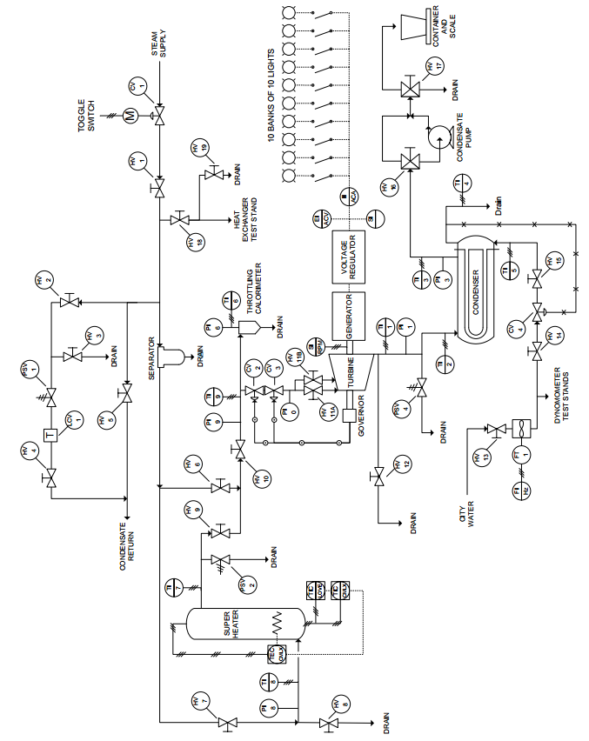

**Procedure:**

**C. White 2/24/15 5:00pm(?) –**

Experiment: The purpose of this experiment is to characterize the performance of the Carling “A Series “steam turbine with a generator by varying the electrical resistance (load) and observing how the theoretical turbine work calculated thorough the first law compares to the actual output work measured by the generator. Thermodynamic properties for steam such as enthalpy and entropy will be determined based on temperature and pressure measurements for the inlet and outlets of each component and the first law of thermodynamics will be applied to determine heat transfer or work.

**Beginning Steps:**

1. Record barometric pressure and ambient air temperature in order to specify experimental environment conditions.
2. Initialize startup by following startup sequence in Operating instructions at 3600 at no-load.
3. The experiment will consist of 10 trials will at intervals of 10 light bulbs. In order analyze the measurements for the temperature, pressure, and mass flow rates using the first law of thermodynamics, the system must be running at steady state in order for the first law to apply and it is characterized by minimal fluxuations in readout measurements. In order to determine when the system has reached steady state, each of the 10 trials will be repeated 3 times in 5 minute intervals to allow sufficient time for the system to reach steady state. When the changes in measurements between intervals insignificant, then steady state is confirmed. If steady state occurs earlier than the 5 minute intervals, then decrease the length of the interval accordingly.
   1. **Run:** **10 trials**, **increasing load by 10 bulbs**, **record temperature, pressure, mass flow rate, voltage,** and **current**.

**REPEAT 10X:**

**Heat Transfer into System:**

1. **Superheater**: saturated vapor enters at a constant pressure, where heat is transferred into steam and it becomes is superheated to prevent condensation from occurring and damaging turbine. We want to record the inlet, exit temperatures of the steam, pressure and steam condensate flow rate, from thermocouples, pressure transducers, and flow rate meters respectively. Knowing the inlet and exit temperature and pressure will allow us to determine the enthalpies and entropies of the control volume. The first law of thermodynamics can be applied using mass flow rate and the two enthalpies to determine the heat transfer in to the system.
   1. **Record:** **inlet (T8)** and **exit (T7) temperatures**, **pressure (P8),** and **determine enthalpy and entropy** to **determine heat transfer.**

**Output Work:**

1. **Trip Speed Valve:** superheated steam exits the superheated and enters the tip speed valve, which varies the mass flow rate of the steam entering the turbine. We want to determine the temperature and pressure at the inlet in order to determine enthalpy and entropy. The inlet temperature will be used for turbine inlet temperature and to account for internal losses in piping between superheater and trip speed valve.
   1. **Record: inlet temperature (T9)** and **pressure (P9)** and **determine enthalpy and entropy**.
2. **Turbine:** the superheated vapor leaves tip speed valve and enters turbine and the steam turns the turbine blades. Want to measure pressure at entrance and turbine outlet temperature and outlet pressure. This will allow us to determine the theoretical work output of the turbine via enthalpy and entropy at the entrance and exit of the turbine using first law of thermodynamics. This is because since the turbine is theoretically considered adiabatic and the theoretical work outputted through shaft can be determined. The pressure drop denotes the work transferred to turbine blades. The actual work out of the turbine will be determined using Eq. () and the voltage, current, and turbine efficiency outputted by generator. The turbine efficiency is determined using the generator efficiency as a function of loading. Determine how the loading affects the turbine rotational speed and measure the voltage and current differences to determine how loading affects the system.
   1. **Record:** **turbine inlet (P0) and exit pressure (P1)**  and **outlet temp (T1)**  to **determine enthalpies and entropy** to calculate **ideal work output.**
   2. **Record: voltage (E)** and **current (I)** to calculate **actual work output** **using the generator efficiency as a function of loading**. Measure the **turbine generator rotational speed**. Measure **voltage difference and current difference**.

**Heat Transfer out of System:**

1. **Condenser:** steam leaves turbine and enters condenser where the steam changes from a mixture to saturated liquid using a heat exchanger with cool water and the saturated liquid steam is discharged to drain. Measure the inlet temperature, pressure, and exit temperature. Also measure the condensate steam flow rate. This information will be used to determine the enthalpy and entropy which will be used to determine the heat transfer out through the first law. Determine the cooling water inlet and outlet temperatures and cooling water flow rate to do a heat exchanger analysis.
   1. **Record:** ***Condenser:*** **inlet (T2) and exit temperatures (T3), pressure (P3), condensate flow rate**. ***Cooling water:* inlet (T5) and outlet(T4) temperature and flow rate. Perform heat exchanger analysis to determine heat exiting system**
2. **Analysis:** Plot 3 T-s curves for the 30, 60, and 90 load conditions. Determine turbine and cycle efficiencies using the actual and theoretical results for each of the 3 selected cases. Determine the condenser effectiveness using an heat exchanger analysis at each of the 3 cases.

**Relevant theory:**

To characterize the performance of the turbine, the ideal rankine cycle must be understood as a model to compare the non-ideal turbine. The

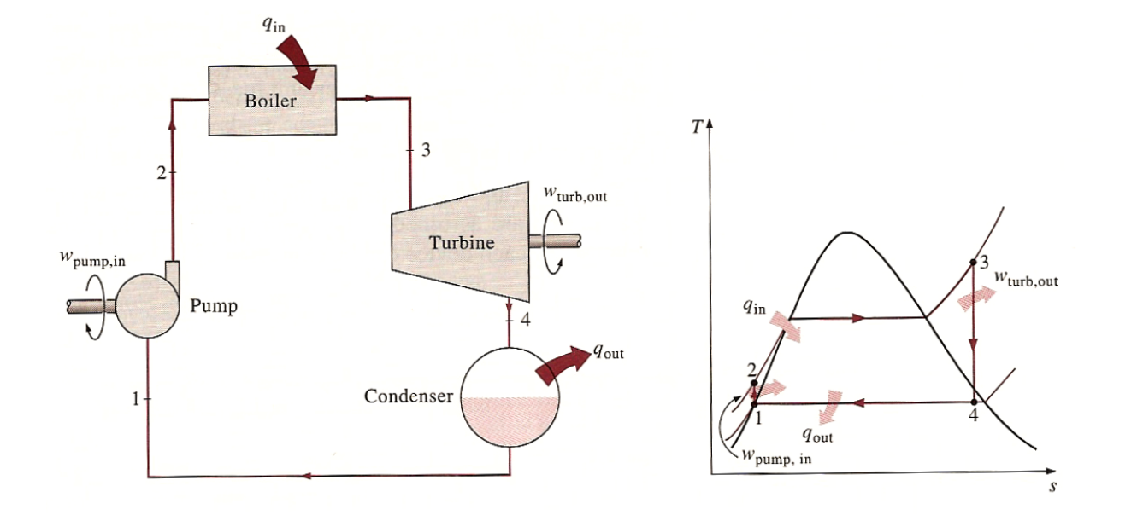

**Data Table:**

|  |
| --- |
| [**B3_Steam_Turbine_Data_V1.xlsx**](B3_Steam_Turbine_Data_V1.xlsx) |
| **Revision Number: 1** |
| **Revision Comments: S. Hordeski 2/24/15 6:30pm – This sheet is subject to change. We also need to copy Sheet 1 ten more times (1 for each test)** |

**Roles and Responsibilities:**

**Sam H. – Objectives, Excel data sheet**

**Chris W. – Procedure**

**David B. – MATLAB**

**Kevin M. – Theory**

**Justin S. – Other stuff…**

**Jorge G. – Apparatus**

**Steam Turbine I – Lab Observations**

**Create a new version of your data file if it was changed following the pre-lab.**

|  |
| --- |
| **A4_WindTunnel_Data_v2.xlsx** |
| **Revision Number:** |
| **Revision Comments:** |

**Insert relevant pictures (or links if media file is large). This is expected to unedited media with initial observations. Not everything included in this section will be seen in the report, but it is critical to record as much as you can as it is difficult to know what will turn out to be most important to your interpretation of the data.**

**Wind Tunnel I – Post Lab**

**Analysis approach described here.**

IMPORTANT! DO NOT BEGIN MATLAB FILE NAMES WITH A NUMBER! MATLAB WILL RETURN A CRYPTIC ERROR

|  |
| --- |
| **A4_WindTunnel_Analysis_m.xlsx** |
| **Revision Number:** |
| **Revision Comments:** |

**Roles and Responsibilities:**

**Identify the primary contribution of the team members during the post-lab.**