UART
What is UART?:
Universal Asynchronous Receiver/Transmitter or UART is an asynchronous (no clock) serial communication (data bits are transferred on by one sequentially) protocol that allows two devices to receive and transmit data between each other.
Wires Involved:
Full Duplex UART requires three wires – TX, RX, and GND.
Single Wire or Half Duplex UART requires only a singular wire and GND.
Baud Rate:
Baud is the number of symbols or signal changes transferred per second. With UART, 1 baud or one signal change represents a single bit, so baud rate and bit rate are the same. That’s why baud rate for UART is expressed in bits per second. In more complex systems such as QAM, one baud represents multiple bits.
Since the sender and receiver don’t share a common clock signal, both ends must agree on a baud rate.
- Baud Rate Calculation:
  - Baud = Number of bytes to send * total bits per frame * output rate of message (Hz)
  - Total bits per frame = start bit + data bit + stop bit + parity bit (if used)
  - Output rate = The number of times a message is output per second. For example, outputting a specific message at 50 Hz means that we will output the same message 50 times per second, so every 0.02 seconds.
  - Example = We need to output a 41-byte message at a rate of 50 Hz. The UART configuration is 8N1 (8 data bits, no parity bits, 1 stop bit). If we want to output this message at the output rate of 50 Hz, then we’ll have:
    - 41-bytes * 10 bits per frame * 50 Hz = 20500 bits per second or 20500 bauds.
    - Result = transmit 20500 bits per second, the closest standard baud rate is 38400.
Protocol:

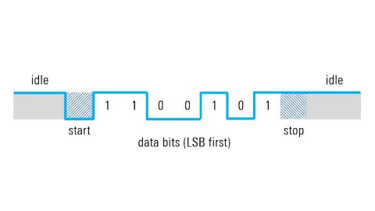

Start Bit:
When idle, the UART data transmission line is held high (1). To start the transmission of data, the transmitting UART pulls the transmission line from high to low for one clock cycle. When the receiving UART detects this high to low voltage transmission, it begins reading the bits in the data frame at the frequency of the baud rate.
Data Frame:
The data frame can be anywhere from 5 to 9 bits long, depending on if a parity bit is used. In most cases, data is sent with the least significant bit first.
Parity:
The parity bit is optional in UART. The parity bit can either be of even parity or odd parity. The parity bit allows the receiving UART to know if any data has been corrupted during transmission. The receiving UART reads the data frame and calculates the correct parity bit. For example, if there is even parity and 3 bits are 1, then the parity bit will be set to make it 4 bits, which is a even number (no s sherlock).
Stop Bits:
To signal the end of the transmission the sending UART drives the data transmission line from a low voltage to high voltage for one-to-two-bit durations. The stop bit is usually either one or two bits.

Oversampling

Pros vs Cons:
Advantages:
- Simplicity – doesn’t require many wires thus low cost.
- Ubiquitous- well supported by many microcontrollers.
- Contains a parity bit
- No clock
Disadvantages:
- Slow compared to SPI
- Point-to-point communication – doesn’t support multiple slaves and or multiple masters.
- Requires a fixed data rate that must be agreed upon by devices before data transmission.
- Baud rates must be the same (some difference is tolerated)

