Two Modes of operation via a selector switch that toggles each mode:
Green is to do
Manual Mode: □
- Set Point Pot will set the amount of power from 0 to 100%□
- in code this will be 0 to 31000 increments that determine how much power gets passed to the heater. This turns the auto mode off. This mode uses Output compare module #3□
- There will be an over temp set in the program of 470 degrees. This is for the feedback temperature, not the set point.
- Over temp condition will shut off the heater. Start LED will blink.
- A Blue LED will come on No LED

Auto mode (not implemented) □
- Will perform a PI function to control the heater based on the set point set via a pot.
- PI code will adjust heater until its up to temp. This turns off manual mode.
- A Blue LED will come on.
In both modes:
Intake and exhaust fans are DC PWM control and come in when start button is on. Exhaust fan not implemented yet.
- Display 0-100%□
- Fans will be OFF when start button is OFF. □
- Start LED will come on□
Drum Speed has on and off latched switch
- Display 0 to 66 RPM (0 to 100% Duty) □

Start mode is a latched switch. This starts either mode. Switching it off will stop the machine and reset any counters
-Addendum: Timer can be reset with start mode off and FC pressed. □
First Crack push button sets the current time to 0 and displays the time at which the button was pressed. □
- 1 second timer counts up until user hits FC button. This will use the INT0 interrupt pin to count up to 120, which is one second. We use the INT0 pin because line frequency might be more accurate. □
- NOTE: FRC is accurate to +/-3%. 1 Second time means 1.03 to 0.98 seconds. Over 10 minutes this is +/-18 seconds.
- Screen will be updated during this time. □
- I2C ADC will also be read during this time □

ADC algorithm will perform calculation on K-type thermocouple using linearization based on voltage.
Formula for final thermocouple is as follows: first the MCP9800 must be read, this gives the temperature in a digital format. Then the temperature must be converted back into a voltage via a linear formula. The onboard temp sensor should only see temperatures up to 40C, so the formula only goes up this far. I’ll call this V_{CJC}, or Voltage Cold Junction Comp. □
Then the thermocouple voltage will be read. This voltage, called Vtc (thermocouple voltage) will then be added to Vcjc. The final voltage will be entered into an equation to solve for the temperature.
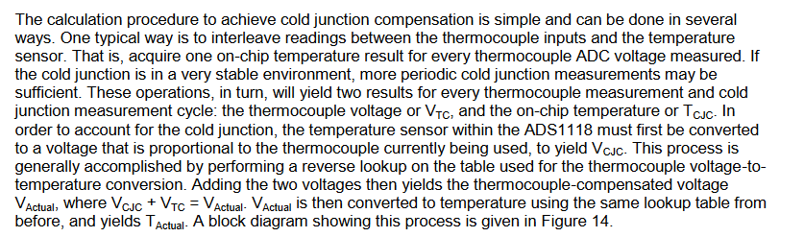
□20 Minute Burn in test without heat
□20 minute burn in test with heat

