Corrélation avec TARGET_PRICE_COL = sp500_close
Tableau des corrélations avec TARGET_PRICE_COL (ordre croissant en valeur absolue) :
transactions_summary_daily_Somme_Achats 0.009873
transactions_summary_daily_Nombre_Achats -0.014797
transactions_summary_daily_Somme_Ventes 0.019400
MACD_Hist -0.021416
ADX 0.027566
DI_Minus -0.030557
sp500_PE_Ratio_Value -0.045972
Market_yield_US_10_year_DGS10 -0.053875
Stoch_K 0.065115
Stoch_D 0.070486
ret_future 0.082744
RSI 0.092250
SP500_historical_data_Volume 0.105535
^VIX_historical_data_Close -0.118932
std_21 -0.123568
hv_30 -0.128816
personal_savings_rate_PSAVERT 0.135936
transactions_summary_daily_Nombre_Ventes 0.136517
sp500_PE_Ratio_YOY -0.149612
DI_Plus 0.156333
MACD 0.219063
MACD_Signal 0.243842
interest_rates_rate 0.332647
silver_historical_data_Close 0.354048
unemployment_rate_U2RATE -0.401412
Inflation_us_FPCPITOTLZGUSA 0.527593
r_sp_bond 0.569617
r_sp_gold 0.588941
ATR 0.690085
Mortgage_debt_percent_of_disposable_personal_income_MDSP -0.731040
dollar_index_historical_data_Close 0.787527
gold_historical_data_Close 0.805045
PPI_ProducerPriceIndexes 0.841008
adp_payroll_2000_aujourdhui_PAYEMS 0.894916
OBV 0.896022
AD 0.912796
Date 0.913391
profit_per_unit_of_real_gross_value_A466RD3Q052SBEA 0.922920
us_federal_debt_GFDEBTN 0.951231
CPI_price_index_CPI 0.951587
average_sales_price_of_houses_sold_us_ASPUS 0.954217
average_hourly_earnings_all_employees_CES0500000003 0.957842
XHB_homebuilder_historical_data_Close 0.960114
GDP_GDP 0.971999
SMA_200 0.982425
SMA_150 0.987281
r_sp_dxy 0.991221
SMA_100 0.991705
BB_High 0.997413
Ichimoku_B 0.997424
PSAR 0.997706
Fib_Level_100 0.997915
Ichimoku_Kijun 0.998367
BB_Low 0.998519
Fib_Level_0 0.998688
BB_Mid 0.998710
Fib_Level_61 0.998718
EMA_26 0.998797
Fib_Level_50 0.998847
Fib_Level_23 0.998910
Fib_Level_38 0.998914
Ichimoku_A 0.999001
VWAP 0.999109
Ichimoku_Tenkan 0.999444
EMA_12 0.999453
SP500_historical_data_Open 0.999818
SP500_historical_data_High 0.999905
SP500_historical_data_Low 0.999910

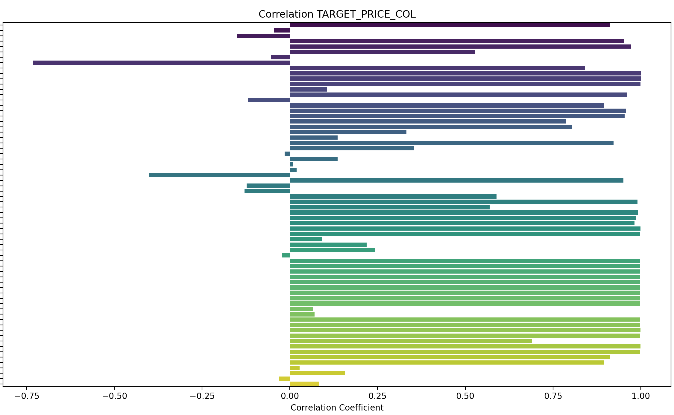

Prediction sur 3 jours

Tableau des corrélations avec ret_future (ordre croissant en valeur absolue) :
SMA_100 0.000291
XHB_homebuilder_historical_data_Close -0.000433
SMA_200 -0.000450
SMA_150 -0.000532
transactions_summary_daily_Somme_Achats 0.000805
SP500_historical_data_Volume 0.001139
Ichimoku_B -0.001186
EMA_26 -0.001928
BB_High -0.002130
Fib_Level_100 -0.002300
PSAR -0.002351
Ichimoku_Kijun -0.002524
Ichimoku_Tenkan -0.002765
EMA_12 -0.002811
VWAP -0.002837
Ichimoku_A -0.002853
BB_Mid -0.002969
Fib_Level_61 -0.002976
Fib_Level_50 -0.003193
Fib_Level_38 -0.003415
SP500_historical_data_Open -0.003631
Fib_Level_23 -0.003700
silver_historical_data_Close 0.003823
SP500_historical_data_High -0.003841
BB_Low -0.003868
SP500_historical_data_Low -0.004128
Fib_Level_0 -0.004167
SP500_historical_data_Close -0.004888
std_21 0.005140
average_sales_price_of_houses_sold_us_ASPUS 0.007123
hv_30 0.007730
PPI_ProducerPriceIndexes -0.007784
interest_rates_rate -0.008104
r_sp_dxy -0.008463
GDP_GDP 0.010371
CPI_price_index_CPI 0.010776
OBV 0.014062
adp_payroll_2000_aujourdhui_PAYEMS -0.016263
gold_historical_data_Close 0.016282
transactions_summary_daily_Nombre_Ventes -0.016553
average_hourly_earnings_all_employees_CES0500000003 0.017179
ATR 0.017954
AD 0.018083
profit_per_unit_of_real_gross_value_A466RD3Q052SBEA 0.019356
Date 0.020142
dollar_index_historical_data_Close 0.020241
sp500_PE_Ratio_YOY 0.020424
transactions_summary_daily_Somme_Ventes -0.020691
us_federal_debt_GFDEBTN 0.022602
MACD_Hist -0.022800
sp500_PE_Ratio_Value 0.025345
r_sp_gold -0.025872
r_sp_bond 0.029638
ADX 0.030156
MACD_Signal -0.036089
DI_Plus -0.036301
Mortgage_debt_percent_of_disposable_personal_income_MDSP -0.039346
^VIX_historical_data_Close 0.039587
Inflation_us_FPCPITOTLZGUSA -0.040021
MACD -0.040708
transactions_summary_daily_Nombre_Achats -0.042691
Market_yield_US_10_year_DGS10 -0.042714
DI_Minus 0.043001
Stoch_D -0.047406
Stoch_K -0.050733
RSI -0.056766
unemployment_rate_U2RATE 0.061933
personal_savings_rate_PSAVERT 0.064816

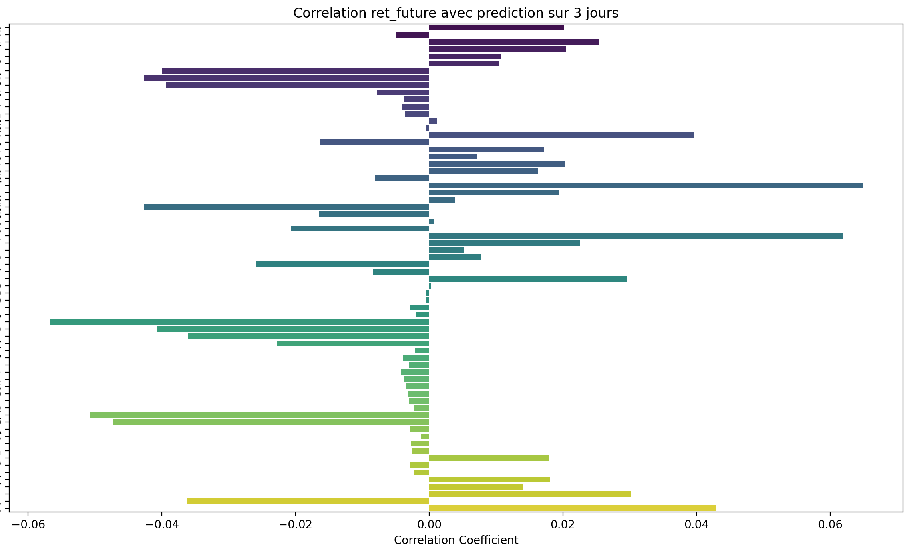

Prediction sur 7 jours

Tableau des corrélations avec ret_future (ordre croissant en valeur absolue) :
XHB_homebuilder_historical_data_Close -0.001032
SP500_historical_data_Volume -0.002152
SMA_100 -0.002449
Ichimoku_B -0.003654
MACD_Hist 0.003724
SMA_200 -0.003963
SMA_150 -0.004305
silver_historical_data_Close 0.004665
EMA_26 -0.005027
Fib_Level_100 -0.005326
BB_High -0.005600
Ichimoku_Kijun -0.005812
EMA_12 -0.005993
Fib_Level_61 -0.006204
SP500_historical_data_Open -0.006370
Fib_Level_50 -0.006484
Ichimoku_A -0.006552
SP500_historical_data_Low -0.006569
VWAP -0.006571
SP500_historical_data_High -0.006666
Ichimoku_Tenkan -0.006689
Fib_Level_38 -0.006774
BB_Mid -0.006808
PSAR -0.006909
SP500_historical_data_Close -0.007129
Fib_Level_23 -0.007146
Fib_Level_0 -0.007757
BB_Low -0.008099
std_21 0.008752
average_sales_price_of_houses_sold_us_ASPUS 0.009369
r_sp_dxy -0.012277
hv_30 0.012774
GDP_GDP 0.014885
CPI_price_index_CPI 0.014999
PPI_ProducerPriceIndexes -0.015327
interest_rates_rate -0.016592
gold_historical_data_Close 0.021803
OBV 0.022523
adp_payroll_2000_aujourdhui_PAYEMS -0.023933
transactions_summary_daily_Somme_Achats 0.024068
average_hourly_earnings_all_employees_CES0500000003 0.024487
ATR 0.025877
transactions_summary_daily_Nombre_Ventes -0.027095
transactions_summary_daily_Somme_Ventes -0.027542
AD 0.028444
profit_per_unit_of_real_gross_value_A466RD3Q052SBEA 0.028715
Date 0.031132
dollar_index_historical_data_Close 0.031881
us_federal_debt_GFDEBTN 0.033830
r_sp_gold -0.036314
ADX 0.038711
sp500_PE_Ratio_YOY 0.039606
^VIX_historical_data_Close 0.041056
DI_Minus 0.042787
DI_Plus -0.044677
MACD -0.045597
sp500_PE_Ratio_Value 0.046176
Stoch_D -0.048912
r_sp_bond 0.048937
transactions_summary_daily_Nombre_Achats -0.050175
MACD_Signal -0.050231
Stoch_K -0.054849
RSI -0.055504
Mortgage_debt_percent_of_disposable_personal_income_MDSP -0.061079
Market_yield_US_10_year_DGS10 -0.066903
Inflation_us_FPCPITOTLZGUSA -0.067031
unemployment_rate_U2RATE 0.089839
personal_savings_rate_PSAVERT 0.100430

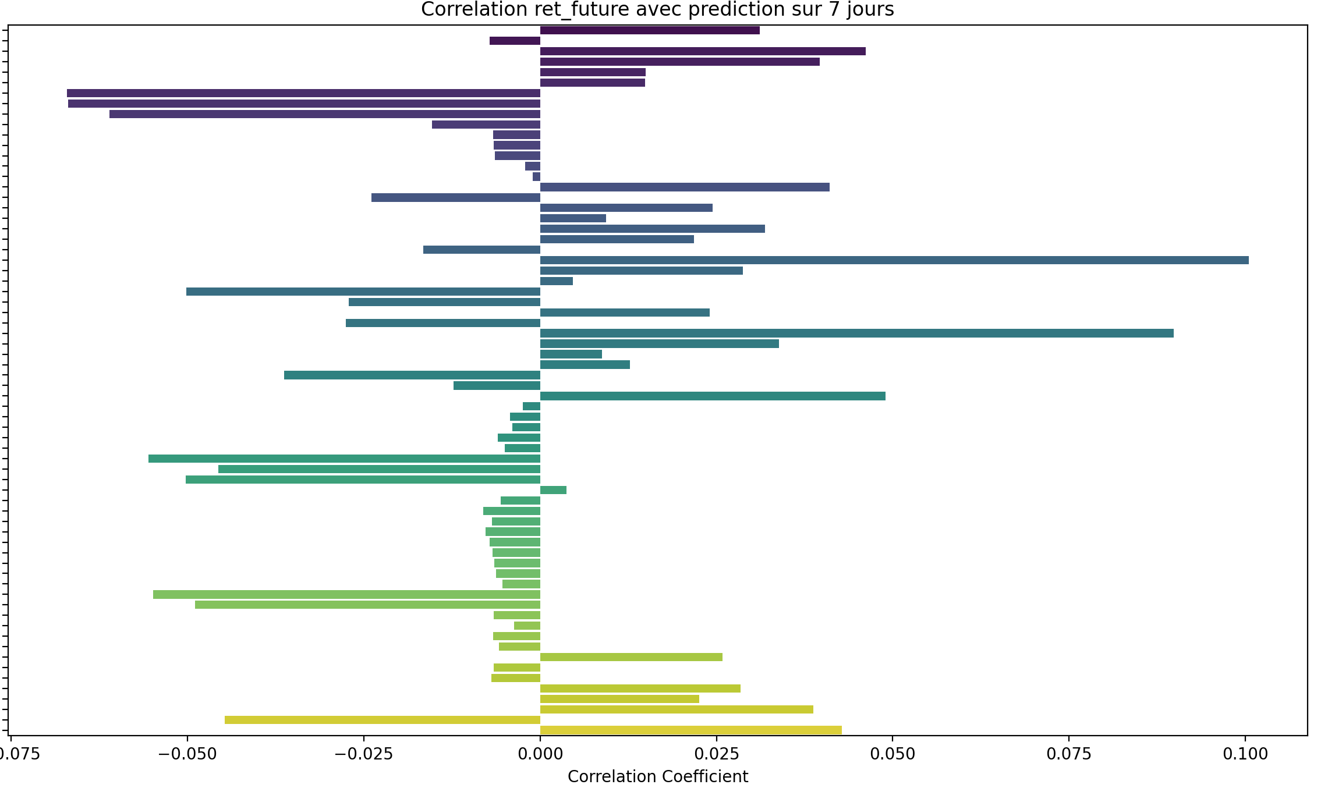

Prediction sur 14 jours

Tableau des corrélations avec ret_future (ordre croissant en valeur absolue) :
EMA_26 0.000048
BB_High -0.000061
Fib_Level_100 -0.000259
SMA_150 0.000928
MACD_Hist -0.001030
EMA_12 -0.001629
Ichimoku_Kijun -0.001647
SMA_200 0.001728
Fib_Level_61 -0.001739
Fib_Level_50 -0.002212
BB_Mid -0.002227
PSAR -0.002244
Ichimoku_B 0.002329
SP500_historical_data_Open -0.002608
VWAP -0.002629
Fib_Level_38 -0.002698
Ichimoku_A -0.002723
Ichimoku_Tenkan -0.002737
SP500_historical_data_High -0.002742
SP500_historical_data_Low -0.002941
Fib_Level_23 -0.003319
SP500_historical_data_Close -0.003324
SMA_100 0.003898
Fib_Level_0 -0.004341
BB_Low -0.004549
XHB_homebuilder_historical_data_Close 0.006048
transactions_summary_daily_Somme_Achats 0.009532
r_sp_dxy -0.010397
SP500_historical_data_Volume 0.015382
silver_historical_data_Close 0.016602
average_sales_price_of_houses_sold_us_ASPUS 0.016796
PPI_ProducerPriceIndexes -0.018471
interest_rates_rate -0.023311
adp_payroll_2000_aujourdhui_PAYEMS -0.024424
transactions_summary_daily_Somme_Ventes -0.025731
std_21 0.026614
GDP_GDP 0.027181
CPI_price_index_CPI 0.027343
hv_30 0.029765
OBV 0.037053
average_hourly_earnings_all_employees_CES0500000003 0.041613
Stoch_D -0.042521
gold_historical_data_Close 0.044245
profit_per_unit_of_real_gross_value_A466RD3Q052SBEA 0.046130
DI_Minus 0.046142
AD 0.046383
ADX 0.046765
transactions_summary_daily_Nombre_Achats -0.047722
dollar_index_historical_data_Close 0.048333
Date 0.049644
Stoch_K -0.050792
ATR 0.052648
DI_Plus -0.052730
us_federal_debt_GFDEBTN 0.053135
r_sp_gold -0.054456
transactions_summary_daily_Nombre_Ventes -0.054537
^VIX_historical_data_Close 0.060530
RSI -0.061185
sp500_PE_Ratio_YOY 0.065640
sp500_PE_Ratio_Value 0.073637
r_sp_bond 0.075903
MACD -0.077276
MACD_Signal -0.082785
Mortgage_debt_percent_of_disposable_personal_income_MDSP -0.088384
Market_yield_US_10_year_DGS10 -0.091313
Inflation_us_FPCPITOTLZGUSA -0.096773
unemployment_rate_U2RATE 0.117339
personal_savings_rate_PSAVERT 0.138614

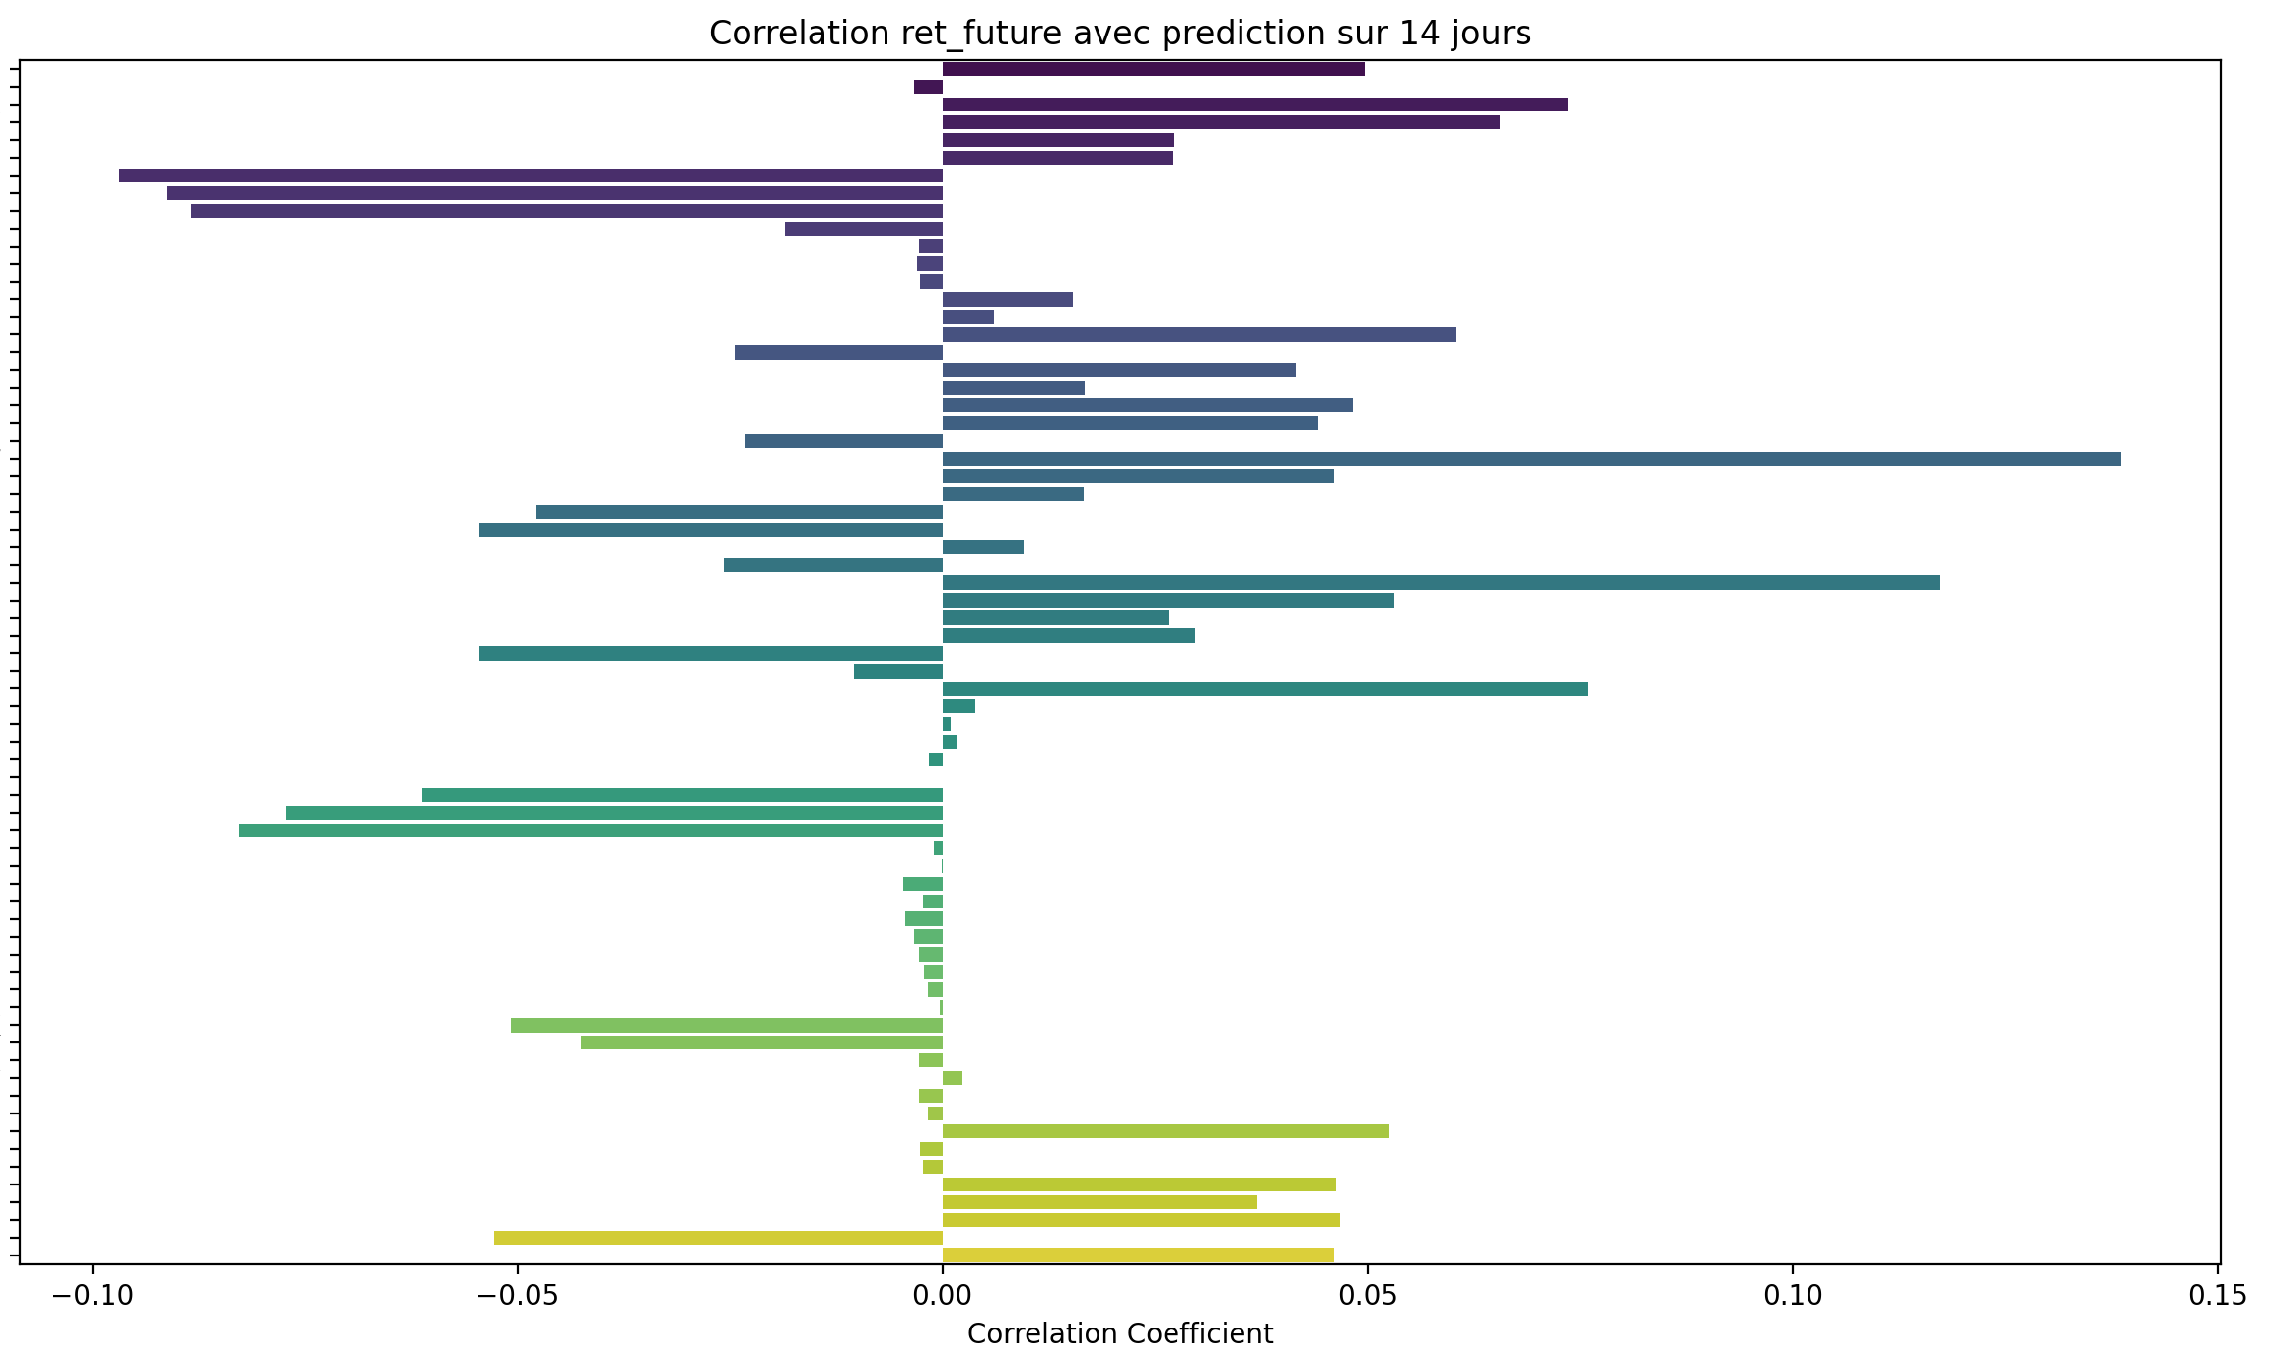

Corrélation avec ret_future sur 21 jours
Tableau des corrélations avec ret_future (ordre croissant en valeur absolue) :
SP500_historical_data_Close 0.000222
Fib_Level_23 0.000298
SP500_historical_data_Low 0.000336
SP500_historical_data_Open 0.000793
Ichimoku_Tenkan 0.000836
SP500_historical_data_High 0.000921
Fib_Level_0 -0.000998
BB_Low -0.001034
Ichimoku_A 0.001049
PSAR 0.001057
Fib_Level_38 0.001085
VWAP 0.001253
Fib_Level_50 0.001701
BB_Mid 0.001775
EMA_12 0.002093
Fib_Level_61 0.002301
Ichimoku_Kijun 0.002572
Fib_Level_100 0.004177
EMA_26 0.004358
BB_High 0.004392
transactions_summary_daily_Somme_Achats -0.005053
SMA_150 0.005292
SMA_200 0.006739
Ichimoku_B 0.007390
r_sp_dxy -0.007856
SMA_100 0.008868
XHB_homebuilder_historical_data_Close 0.011415
MACD_Hist -0.013345
transactions_summary_daily_Somme_Ventes -0.016471
average_sales_price_of_houses_sold_us_ASPUS 0.021248
PPI_ProducerPriceIndexes -0.022006
adp_payroll_2000_aujourdhui_PAYEMS -0.025308
SP500_historical_data_Volume 0.025919
interest_rates_rate -0.027706
silver_historical_data_Close 0.028561
std_21 0.035754
GDP_GDP 0.036201
CPI_price_index_CPI 0.036460
hv_30 0.047539
OBV 0.048559
transactions_summary_daily_Nombre_Achats -0.050302
Stoch_K -0.055016
ADX 0.055300
average_hourly_earnings_all_employees_CES0500000003 0.055331
Stoch_D -0.057786
profit_per_unit_of_real_gross_value_A466RD3Q052SBEA 0.058253
AD 0.060056
dollar_index_historical_data_Close 0.060442
gold_historical_data_Close 0.062503
transactions_summary_daily_Nombre_Ventes -0.062629
DI_Plus -0.063246
Date 0.063358
r_sp_gold -0.067239
us_federal_debt_GFDEBTN 0.067839
DI_Minus 0.067849
ATR 0.069560
RSI -0.074751
^VIX_historical_data_Close 0.080284
sp500_PE_Ratio_YOY 0.087197
r_sp_bond 0.092804
sp500_PE_Ratio_Value 0.098170
MACD -0.103797
MACD_Signal -0.107133
Market_yield_US_10_year_DGS10 -0.107378
Mortgage_debt_percent_of_disposable_personal_income_MDSP -0.109080
Inflation_us_FPCPITOTLZGUSA -0.114563
unemployment_rate_U2RATE 0.139115
personal_savings_rate_PSAVERT 0.172171

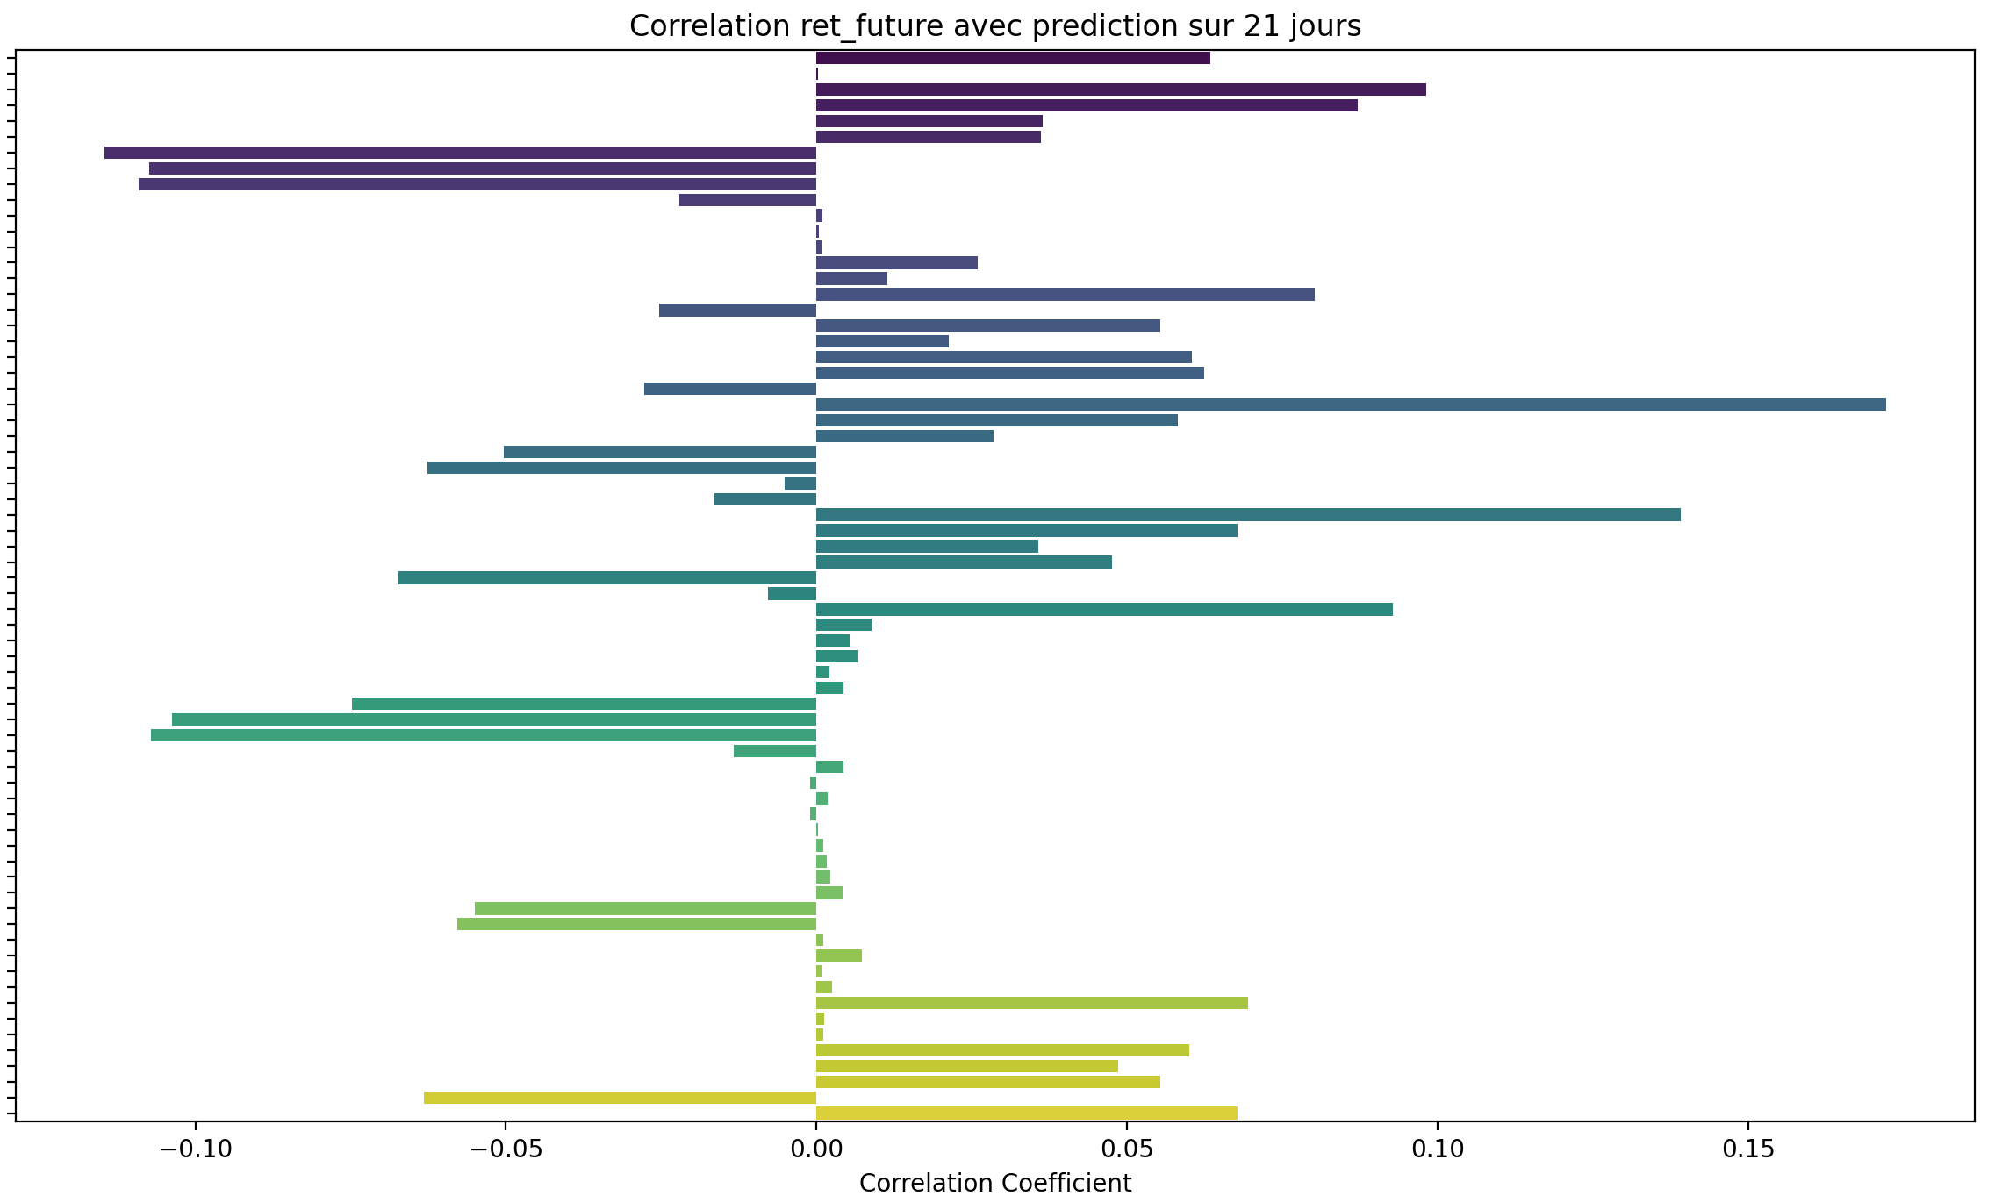

Prédiction pour 30 jours

Tableau des corrélations avec ret_future (ordre croissant en valeur absolue) :
BB_Low 0.002127
Fib_Level_0 0.002287
SP500_historical_data_Close 0.003932
SP500_historical_data_Low 0.003953
Fib_Level_23 0.004154
SP500_historical_data_Open 0.004555
SP500_historical_data_High 0.004715
Ichimoku_Tenkan 0.005185
Fib_Level_38 0.005287
VWAP 0.005546
Ichimoku_A 0.005558
r_sp_dxy -0.005558
Fib_Level_50 0.006178
BB_Mid 0.006531
EMA_12 0.006628
PSAR 0.006910
Ichimoku_Kijun 0.007031
Fib_Level_61 0.007049
transactions_summary_daily_Somme_Ventes -0.009132
EMA_26 0.009229
SMA_150 0.009499
Fib_Level_100 0.009778
BB_High 0.010644
SMA_200 0.010959
Ichimoku_B 0.011820
SMA_100 0.013224
XHB_homebuilder_historical_data_Close 0.016241
average_sales_price_of_houses_sold_us_ASPUS 0.024062
PPI_ProducerPriceIndexes -0.025918
transactions_summary_daily_Somme_Achats -0.028202
adp_payroll_2000_aujourdhui_PAYEMS -0.028551
interest_rates_rate -0.031522
MACD_Hist -0.033393
SP500_historical_data_Volume 0.038628
silver_historical_data_Close 0.040602
GDP_GDP 0.044995
CPI_price_index_CPI 0.046018
std_21 0.052426
OBV 0.060119
ADX 0.060222
hv_30 0.062321
DI_Plus -0.066334
Stoch_D -0.067931
average_hourly_earnings_all_employees_CES0500000003 0.069267
Stoch_K -0.069339
transactions_summary_daily_Nombre_Achats -0.072999
profit_per_unit_of_real_gross_value_A466RD3Q052SBEA 0.073113
AD 0.073704
dollar_index_historical_data_Close 0.074395
Date 0.077177
r_sp_gold -0.079608
gold_historical_data_Close 0.080830
ATR 0.082884
us_federal_debt_GFDEBTN 0.083031
transactions_summary_daily_Nombre_Ventes -0.083180
RSI -0.088284
DI_Minus 0.089715
^VIX_historical_data_Close 0.095411
sp500_PE_Ratio_YOY 0.103538
r_sp_bond 0.108907
MACD_Signal -0.115374
sp500_PE_Ratio_Value 0.117408
MACD -0.118417
Market_yield_US_10_year_DGS10 -0.118952
Mortgage_debt_percent_of_disposable_personal_income_MDSP -0.130035
Inflation_us_FPCPITOTLZGUSA -0.133567
unemployment_rate_U2RATE 0.166156
personal_savings_rate_PSAVERT 0.203446

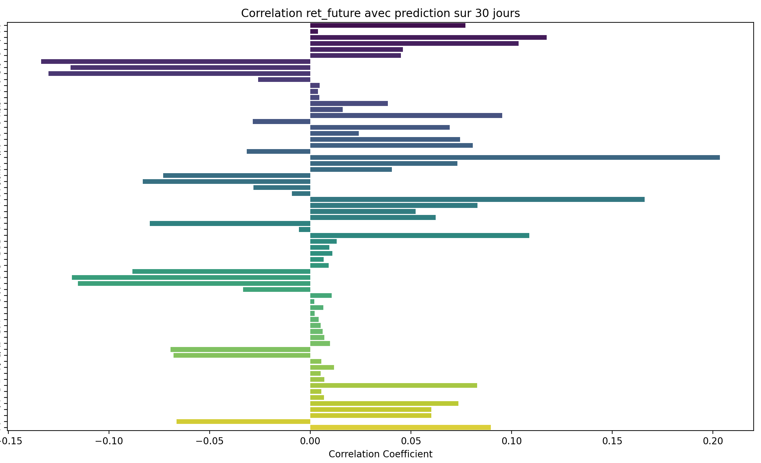

Prediction sur 60 jours

Tableau des corrélations avec ret_future (ordre croissant en valeur absolue) :
transactions_summary_daily_Somme_Ventes -0.001332
ADX -0.007086
r_sp_dxy 0.013308
adp_payroll_2000_aujourdhui_PAYEMS -0.022861
transactions_summary_daily_Somme_Achats -0.023991
BB_Low 0.029440
Fib_Level_0 0.029760
SP500_historical_data_Low 0.030613
SP500_historical_data_Close 0.030786
SP500_historical_data_Open 0.031590
SP500_historical_data_High 0.031759
Fib_Level_23 0.032099
SMA_150 0.032447
Ichimoku_Tenkan 0.032918
interest_rates_rate -0.033115
SMA_200 0.033282
Fib_Level_38 0.033514
EMA_12 0.033897
PPI_ProducerPriceIndexes -0.033909
Ichimoku_A 0.033929
VWAP 0.034001
PSAR 0.034378
Fib_Level_50 0.034635
Ichimoku_Kijun 0.035108
Ichimoku_B 0.035127
BB_Mid 0.035233
Fib_Level_61 0.035736
EMA_26 0.035985
SMA_100 0.036628
average_sales_price_of_houses_sold_us_ASPUS 0.037037
Fib_Level_100 0.039190
BB_High 0.040622
XHB_homebuilder_historical_data_Close 0.048868
std_21 0.052226
hv_30 0.056622
SP500_historical_data_Volume 0.062739
transactions_summary_daily_Nombre_Achats -0.064509
MACD_Signal -0.066976
silver_historical_data_Close 0.067658
transactions_summary_daily_Nombre_Ventes -0.069302
DI_Plus -0.071628
MACD_Hist -0.072396
Stoch_K -0.074425
Stoch_D -0.074883
GDP_GDP 0.077456
CPI_price_index_CPI 0.079801
MACD -0.085625
DI_Minus 0.089616
RSI -0.095201
OBV 0.096701
r_sp_gold -0.101711
^VIX_historical_data_Close 0.105891
ATR 0.110271
profit_per_unit_of_real_gross_value_A466RD3Q052SBEA 0.113507
average_hourly_earnings_all_employees_CES0500000003 0.115757
AD 0.115843
Date 0.120226
dollar_index_historical_data_Close 0.125883
us_federal_debt_GFDEBTN 0.130711
gold_historical_data_Close 0.143553
Market_yield_US_10_year_DGS10 -0.156271
r_sp_bond 0.156286
sp500_PE_Ratio_YOY 0.168448
Mortgage_debt_percent_of_disposable_personal_income_MDSP -0.188129
sp500_PE_Ratio_Value 0.193633
Inflation_us_FPCPITOTLZGUSA -0.214716
unemployment_rate_U2RATE 0.222089
personal_savings_rate_PSAVERT 0.279586

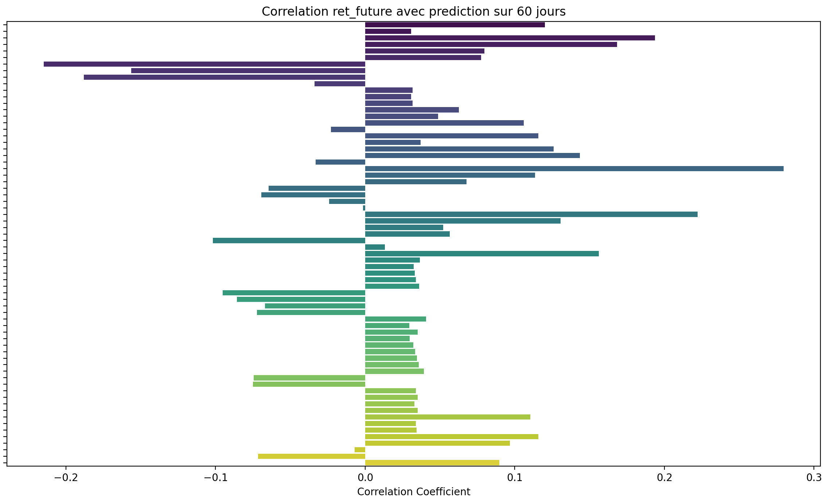

Prédiction pour 90 jours

Tableau des corrélations avec ret_future (ordre croissant en valeur absolue) :
ADX -0.003126
transactions_summary_daily_Somme_Ventes 0.005147
MACD_Signal -0.014566
adp_payroll_2000_aujourdhui_PAYEMS -0.014938
r_sp_dxy 0.023115
DI_Plus -0.027265
MACD -0.030126
transactions_summary_daily_Somme_Achats -0.032271
PPI_ProducerPriceIndexes -0.034660
interest_rates_rate -0.039535
SMA_150 0.046569
BB_Low 0.047153
Fib_Level_0 0.047224
SMA_200 0.047886
Stoch_D -0.048200
Stoch_K -0.048921
average_sales_price_of_houses_sold_us_ASPUS 0.049274
SP500_historical_data_Low 0.049322
Fib_Level_23 0.049465
SP500_historical_data_Close 0.049517
SMA_100 0.049576
SP500_historical_data_Open 0.050048
SP500_historical_data_High 0.050318
Fib_Level_38 0.050816
Ichimoku_Tenkan 0.051081
Ichimoku_B 0.051087
EMA_12 0.051426
VWAP 0.051626
Ichimoku_A 0.051679
Fib_Level_50 0.051888
PSAR 0.051934
MACD_Hist -0.051987
Ichimoku_Kijun 0.052015
EMA_26 0.052407
BB_Mid 0.052442
DI_Minus 0.052724
Fib_Level_61 0.052942
Fib_Level_100 0.056240
RSI -0.057114
BB_High 0.057327
SP500_historical_data_Volume 0.061688
XHB_homebuilder_historical_data_Close 0.065009
transactions_summary_daily_Nombre_Ventes -0.074400
silver_historical_data_Close 0.077493
std_21 0.081612
hv_30 0.096357
GDP_GDP 0.103125
CPI_price_index_CPI 0.107024
transactions_summary_daily_Nombre_Achats -0.108677
r_sp_gold -0.117012
ATR 0.118332
^VIX_historical_data_Close 0.124289
OBV 0.124388
average_hourly_earnings_all_employees_CES0500000003 0.146163
AD 0.147012
profit_per_unit_of_real_gross_value_A466RD3Q052SBEA 0.148387
Date 0.152504
us_federal_debt_GFDEBTN 0.166140
dollar_index_historical_data_Close 0.172604
gold_historical_data_Close 0.185356
r_sp_bond 0.185417
Market_yield_US_10_year_DGS10 -0.189675
sp500_PE_Ratio_YOY 0.214229
Mortgage_debt_percent_of_disposable_personal_income_MDSP -0.223020
sp500_PE_Ratio_Value 0.238617
Inflation_us_FPCPITOTLZGUSA -0.257314
unemployment_rate_U2RATE 0.257716
personal_savings_rate_PSAVERT 0.321936

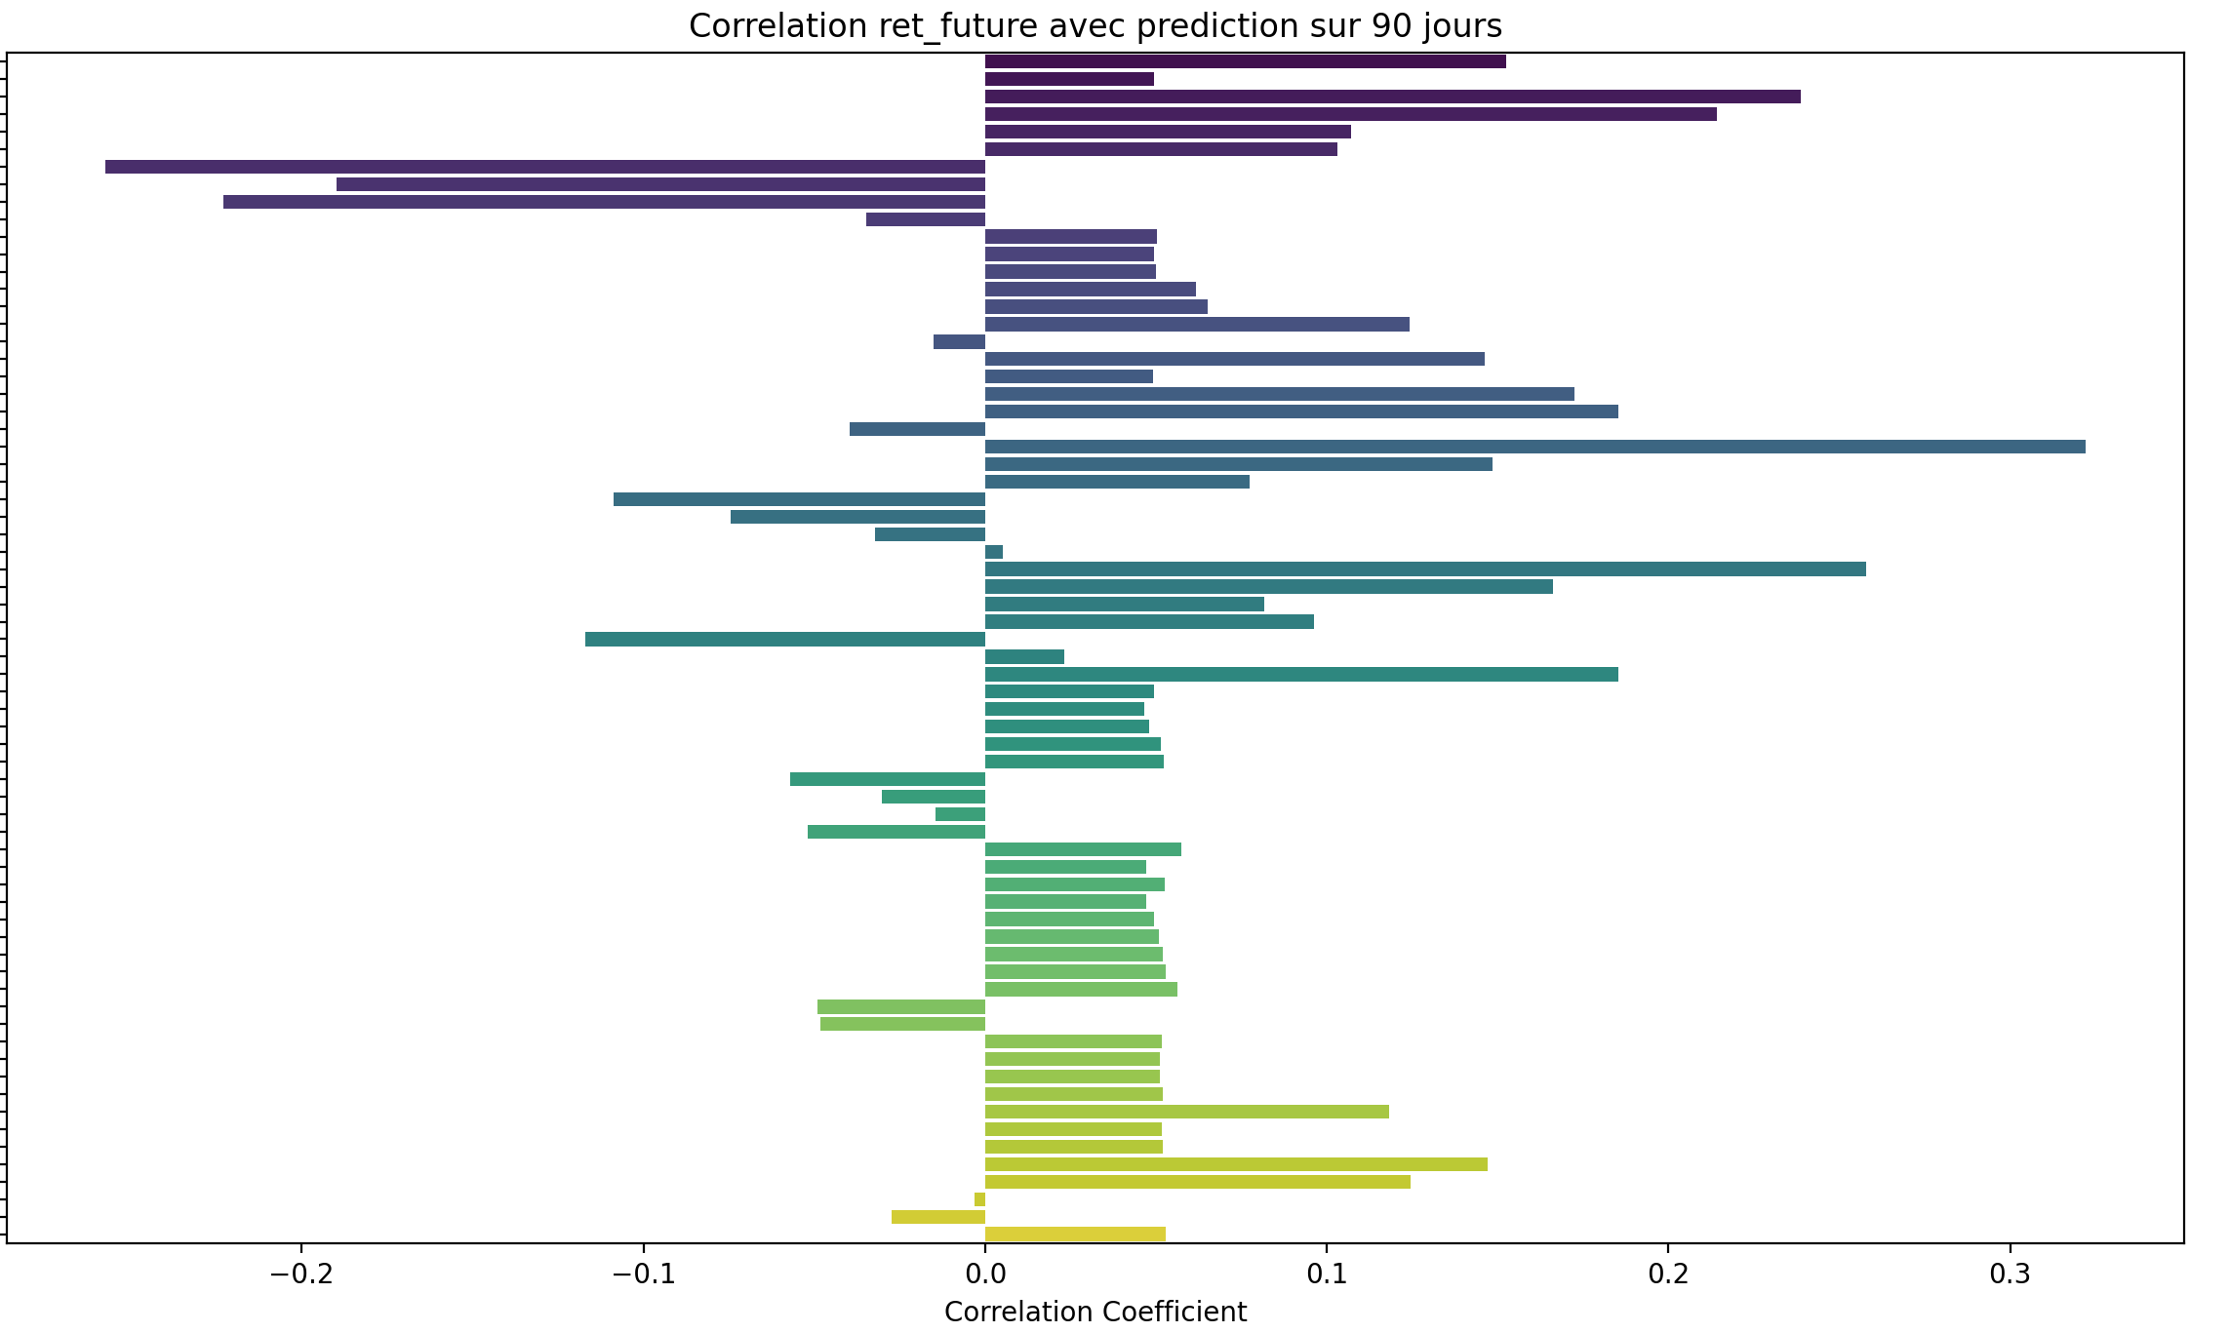

Tableau des corrélations avec ret_future (ordre croissant en valeur absolue) :
adp_payroll_2000_aujourdhui_PAYEMS -0.002756
transactions_summary_daily_Somme_Ventes 0.006912
DI_Plus 0.009316
Stoch_D -0.013577
Stoch_K -0.014452
RSI -0.020188
MACD_Signal -0.022577
r_sp_dxy 0.024051
PPI_ProducerPriceIndexes -0.024359
MACD_Hist -0.029678
MACD -0.030519
DI_Minus 0.035615
transactions_summary_daily_Somme_Achats -0.038245
interest_rates_rate -0.053007
BB_Low 0.053604
Fib_Level_0 0.054450
SMA_150 0.055332
average_sales_price_of_houses_sold_us_ASPUS 0.055632
Fib_Level_23 0.057265
SMA_200 0.057441
SMA_100 0.057452
SP500_historical_data_Low 0.058286
SP500_historical_data_Close 0.058736
Fib_Level_38 0.058963
SP500_historical_data_Open 0.059030
Ichimoku_Tenkan 0.059288
PSAR 0.059364
SP500_historical_data_High 0.059489
VWAP 0.059651
Ichimoku_A 0.059960
EMA_12 0.060045
Fib_Level_50 0.060307
BB_Mid 0.060415
Ichimoku_B 0.060551
Ichimoku_Kijun 0.060761
EMA_26 0.061083
Fib_Level_61 0.061627
Fib_Level_100 0.065752
BB_High 0.066702
ADX 0.069279
XHB_homebuilder_historical_data_Close 0.074707
silver_historical_data_Close 0.086741
transactions_summary_daily_Nombre_Ventes -0.111704
SP500_historical_data_Volume 0.116142
transactions_summary_daily_Nombre_Achats -0.118219
GDP_GDP 0.122092
CPI_price_index_CPI 0.129703
r_sp_gold -0.135824
std_21 0.136176
ATR 0.139356
hv_30 0.140549
OBV 0.142600
average_hourly_earnings_all_employees_CES0500000003 0.166038
AD 0.167145
profit_per_unit_of_real_gross_value_A466RD3Q052SBEA 0.171938
Date 0.175163
^VIX_historical_data_Close 0.176105
r_sp_bond 0.188441
us_federal_debt_GFDEBTN 0.191218
Market_yield_US_10_year_DGS10 -0.200640
dollar_index_historical_data_Close 0.208710
gold_historical_data_Close 0.212546
sp500_PE_Ratio_YOY 0.239355
Mortgage_debt_percent_of_disposable_personal_income_MDSP -0.240999
sp500_PE_Ratio_Value 0.256256
Inflation_us_FPCPITOTLZGUSA -0.262248
unemployment_rate_U2RATE 0.269695
personal_savings_rate_PSAVERT 0.327320

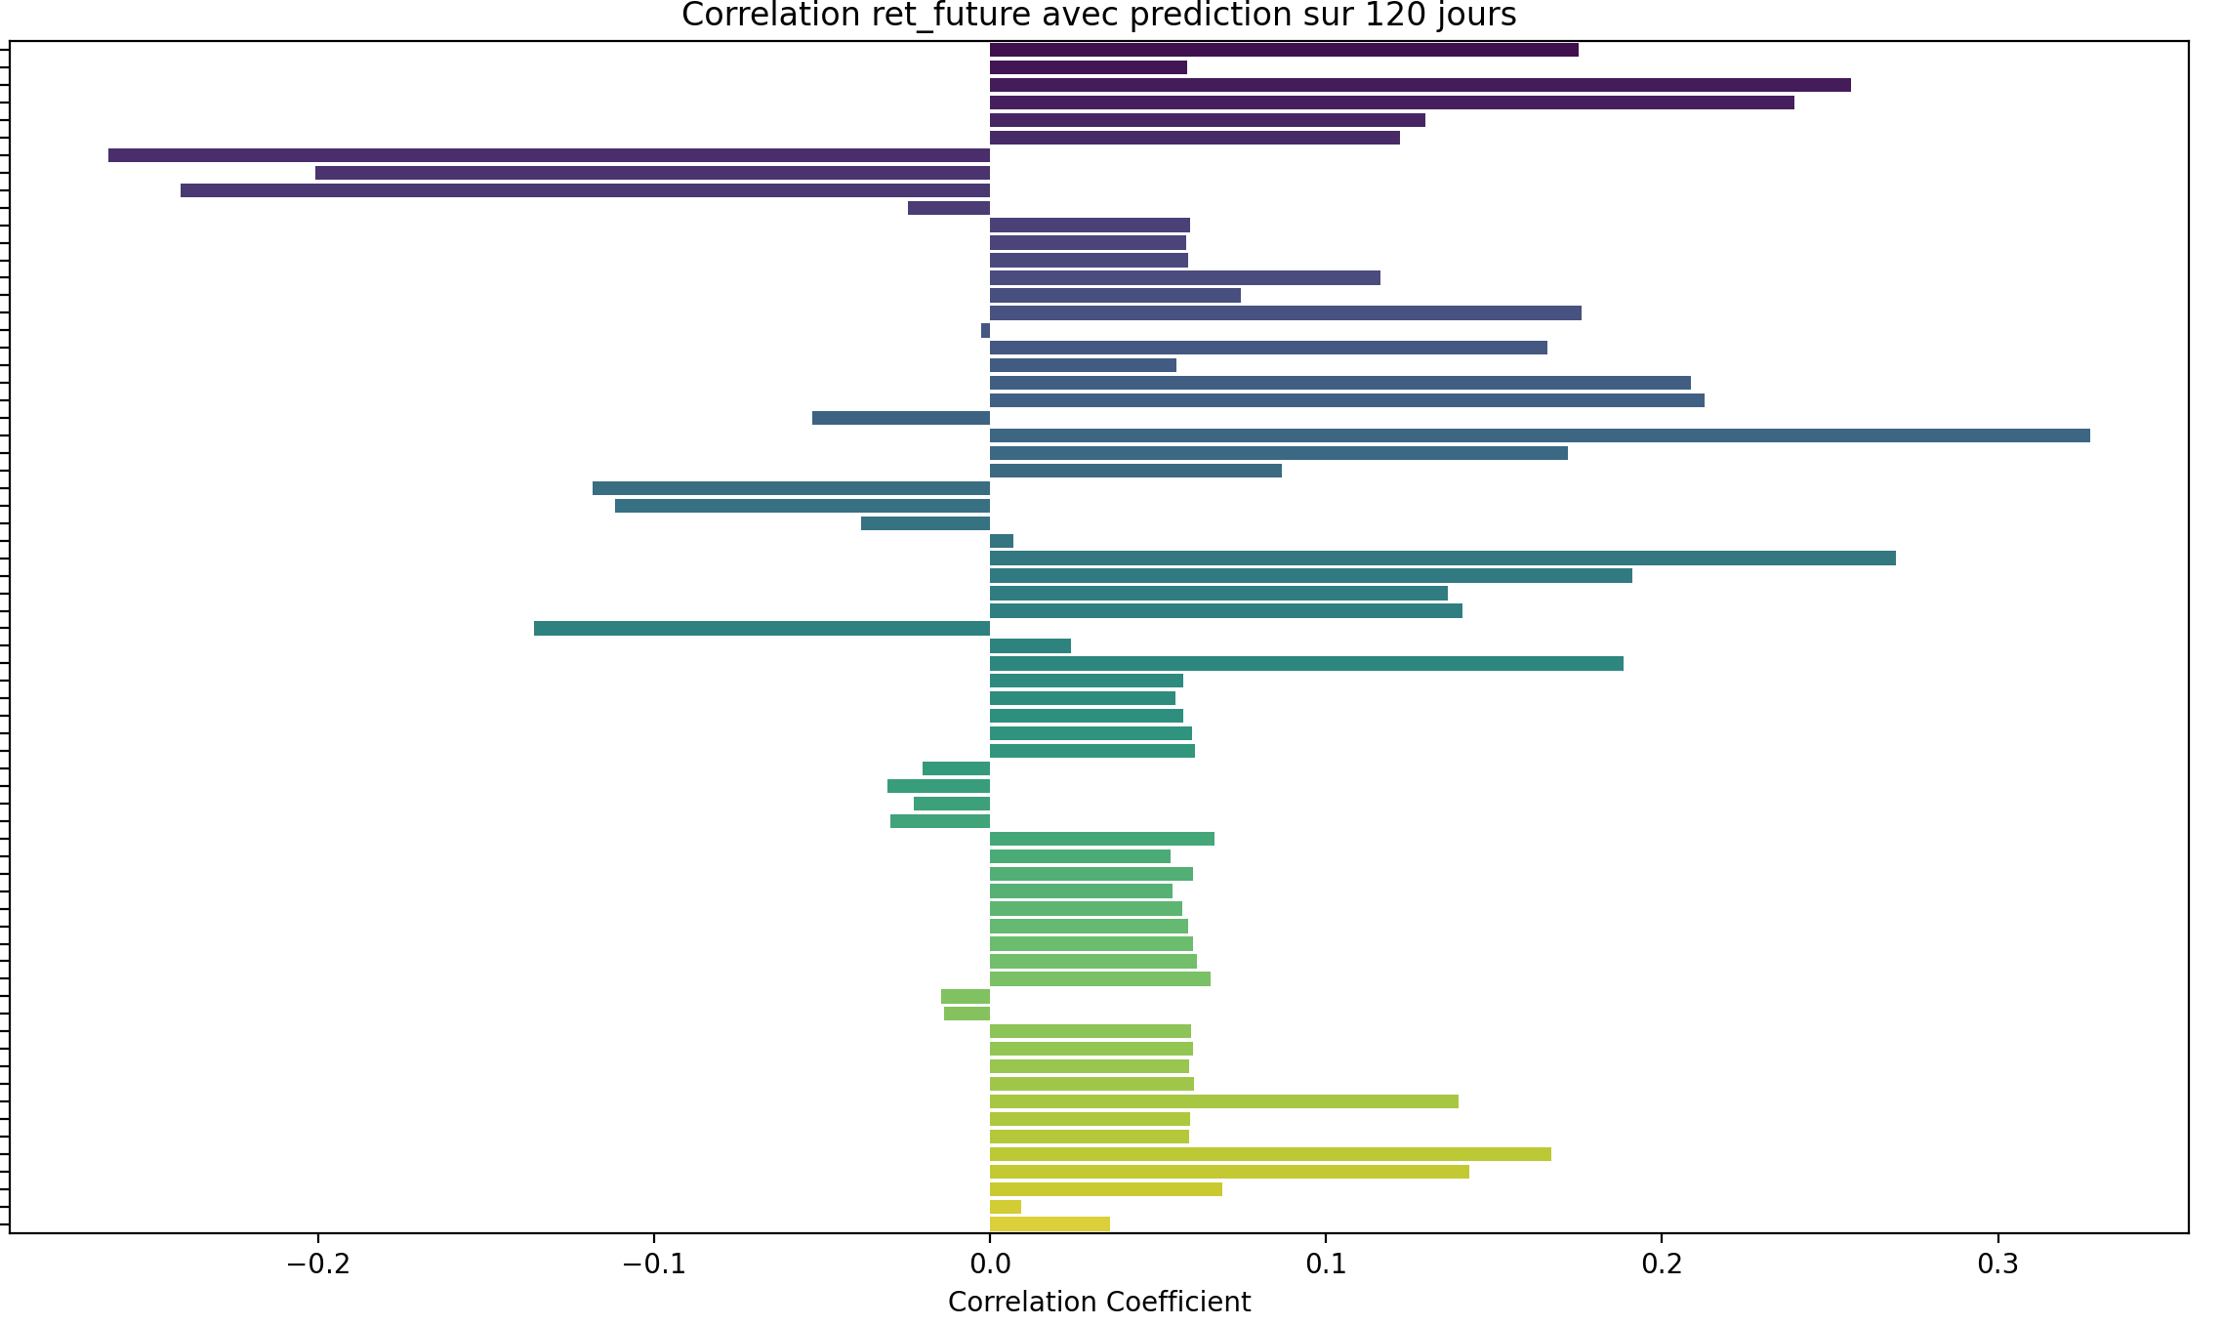
Comparaison des moyennes :

moyenne des corrélations avec TARGET_PRICE_COL : 0.577

moyenne des corrélations avec ret_future (3 jours): -0.001

moyenne des corrélations avec ret_future (7 jours): -0.001

moyenne des corrélations avec ret_future (14 jours): 0.004

moyenne des corrélations avec ret_future (21 jours): 0.008

moyenne des corrélations avec ret_future (30 jours): 0.012

moyenne des corrélations avec ret_future (60 jours): 0.031

moyenne des corrélations avec ret_future (90 jours): 0.048

moyenne des corrélations avec ret_future (120 jours): 0.061

