Corrélation avec TARGET_PRICE_COL = sp500_close
Tableau des corrélations avec TARGET_PRICE_COL (ordre croissant en valeur absolue) :
transactions_summary_daily_Somme_Achats 0.009873
transactions_summary_daily_Nombre_Achats -0.014797
transactions_summary_daily_Somme_Ventes 0.019400
MACD_Hist -0.021416
ADX 0.027566
DI_Minus -0.030557
sp500_PE_Ratio_Value -0.045972
Market_yield_US_10_year_DGS10 -0.053875
Stoch_K 0.065115
Stoch_D 0.070486
ret_future 0.082744
RSI 0.092250
SP500_historical_data_Volume 0.105535
^VIX_historical_data_Close -0.118932
std_21 -0.123568
hv_30 -0.128816
personal_savings_rate_PSAVERT 0.135936
transactions_summary_daily_Nombre_Ventes 0.136517
sp500_PE_Ratio_YOY -0.149612
DI_Plus 0.156333
MACD 0.219063
MACD_Signal 0.243842
interest_rates_rate 0.332647
silver_historical_data_Close 0.354048
unemployment_rate_U2RATE -0.401412
Inflation_us_FPCPITOTLZGUSA 0.527593
r_sp_bond 0.569617
r_sp_gold 0.588941
ATR 0.690085
Mortgage_debt_percent_of_disposable_personal_income_MDSP -0.731040
dollar_index_historical_data_Close 0.787527
gold_historical_data_Close 0.805045
PPI_ProducerPriceIndexes 0.841008
adp_payroll_2000_aujourdhui_PAYEMS 0.894916
OBV 0.896022
AD 0.912796
Date 0.913391
profit_per_unit_of_real_gross_value_A466RD3Q052SBEA 0.922920
us_federal_debt_GFDEBTN 0.951231
CPI_price_index_CPI 0.951587
average_sales_price_of_houses_sold_us_ASPUS 0.954217
average_hourly_earnings_all_employees_CES0500000003 0.957842
XHB_homebuilder_historical_data_Close 0.960114
GDP_GDP 0.971999
SMA_200 0.982425
SMA_150 0.987281
r_sp_dxy 0.991221
SMA_100 0.991705
BB_High 0.997413
Ichimoku_B 0.997424
PSAR 0.997706
Fib_Level_100 0.997915
Ichimoku_Kijun 0.998367
BB_Low 0.998519
Fib_Level_0 0.998688
BB_Mid 0.998710
Fib_Level_61 0.998718
EMA_26 0.998797
Fib_Level_50 0.998847
Fib_Level_23 0.998910
Fib_Level_38 0.998914
Ichimoku_A 0.999001
VWAP 0.999109
Ichimoku_Tenkan 0.999444
EMA_12 0.999453
SP500_historical_data_Open 0.999818
SP500_historical_data_High 0.999905
SP500_historical_data_Low 0.999910

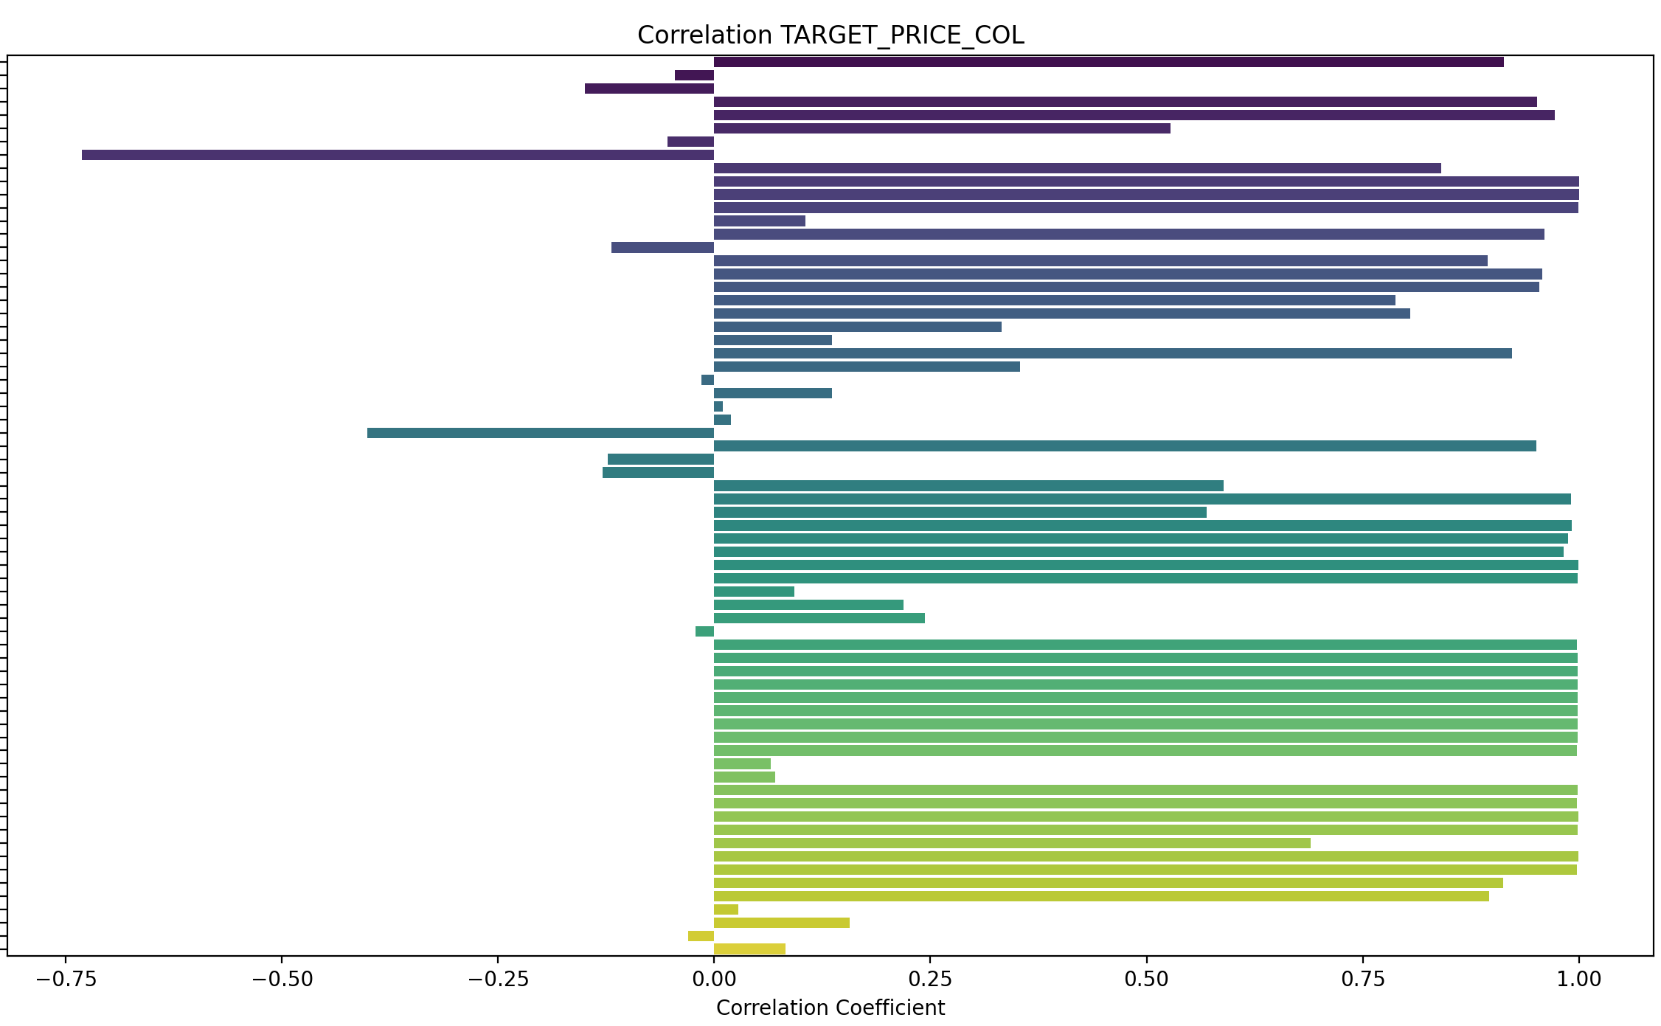

Prediction sur 3 jours

Tableau des corrélations avec ret_future (ordre croissant en valeur absolue) :
SMA_200 0.000215
SMA_150 0.000675
dollar_index_historical_data_Close -0.000867
BB_High -0.000881
SMA_100 0.001710
BB_Mid 0.002009
Fib_Level_100 0.002074
interest_rates_rate -0.002695
VWAP 0.003573
EMA_26 0.003973
Ichimoku_B 0.004043
Ichimoku_Kijun 0.004085
Fib_Level_61 0.004240
Fib_Level_50 0.004925
BB_Low 0.005072
PPI_ProducerPriceIndexes -0.005572
Ichimoku_A 0.005613
Fib_Level_38 0.005616
Fib_Level_23 0.006479
EMA_12 0.007709
Ichimoku_Tenkan 0.007897
Fib_Level_0 0.007901
transactions_summary_daily_Somme_Ventes 0.008755
PSAR -0.010018
transactions_summary_daily_Somme_Achats 0.010368
average_sales_price_of_houses_sold_us_ASPUS 0.011057
adp_payroll_2000_aujourdhui_PAYEMS -0.011325
CPI_price_index_CPI 0.011495
GDP_GDP 0.012274
average_hourly_earnings_all_employees_CES0500000003 0.017733
Market_yield_US_10_year_DGS10 -0.018240
Date 0.020804
SP500_historical_data_Open 0.021282
gold_historical_data_Close 0.021729
profit_per_unit_of_real_gross_value_A466RD3Q052SBEA 0.022349
us_federal_debt_GFDEBTN 0.023100
SP500_historical_data_High 0.023384
AD 0.024450
transactions_summary_daily_Nombre_Achats 0.025666
OBV 0.027075
SP500_historical_data_Low 0.028429
transactions_summary_daily_Nombre_Ventes 0.029192
r_sp_gold 0.029699
SP500_historical_data_Close 0.030113
silver_historical_data_Close 0.030770
r_sp_bond 0.033790
XHB_homebuilder_historical_data_Close 0.035430
ADX -0.036008
r_sp_dxy 0.037134
ATR -0.039700
Mortgage_debt_percent_of_disposable_personal_income_MDSP -0.043195
MACD_Signal 0.043519
Inflation_us_FPCPITOTLZGUSA -0.045344
hv_30 -0.045826
unemployment_rate_U2RATE 0.047964
sp500_PE_Ratio_YOY 0.049628
personal_savings_rate_PSAVERT 0.049929
sp500_PE_Ratio_Value 0.051778
std_21 -0.057953
SP500_historical_data_Volume -0.149839
MACD 0.170209
^VIX_historical_data_Close -0.256435
DI_Plus 0.402991
MACD_Hist 0.410299
DI_Minus -0.435787
Stoch_D 0.447750
RSI 0.498489
Stoch_K 0.604927

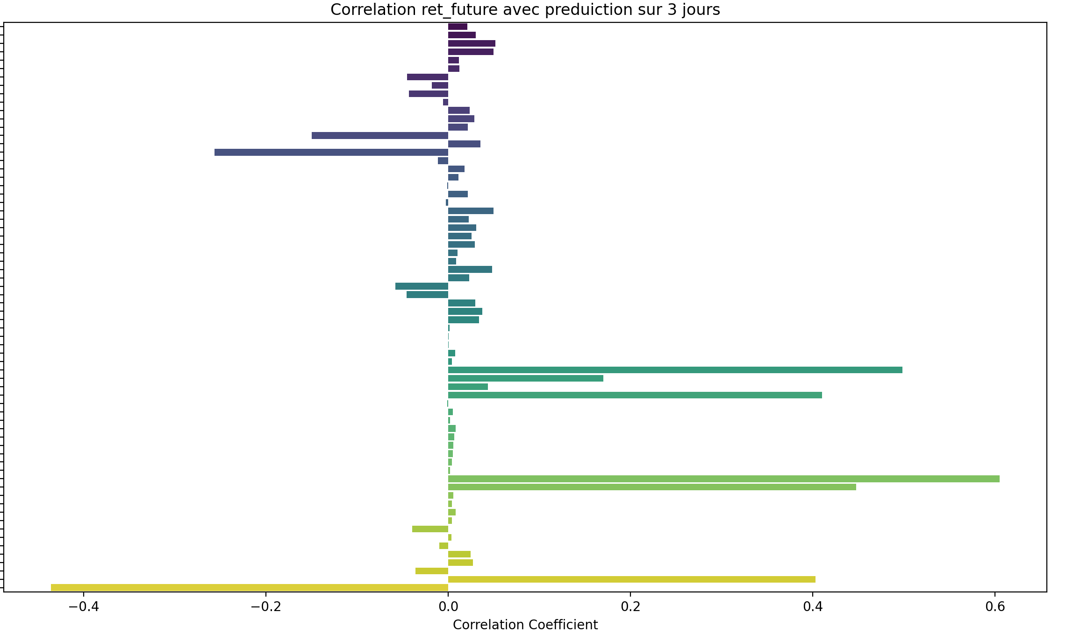

Prediction sur 7 jours

Tableau des corrélations avec ret_future (ordre croissant en valeur absolue) :
SMA_100 0.000914
SMA_150 -0.001113
BB_High -0.001712
SMA_200 -0.001825
dollar_index_historical_data_Close -0.002953
Fib_Level_100 0.003183
BB_Mid 0.005488
interest_rates_rate -0.005495
PSAR -0.005865
Ichimoku_B 0.007249
Fib_Level_61 0.008051
Ichimoku_Kijun 0.008391
EMA_26 0.009207
Fib_Level_50 0.009593
VWAP 0.010454
PPI_ProducerPriceIndexes -0.010786
Fib_Level_38 0.011150
Ichimoku_A 0.012480
Fib_Level_23 0.013098
BB_Low 0.013132
average_sales_price_of_houses_sold_us_ASPUS 0.015403
CPI_price_index_CPI 0.016159
transactions_summary_daily_Nombre_Ventes 0.016167
Fib_Level_0 0.016308
transactions_summary_daily_Somme_Ventes 0.016703
GDP_GDP 0.016825
Ichimoku_Tenkan 0.017655
EMA_12 0.018169
transactions_summary_daily_Nombre_Achats 0.021673
adp_payroll_2000_aujourdhui_PAYEMS -0.022962
average_hourly_earnings_all_employees_CES0500000003 0.026279
transactions_summary_daily_Somme_Achats 0.029478
gold_historical_data_Close 0.030517
Date 0.031540
profit_per_unit_of_real_gross_value_A466RD3Q052SBEA 0.033059
us_federal_debt_GFDEBTN 0.035302
Market_yield_US_10_year_DGS10 -0.036225
SP500_historical_data_High 0.037083
AD 0.037260
SP500_historical_data_Open 0.037875
OBV 0.041503
r_sp_gold 0.042946
SP500_historical_data_Close 0.043317
SP500_historical_data_Low 0.044537
silver_historical_data_Close 0.049182
XHB_homebuilder_historical_data_Close 0.051745
r_sp_dxy 0.054000
r_sp_bond 0.059263
Mortgage_debt_percent_of_disposable_personal_income_MDSP -0.068956
Inflation_us_FPCPITOTLZGUSA -0.072568
sp500_PE_Ratio_YOY 0.081335
personal_savings_rate_PSAVERT 0.082495
unemployment_rate_U2RATE 0.084130
sp500_PE_Ratio_Value 0.084991
hv_30 -0.115544
ATR -0.120421
ADX -0.121632
std_21 -0.148312
MACD_Signal 0.203144
SP500_historical_data_Volume -0.218814
^VIX_historical_data_Close -0.363987
MACD 0.408165
DI_Plus 0.582368
DI_Minus -0.595346
RSI 0.657235
MACD_Hist 0.694931
Stoch_D 0.700168
Stoch_K 0.719985

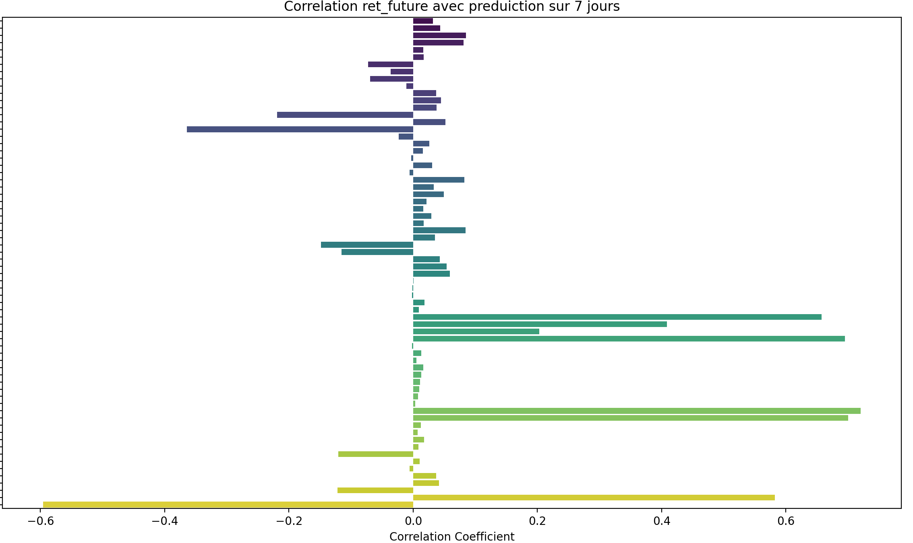

Prediction sur 14 jours

Tableau des corrélations avec ret_future (ordre croissant en valeur absolue) :
dollar_index_historical_data_Close -0.001456
interest_rates_rate -0.001786
SMA_200 0.005401
SMA_150 0.006751
PPI_ProducerPriceIndexes -0.008630
SMA_100 0.009697
BB_High 0.012291
transactions_summary_daily_Somme_Ventes 0.014043
Fib_Level_100 0.017142
transactions_summary_daily_Nombre_Achats 0.017819
Ichimoku_B 0.020447
Ichimoku_Kijun 0.024228
transactions_summary_daily_Nombre_Ventes 0.024835
BB_Mid 0.024943
Fib_Level_61 0.025294
transactions_summary_daily_Somme_Achats 0.026716
average_sales_price_of_houses_sold_us_ASPUS 0.027202
adp_payroll_2000_aujourdhui_PAYEMS -0.027296
Fib_Level_50 0.027877
CPI_price_index_CPI 0.028108
EMA_26 0.028137
GDP_GDP 0.028440
Fib_Level_38 0.030489
PSAR 0.031111
Fib_Level_23 0.033762
Ichimoku_A 0.035022
VWAP 0.035782
BB_Low 0.038366
Fib_Level_0 0.039155
average_hourly_earnings_all_employees_CES0500000003 0.041935
EMA_12 0.042555
Market_yield_US_10_year_DGS10 -0.046538
Ichimoku_Tenkan 0.046772
Date 0.048144
gold_historical_data_Close 0.049603
profit_per_unit_of_real_gross_value_A466RD3Q052SBEA 0.051157
us_federal_debt_GFDEBTN 0.054428
AD 0.056357
SP500_historical_data_High 0.059978
r_sp_gold 0.060277
OBV 0.061728
SP500_historical_data_Open 0.061950
SP500_historical_data_Close 0.065885
SP500_historical_data_Low 0.068206
silver_historical_data_Close 0.073094
XHB_homebuilder_historical_data_Close 0.077954
r_sp_bond 0.079714
r_sp_dxy 0.080471
Inflation_us_FPCPITOTLZGUSA -0.095064
Mortgage_debt_percent_of_disposable_personal_income_MDSP -0.100174
sp500_PE_Ratio_YOY 0.106595
personal_savings_rate_PSAVERT 0.109996
sp500_PE_Ratio_Value 0.114473
unemployment_rate_U2RATE 0.115170
ATR -0.214505
ADX -0.225506
hv_30 -0.238179
SP500_historical_data_Volume -0.258365
std_21 -0.310797
^VIX_historical_data_Close -0.462414
MACD_Signal 0.482629
MACD 0.658843
DI_Plus 0.664319
MACD_Hist 0.669129
DI_Minus -0.671265
Stoch_K 0.689021
Stoch_D 0.725055
RSI 0.726048

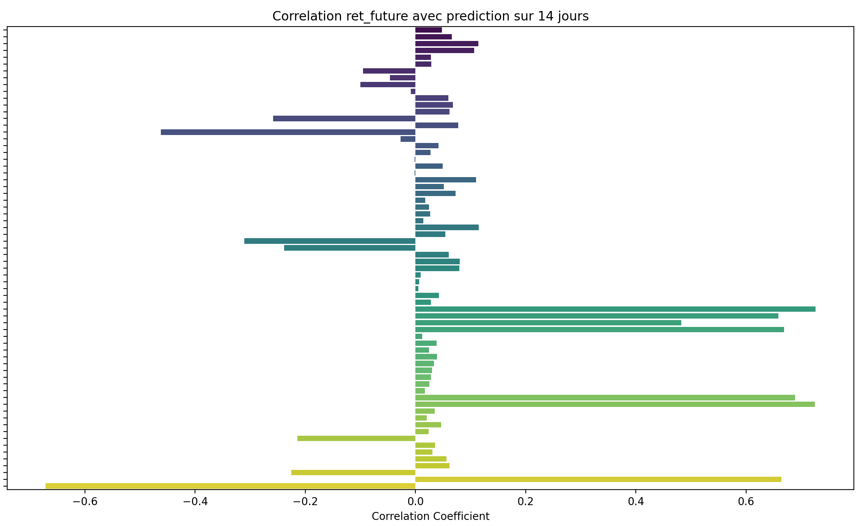

Corrélation avec ret_future sur 21 jours
Tableau des corrélations avec ret_future (ordre croissant en valeur absolue) :
interest_rates_rate 0.002533
dollar_index_historical_data_Close -0.003871
PPI_ProducerPriceIndexes -0.004131
SMA_200 0.011798
SMA_150 0.014145
SMA_100 0.018133
adp_payroll_2000_aujourdhui_PAYEMS -0.018321
transactions_summary_daily_Somme_Ventes 0.018996
transactions_summary_daily_Nombre_Achats 0.020109
BB_High 0.030723
Ichimoku_B 0.032170
transactions_summary_daily_Somme_Achats 0.033233
Fib_Level_100 0.034219
CPI_price_index_CPI 0.037710
average_sales_price_of_houses_sold_us_ASPUS 0.038636
GDP_GDP 0.038790
Ichimoku_Kijun 0.040429
Fib_Level_61 0.044829
EMA_26 0.045747
BB_Mid 0.047018
transactions_summary_daily_Nombre_Ventes 0.047952
Fib_Level_50 0.048191
Fib_Level_38 0.051594
Market_yield_US_10_year_DGS10 -0.051892
average_hourly_earnings_all_employees_CES0500000003 0.052958
Ichimoku_A 0.053905
Fib_Level_23 0.055859
VWAP 0.058506
PSAR 0.058517
Date 0.060553
EMA_12 0.062454
Fib_Level_0 0.062883
profit_per_unit_of_real_gross_value_A466RD3Q052SBEA 0.062905
BB_Low 0.064290
gold_historical_data_Close 0.065667
us_federal_debt_GFDEBTN 0.067164
Ichimoku_Tenkan 0.067592
AD 0.070816
r_sp_gold 0.072212
OBV 0.076914
SP500_historical_data_High 0.077120
SP500_historical_data_Open 0.079564
SP500_historical_data_Close 0.082744
SP500_historical_data_Low 0.085553
silver_historical_data_Close 0.094558
r_sp_bond 0.096089
personal_savings_rate_PSAVERT 0.096234
XHB_homebuilder_historical_data_Close 0.099087
r_sp_dxy 0.100984
unemployment_rate_U2RATE 0.105768
Inflation_us_FPCPITOTLZGUSA -0.111695
sp500_PE_Ratio_YOY 0.118246
Mortgage_debt_percent_of_disposable_personal_income_MDSP -0.120765
sp500_PE_Ratio_Value 0.132229
ADX -0.274013
ATR -0.281112
SP500_historical_data_Volume -0.283034
hv_30 -0.363764
MACD_Hist 0.465865
std_21 -0.475102
^VIX_historical_data_Close -0.527397
Stoch_K 0.563186
Stoch_D 0.601223
DI_Minus -0.665762
MACD_Signal 0.667350
DI_Plus 0.671151
RSI 0.721847
MACD 0.765604

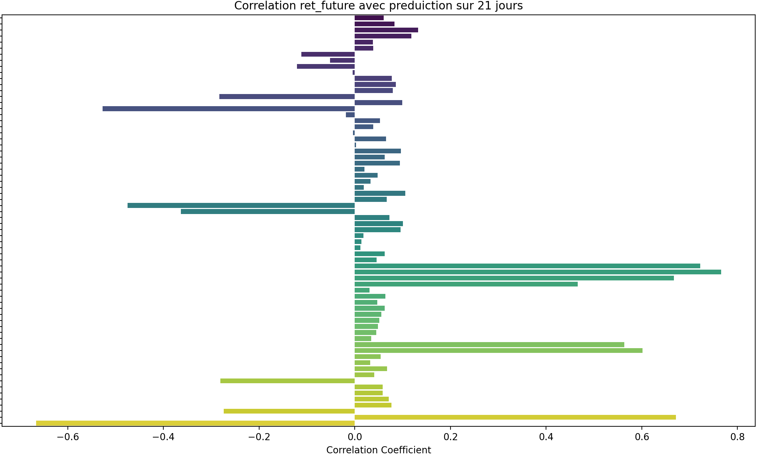

Tableau des corrélations avec ret_future (ordre croissant en valeur absolue) :
dollar_index_historical_data_Close -0.001805
PPI_ProducerPriceIndexes 0.008330
adp_payroll_2000_aujourdhui_PAYEMS 0.009627
interest_rates_rate 0.014849
transactions_summary_daily_Somme_Ventes 0.022233
SMA_200 0.025510
SMA_150 0.030051
transactions_summary_daily_Nombre_Achats 0.034418
SMA_100 0.037021
transactions_summary_daily_Somme_Achats 0.045071
personal_savings_rate_PSAVERT 0.051438
Market_yield_US_10_year_DGS10 -0.056417
Ichimoku_B 0.056812
CPI_price_index_CPI 0.056825
average_sales_price_of_houses_sold_us_ASPUS 0.059051
unemployment_rate_U2RATE 0.060165
GDP_GDP 0.060515
transactions_summary_daily_Nombre_Ventes 0.061514
BB_High 0.064165
Fib_Level_100 0.067983
average_hourly_earnings_all_employees_CES0500000003 0.072345
EMA_26 0.078473
Ichimoku_Kijun 0.078587
Fib_Level_61 0.081147
Date 0.083288
BB_Mid 0.083962
Fib_Level_50 0.085314
profit_per_unit_of_real_gross_value_A466RD3Q052SBEA 0.087227
us_federal_debt_GFDEBTN 0.088495
gold_historical_data_Close 0.089071
Ichimoku_A 0.089294
Fib_Level_38 0.089530
PSAR 0.092711
VWAP 0.093010
Fib_Level_23 0.094813
EMA_12 0.095085
r_sp_gold 0.096767
AD 0.097249
Ichimoku_Tenkan 0.099891
Fib_Level_0 0.103508
BB_Low 0.104902
SP500_historical_data_High 0.105310
OBV 0.105466
SP500_historical_data_Open 0.108295
SP500_historical_data_Close 0.110411
r_sp_bond 0.111141
SP500_historical_data_Low 0.113759
silver_historical_data_Close 0.124506
sp500_PE_Ratio_YOY 0.133172
r_sp_dxy 0.133502
XHB_homebuilder_historical_data_Close 0.137381
Inflation_us_FPCPITOTLZGUSA -0.141730
sp500_PE_Ratio_Value 0.152168
Mortgage_debt_percent_of_disposable_personal_income_MDSP -0.154789
MACD_Hist 0.168548
ADX -0.261841
SP500_historical_data_Volume -0.298448
ATR -0.349438
Stoch_K 0.432583
Stoch_D 0.466236
hv_30 -0.592548
DI_Minus -0.605301
^VIX_historical_data_Close -0.605758
DI_Plus 0.620130
std_21 -0.648172
RSI 0.657913
MACD 0.766806
MACD_Signal 0.770306

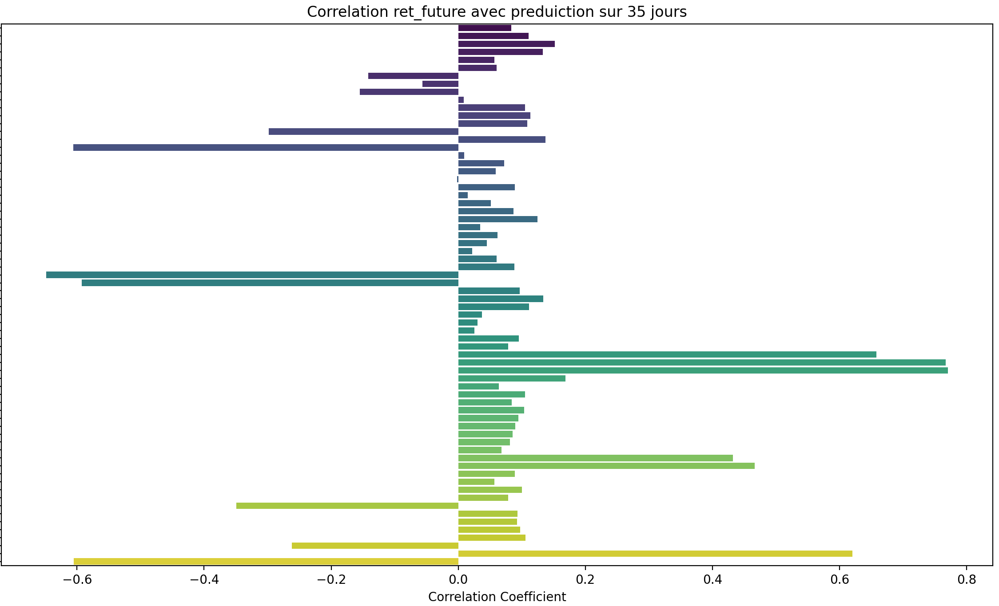

Prediction sur 60 jours

Tableau des corrélations avec ret_future (ordre croissant en valeur absolue) :
unemployment_rate_U2RATE -0.001627
dollar_index_historical_data_Close 0.006911
transactions_summary_daily_Somme_Ventes 0.013435
transactions_summary_daily_Somme_Achats 0.027472
personal_savings_rate_PSAVERT 0.035305
Market_yield_US_10_year_DGS10 -0.035986
interest_rates_rate 0.037056
transactions_summary_daily_Nombre_Achats 0.037883
PPI_ProducerPriceIndexes 0.040227
MACD_Hist 0.044061
transactions_summary_daily_Nombre_Ventes 0.051598
adp_payroll_2000_aujourdhui_PAYEMS 0.054881
SMA_200 0.060062
SMA_150 0.069242
SMA_100 0.079791
average_sales_price_of_houses_sold_us_ASPUS 0.094458
CPI_price_index_CPI 0.095082
GDP_GDP 0.101053
sp500_PE_Ratio_YOY 0.103161
average_hourly_earnings_all_employees_CES0500000003 0.109774
Ichimoku_B 0.113160
BB_High 0.117888
Fib_Level_100 0.121886
Date 0.123174
us_federal_debt_GFDEBTN 0.127097
r_sp_gold 0.127495
profit_per_unit_of_real_gross_value_A466RD3Q052SBEA 0.129976
sp500_PE_Ratio_Value 0.131511
EMA_26 0.132237
Fib_Level_61 0.135086
Ichimoku_Kijun 0.135183
r_sp_bond 0.137069
BB_Mid 0.137405
Fib_Level_50 0.139258
gold_historical_data_Close 0.141101
AD 0.141789
Ichimoku_A 0.142144
Fib_Level_38 0.143475
VWAP 0.143903
PSAR 0.145218
EMA_12 0.145400
Fib_Level_23 0.148754
Ichimoku_Tenkan 0.149004
OBV 0.152011
SP500_historical_data_High 0.152047
SP500_historical_data_Open 0.154956
SP500_historical_data_Close 0.156574
Fib_Level_0 0.157431
BB_Low 0.157961
SP500_historical_data_Low 0.159825
Inflation_us_FPCPITOTLZGUSA -0.170477
r_sp_dxy 0.187185
silver_historical_data_Close 0.190639
ADX -0.192402
XHB_homebuilder_historical_data_Close 0.194550
Mortgage_debt_percent_of_disposable_personal_income_MDSP -0.205189
SP500_historical_data_Volume -0.320487
Stoch_K 0.329835
ATR -0.344480
Stoch_D 0.352742
DI_Minus -0.497286
DI_Plus 0.504485
RSI 0.544059
MACD 0.619550
MACD_Signal 0.653971
^VIX_historical_data_Close -0.659066
hv_30 -0.711950
std_21 -0.714888

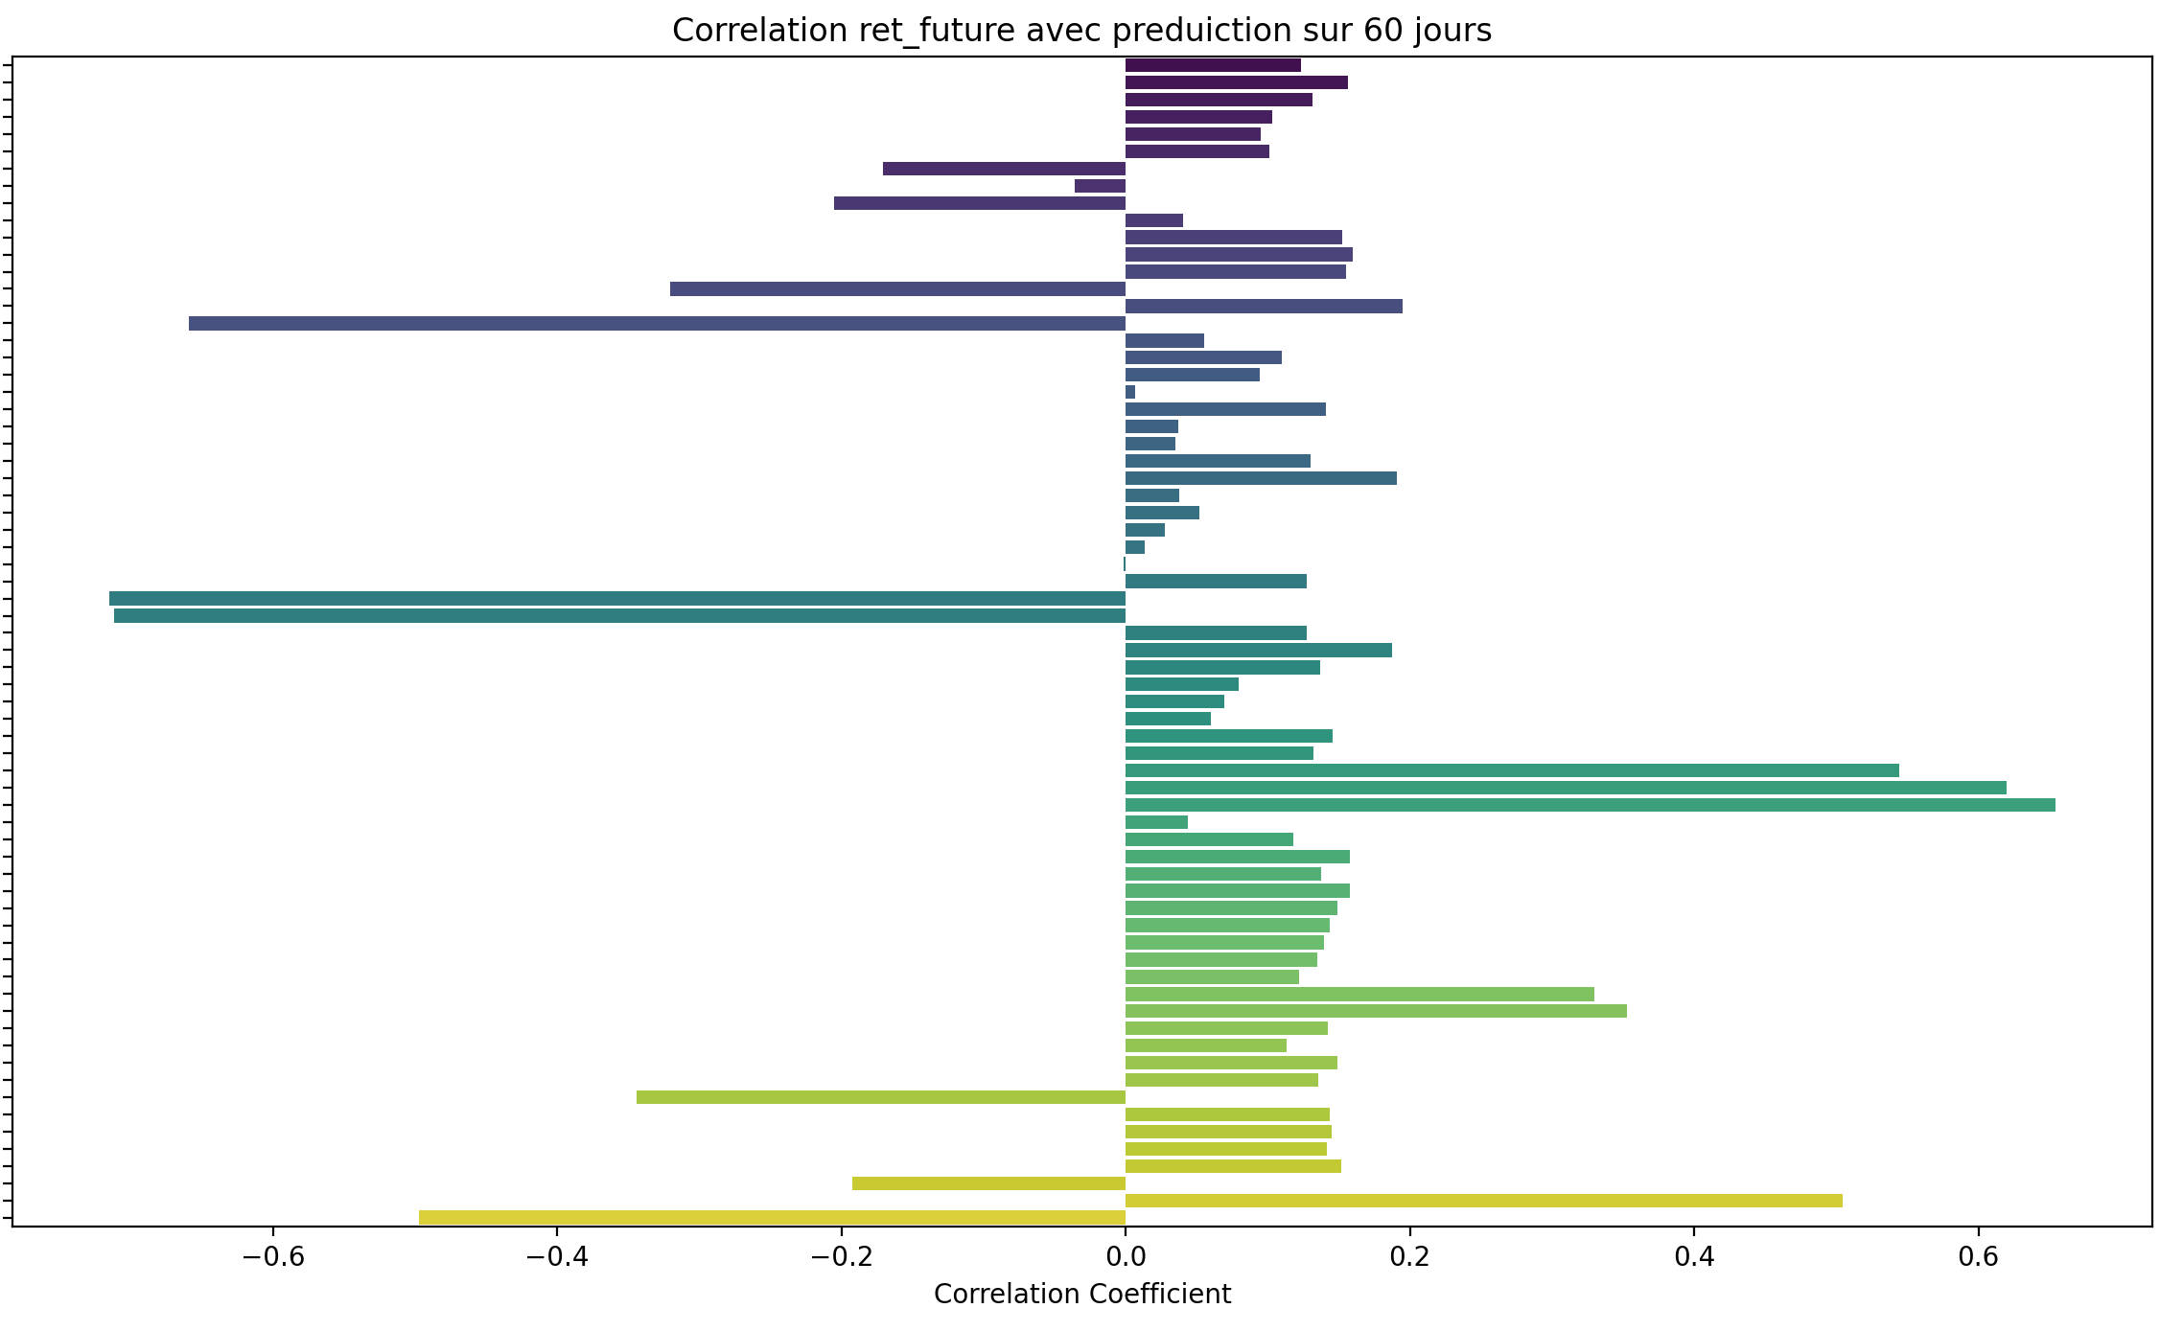
Comparaison :

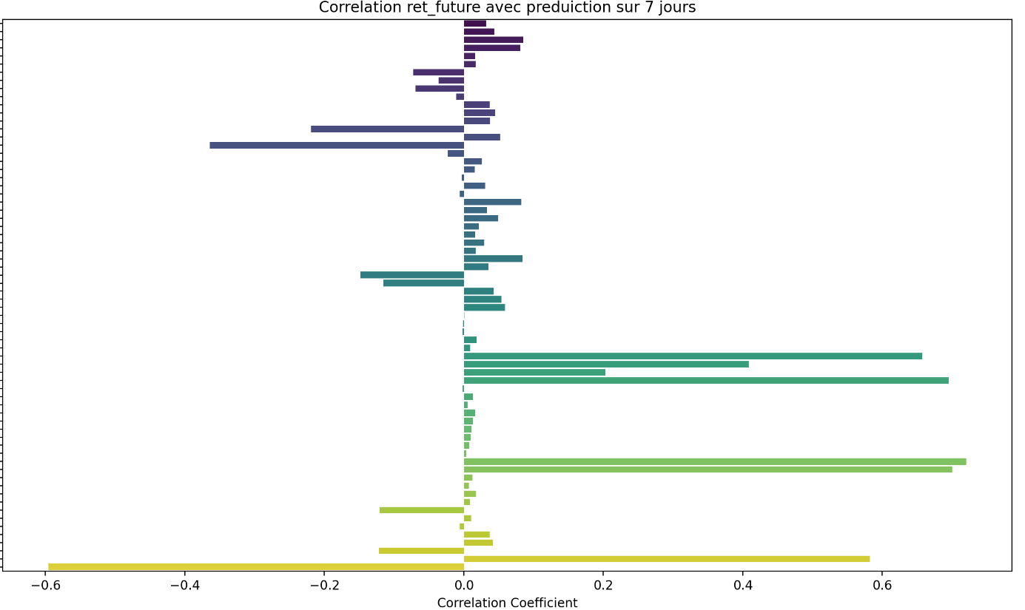




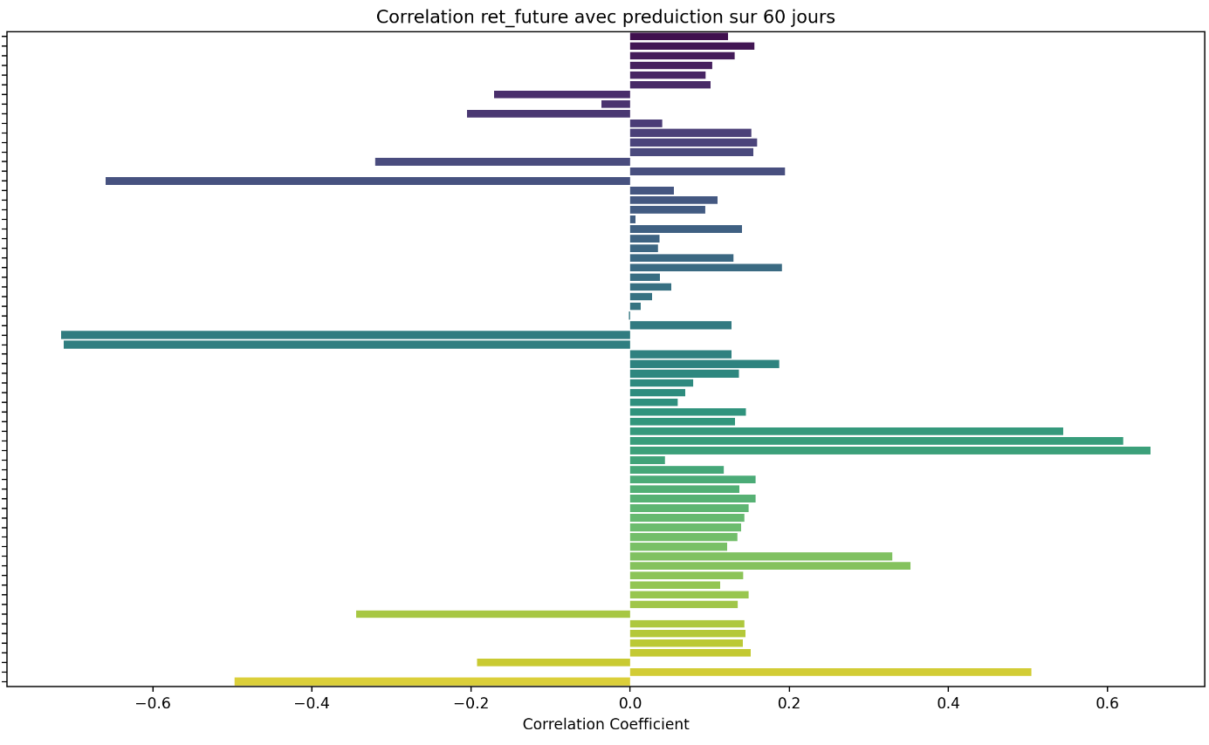

Comparaison des moyennes :

moyenne des corrélations avec TARGET_PRICE_COL : 0.58

moyenne des corrélations avec ret_future (3 jours): 0.03

moyenne des corrélations avec ret_future (7 jours): 0.05

moyenne des corrélations avec ret_future (14 jours): 0.06

moyenne des corrélations avec ret_future (21 jours): 0.06

moyenne des corrélations avec ret_future (35 jours): 0.06

moyenne des corrélations avec ret_future (60 jours): 0.07

