Designing for Experience: The Development of Juicetification: Forecast Frenzy, a Simulation for Teaching Operations Forecasting
Chris Scherpereel
The W. A. Franke College of Business, Northern Arizona University
Author Note: Correspondence concerning this article may be addressed to chris.scherpereel@nau.edu.

Abstract
This article documents the design and development of Juicetification: Forecast Frenzy, a browser-based simulation that teaches demand forecasting in an introductory operations management course. The simulation places each student in the role of the manager of a campus juice bar and asks the student to learn, compute, and then apply the naive, moving-average, exponential-smoothing, seasonal-index, and regression methods before selecting a model and running the business for a simulated day. The design is grounded in the experiential learning cycle (Kolb, 1984) and in complementary work on simulation-based learning, deliberate practice, formative feedback, guided discovery, productive failure, and reflective debriefing. The article explains how specific design decisions operationalize these theories, presents a mapping between design features and intended learning outcomes, and argues that the simulation contributes to experiential learning pedagogy by closing the loop from concrete decision to reflective rule in a single class session. Recommended figures and illustrations are identified to support classroom adoption and future empirical study.
Keywords: experiential learning, business simulation, forecasting, operations management, formative assessment, debriefing

1. Introduction
Forecasting is a foundational competency in operations management, yet it is difficult to teach well. Students can memorize the formula for a moving average or the definition of mean absolute deviation and still fail to appreciate why a forecast matters, how method choice changes a decision, or what a forecast error costs a real operation. In service settings the stakes are sharpened by perishability: unused service capacity cannot be stored for a later day, so a forecast that misses demand produces either idle labor and spoiled inventory or long waits and lost sales (Hyndman & Koehler, 2006). Traditional lecture and problem-set instruction can convey procedures, but it rarely gives students the concrete experience of a consequential decision under uncertainty.
Active and experiential approaches address this gap. Reviews of undergraduate instruction consistently find that active learning improves performance relative to passive lecture (Freeman et al., 2014; Prince, 2004), and business simulations in particular have a long record of use for placing learners in decision roles that mirror practice (Faria et al., 2009; Salas et al., 2009). This article describes Juicetification: Forecast Frenzy, a simulation developed to teach forecasting through a full experiential cycle that a student can complete in approximately one hour. The article has two aims. The first is to make the design rationale explicit by tracing each major feature to an established learning theory. The second is to argue for the contribution of the simulation to experiential learning pedagogy, in particular its integration of computation, consequential decision making, and structured reflection within one continuous activity.

2. Theoretical Foundations

2.1 Experiential Learning
The central organizing framework for the design is the experiential learning cycle (Kolb, 1984), which itself builds on the progressive tradition of learning through reflective experience (Dewey, 1938). Kolb describes learning as a recurring movement through four modes: concrete experience, reflective observation, abstract conceptualization, and active experimentation. Learning is most durable when instruction engages all four modes rather than any one in isolation. The simulation is deliberately structured so that its components populate each mode of the cycle, as shown in Figure 1.
In the simulation, abstract conceptualization occurs in the method modules, where students meet each forecasting technique and its formula. Active experimentation occurs when students vary parameters and re-apply methods to new data. Concrete experience occurs when students run the business and absorb the profit and satisfaction consequences of their plan. Reflective observation occurs in the answer feedback and, most fully, in a closing debrief. Because the four modes are sequenced and revisited, the activity is a cycle rather than a checklist.
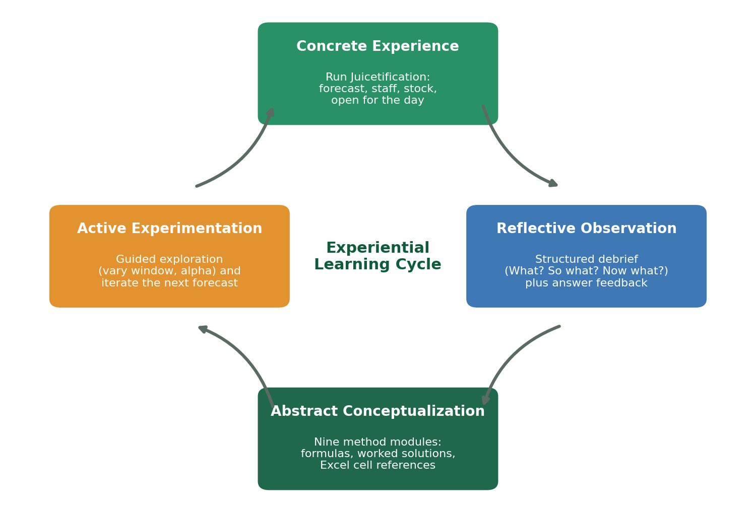
Figure 1. The experiential learning cycle (Kolb, 1984) mapped to the four components of Juicetification: Forecast Frenzy.

2.2 Simulation and Game-Based Learning
Simulations create a protected space in which learners act, observe outcomes, and adjust, and meta-analytic and review evidence supports their use for management education when they are paired with sound instructional design (Faria et al., 2009; Salas et al., 2009). Well-designed learning games share features that the simulation adopts, including clear goals, immediate feedback, an appropriate difficulty ramp, and the freedom to fail safely and try again (Gee, 2003). These properties matter because they convert an abstract topic into a set of decisions with visible results, which is precisely the concrete experience that the experiential cycle requires.

2.3 Constructivism, Scaffolding, and Cognitive Load
Constructivist accounts hold that learners build understanding by acting on problems slightly beyond their current independent ability, within what Vygotsky (1978) termed the zone of proximal development. Instruction supports this by scaffolding, that is, by providing temporary structure that is gradually removed as competence grows (Wood, Bruner, & Ross, 1976). The simulation scaffolds heavily at first, offering worked solutions, hints, and model formulas, and it lets students select how much support they use. At the same time, worked examples and staged tasks manage intrinsic and extraneous cognitive load so that attention is spent on the target concept rather than on interface friction (Sweller, 1988). The seasonal-index module illustrates the balance: students are given multiple weeks of data and must compute the day average and the overall average themselves, which raises germane load on the concept while the interface handles bookkeeping.

2.4 Deliberate Practice, Feedback, and Formative Assessment
Skill develops through deliberate practice, that is, effortful, repeated engagement with well-defined tasks accompanied by immediate, informative feedback (Ericsson, Krampe, & Tesch-Romer, 1993). Feedback is effective when it addresses the task and the process and arrives at a point where the learner can act on it (Hattie & Timperley, 2007), and formative assessment that informs subsequent effort is among the most powerful levers on achievement (Black & Wiliam, 1998). The simulation embodies these principles by checking each computed answer and each spreadsheet formula, by revealing evaluative feedback only after the student has committed a response, and by asking the student to apply the same method again to fresh values.

2.5 Productive Failure and Guided Discovery
Allowing learners to grapple with a problem before receiving full instruction can deepen later understanding, a phenomenon termed productive failure (Kapur, 2008). Discovery is most beneficial when it is guided rather than unaided, because pure discovery can overwhelm novices and reinforce misconceptions (Mayer, 2004). The simulation blends these findings by inviting estimation and exploration before revealing worked solutions, and by pairing every open exploration with an interpretive prompt so that the exploration remains guided.

2.6 Debriefing
Experience without reflection is frequently wasted; the debrief is where participants convert events into transferable understanding, and in simulation-based education the debrief is widely regarded as the single most important phase for learning (Fanning & Gaba, 2007). The simulation therefore closes with a structured debrief organized around the familiar reflective questions of what happened, why it matters, and what the learner will do differently, so that a concrete decision is generalized into a portable rule.

3. Design and Development of the Simulation

3.1 Simulation Context and Demand Model
The simulation casts the student as the manager of Juicetification, a juice bar in a university student union. A demand model generates a term of daily sales driven by the day of the week, temperature, examination periods, campus events, campus attendance, and promotions, with multiplicative noise so that demand is realistic and non-negative. Each student session is seeded with a unique identifier, so the underlying data differ across students while remaining internally consistent and automatically gradable. The economic structure, including price, ingredient cost, wage, service rate, promotion cost, and a goodwill penalty for unmet demand, makes the cost of over-forecasting and under-forecasting concrete and asymmetric.
The choice of a service business is pedagogically deliberate. Because service capacity is perishable, the simulation can make vivid the core lesson that a forecasting error is not a rounding issue but a direct loss, either through waste or through missed sales and diminished goodwill (Hyndman & Koehler, 2006).

3.2 The Learning Arc and Its Alignment with the Experiential Cycle
The activity is organized as a left-to-right sequence of tabs, summarized in Figure 2. A brief orientation is followed by nine method modules, a model-selection step, the decision round, a debrief, and a final report. The order is intentional. Accuracy measurement precedes model selection so that students learn to read error before they are asked to choose a method on the basis of it. Each module follows the same rhythm: state an objective, present the formula, ask the student to apply it, ask for the equivalent spreadsheet formula, provide feedback, pose a guiding question, and then apply the method again. This repetition instantiates deliberate practice within the abstract-conceptualization mode of the cycle (Ericsson et al., 1993; Kolb, 1984).
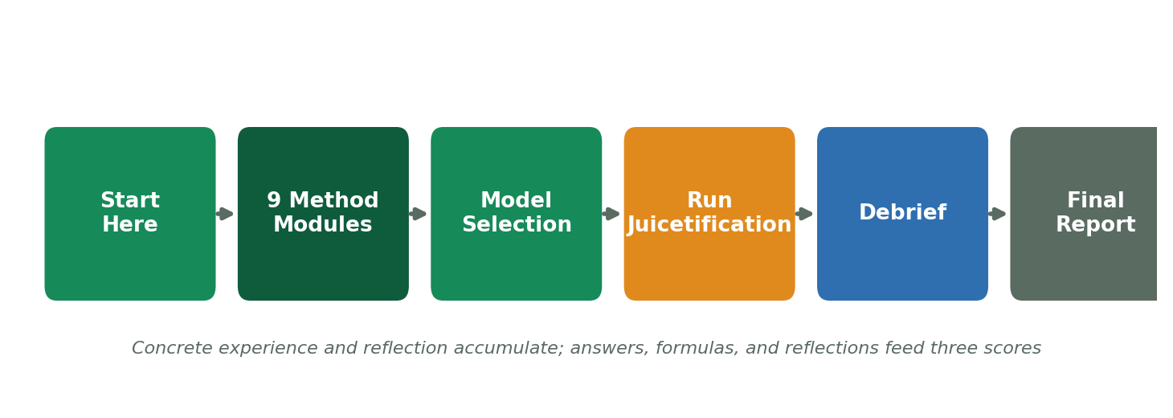
Figure 2. The learning arc of the simulation, from orientation through the method modules to the decision round, debrief, and report.

3.3 Applying the Formulas: Hand Computation and Spreadsheet Fluency
For every calculation the student chooses how hands-on to be. One path asks the student to compute the value and checks it against the correct answer with a worked solution; a second path asks for an estimate and then reveals the solution; a third simply shows the answer for interpretation. This choice supports self-regulated learning by letting students calibrate challenge to their confidence (Zimmerman, 2002). Each module also asks the student to write the corresponding spreadsheet formula, which the simulation evaluates against an on-screen grid of labeled cells. Crucially, the checker rejects formulas that hardcode values available as cells, requiring genuine cell references such as a range average rather than a typed sum. This makes the task authentic and builds a transferable competency rather than a one-time answer (Ericsson et al., 1993). A representative module screen, showing the spreadsheet-style grid and the formula check, is recommended as Figure 4.

3.4 Guided Exploration as Active Experimentation
Two modules include guided exploration in which students vary a parameter, such as the width of a moving-average window or the exponential-smoothing constant, and observe the effect on the fitted line and on the mean absolute deviation. Consistent with guided discovery (Mayer, 2004), the exploration is framed by explicit instructions about what to try and by interpretive feedback that appears only after the student has moved the control. This is active experimentation in Kolb's sense, and it converts the abstract trade-off between responsiveness and stability into something the student manipulates and sees.

3.5 The Decision Layer: Running the Business
After selecting a method, the student runs the business. The student first chooses a forecast, then calculates the staffing and preparation plan from that forecast using stated rules, and then implements the plan and opens for the day. The simulation reveals realized demand and a profit and loss statement, along with a customer-satisfaction measure and coaching that identifies idle labor, waste, or lost sales. This is the concrete experience at the heart of the cycle (Kolb, 1984) and the consequential decision that simulation-based learning is well suited to provide (Salas et al., 2009). The decision screen and its profit and loss output are recommended as Figure 5.

3.6 Assessment as Feedback: Three Complementary Scores
Assessment in the simulation is designed to inform rather than merely to grade. Three scores are reported separately, as illustrated in Figure 3. Completeness reflects effort, that is, how much of the activity the student finished. Mastery reflects skill, computed as the share of calculations and spreadsheet formulas that were correct on the first attempt. Performance reflects application, computed from how closely the operating plan matched realized demand, combining profit relative to an ideal plan with customer satisfaction. Separating the three prevents effort from masking a shaky calculation and gives students an accurate, multidimensional picture of their learning, which supports the calibration of self-judgment central to self-regulated learning (Zimmerman, 2002). Written reflections are supported with lightweight self-rubrics so that qualitative work also receives formative structure (Black & Wiliam, 1998; Hattie & Timperley, 2007).
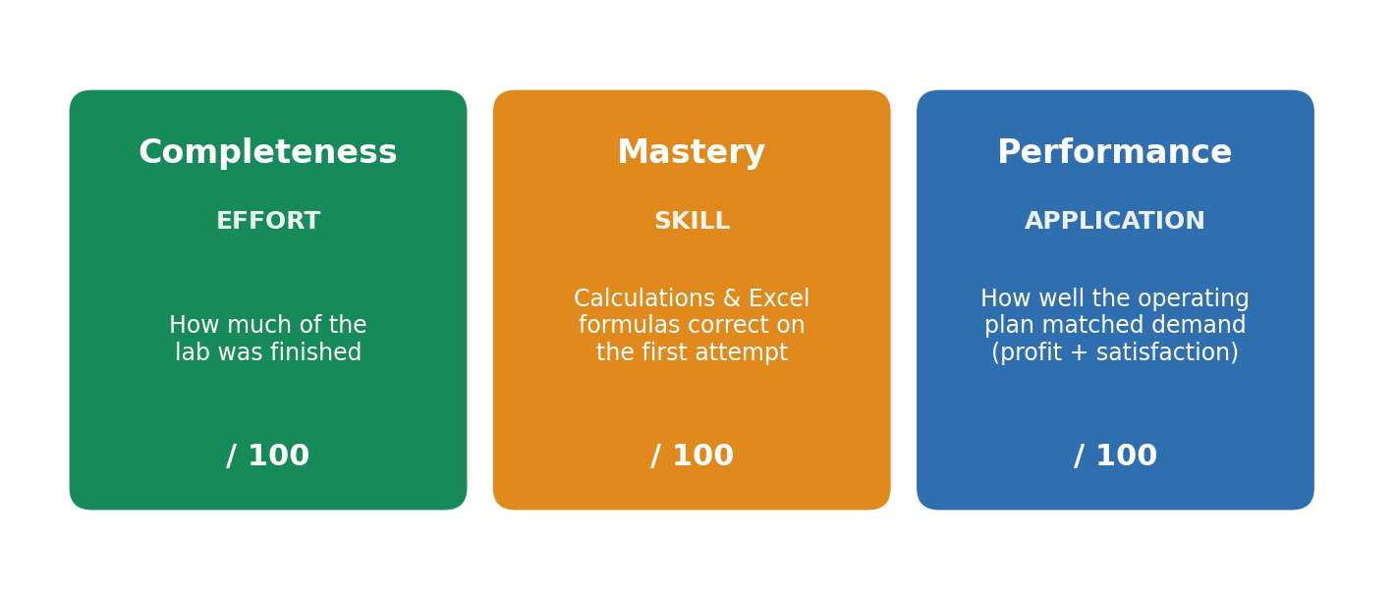
Figure 3. The three-part assessment model, separating effort, skill, and application.

3.7 The Structured Debrief
The penultimate tab is a structured debrief that surfaces the student's own largest forecast miss, the dollar cost of that miss relative to an ideal plan, and the student's tendency to over-forecast or under-forecast across the days played. The student is then asked why the miss occurred and what it cost, and finally to commit one forecasting rule to carry into a real operation. This sequence follows the what, so what, and now what structure common to reflective practice and realizes the reflective-observation mode that the experiential cycle requires (Fanning & Gaba, 2007; Kolb, 1984). A view of the debrief is recommended as Figure 6.

3.8 Unique Scenarios and Academic Integrity
Because each student receives a unique scenario, students can compare methods and reasoning without sharing answers, and instructors can reproduce any student's data from a session identifier. The randomized values are rounded so that hand calculations remain clean and automatically checkable. This design decision serves both integrity and productive struggle, since each learner must engage the computation individually (Kapur, 2008).

4. Mapping Design Features to Theory
Table 1 consolidates the argument by linking each principal design feature to its theoretical basis and to the intended learning outcome. The table is intended both as a summary and as a template for instructors who wish to adapt or extend the simulation while preserving its pedagogical logic.
Table 1
Design features of the simulation, their theoretical basis, and intended learning outcomes
Design feature | Theoretical basis | Intended learning outcome
Nine sequenced method modules | Abstract conceptualization (Kolb, 1984); worked examples and cognitive load (Sweller, 1988) | Procedural fluency in each forecasting method
Learner choice of solution path (compute, estimate, or reveal) | Self-regulated learning (Zimmerman, 2002); optimal challenge (Vygotsky, 1978) | Agency and appropriately calibrated difficulty
Enforced spreadsheet cell references | Authentic tasks and deliberate practice (Ericsson et al., 1993) | Transferable spreadsheet skill valued by employers
Guided exploration of parameters | Active experimentation (Kolb, 1984); guided discovery (Mayer, 2004) | Conceptual grasp of smoothing, lag, and error
Run the business decision and profit and loss | Concrete experience (Kolb, 1984); simulation-based learning (Salas et al., 2009) | Felt dollar consequence of forecast error
Feedback shown only after a response | Formative feedback (Hattie & Timperley, 2007; Black & Wiliam, 1998) | Timely correction without answer leakage
Three separate scores | Assessment for learning; calibration of self-judgment (Zimmerman, 2002) | Accurate metacognition of effort, skill, and application
Structured debrief | Debriefing in simulation (Fanning & Gaba, 2007) | Reflection, generalization, and transfer
Iterative re-application and unique data | Productive failure (Kapur, 2008); academic integrity | Skill consolidation and individual accountability
Note. In-text citations correspond to the References section.

5. Contribution to Experiential Learning Pedagogy
The simulation makes three contributions to experiential learning pedagogy in the operations classroom. First, it completes a full experiential cycle within a single session. Many classroom activities engage one or two of Kolb's modes, for example a problem set that supports abstract conceptualization or a case that supports reflection, but few move a learner from computation through a consequential decision to a committed rule in one continuous arc. By sequencing method practice, a consequential decision, and a structured debrief, the simulation gives students the reflective closure that experiential learning requires and that time-pressured courses often omit (Fanning & Gaba, 2007; Kolb, 1984).
Second, it integrates authentic tool use with conceptual learning. By requiring genuine spreadsheet cell references and by evaluating those formulas, the simulation develops a transferable professional skill alongside the statistical concept, rather than treating the two as separate exercises (Ericsson et al., 1993). The demand that students construct their own averages before forming a seasonal index is a small but consequential example of preserving the cognitive work that produces understanding (Sweller, 1988).
Third, it models assessment as feedback rather than only as judgment. The separation of completeness, mastery, and performance gives students a truthful, multidimensional signal and discourages the common misconception that finishing is the same as learning (Black & Wiliam, 1998; Zimmerman, 2002). Taken together, these features position the simulation not as a game bolted onto a lecture but as an integrated experiential environment whose parts each carry an identifiable pedagogical function.

6. Limitations and Directions for Future Research
Several limitations bound the present contribution. The article documents design rather than measured learning gains, so claims about effectiveness are theoretical rather than empirical. The single-session structure gives limited opportunity for the repeated cycles that deliberate practice ultimately requires (Ericsson et al., 1993). The performance score rewards matching a modeled ideal plan, which simplifies the messier trade-offs of real operations. Finally, the demand model, while realistic, is transparent enough that a determined student could infer its structure.
These limitations suggest a research agenda. A controlled study could compare learning and transfer for the simulation against matched problem-set instruction, using the mastery and performance scores together with a delayed transfer task. A multi-day operating season would allow the study of skill consolidation and of forecast bias over time. Log data from unique scenarios would permit analysis of which design features, such as choosing to compute rather than to reveal, predict later performance. Each of these directions would move the work from a theory-grounded design to an evidence-based one (Salas et al., 2009).

7. Conclusion
Juicetification: Forecast Frenzy was built to teach forecasting the way operations managers actually experience it, as a sequence of computations that inform a consequential decision under uncertainty. By grounding each design decision in established theory, from the experiential cycle to deliberate practice, formative feedback, guided discovery, productive failure, and reflective debriefing, the simulation aims to do more than illustrate formulas. It aims to give students the concrete experience, the authentic tool use, and the reflective closure that convert procedure into understanding. The mapping in Table 1 and the figures identified throughout are offered to support adoption and to invite the empirical study that should follow.

References
Anderson, L. W., & Krathwohl, D. R. (Eds.). (2001). A taxonomy for learning, teaching, and assessing: A revision of Bloom's taxonomy of educational objectives. Longman.
Black, P., & Wiliam, D. (1998). Assessment and classroom learning. Assessment in Education: Principles, Policy & Practice, 5(1), 7-74.
Chickering, A. W., & Gamson, Z. F. (1987). Seven principles for good practice in undergraduate education. AAHE Bulletin, 39(7), 3-7.
Dewey, J. (1938). Experience and education. Kappa Delta Pi.
Ericsson, K. A., Krampe, R. T., & Tesch-Romer, C. (1993). The role of deliberate practice in the acquisition of expert performance. Psychological Review, 100(3), 363-406.
Fanning, R. M., & Gaba, D. M. (2007). The role of debriefing in simulation-based learning. Simulation in Healthcare, 2(2), 115-125.
Faria, A. J., Hutchinson, D., Wellington, W. J., & Gold, S. (2009). Developments in business gaming: A review of the past 40 years. Simulation & Gaming, 40(4), 464-487.
Freeman, S., Eddy, S. L., McDonough, M., Smith, M. K., Okoroafor, N., Jordt, H., & Wenderoth, M. P. (2014). Active learning increases student performance in science, engineering, and mathematics. Proceedings of the National Academy of Sciences, 111(23), 8410-8415.
Gee, J. P. (2003). What video games have to teach us about learning and literacy. Palgrave Macmillan.
Hattie, J., & Timperley, H. (2007). The power of feedback. Review of Educational Research, 77(1), 81-112.
Hyndman, R. J., & Koehler, A. B. (2006). Another look at measures of forecast accuracy. International Journal of Forecasting, 22(4), 679-688.
Kapur, M. (2008). Productive failure. Cognition and Instruction, 26(3), 379-424.
Kolb, D. A. (1984). Experiential learning: Experience as the source of learning and development. Prentice Hall.
Mayer, R. E. (2004). Should there be a three-strikes rule against pure discovery learning? American Psychologist, 59(1), 14-19.
Prince, M. (2004). Does active learning work? A review of the research. Journal of Engineering Education, 93(3), 223-231.
Salas, E., Wildman, J. L., & Piccolo, R. F. (2009). Using simulation-based training to enhance management education. Academy of Management Learning & Education, 8(4), 559-573.
Sweller, J. (1988). Cognitive load during problem solving: Effects on learning. Cognitive Science, 12(2), 257-285.
Vygotsky, L. S. (1978). Mind in society: The development of higher psychological processes. Harvard University Press.
Wood, D., Bruner, J. S., & Ross, G. (1976). The role of tutoring in problem solving. Journal of Child Psychology and Psychiatry, 17(2), 89-100.
Zimmerman, B. J. (2002). Becoming a self-regulated learner: An overview. Theory Into Practice, 41(2), 64-70.

Appendix: Recommended Figures and Illustrations
The following screen captures are recommended to accompany the article. Each should be taken from a live session of the simulation and placed at the point indicated in the text.
Figure 4. A method module (for example, moving average or seasonality), showing the spreadsheet-style grid with lettered columns and numbered rows, the choice of solution path, and the formula checker that requires genuine cell references. Referenced in Section 3.3.
Figure 5. The decision round, Run Juicetification, showing the chosen forecast, the calculated staffing and preparation plan, and the resulting profit and loss statement with the satisfaction measure and coaching notes. Referenced in Section 3.5.
Figure 6. The structured debrief, showing the automatically surfaced largest forecast miss, its dollar cost, the over- or under-forecasting tendency, and the prompts for the so what and now what reflections. Referenced in Section 3.7.

