Juicetification: The Lean Rush — Designing a Discrete-Event Simulation for Experiential Lean-Operations Pedagogy

C. Scherpereel
Northern Arizona University

Author Note
Correspondence concerning this article may be addressed to C. Scherpereel, Northern Arizona University. Email: chris.scherpereel@nau.edu. The simulation described here, Juicetification: The Lean Rush, is an open, single-file application and is available from the author.

Abstract
Lean operations is frequently taught through lecture and case discussion, yet its central lessons — that waste is systemic, that the cheapest changes often return the most, and that improvement is a disciplined cycle rather than a set of tools — are difficult to grasp without doing. This paper reports the design and development of Juicetification: The Lean Rush, a browser-based discrete-event simulation in which students operate a chaotic juice bar through repeated morning rushes and redesign it round by round. The simulation was engineered so that authentic lean improvements are rewarded while the classic intuitive traps — batching, made-ahead inventory, and gold-plated equipment — visibly backfire, allowing learners to discover the seven wastes rather than be told them. The design is grounded in experiential-learning theory: each round enacts Kolb's (1984) cycle, the inherited mess operationalizes Kapur's (2008) productive failure and Mezirow's (1991) disorienting dilemma, guided scaffolding fades within the zone of proximal development (Vygotsky, 1978), and a gated debrief follows best practice in simulation-based education (Fanning & Gaba, 2007). The paper argues that the simulation's principal pedagogical contribution is the tight coupling of a lean management routine (Deming's PDCA and Rother's, 2010, Coaching Kata) to the instructional loop, so that the method the students learn and the method by which they learn it are the same.
Keywords: experiential learning, lean operations, simulation-based education, kaizen, productive failure, debriefing

Juicetification: The Lean Rush — Designing a Discrete-Event Simulation for Experiential Lean-Operations Pedagogy
Lean operations occupies an awkward position in the operations-management curriculum. Its vocabulary — the seven wastes, 5S, standard work, pull, kaizen — is easy to state and hard to feel. Students can recite that overproduction is waste while still believing, at the level of intuition that governs their decisions, that making drinks ahead of time must speed service up. Traditional instruction compounds the problem: a lecture on the seven wastes presents lean as a checklist of virtues rather than as a set of counter-intuitive, cost-constrained trade-offs. Active-learning scholarship has long argued that such material is better learned by doing than by listening (Bonwell & Eison, 1991), and business-simulation research consistently finds that well-designed simulations improve higher-order operational reasoning relative to lecture alone (Anderson & Lawton, 2009; Salas et al., 2009).
This paper describes the design and development of Juicetification: The Lean Rush, a discrete-event simulation built to make the seven wastes experiential. The learner inherits a disorganized juice bar — stations out of sequence, large blend batches, a pile of pre-made cups — and runs it through a 15-minute morning rush. After each rush the shop is diagnosed, a coach poses a single Socratic question, the learner redesigns one aspect of the operation, predicts the effect, and runs again. The remainder of the paper situates the design in learning theory, walks through the development decisions that follow from that theory, and argues for the simulation's specific contribution to experiential-learning pedagogy: the fusion of the object of study (a lean improvement routine) with the mechanism of instruction (an experiential improvement loop).
Theoretical Framework
The design rests on two literatures — the operations-management canon that defines the content, and the learning sciences that define how that content is best acquired. On the content side, the seven wastes and the ideal of one-piece flow derive from the Toyota Production System (Ohno, 1988) and its Western synthesis in lean thinking (Womack & Jones, 2003); the improvement cycle is Deming's (1986) Plan-Do-Check-Act. On the learning side, the organizing frame is Kolb's (1984) experiential-learning cycle, in which knowledge is created through the transformation of experience across four modes: concrete experience, reflective observation, abstract conceptualization, and active experimentation.
Three further principles shape the design. First, productive failure (Kapur, 2008) holds that allowing learners to grapple with a problem before instruction produces deeper conceptual understanding than instruction first; the inherited, deliberately broken shop is a designed failure experience. The overproduction trap, in which the intuitive move to batch and pre-make drinks measurably harms performance, is also a disorienting dilemma in Mezirow's (1991) sense — a confrontation between prior belief and evidence that is the trigger for transformative learning. Second, learning is scaffolded within the zone of proximal development (Vygotsky, 1978; Wood et al., 1976): the simulation surfaces only the decision the learner is ready to act on, then withdraws that support toward independent “free play.” Third, extraneous cognitive load is minimized (Sweller, 1988) by revealing one actionable waste at a time rather than the full instrument at once, reserving working memory for the lean concepts themselves. Feedback throughout is designed as feed-forward in Hattie and Timperley's (2007) terms, answering not only “how am I doing?” but “where to next?”
Design and Development of the Simulation
Simulation Architecture
Juicetification: The Lean Rush is implemented as a single-file web application with an embedded discrete-event engine. Customer arrivals during the rush follow a non-homogeneous Poisson process generated by thinning, so demand peaks and ebbs within the 15-minute window. Each order flows through a fixed process route (cups, fruit, ice, blender, finishing, pickup); stations contend for a shared pool of staff and blenders, customers abandon the queue when their patience is exhausted, and made-ahead or mis-made drinks generate spoilage and rework. Every configuration is evaluated over multiple stochastic replications, so the learner is shown not only an average outcome but the spread across rushes, making variability — and therefore the value of standard work — visible. Crucially, each session is instantiated from a random but always-solvable scenario (a scrambled layout, an inherited batch size and pre-made pile, one covertly slow station, and a demand level), so that no two students face the same optimum and answers cannot be copied.
The Kaizen Loop as Instructional Spine
The simulation's most consequential design decision is to make the screen itself one turn of the PDCA cycle, and to align that cycle explicitly with Kolb's (1984) four modes (see Figure 1). The learner runs the rush (Do / concrete experience), reads the resulting waste and 5S dashboards (Check / reflective observation), works with the coach to name the dominant waste and the lean principle it violates (Act / abstract conceptualization), and then chooses, predicts, and commits a counter-measure (Plan / active experimentation) before running again. Because the Act phase flows directly into the next Plan, the loop is experienced as continuous improvement rather than as discrete exercises — the structure is kaizen, and it is named as such for the learner. This satisfies a recurring recommendation in the transfer literature that learners rarely transfer a strategy they cannot name (Perkins & Salomon, 1988).
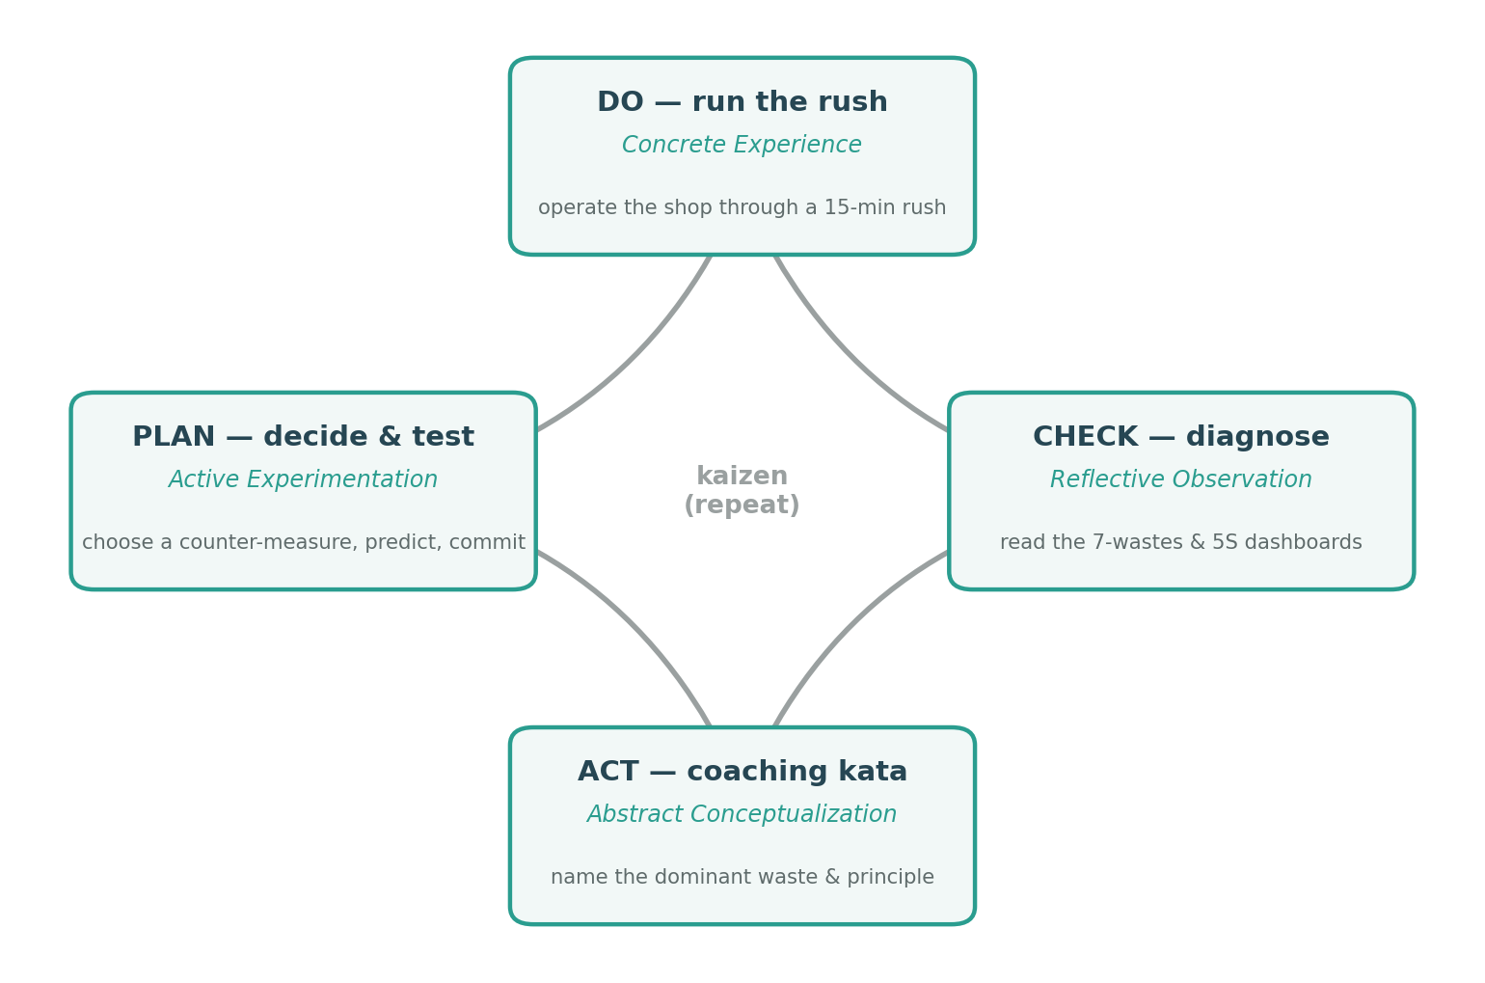
Figure 1
Kolb's Experiential-Learning Cycle Mapped onto the Simulation's PDCA Game Loop
Note. Each round of the simulation traverses all four modes of Kolb's (1984) cycle, labeled for the learner with the corresponding Plan-Do-Check-Act phase and the concrete on-screen activity.
Making Waste Visible
Abstract categories become learnable when they are rendered perceptible. The simulation therefore visualizes each waste rather than merely scoring it. The clearest example is transport waste: the process is drawn as a flow diagram in which forward movement between stations is shown as green arcs above the line and backtracking is shown as red arcs below it (see Figure 2). A scrambled layout produces a tangle of red; dragging the stations into process order turns the diagram green and shortens the walking path. The learner does not need the word “transport” defined; the waste is seen and then removed, and the label is attached to an experience the learner has already had. Inventory, motion, and defects are surfaced through comparable visual dashboards, supporting the multimedia principle that pairing a named concept with a concrete representation reduces the load of holding the abstraction alone (Sweller, 1988).
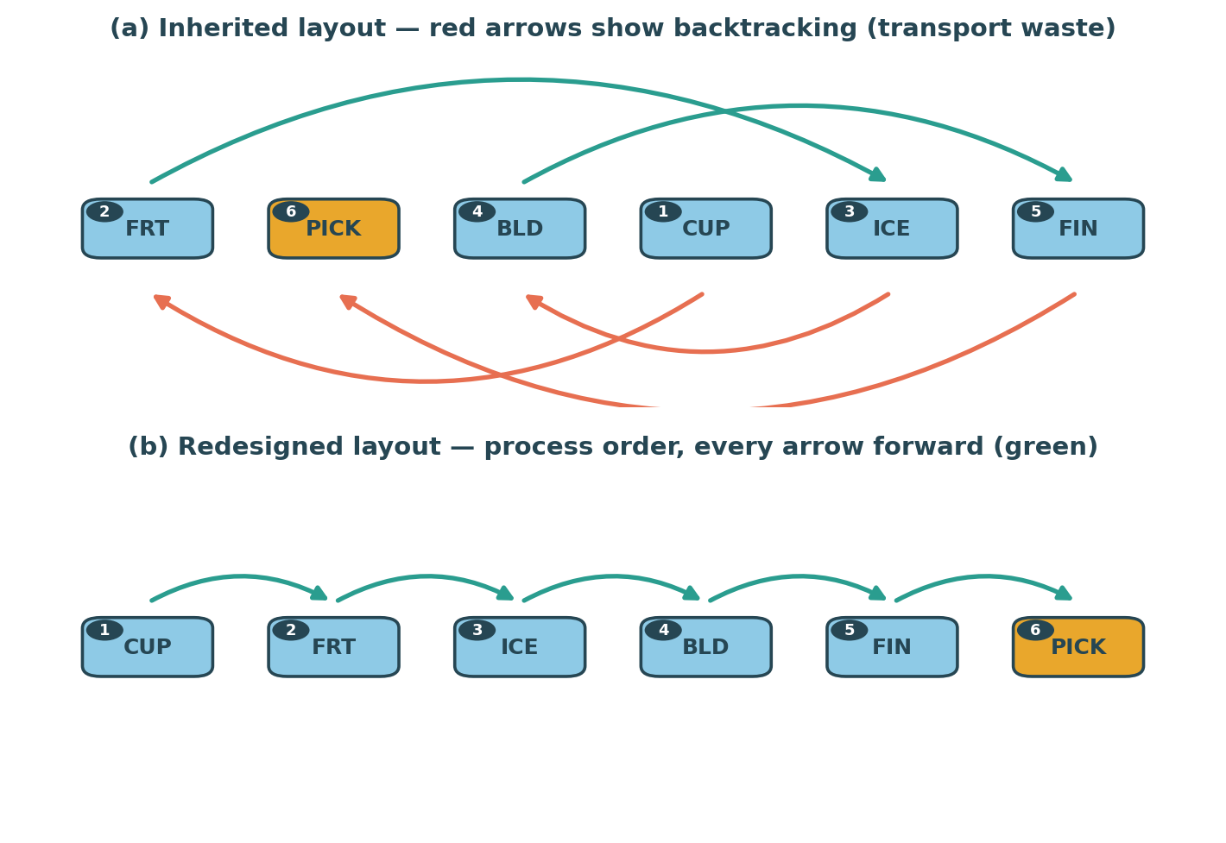
Figure 2
Transport Waste Made Perceptible in the Process-Flow Diagram
Note. Panel (a) shows the inherited, scrambled layout, in which the drink repeatedly doubles back (red arcs, below the line). Panel (b) shows the same process after the learner orders the stations, leaving only forward flow (green arcs, above the line).
The Coaching Kata and Socratic Scaffolding
The Act phase is delivered by a coach modeled on Rother's (2010) Coaching Kata, the five-question routine by which a Toyota manager develops a learner: what is the target condition; what is the actual condition; what obstacle is now in the way; what is the next step; and when can we see what we have learned. This choice is deliberate and, we argue, distinctive: the coaching method is itself an authentic lean-management practice, so the pedagogy models the very discipline it teaches. The coach requires the learner to commit to a diagnosis before the simulation can be run again, enforcing reflection rather than trial-and-error clicking. Consistent with a Socratic stance and with evidence that premature answers depress learning (Kapur, 2008), the coach withholds its specific recommendation until the learner explicitly requests help; when it does advise, it points to the counter-measure that would most improve profitability at that moment and opens exactly that decision, giving Hattie and Timperley's (2007) “where to next” in a single, actionable step.
The Lean Score, Prediction, and the Cost–Benefit Judgment
Performance is summarized in a 0–100 Lean Score composed of five per-unit rates — waste, correctly served customers, quality, speed, and flow — with waste weighted most heavily because its elimination is the core of lean and because doing so prevents the overproduction strategy from ever scoring well. Expressing every dimension as a rate rather than an absolute count was a necessary refinement: an earlier additive-penalty formulation floored the score of any busy shop near zero and thereby hid incremental progress, undermining the feedback loop. The revised score rises smoothly as counter-measures accumulate (see Figure 3), so that each genuine improvement is registered — an application of the principle that feedback must be legible to function as feedback rather than as an opaque grade (Hattie & Timperley, 2007).
Two mechanisms make the cost–benefit judgment — arguably the most sophisticated reasoning the simulation demands — experiential. First, before each run the learner commits a prediction of the plan's effect and is shown, the following round, whether that prediction held; this predict-then-observe structure is a metacognitive calibration exercise. Second, every lean practice carries a realistic per-rush upkeep cost, so “lean is always good” is not a winning strategy. Figure 3 illustrates the resulting tension directly: as the learner adopts one-piece flow before the bottleneck has been relieved, the Lean Score continues to climb while profit collapses, recovering only once capacity is right-sized. The end-of-game reveal (see Figure 4) then shows that the cheapest organizing moves — ordering the line, basic 5S, recipe cards — returned far more per dollar than the expensive ones, the empirical answer to the question of what to do first. Withholding this analysis until the debrief is intentional: the learner is meant to discover the priority ladder, not to be handed it.
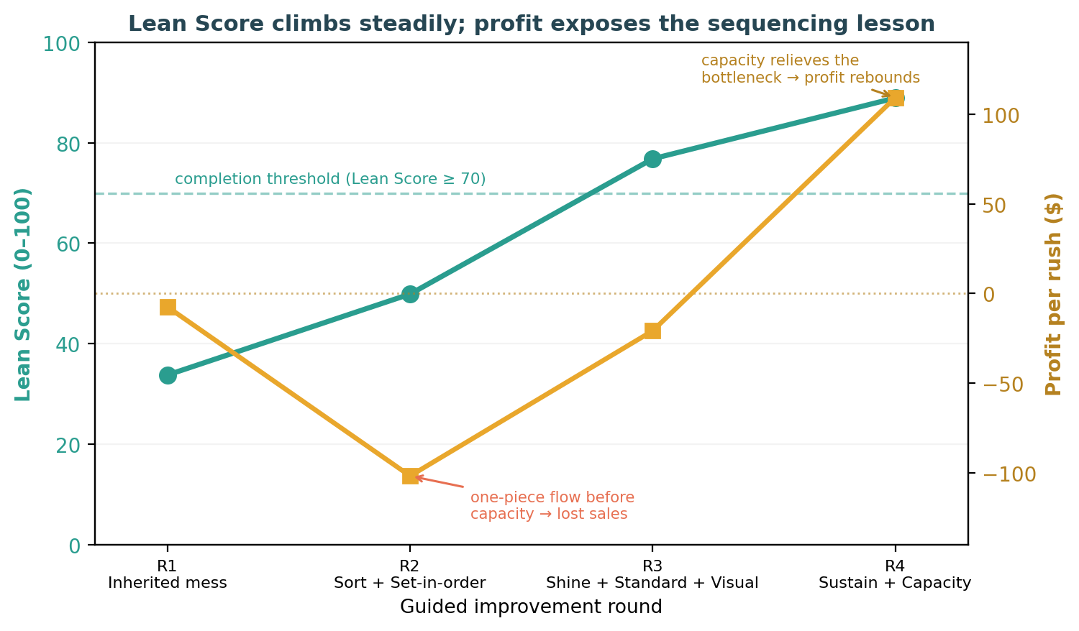
Figure 3
Lean Score and Profit Across a Guided Four-Round Improvement Arc
Note. Data are from the simulation engine for a representative scenario. The Lean Score (left axis) rises monotonically as wastes are removed. Profit (right axis) falls sharply when one-piece flow is adopted before capacity is right-sized and rebounds once the bottleneck is relieved, dramatizing the cost–benefit and sequencing lessons.
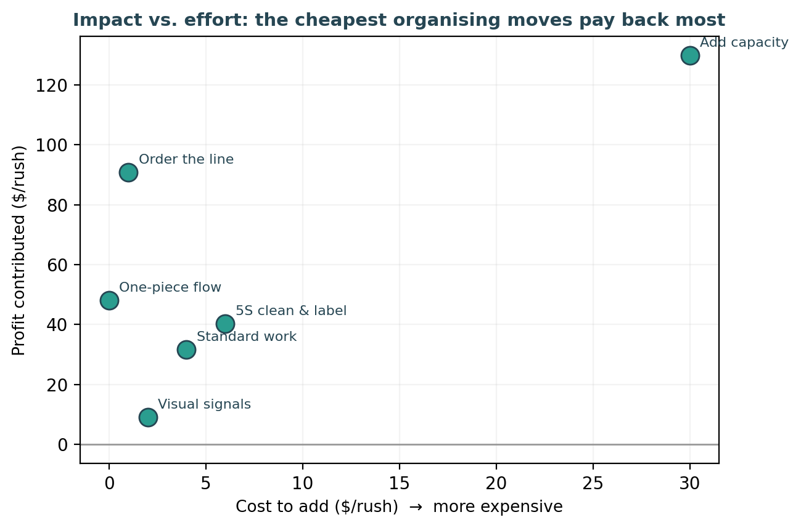
Figure 4
Impact Versus Effort for Each Intervention in the Final Shop
Note. A leave-one-out analysis computed by the engine: each point is the profit lost if that single intervention were reverted, plotted against its cost. Cheap organizing changes cluster at high return per dollar; added capacity is expensive and, once flow is fixed, contributes least.
Debriefing and Constructive Alignment
The most robust finding in simulation-based education is that most learning occurs in the debrief rather than in the doing (Fanning & Gaba, 2007). The simulation therefore treats the debrief as the summative event and gates it: the core game is complete only when the learner has met three objectives simultaneously — all seven wastes addressed, a Lean Score of at least 70, and a profitable shop — a stopping rule that guarantees the learning objectives have actually been achieved rather than a round count elapsed. The debrief then walks the whole arc: it tabulates how each waste was tackled, narrates the learner's trajectory, reveals the return on each of the learner's own decisions, and, following Rudolph et al.'s (2007) “debriefing with good judgment,” asks the learner to reconstruct their reasoning through four written reflections and a short knowledge check. The downloadable report — and hence course credit — is released only when these are complete, an instance of constructive alignment in which the assessed artifact is the reasoning, not the score (Biggs, 1996). Framing the graded product as reflection rather than points also guards against the goal-displacement risk that gamified metrics can crowd out understanding (Deci & Ryan, 2000).
Contribution to Experiential-Learning Pedagogy
The simulation's contribution is less any single feature than the systematic translation of learning-science principles into concrete mechanics, summarized in Figure 5. Several general lessons for the design of experiential learning environments follow.
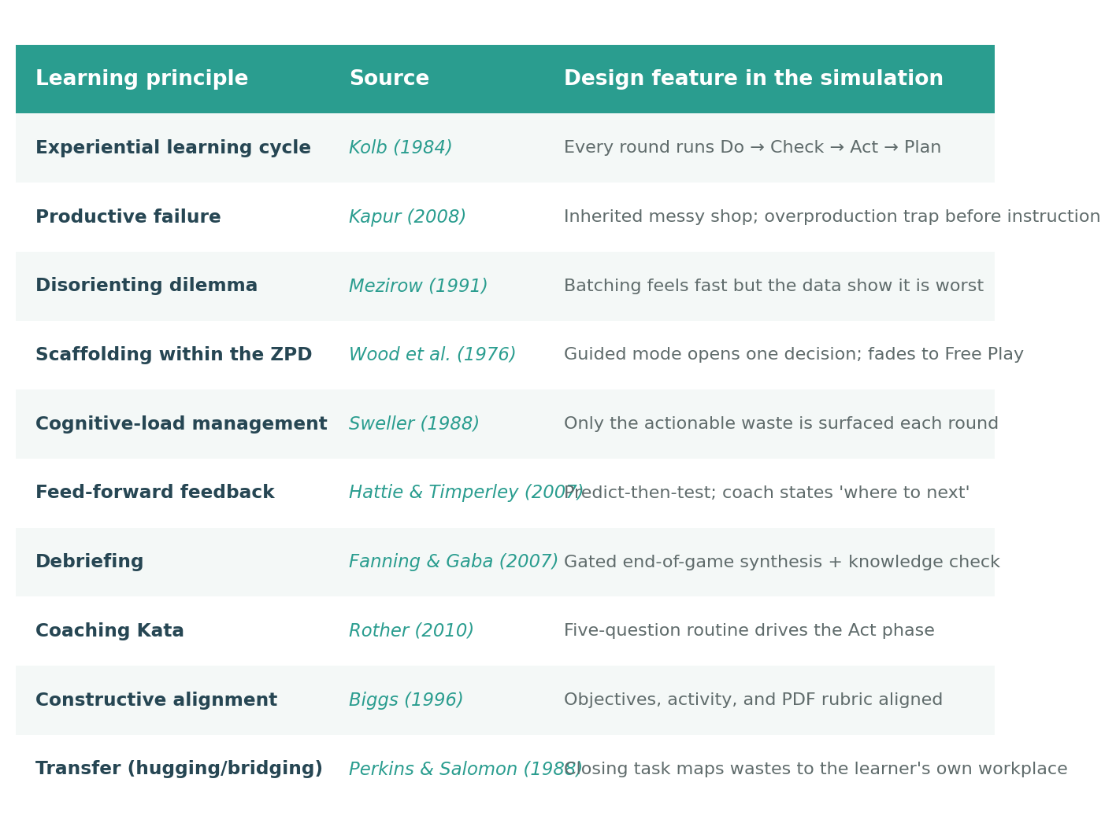
Figure 5
Mapping of Learning-Science Principles to Design Features
Note. Each principle in the learning-sciences literature is realized as a specific, inspectable mechanic in the simulation rather than as a general aspiration.
First, and most distinctively, the simulation collapses the distinction between the method taught and the method of teaching. The learner is taught kaizen and the Coaching Kata, and is taught them by being run through a kaizen loop by a coaching kata. This reflexive alignment is unusual: most simulations teach a domain through a generic game loop, whereas here the loop is itself a faithful instance of the domain's core practice. The pedagogical payoff is transfer (Perkins & Salomon, 1988) — the learner leaves with a portable improvement routine, not merely facts about a juice bar, and the closing reflection explicitly bridges to a process in the learner's own life or workplace.
Second, the design demonstrates that productive failure and cognitive-load management, sometimes treated as opposing commitments, can be reconciled by sequencing. The learner is permitted — indeed engineered — to fail on the inherited shop and on the overproduction trap (Kapur, 2008; Mezirow, 1991), but the interface simultaneously constrains attention to one actionable decision at a time (Sweller, 1988). Struggle is located in the conceptual trade-off, not in navigating the instrument.
Third, the simulation shows how affordable simulation can move beyond Chi and Wylie's (2014) “active” tier toward “constructive” engagement by requiring learners to generate predictions, justify diagnoses, and author reflections rather than merely select options. While the present version is single-player, its randomized scenarios are designed to support the further, “interactive” tier: because each learner confronts a different optimum, comparing strategies across a class becomes a substantive discussion rather than an answer-checking exercise.
Discussion and Limitations
The claims advanced here are design claims, grounded in theory and in the behavior of the instrument, not yet empirical claims about learning gains. The most important next step is evaluation: a pre/post knowledge measure paired with the reflection rubric would test whether the theorized mechanisms produce measurable understanding, and a comparison against a lecture or static-case control would situate the effect. Several design limitations also bound the contribution. The engine models a single, deliberately simple service process, which aids clarity but abstracts away supply variability and multi-product complexity; the Lean Score, though now legible and monotonic on the guided path, embeds weighting choices that are pedagogical rather than empirical; and the current single-player form realizes the social, interactive tier of engagement only latently. Deliberate-practice extensions — single-waste drills with immediate feedback (Ericsson et al., 1993) — and a collaborative mode are natural directions for subsequent versions.
Conclusion
Juicetification: The Lean Rush was built on the premise that the seven wastes are best discovered, not declared. By enacting Kolb's cycle every round, engineering a productive failure to be overcome, scaffolding attention within the learner's zone of proximal development, and gating a rigorous debrief behind genuine reflection, the simulation turns a set of counter-intuitive operational trade-offs into lived experience. Its central pedagogical move — making the improvement routine that is the object of study also the loop through which study occurs — offers a transferable template for teaching any disciplined, iterative practice. Whether that template delivers the learning gains its design predicts is an empirical question the instrument is now positioned to answer.

References
Anderson, P. H., & Lawton, L. (2009). Business simulations and cognitive learning: Developments, desires, and future directions. Simulation & Gaming, 40(2), 193–216.
Biggs, J. (1996). Enhancing teaching through constructive alignment. Higher Education, 32(3), 347–364.
Bonwell, C. C., & Eison, J. A. (1991). Active learning: Creating excitement in the classroom (ASHE-ERIC Higher Education Report No. 1). The George Washington University.
Chi, M. T. H., & Wylie, R. (2014). The ICAP framework: Linking cognitive engagement to active learning outcomes. Educational Psychologist, 49(4), 219–243.
Deci, E. L., & Ryan, R. M. (2000). The “what” and “why” of goal pursuits: Human needs and the self-determination of behavior. Psychological Inquiry, 11(4), 227–268.
Deming, W. E. (1986). Out of the crisis. MIT Center for Advanced Engineering Study.
Ericsson, K. A., Krampe, R. T., & Tesch-Römer, C. (1993). The role of deliberate practice in the acquisition of expert performance. Psychological Review, 100(3), 363–406.
Fanning, R. M., & Gaba, D. M. (2007). The role of debriefing in simulation-based learning. Simulation in Healthcare, 2(2), 115–125.
Hattie, J., & Timperley, H. (2007). The power of feedback. Review of Educational Research, 77(1), 81–112.
Kapur, M. (2008). Productive failure. Cognition and Instruction, 26(3), 379–424.
Kolb, D. A. (1984). Experiential learning: Experience as the source of learning and development. Prentice Hall.
Mezirow, J. (1991). Transformative dimensions of adult learning. Jossey-Bass.
Ohno, T. (1988). Toyota production system: Beyond large-scale production. Productivity Press.
Perkins, D. N., & Salomon, G. (1988). Teaching for transfer. Educational Leadership, 46(1), 22–32.
Rother, M. (2010). Toyota kata: Managing people for improvement, adaptiveness, and superior results. McGraw-Hill.
Rudolph, J. W., Simon, R., Rivard, P., Dufresne, R. L., & Raemer, D. B. (2007). Debriefing with good judgment: Combining rigorous feedback with genuine inquiry. Anesthesiology Clinics, 25(2), 361–376.
Salas, E., Wildman, J. L., & Piccolo, R. F. (2009). Using simulation-based training to enhance management education. Academy of Management Learning & Education, 8(4), 559–573.
Sweller, J. (1988). Cognitive load during problem solving: Effects on learning. Cognitive Science, 12(2), 257–285.
Vygotsky, L. S. (1978). Mind in society: The development of higher psychological processes. Harvard University Press.
Womack, J. P., & Jones, D. T. (2003). Lean thinking: Banish waste and create wealth in your corporation (2nd ed.). Free Press.
Wood, D., Bruner, J. S., & Ross, G. (1976). The role of tutoring in problem solving. Journal of Child Psychology and Psychiatry, 17(2), 89–100.

