Chris Sclipei

2/24/19

CMPE 150

**Lab 3**

1. pingall: this command is testing the connection between all the different hosts to make sure there is a valid and stable connection between the 4 different hosts, in this case. You will notice below that there were 12 packets sent and 12 packets received, indicating 0% packet loss.

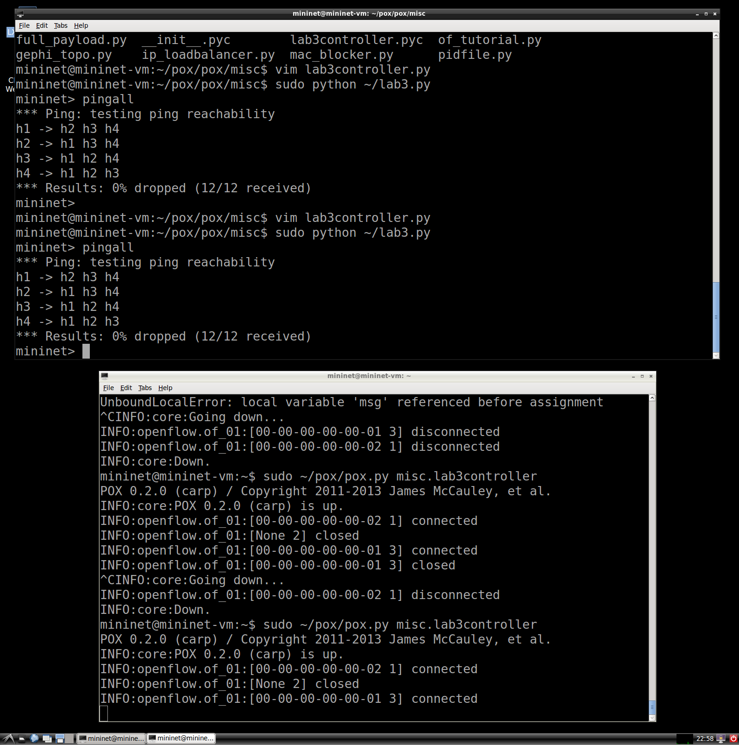

1. dpctl dump-flows: this command returns a couple entries which refer to the rules and matches you’ve set for the packets. You’ll notice in my picture below, that I have quite a few and that is because in my code, I set packet matching and rules for each individual packet, thus why so many entries are returned. You can see below all the conditions set for each packet along with the action, which in this case is FLOODING.

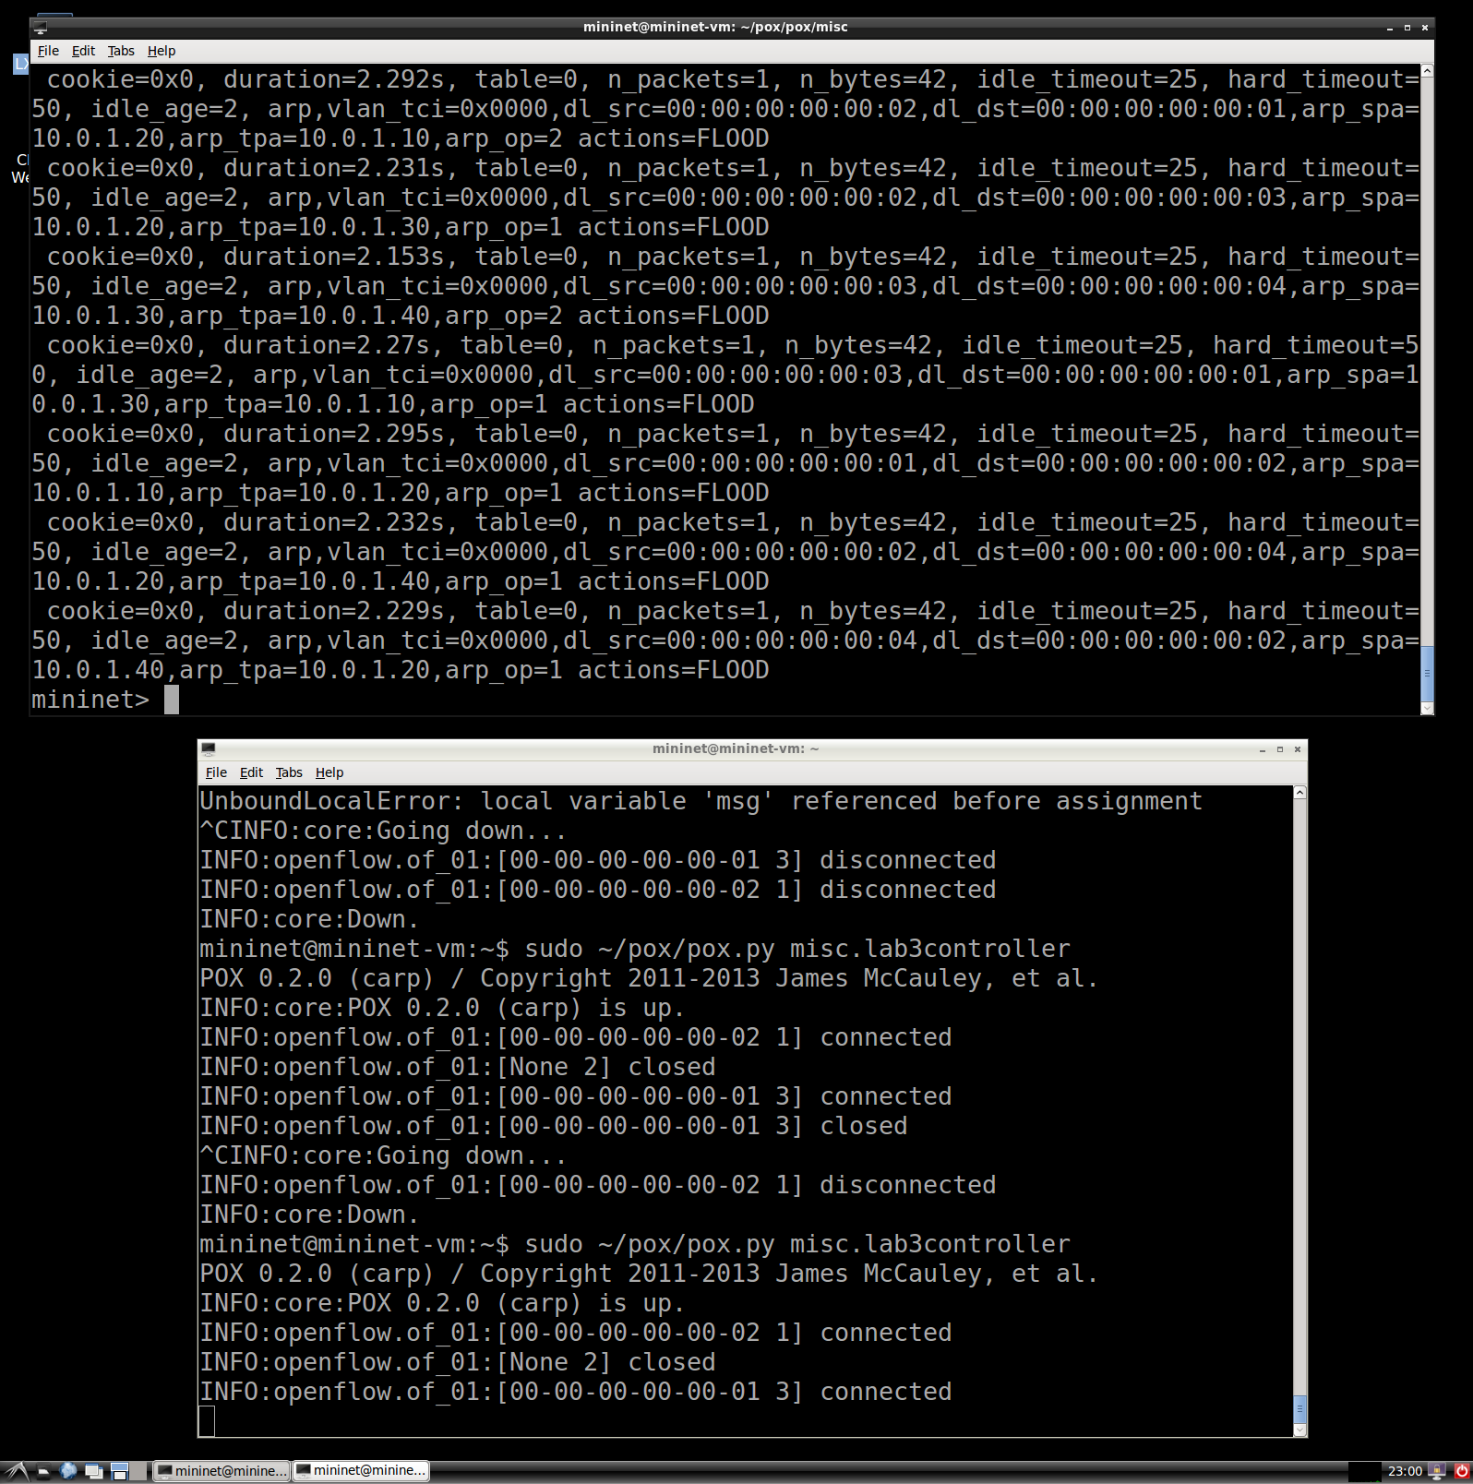

1. iperf h1 h3: this command tested the TCP bandwidth between h1 and h3 which we specified in our rules and matching, allowing only h1 and h3 to proceed with a FLOOD action given a TCP protocol. All the other hosts hang when using iperf because we blocked packet sending between the other host, which results in the terminal hanging.

