Chris Sclipei

1/20/19

CMPE 150

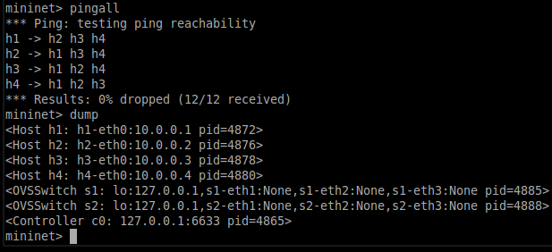

1. The pingall command shows that there is a valid connection between the 4 different hosts where each host can ping to the other 3 hosts. Out of the 12 pings sent, 12 of them were received meaning there is a stable connection. The dump command shows all the information about the nodes, which produces information about the 4 hosts, the 2 switches, and the controller which is typically outside of the VM. It also shows the IP address for each of the hosts.



1. Running the iperf command on our given topography gives the bandwidth speed, which is 30.4 Gbits/sec and 30.5 Gbits/sec, respectively.

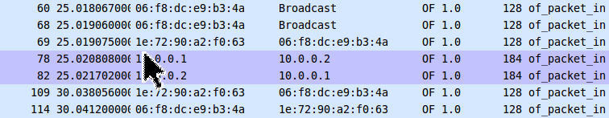

1. After running the ping command between host1 and host2, we see that we have 7 messages regarding of_packet_in.



1. You’ll notice that the source and destination IP addresses of the packets coming in are relative to the IP addresses of the host1 and host2 which are 10.0.0.1 and 10.0.0.2, and you will also notice that the rest have MAC addresses that match up with source and destination. From this, we have 2 out packets, one from each host, which are host1 and host2 that have the same destination IP address as the source IP address.

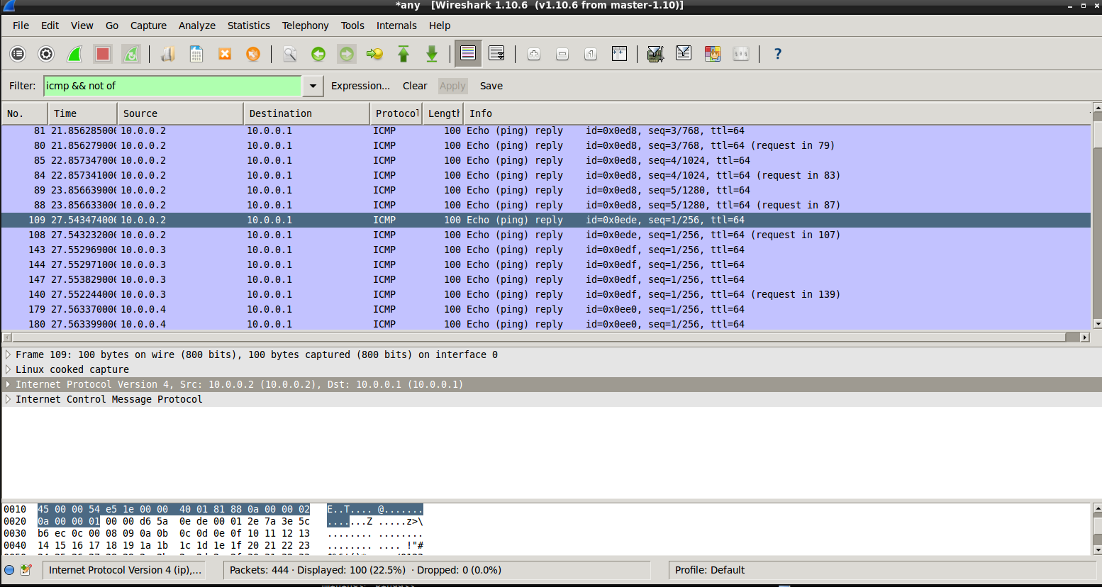

1. Out of 444 packets, only 100 were displayed while using the filter. 50 of these packets were replies and 50 were requests. This showed the pingall results along with the h1 ping -c 5 h2 results.