Causal Blame Attributions Regarding Climate Change:   
Individual and In-group Dynamics of Control Restoration

Christopher S. Romano

Loyola University Chicago

Abstract

The present research extends the assumptions of Bukowski et al. 2017, in which the authors demonstrated how the salience and specificity of different blame targets affected the impact of the 2008 global financial crisis on subjects’ perceptions of personal control. Bukowski et al. 2017 found that blaming of a specific outgroup (as opposed to the abstract concept of “the global economic system”) reduced the negative impact of the crisis on perceived personal control and did so independently of the outgroup’s perceived social threat. In the present research, I apply this model using climate change as the threat to personal control. I predict the model to be applicable to climate change, producing similar results to those of the prior study. I also propose a basic model of inter-group dynamics as they relate to control-restoration and crisis. I also use an exemplar as well as the participant’s own in-group as blame groups to further explore the interplay of group dynamics and management of perceived control.

**Perceived control and the self**

Our concept of self is an essential underpinning of many of our actions and allegiances. While philosophers like Schopenhauer posit a human ability to transcend the self through aesthetic appreciation and/or ascetic living, we typically spend our time in a state of self-awareness (Schopenhauer, A 1859). Thus, behaviors arising from the integration of general perception, cognition, and self-perception are of great importance to cognitive science. The self is typically “at its best” when it maintains a high level of perceived control over external factors. Threats to the perception of control can manifest into pathological outcomes such as depression and learned helplessness (Seligman, 1972). This is to say that low levels of perceived control over one’s environment stand to impair one’s sense of agency and is therefore likely to diminish the likelihood of the successful planning and achievement of goals.

When there is a reduction of perceived personal control, one may seek to remedy the resulting diminutive effects by joining a social group (Fritsche et al., 2013). While this can be effective, both attractiveness of a group (a determinant of whether group is joined) and efficacy of the group as a control-restorative influence depend on whether the group is perceived as agentic (Stollberg, Fritsche & Backer, 2015). In other words, one can only restore a sense of control through group membership if one perceives the group as possessing the agency that they themselves lack.

**Group membership**

When one joins an ideologically demarcated group, the dynamics of the in-group/out-group relationship come into play. While an in-group can technically recognize all of those who do not also belong to it as its out-group, groups maintaining ideas in opposition to those of the in-group are typically more salient as out-groups. For example, if the American Democratic party is considered as an in-group, while its definitional out-group includes any person who does not identify as a Democrat, the most salient out-group is likely the American Republican party.

The favoritism of one’s in-group over one’s out-group is central to human nature (Sumner 1906). This favoritism is referred to as in-group bias and is thought to arise in response to competition over limited resources (Sherif et al., 1961), threats to self-esteem (Billig & Tajfel 1973), and unsatisfactory conceptions of identity (Tajfel 1974). This is to say that, respectively, we favor the needs of our group over other groups, we view our group more positively than other groups as a function of self-esteem maintenance, and we consider our group memberships to be at least partially constitutive of our identities. While these components of group mentality are therapeutic to the self and its in-group, they often act in concert to produce unfavorable results within the broader intergroup arena. Notable among these byproducts of in-group bias are prejudice, xenophobia, and ethnocentrism.

**In-group bias in times of crisis**

Crisis can be reasonably defined as a temporally constrained series of conditions and events that, due to their destructive and alarming nature, significantly reduce feelings of personal control in the affected populace. In accordance with principles of the self as it reacts to differing levels of perceived control, times of crisis often foster the genesis of situationally designed social groups and/or increase membership of existing groups that operate to similar ends. From this, we can reason that the greater the impact of the crisis, the more compelled people will be to turn to groups to provide a sense of control. It follows that lower perceived personal control results in higher dependency on one’s in-group to provide perceived agency. As one’s identity becomes increasingly derived from one’s group membership, one becomes increasingly susceptible to in-group bias.

Additionally, as crisis impact increases, the rising number of people resorting to agentic group membership as a way to restore perceived control will alter the dynamics of the intergroup arena. Groups may gradually cease to act like cooperative entities existing in relative balance and begin to act tribally. The consequences of in-group biases pushed to their extremes are as numerous as they are horrific. The model shown in the next section of the introduction proposes a conceptual framework that attempts to capture how crisis deforms the relative harmony of inter-group dynamics as they operate under normal circumstances.

**Blame**

An in-group of a crisis-responsive nature is likely to define its primary out-group as the one it blames for the crisis. For instance, many critics of the presidency of George W. Bush purchased and displayed bumper stickers reading “Don’t blame me, I voted for [Kerry/Gore],” indicating blame directed towards their chosen out-group of Bush voters. While the Bush presidency may not necessarily qualify as a crisis, the sentiment of the aforementioned bumper sticker poignantly illustrates intergroup dynamics under circumstances perceived as unfavorable.

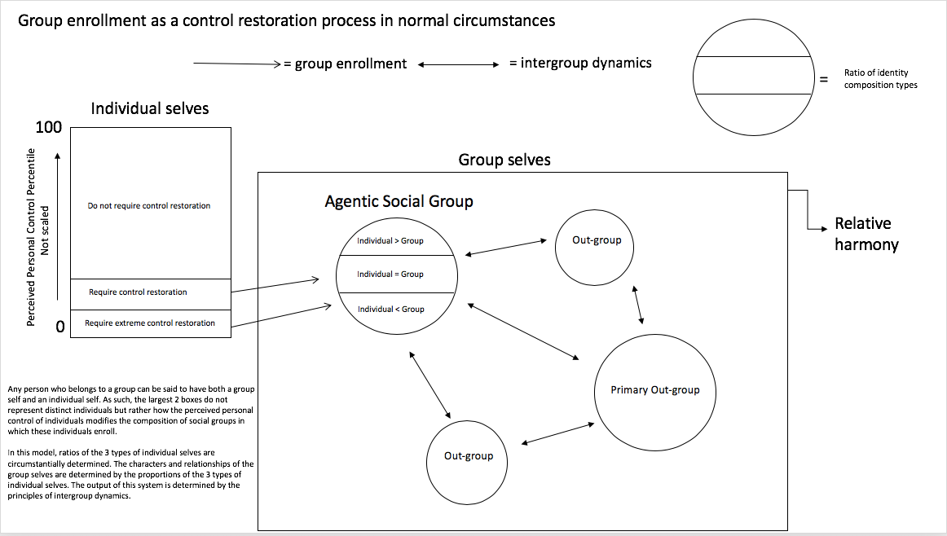

(fig 1.) Group dynamics in non-crisis. Few individuals are driven to join groups as a way of restoring control. Consequently, social groups are composed of a balanced distribution of members that derive some, much, or most of their identity from their membership within the group (corresponding to their susceptibility to in-group biases). No crisis is present, so no blame is assigned, and the out-group landscape consists of multiple groups of varying salience to one’s in-group. Groups exist in relative harmony.

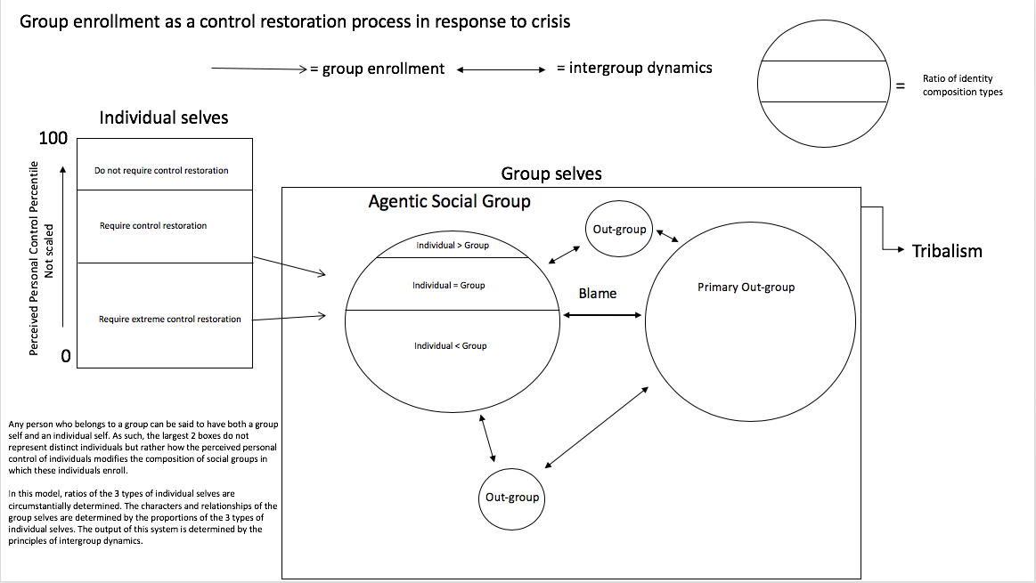

(fig. 2) Group dynamics in crisis. Many people now require control restoration and so many people join agentic social groups. Social groups become dominated by those who derive larger shares of their identity from their membership in the group, skewing the group’s population towards those most susceptible to in-group bias. The presence of crisis prompts the assigning of blame, typically towards the primary, or most salient, out-group. Other out-groups diminish in salience. The group landscape becomes tribalistic.

While it is clear that crisis, by way of its threat to personal control and the resulting exacerbation of in-group bias, precipitates destructive behaviors and beliefs within the intergroup arena, it is not clear why blaming is a function of this process. Blaming in general can rationally be considered a method of assigning culpability for reasons of diagnosis and/or retribution. Thus, it would seem that the use of blame enables a group to better assess a problematic scenario, therefore increasing actual and perceived control over the outcome of said scenario. However, research in the domain of inter-group relations finds this not to be the case.

In assessing blame attributions regarding the 2008 financial crisis it was found that subjects perceived a much greater threat to control from the global economic system than from any of the more specific groups tested. Nevertheless, blaming the specific groups resulted in perceived control restoration while blaming the global economic system did not (see Table1.) (Bukowski et al. 2017). Further study revealed that blaming of specific out-groups restores perceived control regardless of whether or not the group is perceived as responsible for that which they are blamed. In fact, out-group blaming as a control restoration tactic proved so generalizable that subjects would experience restoration after being made to assign blame value to a group which they perceived as having no negative characteristics or intentions (Bukowski et al., 2017).

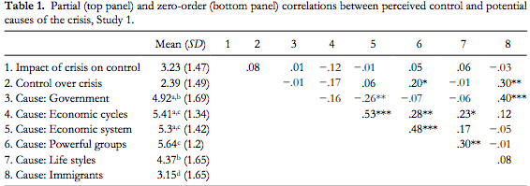

From the work of these authors, we are afforded a fairly comprehensive model of out-group blaming as a strategy of perceived control restoration. When a person’s perceived personal control is sufficiently low, said person may seek group membership to restore a sense of global control (Fritsche 2013). The attractiveness of a prospective group is determined by the perceived agency of the group such that highly agentic groups are considered most attractive1 (Stollberg 2015). Once a group is joined, its success in restoring the person’s perceived personal control relates directly to the perceived agency, or collective control, of the group (Stollberg, Fritsche, & Backer, 2015). This follows naturally from our knowledge of group membership as a component of identity (Tajfel 1974).

Bukowski et al. proposed that, once one is in such a position, blaming of specific out-groups restores perceived control (2017). This restoration is thought to occur because the identification of a specific out-group as the cause of a control threat activates an inter-group context in which the in-group is understood to be an agent of control restoration (Bukowski et al., 2017). This is to say that the inter-group context activated by blaming a specific out-group increases perceived agency of one’s in-group through the mechanisms of in-group bias. Since the inter-group context is not activated when blaming an abstract system, the restoration process never occurs. Such differences are consistent with Fritsche et al. in which it is proposed that out-group blaming succeeds in restoring perceived control simply by engaging the social self in control-restorative processes (2013).

**The present research**

I aim to further explore the intergroup framework of blame-induced control restoration. I start by assuming the blaming of specific out-groups to be effective to this end by sheer virtue of its activation of the inter-group context. It is proposed that so long as one’s in-group is perceived as sufficiently agentic, blaming a specific out-group for causing an active (i.e. currently occurring) control threat will activate the inter-group context and the group mentality that follows, ultimately resulting in a restoration of perceived control.

In terms of the 3 components of in-group bias (competition, self-esteem, identity), blaming leads us to perceive the desired resource (control) as being in short supply due to the actions of the blamed out-group. Whether or not this is truly believed, the competitive dynamics of in-group bias will cause a higher prioritization of our in-group’s goals over those of others. Additionally, the self-esteem dynamic will skew our perceptions of our in-group and out-group towards and away from favorability respectively. Finally, the identity dynamic of in-group bias, through increasing the salience of our group membership, will cause us to perceive our in-group as a larger chunk of our identity than we had thought it to be prior to the blaming. At this point, we have increased the amount of our identity that is derived from our membership in a group that was recently assessed as having more favorable characteristics and higher priority needs. It is in this way that I propose this restoration of perceived control to be a result of in-group bias as it performs in an inter-group context activated by the blaming of a specific out-group.

The present study extends the methods of Bukowski et al. against these assumptions with the goal of elaborating our understanding of control perception (2017). I aim to examine subjects belonging to an in-group on one end of a diametric continuum, to replicate previous findings within the context of a new crisis, and to examine effects of blaming an individual who is widely seen as an exemplar of the out-group most salient to the in-group of our subjects. Further, I aim to examine the effects of blaming one’s own in-group for causing the control threat.

At the time of writing, the United States is no longer suffering an economic crisis on the scale of the 2008 housing market crash. Thus, I must adapt my research model to a crisis that is yet to truly begin: climate change. While the most devastating predicted effects of climate change remain in the future, the ‘worst-case-scenario’ (i.e., the predicted outcome of total inaction) is sufficiently disturbing that merely approaching it at the current rate could be considered a crisis to some. It is around this ‘some’ that I tailor my participant group.

To achieve the desired conditions, I recruit environmental science students of sophomore standing or higher that answer yes to the question “Are you or do you plan to become a part of the effort to combat climate change?” as participants. By doing this, I create a subject pool that is ostensibly representative of a group termed ‘environmental activists.’ This group is, by its ideological nature, diametrically opposed to a group termed ‘climate change skeptics.’ The individual used as an exemplar of the blame group is United States President Donald Trump, a highly notable figure who can reasonably be identified with the group termed ‘climate change skeptics.’

From the above, I form the following hypotheses:

H1: Out-group blaming will outperform system blaming as a control restorative function, just as it did in Bukowski et al. (2017).

H2: Exemplar blaming will outperform out-group blaming as a control restorative function due to the increased specificity of blame target without loss of inter-group context activation.

H3: In-group blaming will be outperformed by all other blaming strategies as it constitutes a reversal of the inter-group dynamic responsible for control restoration.

**Methods**

*Participants.* Participants were n students of environmental science at Loyola University Chicago. Participants were prescreened and only admitted to the study if they were of sophomore or higher standing and responded “yes” to the question “Are you or do you plan to become a part of the effort to combat climate change?”

*Procedure.* Participants were asked to give their opinions concerning climate change. Prior to measurement, participants were given a condition-appropriate version of the climate crisis mindset priming inventory (see appendix.1) after which they were asked to write down two negative and uncontrollable effects of climate change which they believed would happen in the future. This priming was done to guarantee participant exposure to an appropriate level of perceived threat in relation to climate change.

*Manipulation of blame attribution.* Depending on condition, participants were then asked to think about the possibility that climate change skeptics/ the global economic and sociopolitical systems/ Donald Trump/ environmental activists are partially responsible for the ensuing crisis. After a brief period of contemplation, participants were then asked to indicate their levels of agreement to four statements (“The continued development of climate change is due to… (a.) out-group condition: […climate change skeptics’ refusal to acknowledge the truth/…climate change skeptics’ refusal to act in an environmentally conscious manner/…climate change skeptics’ influence on others’ beliefs/…climate change skeptics’ voting patterns] (b.) system condition: […the uncontrollable and chaotic nature of the global economic and sociopolitical system/…the current structure of the global economic and sociopolitical system/…the unchecked activity of the global economic and sociopolitical system/…the refusal of the global economic and political system to act in pursuit of anything besides monetary gain] (c.) exemplar condition: […the presidency of Donald Trump/…Donald Trump’s influence over American minds/…Donald Trump’s choice to withdraw the United States from the Paris Climate Agreement/…the governmental appointments made by Donald Trump] (d.) in-group condition: […the failed recruiting efforts of environmental activists/…the ineffective policy strategies employed by environmental activists/…the lack of coordination between environmental activist groups/…the inability of environmental activists to secure important political positions].”). These items were rated on a 7-point Likert scale ranging from 1 (*strongly disagree*) to 7 (*strongly agree*). These responses were not designed for analysis and only exist to manipulate conditions by increasing the salience of blame towards the conditionally assigned blame group.

*Measures*

*Personal control.* Personal control was assessed with 4 items composing 2 aggregated scales. The aggregate measure of climate change’s impact on personal control consisted of the items (“To what extent will unchecked climate change negatively affect your life and the lives of those like you?” and “To what extent does climate change’s development make you feel that you and those like you have no control over things that happen to you and those like you?”) and the aggregate measure of perceived personal control over the effects of climate change consisted of the items (“To what extent can you and those like you control how climate change develops?” and “To what extent do you believe that climate change will continue, no matter what you and those like you do?”). Items were rated on an 11-point scale ranging from 0 (*not at all*) to 10 (*totally)*. The questions were adapted from Bukowski et al. to include the different crisis and induce the desired in-group mindset.

References

Billig, Michael; Tajfel, Henri (1973-01-01). "Social categorization and similarity in intergroup

behaviour". *European Journal of Social Psychology*. **3**(1): 27–52.

Bukowski, M., Lemus, S. D., Bailon, R. R., & Willis, G. B. (2014). Who’s to blame? Causal

attributions of the economic crisis and personal control. *PsycEXTRA Dataset*.

doi:10.1037/e514472015-365

Fritsche, I., Jonas, E., Ablasser, C., Beyer, M., Kuban, J., Manger, A., & Schultz, M. (2013). The

power of we: Evidence for group-based control. *Journal of Experimental Psychology,49*,

19-32.

Seligman, M. E. (1972). Learned Helplessness. *Annual Review of Medicine,23*(1), 407-412. doi:10.1146/annurev.me.23.020172.002203

Sherif, M.; Harvey, O.J.; White, B.J.; Hood, W. & Sherif, C.W. (1961). *Intergroup Conflict and*

*Cooperation: The Robbers Cave Experiment*. Norman, OK: The University Book

Exchange. pp. 155–184.

Stollberg, J., Fritsche, I., & Backer, A. (2015). Striving for Group Agency: Threat to personal

control increases the attractiveness of agentic groups. *Frontiers in Psychology,6*(649).

Retrieved April 24, 2019.

Sumner, William Graham. (1906). *Folkways: A Study of the Social Importance of Usages,*

*Manners, Customs, Mores, and Morals*. Boston, MA: Ginn.

Tajfel, Henri (1974-04-01). "Social identity and intergroup behaviour". *Social Science*

*Information*. **13** (2): 65–93.

Appendix

1. Climate crisis mindset priming inventory. Presented as an excerpt from a newly published climate-science report.

“All measures taken to decrease the speed at which the Earth’s temperature continues to rise have been insufficient. Experts have recently (2019) confirmed that speed of climate change development has become uncontrollable and may even begin to increase beyond their ‘worst case’ projections. Predictions of the climate change timeline have become uncertain and no consensus can be reached as to how quickly we must act. Climate scientists are sure of only one thing; serious negative consequences will eventually be imposed onto a population which has no means to control them.”

-Nelpyik & Vonn 2019

Footnote

1. Keep in mind that agency determines attractiveness in this manner when the group is being considered as a control restoration strategy. General attractiveness of groups to individuals is not necessarily related to their perceived agency.