Christopher Seamount

1. BE SURE TO DRINK YOUR OVALTINE

2. a) C++ uses static type checking.
b) This means that all types need to be declared on each variable.

3. a , d, and e

4. Zero or more c’s but must be an even amount. Zero or more a’s on the left of the c’s and zero or more b’s on the right of the c’s. Must be an equal amount of a’s and b’s.

5. c, d, e, and g

6. S(a|b)*b(a|b)*

7. a) b) both questions generate the same tree

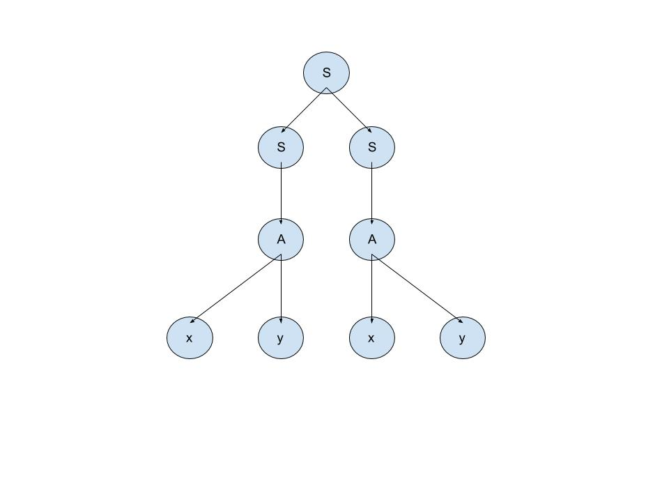

c) xyxyxy
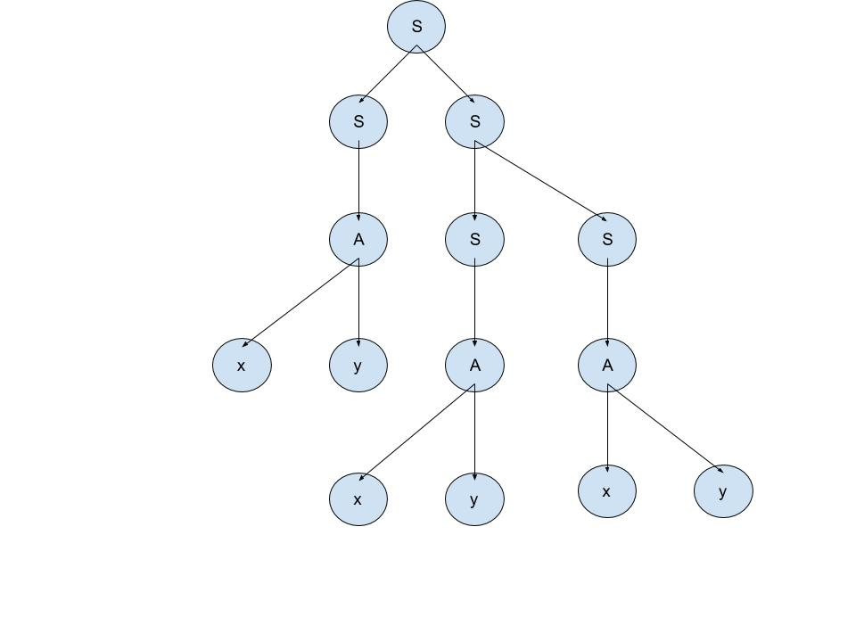

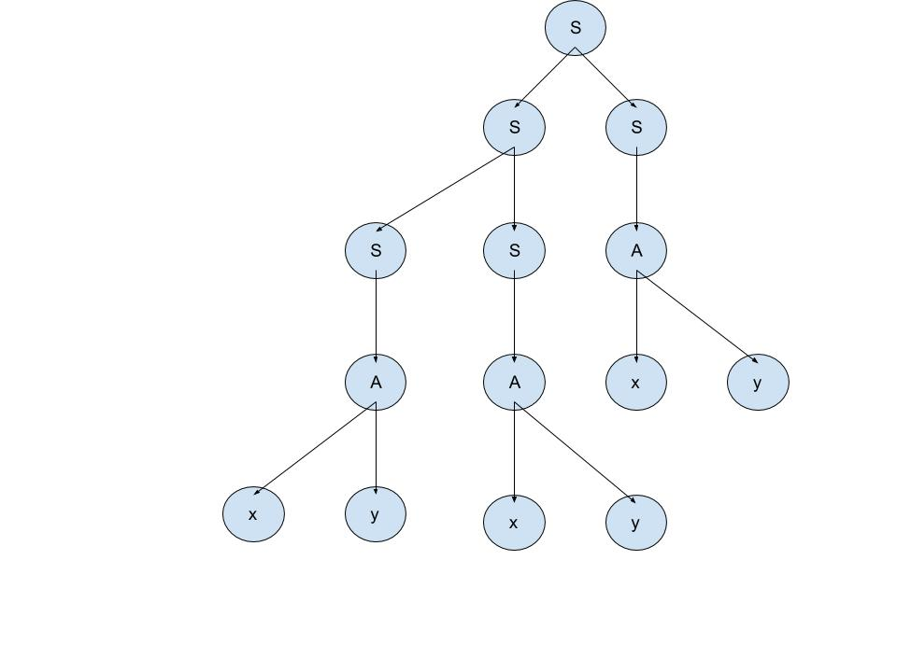

d) S→(xy)+

8. a) (aa)a*x

b)
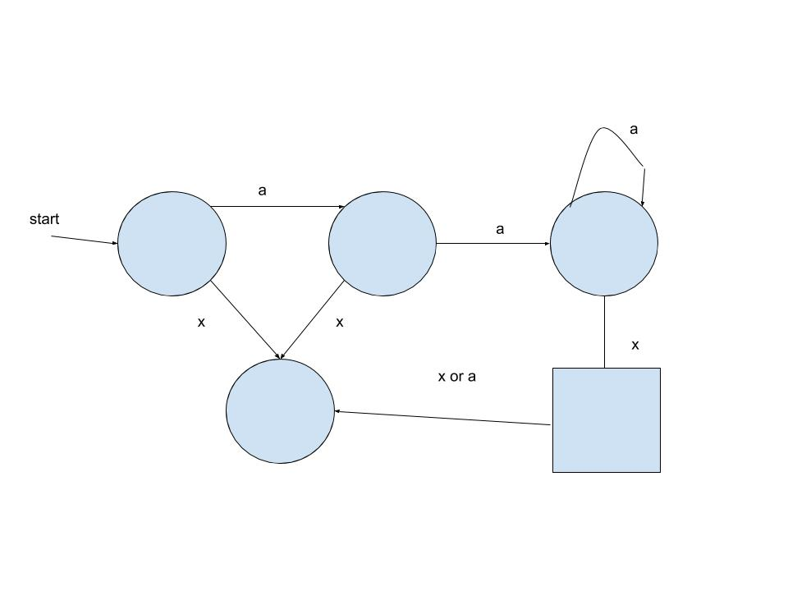

c) <start> ::= ‘a’ ’a’ <letter> ’x’
<letter> ::= ‘a’ <letter>
<letter> ::= ε

d) this is non ambiguous because there is one derivation for each string

9.

<regx> ::= ‘(‘ <regx> ‘)’ | <regx> ‘|’ <regx> | <regx> ‘*’ | <single-char> | <epsilon> | <regx> <regx>

