Product Requirement Document (PRD): The Intelligent Financial Coach for Home Ownership

1. Executive Summary & Vision
The Shift: We are moving from "Product Centric" (pushing a 30-year fixed mortgage) to "Life-Plan Centric" (facilitating the journey to homeownership). The Problem: 68% of aspiring First-Time Home Buyers (FTHB) defer their application due to "perceived" unreadiness, while 22% are rejected due to fixable DTI or credit issues. The Solution: An AI-driven Financial Coach that operates 6–24 months pre-application. It ingests Open Banking data to bridge the gap between financial literacy and underwriting readiness.

Target Personas & Friction Points
Persona | Archetype | Primary Friction | The "Coach" Solution
The Gig Economy Striver | Variable income, multiple 1099s, thin credit file. | Underwriting struggles to normalize their income; they fear rejection. | Income Normalization: Analyzes 24 months of cash flow to present a "blended" income view accepted by non-QM standards.
The HENRY Spender | High Earner, Not Rich Yet. Excellent income, poor DTI due to lifestyle creep. | High discretionary spending reduces borrowing power. | The "Truth" Mirror: Deterministic simulations showing exactly how a car lease reduces home buying power by $80k.
The Credit Rebuilder | 580-620 FICO, past medical debt or student loans. | Paralysis; doesn't know which debt to pay off first to maximize score. | Credit Simulator: "If you pay $200 to Debt A vs Debt B, your score moves +15 points faster."

2. High-Level Technical Architecture
The system relies on a Neuro-Symbolic AI Architecture. This is the critical differentiator: we separate the "Talker" (LLM) from the "Calculator" (Rules Engine).

2.1 The "Empathy Layer" (Probabilistic / LLM)
- Role: Conversational interface, motivation, behavioral framing, and complex concept explanation.
- Tech Stack: Azure OpenAI (GPT-4o) or Anthropic Claude 3.5 Sonnet (via Azure Gateway for data residency).
- Integration: Hosted within a custom Backbase (Angular) embedded in the EBP Web/Mobile App.

2.2 The "Truth Layer" (Deterministic / Rules Engine)
- Role: The non-negotiable mathematical backbone. The LLM is forbidden from performing arithmetic related to affordability.
- Crucial Architecture Decision: We will not rebuild DTI logic. We will wrap existing systems to prevent "Shadow Logic" drift.
  - DTI/Eligibility: API calls to Encompass/Empower (LOS) dummy file pricing engine.
  - Cash Flow Engine: Custom Python service aggregating transaction data to determine "True Discretionary Income."
  - Rate Engine: Real-time API calls to Optimal Blue (PPE).

2.3 Data Ingestion & Context (The Bridge)
- Open Banking Aggregation: Integration via Plaid or MX to fetch held-away accounts.
- Internal Data: Ingestion of checking/savings transaction history via Backbase DBS (Digital Banking Services).
- Vector Database (RAG):
  - Store: chroma
  - Content: Indexed FTHB educational content, regulatory disclosures, and anonymized "success paths."

2.4 Neuro-Symbolic Interaction Flow (Sequence)
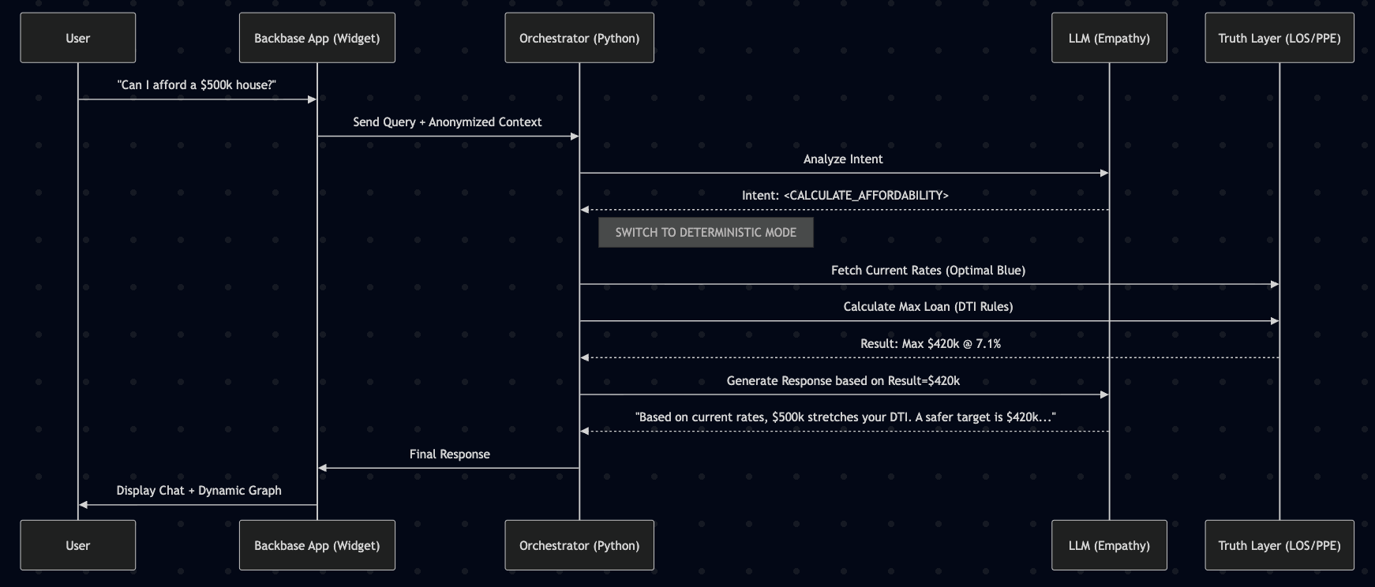

3. Phased Product Roadmap

Phase 1: MVP - "The Financial MRI" (Months 1-4)
Objective: Read-only assessment of current readiness. No advice, just data.
- User Feature:
  - Readiness Score: A dashboard showing a 0-100 score based on Credit, Cash, and Income.
  - Educational Chat: "What is PMI?" (Static RAG).
  - The "Gap" Analysis: "You need $12k more for a down payment."
- Technical Enabler:
  - Data Pipeline: ETL pipelines to ingest Plaid data into a secure data lake (Databricks).
  - Categorization Engine: Implementation of Transaction Categorization (clean raw text to "Dining", "Utilities").
  - Safety Guardrails: System prompt engineering to refuse advice on interest rate speculation.

Phase 2: Intermediate - "The Proactive Coach" (Months 5-9)
Objective: Behavioral modification through nudges and simulation.
- User Feature:
  - "What-If" Simulator: Sliders to adjust "Monthly Savings" or "Home Price" to see impact on timeline.
  - Smart Nudges: "You spent $400 on dining this week. That delays your home purchase by 11 days."
  - Affordability Alerts: "Interest rates dropped 0.25%; your buying power just increased by $15k."
- Technical Enabler:
  - Predictive ML: Time-series forecasting (Prophet or ARIMA) on user cash flow.
  - Event-Driven Architecture: Kafka topics triggering alerts based on real-time transaction processing.
  - Dynamic Prompting: Injecting user-specific JSON data into the LLM context window for hyper-personalized critiques.

Phase 3: Advanced - "The Autonomous Agent" (Months 10+)
Objective: Action execution and underwriting pre-flight.
- User Feature:
  - Auto-Save: Agent identifies "safe to save" funds and moves them to a high-yield down payment fund.
  - Document Hunter: Agent identifies missing documents (e.g., "Upload gift letter") before Underwriting review.
  - Pre-Lock: API integration to lock a rate.
- Technical Enabler:
  - Agentic Workflow (LangGraph): LLM granted permission to call internal banking APIs (transfer funds, generate PDF).
  - Human-in-the-Loop (HITL): Critical gate. Agent prepares the locking request, but a human Mortgage Loan Officer (MLO) must press "Approve" until model confidence > 99.9%.

4. Compliance, Security & Guardrails

4.1 The "No-Hallucination" Protocol
- Grounding: The LLM temperature is set to 0.1 for financial queries.
- Tool Use: The LLM is instructed that it cannot calculate numbers. It must emit a tool-call token <CALCULATE_DTI> which invokes the deterministic Python engine.

4.2 Regulatory Adherence
- ECOA (Equal Credit Opportunity Act):
  - Risk: AI bias in advising specific demographics differently.
  - Mitigation: "Fairness through Unawareness" in the model training, plus post-hoc analysis of advice distribution.
- UDAAP (Unfair, Deceptive, or Abusive Acts or Practices):
  - Risk: Framing a risky loan as "easy."
  - Mitigation: Hard-coded disclaimers appended to every piece of advice regarding rates or approvals.
- Data Privacy (GLBA):
  - PII Redaction Layer: Middleware strips Names/SSNs before the prompt is sent to the LLM. The LLM only sees User_ID_123.

5. Non-Functional Requirements (NFRs)
- Latency: The "Empathy Layer" (LLM) must respond within 1.5 seconds for general chat (streaming enabled). The "Truth Layer" (Calculations) must complete within 800ms.
- Availability: 99.9% uptime required during market hours (rate locks are time-sensitive).
- Auditability: Every single LLM interaction must be logged with the Prompt, the Context, and the Response for 7 years (Compliance retention).

6. Success Metrics (KPIs)

User Health Metrics (North Star)
- Readiness Velocity: Average time to move from "Not Ready" to "Mortgage Ready" status.
- Savings Rate Delta: % increase in savings rate after 3 months of coaching.
- DTI Optimization: Average reduction in DTI points per user per quarter.

Business Health Metrics
- Coach-to-App Conversion: % of Coach users who eventually submit a 1003 (Loan Application).
- Pull-Through Rate: Do "Coached" files close faster? (Target: 15% reduction in time-to-close).
- CAC Reduction: Lowering Cost of Acquisition by nurturing organic existing banking clients.

