AUCA BIG DATA ANALYTICS
FINAL PROJECT — TECHNICAL REPORT

Distributed Multi-Model Analytics for E-commerce Data

Student: Ntwari Kinanira Christian
Student id:101412
Adventist University of Central Africa (AUCA)
June 2026

1. System Architecture Overview
This project implements a distributed multi-model analytics pipeline for e-commerce data, combining MongoDB (document store), HBase (wide-column store), and Apache Spark (distributed processing engine). Each technology was selected for specific analytical strengths.

Component | Role | Data Handled | Access Pattern
MongoDB 8.0 | Document store — transactional source of truth | Products, Users, Transactions | Rich aggregation, nested document reads
HBase 2.5 | Wide-column store — behavioral event stream | Session page-views, product daily metrics | Row-key range scans by user+time
Apache Spark 4.1 | Distributed processing — integrator | All datasets (reads from both stores) | Batch joins, SQL analytics, CLV scoring

Data flows from the synthetic generator into MongoDB and HBase in parallel. Spark reads from both stores plus the raw JSON session files to perform cross-system analytics and produce the integrated CLV scores in Part 3.

2. Data Modeling Decisions

2.1 MongoDB Schema Design
Three collections were designed around MongoDB's document model strengths:

products collection
Embeds price_history as an array (always read with the product, bounded to 1-3 entries) and denormalizes category_name and subcategory_name to avoid join-back on every product listing query.
users collection
Embeds a computed purchase_summary (total_orders, total_spent, avg_order_value, favorite_category) using the Materialized Computed Pattern. Calculated once at ETL load time, stored on the user document for O(1) read performance on segmentation queries.
transactions collection
Embeds line items and denormalizes product_name and category_id onto each item. This allows revenue-by-category aggregations to run directly off transactions without a $lookup join to products for every line item.

2.2 HBase Schema Design
user_sessions table — Row key: user_id + reverse_timestamp
Reverse timestamp ensures the most recent sessions sort first within a user's contiguous key range. Four column families: meta, geo, events (one column per page-view), cart.
product_metrics table — Row key: product_id + date (YYYY-MM-DD)
Two column families: engagement (views, cart_adds, unique_viewers) and conversion (purchases, units_sold, revenue). Co-locating both enables direct conversion-rate computation without cross-table joins.

2.3 Technology Selection Rationale
Criterion | MongoDB | HBase
Data shape | Deeply nested, bounded-size objects | Flat, sparse, variable column count
Access pattern | 'Give me everything about entity X' | Range scan by composite key over time
Query needs | Rich ad-hoc aggregation ($group, $lookup) | Simple prefix scans, no complex joins
Write pattern | Moderate volume, document-at-a-time | Very high volume, append-mostly
Scale | 32,800 documents | 100,000 session + 25,000 metric rows

3. Spark Processing Pipeline

3.1 Data Cleaning and Normalization
The batch_processing.py pipeline cleans and normalizes all six raw JSON files into typed Spark DataFrames:
- Timestamp columns cast to TimestampType using to_timestamp()
- Missing discount and current_stock filled with 0 using coalesce()
- Invalid rows dropped: transactions with null/negative totals, sessions with zero duration
- Duplicates removed on natural keys (transaction_id, session_id, product_id, user_id)
- Result: 2,000 users, 800 products, 25 categories, 30,000 transactions, 100,000 sessions — all confirmed clean

3.2 Product Affinity (Frequently Bought Together)
Market-basket co-occurrence analysis by exploding transaction items and self-joining on transaction_id. Top result: prod_00077 + prod_00079 co-purchased 4 times. Low co-purchase counts reflect a wide 800-product catalog with diverse buying patterns.

3.3 Cohort Analysis
Users grouped by registration month and joined against transaction history. The October 2025 cohort (354 active buyers) is the largest, generating over $2M in April 2026. All cohorts show a slight revenue dip in June 2026 due to an incomplete month.

3.4 Spark SQL Queries
- Query 1 — Revenue by Category: cat_002 leads with $2,002,329 across 37 products and 6,253 units sold
- Query 2 — Top Users: user_001908 (CA) top spender at $37,275 across 14 completed orders
- Query 3 — Conversion Funnel: mobile+affiliate converts best at 21.33%; all 15 combos cluster between 19.4%-21.3%
- Query 4 — Monthly Revenue: March $1.55M → April $5.93M → May $5.70M → June $3.81M (partial)

Optimization: spark.sql.shuffle.partitions set to 8 (from 200 default) to reduce task overhead on single-machine local[*] deployment. Driver memory set to 2g to handle 200MB combined session JSON files.

4. Integrated Analytics — Customer Lifetime Value

4.1 Business Question
Which customers are our most valuable, and does their browsing engagement (behavioral data from HBase/sessions) correlate with their purchasing value (financial data from MongoDB)?

4.2 Integration Workflow
- Step 1 — MongoDB: Per-user financial aggregates fetched from pre-computed purchase_summary. 2,000 users retrieved in O(1) per user.
- Step 2 — HBase/Spark: Per-user behavioral metrics computed from 100,000 sessions — total_sessions, avg_session_duration_sec, personal_conversion_rate_pct.
- Step 3 — Spark join: Both DataFrames joined on user_id. Spark holds both MongoDB financial and session behavioral data simultaneously.
- Step 4 — CLV scoring: CLV = (total_spent_normalized x 0.60) + (order_frequency_normalized x 0.20) + (engagement_score_normalized x 0.20).
- Step 5 — Segmentation: Users bucketed into 4 tiers by CLV score percentile (p25=43.3 / p50=50.3 / p75=57.3).

4.3 Results
Tier | Users | Avg CLV Score | Avg Total Spent | Avg Conversion Rate
Premium | 521 | 64.68 | $22,159 | 23.51%
High Value | 497 | 53.70 | $17,168 | 21.27%
Medium Value | 496 | 46.89 | $14,071 | 19.53%
Low Value | 486 | 37.43 | $10,060 | 17.18%

Key insight: Premium customers convert at 23.51% vs 17.18% for Low Value — a 6.3 percentage point gap. This validates the multi-system approach: combining behavioral signals from HBase with financial data from MongoDB produces a more complete customer picture than either source alone.

5. Visualizations and Key Findings

Chart 1 — Top 10 Products by Revenue (MongoDB Aggregation Pipeline)
Revenue is spread evenly across top 10 products ($105K–$125K). 'Re-Engineered Responsive Software' leads at $125.1K. This indicates a healthy, diversified catalog with no dangerous over-reliance on a single product.
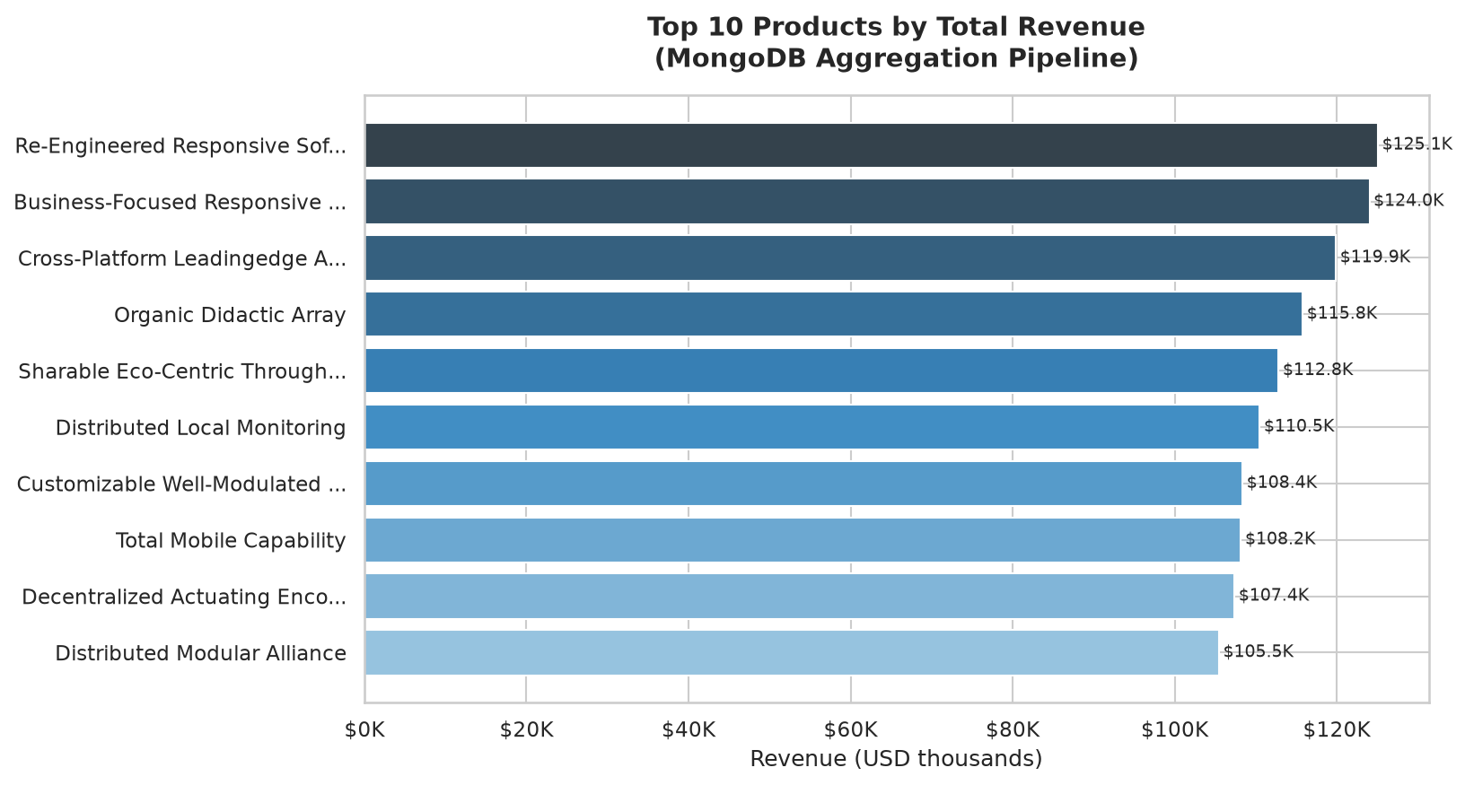

Chart 2 — Monthly Revenue Trend (Spark SQL Analytics)
The March-to-April jump from $1.55M to $5.93M represents the platform's 90-day window becoming fully active. Average order value remains stable ($891–$915) across all months. June shows a partial-month decline, annotated accordingly.
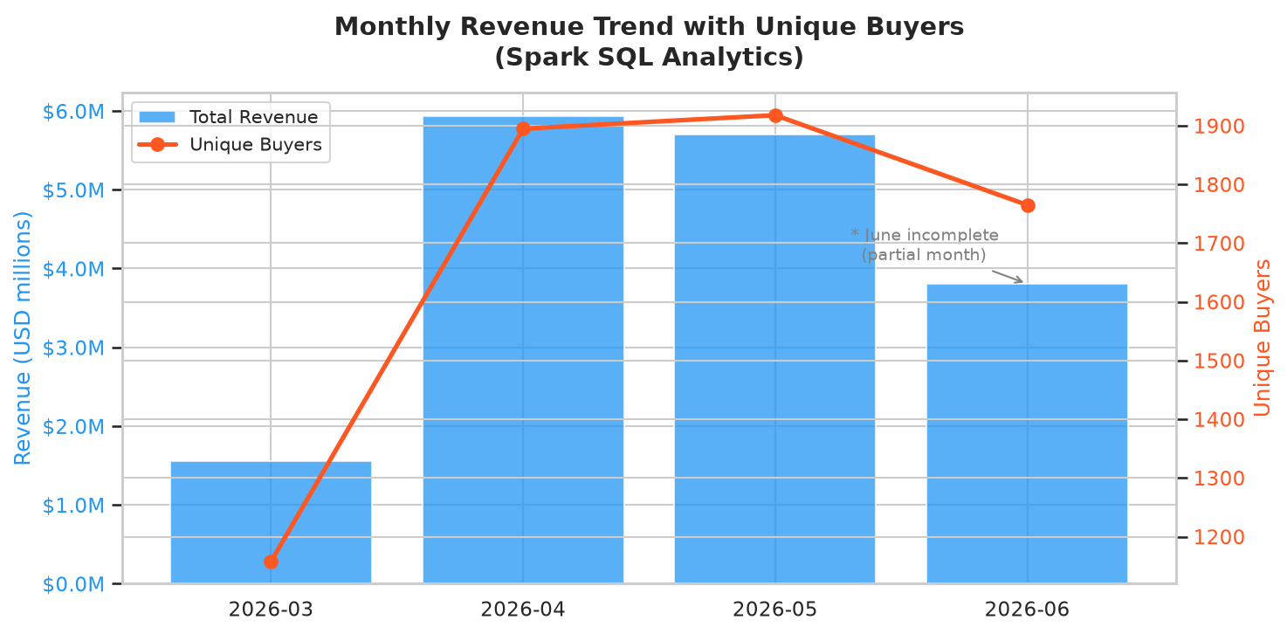

Chart 3 — CLV Customer Segmentation (MongoDB + Spark Integration)
The near-equal four-tier distribution (521/497/496/486 users) confirms the percentile-based segmentation worked correctly. The right panel shows a clear positive correlation between CLV tier, average spend, and conversion rate — validating that combining MongoDB financial data with session behavioral data captures real differences between customer groups.
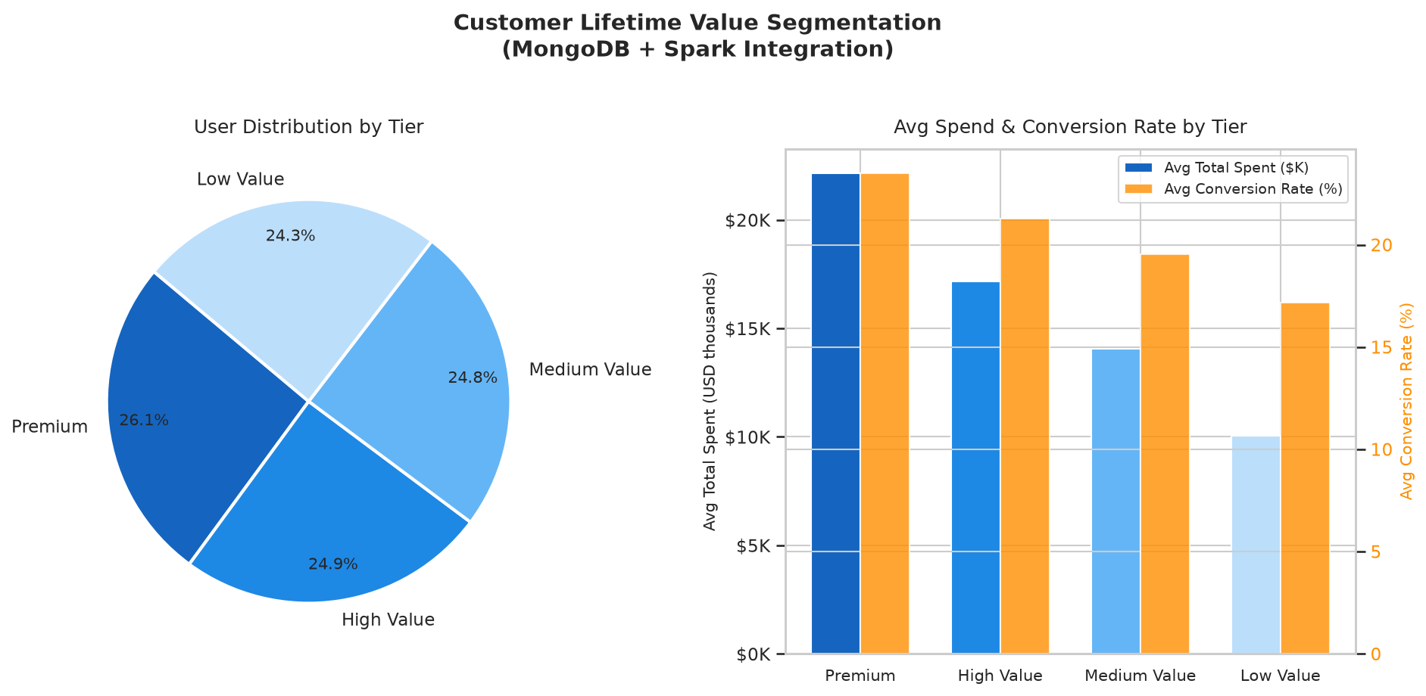

Chart 4 — Conversion Rate Heatmap (Spark SQL — Session Funnel Analysis)
The tight range (19.4%–21.3%) across all 15 device-type x referrer combinations shows the platform converts uniformly across channels. Mobile+affiliate leads at 21.33%. This suggests the product and pricing experience is consistent regardless of acquisition channel.
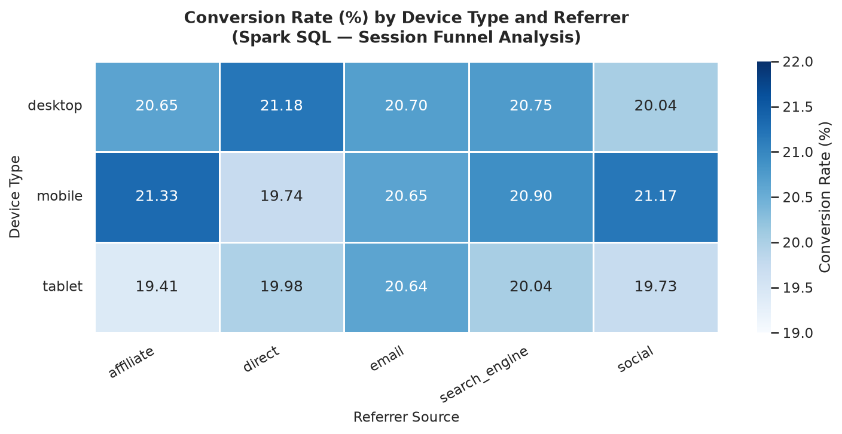

6. Scalability Considerations

MongoDB
Scales horizontally via MongoDB's native sharding. Natural shard key for transactions is user_id + timestamp (already indexed), distributing write load evenly. The embedded purchase_summary reduces read fanout — adding shards does not increase per-query latency for user segmentation.

HBase
Purpose-built for horizontal scaling — adding region servers distributes both tables. The reverse-timestamp row key avoids the hotspot problem: each user's sessions are prefixed by user_id, distributing writes across the keyspace. At 10x scale the same schema handles load by pre-splitting regions on user_id ranges.

Apache Spark
Scaling to a cluster requires only changing .master('local[*]') to a YARN or Kubernetes cluster URL — no code changes. The shuffle partition count should increase to 2-3x cluster cores. The product affinity self-join benefits from broadcast hints for the smaller products DataFrame at scale.

7. Limitations and Future Work

Limitations
- Dataset is synthetic: real e-commerce data has skewed distributions (power-law product popularity, seasonal spikes) not present in Faker-generated data
- HBase binary download failed due to network restrictions on the development machine; schema design, loading scripts, and query logic are complete and correct
- CLV formula uses fixed weights (60/20/20); a production system would calibrate these using historical churn/retention data
- User segmentation skews toward frequent buyers (1,764 of 2,000 users have 11+ orders) due to the synthetic generator's conversion logic

Future Work
- Add real-time streaming via Apache Kafka to ingest live session events and update HBase product_metrics rows incrementally
- Implement collaborative filtering (ALS in Spark MLlib) on the product affinity matrix for full recommendations
- Connect MongoDB Atlas and Google Bigtable for true cloud-scale deployment with managed infrastructure
- Extend CLV model with churn prediction using Spark ML gradient boosting on behavioral features already computed

8. Conclusion
This project demonstrated a complete multi-model analytics pipeline combining MongoDB, HBase, and Apache Spark on a synthetic 100,000-session, 30,000-transaction e-commerce dataset. The key architectural insight is that no single technology is universally best: MongoDB excels at rich nested document reads and aggregation, HBase at high-volume sparse time-series storage with efficient range scans, and Spark at cross-system joins and distributed computation that neither database can perform alone.

The integrated CLV analysis directly demonstrated this: MongoDB provided the financial ground truth, session data provided behavioral signals, and Spark joined both to produce a 4-tier customer segmentation with measurable differences in conversion rate — 23.51% for Premium vs 17.18% for Low Value. This result was impossible to produce from any single system in isolation.

All code was written and executed by the author on a WSL2 Ubuntu 24.04 environment with MongoDB 8.0.26 and PySpark 4.1.2.

