Portable Polarization: Partisan Identity, Expressive Attitudes, and COVID-19 Health Behavior

Abstract

Introduction
That COVID-19 health behaviors became politically polarized is well established (Gadarian, Goodman, and Pepinsky 2021; Allcott et al. 2020; Clinton et al. 2021). Less clear is whether these differences persist after accounting for factors that covary with partisanship, such as differences in mask-mandate policy, geographic, and/or pandemic severity contexts and perceptions of them. This distinction has direct, quantifiable implications for disease spread: behavioral gaps that are independent of these factors represent a source of heterogeneity that may warrant incorporation into transmission modeling. We use individual-level behavioral data from the Berkeley Interpersonal Contact Study (BICS) to adjudicate between these competing explanations.

Methods
BICS is a nationally representative survey conducted across six waves from April 2020 to May 2021 (N = 18,233) that includes detailed counts of daily face-to-face contacts and mask usage during specific interactions. Individual survey responses are linked to county-level COVID-19 incidence and mortality rates, congressional district partisan composition, and county mask mandate status. Survey weights are raked on party identification to match national Gallup targets. We use regression models to examine whether partisan associations persist within shared policy environments, geographic regions, levels of stated concern, and local partisan compositions.

Results
Republicans reported more daily contacts than Democrats across all six waves (adjusted wave-pooled gap: 1.2 contacts/day), had substantially lower vaccine acceptance in Wave 6 (68.4% vs. 87.5%), and wore masks at consistently lower rates. While the contact gap narrowed substantially during the winter 2020–21 mortality surge — falling to 0.3 contacts/day in February 2021 — the partisan gap in mask usage widened monotonically from 4.9 to 10.9 percentage points, showing no compression during mortality peaks. At its widest, the mask gap exceeded cross-group differences by race, gender, or education. Mask usage was also the most context-sensitive behavior: Republicans in Democrat-majority districts wore masks at higher rates than their co-partisans in Republican-majority areas, yet Democrats shifted upward in Democrat-majority contexts as well, leaving the partisan gap intact.
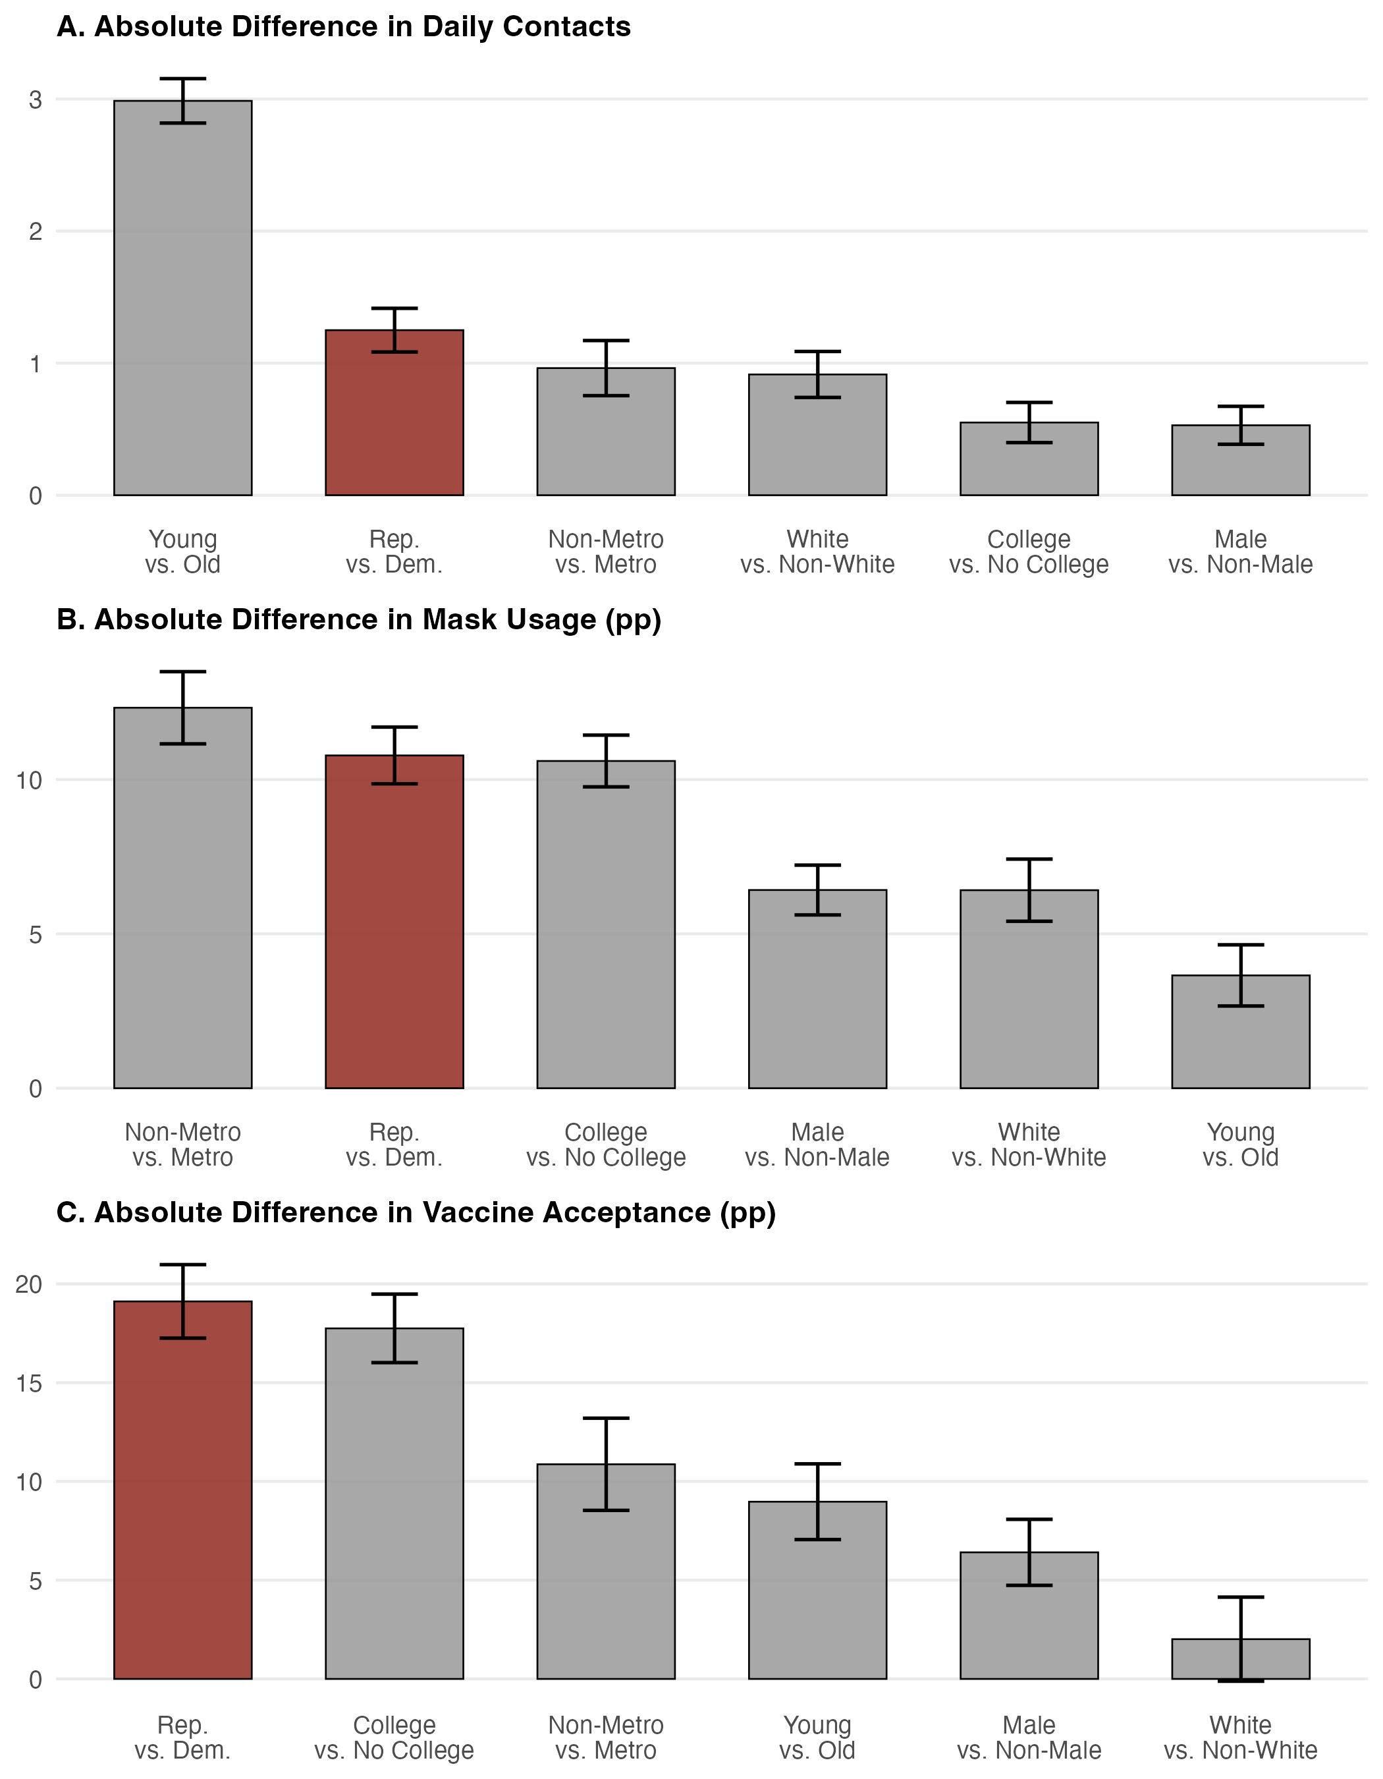
Absolute unadjusted differences in daily contacts (A), mask usage (B), and vaccine acceptance (C) by group. The partisan gap (red) is shown alongside gaps by age, urbanicity, race/ethnicity, education, and gender. Bars are ordered from largest to smallest gap within each panel. Error bars = ±1 SE.

Discussion
These patterns are consistent with theoretical accounts in which partisan identity structures health behavior independent of policy, place, and demography. The temporal trajectories are telling: contact gaps were smallest at peak mortality, while the mask gap widened monotonically regardless of local conditions, consistent with masking functioning as a publicly legible group marker subject to identity costs (Goffman 1963). During the winter 2020–21 surge, Republicans reported their lowest concern levels yet reduced contacts substantially, while the mask gap continued to widen, consistent with expressive responding shaping stated concern (Clinton et al. 2021). That these gaps rival those by race, gender, and education and persist across policy environments, geographic contexts, and demographic controls points to partisan identity as a robust correlate of COVID-19 health behavior with implications for health inequality and partisan polarization.
Word count: 528
Allcott, Hunt, Levi Boxell, Jacob Conway, Matthew Gentzkow, Michael Thaler, and David Yang. 2020. “Polarization and Public Health: Partisan Differences in Social Distancing During the Coronavirus Pandemic.” Journal of Public Economics 191 (November): 104254. https://doi.org/10.1016/j.jpubeco.2020.104254.
Clinton, J., J. Cohen, J. Lapinski, and M. Trussler. 2021. “Partisan Pandemic: How Partisanship and Public Health Concerns Affect Individuals’ Social Mobility During COVID-19.” Science Advances 7 (2): eabd7204. https://doi.org/10.1126/sciadv.abd7204.
Gadarian, Shana Kushner, Sara Wallace Goodman, and Thomas B. Pepinsky. 2021. “Partisanship, Health Behavior, and Policy Attitudes in the Early Stages of the COVID-19 Pandemic.” PLOS ONE 16 (4): e0249596. https://doi.org/10.1371/journal.pone.0249596.
Goffman, Erving. 1963. Stigma: Notes on the Management of Spoiled Identity. Englewood Cliffs, NJ: Prentice-Hall.

