Lute Guitar Care Instructions

A lute guitar is not the same as a regular contemporary acoustic guitar, and requires different care.

Failure to follow these instructions may result in the destruction of your instrument.

Rule 1. Use correct strings.

NEVER use steel or high tension strings, especially those meant for steel-string acoustic guitars. Those will destroy the instrument.

Always use medium to low tension nylon or gut strings.

A string log with a history of past string recommendations has been included. I've found that Savarez KF50, KF64, and KF81 work best for the top three treble strings, while the Pyramid 1013, 1022, and 1034 work best for the low three bass strings.

In general, strings designed for lutes, not guitars, perform better on this instrument. However, any low to medium tension standard set of nylon guitar strings should work.

Tie a simple stopper knot at the bridge end of the string if the string does not have a ball end. Refer to the included diagram on how to tie a stopper knot.

When not in use or during travel, it's recommended to tune down the strings by a few steps, to reduce tension on the neck.

Rule 2. Control temperature.

Keep it in an area with approximately room temperature, 72 degrees.

Never leave it in a hot car. This will destroy the instrument. Even on a cool day, car temperatures will soften glues and cause the wood and glue to warp, resulting in a bowed neck or detached bridge.

Think of it like a pet or small child. Never leave it where you wouldn't leave one of those.

Rule 3. Control humidity.

Keep it in an area between 45%-75% humidity.

Excessive dryness could cause the wood to shrink and crack.

Excessive dampness could cause the wood to swell and buckle.

It's recommended to use a chemical humidity control pack in the case to maintain correct humidity while stored. Note, these packs only last for about 6-12 months. If you replace the pack, record the date when you opened it on the pack so you know when to change it in the future.

Rule 4. Maintain stability.

Due to its round back, a lute guitar may roll or slide more when left unattended or leaning against something.

To lessen the chance of the guitar sliding and being damaged, when not in use, always keep it in its case or in a guitar stand with neck support. DO NOT leave it leaning against a wall or furniture.

Rule 5. Repairing finish.

The finish is common shellac. If you ever scratch or damage the finish, it can easily be repaired by any competent luthier with experience in shellac.

These instruments were usually played with bare fingers, so there's no pick guard.

If you do play with a pick, it's recommended to apply a cling-on clear plastic soundboard protector in the pick area, commonly used with classical guitars, to prevent the pick from scratching the soundboard.

Rule 6. Rose removal.

This lute guitar has had its rose modified to allow for optional removal.

This greatly simplifies care and maintenance, like inspecting the bracing or changing the pickup, as otherwise the soundboard would have to be removed, which can prohibitively expensive.

However, the rose is still a delicate hand carved piece of wood and must be treated carefully to prevent damage.

A special tool has been included to help with removing the rose.

To remove the rose:

Step 1: Place the guitar in a position where it will not roll around. The case is a suitable location.



Step 2: Gently place the included rose removal tool into the rose, parallel to the bridge, so that the tool's four tabs slide into cutouts in the rose. You do not need to remove the strings.

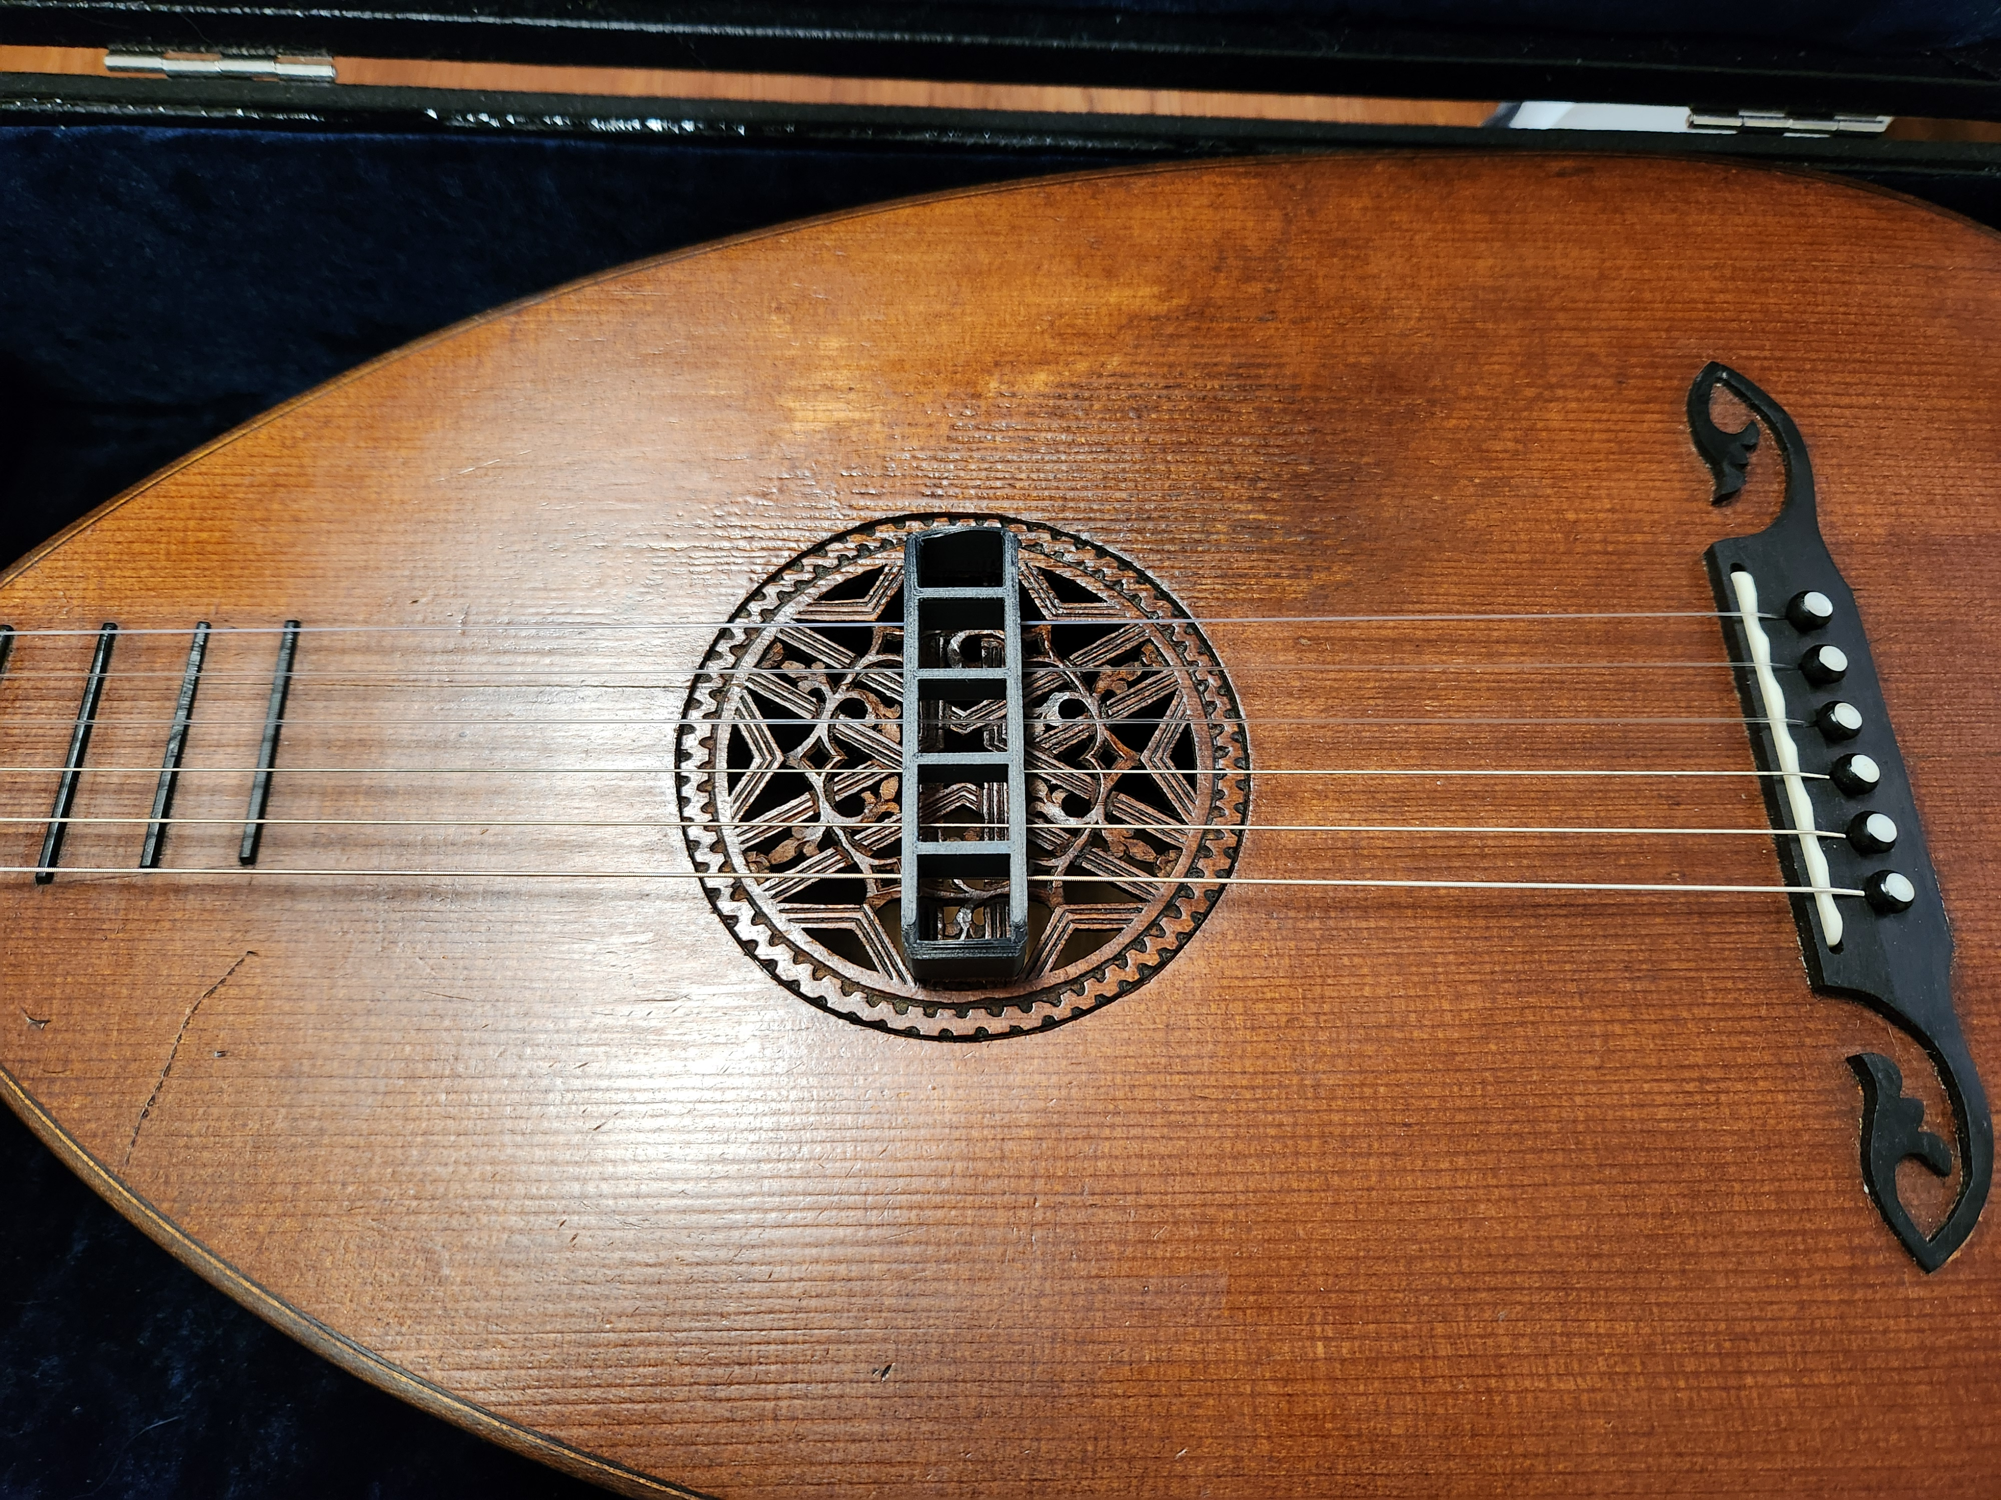
Step 3: Using the tool as a handle, gently turn it counter-clockwise about 10 degrees to release the rose.

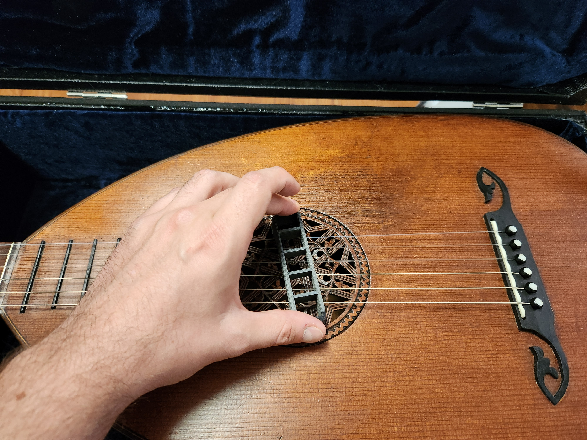

Step 4: Using the tool as a lever, carefully use it to lift the rose out just enough to grab it with your fingers and then slide it out from under the strings.

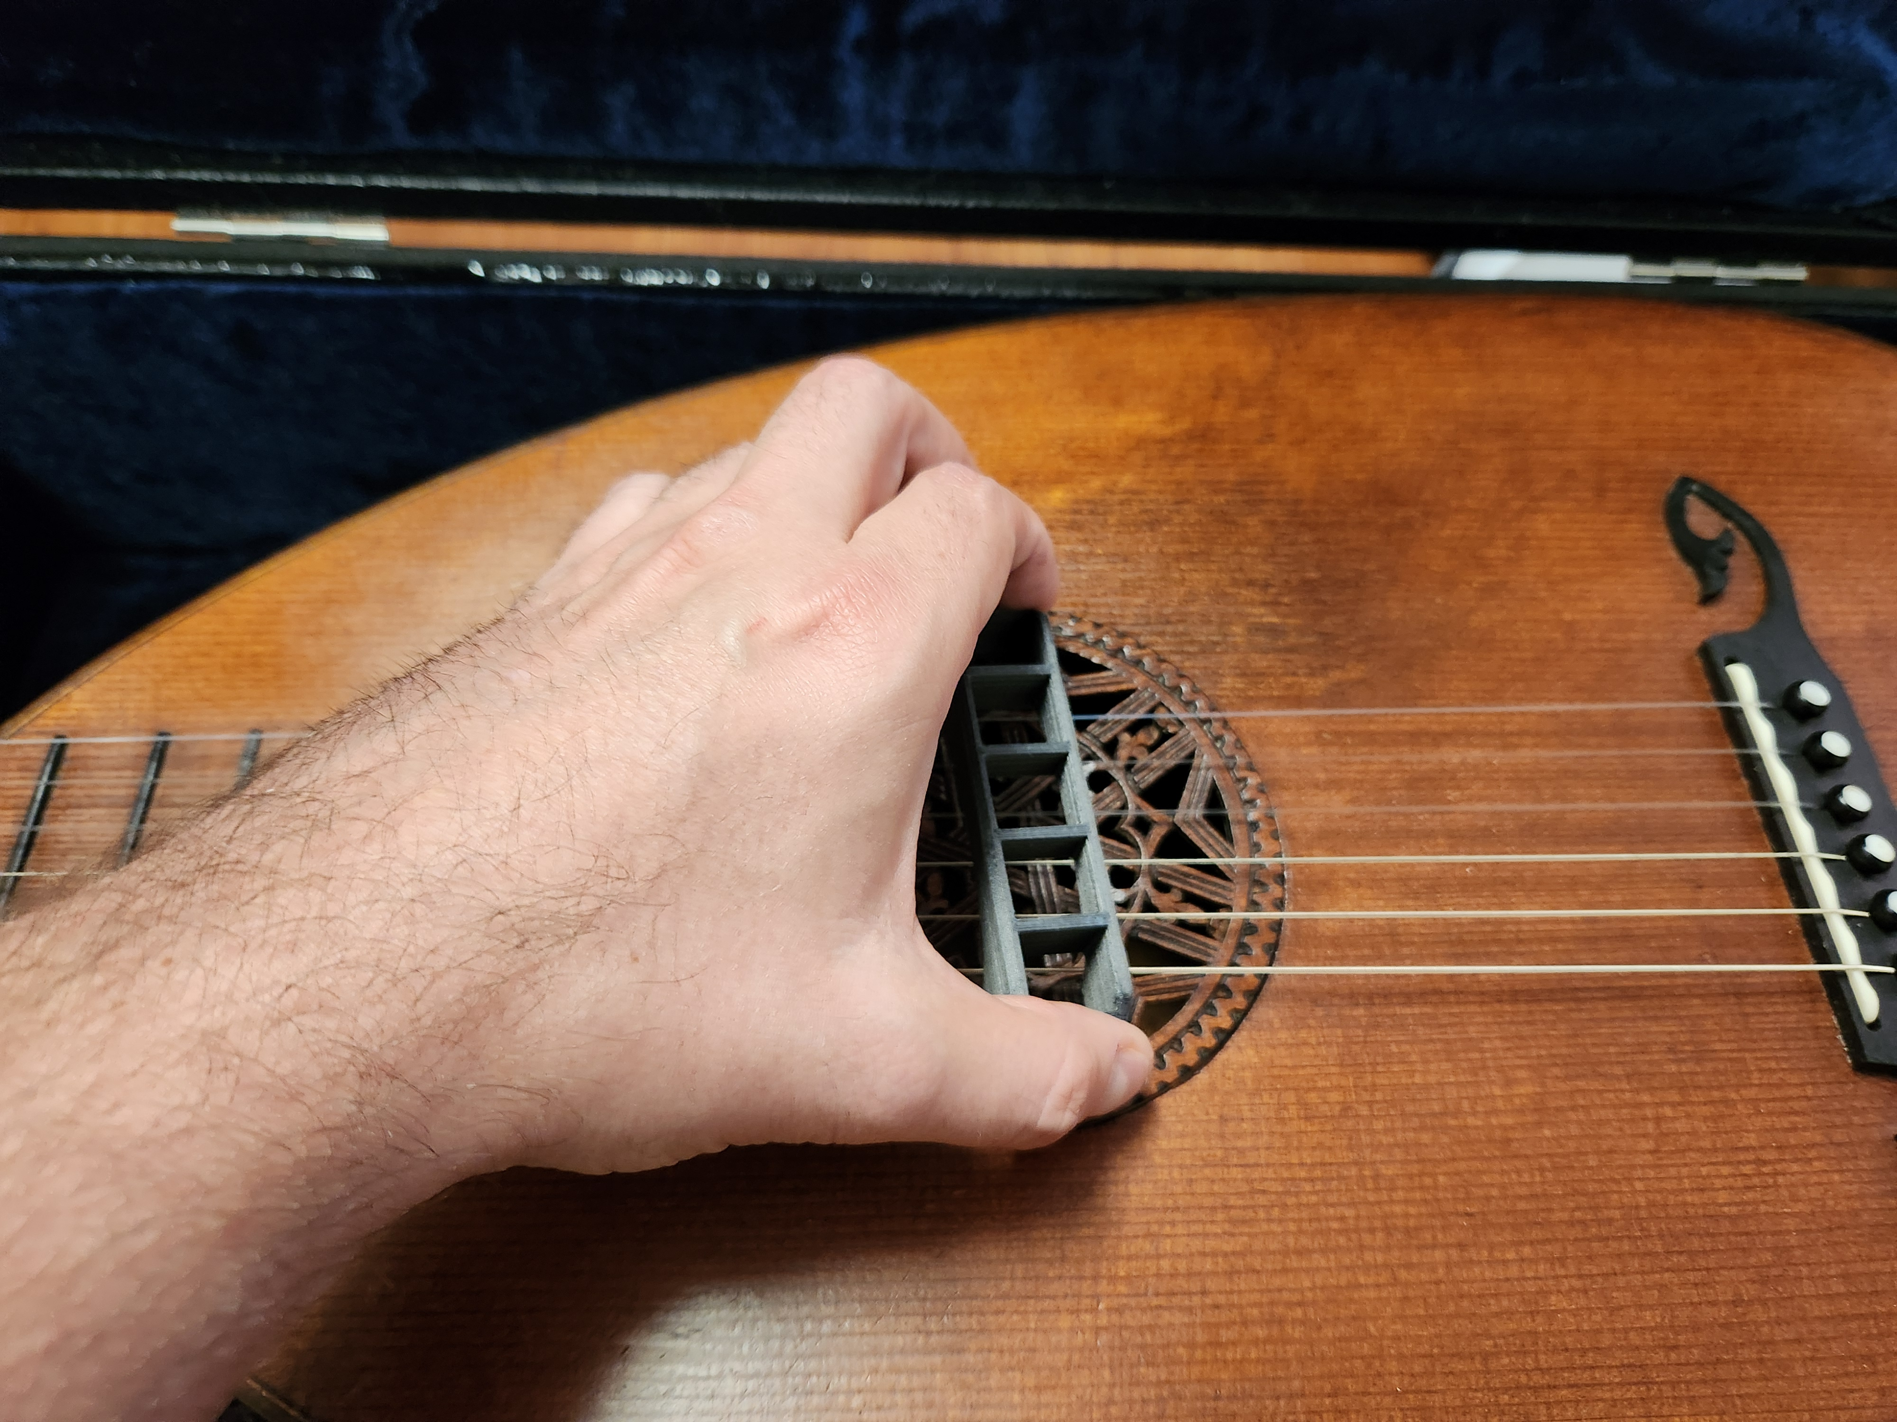

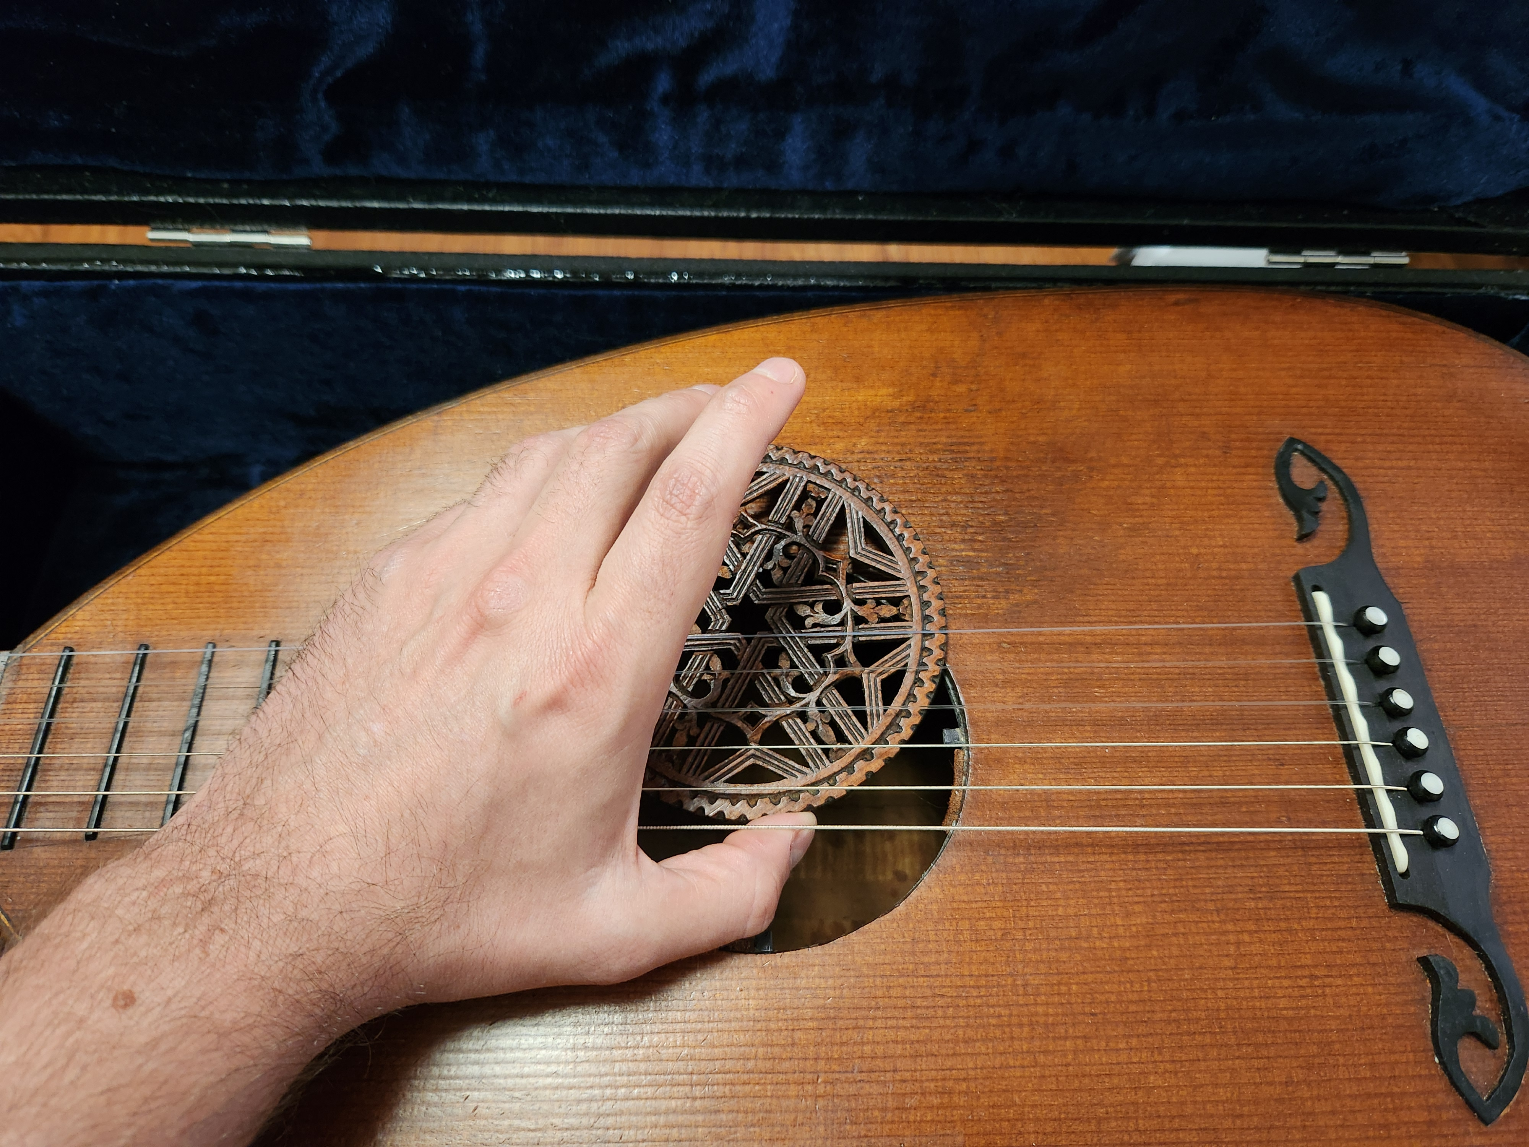

Step 5: When the rose is not inserted, place it in the storage bag and place the bag in the lower storage compartment containing the strings and string log. Do not place any hard items in that compartment that could bang around and damage the rose.

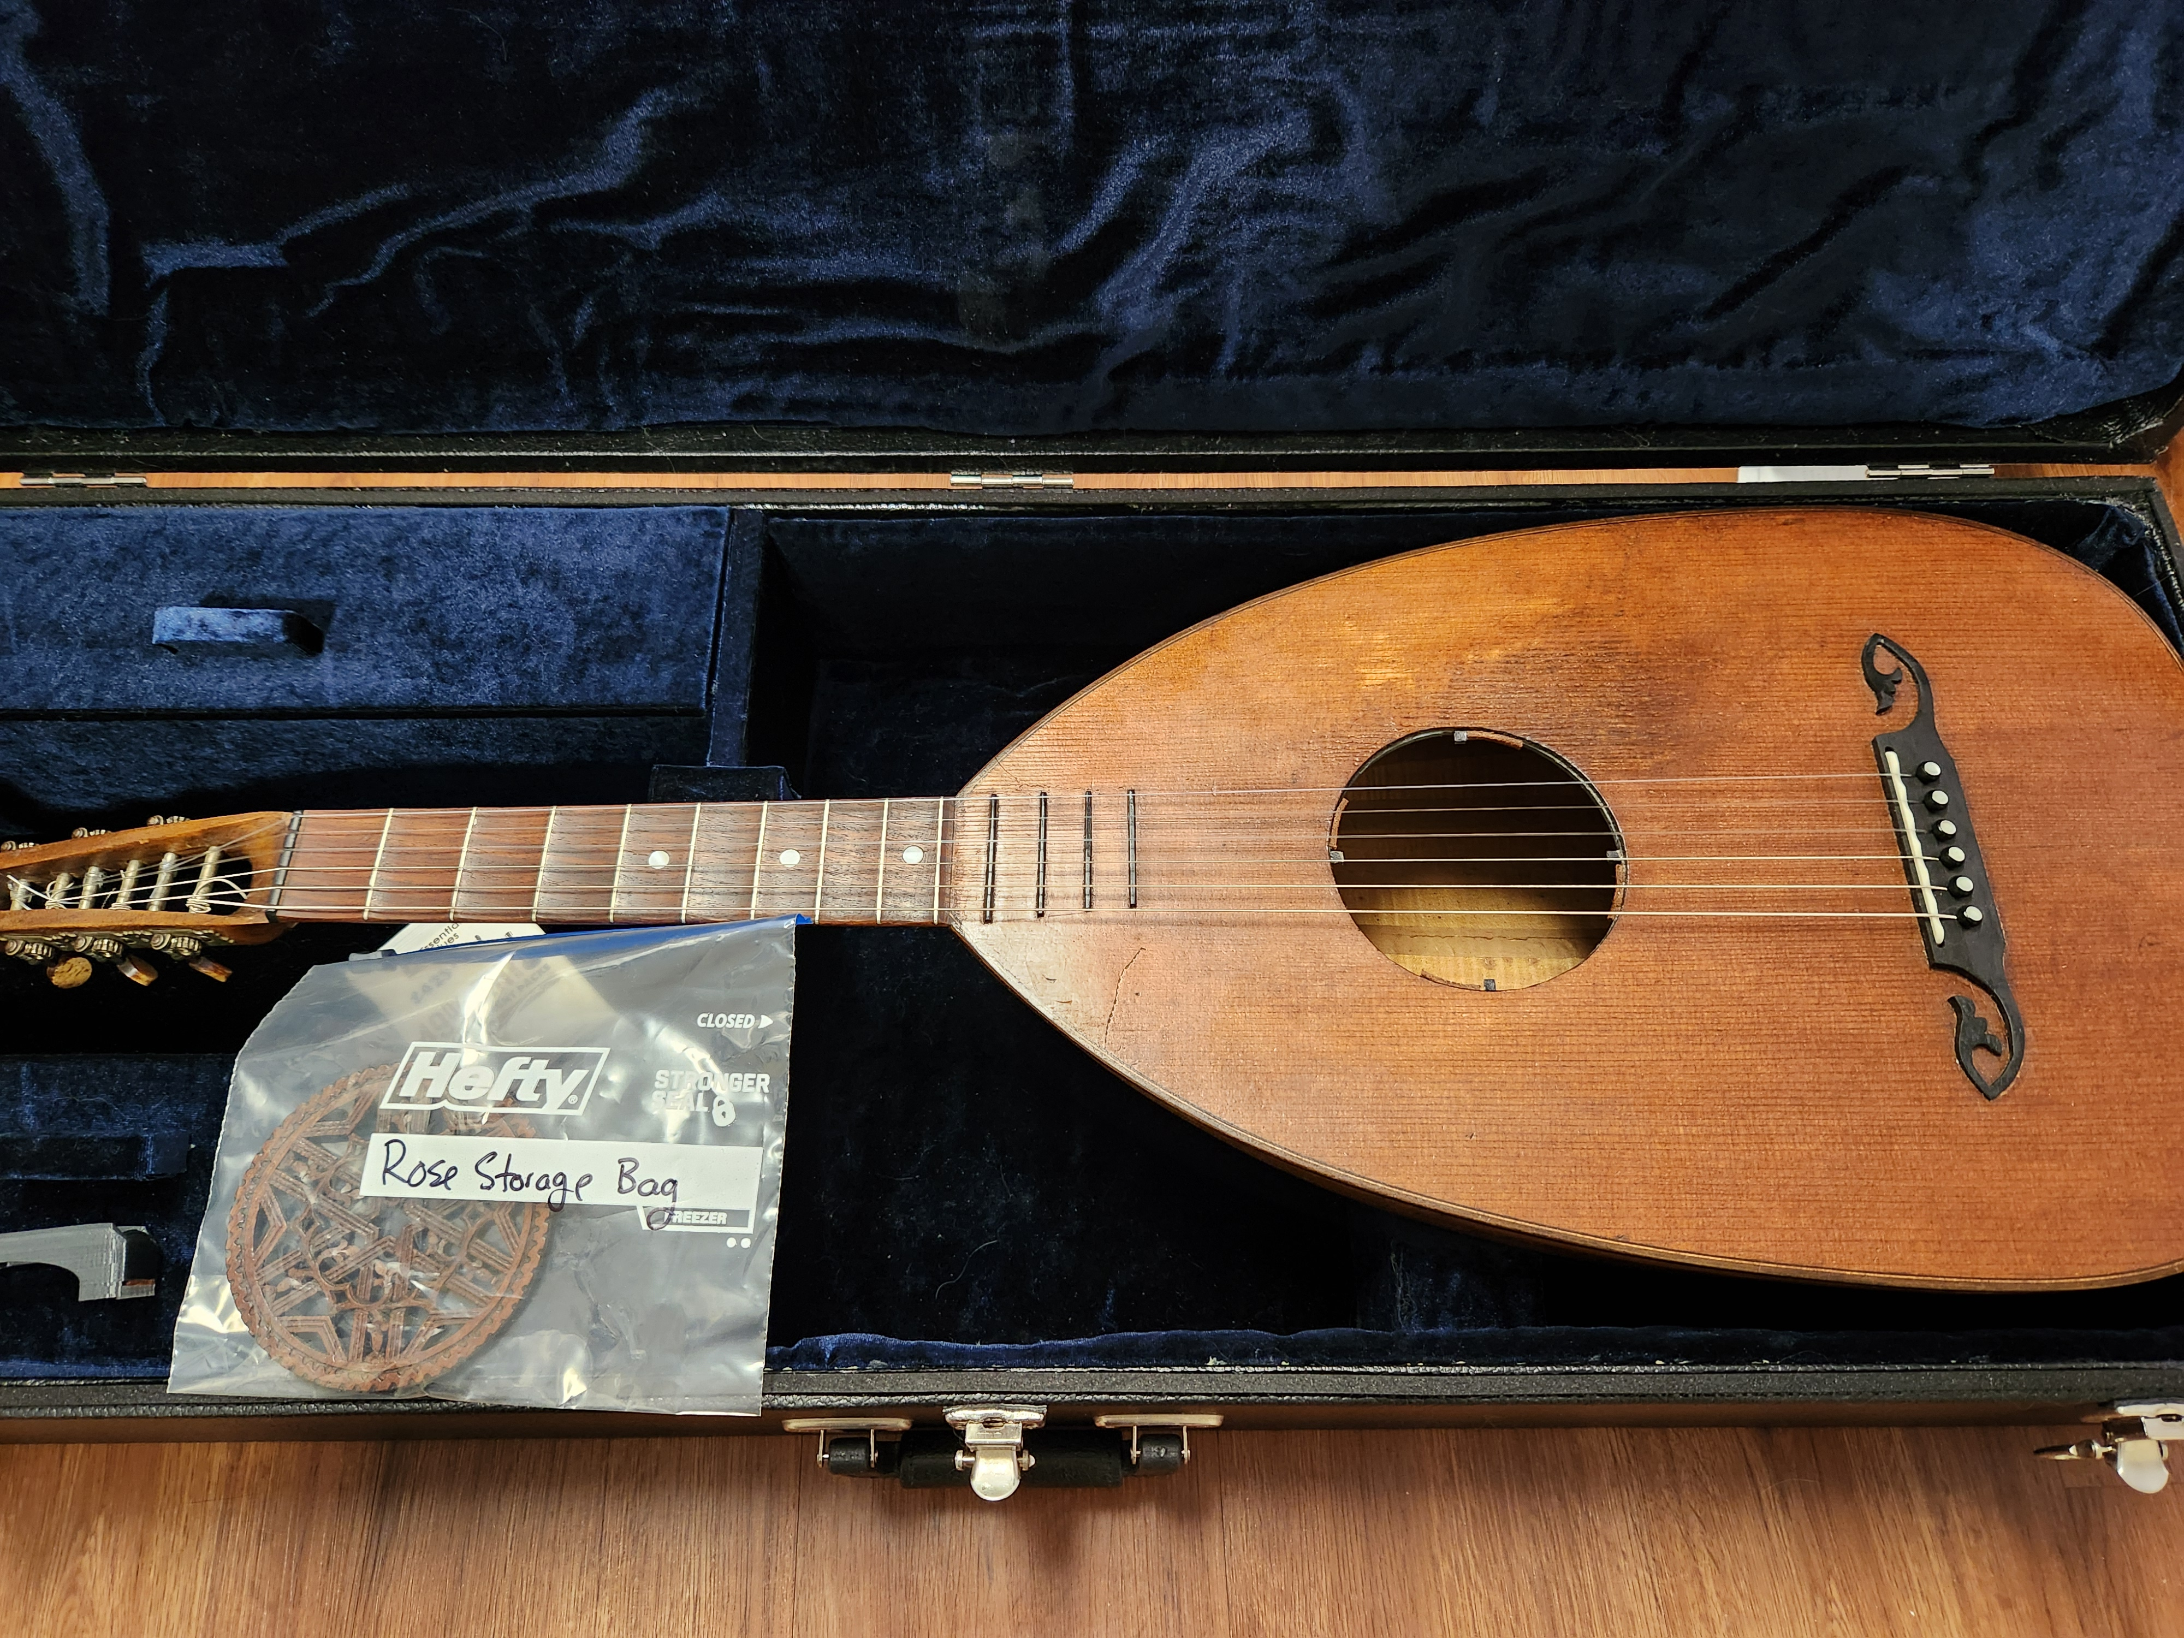

Step 6: To reinsert the rose, follow these instructions in reverse. Note that the rose is directional and must be reinserted in the same position as you removed it. Inserting it at a different angle may damage it. Since the rose was carved from the soundboard, the wood grain should match once in place. There are also arrows on the underside of the rose to indicate the direction to insert. When correctly inserted, these arrows should be pointing directly to the neck.



