**IISE Budget Request Tracker Guide**

**To enter the app, visit** [**https://iise-budget-tracker.herokuapp.com/**](https://iise-budget-tracker.herokuapp.com/)

**On the Home page, you can view most functionality, but you will need to Sign in to access the features**

* Click **Sign In** on the banner at the top right, or attempt to interact with a specific request to be prompted to sign in.
* View provided information for credentials.

**General:**

* Once signed in, the features below become available. Features only available for those with Administrator privileges are denoted (Admin).
* From any page, you can return to the Home page by clicking Home on the top banner.
* If you wish sign out or change your password, please go to the Home page to do either of those things.

**Creating a request:**

* From the home page, click **Create New Budget Request**, either on the top banner or under the Budget Request section.
* You will be brought to a form, which requires that you fill out the form fields.
* After creating the request, you will be redirected to the Items page, where you **must** fill in the individual costs, quantities, and types of the items on your receipt.
* If you find that you’ve made a mistake in typing out any of the form fields, you can go back and edit the items or the budget request on the home screen with **Edit** or **Add Items**

**Removing a request:**

* Once you are done with a request or it is no longer necessary, press **Remove** to delete the budget request from the home page.
* This action is final, without prompt, and cannot be undone, but records from previous downloads (Excel or PDF) will remain in-tact.

**Filtering and sorting:**

* In order to organize the view of the budget requests, filtering and sorting options are available to you.
* **Sorting** can be adjusted by Date, Status, or Individual name in ascending order.
* **Filtering** will take all requests with a particular Request Description and display those

**(Admin) Managing other members:**

* In order to manage other member accounts, you must first be signed in to an admin account
* Then from the home page, add “/admin” to the end of the URL to navigate to the admin dashboard.
  + URL should then be [**https://iise-budget-tracker.herokuapp.com/admin**](https://iise-budget-tracker.herokuapp.com/admin)
* Click the “Users” Tab on the left side of the page to view a list of all current users
* In this page there is an “+ Add New” button to create a new account, along with edit and delete buttons on the right side of each listed account

**(Admin) Changing the status of a request:**

* From the Home page, click **Edit** on a specific request.
* Scroll down to status, and make your selection, then submit the form.
  + Our intention for the statuses is as follows, feel free to change and clarify within the organization:
    - Submitted – the only option for officers when submitting a form
    - Processing – The information has been passed to SOFC and is awaiting reimbursement
    - Processed – SOFC has approved the request for reimbursement and has either paid, or soon will pay, the student. This distinction can reflected in the comments.
    - Needs Review – Accompanied with comments, this option lets the officer know that there may need more clarification for the Request Description, there might be typos, or some other issue.
    - Denied – The request has been denied, either within IISE or by SOFC.
* You can choose to make comments for any reason on the form in the Edit functionality above the status option.

**(Admin) Exporting to PDF for SOFC:**

* From the **Home** page, click **Details** on a specific request.
* Scroll to the bottom and click “**Download Request**”.
* On windows, it should prompt where to save the PDF, on Mac it will automatically download in the Downloads folder.

**(Admin) Exporting to Excel:**

* From the **Home** page, click the **Export to Excel** button (this will only appear when Signed in) on the bottom of the screen to send budget request data to an xlsx file.
* On Windows, it should prompt where to save the PDF, on Mac it will automatically download in the Downloads folder.

**(Admin) Adjusting budget balance:**

* You can adjust the balance of the organization by clicking the **Set/Change/Clear Max Balance** buttons from the Home page. It will bring you to a page where you will be able to adjust the current balance of the organization.
  + **Set** **Max Balance** will only appear the first time you set the initial budget balance. After that, the buttons of **Change Max Balance** and **Clear Max Balance** will appear instead.
* The balance will be reflected at the top of the website after calculations from the budget requests.

**Heroku Documentation**

1. Transfer of application to another Heroku account, in the event that the member is no longer with the organization.

You can transfer applications between Heroku accounts or to a team of which you are a member at any time. Apps can be transferred to a collaborator on the app. If the user is not a collaborator, first add them as a collaborator. If you can’t see the team that you want to transfer the app to, then you must ask the team admin to add you to the team.

To initiate the transfer of the application using the Dashboard:

1. In Dashboard, click the Settings tab of the application.

2. Scroll down to the Transfer Ownership section.

3. Click the Select a new owner field. The list of people who are collaborators on the app and the list of Teams and Organizations to which you belong will be displayed.

4. If you don’t see the person you want to transfer the app to, then you must first add them as a collaborator. If you can’t see the team that you want to transfer the app to, then you must ask the team admin to add you to the team.

5. Select an item from the list.

6. Click Transfer.

Accept transfer

The new owner can receive the transfer by accepting the pending transfer request at the top of the dashboard, once it’s initiated:

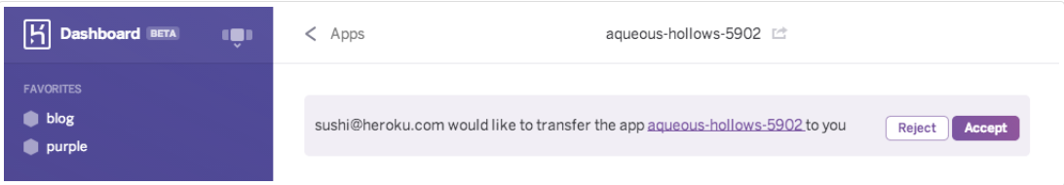

As the new owner, you will have the option to accept or decline all transfer requests. If the app has an ongoing cost, such as paid add-ons or dynos, then you will be asked to enter in a credit card before accepting, if you haven’t done so already.

2. Recovering / restarting the application in the event it crashes or is consistently slow or how to reach Heroku support.

In case you are experiencing this type of problems follow these steps:

* Log in to Heroku and click on your app from the home page click on your app -> click on your app name again -> click More button -> restart all Dynos.

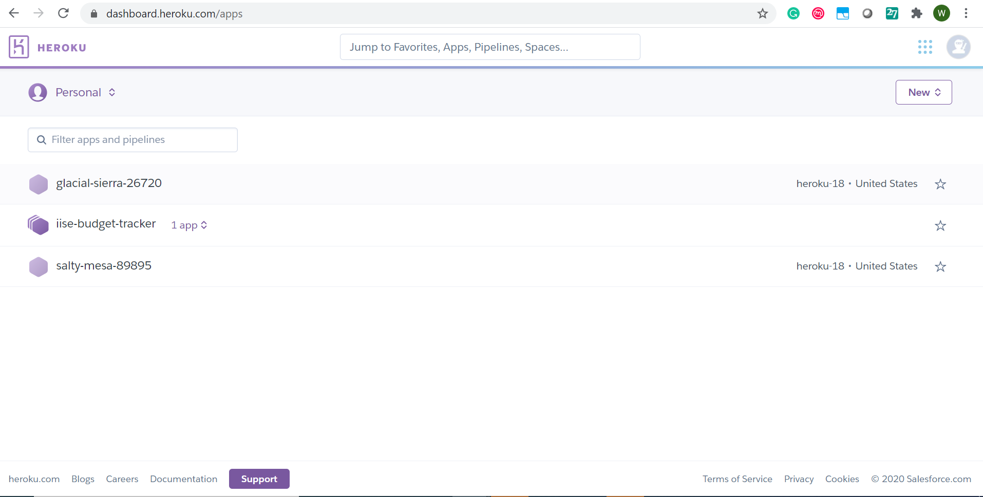

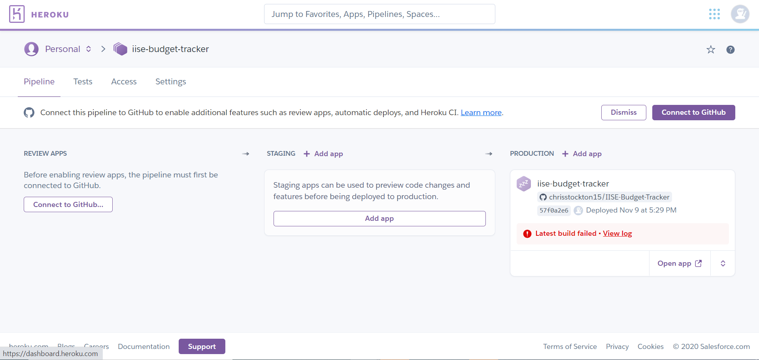

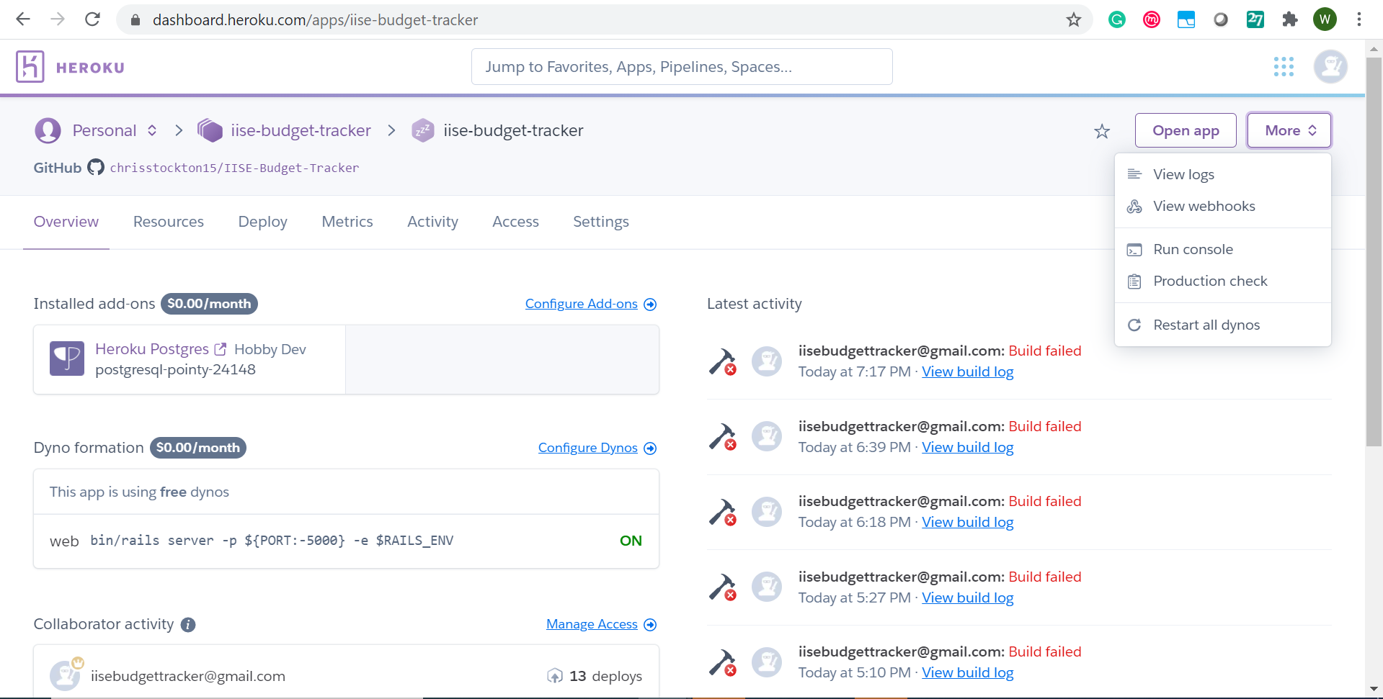

3. Details on how often we need to backup the data.

You should not be worried about this as long as you export the excel reports from the app weekly. The data comes directly from the app database.

4. Backing up the data using Heroku functionality and restoring.

Go to the following website and download Heroku for your system: <https://devcenter.heroku.com/articles/heroku-cli>

Now open the command line on your system:

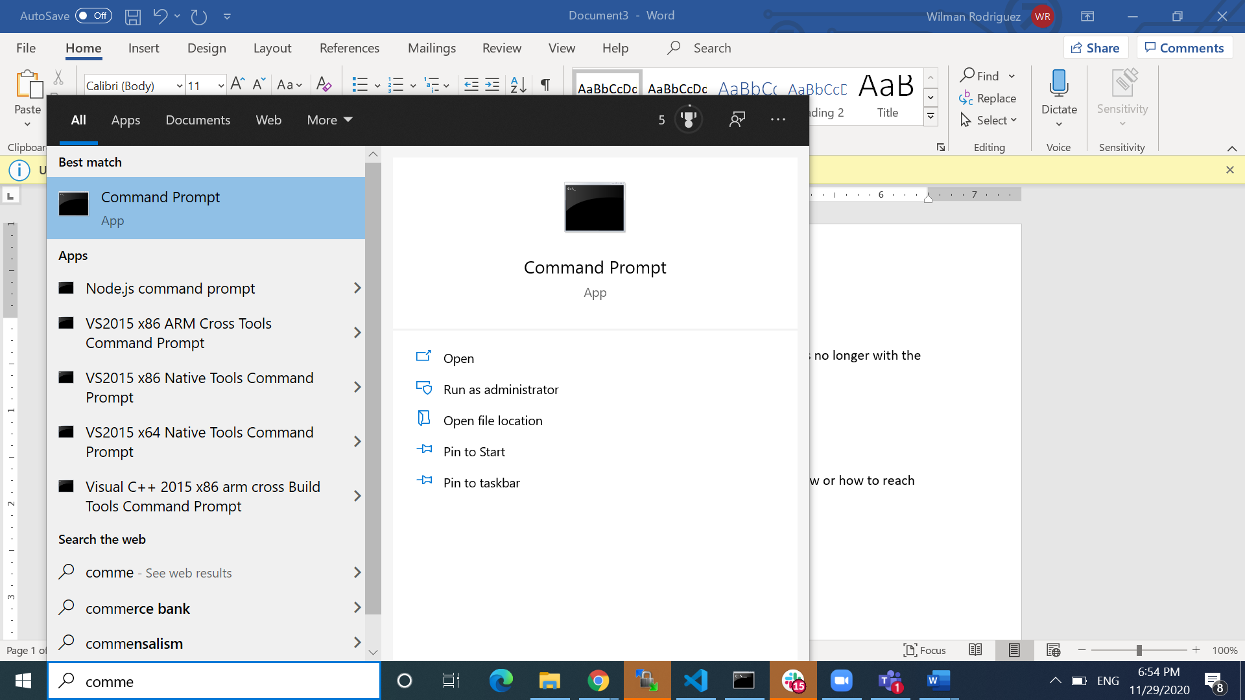 This is what it looks like in Windows.

Type Heroku login and enter account credentials.

After login in you are ready to backup the data. Type the command below: (use iise-budget-tracker instead of sushi for the app name)

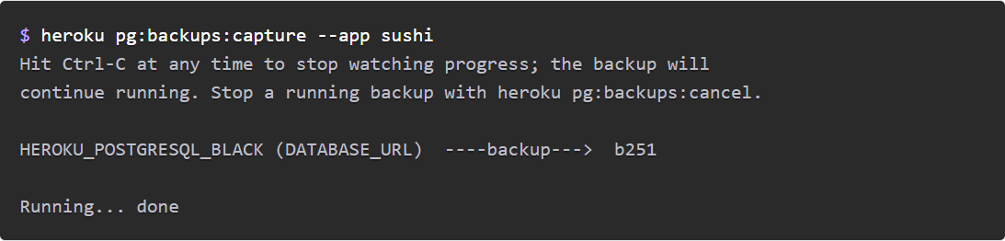

The code b251 is what you will need to restore the database using the command below: (b101 represents the backup you want to restore, if you want the one created before then substitute b101 for b251)



For more info: https://devcenter.heroku.com/articles/heroku-postgres-backups

5. Creating a local backup and restoring (e.g., export/import).

Please check the following website and follow the instructions in the command line after login in as in the previous item:

<https://devcenter.heroku.com/articles/heroku-postgres-import-export>

Export:



Restore:

