AI

Topics

Agents and types, AI architecture, performance measures,arrays,linked list , graph problems like degree and finding cycles. Searching a node in graph (example tic tac toe , 8 puzzle, state spce search tree , random search, dfs , Bfs ,dls

**Agents in Artificial Intelligence**

In artificial intelligence, an agent is a computer program or system that is designed to perceive its environment, make decisions and take actions to achieve a specific goal or set of goals. The agent operates autonomously, meaning it is not directly controlled by a human operator.

Agents can be classified into different types based on their characteristics, such as whether they are reactive or proactive, whether they have a fixed or dynamic environment, and whether they are single or multi-agent systems.

* Reactive agents are those that respond to immediate stimuli from their environment and take actions based on those stimuli. Proactive agents, on the other hand, take initiative and plan ahead to achieve their goals. The environment in which an agent operates can also be fixed or dynamic. Fixed environments have a static set of rules that do not change, while dynamic environments are constantly changing and require agents to adapt to new situations.
* Multi-agent systems involve multiple agents working together to achieve a common goal. These agents may have to coordinate their actions and communicate with each other to achieve their objectives. Agents are used in a variety of applications, including robotics, gaming, and intelligent systems. They can be implemented using different programming languages and techniques, including machine learning and natural language processing.

Artificial intelligence is defined as the study of rational agents. A rational agent could be anything that makes decisions, such as a person, firm, machine, or software. It carries out an action with the best outcome after considering past and current percepts(agent’s perceptual inputs at a given instance). An AI system is composed of an **agent and its environment**. The agents act in their environment. The environment may contain other agents.

An agent is anything that can be viewed as:

* Perceiving its environment through **sensors** and
* Acting upon that environment through **actuators**

***Note****: Every agent can perceive its own actions (but not always the effects).*

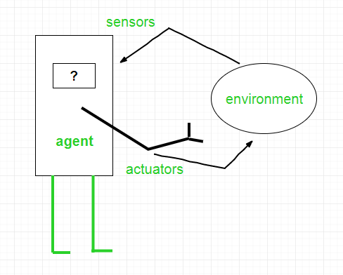

*Interaction of Agents with the Environment*

**Structure of an AI Agent**

To understand the structure of Intelligent Agents, we should be familiar with *Architecture* and *Agent*programs. **Architecture** is the machinery that the agent executes on. It is a device with sensors and actuators, for example, a robotic car, a camera, and a PC. **An agent program** is an implementation of an agent function. An **agent function** is a map from the percept sequence(history of all that an agent has perceived to date) to an action. 

*Agent = Architecture + Agent Program*

There are many examples of agents in artificial intelligence. Here are a few:

* **Intelligent personal assistants:**These are agents that are designed to help users with various tasks, such as scheduling appointments, sending messages, and setting reminders. Examples of intelligent personal assistants include Siri, Alexa, and Google Assistant.
* **Autonomous robots:**These are agents that are designed to operate autonomously in the physical world. They can perform tasks such as cleaning, sorting, and delivering goods. Examples of autonomous robots include the Roomba vacuum cleaner and the Amazon delivery robot.
* **Gaming agents:**These are agents that are designed to play games, either against human opponents or other agents. Examples of gaming agents include chess-playing agents and poker-playing agents.
* **Fraud detection agents:**These are agents that are designed to detect fraudulent behavior in financial transactions. They can analyze patterns of behavior to identify suspicious activity and alert authorities. Examples of fraud detection agents include those used by banks and credit card companies.
* **Traffic management agents:**These are agents that are designed to manage traffic flow in cities. They can monitor traffic patterns, adjust traffic lights, and reroute vehicles to minimize congestion. Examples of traffic management agents include those used in smart cities around the world.
* A **software agent** has Keystrokes, file contents, received network packages that act as sensors and displays on the screen, files, and sent network packets acting as actuators.
* A Human-agent has eyes, ears, and other organs which act as sensors, and hands, legs, mouth, and other body parts act as actuators.
* A **Robotic agent** has Cameras and infrared range finders which act as sensors and various motors act as actuators.

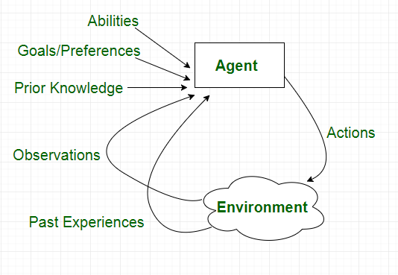

*Characteristics of an Agent*

**Types of Agents**

Agents can be grouped into five classes based on their degree of perceived intelligence and capability :

* Simple Reflex Agents
* Model-Based Reflex Agents
* Goal-Based Agents
* Utility-Based Agents
* Learning Agent
* Multi-agent systems
* Hierarchical agents

**Simple Reflex Agents**

Simple reflex agents ignore the rest of the percept history and act only on the basis of the **current percept**. Percept history is the history of all that an agent has perceived to date. The agent function is based on the **condition-action rule**. A condition-action rule is a rule that maps a state i.e., a condition to an action. If the condition is true, then the action is taken, else not. This agent function only succeeds when the environment is fully observable. For simple reflex agents operating in partially observable environments, infinite loops are often unavoidable. It may be possible to escape from infinite loops if the agent can randomize its actions.

Problems with Simple reflex agents are :

* Very limited intelligence.
* No knowledge of non-perceptual parts of the state.
* Usually too big to generate and store.
* If there occurs any change in the environment, then the collection of rules needs to be updated.

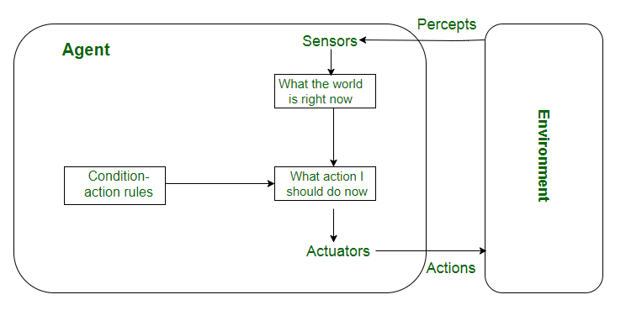

*Simple Reflex Agents*

**Model-Based Reflex Agents**

It works by finding a rule whose condition matches the current situation. A model-based agent can handle **partially observable environments** by the use of a model about the world. The agent has to keep track of the **internal state** which is adjusted by each percept and that depends on the percept history. The current state is stored inside the agent which maintains some kind of structure describing the part of the world which cannot be seen.

Updating the state requires information about:

* How the world evolves independently from the agent?
* How do the agent’s actions affect the world?

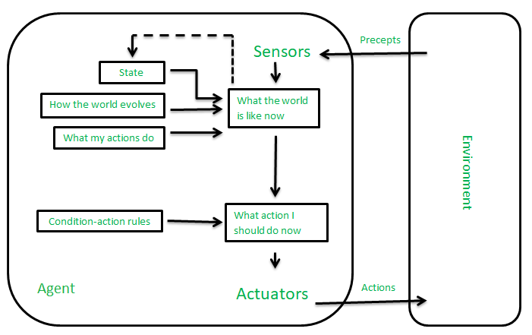

*Model-Based Reflex Agents*

**Goal-Based Agents**

These kinds of agents take decisions based on how far they are currently from their **goal**(description of desirable situations). Their every action is intended to reduce their distance from the goal. This allows the agent a way to choose among multiple possibilities, selecting the one which reaches a goal state. The knowledge that supports its decisions is represented explicitly and can be modified, which makes these agents more flexible. They usually require search and planning. The goal-based agent’s behavior can easily be changed.

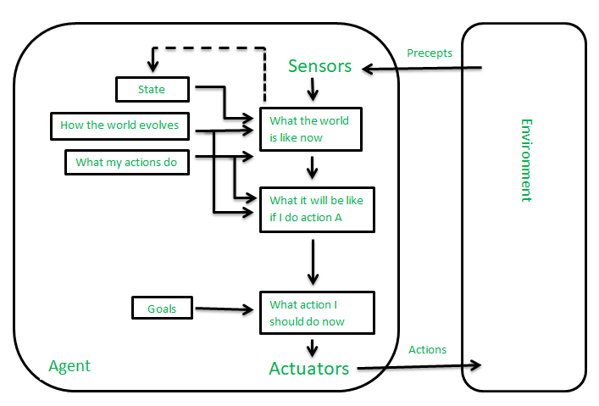

*Goal-Based Agents*

**Utility-Based Agents**

The agents which are developed having their end uses as building blocks are called utility-based agents. When there are multiple possible alternatives, then to decide which one is best, utility-based agents are used. They choose actions based on a **preference (utility)** for each state. Sometimes achieving the desired goal is not enough. We may look for a quicker, safer, cheaper trip to reach a destination. Agent happiness should be taken into consideration. Utility describes how **“happy”** the agent is. Because of the uncertainty in the world, a utility agent chooses the action that maximizes the expected utility. A utility function maps a state onto a real number which describes the associated degree of happiness.

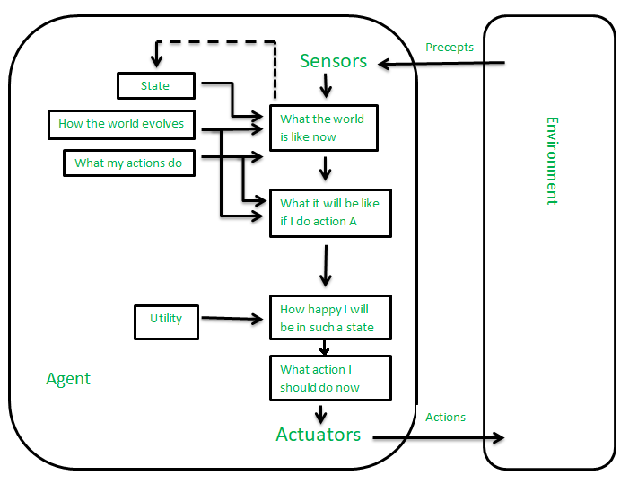

*Utility-Based Agents*

**Learning Agent**

A learning agent in AI is the type of agent that can learn from its past experiences or it has learning capabilities. It starts to act with basic knowledge and then is able to act and adapt automatically through learning. A learning agent has mainly four conceptual components, which are:

1. **Learning element:** It is responsible for making improvements by learning from the environment.
2. **Critic:**The learning element takes feedback from critics which describes how well the agent is doing with respect to a fixed performance standard.
3. **Performance element:** It is responsible for selecting external action.
4. **Problem Generator:** This component is responsible for suggesting actions that will lead to new and informative experiences.

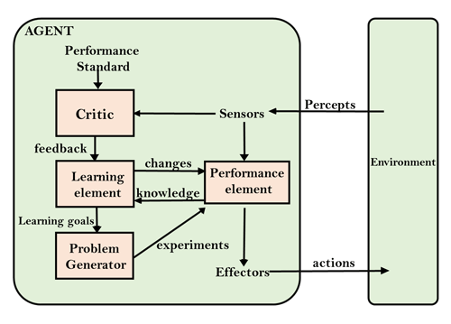

***Learning Agent***

**Multi-Agent Systems**

These agents interact with other agents to achieve a common goal. They may have to coordinate their actions and communicate with each other to achieve their objective.

A multi-agent system (MAS) is a system composed of multiple interacting agents that are designed to work together to achieve a common goal. These agents may be autonomous or semi-autonomous and are capable of perceiving their environment, making decisions, and taking action to achieve the common objective.

MAS can be used in a variety of applications, including transportation systems, robotics, and social networks. They can help improve efficiency, reduce costs, and increase flexibility in complex systems. MAS can be classified into different types based on their characteristics, such as whether the agents have the same or different goals, whether the agents are cooperative or competitive, and whether the agents are homogeneous or heterogeneous.

* In a homogeneous MAS, all the agents have the same capabilities, goals, and behaviors.
* In contrast, in a heterogeneous MAS, the agents have different capabilities, goals, and behaviors.

This can make coordination more challenging but can also lead to more flexible and robust systems.

Cooperative MAS involves agents working together to achieve a common goal, while competitive MAS involves agents working against each other to achieve their own goals. In some cases, MAS can also involve both cooperative and competitive behavior, where agents must balance their own interests with the interests of the group.

MAS can be implemented using different techniques, such as [game theory](https://www.geeksforgeeks.org/game-theory/), [machine learning](https://www.geeksforgeeks.org/machine-learning/), and agent-based modeling. Game theory is used to analyze strategic interactions between agents and predict their behavior. Machine learning is used to train agents to improve their decision-making capabilities over time. Agent-based modeling is used to simulate complex systems and study the interactions between agents.

Overall, multi-agent systems are a powerful tool in artificial intelligence that can help solve complex problems and improve efficiency in a variety of applications.

**Hierarchical Agents**

These agents are organized into a hierarchy, with high-level agents overseeing the behavior of lower-level agents. The high-level agents provide goals and constraints, while the low-level agents carry out specific tasks. Hierarchical agents are useful in complex environments with many tasks and sub-tasks.

* Hierarchical agents are agents that are organized into a hierarchy, with high-level agents overseeing the behavior of lower-level agents. The high-level agents provide goals and constraints, while the low-level agents carry out specific tasks. This structure allows for more efficient and organized decision-making in complex environments.
* Hierarchical agents can be implemented in a variety of applications, including robotics, manufacturing, and transportation systems. They are particularly useful in environments where there are many tasks and sub-tasks that need to be coordinated and prioritized.
* In a hierarchical agent system, the high-level agents are responsible for setting goals and constraints for the lower-level agents. These goals and constraints are typically based on the overall objective of the system. For example, in a manufacturing system, the high-level agents might set production targets for the lower-level agents based on customer demand.
* The low-level agents are responsible for carrying out specific tasks to achieve the goals set by the high-level agents. These tasks may be relatively simple or more complex, depending on the specific application. For example, in a transportation system, low-level agents might be responsible for managing traffic flow at specific intersections.
* Hierarchical agents can be organized into different levels, depending on the complexity of the system. In a simple system, there may be only two levels: high-level agents and low-level agents. In a more complex system, there may be multiple levels, with intermediate-level agents responsible for coordinating the activities of lower-level agents.
* One advantage of hierarchical agents is that they allow for more efficient use of resources. By organizing agents into a hierarchy, it is possible to allocate tasks to the agents that are best suited to carry them out, while avoiding duplication of effort. This can lead to faster, more efficient decision-making and better overall performance of the system.

Overall, hierarchical agents are a powerful tool in artificial intelligence that can help solve complex problems and improve efficiency in a variety of applications.

**Uses of Agents**

Agents are used in a wide range of applications in artificial intelligence, including:

* **Robotics:**Agents can be used to control robots and automate tasks in manufacturing, transportation, and other industries.
* **Smart homes and buildings:**Agents can be used to control heating, lighting, and other systems in smart homes and buildings, optimizing energy use and improving comfort.
* **Transportation systems:**Agents can be used to manage traffic flow, optimize routes for autonomous vehicles, and improve logistics and supply chain management.
* **Healthcare:**Agents can be used to monitor patients, provide personalized treatment plans, and optimize healthcare resource allocation.
* **Finance:**Agents can be used for automated trading, fraud detection, and risk management in the financial industry.
* **Games:**Agents can be used to create intelligent opponents in games and simulations, providing a more challenging and realistic experience for players.
* **Natural language processing:** Agents can be used for language translation, question answering, and chatbots that can communicate with users in [natural language](https://www.geeksforgeeks.org/natural-language-processing-nlp-tutorial/).
* **Cybersecurity:** Agents can be used for intrusion detection, malware analysis, and network security.
* **Environmental monitoring:** Agents can be used to monitor and manage natural resources, track climate change, and improve environmental sustainability.
* **Social media:**Agents can be used to analyze social media data, identify trends and patterns, and provide personalized recommendations to users.

Overall, agents are a versatile and powerful tool in [artificial intelligence](https://www.geeksforgeeks.org/artificial-intelligence-an-introduction/) that can help solve a wide range of problems in different fields.

AI architecture refers to the overall structure and organization of an artificial intelligence system. It encompasses the design principles, components, and interactions that enable an AI system to perform specific tasks or solve problems. There are various AI architectures, each tailored to different types of tasks and goals. Here are some common AI architecture types:

1. **Layered Architecture**: This architecture involves organizing an AI system into layers, each responsible for specific tasks or functions. Layers are stacked on top of each other, with information flowing between them. For instance, in a neural network, you might have input, hidden, and output layers. This approach simplifies design and allows for modularity.
2. **Reactive Architectures**: Reactive architectures are designed for specific tasks and are often rule-based. They operate in a stimulus-response manner, where the AI responds to input with predefined rules. These architectures are suitable for tasks with well-defined and predictable environments.
3. **Deliberative Architectures**: Deliberative architectures involve planning and decision-making. These systems use knowledge representation and reasoning to generate plans or strategies based on the current state and goals. Procedural Reasoning System (PRS) is an example of such an architecture.
4. **Hybrid Architectures**: Hybrid architectures combine elements from multiple AI architecture types to take advantage of their strengths. For instance, a hybrid system might use reactive components for quick decision-making and deliberative components for long-term planning.
5. **Behavior-Based Architectures**: Behavior-based architectures focus on creating complex behavior through the interaction of simple, reactive behaviors. Agents in these architectures respond to sensor inputs directly and can combine to produce emergent behaviors.
6. **Blackboard Architecture**: In a blackboard architecture, different AI modules work together on a shared "blackboard" where they can read and write information. This allows for collaboration among specialized modules and can be useful in complex problem-solving.
7. **Subsumption Architecture**: Subsumption architecture, developed by Rodney Brooks, emphasizes layering behaviors with increasing complexity and capability. Simple behaviors "subsume" more complex behaviors, allowing for emergent and adaptive behavior.
8. **Connectionist Architectures**: Connectionist architectures, such as neural networks, are inspired by the brain's interconnected neurons. These architectures learn patterns from data through the adjustment of connection weights.
9. **Cognitive Architectures**: Cognitive architectures aim to mimic human cognitive processes. Examples include ACT-R and Soar. These architectures attempt to capture how humans perceive, reason, and learn to solve problems.
10. **Reinforcement Learning Architectures**: These architectures focus on learning optimal strategies through interaction with an environment. Agents learn by receiving feedback in the form of rewards or penalties for their actions.

The choice of AI architecture depends on the nature of the task, the available data, and the desired behavior of the AI system. In practice, many modern AI systems use a combination of these architectures to achieve the best results for their specific applications.

Top of Form

Regenerate

Performance measures in the context of artificial intelligence (AI) refer to the metrics or criteria used to evaluate and quantify the effectiveness, efficiency, accuracy, and overall quality of an AI system's performance. These measures provide a way to assess how well an AI system is accomplishing its intended tasks. The choice of performance measures depends on the specific goals and nature of the AI application. Here are some common performance measures used in AI:

1. **Accuracy**: Accuracy measures the proportion of correct predictions or decisions made by an AI system. It's commonly used for classification tasks where the system needs to assign a label to input data. Accuracy is calculated as the ratio of correct predictions to the total number of predictions.
2. **Precision and Recall**: Precision is the ratio of true positive predictions to the total predicted positives, while recall is the ratio of true positive predictions to the total actual positives. These measures are often used in binary classification tasks and help balance the trade-off between false positives and false negatives.
3. **F1 Score**: The F1 score is the harmonic mean of precision and recall. It provides a single value that considers both false positives and false negatives. The F1 score is useful when the class distribution is imbalanced.
4. **Mean Squared Error (MSE)**: MSE is a common metric for regression tasks. It measures the average squared difference between the predicted values and the actual values. Lower MSE values indicate better performance.
5. **Root Mean Squared Error (RMSE)**: RMSE is the square root of the MSE and provides a measure of the average magnitude of errors in regression predictions.
6. **Mean Absolute Error (MAE)**: MAE is another metric for regression tasks. It measures the average absolute difference between the predicted values and the actual values.
7. **Confusion Matrix**: A confusion matrix is a tabular representation of the performance of a classification algorithm. It shows true positive, true negative, false positive, and false negative counts, which can be used to calculate various metrics like accuracy, precision, recall, and F1 score.
8. **Area Under the Receiver Operating Characteristic Curve (AUC-ROC)**: AUC-ROC measures the area under the curve of the receiver operating characteristic plot. It's used to evaluate the performance of binary classifiers, indicating how well the classifier distinguishes between positive and negative classes.
9. **Mean Average Precision (mAP)**: mAP is often used to evaluate the performance of object detection and instance segmentation models. It considers both precision and recall across different levels of confidence thresholds.
10. **Computational Efficiency**: In some cases, the speed and resource efficiency of an AI system are important measures. This includes factors like inference time, memory usage, and computational complexity.
11. **Generalization Performance**: For machine learning models, how well they perform on unseen data (generalization) is crucial. Performance on validation or test datasets is used to gauge this.
12. **Custom Metrics**: Depending on the specific application, custom metrics may be devised to evaluate performance. These metrics could reflect domain-specific requirements or business objectives.

It's important to choose performance measures that align with the goals of the AI system and the specific challenges of the task at hand. A combination of multiple measures often provides a more comprehensive understanding of an AI system's performance.

PEAS

ChatGPT

PEAS stands for Performance measure, Environment, Actuators, and Sensors. It's a framework used in artificial intelligence to define the key components and considerations when designing an intelligent agent to perform a specific task. Each letter in the acronym represents a different aspect of the framework:

1. **Performance Measure**: This refers to the criterion by which the success of the intelligent agent is evaluated. It defines what the agent is trying to achieve in its task. The performance measure can be quantitative (e.g., accuracy, speed) or qualitative (e.g., user satisfaction).
2. **Environment**: The environment is the external context in which the intelligent agent operates and interacts. It encompasses everything the agent perceives and interacts with. The environment can be physical, virtual, or a combination of both.
3. **Actuators**: Actuators are the components through which the agent affects the environment. They allow the agent to perform actions or make changes in the environment based on its decisions and reasoning.
4. **Sensors**: Sensors are the components through which the agent perceives or gathers information from its environment. Sensors provide input to the agent, allowing it to make informed decisions and take appropriate actions.

The PEAS framework helps in understanding and defining the scope of an AI system by clarifying what the system is expected to do, in what context, and how it will achieve its goals. When designing an AI system, considering each aspect of PEAS helps in making informed decisions about the architecture, algorithms, and components of the system.

Here's a simple example to illustrate PEAS:

**Example: Autonomous Driving System**

* **Performance Measure**: Safe navigation, minimal travel time, adherence to traffic rules.
* **Environment**: Roadways, traffic signals, pedestrians, other vehicles, weather conditions.
* **Actuators**: Steering, brakes, accelerator, turn signals.
* **Sensors**: Cameras, lidar, radar, GPS, inertial sensors.

In this example, the PEAS framework helps define the goals of the autonomous driving system, the context in which it operates, the actions it can take, and the information it uses to make decisions.

Keep in mind that while the PEAS framework provides a structured way to define AI systems, it might not cover all aspects of complex AI systems. It's a foundational concept that can be extended and adapted based on the specific requirements of the AI application.

Arrays, linked lists, and graphs are fundamental data structures used in computer science and programming to organize and manage collections of data. Each of these data structures has its own characteristics and use cases.

1. **Arrays**: An array is a linear data structure that stores elements of the same data type in contiguous memory locations. Elements in an array are accessed using an index, which represents the position of an element within the array. Arrays have constant-time access to individual elements, but their size is typically fixed when they are created.

**Key Characteristics**:

* + Constant-time access to elements using an index.
  + Fixed size upon creation.
  + Elements are stored in contiguous memory locations.
  + Well-suited for situations where elements have a specific order and direct access is important.

1. **Linked Lists**: A linked list is a linear data structure where elements, known as nodes, are connected using pointers. Each node contains the data and a reference (or link) to the next node in the list. Linked lists can be singly linked (each node points to the next) or doubly linked (each node points to both the next and previous nodes). Linked lists allow for dynamic memory allocation and efficient insertion and deletion operations.

**Key Characteristics**:

* + Dynamic size; nodes can be added or removed easily.
  + No need for contiguous memory; nodes can be scattered in memory.
  + Efficient insertions and deletions, especially when performed within the list.
  + Relatively slower access time compared to arrays due to traversing.

1. **Graphs**: A graph is a non-linear data structure that consists of nodes (vertices) connected by edges. Graphs are used to represent relationships between objects or entities. They can be directed (edges have a direction) or undirected (edges have no direction). Graphs can have various properties, such as cyclic or acyclic, weighted or unweighted edges, etc.

**Key Characteristics**:

* + Represent complex relationships and connections.
  + Can model a wide range of scenarios, from social networks to computer networks.
  + Graph traversal algorithms (e.g., depth-first search, breadth-first search) help explore the graph's structure.

Graphs can be further categorized into various types, including:

* **Directed Graphs (Digraphs)**: Edges have a specific direction from one node to another.
* **Undirected Graphs**: Edges have no direction; connections are symmetric.
* **Weighted Graphs**: Edges have associated weights to represent costs, distances, or other attributes.
* **Unweighted Graphs**: Edges have no associated weights.
* **Cyclic Graphs**: Contain at least one cycle (a path that starts and ends at the same node).
* **Acyclic Graphs**: Do not contain any cycles.

These data structures serve as building blocks for more complex algorithms and applications. Choosing the appropriate data structure depends on the specific problem you're trying to solve and the efficiency requirements of your solution.

Certainly! Graph problems involve analyzing and manipulating graphs to solve various tasks. Here are explanations for finding degrees of nodes and detecting cycles in graphs:

1. **Degree of Nodes**: The degree of a node in a graph refers to the number of edges connected to that node. It's an important concept as it provides insights into the structure of the graph. There are two types of degrees: in-degree and out-degree.
   * **In-Degree**: In a directed graph, the in-degree of a node is the number of incoming edges it has. It represents how many other nodes point to that particular node.
   * **Out-Degree**: In a directed graph, the out-degree of a node is the number of outgoing edges it has. It represents how many other nodes the node points to.

In an undirected graph, the degree of a node is the total number of edges connected to that node, regardless of direction.

1. **Finding Cycles**: A cycle in a graph is a path that starts and ends at the same node, and it involves visiting the same node more than once. Detecting cycles is important in various applications, such as identifying potential deadlocks in concurrent systems or analyzing dependencies in project scheduling.

There are several algorithms to detect cycles in graphs:

* + **Depth-First Search (DFS)**: In a depth-first traversal of the graph, if you encounter an already visited node (excluding the parent node in the traversal), then there is a cycle in the graph. DFS can be used both in directed and undirected graphs.
  + **Breadth-First Search (BFS)**: Similar to DFS, BFS can be used to detect cycles. If you encounter an already visited node (excluding the parent node in the traversal) during BFS, then a cycle is present.
  + **Union-Find (Disjoint Set Union)**: This is often used in cases where edges are being added to the graph dynamically. The union-find data structure can efficiently detect cycles while maintaining connectivity components.
  + **Topological Sort and Cycle Detection**: In directed acyclic graphs (DAGs), you can perform a topological sort. If the graph is not a DAG (i.e., contains cycles), a topological sort is not possible.

It's important to note that the algorithm used for cycle detection might vary based on the type of graph (directed, undirected), its size,

Tic-Tac-Toe is a simple example of a game that can be represented as a graph for various search and decision-making algorithms. In this case, we can model the game as a state space graph, where each node represents a unique game configuration, and edges represent valid moves from one configuration to another.

Let's walk through an example of searching a node in a Tic-Tac-Toe state space graph using a depth-first search (DFS) algorithm. The goal is to find a specific game configuration (node) that matches a given pattern. Here's how the process might work:

1. **Setup**:
   * The Tic-Tac-Toe board is a 3x3 grid.
   * Each cell can be empty, marked with "X", or marked with "O".
   * The search goal is to find a specific pattern, such as "XOX" in a row.
2. **State Space Graph**:
   * Nodes: Each node represents a unique game configuration (Tic-Tac-Toe board).
   * Edges: Edges connect nodes that represent legal moves from one configuration to another.
3. **Depth-First Search (DFS)**:
   * Start from an initial game configuration (root node).
   * Explore child nodes by applying legal moves to the current configuration.
   * Apply the DFS algorithm recursively until the desired pattern is found or the entire graph is explored.

Example DFS process:

1. Start with the initial configuration (root node).
2. Generate child nodes by making legal moves from the current configuration.
3. Apply DFS recursively to explore each child node:
   * If a child node matches the desired pattern, the search is successful.
   * If not, continue exploring child nodes until a match is found or all options are exhausted.

DFS will traverse through the state space graph, exploring each path until it either finds the desired pattern or exhausts all possibilities. The search depth determines how many moves ahead the algorithm looks before backtracking.

It's important to note that DFS can be efficient for small state spaces, like Tic-Tac-Toe, but it may become inefficient for larger and more complex games due to its blind exploration of paths. More advanced search algorithms, such as minimax with alpha-beta pruning, are used for games with larger state spaces like chess.

In this example, the "searching a node in a graph" process involves searching for a specific game configuration (node) in a Tic-Tac-Toe state space graph using a DFS algorithm.

Searching for a specific node in a graph, particularly in the context of solving the 8-puzzle, involves finding a sequence of moves that transforms the initial puzzle configuration into the desired target configuration. The 8-puzzle is a classic sliding puzzle game that consists of a 3x3 grid with numbered tiles and an empty space.

Here's how you might approach searching for a node in the 8-puzzle using a search algorithm like the Breadth-First Search (BFS):

1. **Setup**:
   * The 8-puzzle consists of a 3x3 grid where each tile has a number from 1 to 8 and one empty space.
   * Given an initial configuration of the puzzle and a target configuration you want to achieve.
2. **State Space Graph**:
   * Nodes: Each node represents a unique configuration of the puzzle.
   * Edges: Edges connect nodes that represent valid moves from one configuration to another.
3. **Breadth-First Search (BFS)**:
   * Start from the initial puzzle configuration (root node).
   * Generate child nodes by making legal moves from the current configuration.
   * Apply BFS to explore the graph layer by layer, considering all possible moves before moving to the next layer.
   * If a child node matches the target configuration, the search is successful.

Example BFS process:

1. Start with the initial configuration (root node).
2. Generate child nodes by making legal moves (up, down, left, right) from the current configuration.
3. Apply BFS to explore each layer:
   * Check if a child node matches the target configuration. If yes, the search is successful.
   * If not, enqueue the child nodes to be explored in the next layer.

Repeat the BFS process until the target configuration is found or until all possibilities are explored. BFS ensures that you explore all possible solutions of increasing lengths before moving on to longer solutions.

It's important to note that the 8-puzzle has a finite state space, so BFS is a suitable choice for this problem. However, BFS can become inefficient for problems with larger state spaces due to its memory and time complexity. For more complex puzzles, like the 15-puzzle or larger grid sizes, more sophisticated search algorithms like A* (A-star) with heuristics are often used to improve efficiency.

Let's explore the concepts of state space, search tree, and random search in the context of problem-solving and search algorithms:

1. **State Space**: The state space refers to the set of all possible states or configurations that a problem-solving system can be in. In other words, it's the entire range of possible situations that the system can encounter while trying to solve a problem. Each state represents a specific situation or arrangement of elements relevant to the problem.

In the context of puzzles or games, like the 8-puzzle or chess, the state space includes all possible board configurations. Understanding and modeling the state space is crucial for designing efficient search algorithms to navigate through different states in order to reach a solution.

1. **Search Tree**: A search tree is a hierarchical representation of the exploration process during a search algorithm's operation. It's used to visualize the different paths explored by the algorithm as it progresses towards a solution. Each node in the search tree represents a state, and edges between nodes represent transitions or actions that lead from one state to another.

The root of the search tree corresponds to the initial state, and the leaf nodes represent possible solutions or terminal states. The branching factor at each level of the tree corresponds to the number of possible actions or moves that can be taken from a given state.

1. **Random Search**: Random search is a simple and basic approach to exploring a search space in order to find a solution. In this method, you randomly choose potential solutions or actions without considering their merit, heuristic information, or systematic planning.

For example, in the context of the 8-puzzle, random search would involve randomly selecting legal moves until you stumble upon a sequence of moves that solves the puzzle. However, because there's no intelligent decision-making involved, random search is generally inefficient and not suitable for solving complex problems.

Random search is often used for comparison purposes to evaluate the performance of more sophisticated search algorithms. While it may be effective for problems with small state spaces, it's not a scalable or reliable approach for most real-world problems due to its lack of strategy or optimization.

In contrast, more advanced search algorithms like breadth-first search, depth-first search, A* with heuristics, and other informed search methods are designed to navigate the state space in a more systematic and efficient manner, improving the chances of finding a solution quickly and effectively.

Breadth-First Search (BFS), Depth-First Search (DFS), and Depth-Limited Search (DLS) are popular search algorithms used to explore state spaces and search trees in various problem-solving scenarios. Each algorithm has its own characteristics and strengths. Let's dive into each one:

1. **Breadth-First Search (BFS)**: BFS is an uninformed search algorithm that explores a search tree layer by layer, considering all possible moves from the current state before moving to the next layer. It guarantees finding the shortest path to a solution if the state space is finite and each step has a uniform cost.
   * **Advantages**:
     + Guarantees finding the shortest path to the solution.
     + Complete and optimal for uniformly-costed problems.
   * **Disadvantages**:
     + Requires a lot of memory to store the entire level.
     + Can be slow when the branching factor is high or the depth of the solution is deep.
2. **Depth-First Search (DFS)**: DFS is an uninformed search algorithm that explores as far as possible along a branch before backtracking. It uses a stack (or recursion) to manage the search process. DFS is memory-efficient compared to BFS but does not necessarily find the shortest path.
   * **Advantages**:
     + Memory-efficient as it only needs to store a single path.
     + Can find solutions quickly if the goal state is deep.
   * **Disadvantages**:
     + Not guaranteed to find the shortest path.
     + Can get stuck in infinite loops if not implemented properly.
3. **Depth-Limited Search (DLS)**: DLS is a modification of DFS that limits the maximum depth of the search. It aims to combine the advantages of DFS (memory efficiency) with the advantages of BFS (potential for finding a shorter solution).
   * **Advantages**:
     + Can explore deep branches while avoiding infinite loops.
     + Can be more memory-efficient compared to BFS.
   * **Disadvantages**:
     + If the depth limit is too shallow, the algorithm might not find the solution even if it exists.

In some cases, you might use DLS as a compromise between BFS and DFS. By setting an appropriate depth limit, you can balance the memory consumption of BFS and the search depth of DFS. If the depth limit is chosen well, DLS can be more efficient than both BFS and DFS for certain problems.

It's important to choose the right search algorithm based on the problem's characteristics, such as the size of the state space, the branching factor, and the desired solution quality. In some cases, hybrid approaches that combine different algorithms or heuristics might be the most effective solution.

<https://www.techiedelight.com/count-the-number-of-islands/https://www.geeksforgeeks.org/find-the-number-of-islands-using->

<https://favtutor.com/coding-problems/number-of-islands>

<https://www.youtube.com/watch?v=__98uL6wst8>

<https://javabypatel.blogspot.com/2016/08/find-number-of-islands-using-dfs.html>

https://www.coconino.edu/resources/files/pdfs/academics/arts-and-sciences/MAT142/Chapter_6_GraphTheory.pdf

We use recursion to solve the problem. We start traversing the cells in the matrix linearly and when we find a cell whose value is 1, then we recursively explore its neighboring cells. For instance, consider the matrix below:

First we traverse the cells A1 and B1 which have a 0 in them. Next we encounter the cell C1 which has a 1 in it. We then recursively search the neighborhood of C1, and we find that the cells C2 -> C3 and D1 have a 1. So the cells C1, C2, C3 and D1 form an island.

So we essentially do a Depth First Search. To avoid from looping, we will keep track if a cell has already been visited and once a cell has been visited, we will not visit it again.

https://www.quora.com/What-is-an-efficient-algorithm-to-find-an-island-of-connected-1s-in-a-matrix-of-0s-and-1s

dfs/

Sure, I can help you design an algorithm to find the number of islands in a given matrix using Depth-First Search (DFS). The problem of finding islands in a matrix is a common graph traversal problem where you consider adjacent 1s as part of the same island.

Here's a step-by-step algorithm to achieve this:

1. Initialize a variable to keep track of the number of islands, let's call it **numIslands**. Initialize a 2D array to mark visited cells.
2. Iterate through each cell in the matrix: a. If the cell is not visited and it contains a '1', perform a DFS to mark all connected cells as visited and belonging to the same island. Increment the **numIslands** counter. b. Implement the DFS function to explore the adjacent cells in a recursive manner.

Here's a Python-like pseudocode representation of the algorithm:

pythonCopy code

def numIslands(matrix): if not matrix: return 0 numIslands = 0 rows = len(matrix) cols = len(matrix[0]) visited = [[False for _ in range(cols)] for _ in range(rows)] def dfs(row, col): if ( row < 0 or row >= rows or col < 0 or col >= cols or visited[row][col] or matrix[row][col] == '0' ): return visited[row][col] = True # Explore all 4 adjacent cells dfs(row + 1, col) dfs(row - 1, col) dfs(row, col + 1) dfs(row, col - 1) for row in range(rows): for col in range(cols): if matrix[row][col] == '1' and not visited[row][col]: numIslands += 1 dfs(row, col) return numIslands

Make sure to replace **'0'** and **'1'** with the actual values you have in your matrix. You can call the **numIslands** function with your matrix as an argument, and it will return the count of islands present in the matrix.

Top of Form

Regen

Bottom of Form

def numIslands(matrix):

if not matrix:

return 0

numIslands = 0

rows = len(matrix)

cols = len(matrix[0])

visited = [[False for _ in range(cols)] for _ in range(rows)]

def dfs(row, col):

if (

row < 0

or row >= rows

or col < 0

or col >= cols

or visited[row][col]

or matrix[row][col] == '0'

):

return

visited[row][col] = True

# Explore all 4 adjacent cells

dfs(row + 1, col)

dfs(row - 1, col)

dfs(row, col + 1)

dfs(row, col - 1)

for row in range(rows):

for col in range(cols):

if matrix[row][col] == '1' and not visited[row][col]:

numIslands += 1

dfs(row, col)

return numIslands

Top of Form

Top of Form

Top of Form

Top of Form

Top of Form

Top of Form

Top of Form

https://takeuforward.org/data-structure/number-of-islands/

1. Define in your own words: (a) intelligence, (b) artificial intelligence, (c) agent, (d) rationality, (e) logical reasoning.