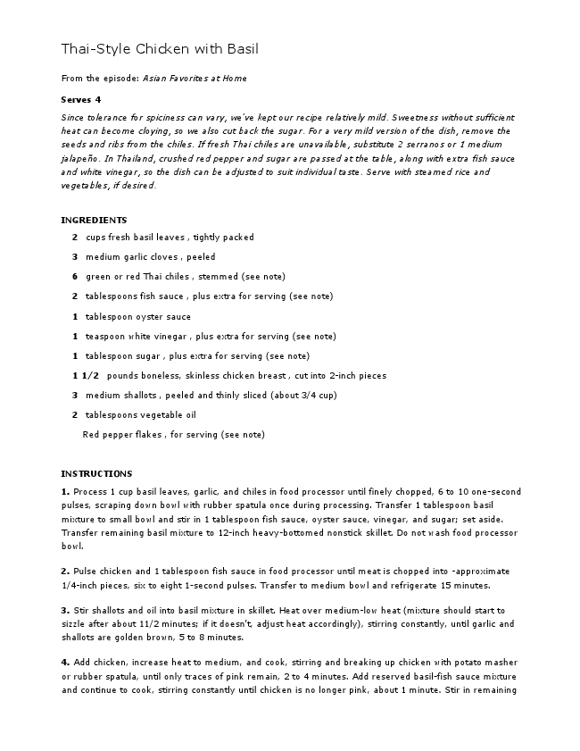
Thai-Style Chicken with Basil
From the episode: Asian Favorites at Home
Serves 4
Since tolerance for spiciness can vary, we’ve kept our recipe relatively mild. Sweetness without sufficient heat can become cloying, so we also cut back the sugar. For a very mild version of the dish, remove the seeds and ribs from the chiles. If fresh Thai chiles are unavailable, substitute 2 serranos or 1 medium jalapeño. In Thailand, crushed red pepper and sugar are passed at the table, along with extra fish sauce and white vinegar, so the dish can be adjusted to suit individual taste. Serve with steamed rice and vegetables, if desired.
INGREDIENTS
2 cups fresh basil leaves , tightly packed
3 medium garlic cloves , peeled
6 green or red Thai chiles , stemmed (see note)
2 tablespoons fish sauce , plus extra for serving (see note)
1 tablespoon oyster sauce
1 teaspoon white vinegar , plus extra for serving (see note)
1 tablespoon sugar , plus extra for serving (see note)
1 1/2 pounds boneless, skinless chicken breast , cut into 2-inch pieces
3 medium shallots , peeled and thinly sliced (about 3/4 cup)
2 tablespoons vegetable oil
Red pepper flakes , for serving (see note)
INSTRUCTIONS
1. Process 1 cup basil leaves, garlic, and chiles in food processor until finely chopped, 6 to 10 one-second pulses, scraping down bowl with rubber spatula once during processing. Transfer 1 tablespoon basil mixture to small bowl and stir in 1 tablespoon fish sauce, oyster sauce, vinegar, and sugar; set aside. Transfer remaining basil mixture to 12-inch heavy-bottomed nonstick skillet. Do not wash food processor bowl.
2. Pulse chicken and 1 tablespoon fish sauce in food processor until meat is chopped into -approximate 1/4-inch pieces, six to eight 1-second pulses. Transfer to medium bowl and refrigerate 15 minutes.
3. Stir shallots and oil into basil mixture in skillet. Heat over medium-low heat (mixture should start to sizzle after about 11/2 minutes; if it doesn’t, adjust heat accordingly), stirring constantly, until garlic and shallots are golden brown, 5 to 8 minutes.
4. Add chicken, increase heat to medium, and cook, stirring and breaking up chicken with potato masher or rubber spatula, until only traces of pink remain, 2 to 4 minutes. Add reserved basil-fish sauce mixture and continue to cook, stirring constantly until chicken is no longer pink, about 1 minute. Stir in remaining
cup basil leaves and cook, stirring constantly, until basil is wilted, 30 to 60 seconds. Serve immediately, passing extra fish sauce, sugar, red pepper flakes, and vinegar separately.
TECHNIQUE
A NEW WAY TO STIR-FRY MINCE YOUR MEAT
Thai stir-fries often feature small pieces of chopped meat versus the
larger strips or chunks in many Chinese stir-fries.
USE LOW HEAT
A moderately hot pan instead of a blazing hot wok means lean meats such
as chicken breast won't easily overcook.
SAUTÉ AROMATICS FIRST
With a low temperature, aromatics can be added to the pan first, deeply
flavoring the oil without risk of burning
SAUTÉ MEAT LAST
At low heat, the meat won't get a flavor boost from browning. Instead, it
absorbs the fully developed flavors of the oil.
SEASON WITH FISH SAUCE
Fish sauce added before and after cooking is an even more potent flavor
enhancer than soy sauce.
TECHNIQUE
MAKE A HAPPY MEAL
Nearly every dish in Thai cuisine features a combination of sweet and spicy flavors, including our Thai-
Style Chicken with Basil. During testing, we noticed that adding sugar to the recipe significantly toned
down the heat of the chiles. It turns out that this phenomenon is the result of complex interactions in
the brain that regulate our perception of flavor, pitting pain against pleasure. Compounds in chiles
(mainly capsaicin) stimulate nerves (called trigeminals) surrounding the taste buds to signal discomfort
to the brain, in a process known as chemesthesis. Sugar, on the other hand, stimulates the taste buds
to signal pleasure. These signals are so enjoyable, scientists believe they overshadow the “pain”
caused by chiles.
Spicy chiles send signals of discomfort to the brain.
Sweet sugar sends signals of pleasure.
America's Test Kitchen is a 2,500-square-foot kitchen located just outside of Boston. It is the home of Cook's Country and Cook's Illustrated magazines and is the workday destination for more than three dozen test cooks, editors, and cookware specialists.
, , p Our mission is to test recipes until we understand how and why they work and arrive at the best version. We also test kitchen equipment and supermarket ingredients in search of brands that offer the best value and performance. You can watch us work by tuning in to America's Test Kitchen (www.americastestkitchen.com) on public television.

