**General**

We are planning on 24-hour operations.

Types of Stations and Activities at Each:

Three types of activities will be conducted:

1) Mooring deployments

2) Acrobat Lines: Transect lines (60 km long) with a towed profiling sampler (Acrobat) and acoustics (EK60, ADCP)

3) Station Lines: Transect lines (60 km long) with CTD stations every 5 km (12 stations/line), plankton nets (Bongo, Tucker Trawl, occasional Ring Net) conducted at every other station (6 stations/line), and at least one trawl with the midwater fish net on each line, likely during daylight hours.

All transect lines are located within a ~100 km long, 60 km wide region over the Beaufort Shelf, with lines oriented perpendicular to the shelf topography (Figure 1). Transect lines are ~15 km apart. The types of transect lines will alternate, with lines 1, 3, 5, and 7 being Acrobat lines and lines 2, 4, and 6 being Station lines. Acrobat lines will be conducted from south to north; Station lines will be conducted from north to south.

Avoiding Interference with Nuiqsut Whaling

Nuiqsut whaling on Cross Island starts on August 25, the same date that the ship leaves Nome. Usually, whaling is very efficient and the whalers are able to reach their quota relatively quickly. Consistent with the 2016 Conflict Avoidance Agreement between the Alaska Eskimo Whaling Commission and industry, we will remain to the west of 150° 10.2’ longitude until whaling is completed at Nuiqsut.

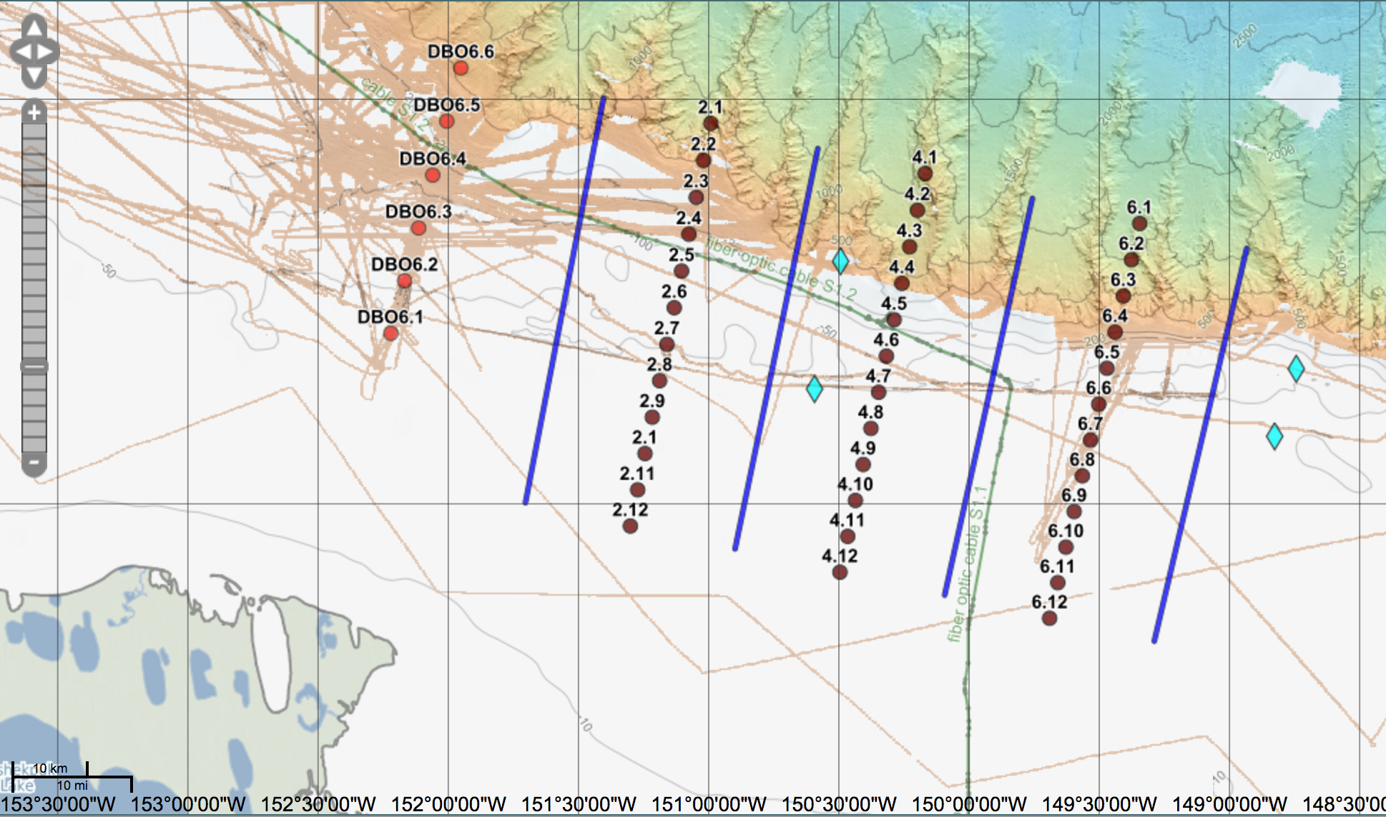

Figure 1. Nominal transect and station locations. Blue lines show transect lines along which we will sample using hull mounted acoustics and a towed vertically profiling instrument (Acrobat; SeaSciences, Inc.). Dark brown circles show nominal locations of planned stations at which we will conduct CTDs and pelagic fish and plankton tows. Cyan diamonds show nominal locations of moorings. Green line shows location of fiber optic cable. Red filled circles show locations of Distributed Biological Observatory stations (https://www.pmel.noaa.gov/dbo/).

Table 1. Nominal locations of stations along lines 2, 4, and 6 (see also SKQ201713S_Science_WPT.xls).

|  |  |  |  |  |
| --- | --- | --- | --- | --- |
| Station | Lat Deg | Lat Min | Lon Deg | Lon Min |
| 2.1 | 71 | 28.16 | 150 | 59.28 |
| 2.2 | 71 | 25.44 | 151 | 0.9655 |
| 2.3 | 71 | 22.72 | 151 | 2.651 |
| 2.4 | 71 | 20 | 151 | 4.3365 |
| 2.5 | 71 | 17.28 | 151 | 6.022 |
| 2.6 | 71 | 14.56 | 151 | 7.7075 |
| 2.7 | 71 | 11.84 | 151 | 9.393 |
| 2.8 | 71 | 9.13 | 151 | 11.0785 |
| 2.9 | 71 | 6.41 | 151 | 12.764 |
| 2.1 | 71 | 3.69 | 151 | 14.4495 |
| 2.11 | 71 | 0.97 | 151 | 16.135 |
| 2.12 | 70 | 58.25 | 151 | 17.8205 |
| 4.1 | 71 | 24.474 | 150 | 9.9 |
| 4.2 | 71 | 21.77 | 150 | 11.684 |
| 4.3 | 71 | 19.07 | 150 | 13.468 |
| 4.4 | 71 | 16.37 | 150 | 15.252 |
| 4.5 | 71 | 13.67 | 150 | 17.036 |
| 4.6 | 71 | 10.97 | 150 | 18.82 |
| 4.7 | 71 | 8.27 | 150 | 20.604 |
| 4.8 | 71 | 5.57 | 150 | 22.388 |
| 4.9 | 71 | 2.87 | 150 | 24.172 |
| 4.1 | 71 | 0.17 | 150 | 25.956 |
| 4.11 | 70 | 57.47 | 150 | 27.74 |
| 4.12 | 70 | 54.77 | 150 | 29.524 |
| 6.1 | 71 | 20.79 | 149 | 20.46 |
| 6.2 | 71 | 18.11 | 149 | 22.35 |
| 6.3 | 71 | 15.43 | 149 | 24.23 |
| 6.4 | 71 | 12.75 | 149 | 26.12 |
| 6.5 | 71 | 10.06 | 149 | 28.01 |
| 6.6 | 71 | 7.38 | 149 | 29.9 |
| 6.7 | 71 | 4.7 | 149 | 31.78 |
| 6.8 | 71 | 2.02 | 149 | 33.67 |
| 6.9 | 70 | 59.34 | 149 | 35.56 |
| 6.1 | 70 | 56.66 | 149 | 37.45 |
| 6.11 | 70 | 53.98 | 149 | 39.33 |
| 6.12 | 70 | 51.29 | 149 | 41.22 |

Table 2. Nominal endpoints of the transect lines along which the Acrobat will be towed (see also SKQ201713S_Science_WPT.xls).

|  |  |  |  |  |
| --- | --- | --- | --- | --- |
| Transect | Long. 1 | Lat. 1 | Long. 2 | Lat. 2 |
| 1 | 151.4 | 71.5 | 151.7 | 71 |
| 3 | 150.577 | 71.4386 | 150.895 | 70.942 |
| 5 | 149.753 | 71.3774 | 150.09 | 70.8839 |
| 7 | 148.93 | 71.3158 | 149.285 | 70.8259 |

Table 3. Nominal locations of four moorings (see also SKQ201713S_Science_WPT.xls).

|  |  |
| --- | --- |
| 71.300 | 150.500 |
| 71.142 | 150.600 |
| 71.167 | 148.750 |
| 71.083 | 148.833 |

**Nominal Cruise Plan:**

1. Depart Nome. During the transit to the operating area, weather conditions permitting, conduct test station in the Chukchi Sea (not in Barrow Canyon) during daylight hours. Deploy all gear (CTD, Bongo, Tucker, Fish Net, Acrobat). Since the fish net is the most complex, we might lead off the sequence with this net if the crew wishes. The other equipment is much less complex and everyone has a much greater familiarity with deploying it. The Acrobat may require several deployments to adjust the wings/trim since it has new equipment on the frame and may fly differently than when we last used it.
2. Arrive in operating area (Day 3-4). Weather permitting, deploy the two westernmost moorings.
3. Whaling, and again weather, permitting, potentially deploy two easternmost moorings. We might also decide to sample the transect lines to go east, depending on weather forecasts, timing, and the clutter of gear on the deck. At some point, we are going to have to deadhead between the two ends of the box.
4. First survey of box, going from west to east.
5. Second survey of box, going from west to east.
6. Sample DBO6 Line (purple dots on map) at some point either early-, mid-, or late-cruise. Sampling will be done using CTD and plankton nets only.
7. Return to Nome, passing Barrow early on September 15.

**Specific Sampling Procedures**

Mooring Deployments:

Four moorings will be deployed; three equipped with a MicroCAT, ADCP, and passive acoustic recorder (Aural) and one equipped with a MicroCAT and an Acoustic Zooplankton Fish Profiler (AZFP). The general configurations of the moorings are shown in Figure 2. The moorings will be assembled on deck and then deployed along the ~80 m and ~120 m isobaths at locations nominally indicated by the blue diamonds in Figure 1. The AZFP mooring will be deployed at the westernmost 80 m location. Multibeam surveys of the selected site bathymetry will be conducted prior to deploying each mooring.

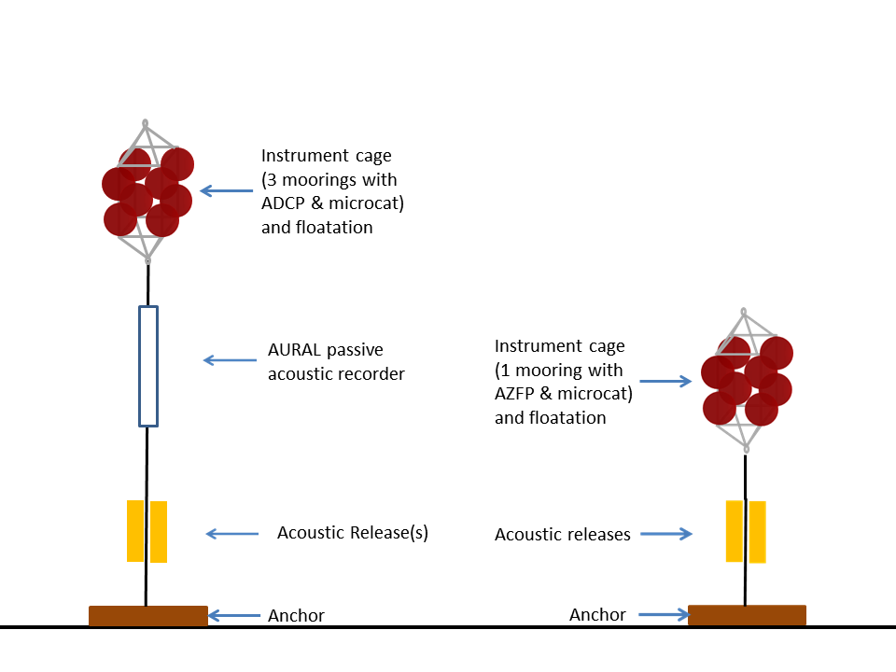

Bongo Nets

Oblique tows from the surface to ~5-10 m off of the bottom or to 300 m in deep water will be conducted using paired, 60-cm diameter Bongo nets. These will be done from the stern using the 0.322 wire and a weight supplied by the ship. The ship should be moving forward at ~1-2 knots. The direction of the tow should be into the current or the seas, depending on conditions. Wire out speed will be ~50 m/min, wire retrieval speed will be ~20 m/min. The amount of wire that will be deployed will depend on the wire angle of the net and will be determined once the net is in the water. At a 60 degree wire angle, 2x the length of wire is required to reach the desired depth.

Need from Ship: Weight, 0.322” wire and block, wire/block.

Tucker Trawl

Oblique tows from the surface to ~5-10 m off of the bottom or to 300 m in deep water will be conducted using a 1-m2, three-net Tucker Trawl from the 0.322” wire. The Tucker Trawl is tripped using three messengers that are deployed on the wire 1) when the net is at the bottom, 2) midway through the tow (hydrographic structure dependent), and 3) at the surface. *This requires pulling the 0.322 wire close enough so that the messenger can be attached and released; the wire should be kept close until the messenger “hit” is felt.*

The ship should be moving forward at ~2-3 knots. The direction of the tow should be into the current or the seas, depending on conditions. Wire out speed will be ~50 m/min, wire retrieval speed will be ~20 m/min. The amount of wire that will be deployed will depend on the wire angle of the net and will be determined once the net is in the water. At a 60 degree wire angle, 2x the length of wire is required to reach the desired depth.

Need from Ship: 0.322” wire and block, clever way to pull wire down to deck during tow.

Ring Net Tow

If insufficient plankton are collected in the Bongo tows for picking animals for morphological and chemical analyses, collections will be augmented using a 1 m2 ring net at selected stations. These are conducted from the 0.322” wire off of the stern. This will be a gentle oblique tow at 30 m/min wire speed to 3 - 10 m off the bottom or 100 m maximum depth with the ship barely moving or drifting. A 50-100# weight is attached to the end of the wire, deployed and lowered into the water. The net is then attached to the wire at deck level using a book clamp and the tow is conducted and the wire is lowered. The amount of wire that will be deployed will depend on the wire angle of the net and will be determined once the net is in the water. At a 60 degree wire angle, 2x the length of wire is required to reach the desired depth.

Need from Ship: Weight, 0.322” wire and block, wire/block.

Acrobat

The Acrobat profiler is deployed from the stern using a faired Kevlar line that is spooled onto a small winch. While towing at speed, the load on the line is supported using a cable grip, a snatch block, and a rope clutch system that is attached to the side of the A-frame; there is no load on the winch. The depth to which the Acrobat can profile depends on the length of line that is deployed. During a single tow, several cable grips may be applied to the line to permit longer lengths to be paid out; at the bottom depths in which we will be working, we may end up using only a single finger located near full line payout.

For deployment, the ship should be moving forward slowly (1 knot). The Acrobat is lowered by hand over the stern and wire is paid out manually by two people, spooling off of the winch but also putting the wire out hand over hand. Once the target length of wire has been paid out, the cable grip is applied and the load taken onto the rope clutch system. The ship speed will then be increased gradually while the Acrobat operator is monitoring the system and testing the instrument’s profiling. Once the operator is satisfied that the Acrobat is flying correctly, the ship speed may reach 6-8 knots.

For recovery, the ship speed is slowed so that the line can be retrieved manually by two people working at the stern. The Acrobat is set to ride at the surface during recovery. The line is hauled in, with the spooling winch assisting. Once the instrument gets very close, forward speed of the ship can cease. The instrument is brought on board manually.

Occasionally, the Acrobat flips while being towed. This usually requires recovery however the vehicle can right itself. The downside of this is that the line twists and increases the likelihood of flipping in subsequent tows. We have had to occasionally spool out the line without the profiler so that the twists come out.

Need from the Ship: Clever way to attach winch to deck, power for the winch (port crane tower). Attach snatch block to A-frame. Note, we are not entirely assured of the water tightness of the winch motor. If we get into a big storm during which we cannot work, we might want to move the winch off of the deck (it can be carried by 4 people).

CTD

CTD stations will be conducted every 5 km using the Sikuliaq CTD. We will be installing a nitrate sensor and battery pack on the CTD rosette. Water will be collected at key depths (up to 6) at stations at which net tows are conducted.

Need from ship: Assistance installing NO3 sensor so we put it in a good place. Training on Sikuliaq procedure for CTD operation.

Marine Mammal and Bird Observations

Observers will be on the bridge while the ship is transiting during daylight hours. Bird observations will be conducted from the port side; marine mammal observations from the starboard side. Each will require space for a computer and a GPS drop. This should be the same as for the Danielson cruise in May-June, as the teams are from the same groups.

Need from ship: GPS drops one each side.

Fish Net

The fish net will be deployed from either the 0.68” or 9/16” wires (ship can choose). In addition to the primary wire and block, the deployment/recovery requires two Gifford blocks and two tuggers (one of each on each side) as well as the TSA winch on the deck. We are supplying one Gifford block; Sikuliaq is supplying the second Gifford block.

*General Notes*

* Safety is Key; May not trawl in seas bigger than 4-6 foot and 20 knot winds
* Use the 38 kHz full screen while trawling to target fish layers
* Lines hanging through Gifford blocks are called “gantry lines”
* Have to calculate from tow wire angle for net estimated depth
* Max 30 min tow for fish catching. While we could tow longer to catch more fish, this would compromise our ability to get informative RNA/DNA ratios.

*Doors*

* 15VF
* Speed ~1.5 knots when doors are disconnected from deck
* Doors will spread when lowering into water. Once confident of orientation, more speed and the doors will spread immediately
* If doors dive or twist, bring the whole net back on deck!!! You’ll need to untangle and untwist.
* 2 door legs per door
* Weighted ends of door at the center of the deck, positioned toward the end of the gantry
* Make sure door chains are tight on deck; don’t have to use full amount of chain

*Deploy*

* Generally rule while fishing 3:1 line:depth ratio
* When attaching TDR’s put one on the head rope and one on the foot rope to calculate the vertical opening of the net mouth
* Make sure each side port and starboard sides of the net are even while paying out
* Keep the head rope separated; I.e. make sure it doesn’t get twisted while being deployed
* Tom weights will drag across deck just like doors

*Retrieve*

* Attach tuggers to upper flat link for positioning doors so can attach chains to deck (using lower flat link)
* Make sure you attach gantry lines to bridles that come through the Gifford blocks for next tow!!!

Need from Ship: Gifford block (1), tuggers, space for two Gifford blocks (plus block for the 0.68” or trawl wire) on the A-Frame, assistance removing level wind from TSK winch.







**Outreach and Communication**

There will be three primary groups of people conducting outreach and communication with needs to transmit off-ship.

1. We have a PolarTrec teacher, Lisa Seff, who will be sending near-daily journals back to the PolarTrec team to be posted on-line on the PolarTrec site. Lisa will need to send images and hopefully some short video clips off of the ship. She also will do a PolarConnect event for which she will send off a powerpoint in advance of the event and during which she will need to connect by phone with the PolarTrec office in Fairbanks.
2. We will have a UAF journalism graduate student, Diana Campbell, who will be taking the lead on the cruise Facebook page and other modern media with which much of the PI team, being dinosaurs, are unfamiliar. We will be using Facebook to communicate with a broad audience but are in particular hoping that local Alaskan communities such as Barrow and Nuiqsut will enjoy the page.
3. The Chief Scientist, Carin Ashjian, will be providing daily updates regarding ship’s position, ship’s track, plans for the next day, what we have seen, the weather, etc. to an email list of interested local community members and organizations (such as the AEWC). These messages are small but it is critical to get them out.