Introduction to Java

CS9053

Thursday 6pm – 8:30pm

Prof. Dean Christakos

Assignment 6

Jul 13th, 2024

Due: Saturday, July 13th, 2024 11:59pm

You’re going to write a GUI application that loads Person data from a file and puts the Person objects in a JComboBox. When you select a Person in the JComboBox, you can modify the name, age, gender, and ID and press the “Update” button to update the Object. Which means that when you select that Person later, it shows the newly updated data.

Your job is to implement this UI, with the JComboBox, the File meus, and so on.

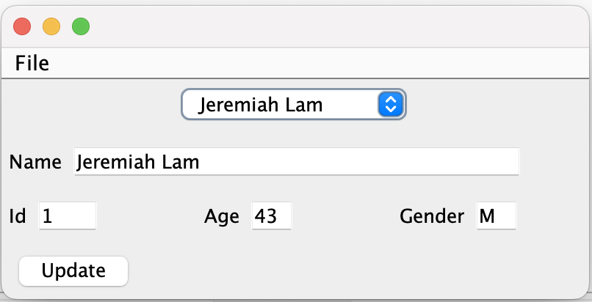

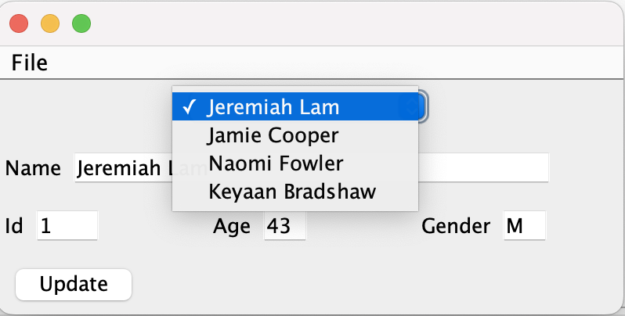

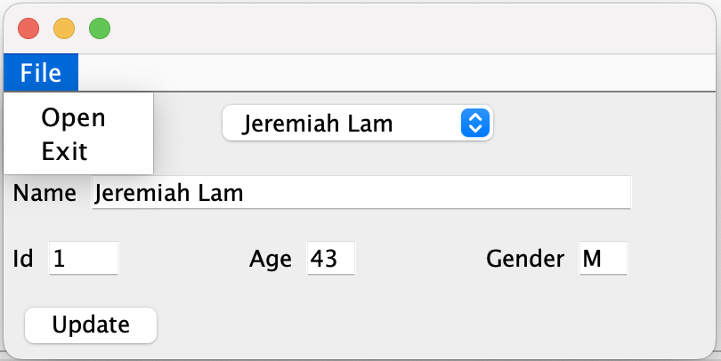

Remember that JComboBox components can take an object, as long as the toString method is something “displayable” in the JComboBox. Though there are other ways to deal with this using a JComboBox of Strings.

I have included code that opens a JFileChooser which will get a file you select to load in a personnel.txt file when you choose the “Open” item on the File Menu, and I have also included Assignment 5’s solutions for loading the data. Modify either/both as you choose.

