

User Manual

Version 1.1 – 9th March 2016

**Dr Chrissy h. Roberts**

**Dr Michael Marks**

[**ODK@LSHTM.AC.UK**](mailto:ODK@LSHTM.AC.UK)

[**OPENDATAKIT.LSHTM.AC.UK**](opendatakit.lshtm.ac.uk)

**Setting up and Using ODK @ LSHTM**

*This is not meant to be a definitive guide to using ODK but provides an overview of configuring your device to work with the ODK@LSHTM Server Setup.*

Requesting an ODK Server at LSHTM

* Complete the Server Request form at [opendatakit.lshtm.ac.uk](https://opendatakit.lshtm.ac.uk/files/2015/09/LSHTM-ODK-Server-%E2%80%93-Project-Request.docx)
* Email the form to <mailto:ODK@lshtm.ac.uk>

If you have used ODK and Aggregate Servers before

* Sections 1 and 3 provide specific details for setting up your ODK @ LSHTM Server

If you have not used ODK or an Aggregate Server before

* Sections 1 and 2 provide details for setting up your server and uploading blank survey forms
* Sections 3 and 4 provide details for downloading blank forms to smartphones/tablets, collecting data and uploading completed surveys to the server
* Section 5 provides details for downloading completed data from the server

Advanced Users: Nested Repeats and Media File Downloads

* Section 6 provides details for using ODK Briefcase for downloading nested repeats and media files associated with your survey

**SECTION 1: Setting up your ODK Aggregate Server**

**Please follow the instructions below on First Login – this is essential to ensure the full security of your data**

**1)** Your project will be accessed at:

example.odk.lshtm.ac.uk

**2)** Click *Log In*

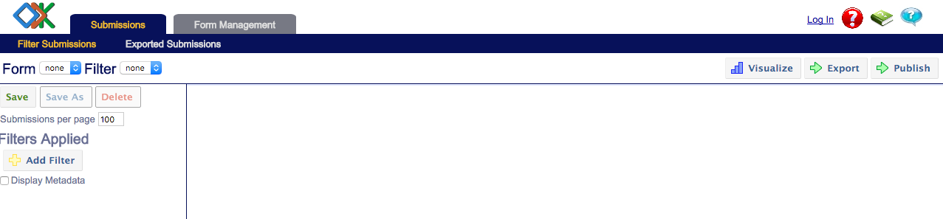

**3)**Select *Sign in with Aggregate password*

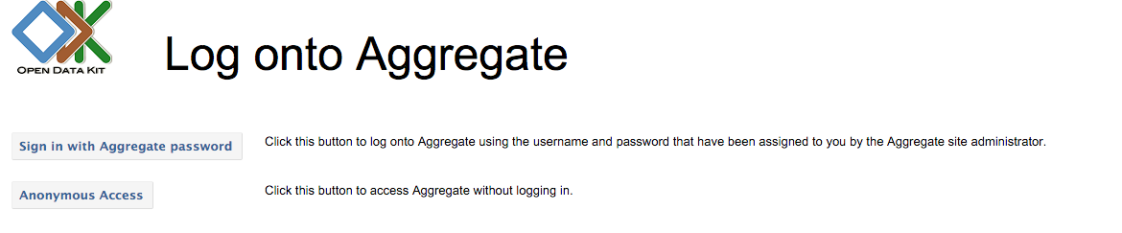

The default account details are:

Username: admin

Password: lshtm

**4)** The *Site Admin* tab will now appear



**5)** Select the *Site Admin* tab

By default there are two users setup:

1) admin 2) anonymoususer

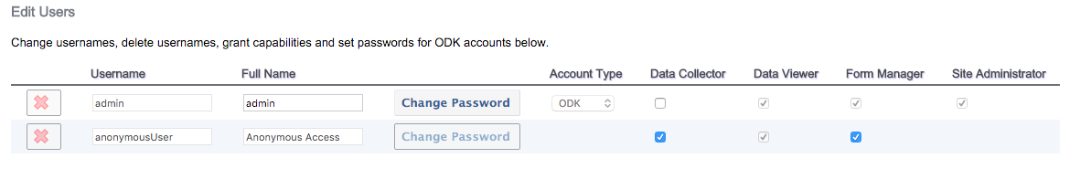

**6)** CHANGE admin Password



**7)** DISABLEAnonymoususer Form Manager



*You must disable Anonymoususer Form Manager – Otherwise people can access your data without a password!*

**8)** SAVE your changes

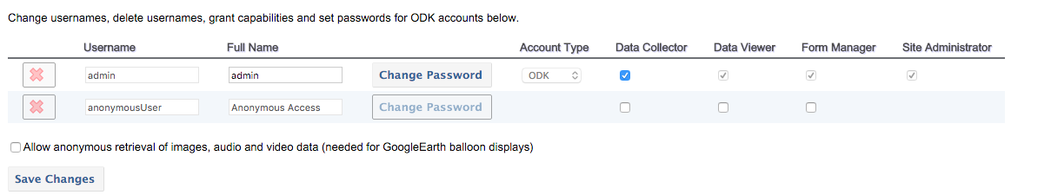

**8)** OPTIONAL BUT RECOMMENDED

We strongly recommend you also disable *Data Collector* for Anonymous Users and create a password protected account with *Data Collector* rights

The new account can be created by

a) Type a new username in the *Add Users* box and click *Add*

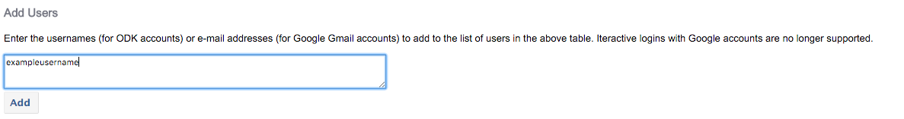

b) Give the new username *Data Collector* rights and set a password

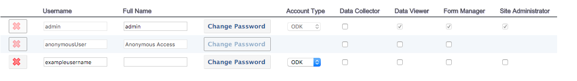

c) Save your changes

**

**YOUR ODK SERVER IS NOW SETUP AND SECURE**

**SECTION 2: Uploading Blank Forms to the ODK Server**

**1)** You need to upload your *Blank forms* to the ODK Server.

A project might have more than 1 form (e.g First Visit, Second Visit etc)

This guide does not cover designing your forms - Links and guidance for writing forms are available at <opendatakit.lshtm.ac.uk>

**2)** Login to your server using the Admin Username and Password

Select the *Form Management* tab

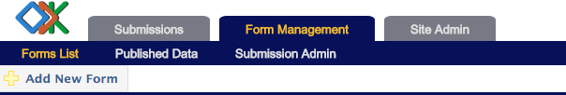

**3)** Click Add New Form



**4)** Select the location of your ODK Form File and Click *Upload Form***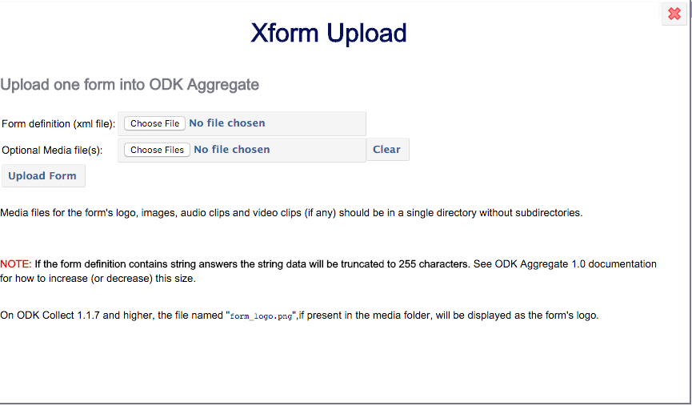**

**5)** Repeat as needed. All of the uploaded forms will be displayed on this page.



Remember if you update a survey form that you might need to delete old versions of it from the server.

**YOUR FORMS ARE NOW AVAILABLE TO BE SYNCED TO DEVICES AND FOR DATA TO BE UPLOADED**

**SECTION 3: Setting up devices using ODK Collect and the LSHTM Server**

**1)** Open ODK Collect on your smart phone/tablet and access *General Settings*

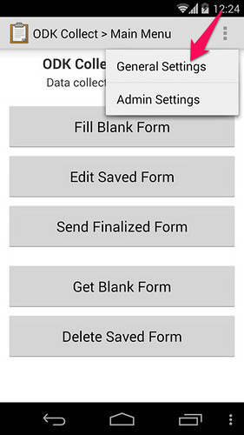

**2)** Select*Configure Platform Settings*

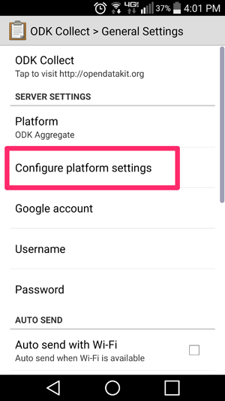

**3)** Enter the URL of your ODK Server **–** Make sure you include the https://

e.g <https://example.odk.lshtm.ac.uk>

*The https (not http) is very important as that makes it a secure connection*

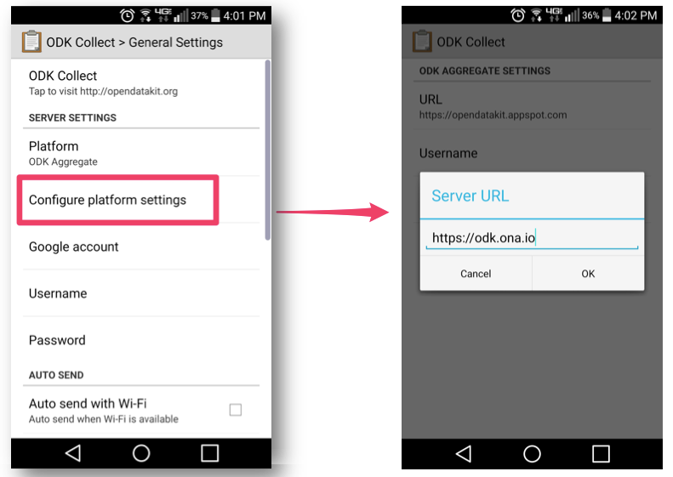

**4)** OPTIONAL BUT RECOMMENDED

If you have setup a Data Collector account with a username and password (See Section 2 Above) also enter these now.

**5)** Return to the main screen and click *Get Blank Forms*

This will bring up a list of all the forms on your ODK server. Select the ones you want and click *Get Selected.*

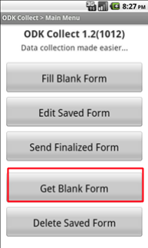 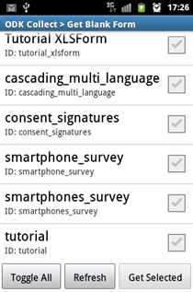

**YOUR SMART DEVICE IS NOW SETUP TO COLLECT DATA**

**SECTION 4: Collecting and Uploading Data**

*Collecting Data (Steps 1-3) does not require a mobile or Wi-Fi connection. Uploading data (Steps 4-5) requires a data connection.*

**1)** From the front screen select *Fill Blank Form*

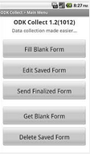

**2)** Select the appropriate Survey Form from the list

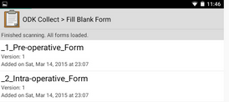

**3)** Complete the Survey

**4)** On the final screen select *Save Form and Exit*

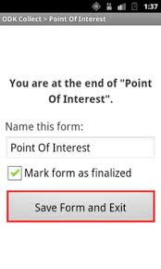

**5)** Select *Send Finalized Form*



**5)** Select *Toggle All* then click *Send Selected* – Data will now be uploaded to your server

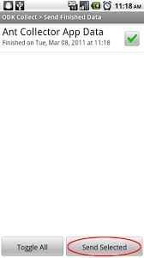

**SECTION 5: Exporting Data – Basic CSV Files Only**

**If your data contains Nested Repeat Groups or Media Files please go to Section 6**

**1)** Login to your ODK server

**2)** Uploaded data will be displayed for the currently selected form.

**3)** Select the *Form* you want to export 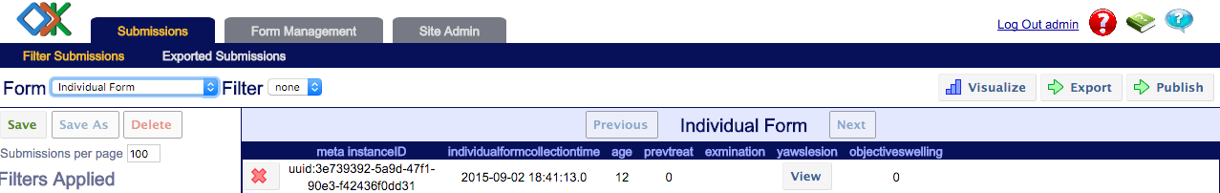

**4)** Click *Export*



**5)** It will list the data that is being exported. Normally this will be a CSV. Click *Export*

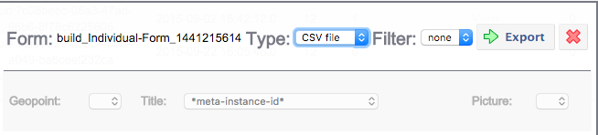

**6)** You will be taken to the *Exported Submissions* tab. This will list the time and date of all exported data. Select the Dataset you want to download the full dataset as a CSV

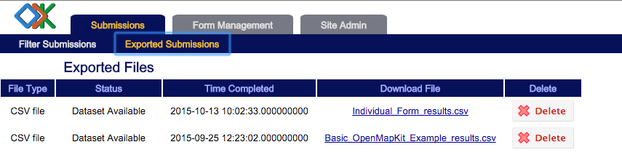

**SECTION 6: Export Data – Complex Datasets**

*If your survey includes repeated group questions or large amounts of media associated with surveys you should use the* [*ODK Briefcase package*](https://opendatakit.org/downloads/download-category/briefcase/) *to download the survey*

**1)** Select *Pull data from* Aggregate 1.0 and click the *Connect* button

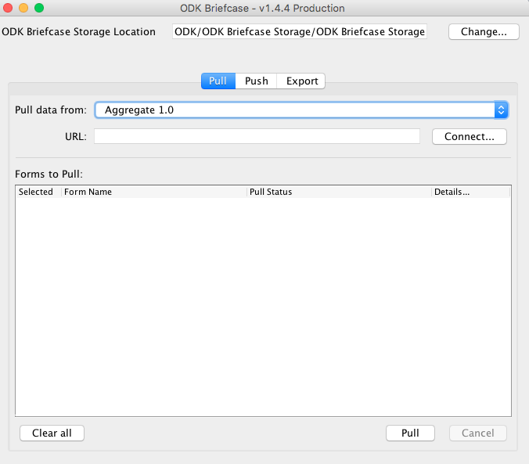

**2)** Enter the URL of your server and enter the username and password of an account with Form Viewer and Data Manager rights (e.g the Admin account).

Click *Connect.*

**URL BOX:** If your servers is called ABC.odk.lshtm.ac.uk then you need to enter

https://ABC.odk.lshtm.ac.uk/ABC

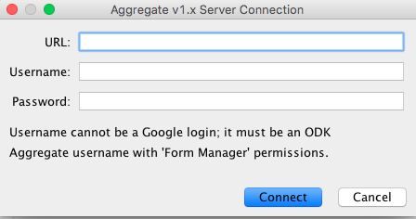

**3)** ODK Briefcase will list all of the Survey forms available on the server. Select the ones you want to download and click *Pull*

**

**4)** Switch to the *Export Tab.* Select the form you want to download and set an export directory then click *Export*

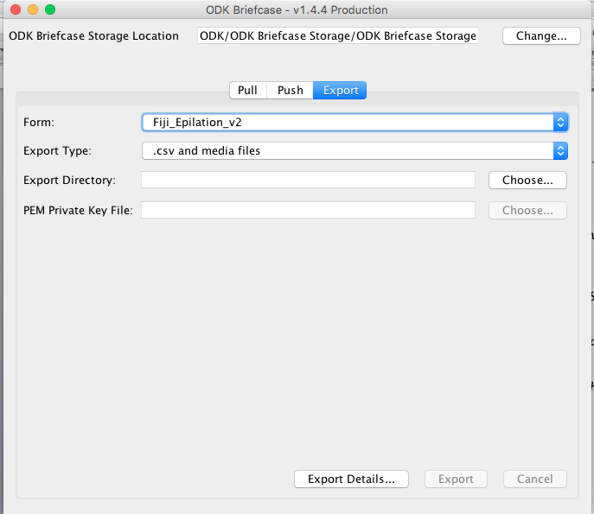

**5)** ODK Briefcase will download the survey for you.

* The main survey data will be downloaded in to a single CSV.
* Nested repeats will be downloaded into a separate CSV – these can be linked in a statistical package of your choice.
* Media files will be downloaded into a folder with a linking identifier.
* If you have collected data using OpenMapKit the OSM files will be in the Media Folder