Controls Guide
This document explains all keyboard controls used to play the game.
The game is played entirely in the terminal using text input.

1. General Controls
These commands are available at most times during the game.
Key | Action:
q | Quit the game
h | Show help / controls
x | End player turn

2. Unit Selection
To select a unit, use its symbol shown on the map.
s <SYMBOL>
Example
s A
Selects the unit with symbol A.
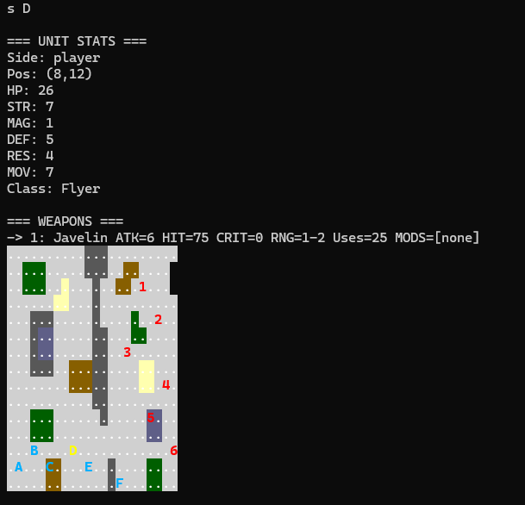
Notes:
- Both player and enemy Units can be selected. Enemy can onyl be inpected for stats but not moved.
- Units that already moved this turn cannot be selected again

3. Movement Mode
Enter Movement Mode
m
- Shows all tiles the selected unit can reach
- Enters cursor-based movement mode
- Also usable for enmies but only to see were they can reach
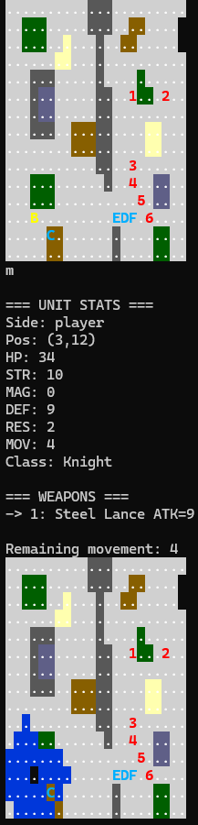
blue tiles are the tiles B can reach
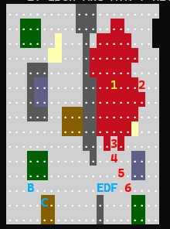
exmaple for enemy
Move the Cursor
While in movement mode:
Key | Action
w | Move cursor up
a | Move cursor left
s | Move cursor down
d | Move cursor right
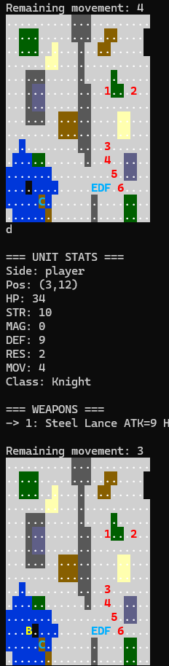
:black movemnt cursor moves with wasd
Confirm or Cancel Movement
Key | Action
r | Confirm movement
c | Cancel movement
- Confirming movement commits the unit’s position
- After moving, the unit is marked as moved
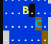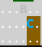unit moves to cursor and turns gray

4. Attacking
List Targets
t
- Lists all enemy units in range of the selected unit’s active weapon
- Targets are numbered

Choose a Target
After targets are listed, type the target number:
1
This shows a combat preview.
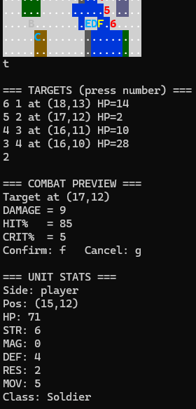
target selection

5. Combat Confirmation
After a combat preview is shown:
Key | Action
f | Confirm attack
g | Cancel attack
- Confirming resolves combat
- Canceling returns to the previous state

6. Switching Weapons
To switch the active weapon of a selected unit:
1
2
3
- The number corresponds to the weapon list shown on screen
- Weapon switching does not consume a turn
- Only player units can switch weapons
- 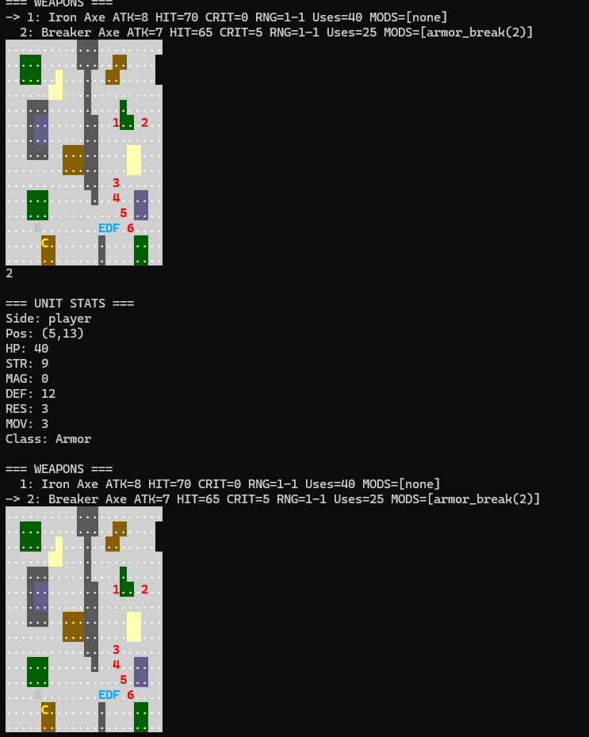
weaponon swicthing

7. End of Turn
x
- Ends the player turn
- Triggers the enemy phase
- All enemies move and attack automatically
- A new player turn begins afterward

8. Visual Indicators
Indicator | Meaning
Blue unit | Player unit
Red unit | Enemy unit
Yellow unit | Currently selected unit
Black unit | Unit that already moved
Highlighted tiles | Movement range or cursor

