User Documentation – Setup & Running the Game

1. Prerequisites
You need the following software installed on your system:
-node.js
-java
-effekt

2. Project Setup

2.1 Clone This Repository
git clone https://github.com/christiNnnNNNn/Turn-based-Strategy-Name-in-Effect.git

2.2 Map File Location
This project loads a map file from a hard-coded path inside main.
Open the file:
src/main.effekt
Find this line:
val text = readFile("C:/Users/Christian/Documents/testMap.txt")
Change the path to point to the map file provided in the root of this repository, called testMap.txt, for example:
val text = readFile("./testMap.txt")
Make sure:
- testMap.txt is located in the root directory of the repo
- The path matches your operating system

3. Running the Game
From the root of the repository, run:
effekt run src/main.effekt
If everything is set up correctly:
- The map will render in the terminal
- Controls will be printed
- You can interact using the keyboard
If succesful output should look like this:
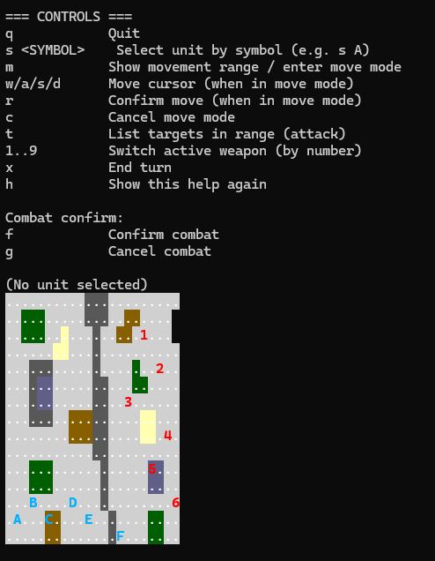
Try to entert the command:s A
You should get somehting like this:
