Memesy
Production Stack Proposal
DevOps Interview — C2C Marketplace

1. Requirements Addressed
Each requirement from the brief is addressed below with the specific technology or design decision that satisfies it.

Requirement | How it is addressed | Stack component
Users will primarily use email and password-based authentication. | Flask handles login using email and password. On success it issues a JWT (JSON Web Token) — a secure digital ID card the user carries for their session. Sessions are stored in Redis for fast validation on every request. | JWT Auth + Redis
Memesy is a peer-to-peer marketplace expecting equal amounts of listing and browsing activities. | Equal read/write load is handled by placing Redis in front of PostgreSQL for all browse requests. Popular listings are cached in Redis so browse traffic does not compete with seller write traffic on the database. AWS ALB routes requests to the correct Flask service via path-based listener rules. | Redis + ALB + PostgreSQL
Memesy is discovering their market and needs to adapt quickly to changes in data structure. | PostgreSQL is used with JSONB columns for listing attributes. JSONB allows variable, flexible fields per meme format (e.g. video duration, image dimensions, audio bitrate) without requiring database migrations every time the data shape changes. | PostgreSQL + JSONB
Buyers can purchase multiple assets in a single payment transaction. Once purchased, each buyer has a unique access link to their copy of the asset. | Stripe Payment Intents support multi-item checkout in one transaction. After payment, SQS triggers Lambda which generates a CloudFront signed URL per asset scoped to the buyer's order ID. No file duplication — one S3 file serves all buyers with individual signed links. | Stripe + SQS + Lambda + S3 + SES
Memesy will launch in US markets, expecting 1M MAU within the first quarter. | CloudFront CDN delivers assets globally from US edge locations. ECS Fargate auto-scales Flask services horizontally based on traffic. RDS Multi-AZ ensures database availability. All infrastructure is managed by Terraform for fast, reproducible environment provisioning. | CloudFront + ECS Fargate + RDS + Terraform

2. Proposed Stack
The stack below is selected based on the requirements above.

Layer | Technology | Rationale
Client | React + TypeScript | SPA compiled to static files, hosted on S3, served via CloudFront. No server needed at runtime.
Edge | CloudFront + WAF | CDN for low-latency US delivery. WAF attaches here for DDoS protection and request filtering.
Media | S3 | Stores all meme assets (image, video, audio) and React static files. Raw bucket is never public.
Load Balancer | AWS ALB | Fully managed Application Load Balancer. Path-based routing to ECS Fargate target groups. Native health checks, TLS termination via ACM, multi-AZ by default. No self-managed proxy to operate or patch.
Backend | Flask (Python) | Lightweight, fast to build. Strong Python ecosystem for media handling (boto3, Pillow). Three services: listing, order, payment.
Auth | JWT (Flask) | Email/password login issues JWT token. Sessions stored in Redis for fast per-request validation.
Payments | Stripe | Multi-item Payment Intents for single transaction checkout. Webhook triggers SQS on payment success.
Database | PostgreSQL (RDS Multi-AZ) | Primary data store for users, listings, orders, tokens. JSONB columns for flexible listing attributes.
Cache | Redis (ElastiCache) | Hot listing cache, JWT session store, and Celery task broker. Reduces PostgreSQL read load at 1M MAU.
Jobs | Celery | Background tasks: thumbnail generation, metadata extraction, cache invalidation, seller notifications.
Async / Events | SQS + Lambda + SES | Guaranteed delivery for purchase events. Lambda generates signed URLs. SES emails buyer. DLQ on failure.
Containers | ECS Fargate + Docker | Managed container hosting. No node/cluster management. Scales horizontally on CPU/request metrics.
CI/CD | GitHub Actions | Automated build, test, and deploy pipeline on every merge to main.
IaC | Terraform | All AWS infrastructure as code. Reproducible, version-controlled, no manual console clicking.

3. Architecture Diagram
The diagram below shows the full production architecture with data flows annotated per scenario — browse/auth flow, seller upload flow, purchase/payment flow, and cache/broker flow.
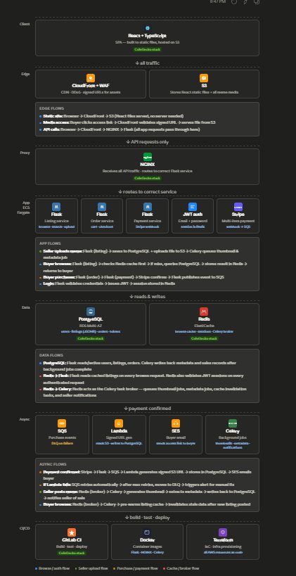

4. How It Works

When a user visits the site
- Browser loads React app from S3 via CloudFront — no server needed, the static site is cached at edge locations across the US.
- WAF sits on CloudFront as a security bouncer — blocking bots, DDoS attempts, and malicious requests before they reach the app.

When a user logs in
- Login request flows: Browser → CloudFront → ALB → Flask (auth target group).
- Flask validates credentials against PostgreSQL and issues a JWT token. Session is stored in Redis for fast validation on every subsequent request.

When a seller posts a meme
- Flask (listing service) saves listing details to PostgreSQL and uploads the media file to S3.
- Celery picks up background tasks: generates thumbnail, extracts metadata (dimensions, duration), invalidates Redis cache so buyers see the new listing immediately.
- Seller notification is queued via Celery — sends an email confirmation that the listing is live.

When a buyer browses listings
- Flask (listing service) checks Redis cache first — if the listings are cached, returned instantly without touching PostgreSQL.
- If cache miss: queries PostgreSQL, stores result in Redis, returns to buyer. Celery pre-warms the cache in the background for popular listings.

When a buyer purchases memes
- Flask (order + payment services) sends a multi-item checkout to Stripe. One payment, multiple assets.
- Stripe webhook fires on success → Flask publishes purchase event to SQS. SQS guarantees the event is not lost even if downstream services fail.
- Lambda generates a buyer-scoped CloudFront signed URL per asset — unique to that buyer's order. SES emails the buyer their access links.
- If Lambda fails: SQS auto-retries. After max retries, message moves to Dead Letter Queue (DLQ) — no purchase event is ever silently lost.

When a seller sells a meme
- Celery updates the seller's sales record in PostgreSQL and sends a seller notification email via SES — confirming their meme was sold.

5. Assumptions
- Unique access link = buyer-scoped signed URL, not a physical copy of the file per buyer. One S3 file serves all buyers.
- 1M MAU does not mean 1M concurrent. Estimated 20-30K peak concurrency, handled by ECS Fargate with 2-4 tasks per service.
- US-only launch — single primary region (us-east-1) is acceptable. CloudFront handles latency at the edge.
- No video transcoding, DRM, or content moderation in MVP scope — raw upload to S3, served direct.
- Platform commission model is expected but not in MVP scope. Stripe Connect can be added later without architectural change.

Memesy Production Stack Proposal • DevOps Interview

