Hebbian and Hopfield Networks: Computational Models of Memory

By Christian G. Fink

Memories come in many different forms, and they are forged through many different neuronal processes. For example, learning to ride a bike (an example of procedural memory) is very different from learning facts for an exam (an example of semantic memory). One particularly interesting aspect of episodic memory is that we are able to form memories from one exposure to a sensory stimulus (unlike memorizing facts for a test, for example). How does the brain do this? In this lab we will explore a computational model that applies the Hebbian principle “neurons that fire together, wire together” to simulate memory encoding, storage, and retrieval in a simulated neural network. In a related model (proposed by John Hopfield in 1982 [1]) memories are formed after each sensory pattern is experienced only once, mimicking the brain’s (more specifically, the hippocampus’s) ability to form episodic memories from just one exposure.

Note that some of the exercises in this laboratory are inspired by the discussion of covariation learning in chapter 4 of Tutorial on Neural Systems Modeling, by Thomas J. Anastasio [2].

Part 1: Simulating encoding, storage, and retrieval

1. Start by going to http://chrisfink.xyz/teaching/teaching_resources.html and downloading the memory app. Unzip it and open the file ‘memory_app.exe.’

2. The program that opens is divided into three panes. The first simulates sensory encoding, the second memory storage, and the third memory retrieval. To get a sense for how this model simulates these three stages of memory, start in the “Encoding” pane and select “5 neuron(s) activated” from the drop-down menu in the row for “Pattern #1.” Then click the adjacent button “Generate Random Pattern.” You will see five of the twenty boxes change from gray to red, representing five spiking neurons. In this model neurons are either active or silent, and the pattern of neural activation is used to encode different sensory stimuli. As a concrete example, you might imagine that one set of neurons activates in response to a particular image of the ocean, while another set activates in response to a particular image of a mountain. (These would be two different patterns in our Encoding pane.)

3. So far, our simulated “brain” (consisting of only 20 neurons) has been exposed to and encoded only one sensory stimulus (or one “image”). This pattern must somehow be stored, so that if a similar pattern is induced in the future, this original pattern will be recovered. Donald Hebb famously postulated that such storage could be achieved through activity-dependent plasticity, which implies that a neuron’s activity influences its connectivity (“neurons that fire together, wire together”). To see this principle in action, go to the Storage pane and click the “LEARN” button. Describe the changes you observe in the network, and explain how these changes are consistent with Hebb’s famous adage.

4. To simulate retrieval, go to the Retrieval pane and start with the pattern that was originally encoded in the network by clicking the button to “Use pattern number 1.” Then, choose any two of the activated neurons, and de-activate them by clicking on the corresponding squares, turning them from red to gray. If the original pattern of neural activation might be thought of as encoding an image of the ocean, what might this altered pattern represent?

Now click the button “Compute Output.” This runs a simulation in which the initial activation pattern evolves forward in time, possibly resulting in other neurons activating or inactivating. Neurons that have positive connections will force each other to activate, and neurons that have negative connections will force each other to inactivate, and these interactions will continue until none of the neurons can change their state. At this point we say the network has reached “steady state” (at this point the simulation time will say “Finished”).

What is the steady state pattern that you observe? Does it match Pattern #1 from the encoding pane? How does this happen? (Answer in terms of what you observed in the Storage stage.) What significance does this have in terms of memory?

Part 1 Notes

Part 2: Pattern completion

You should have seen that the stable output pattern matched Pattern #1. This is an example of pattern completion, in which a neural network takes an incomplete version of a previously-encoded pattern as input, and outputs the completed version.

1. To explore this idea further, start by clicking the “Reset” button in the Retrieval pane, the “Erase Learning & Reset” button in the storage pane, and the “Clear All” button in the Encoding pane.

2. Then create five distinct sensory patterns in the Encoding pane, the first with neurons 1-4 activated, the second with neurons 5-8 activated, etc. Do this by directly clicking on the squares you wish to activate. In the end the sensory patterns should be defined like so:

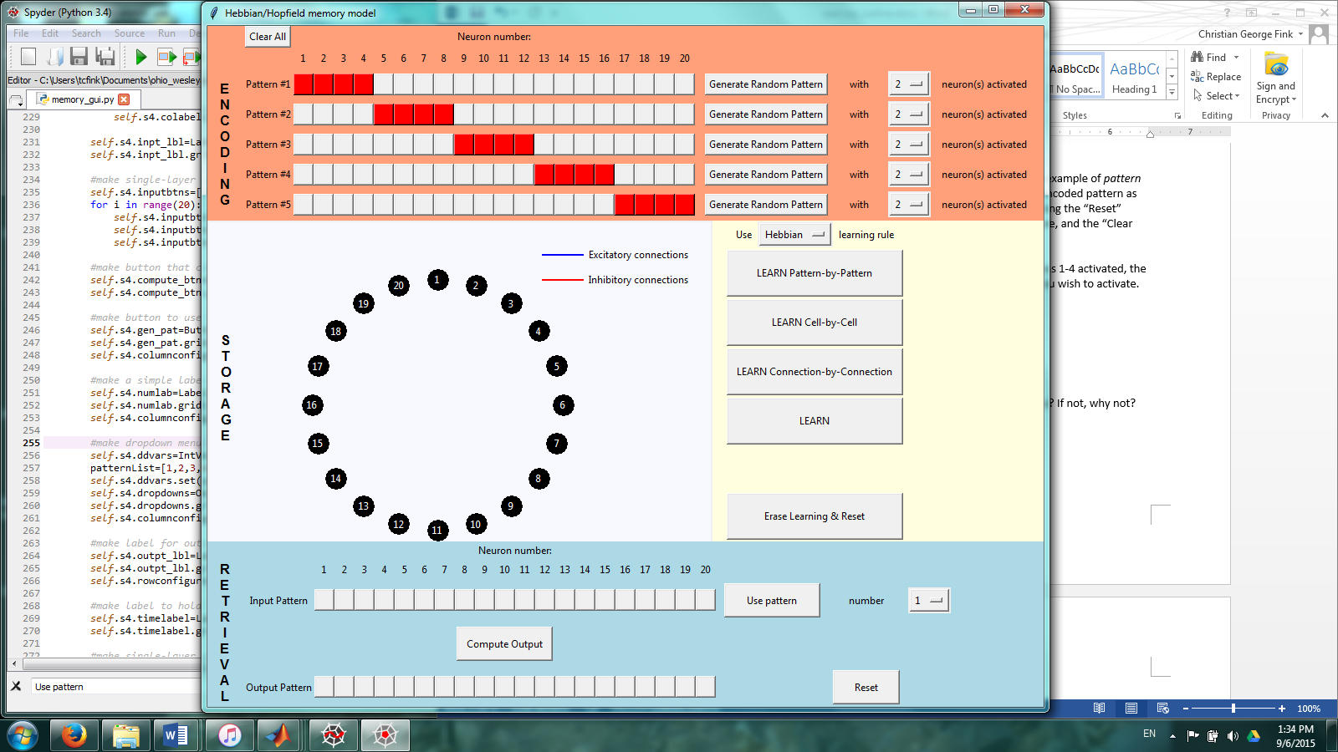

3. Store the memories in the network by pressing the “LEARN” button in the Storage pane. Describe the connectivity that results, and explain why it takes the form you observe.

4. Test memory retrieval by activating just neuron 7 (by clicking on the appropriate square in the Retrieval pane), then clicking “Compute Output.” Is a memory successfully retrieved? If so, which memory? If not, why not? (The evolution of network activity is somewhat random, so you should click “Compute Output” several times and base your answer upon the typical outcome.)

5. Before actually doing it, predict which memory will be recalled if just neuron 17 is initially activated. How do you know this? (You can check your prediction by clicking the “Reset” button in the Retrieval pane, then following the same procedure as in Step 4.)

Part 2 Notes

Part 3: Pattern separation

1. Reset all panes, as at the beginning of Part 2. Then define two sensory input patterns, the first with neurons 1-10 activated, and the second with alternating neurons 2, 4, 6,…, 20 activated.

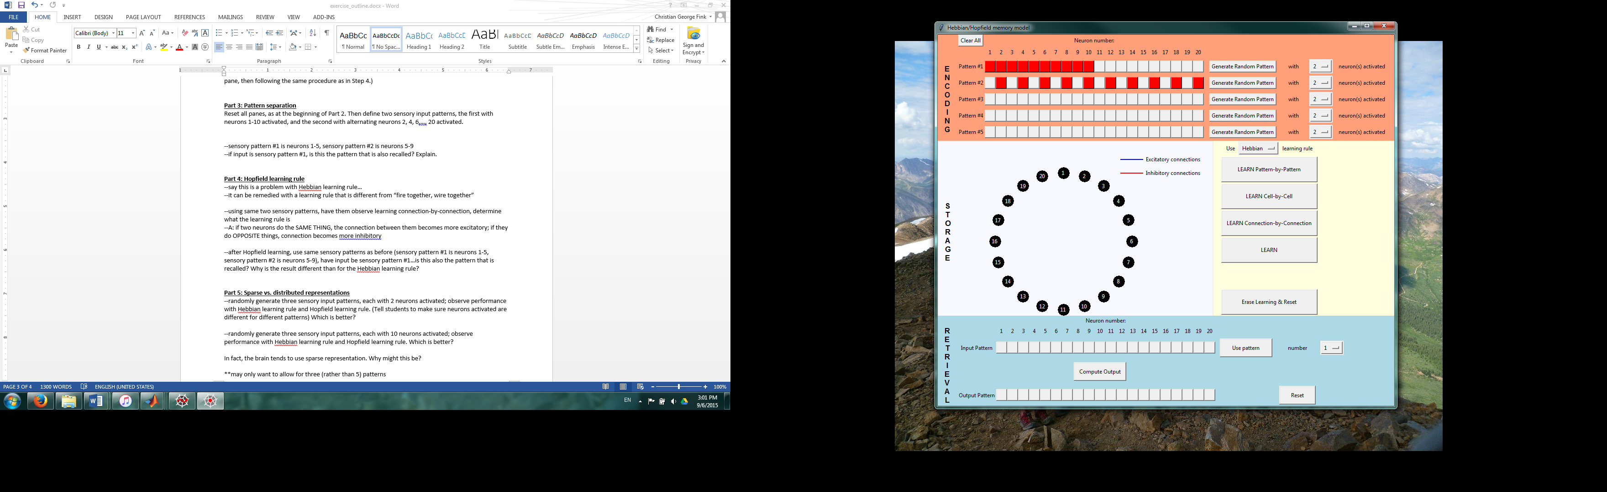

2. Click “LEARN” in the Storage pane. Note that some of the lines are thicker than others, indicating stronger connections. Which connections are stronger than the others, and why are they stronger? (You may find it helpful to use the designated buttons to generate the network connectivity connection-by-connection, cell-by-cell, or pattern-by-pattern. Just make sure to click “Erase Learning & Reset” before switching from one button to another.)

3. Check how well the network is able to retrieve the first pattern by setting the dropdown menu in the Retrieval pane to “1” and clicking “Use pattern.” Then randomly choose one of the activated neurons and de-activate it, so that the input pattern is not exactly the same as sensory Pattern #1. What happens when you compute the output?

Follow the same procedure to input an incomplete version of sensory Pattern #2. What happens when you compute the output?

In either case, is the memory successfully retrieved? Why or why not? (Answer in terms of the network connectivity.)

Part 3 notes

Part 4: Hopfield learning rule

The ability of a neural network to store memories of overlapping sensory patterns, and to correctly retrieve each pattern, is an example of pattern separation. You saw in Part 3 how the Hebbian network failed to separate two overlapping patterns. Hebbian networks use a very specific learning rule to generate connections between neurons: if two neurons are activated within a pattern, an excitatory connections forms between them. If the same two neurons are also activated in other patterns, then the excitatory connection between them grows even stronger.

However, this is not the only conceivable method of determining the connections in a network. There are other possible learning rules, with the most famous being the Hopfield learning rule, named after the person who proposed it, John Hopfield [1].

1. To investigate this learning rule, reset the Retrieval pane and the Storage pane, but leave the Encoding pane as it was in Part 3. Then, in the Storage pane click the dropdown menu and select the Hopfield learning rule. Then click the “LEARN” button. What is the most obvious difference between the connectivity you now observe, and the connectivity you observed previously using the Hebbian learning rule?

2. Click “Erase Learning & Reset.” Investigate how neural activation patterns determine network connections by using the designated buttons to generate connectivity connection-by-connection, cell-by-cell, or pattern-by-pattern. As before, make sure to click “Erase Learning & Reset” before switching from one button to another. What is the Hopfield learning rule? (You may reference the above explanation of the Hebbian learning rule as an example of an appropriate description.)

3. Click “Erase Learning & Reset,” then click the “LEARN” button. Using the same sensory patterns as in Part 3, check how well the network is able to recall the first pattern by setting the dropdown menu in the Retrieval pane to “1” and clicking “Use pattern.” Then randomly choose one of the activated neurons and de-activate it, so that the input pattern is not exactly the same as sensory Pattern #1. What happens when you compute the output?

Follow the same procedure to input an incomplete version of sensory Pattern #2. What happens when you compute the output?

In either case, is the memory successfully retrieved? Why are these results different from those observed using the Hebbian learning rule?

Part 4 notes

Part 5: Sparse vs. distributed representations

Even though the Hopfield learning rule performed better than the Hebbian learning rule in the pattern separation task from Parts 3 and 4, there are some circumstances in which the Hebbian learning rule offers distinct advantages.

1. Reset all three panes. Then generate five random patterns with 2 neurons activated. Make sure that no neuron is activated in more than one pattern by finding those that are and re-generating random patterns until every neuron is activated in at most one pattern. Create the network connections using the Hebbian learning rule.

2. Test the network’s ability to retrieve all five patterns by going to the Retrieval pane and first selecting “Use pattern number 1.” Randomly select one of the two activated neurons and de-activate it, then compute the output and record whether or not the memory was successfully retrieved. Do this for all five sensory patterns. How many are correctly retrieved?

3. Reset the network connections and re-create them using the Hopfield learning rule. Then repeat Step 2 (using the same sensory patterns as before). How many patterns are correctly retrieved? What pathological brain event might this be likened to? Explain why this happens.

4. Reset all three panes, then generate five random patterns, each with 10 neurons activated (in this case it is okay for a neuron to be activated in more than one pattern). Then create the network connections using the Hopfield learning rule.

5. Test the network’s ability to retrieve each pattern, as in Step 2. (Again, you should randomly select one of the activated neurons and de-activate it before computing the output.) How many patterns are correctly retrieved?

6. Reset the network connections and re-create them using the Hebbian learning rule. Then repeat Step 5 (using the same patterns as before). How many patterns are correctly retrieved? Explain why this happens.

When encoding incoming sensory signals, neural networks may use either a sparse representation in which relatively few neurons are activated, or a distributed representation in which many neurons are activated. Which learning rule exhibits better performance for a sparse representation? For a distributed representation? Explain why the performance of these learning rules differs in these two situations.

The model of memory you have just explored is thought to reflect many properties of the CA3 region of the hippocampus, which has been shown to be capable of learning patterns with just one exposure. The CA3 region of hippocampus also employs a sparse representation, with approximately 2% active neurons. Why might the brain have evolved to prefer sparse representations to distributed representations?

Part 5 notes

Part 6: Exploration
Pose your own question(s) related to this computational model of memory, then use this applet to run simulations to answer your question. Print screen shots and explanations of your results.

References
[1] Hopfield JJ (1982) Neural networks and physical systems with emergent collective computational abilities. P Natl Acad Sci USA 79:2554-2558.
[2] Anastasio TJ (2010) Tutorial on Neural Systems Modeling. Sinauer Associates Inc. Publishers Chapter 4.

