Here is some text

**I am bold**

*I am italic*

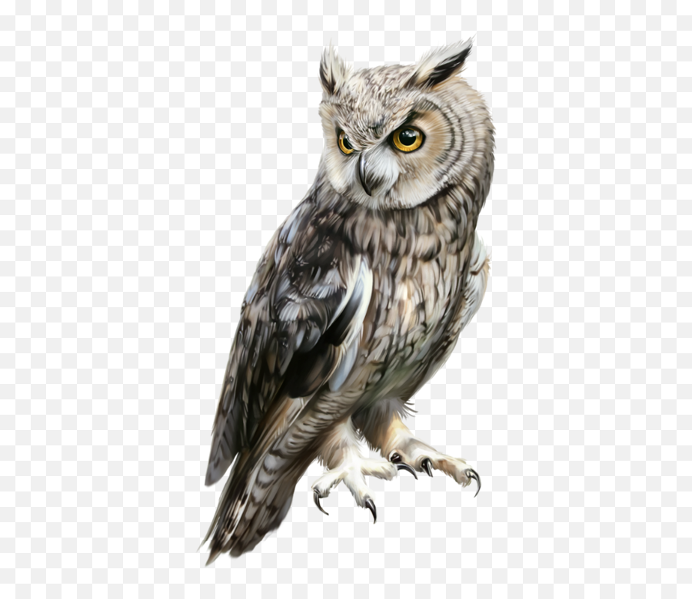

|  |  |  |  |  |  |
| --- | --- | --- | --- | --- | --- |
| Boibuiobib | Bhbhbh | Bobiobi | Uyv | Ytccr | Bl |
| Uiboyvyt | Kh | Jkl | Bluyv | Lvgt | Hb |
| Hbv | Luybg | Ui | Ioyg | Ulybv | Liug |
| Ou8gyv | V | Tyikv | Kybg | Gto | 87uyg |
| Ilyg | Olg | Uy | Gugy | Il | Ubnp; |
| Uho | Gb | Lubgy | Lih | ;ouih | Luig |
| Bluib | Ol | Byol | Yli | Bnuil;bn | lbluj |

HIGHLIGHT ME

Underlines exist too

This text is big