COMP 476 Assignment 2 Theory Questions

Christian Plourde

I.D. 26572499

**Question 1:**

1. The following table shows the operations for Dijkstra’s Shortest Path algorithm for finding the shortest path from the start to the goal node in the graph described in the assignment description. If a cost so far or connection is changed from one step to another it will be shown in red.

|  |  |  |
| --- | --- | --- |
| **Current Node** | **Open List** | **Closed List** |
| - | (S, 0, -) | - |
| S | (A, 3, SA), (B, 10, SB) | (S, 0, -) |
| A | (B, 8, AB), (C, 12, AC), (D, 9, AD) | (S, 0, -), (A, 3, SA) |
| B | (C, 11, BC), (D, 9, AD),  (G, 23, BG) | (S, 0, -), (A, 3, SA), (B, 8, AB) |
| D | (C, 11, BC), (G, 23, BG),  (E, 15, DE) | (S, 0, -), (A, 3, SA), (B, 8, AB),  (D, 9, AD) |
| C | (G, 17, CG), (E, 15, DE) | (S, 0, -), (A, 3, SA), (B, 8, AB),  (D, 9, AD), (C, 11, BC) |
| E | (G, 17, CG) | (S, 0, -), (A, 3, SA), (B, 8, AB),  (D, 9, AD), (C, 11, BC),  (E, 15, DE) |
| G |  | (S, 0, -), (A, 3, SA), (B, 8, AB),  (D, 9, AD), (C, 11, BC),  (E, 15, DE), (G, 17, CG) |

Now to find the shortest path we start at the end node and look at the connections. This gives us:

G -> C -> B -> A -> S

Or from start to end:

S -> A -> B -> C -> G with a total cost of: 17

1. The following table shows the operations for the A* Pathfinding algorithm for finding the shortest path from the start to the goal node in the graph described in the assignment description. If a cost so far or connection is changed from one step to another it will be shown in red.

|  |  |  |
| --- | --- | --- |
| **Current Node** | **Open List** | **Closed List** |
| - | (S, 0, -, 11) | - |
| S | (A, 3, SA, 15), (B, 10, SB, 14) | (S, 0, -, 11) |
| B | (A, 3, SA, 15), (C, 13, BC, 24),  (G, 25, BG, 25) | (S, 0, -, 11), (B, 10, SB, 14) |
| A | (C, 12, AC, 23), (G, 25, BG, 25),  (B, 8, AB, 12), (D, 9, AD, 13) | (S, 0, -, 11), (A, 3, SA, 15) |
| B | (C, 11, BC, 22), (G, 23, BG, 23),  (D, 9, AD, 13) | (S, 0, -, 11), (A, 3, SA, 15),  (B, 8, AB, 12) |
| D | (C, 11, BC, 22), (G, 23, BG, 23),  (E, 15, DE, 24) | (S, 0, -, 11), (A, 3, SA, 15),  (B, 8, AB, 12), (D, 9, AD, 13) |
| C | (G, 17, CG, 17), (E, 15, DE, 24) | (S, 0, -, 11), (A, 3, SA, 15),  (B, 8, AB, 12), (D, 9, AD, 13),  (C, 11, BC, 22) |

Since the goal node G is now the one with the lowest estimated total cost, we can stop. We can work out the path by looking at the connections in reverse order. This yields the path:

S -> A -> B -> C -> G with a total cost of 17.

**Question 2:**

1. Below is a diagram showing an equivalent finite state machine.

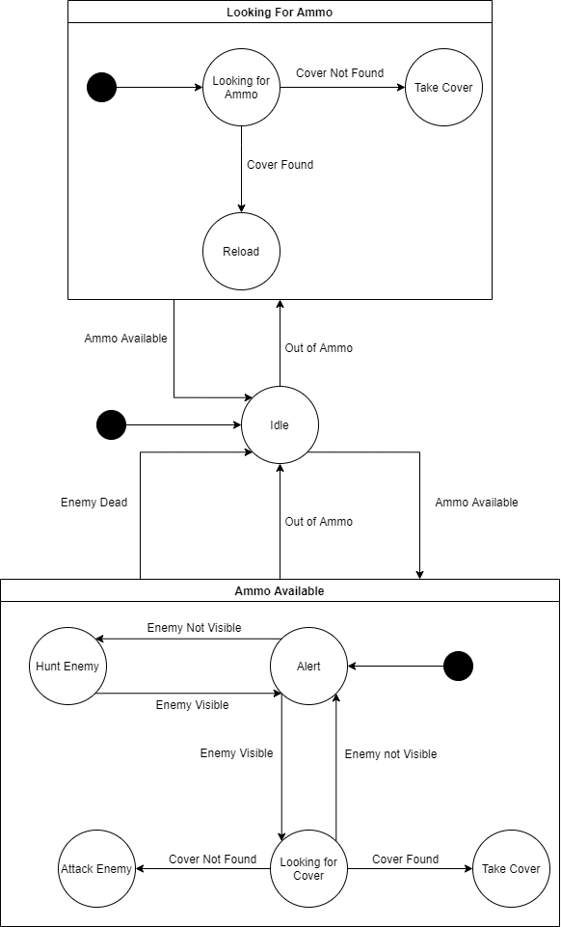

1. Below is a finite state machine like the one in part a) but with the alarm behaviour.

