**Title** Mistborn - Ragnarok

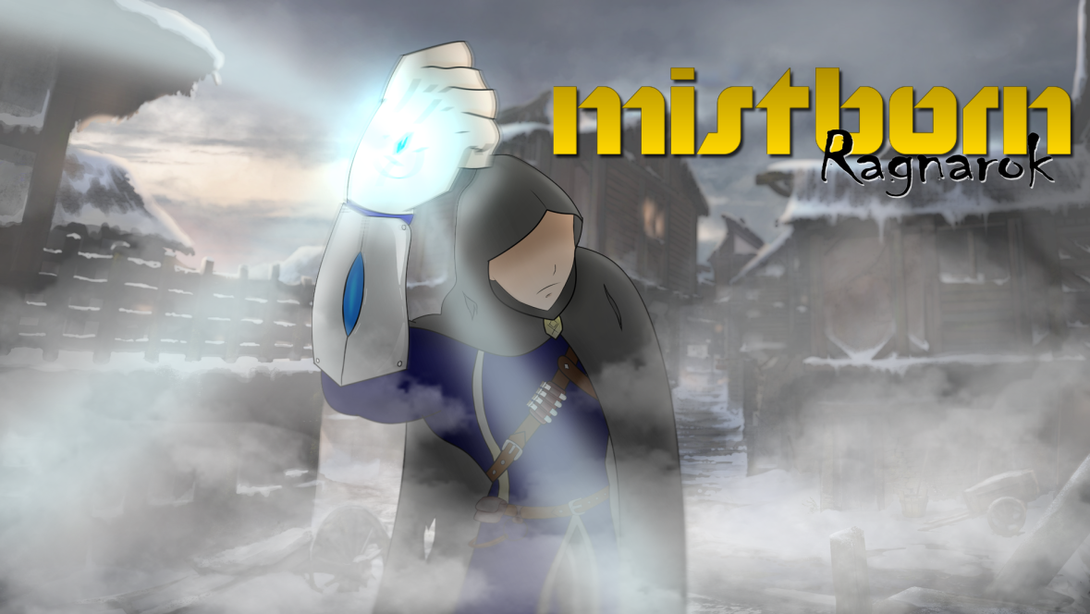

**Tag line** All paths leads to Ruin.

**Your names** Christian Plourde

Ayush Kharade

Daniel Vellucci

Samer Yazbeck

Luciano Porchet

**Genre** Action, Platformer/Puzzle

**Platform** PC

*Logo or Box Art*

**Target**  Everyone ages 12 and up, into platforming games & puzzle solving.

**Audience**

**Setting Medieval/Fantasy setting, in cold world where ash falls constantly from the sky and mists come**

**out during the night. The sun is red.**

**Goal The player must fight through enemies and solve puzzles in order to make it to a final**

**fight with Ruin (the main antagonist) where he is confronted.**

**Plays like** Trine meets Captain Claw (1997)

*Popular Game A Popular Game B or twist*

**Mechanics**

1.Platforming 3. Puzzle solving

2.Manipulate environment with your powers 4. Combat

1.Mistborn Trilogy Books – Brandon Sanderson 4. Nordic themed architecture

**Reference** **Art**

2. Limbo – game (2010) 5. Ori and the blind forest - game (2015)

3. Trine Trilogy - game (2009) 6. INSIDE - game (2016)

**Related Games**

1. ________________________________________________________________________________________

*Title Publisher or Developer Genre/Platform Year*

Hollow Knight Team Cherry Action-Platformer / PC 2017

Hollow Knight Description: Fight enemies in a forsaken world using spells and abilities unlocked along the way. Platforming areas lead to a final boss fight, requiring the player to use the abilities he/she has learned along the way. Mistborn implements similar mechanics especially abilities to fight enemies, and a boss fight.

________________________________________________________________________________________

2. ________________________________________________________________________________________

*Title Publisher or Developer Genre/Platform Year*

INSIDE Playdead Indie-Platformer/PC 2016

Protagonist is being hunted by an entity while everyone else is enthralled by the entity. The protagonist has to sneak around and solve puzzles. This dark setting resembles the mistborn world. It also implements similar puzzle solving mechanics.

________________________________________________________________________________________

3. ________________________________________________________________________________________

*Title Publisher or Developer Genre/Platform Year*

Trine Frozenbyte Action-Platformer/PC 2009

Fantasy setting platformer, fighting enemies, solving puzzles along the way. Use character abilities to interact with the environment and achieve you goal. Mistborn is inspired by the puzzle solving element and the ability to interact with the world.

________________________________________________________________________________________

*Supporting Screenshot or Mechanic Analysis Diagram (for the proposed game)*