**Assignment --- MODULE 8**

1. Consider a four layer fully-connected (include input layer) network with $n_{1}, n_{2}, n_{3}$, $n_{4}$ neurons in four layers respectively. Input are fed into the first layer and represented by x, the loss is mean squared error E, and the activation function for each layer is sigmoid function $\frac{1}{1+ e^{-x}}$. Let the label vector be t of size $n_{4}$ and let each layer output vector be $y_{i}$ and the input for each layer be $z_{i}$, both of size $n_{i}.$

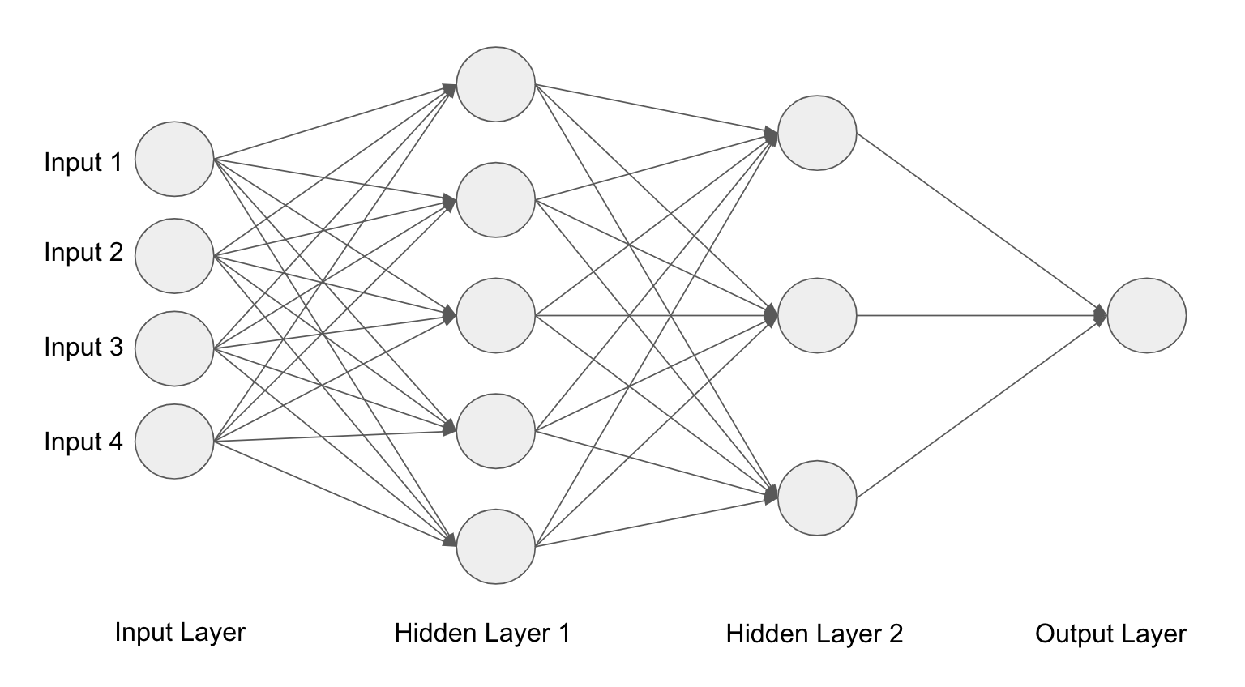

How many trainable parameters in this model (You don’t need to consider the bias term in this exercise)

$n_{1}$ is the input layer where we have 4 inputs ($n_{1}=4$). $n_{2}$ is the first hidden layer containing 5 neurons ($n_{2}=5$) and the second hidden layer contains 3 neurons ($n_{3}=3$) and finally our output layer only containing 1 neuron ($n_{4}=1$). The number of parameters is equal to the product of each layer $n_{i}$. That is ${(n}_{1}×n_{2})+{(n}_{2}×n_{3})+{(n}_{3}×n_{4})=number of parameters$. That is $\left(4 ×5\right)+\left(5 ×3\right)+\left(3 ×1\right)=38$ trainable parameters

1. Fill out the code cells in hw_8_tf.ipynb to get yourself familiar with Tensorflow.
2. Go to the datasets folder and run the script get_datasets.sh to download cifar-10 dataset (for mac you can simply type “sh ./get_datasets.sh” to run the script). Fill out the code cells hw_8.ipynb.

Submit a .doc or .pdf with your written answers. Submit your Python notebook. Submit a PDF of your Python notebook.