Integricity Technology
MSP Report Builder
System Architecture
August 2026

1. Overview
The Integricity MSP Report Builder is a web application that generates monthly IT health reports for client Microsoft 365 and Intune tenants. It runs entirely on Netlify — a single-page front end plus five serverless functions — and calls the Microsoft Graph API directly from the server side using per-session, per-tenant credentials (browser wizard) or stored per-client credentials (report-hub integration).

Item | Detail
Live URL | https://integricitymsp.netlify.app
Hosting | Netlify (free tier)
Front end | Single HTML file — no build step, no framework
Back end | Five Netlify serverless functions (Node.js)
Data source | Microsoft Graph API v1.0
Auth model | OAuth 2.0 Client Credentials flow, app-only, read-only
Credential storage | Browser wizard: none, session memory only. Report-hub integration: server-side, via the INTUNE_CLIENTS_JSON environment variable

2. Architecture Diagram
Data flows left to right: the account manager enters tenant credentials into the browser app, which calls Microsoft Graph on the server side, reads data from the client tenant, and renders both an on-screen report and a Word/PDF export. A second, parallel path (top of diagram) shows report-hub — a separate consumer application — reaching the same Netlify app through clients.js and report-data.js, using credentials held server-side in lib/clients-store.js rather than the browser wizard's session-only credentials.

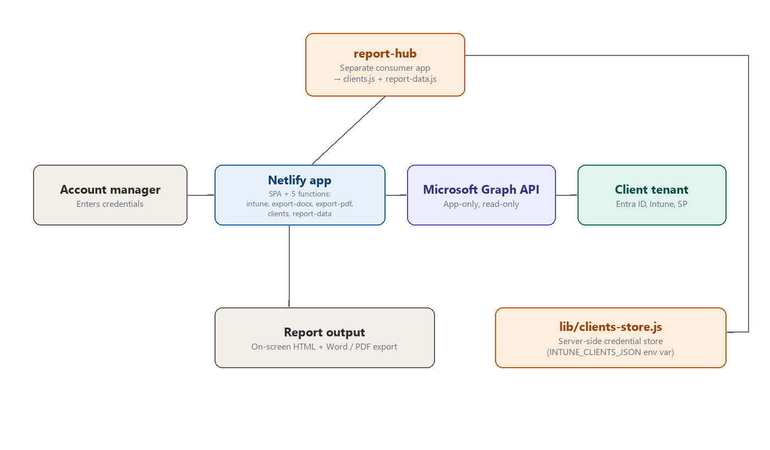

3. Components

3.1 Front end — index.html
A single HTML file containing all markup, CSS, and JavaScript. There is no build step or bundler — the file is served as-is by Netlify. It implements a 4-page wizard-style flow:
- Page 1 — select a saved credential set or enter new Tenant ID / Client ID / Client Secret
- Page 2 — set the report period and account manager name
- Page 3 — pull data (triggers the intune function), review KPIs, add manual commentary
- Page 4 — full on-screen report, with Export to Word and browser print-to-PDF

3.2 Back end — Netlify Functions

netlify/functions/intune.js
The data-gathering function. Accepts tenant credentials and a date range, authenticates against Microsoft Entra ID using the client credentials flow, then issues 16 parallel Graph API calls in a first batch, followed by 2 more parallel sign-in-log calls (full-period and half-period fallback) in a second batch — 18 real Graph API calls in total — to build a single structured JSON payload of 50+ metrics.
- Sign-in log queries (full period + half-period fallback) run as their own parallel batch after the first 16 calls complete — the half-period result is used only if the full-period query errors or times out
- Per-IP rate limit: 10 requests / 5 minutes (in-memory, resets on cold start)
- Typical response time: 3-8 seconds depending on tenant size

netlify/functions/export-docx.js
Takes the same structured data plus manual commentary fields and generates a formatted Word document (.docx) using the docx npm package, returned to the browser as base64.
- Per-IP rate limit: 20 requests / 5 minutes
- Cover page, nine report sections (Executive Summary, Device & Asset Management, Security Posture, Patch Status, User Data, SharePoint / MS Teams, Ticketing & Support, Recommendations & Opportunities, Security Risk Register), KPI cards, callouts, tables, and an auto-generated risk register all built as native Word tables and paragraphs — not an HTML-to-Word conversion. Executive Summary, Ticketing & Support, and Recommendations & Opportunities are manual-entry sections only, rendered when the account manager fills in the corresponding commentary fields — they carry no Graph-sourced data

netlify/functions/export-pdf.js
A second, PDF-native export path mirroring export-docx.js’s full nine-section structure, accepting the same input shape. Built with the jspdf and jspdf-autotable npm packages, Helvetica font only (no custom font files bundled).
- No per-IP rate limiting (unlike intune.js and export-docx.js)
- Dormant from the app’s own perspective — index.html’s wizard does not call it anywhere; page 4 only offers browser print-to-PDF and Export to Word. Exists for a possible future PDF-export button or other consumers, but is not wired into any UI control today.

netlify/functions/clients.js
Serves report-hub — a separate consumer application, not part of this app’s own browser UI — a stripped-down client picker list: id and display name only, no credentials — sourced from the shared credential store below.

netlify/functions/report-data.js
A headless data endpoint for report-hub. Takes a clientId (plus optional from/to) query parameter, looks up that client’s stored Entra ID credentials via lib/clients-store.js, and calls intune.js’s exported handler directly and internally with those credentials — passing its response straight through unchanged. intune.js itself required no modification to support this.

netlify/functions/lib/clients-store.js (shared helper, not a Netlify function)
Not itself invoked as an HTTP endpoint — a shared internal module used by clients.js and report-data.js. Reads a single Netlify environment variable, INTUNE_CLIENTS_JSON (a JSON array of {id, displayName, tenantId, clientId, clientSecret} objects), and exposes lookup and credential-stripping helpers. This is the only server-side credential storage in the whole application, and it is strictly additive: the browser wizard’s existing per-session, paste-your-own-credentials flow (index.html → intune.js) is completely unaffected and does not require a client to be listed here at all.

4. Data Flow — Step by Step
- 1. Account manager enters Tenant ID, Client ID, and Client Secret in the browser
- 2. Browser POSTs credentials + date range to /.netlify/functions/intune
- 3. Function requests an OAuth token from https://login.microsoftonline.com/{tenantId}/oauth2/v2.0/token
- 4. Function issues 16 parallel calls to Microsoft Graph (https://graph.microsoft.com/v1.0/...), followed by 2 more parallel sign-in-log calls (18 total)
- 5. Function shapes the raw Graph responses into 50+ structured metrics
- 6. Structured JSON returned to the browser and rendered as the on-screen report
- 7. On request, browser POSTs the same JSON + manual fields to /.netlify/functions/export-docx
- 8. Function builds a Word document in memory and returns it as base64
- 9. Browser decodes the base64 and triggers a file download

Data Flow — report-hub integration (parallel path)
report-hub, a separate consumer application, reaches this same back end through two additional endpoints that the browser wizard never calls:
- 1. report-hub calls /.netlify/functions/clients to get a list of configured client ids/names (no credentials returned)
- 2. report-hub calls /.netlify/functions/report-data?clientId=... for a specific client
- 3. report-data.js looks up that client’s stored credentials from the INTUNE_CLIENTS_JSON environment variable (via lib/clients-store.js) and invokes intune.js’s handler internally with them, returning the same structured JSON payload the browser wizard would have received
This path never touches the browser, never uses browser session memory, and does not affect the credential handling described in Section 5 for the wizard flow.

5. Security Model
Control | Detail
Authentication | OAuth 2.0 Client Credentials — app-only, no interactive user sign-in required
Permission scope | 12 Microsoft Graph Application permissions, all read-only (see Setup Guide)
Credential handling | Tenant ID, Client ID, and Client Secret exist only in browser memory for the session — never written to disk, database, or logs on the server
Transport security | HTTPS enforced by Netlify. Strict-Transport-Security header set for 2 years
Content Security Policy | Restrictive CSP in netlify.toml — script-src and style-src limited to self plus unsafe-inline for the SPA; connect-src limited to self, login.microsoftonline.com, and any *.netlify.app subdomain (to support Netlify deploy previews)
Rate limiting | In-memory per-IP limits on intune.js (10 requests/5 min) and export-docx.js (20 requests/5 min) to reduce abuse risk. export-pdf.js, clients.js, and report-data.js currently have no rate limiting
Audit trail | Every Graph API call made by the app registration appears in the client tenant's own Entra ID sign-in logs, attributed to the app name
No write access | Every permission requested is Read-only. The app cannot create, modify, or delete any data in a client tenant

6. Metrics Collected (50+ total)
Section | Metrics | Notes
Device & Asset Mgmt | Total, compliant, non-compliant, not evaluated, stale 90d+, OS breakdown (Win 11 25H2/24H2, Win 10, macOS, iOS, Android, Linux), encryption, antivirus, low disk, patch tiers | macOS excluded from encryption count — Intune does not reliably report FileVault
Security Posture | Secure Score, Conditional Access enforced/report-only, risky users, compliance policies, app protection, security defaults, key policy status, auth methods | Requires Entra ID P2 for risky user detection
User Data | Total licensed users, shared mailboxes, guests, inactive 90d+ (licensed and guest), admin roles, overseas sign-ins, licence assignment | Licensed = assignedLicenses.length > 0. Shared mailboxes = mail-enabled with no licence
SharePoint / Teams | Total sites, M365 group sites, comm sites, classic sites, groups, security groups, storage used, inactive 180d+ | Storage allocation no longer exposed by Graph — only usage shown
Risk Register | Auto-generated High / Medium / Low findings with area, finding, and recommended action | Derived from thresholds across all other sections

7. Key Implementation Decisions
Decision | Rationale
Mobile devices in compliance only | iOS and Android included in compliance counts but excluded from patch, encryption, AV and disk metrics — those checks are not meaningful on mobile OSes
macOS encryption excluded | isEncrypted=false is unreliable for macOS in Intune — excluding avoids false positives in the unencrypted device list
Sign-in queries run as a parallel fallback pair | A full-period and half-period sign-in query run in parallel with each other (after the first 16 calls complete); the half-period result covers tenants where the full-period query times out
Overseas sign-ins exclude AU/NZ/MY | These are expected travel and business destinations for NZ-based clients — only genuinely unusual countries are flagged
Stale device threshold: 90 days | Balances catching genuinely offline devices against false positives from staff on leave
Low disk threshold: 15% | Standard Windows guidance for when performance degradation begins
Licensed users vs shared mailboxes | Split cleanly by assignedLicenses.length — avoids service accounts and room mailboxes inflating the user count
Never-signed-in users included | Treated as maximum inactivity (not excluded) — these are the accounts most likely to be forgotten and unlicensed

8. Deployment
This repository is linked to GitHub (christian-wood-code/msp-report-builder) and to the live Netlify site (integricitymsp.netlify.app) for continuous deployment. The application has no build step other than npm install, which Netlify’s own build process runs automatically on every deploy.

Primary — GitHub + Netlify continuous deployment
git add -A
git commit -m "Describe the change"
git push

Netlify detects the push, builds, and deploys automatically. Critically, the Netlify build always runs npm install — this permanently avoids the "Cannot find module 'docx'" failure that affects the drag-and-drop method below.

Fallback — Netlify CLI (manual deploy, e.g. before the Git link existed, or for out-of-band testing)
cd msp-report-builder
npm install
netlify deploy --prod

Option — Netlify UI drag-and-drop
Drag the project folder (or a zip including node_modules) onto the Deploys tab in the Netlify dashboard. Note: the UI method does not run npm install automatically — node_modules must be included in the zip, or the export-docx and export-pdf functions will fail to load their npm packages at runtime.
Linking a GitHub repo to Netlify for continuous deployment itself required one interactive, non-scriptable step (Netlify’s dashboard "Link repository" flow, which installs a deploy key on the GitHub repo) — see DEPLOY.md for the full one-time setup runbook. That step has already been completed for this project.

9. Known Limitations
Limitation | Detail
In-memory rate limiting | Resets whenever Netlify spins up a new function instance — not a durable limit
10-second function timeout | Netlify free tier hard limit — very large tenants may see the sign-in log query time out and fall back to a shorter window
Antivirus detection is Windows-only | Third-party AV is inferred via realTimeProtectionEnabled, not by product name
Sign-in log retention | 30 days by default, 90 days with Entra ID P2
Site password protection breaks functions | Netlify's built-in site password intercepts all requests including function calls — use an in-app password gate or Netlify Identity instead

