Integricity Technology
MSP Report Builder
System Architecture
June 2026

1. Overview
The Integricity MSP Report Builder is a web application that generates monthly IT health reports for client Microsoft 365 and Intune tenants. It runs entirely on Netlify — a single-page front end plus two serverless functions — and calls the Microsoft Graph API directly from the server side using per-session, per-tenant credentials.

Item | Detail
Live URL | https://integricitymspreport.netlify.app
Hosting | Netlify (free tier)
Front end | Single HTML file — no build step, no framework
Back end | Two Netlify serverless functions (Node.js)
Data source | Microsoft Graph API v1.0
Auth model | OAuth 2.0 Client Credentials flow, app-only, read-only
Credential storage | None — browser session memory only

2. Architecture Diagram
Data flows left to right: the account manager enters tenant credentials into the browser app, which calls Microsoft Graph on the server side, reads data from the client tenant, and renders both an on-screen report and a Word export.

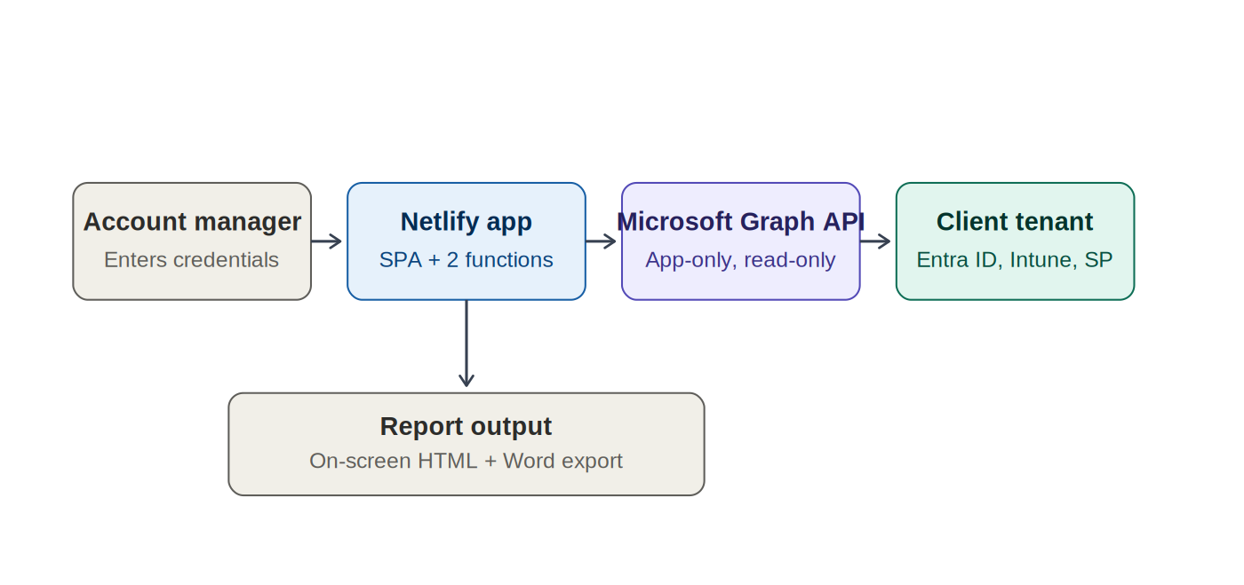

3. Components

3.1 Front end — index.html
A single HTML file containing all markup, CSS, and JavaScript. There is no build step or bundler — the file is served as-is by Netlify. It implements a 4-page wizard-style flow:
- Page 1 — select a saved credential set or enter new Tenant ID / Client ID / Client Secret
- Page 2 — set the report period and account manager name
- Page 3 — pull data (triggers the intune function), review KPIs, add manual commentary
- Page 4 — full on-screen report, with Export to Word and browser print-to-PDF

3.2 Back end — Netlify Functions

netlify/functions/intune.js
The data-gathering function. Accepts tenant credentials and a date range, authenticates against Microsoft Entra ID using the client credentials flow, then issues 17 parallel Graph API calls to build a single structured JSON payload of 52 metrics.
- Sign-in log query runs sequentially after the other 16 calls to avoid resource contention on large tenants
- Per-IP rate limit: 10 requests / 5 minutes (in-memory, resets on cold start)
- Typical response time: 3-8 seconds depending on tenant size

netlify/functions/export-docx.js
Takes the same structured data plus manual commentary fields and generates a formatted Word document (.docx) using the docx npm package, returned to the browser as base64.
- Per-IP rate limit: 20 requests / 5 minutes
- Cover page, six report sections, KPI cards, callouts, tables, and an auto-generated risk register all built as native Word tables and paragraphs — not an HTML-to-Word conversion

4. Data Flow — Step by Step
- 1. Account manager enters Tenant ID, Client ID, and Client Secret in the browser
- 2. Browser POSTs credentials + date range to /.netlify/functions/intune
- 3. Function requests an OAuth token from https://login.microsoftonline.com/{tenantId}/oauth2/v2.0/token
- 4. Function issues 17 parallel calls to Microsoft Graph (https://graph.microsoft.com/v1.0/...)
- 5. Function shapes the raw Graph responses into 52 structured metrics
- 6. Structured JSON returned to the browser and rendered as the on-screen report
- 7. On request, browser POSTs the same JSON + manual fields to /.netlify/functions/export-docx
- 8. Function builds a Word document in memory and returns it as base64
- 9. Browser decodes the base64 and triggers a file download

5. Security Model
Control | Detail
Authentication | OAuth 2.0 Client Credentials — app-only, no interactive user sign-in required
Permission scope | 12 Microsoft Graph Application permissions, all read-only (see Setup Guide)
Credential handling | Tenant ID, Client ID, and Client Secret exist only in browser memory for the session — never written to disk, database, or logs on the server
Transport security | HTTPS enforced by Netlify. Strict-Transport-Security header set for 2 years
Content Security Policy | Restrictive CSP in netlify.toml — script-src and style-src limited to self plus unsafe-inline for the SPA; connect-src limited to self and login.microsoftonline.com
Rate limiting | In-memory per-IP limits on both functions to reduce abuse risk
Audit trail | Every Graph API call made by the app registration appears in the client tenant's own Entra ID sign-in logs, attributed to the app name
No write access | Every permission requested is Read-only. The app cannot create, modify, or delete any data in a client tenant

6. Metrics Collected (52 total)
Section | Metrics | Notes
Device & Asset Mgmt | Total, compliant, non-compliant, not evaluated, stale 90d+, OS breakdown (Win 11 25H2/24H2, Win 10, macOS, iOS, Android, Linux), encryption, antivirus, low disk, patch tiers | macOS excluded from encryption count — Intune does not reliably report FileVault
Security Posture | Secure Score, Conditional Access enforced/report-only, risky users, compliance policies, app protection, security defaults, key policy status, auth methods | Requires Entra ID P2 for risky user detection
User Data | Total licensed users, shared mailboxes, guests, inactive 90d+ (licensed and guest), admin roles, overseas sign-ins, licence assignment | Licensed = assignedLicenses.length > 0. Shared mailboxes = mail-enabled with no licence
SharePoint / Teams | Total sites, M365 group sites, comm sites, classic sites, groups, security groups, storage used, inactive 180d+ | Storage allocation no longer exposed by Graph — only usage shown
Risk Register | Auto-generated High / Medium / Low findings with area, finding, and recommended action | Derived from thresholds across all other sections

7. Key Implementation Decisions
Decision | Rationale
Mobile devices in compliance only | iOS and Android included in compliance counts but excluded from patch, encryption, AV and disk metrics — those checks are not meaningful on mobile OSes
macOS encryption excluded | isEncrypted=false is unreliable for macOS in Intune — excluding avoids false positives in the unencrypted device list
Sign-in query runs sequentially | Avoids resource contention on the Graph API when the other 16 calls are already running in parallel
Overseas sign-ins exclude AU/NZ/MY | These are expected travel and business destinations for NZ-based clients — only genuinely unusual countries are flagged
Stale device threshold: 90 days | Balances catching genuinely offline devices against false positives from staff on leave
Low disk threshold: 15% | Standard Windows guidance for when performance degradation begins
Licensed users vs shared mailboxes | Split cleanly by assignedLicenses.length — avoids service accounts and room mailboxes inflating the user count
Never-signed-in users included | Treated as maximum inactivity (not excluded) — these are the accounts most likely to be forgotten and unlicensed

8. Deployment
The application has no build step. Deployment is either of the following:

Option A — Netlify CLI (recommended)
cd msp-report-builder
npm install
netlify deploy --prod

Option B — Netlify UI drag-and-drop
Drag the project folder (or a zip including node_modules) onto the Deploys tab in the Netlify dashboard. Note: the UI method does not run npm install automatically — node_modules must be included in the zip, or the export-docx function will fail to load the docx package at runtime.

9. Known Limitations
Limitation | Detail
In-memory rate limiting | Resets whenever Netlify spins up a new function instance — not a durable limit
10-second function timeout | Netlify free tier hard limit — very large tenants may see the sign-in log query time out and fall back to a shorter window
Antivirus detection is Windows-only | Third-party AV is inferred via realTimeProtectionEnabled, not by product name
Sign-in log retention | 30 days by default, 90 days with Entra ID P2
Site password protection breaks functions | Netlify's built-in site password intercepts all requests including function calls — use an in-app password gate or Netlify Identity instead

