Week 04 Foundation Programs — My Design Notes
Just a heads up — I'm still getting comfortable with abstraction and encapsulation, so this is my working draft. I tried to follow what we talked about as a team and think through the rest on my own, but I might be missing edge cases or overcomplicating something. Open to feedback.

Program 1: YouTube Videos (Abstraction)

What the program does (in my own words)
We need to store a handful of videos, and each video has some comments on it. So really it's just two things: a Video and a Comment that lives inside a video. The program creates a few videos, adds some comments to each, and then prints it all out. No user input, no menu — just build the objects and print them.

Classes I think we need
Class | What it's responsible for
Comment | Holds who left the comment and what they said.
Video | Holds the title, author, and length, plus a list of Comments. Also needs a way to tell you how many comments it has.
Program | Not really a "class" in the design sense, just the entry point that creates everything and prints it.
I don't think we need more classes than this for Program 1: it's tempting to add something like a VideoLibrary class to hold the list of videos, but the assignment just says "put them in a list," so I'm going to keep it simple with a plain List<Video> in Program.cs unless that turns out to be awkward once I'm actually coding.

Class diagram
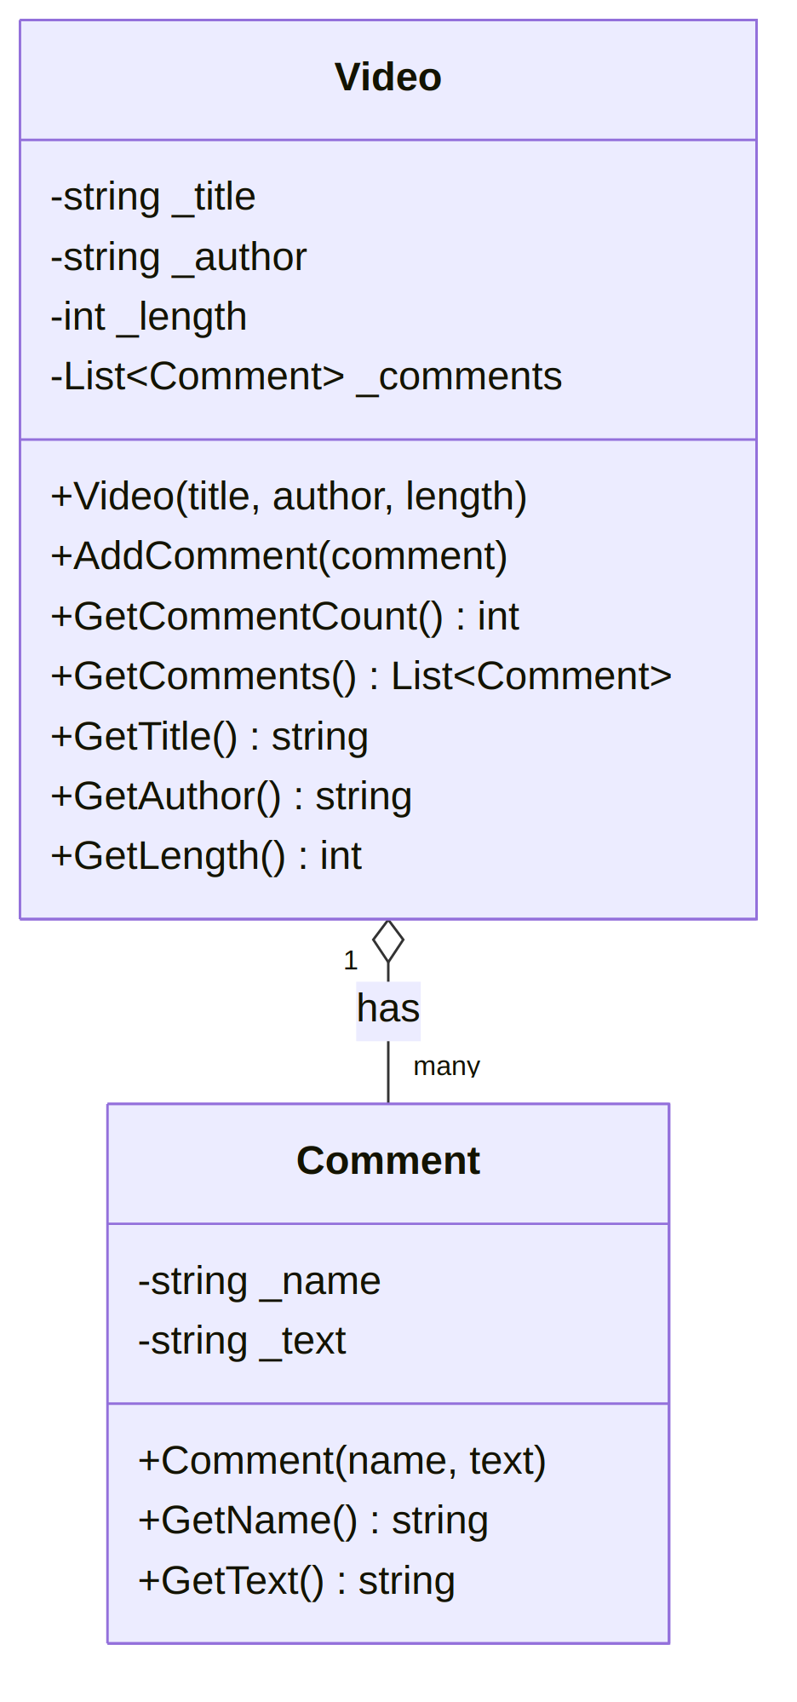
Figure 1 — Video / Comment class diagram (Asked AI to create the images)

Attributes (member variables)
- Comment: _name (string), _text (string)
- Video: _title (string), _author (string), _length (int — seconds), _comments (a List of Comment)

Methods for each class needs
- Comment: a constructor, plus GetName() and GetText() so we can read the values back out later
- Video: a constructor for title/author/length, AddComment() to add one to the list, GetCommentCount() (probably just _comments.Count, so this might be more of a "wrapper" than real logic — not sure if that's fine or if I'm missing the point of it), and getters for the other fields

Rough flow of the program
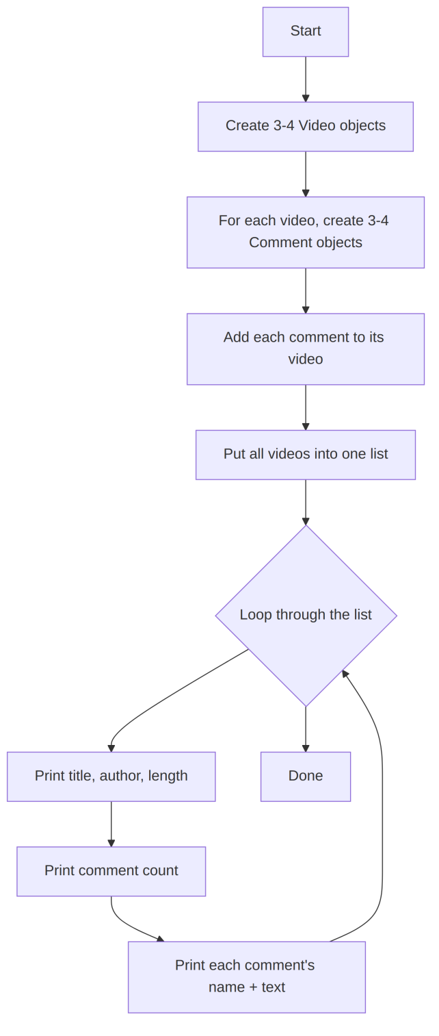
Figure 2 — Program 1 flow
I think this is roughly right, but I might reorganize the loop once I see how messy the print statements look in practice.

Program 2: Online Ordering (Encapsulation)

What the program does
This one has more moving pieces. An Order has a Customer and a bunch of Products. A Customer has a name and an Address. The tricky part (for me) is that the shipping cost depends on whether the customer lives in the USA, and that check has to start at the Address, then get used by Customer, then get used by Order. I had to read the "how the methods relate" part of the spec a couple times to understand that Order doesn't check the address directly — it asks the Customer, who asks the Address. That's the delegation pattern the encapsulation lesson keeps mentioning, I think.

Classes and what each one owns
Class | Responsibility
Address | Street, city, state, country. Knows if it's in the USA. Can print itself as one string.
Customer | Name + an Address. Can answer "do you live in the USA" by asking its Address.
Product | Name, id, price, quantity. Knows its own total cost (price × quantity).
Order | A Customer + a list of Products. Figures out the total cost (including shipping), and can build the packing label and shipping label as strings.

Class diagram.
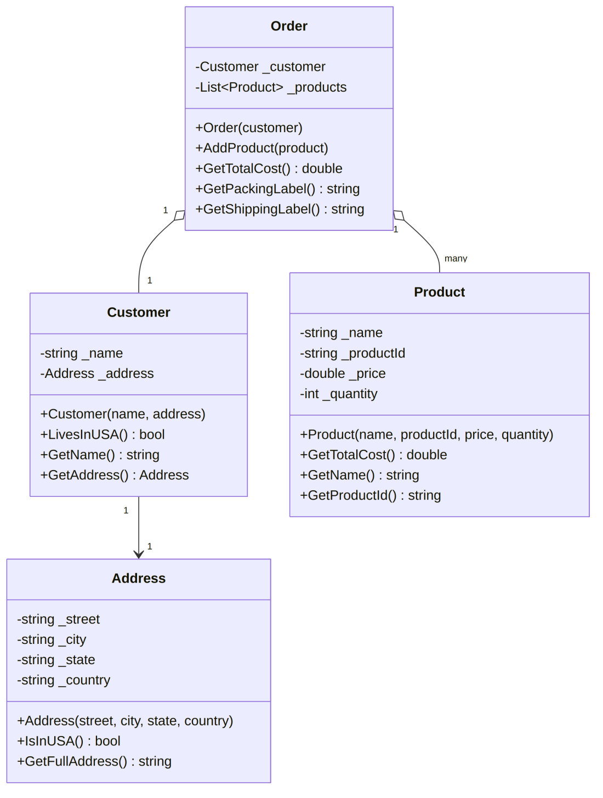
Figure 3 — Address / Customer / Product / Order class diagram

Attributes (member variables)
- Address: _street, _city, _state, _country — all strings, all private
- Customer: _name (string), _address (an Address object)
- Product: _name (string), _productId (string), _price (double), _quantity (int)
- Order: _customer (a Customer object), _products (a List of Product)

Methods each class needs
- Address.IsInUSA() — checks if _country equals "USA" (I'm guessing a simple string comparison is fine for this assignment, though in a real app I'd worry about people typing "United States" or "US" instead)
- Address.GetFullAddress() — puts street/city/state/country together into one string so it can be printed as a label
- Customer.LivesInUSA() — just calls _address.IsInUSA() and returns whatever that says
- Product.GetTotalCost() — _price * _quantity
- Order.AddProduct() — adds one product to _products
- Order.GetTotalCost() — adds up every product's total cost, then adds $5 shipping if the customer is in the USA or $35 if not
- Order.GetPackingLabel() — loops the products and lists each name + id
- Order.GetShippingLabel() — customer's name plus their address

How the methods call each other
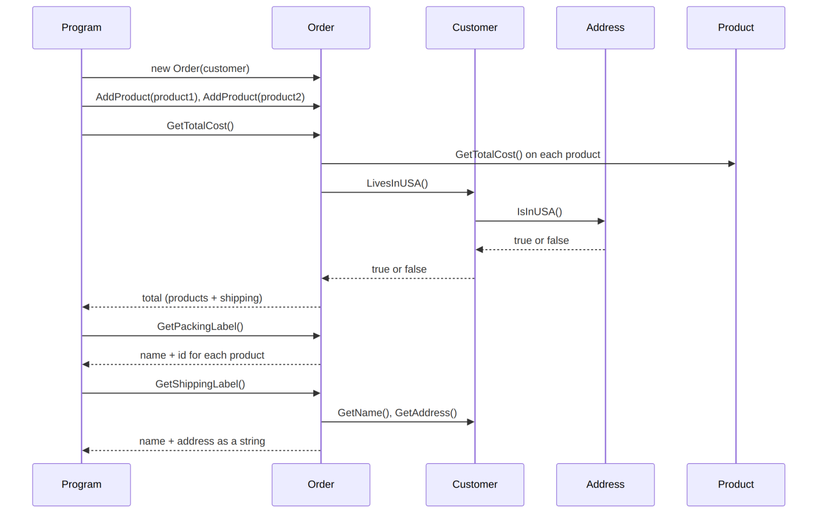
Figure 4 — Order total-cost / label call sequence

Things I'm still unsure about
- Whether IsInUSA() should be a simple == check or something a little more forgiving. Going simple for now since the assignment doesn't ask for anything fancy.
- Whether Order should take the Customer in the constructor or have a setter — going with constructor for now since it feels weird for an order to exist without a customer attached, but I could see the setter approach working too.
- Whether GetCommentCount() on Video is "too simple" to count as a real method, but I think that's kind of the point of encapsulation/abstraction — the caller doesn't need to know it's just _comments.Count under the hood.
Note: 1. This feels like a solid starting point, but I expect a few of these details to shift once I actually start writing the C# and run into things I didn't think through here.
2. All the pictorial representation I commanded AI generate from what I thought was the procedure from the meeting and also reserch online.

