UNIT TEST:  assertEquals(DateTimeZone.forID("-02:15"), DateTimeZone.forOffsetHoursMinutes(-2, -15));

FAILURE MESSAGE:   java.lang.IllegalArgumentException: Minutes out of range: -15  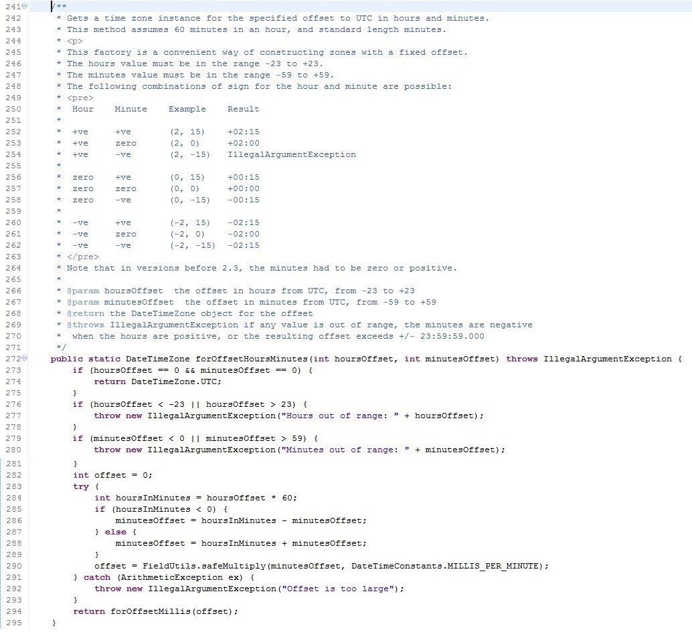

UNIT TEST:

GrayPaintScale gps = new GrayPaintScale();  
c = (Color) gps.getPaint(-0.5);  
assertTrue(c.equals(Color.black));

FAILURE MESSAGE:

java.lang.IllegalArgumentException: Color parameter outside of   
expected range: Red Green Blue

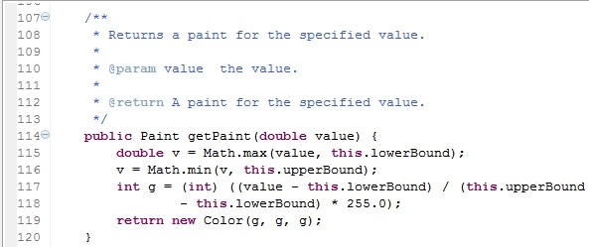

UNIT TEST:

assertTrue(Arrays.equals(new Class[] { String.class, null, Double.class },  
                ClassUtils.toClass(new Object[] { "Test", null, 99d })));

FAILURE MESSAGE:   java.lang.NullPointerException

