iAssetsPro
Enterprise Asset Management (EAM)
SYSTEM IMPLEMENTATION & WORKFLOW GUIDE
Asset Hierarchy • Repairs Maintenance • Preventive Maintenance
Presentation Edition - 12 October 2026
Presentation scope
This guide documents the working production flow from asset registration and deep machine hierarchy through corrective repairs and preventive maintenance. Screenshots are captured from the live iAssetsPro interface and use the Rotary Printing Machine 01 demonstration asset.

Prepared by Lightworld Technologies Ltd

1. Executive Summary
iAssetsPro is an enterprise asset management platform designed to control the full maintenance life of industrial assets: asset registration, engineering hierarchy, corrective repairs, resources and custody, preventive maintenance, evidence, approvals, costing, closure and auditability.
For tomorrow's demonstration, the strongest end-to-end story is the Rotary Printing Machine 01. It is registered as a machine, commissioned into a deep internal hierarchy, maintained through controlled repair work orders, and protected by component/part-level PM schedules that can generate work orders automatically.
Capability | Status | Presentation note
Asset Registry & machine master | LIVE | Create and classify machines with plant, department, location, criticality and lifecycle data.
Assembly/component hierarchy | LIVE | Commission assemblies, subassemblies, components and parts with parent relationships and health context.
Visual Explorer | LIVE | Drill through the machine in diagram/engineering/exploded views and select exact nodes.
Repairs / RWOP | VALIDATED | Controlled request-to-close workflow with roles, resources, evidence, timers, verification and audit.
Materials & tools custody | VALIDATED | Approval, issue, return, reconciliation, quarantine, refurbishment/repair and QC handling.
Preventive Maintenance | VALIDATED | Templates, time/meter schedules, exact hierarchy targeting, triggers, calendar and automatic WO generation.
Production release | LIVE | Current production lineage includes the PM/Repairs hotfix and damaged-tool quantity/QC hardening.
Current release evidence
The PM/Repairs hotfix passed Unit Tests, Lint, Repairs TypeScript, production Build, production Container Build, platform Playwright E2E, Repairs Playwright UAT and the Required CI Gate before merge. Production currently runs a newer commit that is one commit ahead of that merge, so it contains the complete hotfix plus the damaged-tool custody hardening.

2. Presentation Route / Contents
- System dashboard and navigation
- Asset creation and enterprise placement
- Machine engineering hierarchy: assembly > subassembly > component > part
- Components register and Visual Explorer
- Corrective Repairs workflow from request to closure
- Materials, spare-parts and tool custody workflows
- Damaged/defective quality hold, refurbishment/repair and QC
- Preventive Maintenance templates and schedules
- Exact PM target selection through the Visual Explorer
- Time-based and meter-based PM triggers and automatic work orders
- PM calendar, compliance and operational monitoring
- Roles, security, auditability and offline controls
- Live demonstration sequence and presenter talking points
One story connects the whole presentation
Register asset | > | Commission hierarchy | > | Repair defects | > | Plan PM | > | Auto-generate WO

Recommended opening line
“iAssetsPro does not stop at recording a machine. It understands the machine down to the exact maintainable part, controls every repair resource and approval, and then uses that same hierarchy to drive preventive maintenance automatically.”

3. System Dashboard & Navigation
The operations dashboard brings maintenance KPIs and cross-module signals together. Users enter role-appropriate modules from the left navigation while the top bar maintains site/plant context and global navigation.
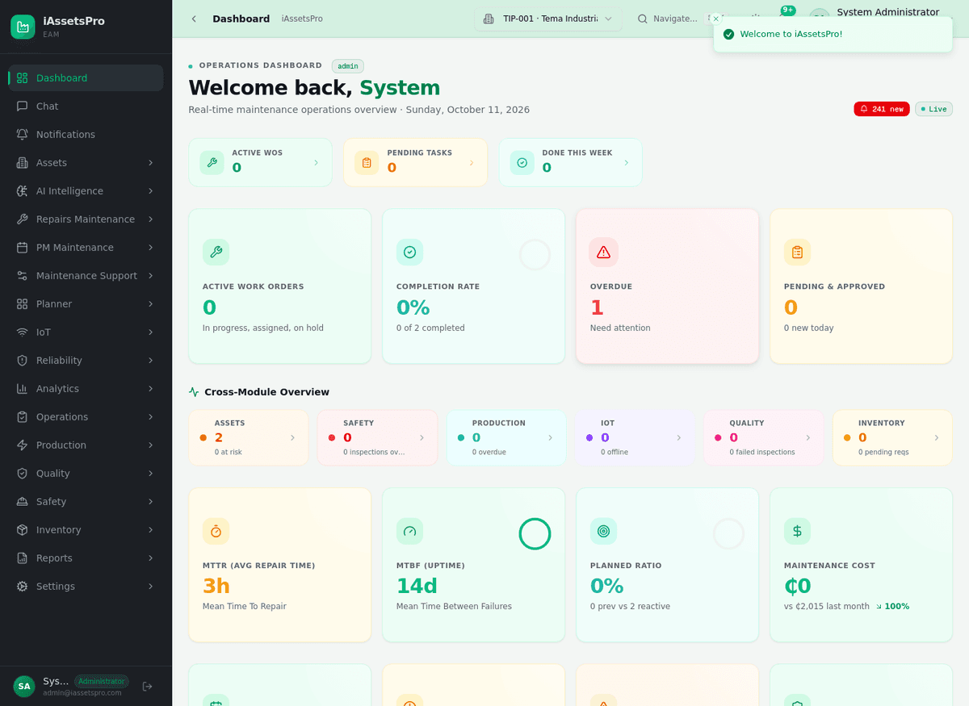
Figure 1. Operations Dashboard - maintenance KPIs and cross-module overview
What to point out: Active work orders, pending tasks, completion rate and overdue work are visible immediately.
- MTTR, MTBF, planned-maintenance ratio and maintenance cost support management conversations.
- The same navigation exposes Assets, Repairs Maintenance, PM Maintenance, Inventory, Reliability, Analytics and related modules.

4. Asset Registry & Asset Creation
Asset creation establishes the master record that every later repair, PM schedule, inventory transaction, reliability event and report references. The Create Asset form captures identity, classification, operational context and lifecycle information in one controlled record.
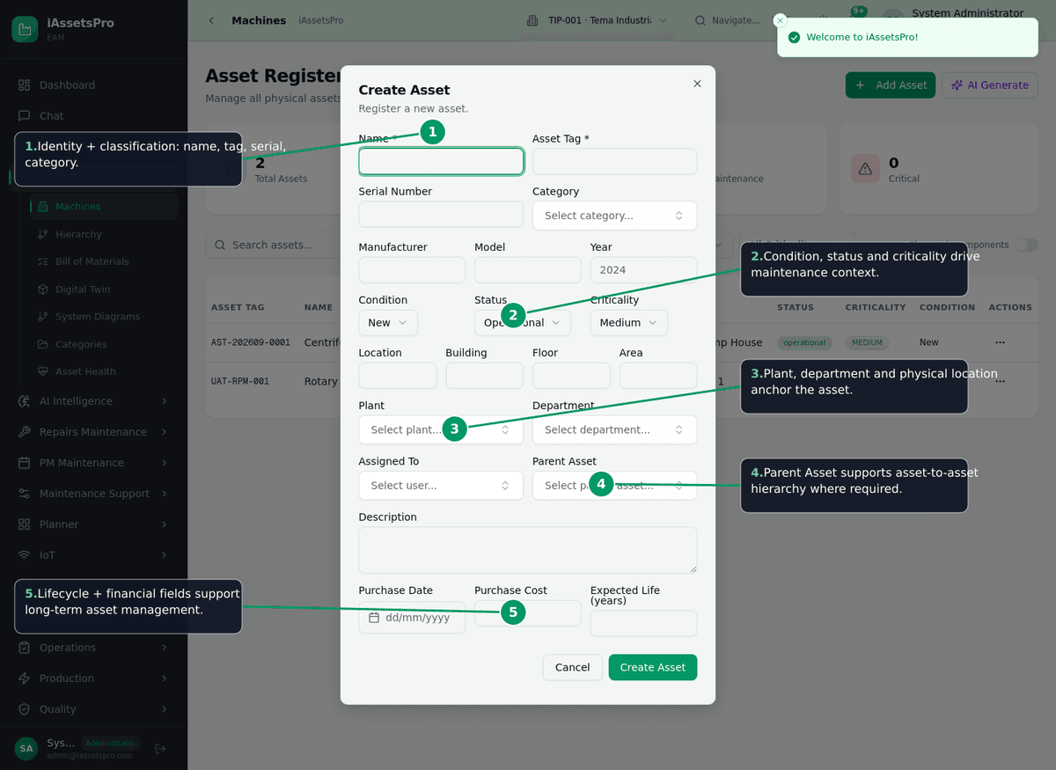
Figure 2. Create Asset - annotated master-data form
What to point out: Name and asset tag are required identifiers; serial, category, manufacturer and model provide engineering identity.
- Condition, status and criticality determine how the asset appears in maintenance and risk views.
- Plant, department and physical location enforce organizational context and plant-scoped security.
- Parent Asset supports asset-to-asset hierarchy where a whole asset belongs under another asset/system.
- Purchase/life fields support lifecycle and financial management.

Asset master area | Purpose
Identity | Name, asset tag, serial number, category, manufacturer, model, year.
Operational state | Condition, operational status and criticality.
Location & ownership | Plant, department, location, building, floor, area and assigned user.
Structural relation | Optional Parent Asset for asset-to-asset hierarchy.
Lifecycle | Description, purchase date/cost and expected useful life.
Presenter cue
Use “Rotary Printing Machine 01 / UAT-RPM-001” as the main demo asset. It is deliberately clean commissioning data with high criticality and enough internal hierarchy to demonstrate drilling, Repairs and PM.

5. Asset Detail: One Engineering Home for the Machine
After creation, the asset detail becomes the machine’s engineering and maintenance home. The same asset exposes overview data, hierarchy, BOM, component register, Visual Explorer, monitoring, digital twin and diagrams.
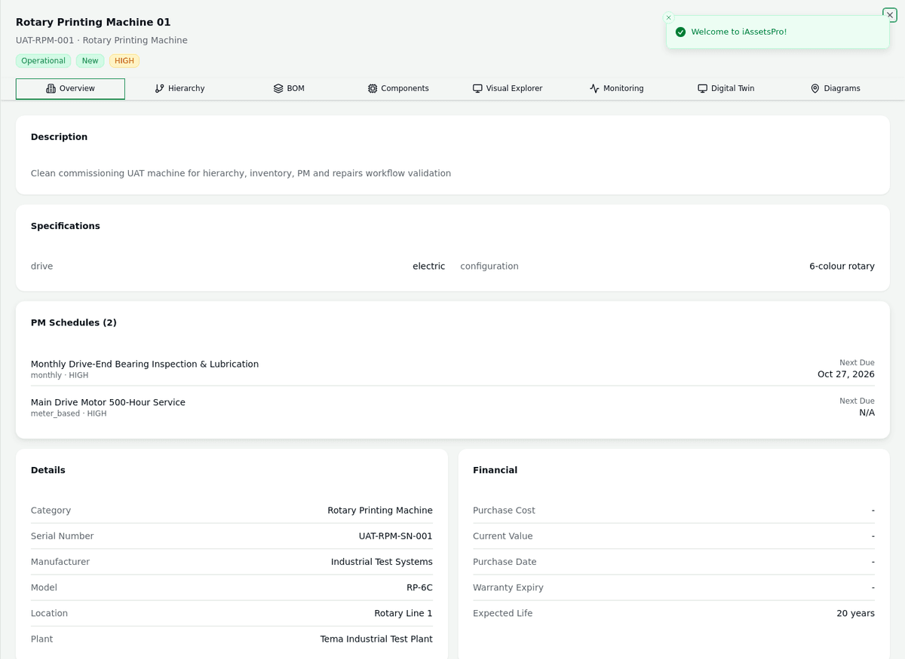
Figure 3. Rotary Printing Machine 01 - asset overview and linked PM schedules
What to point out: The header preserves machine identity, tag, operational state, condition and criticality.
- The overview already shows PM schedules connected to this machine.
- Specifications and enterprise details remain available without leaving the asset context.

Asset detail tabs
Overview | > | Hierarchy / BOM | > | Components | > | Visual Explorer | > | Monitoring / Twin

6. Commissioning the Machine Hierarchy
iAssetsPro separates two useful structures: (1) asset-to-asset Parent Asset relationships for large enterprise structures, and (2) an internal maintainable component registry for the engineering breakdown inside a machine. For maintenance, the component registry is the key structure.
Maintainable hierarchy model
Machine root | > | Assembly | > | Subassembly | > | Component | > | Part

The demonstration machine is commissioned as:
Level | Example
Machine | Rotary Printing Machine 01 - UAT-RPM-001
Assembly | Main Drive Assembly - RPM01-DRV-ASSY
Subassembly | Drive Train - RPM01-DRV-TRN
Component | Main Drive Motor - RPM01-MTR-001
Part | Drive-End Bearing - RPM01-BRG-DE
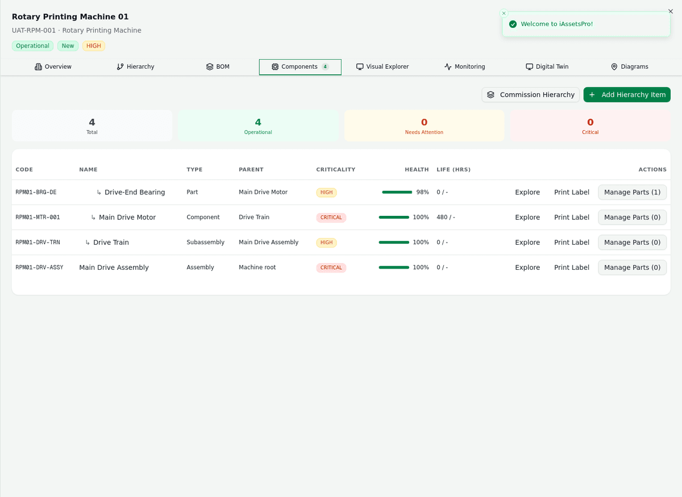
Figure 4. Components register - coded parent/child engineering hierarchy
What to point out: Every internal node has a unique code, type and parent relationship.
- Criticality, health and life/operating-hour information can be tracked at the maintainable-node level.
- Commission Hierarchy supports structured bulk commissioning; Add Hierarchy Item supports incremental authoring.
- Explore and Manage Parts actions let users drill further without losing the parent machine.

Why this matters
A repair or PM instruction should not say only “Rotary Printing Machine.” It can target “Main Drive Motor” or “Drive-End Bearing,” preserving exact history, failure patterns, cost and maintenance strategy at the level where work actually occurs.

7. Deep Visual Explorer & Engineering Drill-Down
The Visual Explorer turns the component registry into an operator-friendly engineering view. The same underlying hierarchy can be navigated as a tree and as a visual chain, with display modes for different audiences.
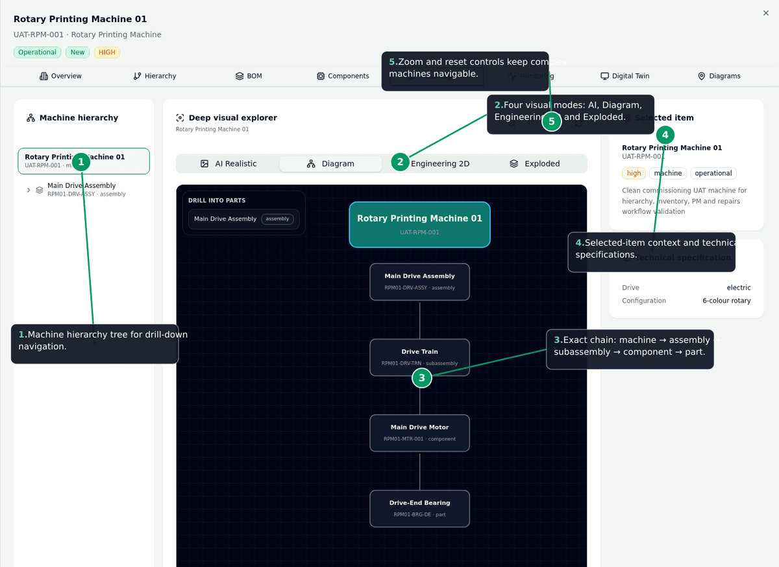
Figure 5. Visual Explorer - annotated machine-to-part drill-down
What to point out: The hierarchy tree anchors navigation on the left.
- AI Realistic, Diagram, Engineering 2D and Exploded modes support different explanation/engineering needs.
- The main canvas shows the maintainable chain from machine root down to the bearing part.
- Selecting a node exposes its metadata and technical specifications.
- Zoom and reset controls support large or complex machines.

Presentation moment
This is the visual that best differentiates iAssetsPro. Pause here and explain that the same exact node used for engineering navigation is also the node used by Repairs and Preventive Maintenance.

8. Complete Repairs / RWOP Workflow
Repairs is a governed workflow rather than a simple work-order list. It starts with a Maintenance Request and carries authorization, planning, execution, resource custody, evidence, review, costs and final closure through one auditable chain.
Corrective maintenance lifecycle - part 1
Maintenance Request | > | Supervisor decision | > | Planner converts to WO | > | Assign technician/team | > | Start execution

Corrective maintenance lifecycle - part 2
Tasks + time + evidence | > | Materials/tools/assistance | > | Resource reconciliation | > | Completion + verification | > | Planner closure

Control principle
Every state change is server-authoritative. Permissions are derived from the authenticated user, assignment/team role, work-order status, plant scope and permissions - not from a frontend role label alone.

9. Step 1 - Maintenance Request Intake & Approval
A Maintenance Request (MR) captures the defect, affected asset, priority and requester before work is authorized. This separates “someone reported a problem” from “maintenance is approved to perform work.”
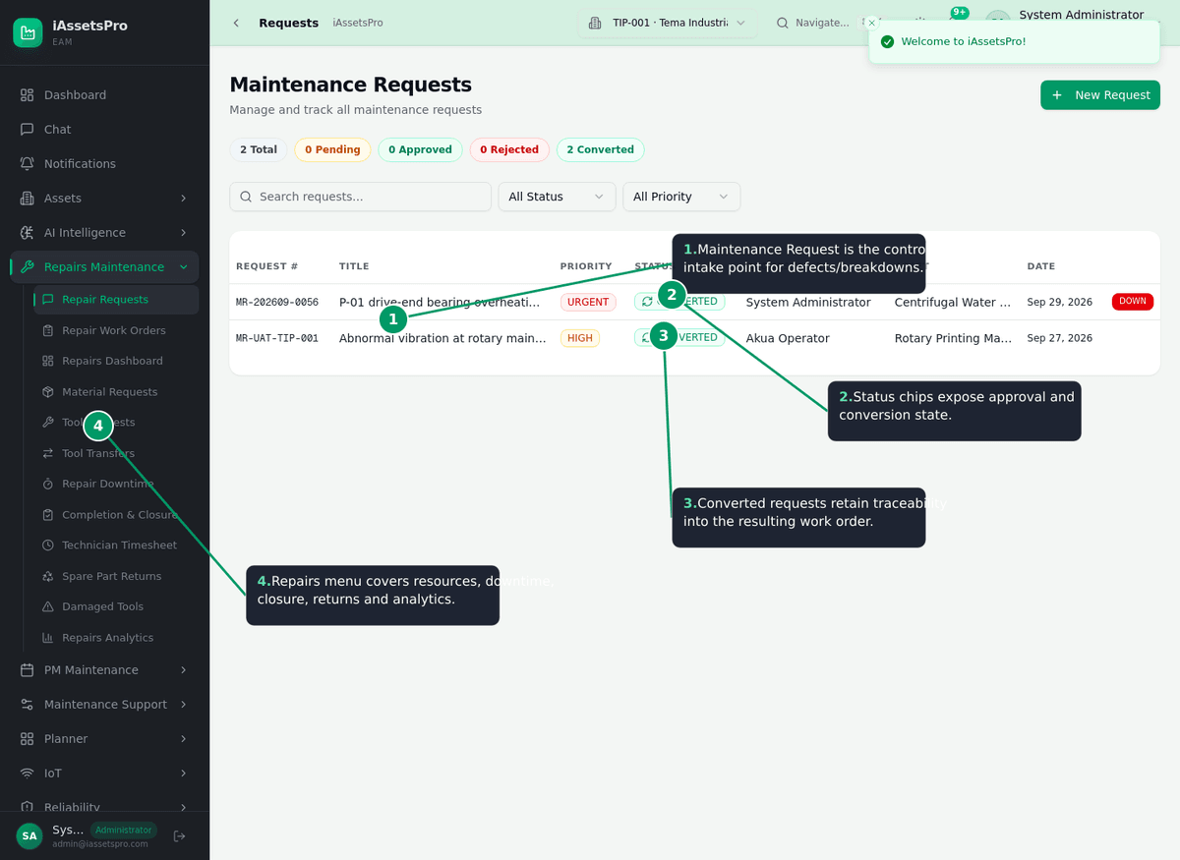
Figure 6. Maintenance Requests - annotated controlled intake and conversion
What to point out: MRs have explicit pending/approved/rejected/converted states.
- Supervisor approval/rejection is separated from planner work-order planning.
- Converted requests remain traceable to the resulting work order.
- Plant scoping prevents unauthorized cross-plant access.

Role | Responsibility
Requester | Creates the MR and tracks it; cannot approve own request.
Supervisor | Approves or rejects; rejection requires reason; can verify later depending authority.
Planner | Receives approved MR and converts it into a planned work order.

10. Step 2 - Work Order Planning, Assignment & Execution
After approval, the planner converts the MR to a Work Order (WO), adds tasks, required resources, safety notes, priority and assignment. Work can be assigned to one technician, a multi-technician team with a team leader, or delegated to a supervisor for assignment.
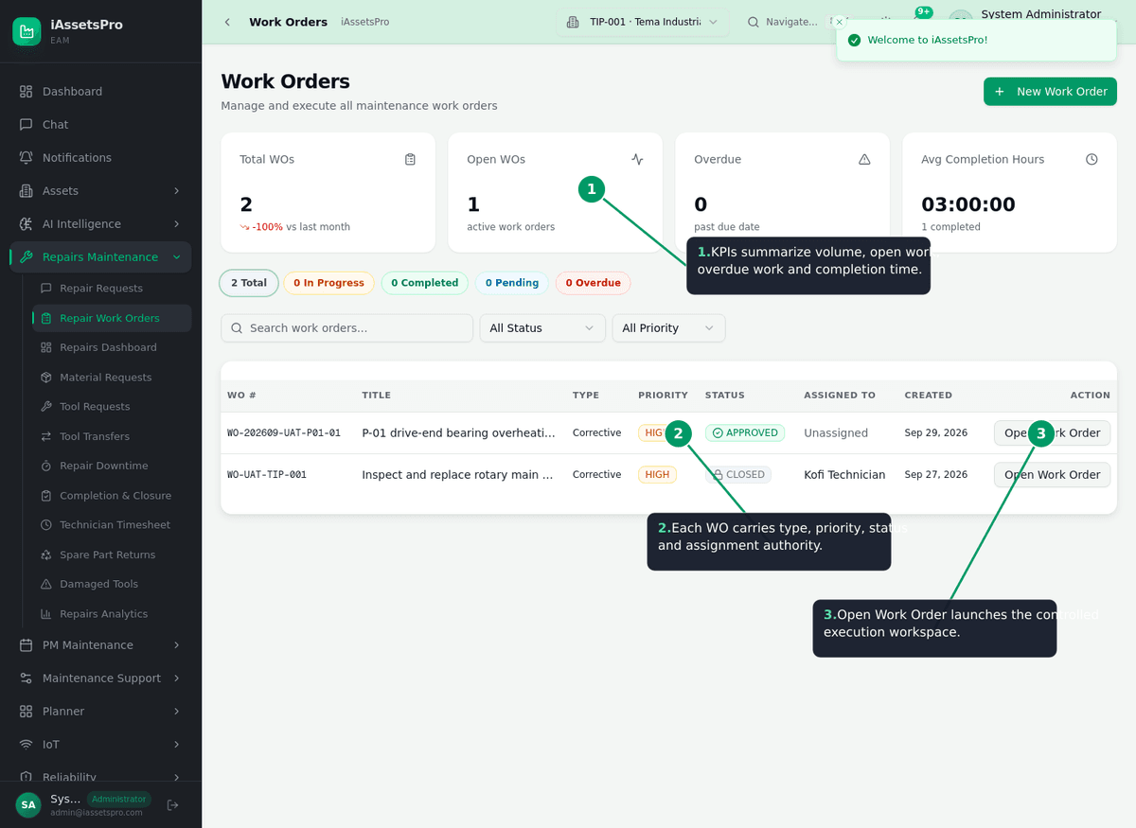
Figure 7. Repair Work Orders - annotated operational register
What to point out: WO cards summarize open work and completion performance.
- The register shows type, priority, status, assignee and creation date.
- Opening the work order launches the controlled Technician/Execution Workspace.

During execution, iAssetsPro supports:
- Start, pause, resume, waiting-state and shift-handover lifecycle with atomic state changes.
- Active labor, waiting/hold and calendar time calculated from real time logs.
- Task completion, team time logging and team-leader-only final completion for multi-tech work.
- Assistance requests that can add approved help to the team.
- Evidence: photos/files, voice notes and structured before/after measurements with threshold alarm calculation.
- Offline-safe queueing for selected low-risk actions such as comments, task updates, time logs, measurements and assistance requests; physical issuance and final completion remain online-authoritative.
Readiness gates
Completion can be blocked while timers are active, tools/materials are unreconciled, assistance is pending or handover is unresolved. Verification/closure have their own completion-report, cost, rework and status gates.

11. Materials & Spare-Parts Workflow
Materials are not simply deducted from stock. The workflow maintains quantity custody from request through approval, issue, consumption/return and final reconciliation against the work order.
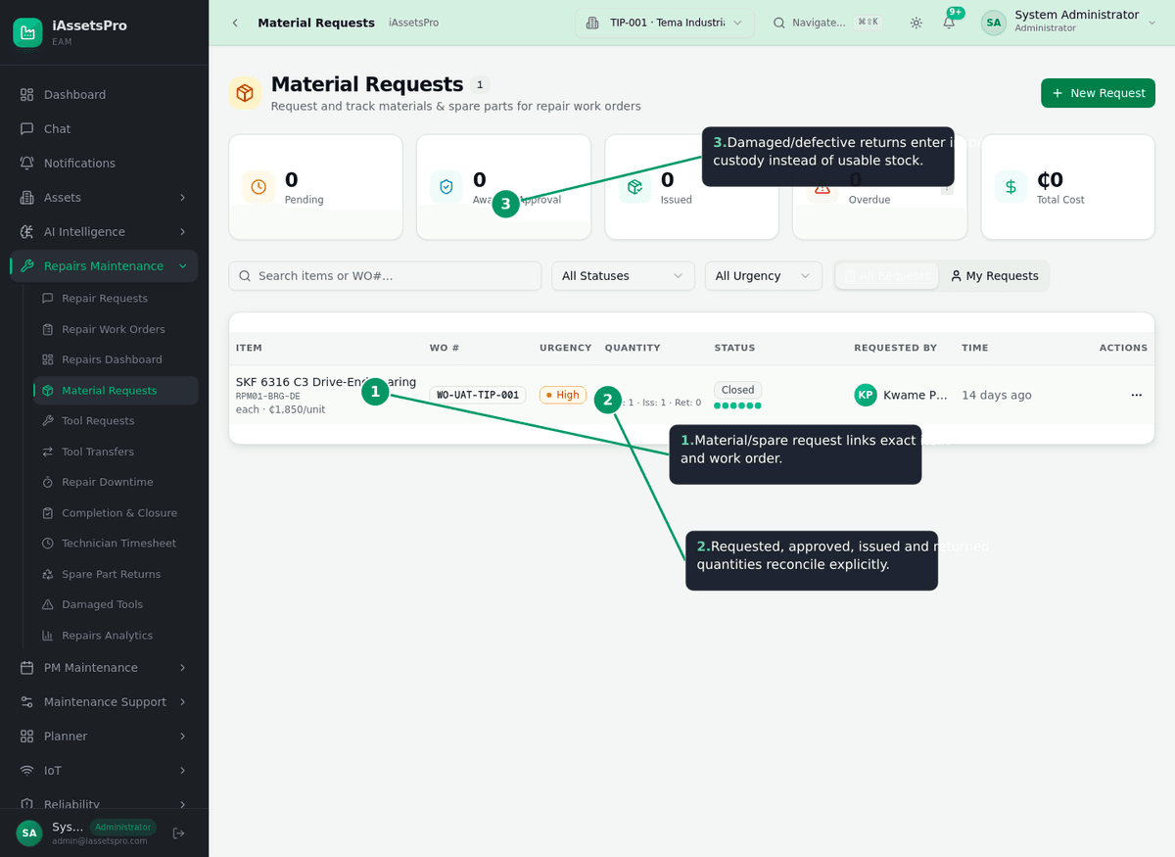
Figure 8. Material Requests - annotated quantity and custody control
What to point out: The item is explicitly linked to the work order.
- Requested, approved, issued and returned quantities remain distinct.
- Serviceable returns are restored to usable stock; damaged/defective returns are quarantined instead of being silently restocked.

Material custody
Technician requests | > | Approval | > | Store issues | > | Use / consume | > | Return / reconcile

Damaged or defective material return follows a controlled quality path:
Damaged spare-part return
Return as damaged | > | Inspection custody | > | Repair / refurbish | > | QC decision | > | Stock / supplier / scrap

For receiving from Purchase Orders, damaged/defective items can enter a quality hold immediately. Supplier return can reopen the PO quantity so the replacement is still expected rather than falsely treating the receipt as complete.

12. Tools Workflow, Calibration & Damaged-Tool Custody
Reusable tools are treated as custody assets, not material consumption. The work order requests tools, approvals control issuance, and the store confirms physical return. Calibration requirements can block issuance where configured.
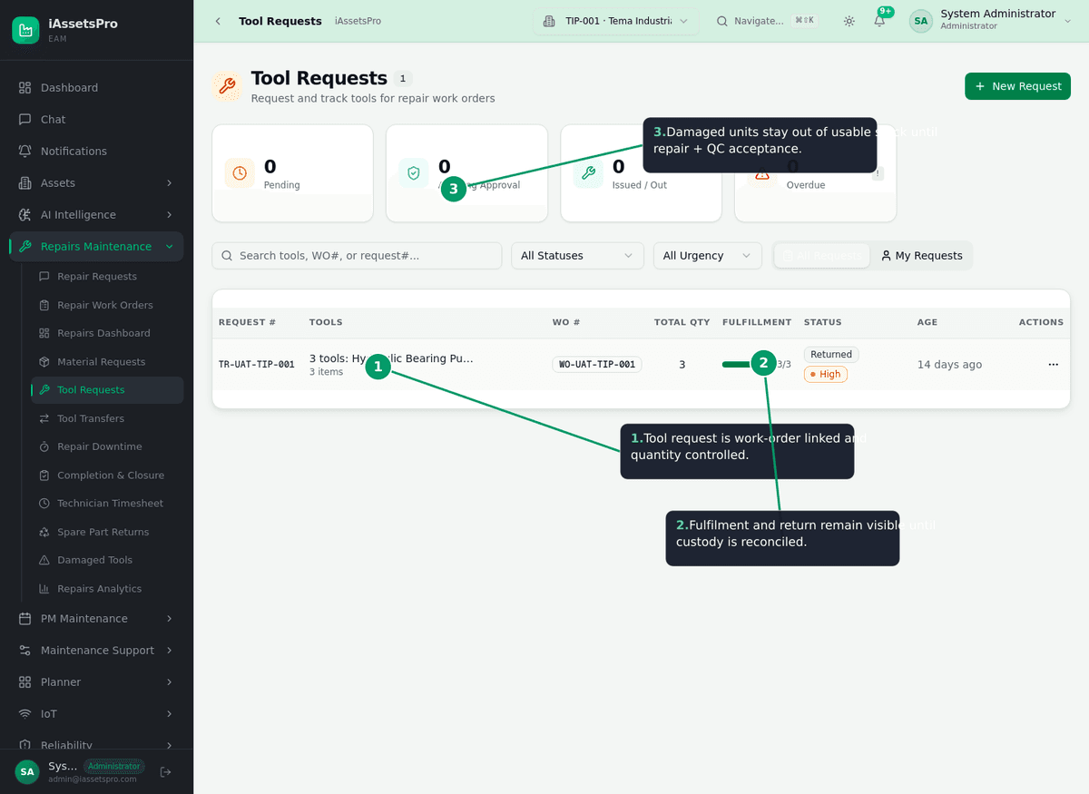
Figure 9. Tool Requests - annotated fulfilment and return custody
What to point out: Work-order linkage preserves the reason and accountable execution context.
- Fulfilment remains visible until issued units are physically reconciled.
- Damaged units are separated from usable quantity and tracked through repair/QC.

The current production hardening makes damaged-tool quantity control explicit:
Damaged tool unit lifecycle
Issue unit(s) | > | Return damaged | > | Repair custody | > | Repair complete | > | Store/QC accept

- Usable quantity and repair-held quantity are separate.
- A damaged returned unit does not become available simply because it was physically returned.
- Repair completion leaves the unit in awaiting-QC custody.
- Only store/QC acceptance restores it to usable stock; write-off/replacement is quantity-aware.
- Direct edits cannot bypass the canonical custody workflow for quantity/status/condition/assignment fields.
Example validated in UAT
3 usable units -> issue 2 -> return 1 damaged -> usable 1 / repair-held 1 -> repair completes (still usable 1) -> QC accepts -> usable 2 / repair-held 0.

13. Completion, Verification, Rework & Final Closure
The final stage deliberately separates technician completion, supervisor verification/rework and planner closure. This creates accountability and prevents a technician from both executing and administratively closing their own work without required review.
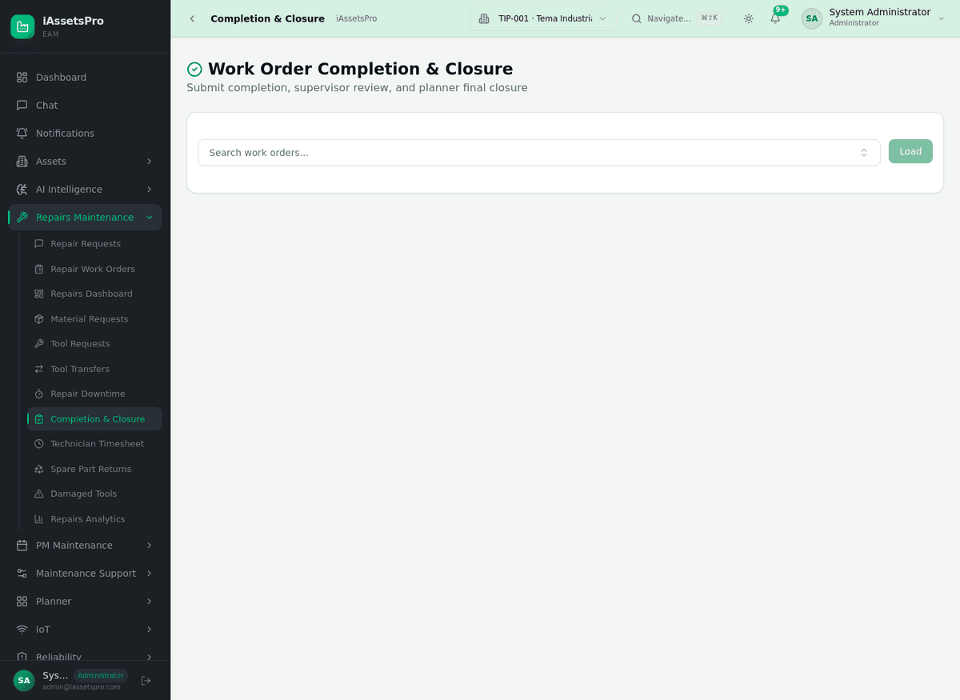
Figure 10. Completion & Closure workspace
What to point out: The page loads a work order into the controlled completion/verification/closure flow.
- Final closure is blocked until required readiness and verification conditions are satisfied.

Closeout authority
Technician completes | > | Supervisor verifies | > | Rework if required | > | Planner reviews costs/codes | > | Close + lock

Authoritative costing is calculated on the server from actual records:
Cost area | Rule
Labor | Active time logs x configured user/trade/plant labor rate; rate/currency are snapshotted for history.
Materials | (Consumed quantity + wasted quantity) x inventory unit cost; returned stock is excluded.
Tools | Reusable custody: no consumption cost by default.
Contractor | Server-side contractor cost field only.
Audit | Client-submitted cost totals are not trusted as authoritative.

14. Preventive Maintenance - Complete Workflow
Preventive Maintenance uses the same asset and component hierarchy as Repairs. A reusable template defines the checklist, a schedule defines when/where the work applies, a trigger determines when it is due, and the resulting preventive work order executes through the same governed Repairs engine.
PM lifecycle
PM Template | > | PM Schedule | > | Exact hierarchy target | > | Time / meter trigger | > | Auto-generate WO

Execution feedback loop
Preventive WO | > | Execute + evidence | > | Verify + close | > | History / compliance | > | Calculate next due

Architectural advantage
Corrective and preventive maintenance do not create two disconnected histories. Both converge on the same work-order execution, resource custody, evidence, costing and closure controls.

15. PM Templates - Reusable Maintenance Checklists
Templates standardize recurring maintenance work. They can represent preventive service, inspection, calibration, safety functional tests or other repeatable task sets. When a schedule generates a WO, the selected template checklist is carried into that work order.
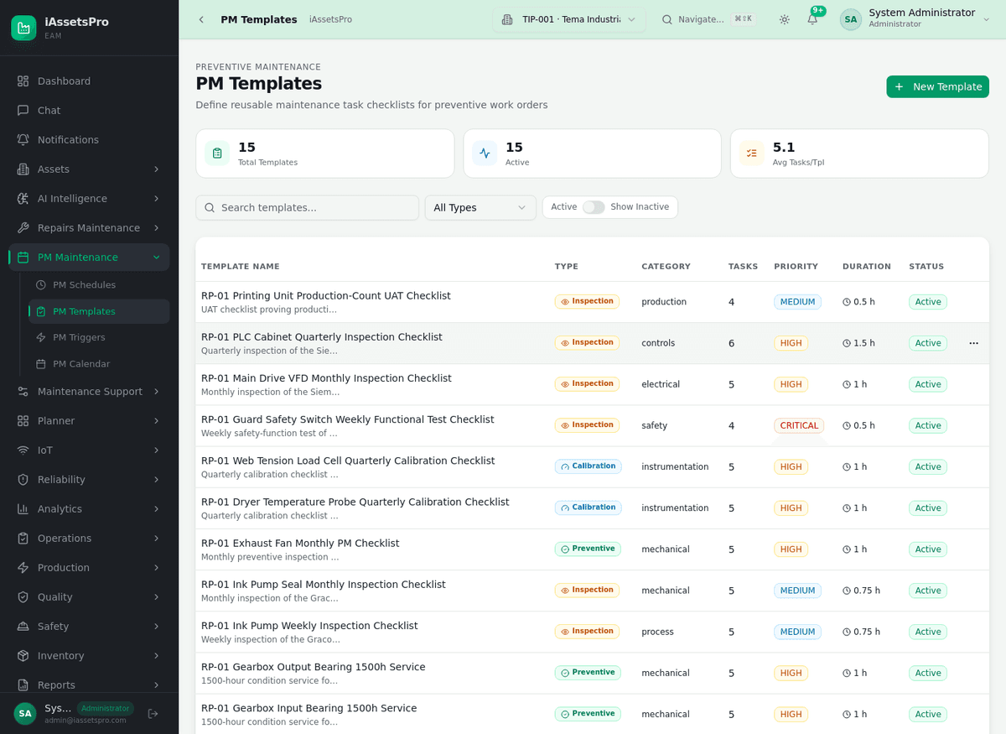
Figure 11. PM Templates - reusable industrial checklists
What to point out: Templates show type/category, task count, priority, estimated duration and active state.
- The current demonstration data includes production-count, inspection, safety, calibration and mechanical service templates.
- Reusable templates reduce planner repetition and standardize technician execution.

16. Creating a PM Schedule
The PM Schedule is the policy that connects a maintenance strategy to a real asset and exact maintainable target. The form has been widened and bounded so long hierarchy selections stay inside the modal on desktop and mobile.
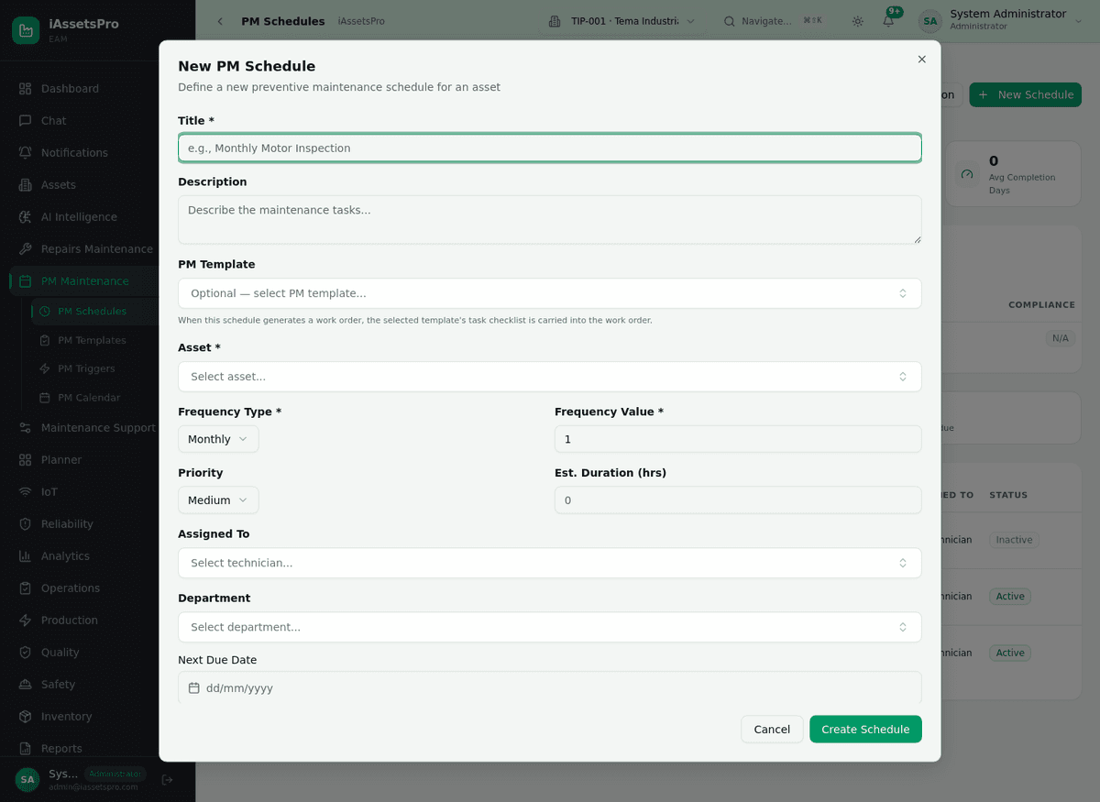
Figure 12. New PM Schedule form
What to point out: Title and description explain the recurring maintenance intent.
- An optional PM Template supplies the reusable task checklist.
- Asset search covers all accessible assets using server-side search/pagination.
- Frequency can be time-based or meter-based, with value, priority, duration, assignee, department and next due date.

Schedule capability | Behavior
Time based | Daily / weekly / monthly / other configured intervals with next-due calendar date.
Meter based | Operating hours / production-count style intervals evaluated against baseline and threshold.
Auto-generate WO | Due schedules/triggers can create a preventive work order automatically.
Lead time | Allows work order generation before the due point where configured.

17. Selecting the Exact PM Target
After choosing the parent asset, the planner opens “Choose PM Target.” This launches the same complete Machine Visual Explorer used on Asset Detail. The planner drills to an assembly, subassembly, component or part, stages the choice, and commits it only by pressing Confirm Selection.
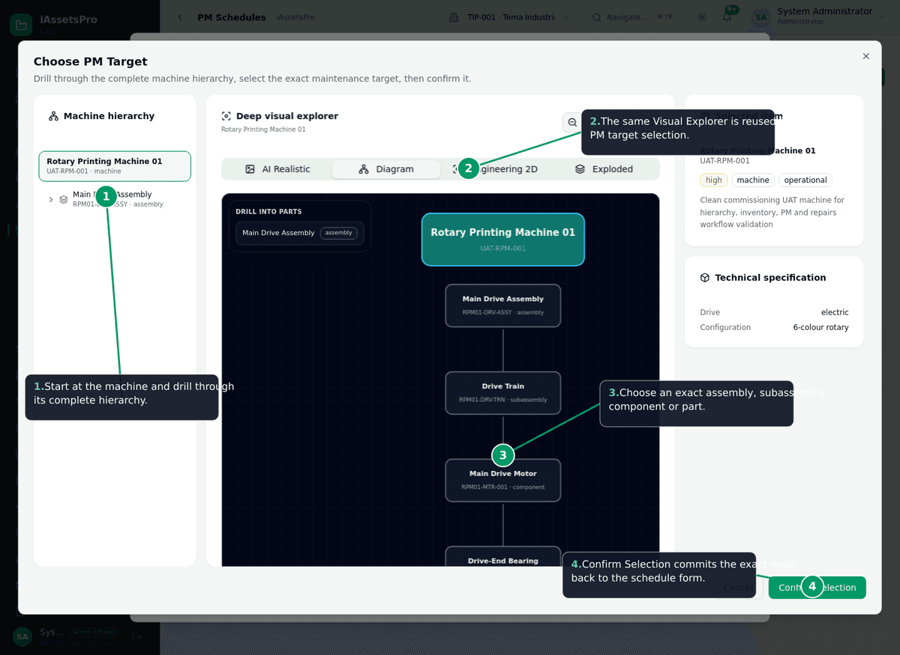
Figure 13. Choose PM Target - annotated exact-node selection
What to point out: The main schedule remains intact while the selection explorer is open.
- Whole-machine maintenance remains valid, but planners can choose any internal maintainable node.
- The selected componentId is persisted against the schedule so generated WOs retain exact equipment history.
- Confirm semantics prevent accidental retargeting while browsing.

Live demo suggestion
Select Rotary Printing Machine 01, open Choose PM Target, expand Main Drive Assembly, drill through Drive Train and Main Drive Motor, then choose Drive-End Bearing. Pause before pressing Confirm so the audience sees the hierarchy logic.

18. PM Schedule Register, Triggers & Automation
The schedule list combines planning KPIs, department compliance and row-level targeting. It makes the important distinction between the parent machine and the exact internal PM target visible without opening the schedule.
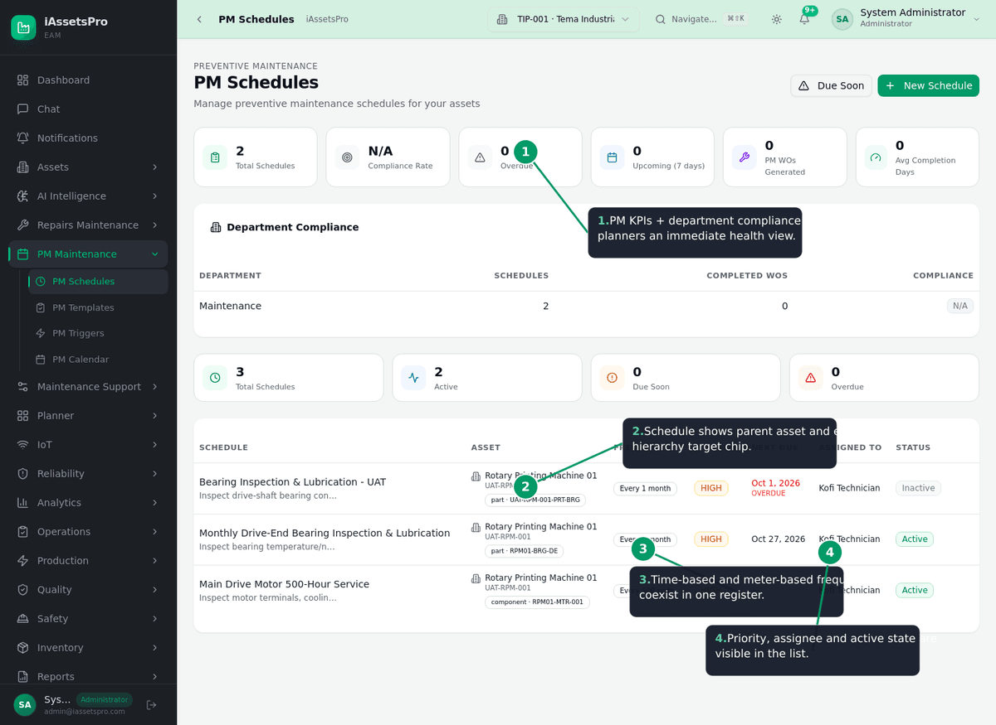
Figure 14. PM Schedules - annotated hierarchy targets and frequency types
What to point out: Target chips distinguish part-level and component-level schedules under the same machine.
- Monthly and “Every 500 units” demonstrate calendar and meter strategies together.
- Priority, assignee and active state support day-to-day planning.

Meter-trigger automation has been validated to:
- Capture a baseline reading for the exact component.
- Generate only when the configured threshold is crossed.
- Prevent duplicate WOs at the same reading/threshold.
- Respect plant scope so another plant cannot generate or mutate the PM.
- Link the generated WO back to the PM schedule and exact component/part.
- Re-arm appropriately after cancellation so the maintenance strategy remains operational.

19. PM Calendar & Compliance
The PM Calendar turns schedule data into an operational planning view. Planners can review upcoming work in month/week views, identify due-soon and overdue items, and use compliance metrics to monitor execution by department.
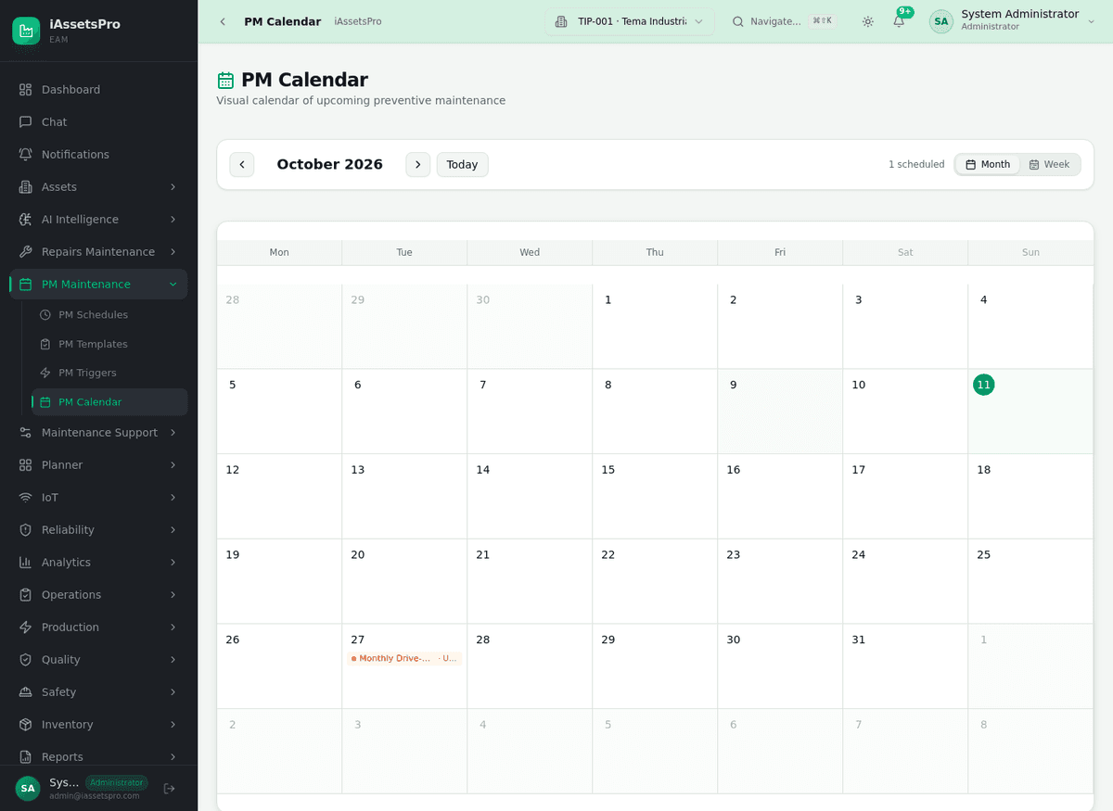
Figure 15. PM Calendar - upcoming preventive maintenance
What to point out: Calendar events provide a visual date-based view of scheduled preventive work.
- Month/week controls support different planning horizons.
- Schedule register KPIs and department compliance provide the management layer above the calendar.

20. How Asset Hierarchy, Repairs and PM Connect
The core design is a single traceable chain. The engineering hierarchy is not decorative: it becomes the shared reference for failure history, repair work, resource consumption and preventive strategy.
End-to-end data continuity
Asset master | > | Maintainable node | > | MR / PM trigger | > | Work Order | > | Execution evidence

Closed-loop maintenance
Close WO | > | Cost + failure history | > | Reliability insight | > | Adjust PM strategy | > | Next intervention

Layer | What it contributes
Machine root | Enterprise identity, plant/location, asset criticality and lifecycle.
Exact component/part | Failure, work, readings, PM interval and condition context.
Work Order | Tasks, people, tools, materials, evidence, downtime, costs and status.
History | Closed, immutable record feeding reporting/reliability decisions.

21. Roles, Permissions, Security & Auditability
iAssetsPro is designed for separation of duties. The frontend displays actions from server-calculated capability flags, while APIs enforce the same authority and plant scope. This prevents UI manipulation from becoming operational authority.
Capability | Status | Presentation note
Requester | Controlled | Creates/tracks MRs; cannot self-approve.
Supervisor | Controlled | Approve/reject MRs, verify work, request rework, assist with assignment where delegated.
Planner | Controlled | Converts MR, plans/assigns resources, authors PM, closes verified WOs.
Technician | Controlled | Executes assigned work, logs time/tasks/evidence, requests resources, completes when authorized.
Team Leader | Controlled | Can log team time and submit final completion for multi-tech work.
Assistant Technician | Restricted | Can work/log evidence but cannot submit team completion.
Storekeeper / Tool Keeper | Controlled | Approves/issues/receives resources and performs custody/QC operations.
Administrator / Manager | Scoped | Administrative and cross-module oversight subject to configured access.
Additional controls already implemented include transaction atomicity, idempotency keys for replay safety, closed-WO immutability, cross-plant access enforcement, and server-side calculation of costs and readiness.

22. Validation & Current Production Status
The presentation scope is not being shown as a prototype-only flow. The current production lineage includes the merged PM/Repairs release and the subsequent damaged-tool custody hardening.
Capability | Status | Presentation note
Unit Tests (Vitest) | PASS | Final corrected PM/Repairs hotfix run passed.
Lint | PASS | No release-blocking lint failure.
Repairs TypeScript hard gate | PASS | Canonical Repairs release TypeScript gate passed.
Production Build | PASS | Optimized Next.js standalone build passed in CI.
Production Container Build | PASS | Production image build passed.
Platform E2E (Playwright) | PASS | Full platform browser E2E job passed.
Repairs UAT (Playwright) | PASS | Repairs browser UAT passed, including hierarchy/PM flows.
Required CI Gate | PASS | All required jobs verified before merge.
Production HTTP health | LIVE | Production endpoint returns HTTP 200.
Release lineage
Merged PM/Repairs hotfix: fa9419f. Active production: 3839870, one commit ahead of fa9419f, so it contains that complete hotfix plus damaged-tool quantity/QC custody hardening.

23. Recommended Live Demonstration - 15 to 20 Minutes
- Login as System Administrator and spend 30-45 seconds on the Dashboard. State the business outcome: one operational view of asset health and maintenance performance.
- Open Assets > Machines. Show the Asset Register, then open Rotary Printing Machine 01.
- On Overview, point out identity, criticality, specifications and the already-linked PM schedules.
- Open Components. Explain the coded engineering chain: Main Drive Assembly > Drive Train > Main Drive Motor > Drive-End Bearing.
- Open Visual Explorer. Switch briefly between Diagram / Engineering 2D / Exploded (where useful), zoom and select a node. This is the “wow” moment.
- Open Repairs Maintenance > Repair Requests. Explain request -> approval -> conversion and the audit trail.
- Open Repair Work Orders. Explain assignment, execution, time/evidence and status controls.
- Open Material Requests, then Tool Requests. Explain quantity reconciliation and custody. Mention damaged returns are quarantined rather than returned to usable stock.
- Open Completion & Closure and explain technician completion -> supervisor verification/rework -> planner closure.
- Open PM Maintenance > PM Templates. Show reusable checklists.
- Open PM Schedules. Point to different exact target chips and monthly versus meter-based schedules.
- Click New Schedule (do not necessarily save). Select the asset, then Choose PM Target. Drill to Drive-End Bearing and explain Confirm Selection.
- Open PM Calendar. Finish by showing the scheduled event and explain that due PM can auto-generate a work order that runs through the same governed execution engine.
Fallback strategy for tomorrow
Do not depend on creating new production data live. Use the existing Rotary Printing Machine 01 and existing PM/repair records. If connectivity is slow, this guide contains the same screenshots in the exact demonstration order.

24. Presenter Talking Points - What Makes iAssetsPro Different
- “We maintain the exact part, not just the parent machine.” - deep component hierarchy with codes and parent relationships.
- “The diagram is operational, not cosmetic.” - the Visual Explorer selects the same node used by PM and work history.
- “Repair resources are controlled assets.” - materials and tools have approval, issue, return and reconciliation custody.
- “Damaged does not mean available.” - damaged materials/tools remain quarantined until inspection/refurbishment/repair and QC release.
- “PM and Repairs share one execution engine.” - preventive work receives the same task, evidence, resource, cost and closeout controls as corrective work.
- “Authority is server-side.” - capabilities, plant scope and state transitions are not trusted to the browser alone.
- “History remains trustworthy.” - idempotency, atomic transitions, closed-WO immutability and authoritative costing protect audit records.
Closing line
“The value of iAssetsPro is the continuity of information: from the machine name to the bearing, from the bearing to the repair, from the repair to the cost and evidence, and from that history back into the next preventive-maintenance decision.”

Appendix A. Quick Status Glossary
Term | Meaning
MR - Maintenance Request | Controlled intake record for a reported maintenance need.
WO - Work Order | Authorized/planned execution record for maintenance work.
PM - Preventive Maintenance | Planned recurring maintenance based on time, meter or configured trigger.
Assembly | Major maintainable group under the machine root.
Subassembly | Child group inside an assembly.
Component | Maintainable equipment unit inside the hierarchy.
Part | Lowest maintainable/replacement item represented in the component registry.
Quality hold / quarantine | Custody state preventing suspect items from entering usable stock.
Awaiting QC | Repaired tool/item is not yet usable until inspection acceptance.
Rework | Supervisor sends completed work back to execution with reason.

Appendix B. Demonstration Asset Reference
Field | Demo value
Asset | Rotary Printing Machine 01
Asset Tag | UAT-RPM-001
Criticality | High
Plant | Tema Industrial Test Plant
Assembly | Main Drive Assembly / RPM01-DRV-ASSY
Subassembly | Drive Train / RPM01-DRV-TRN
Component | Main Drive Motor / RPM01-MTR-001
Part | Drive-End Bearing / RPM01-BRG-DE

