iAssetsPro
Enterprise Asset Management System
Full Illustrated System Documentation & Presentation Guide
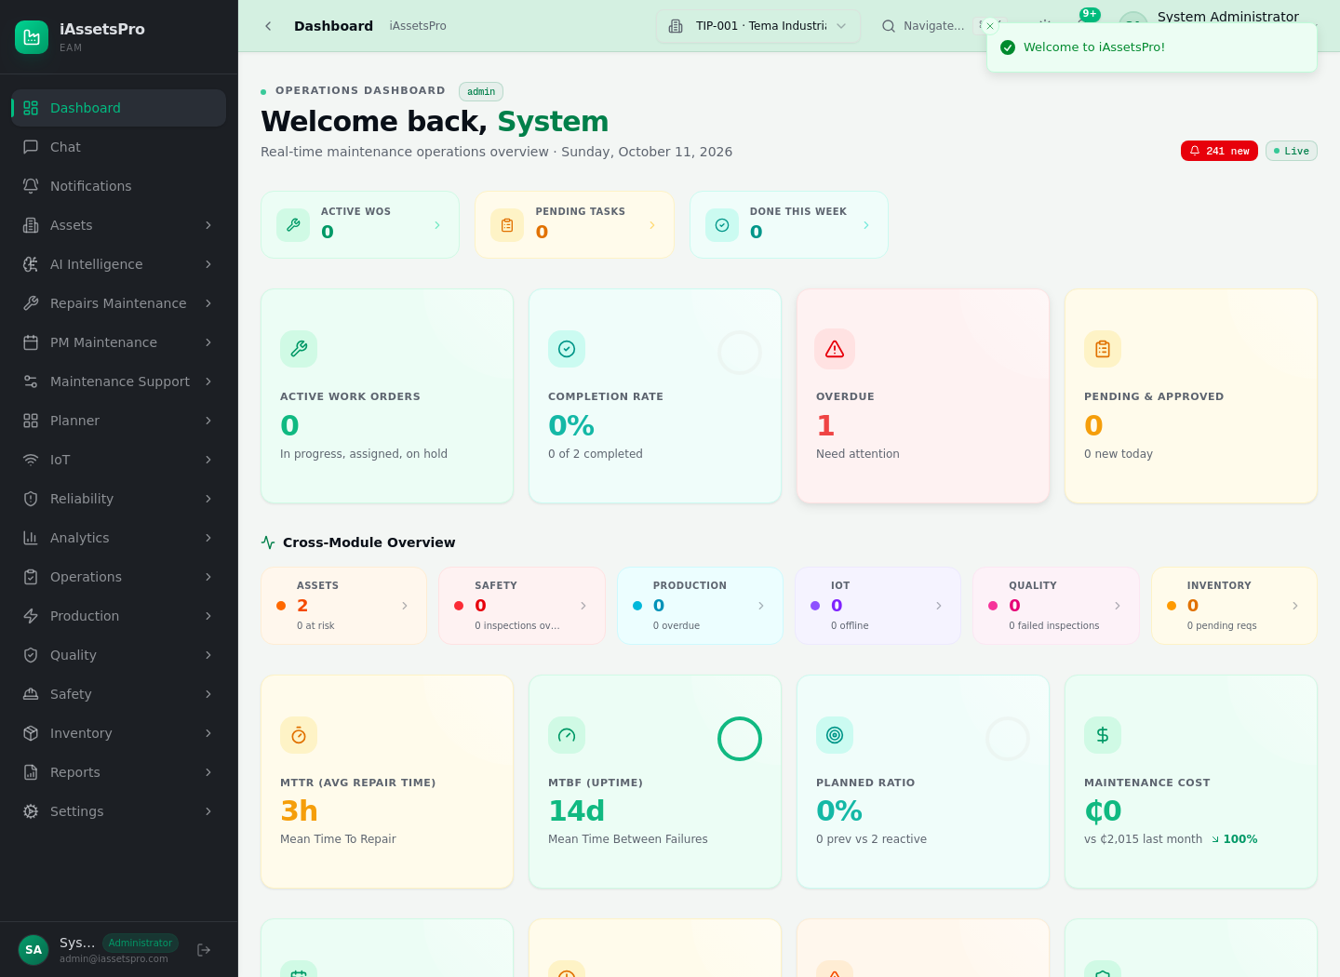
Prepared for system presentation - October 2026
Lightworld Technologies Ltd

1. Executive Overview
iAssetsPro is an integrated enterprise asset management platform designed to control the complete operational life of industrial assets - from registration and technical hierarchy commissioning through corrective repairs, preventive maintenance, inventory/tool custody, downtime, evidence, closure and analytics.
Core idea: Every maintenance event is anchored to a physical asset and, where required, to the exact assembly, subassembly, component or part being maintained. This keeps engineering context, work history, spares, tools, costs and PM history traceable to the correct level of the machine.

Area | Implemented capability | Presentation message
Asset register | Asset master data, plant/department/location, lifecycle and parent-asset relations | One source of truth for physical equipment.
Machine hierarchy | Machine -> assembly -> subassembly -> component -> part | Maintenance can be targeted to the exact maintainable item.
Repairs / RWOP | Request -> approval/conversion -> planning -> execution -> resource custody -> completion -> closure | Controlled corrective-maintenance lifecycle with auditability.
Preventive maintenance | Templates, schedules, exact hierarchy targets, time/meter triggers, calendar and auto work orders | PM is planned and generated from the same asset structure used by Repairs.
Materials & tools | Request, approval, issue, return, damaged/defective custody and reconciliation | Stock and tool custody remain accountable throughout work execution.
Platform controls | RBAC, audit history, PostgreSQL, Redis/BullMQ background processing, automated tests | Enterprise controls protect operations and support scale.

2. Access, Dashboard and Navigation
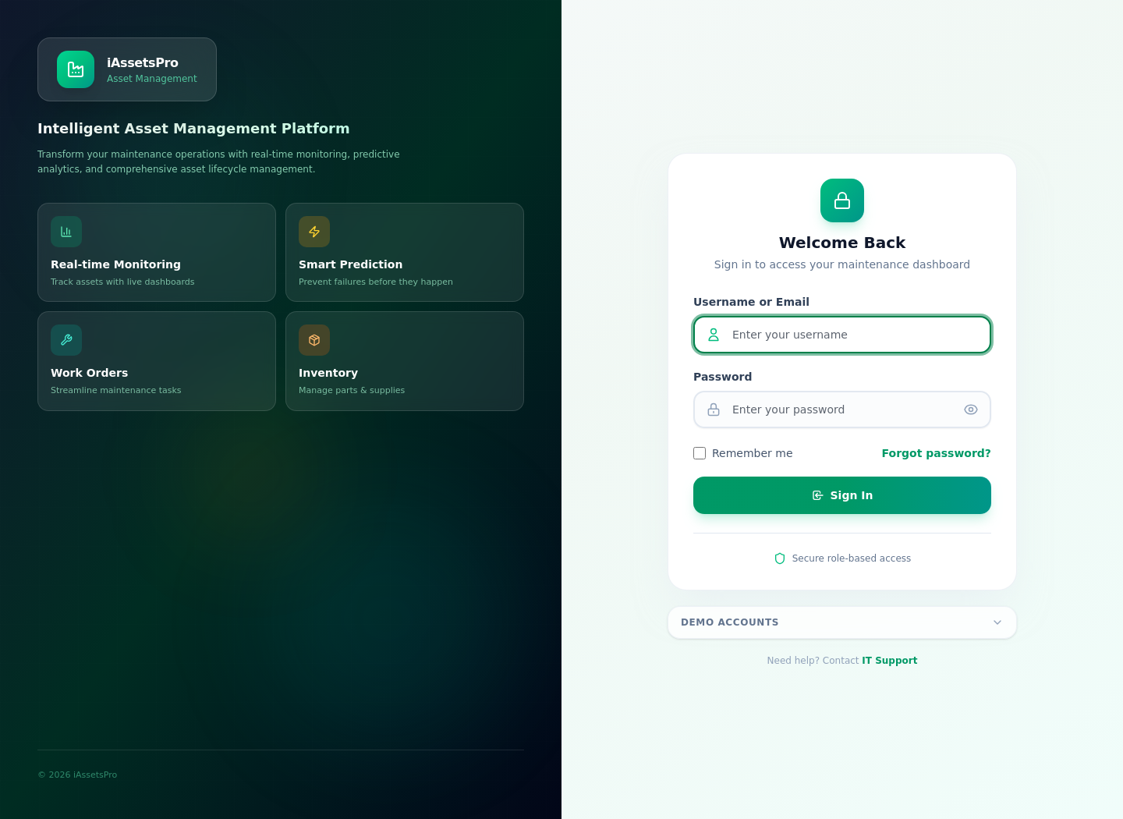
Figure 1 - iAssetsPro login screen
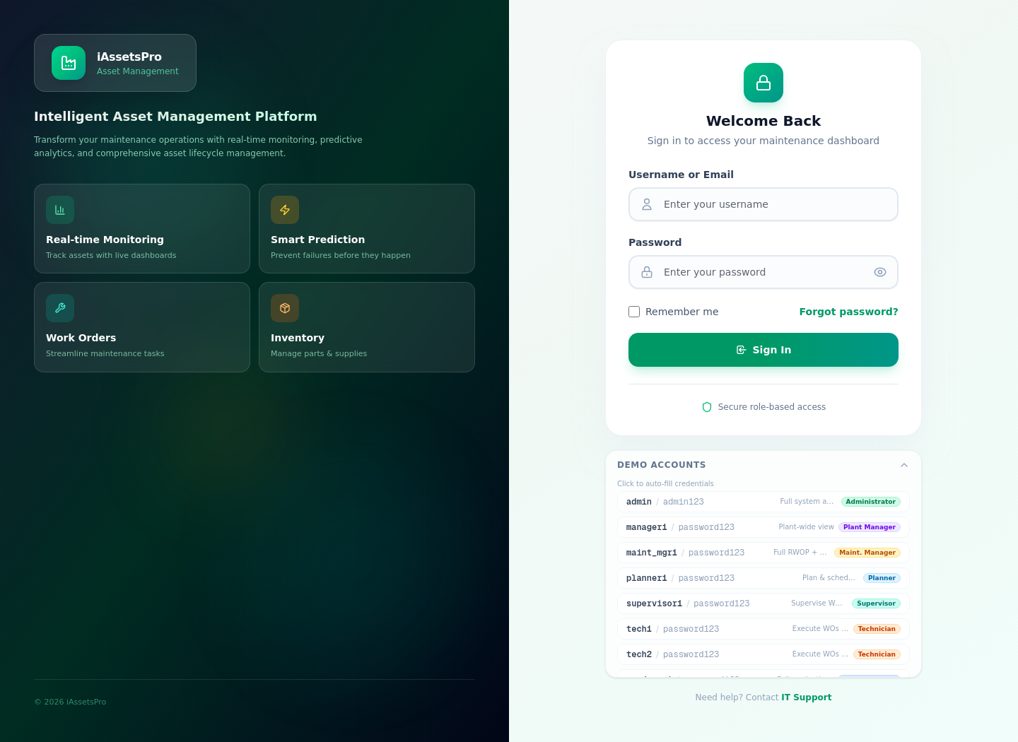
Figure 2 - Demo account selector for presentation and role-based testing
Figure 3 - Main dashboard and module navigation
- Users authenticate into role-based workspaces. Navigation and actions are controlled by permissions and licensed modules.
- The dashboard provides operational entry points while each specialist module exposes its own KPIs, queues and controlled actions.
- For a presentation, begin as System Administrator or Maintenance Planner, then switch to Technician/Store roles if you want to demonstrate segregation of duties.

3. Asset Creation and Registration
Asset registration creates the machine-level master record that every downstream maintenance process references. The form captures both engineering identity and organizational ownership.
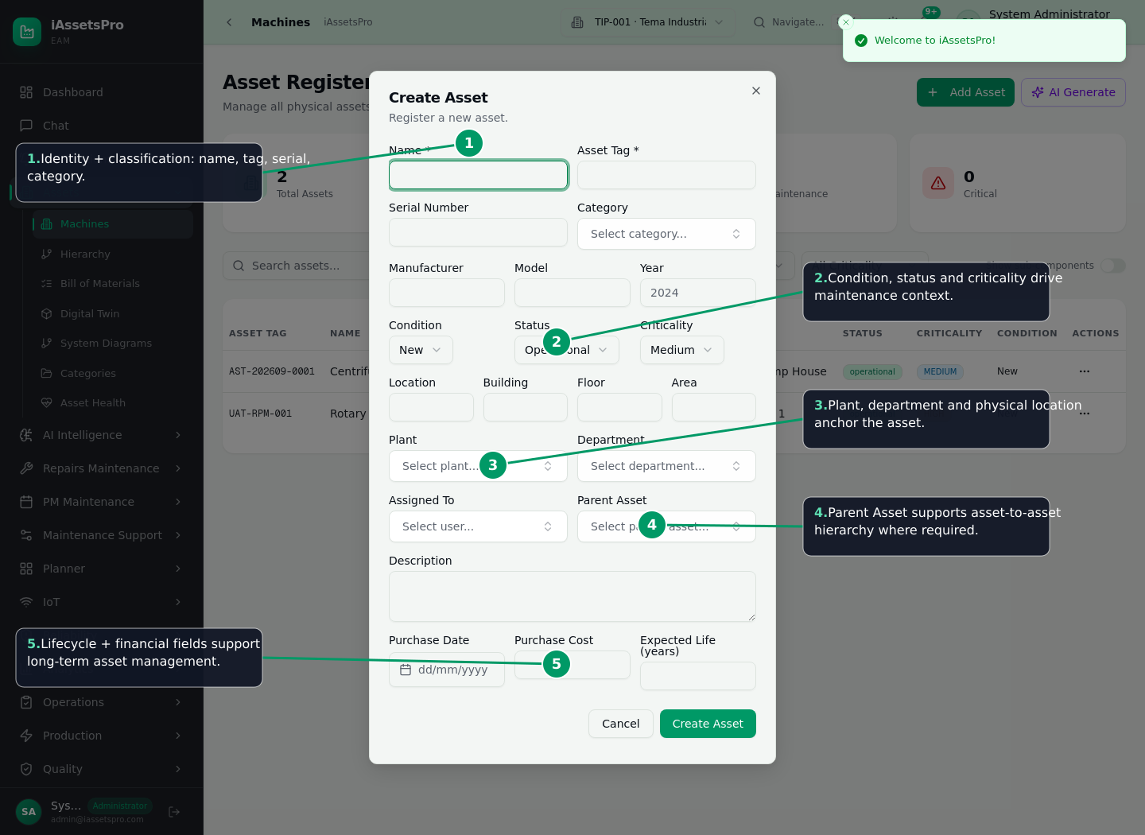
Figure 4 - Annotated Create Asset form
- Open Assets -> Machines (Asset Register) and choose Add Asset.
- Enter identity: Name, Asset Tag, Serial Number and Category.
- Capture engineering context: Manufacturer, Model, Year, Condition, Status and Criticality.
- Anchor the asset physically: Location, Building, Floor, Area, Plant and Department.
- Assign responsible personnel where appropriate and choose a Parent Asset when creating asset-to-asset hierarchy.
- Capture description, purchase date, purchase cost and expected useful life, then Create Asset.
Why it matters: Criticality, plant, department and status are not cosmetic fields; they become planning, filtering, prioritization and analytics dimensions across Repairs and PM.

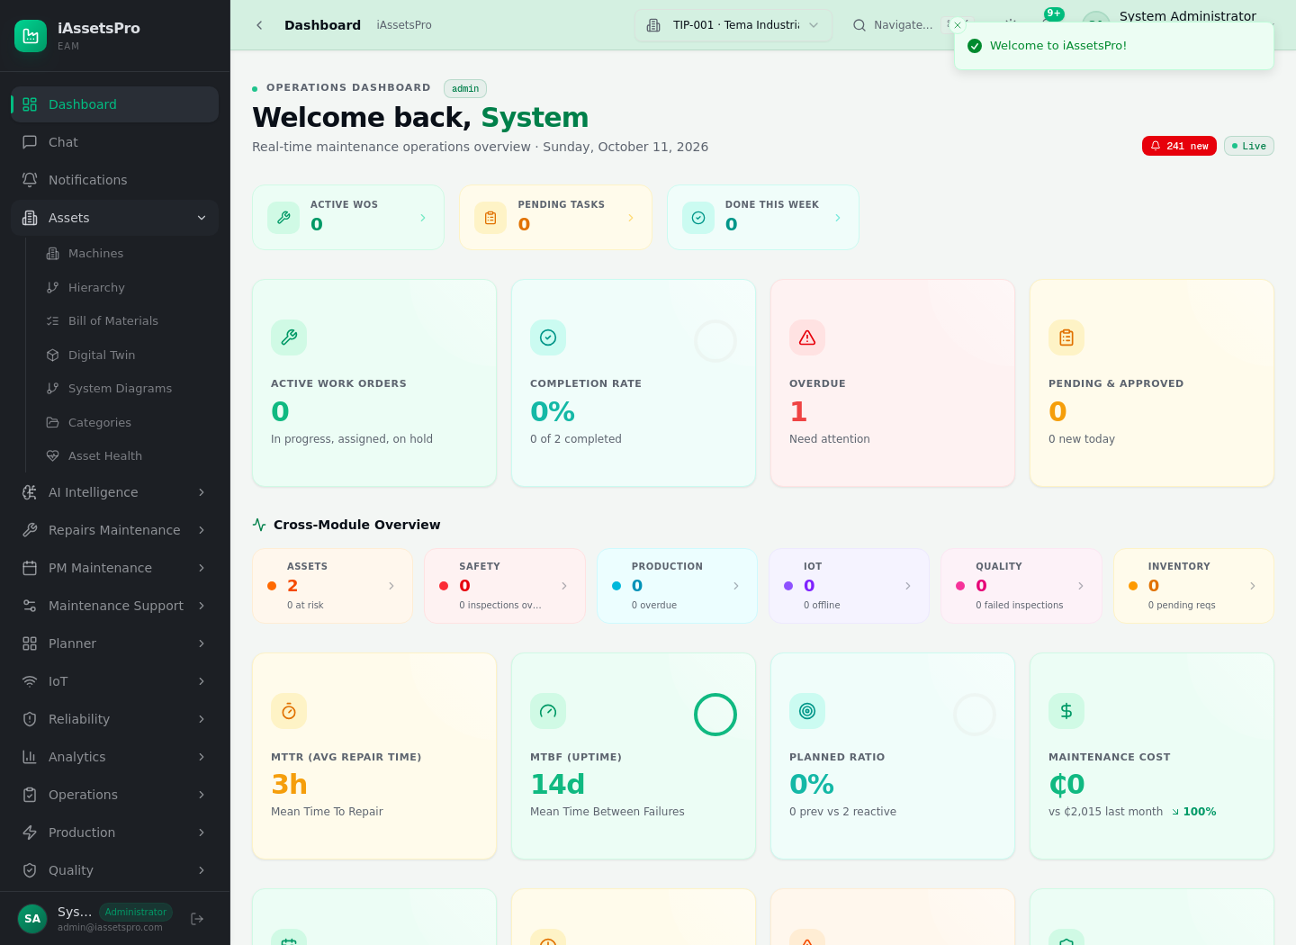
Figure 5 - Asset register / machine list
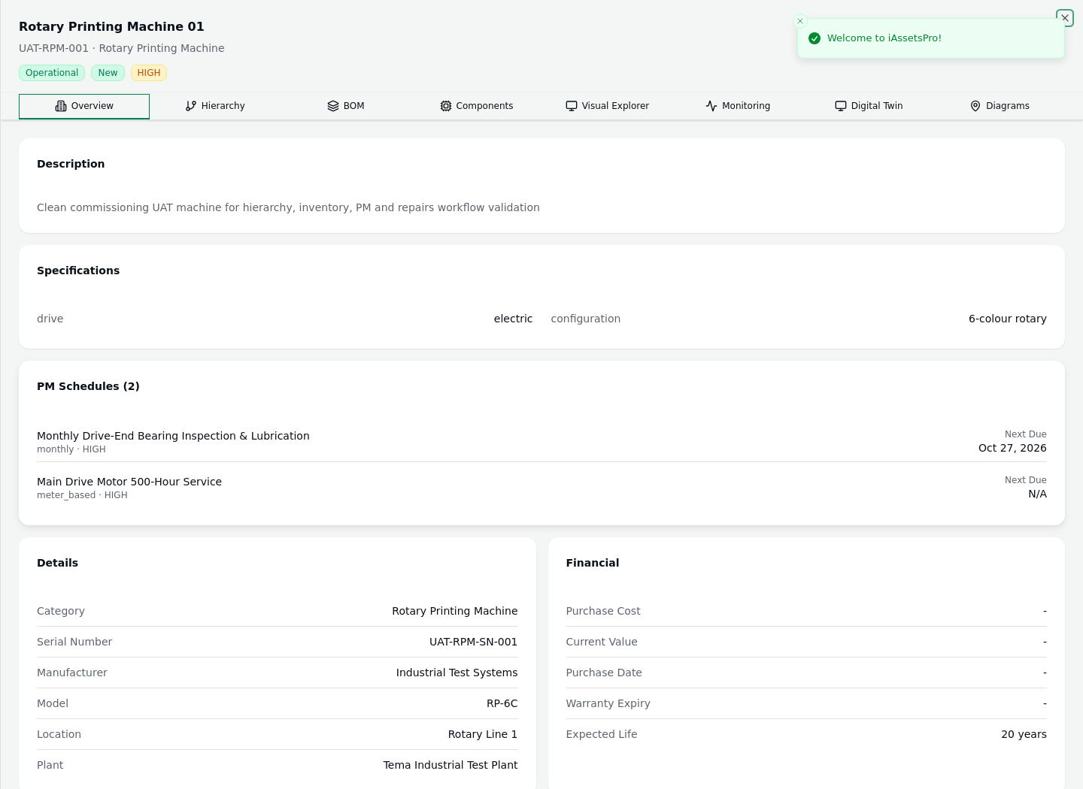
Figure 6 - Asset detail workspace

4. Building the Machine Technical Hierarchy
After the machine exists, maintainable structure is commissioned beneath it. iAssetsPro distinguishes engineering hierarchy nodes so that work can be recorded at the correct physical level.
Level | Example | Maintenance meaning
Machine | Rotary Printing Machine 01 | Top-level asset / parent machine
Assembly | Main Drive Assembly | Major functional group
Subassembly | Drive Train | Nested functional group inside an assembly
Component | Main Drive Motor | Maintainable component with its own operating context
Part / sub-part | Drive-End Bearing | Lowest replaceable/inspectable target
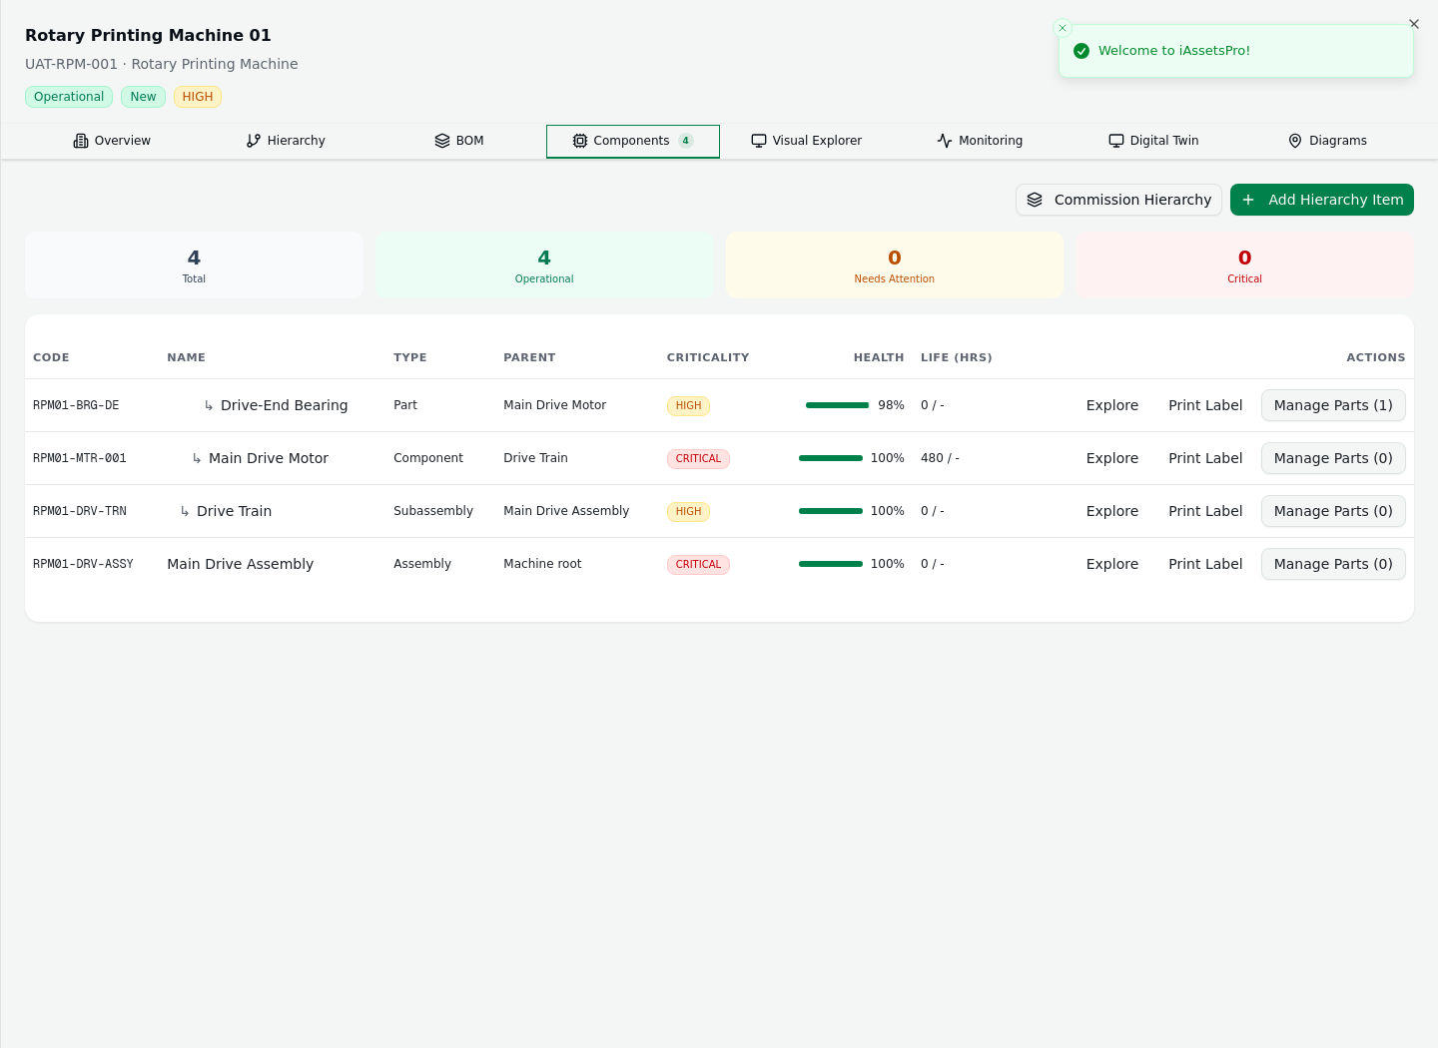
Figure 7 - Component/hierarchy commissioning workspace
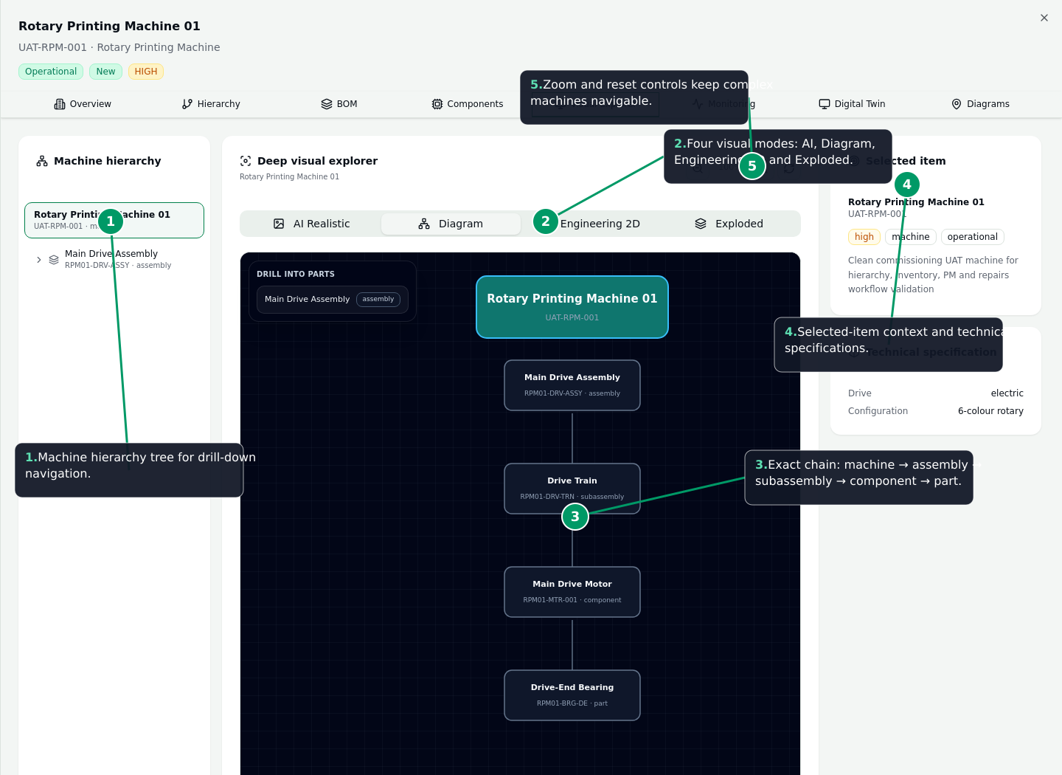
Figure 8 - Annotated Deep Visual Explorer
- Open the selected asset and use Hierarchy/Components or the Visual Explorer.
- Create or bulk-commission assemblies and child nodes with unique component codes and parent relationships.
- Drill from the machine through each child level; circular/unresolved parent relationships are rejected by validation.
- Select a node to see its technical context and, where configured, engineering visuals/specifications.
- Reuse the same hierarchy in corrective work orders, preventive schedules, part-replacement history and reports.
Presentation phrase: “We do not only maintain a machine. We can maintain the exact bearing, motor, gearbox, shaft or subassembly inside that machine, while still preserving the relationship to the parent asset.”

5. Visual Engineering Explorer
- Left pane: hierarchy tree for deterministic drill-down.
- Center pane: deep visual explorer with AI Realistic, Diagram, Engineering 2D and Exploded modes.
- Right pane: selected-item context and technical specifications.
- Zoom/reset controls allow complex equipment structures to remain navigable.
- The explorer is reused by PM target selection so maintenance planners do not need a separate hierarchy interface.

6. Complete Repairs Maintenance Workflow
The Repairs/RWOP flow controls the journey from a reported defect to a reviewed and closed work order. The same work order becomes the traceability hub for people, tasks, time, downtime, materials, tools, evidence and cost.
Repairs lifecycle: Defect / Maintenance Request -> Review & approval -> Convert/Create Work Order -> Plan scope/resources -> Approve/assign -> Technician execution -> Materials/tools/downtime/evidence -> Completion report -> Supervisor review -> Close -> Analytics & history.

6.1 Defect or Breakdown Intake
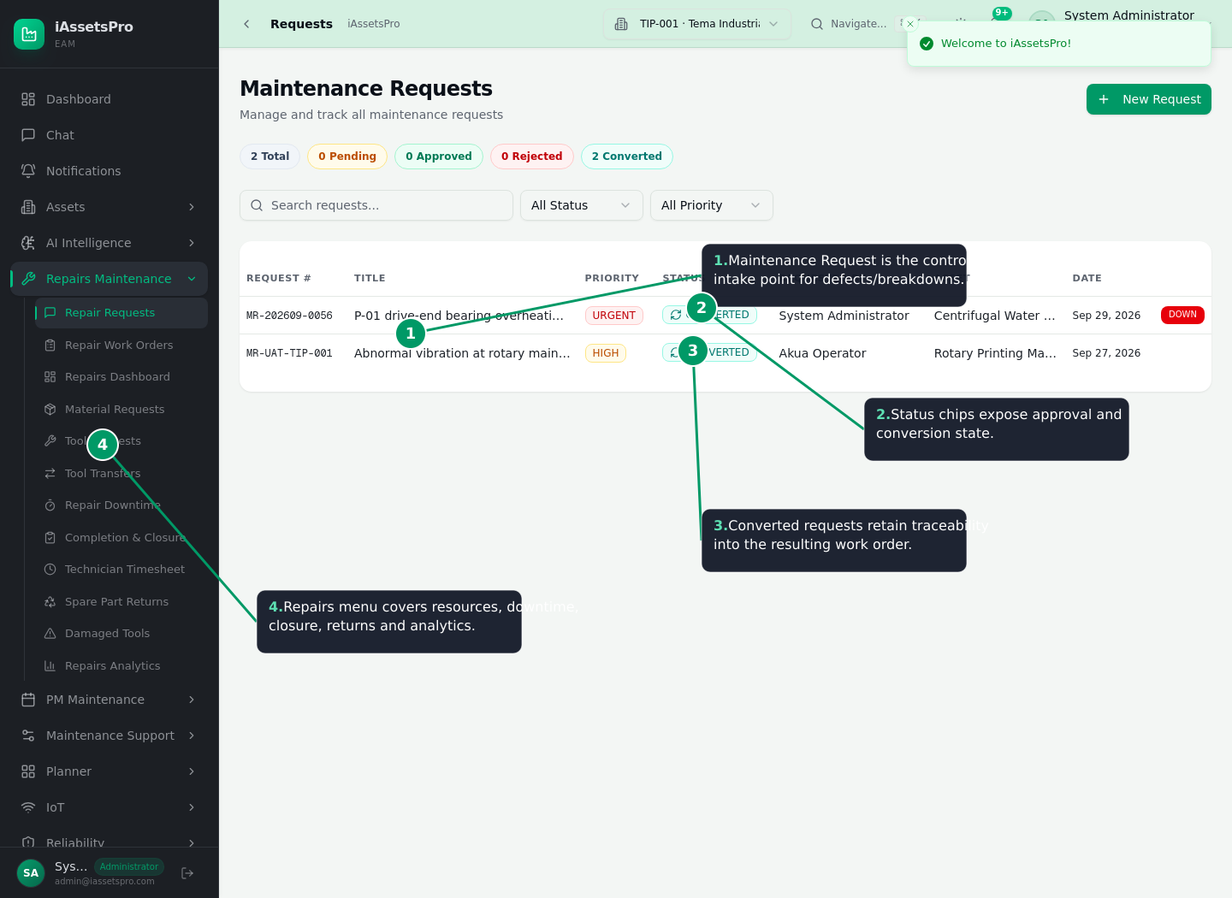
Figure 9 - Annotated Maintenance Requests register
- Operator, planner or authorized user raises a Maintenance Request against the affected asset.
- The request records the issue description, priority/urgency, requester, asset and state.
- Planner/Supervisor reviews the request and either rejects, approves or converts it to a repair work order.
- Converted requests retain their linkage to the resulting work order for audit and history.

6.2 Work Order Planning, Approval and Assignment
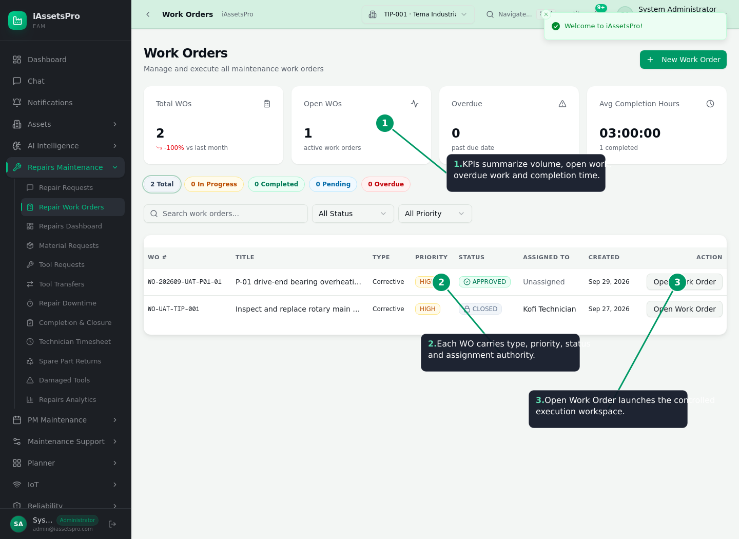
Figure 10 - Annotated Repair Work Orders register
- Work orders carry type, priority, status, planner, assignment and exact asset/component scope.
- Planner can define multiple technicians and nominate a Team Leader.
- Planned tasks, estimated duration, required materials and required tools form the execution plan.
- Authorized approval moves the work into controlled execution rather than informal technician activity.

6.3 Technician Execution Workspace
- Technician starts work and the system records actual execution time through start/pause/resume/complete lifecycle actions.
- Technicians can log task progress, shift notes, findings and work evidence/photos.
- Assistance requests allow controlled escalation when another skill/trade is required.
- Downtime is tracked separately so equipment unavailability can be measured and analyzed.
- Execution history remains associated with the work order and affected hierarchy target.

6.4 Material and Spare-Part Control
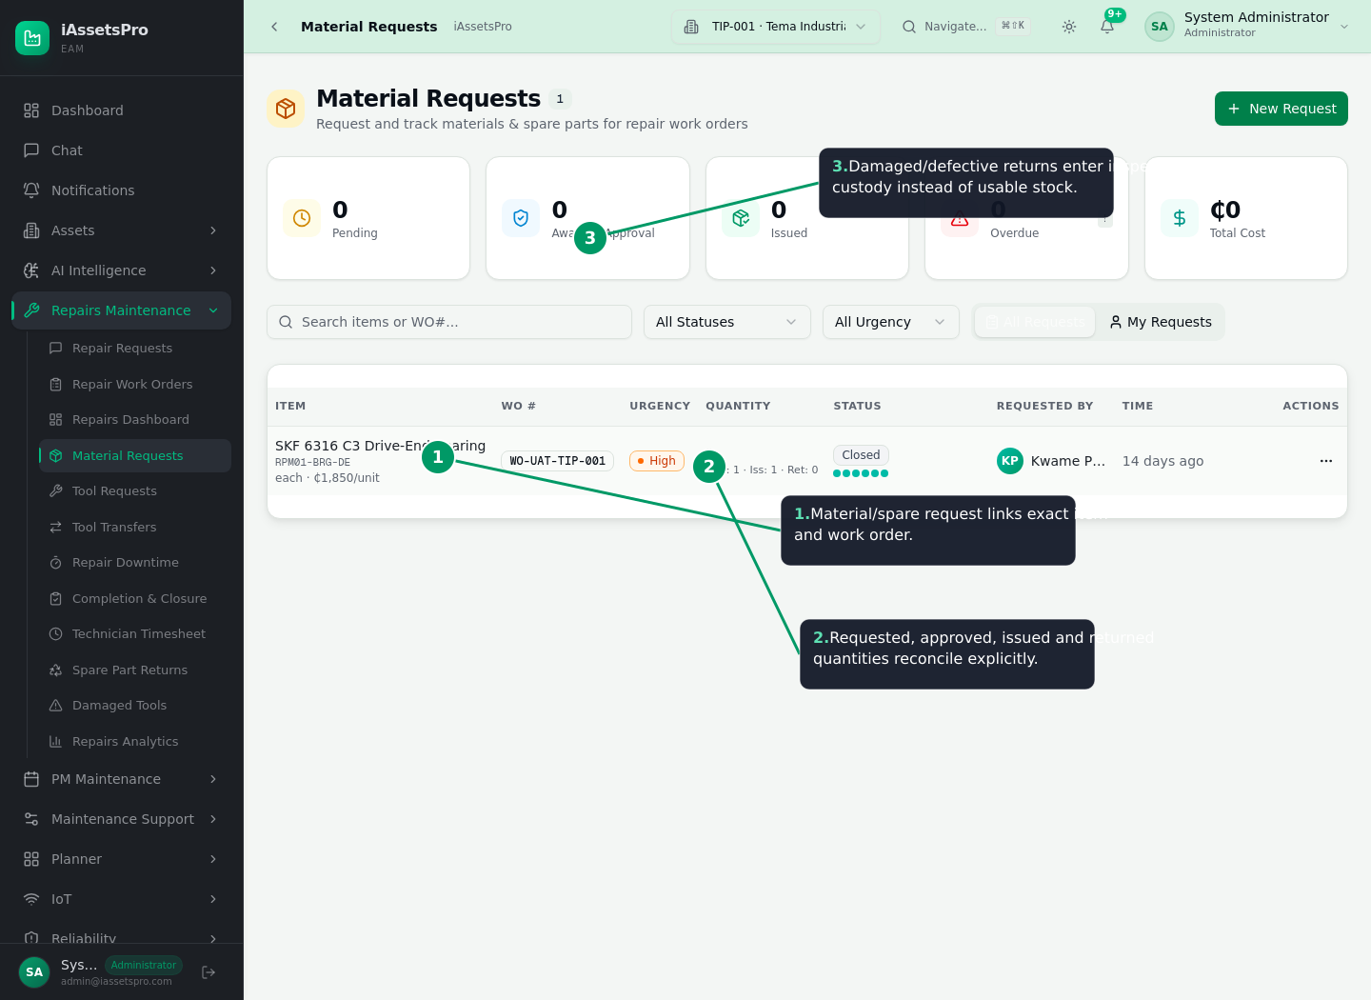
Figure 11 - Annotated Material Requests and spare-part reconciliation
- Technician or planner requests materials/spares against the work order.
- Authorized store/planning roles review and approve requested quantities.
- Stores issue approved quantities and inventory movement is recorded against the work order.
- Used quantities contribute to repair cost and installed-part history.
- Unused serviceable quantities return to usable stock.
- Damaged or defective returned quantities do NOT become usable stock; they enter inspection/refurbishment custody for disposition.
- Disposition can return an item to stock after QC, send it for repair/refurbishment, return it to supplier, or scrap it according to the relevant lifecycle.

6.5 Tool Request, Issue, Transfer and Return
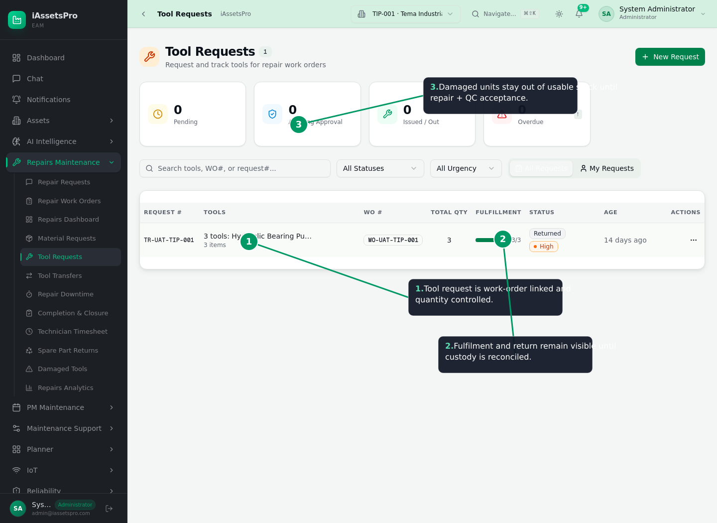
Figure 12 - Annotated Tool Requests and custody state
- Tool requests are linked to the work order and quantity controlled.
- Issue/fulfilment creates visible custody until the tool is returned/reconciled.
- Tools can be transferred where permitted while maintaining accountability.
- Damaged tools remain outside usable stock until repair and QC acceptance; this prevents false availability.

6.6 Completion, Review and Closure
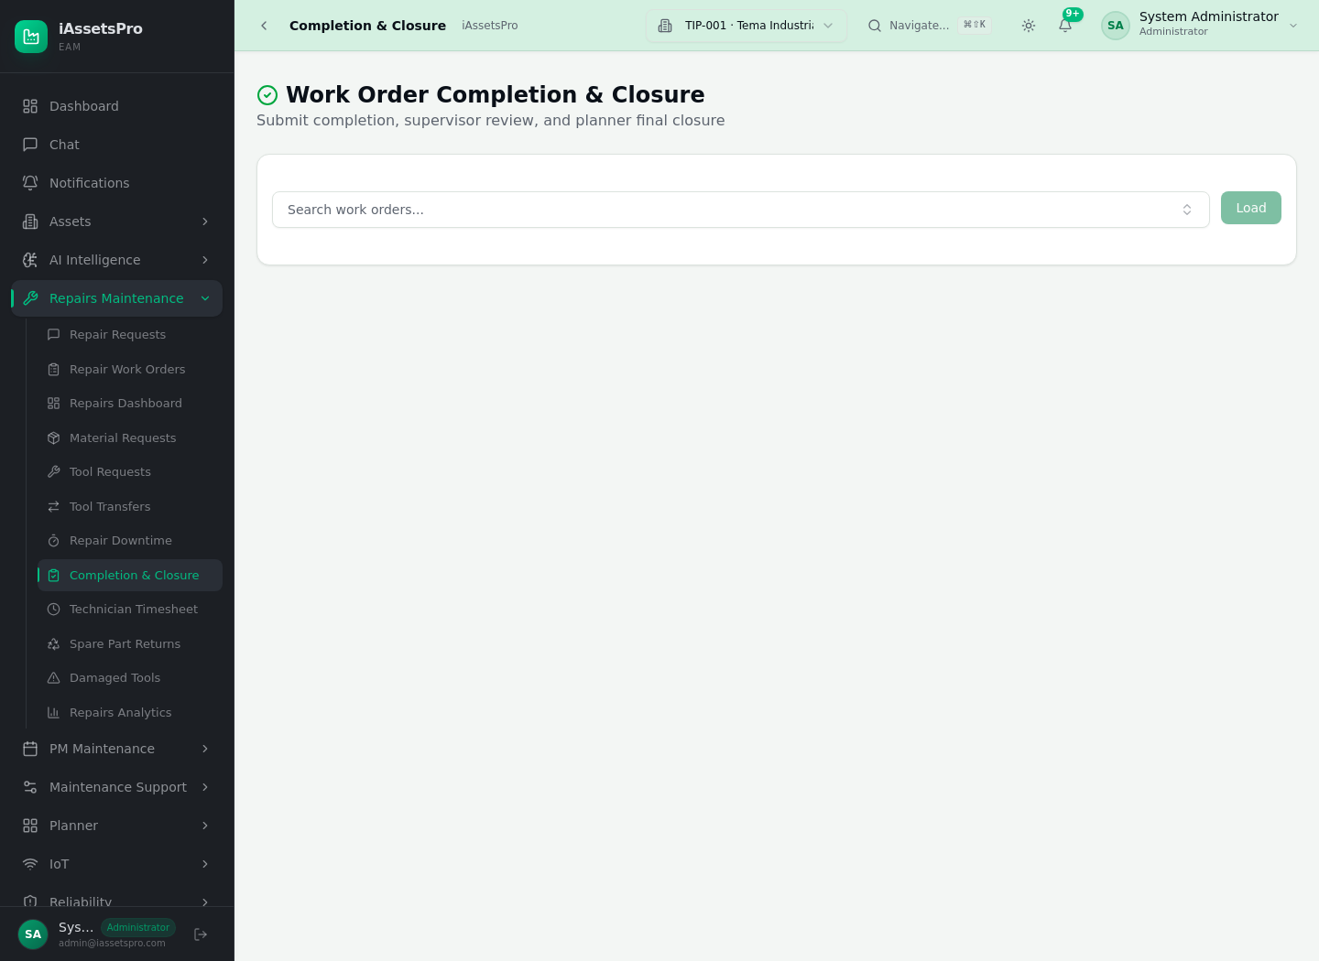
Figure 13 - Completion & Closure workspace
- Technician completes execution tasks and submits a completion report with findings/actions/evidence.
- Required time logs, resource returns and completion conditions are checked before final closure.
- Supervisor/planner reviews the completion, validates the repair outcome and closes the work order.
- Closed work preserves the complete audit trail: request, work order, people, time, downtime, materials, tools, evidence and costs.
- Analytics can then calculate breakdown counts, response time, repair duration, downtime, labor/material/tool cost and repeat-failure patterns.

6.7 Condition-Aware Returns and Receiving Quality Hold
- New purchasing receipts can be placed into quality hold when damaged/defective instead of silently increasing usable stock.
- Quality-hold lifecycle supports quarantine -> repair/refurbish -> usable stock, supplier return or scrap.
- Supplier-returned quantities reopen purchase-order replacement quantity where applicable.
- Work-order material returns use the same condition-aware principle: serviceable returns credit usable stock; defective returns go to inspection/refurbishment custody.
- Serialized spare replacement remains linked to the parent machine/component and work order for installed-part history.

7. Full Preventive Maintenance (PM) Workflow
Preventive maintenance uses the same asset and technical hierarchy as Repairs. The objective is to define repeatable maintenance content, target the exact maintainable item, trigger work at the correct time/meter threshold and execute it through the governed work-order engine.
PM lifecycle: Template/checklist -> Create schedule -> Select asset -> Drill/select exact hierarchy target -> Set time/meter frequency -> Assign priority/owner -> Activate -> Trigger/due evaluation -> Auto-generate preventive WO -> Execute checklist/resources -> Complete/close -> Update compliance and next due.

7.1 PM Templates and Standard Tasks
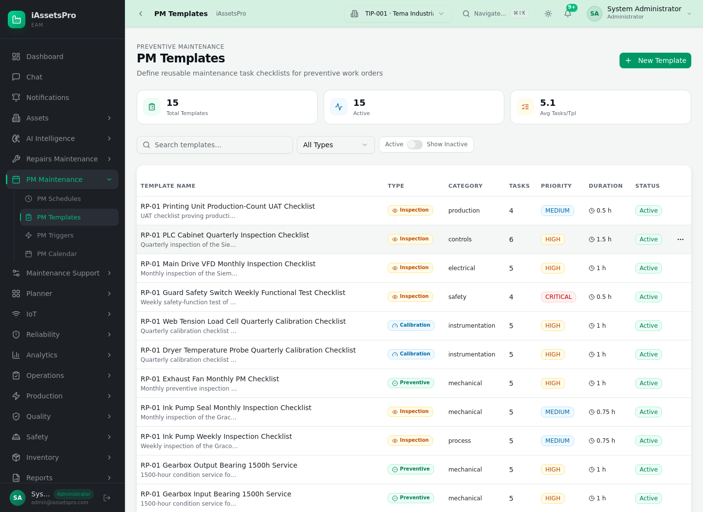
Figure 14 - PM Templates
- Templates standardize recurring maintenance jobs and can contain multiple ordered checklist tasks.
- Templates capture repeatable instructions, task types, expected duration and priority.
- A schedule may reference a template so generated work orders inherit consistent execution content.

7.2 Creating a PM Schedule
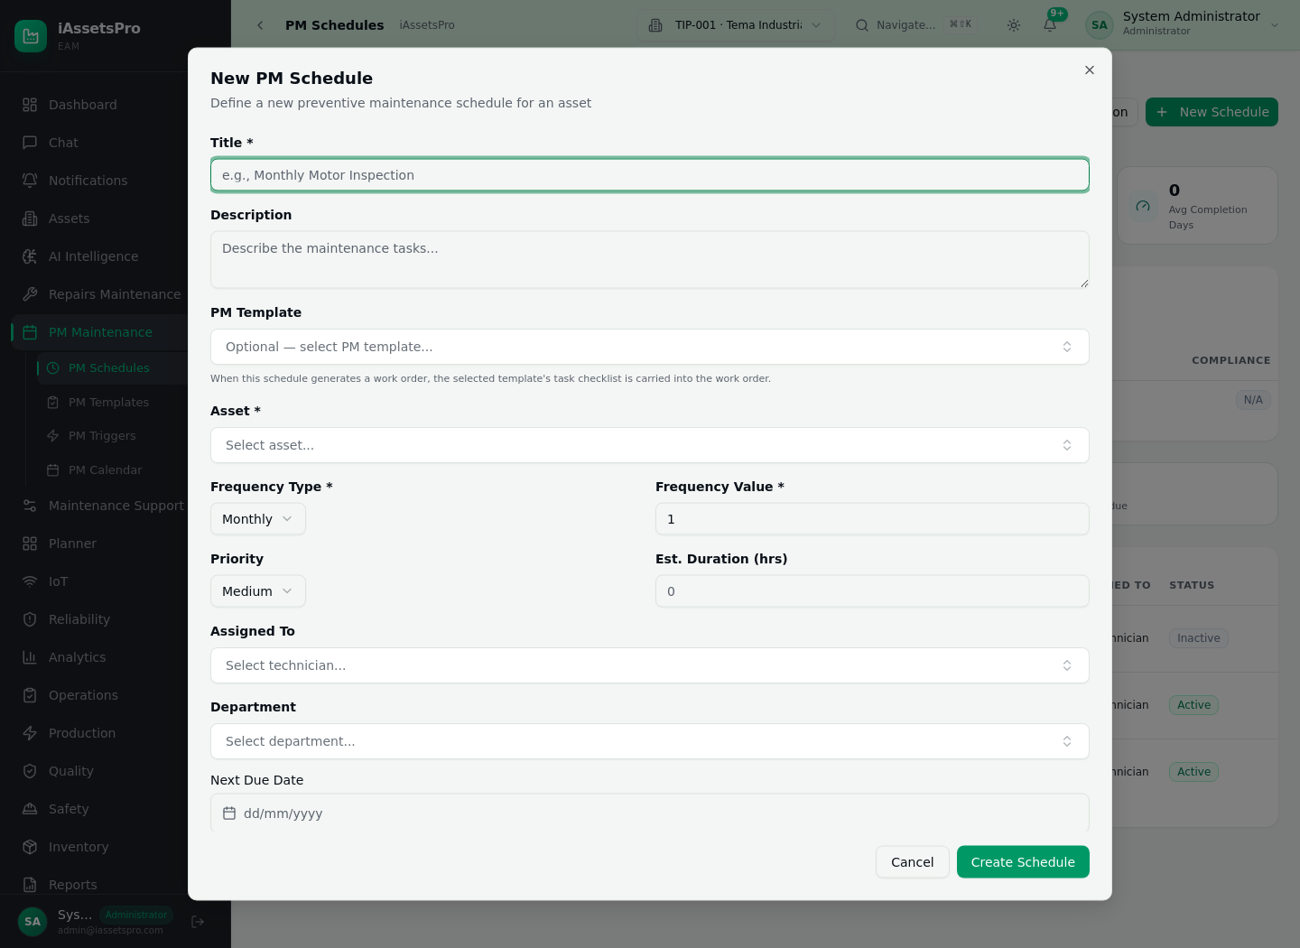
Figure 15 - Create PM Schedule form
- Choose New Schedule and enter the PM title/description.
- Optionally choose a PM template to inherit standardized tasks.
- Search all accessible assets by name or asset tag and select the parent machine.
- Open Choose PM Target to drill into the machine hierarchy and select the exact assembly, subassembly, component or part.
- Set frequency type and frequency value. The platform supports both time-based and meter-based schedules.
- Set priority, estimated duration, department/assignee, lead time and Auto-generate Work Order behaviour.
- Activate the schedule; the register then tracks next due, status and compliance context.

7.3 Exact PM Target Selection
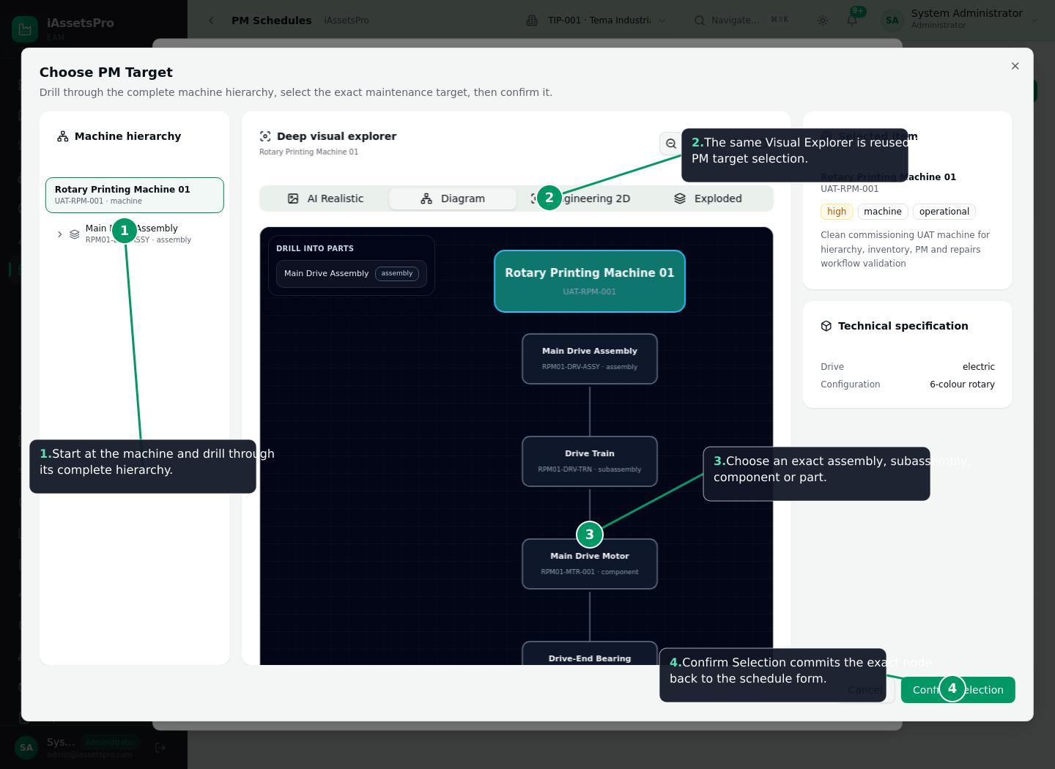
Figure 16 - Annotated PM Target Visual Explorer
Important control: Selecting a node inside the explorer is staged. The planner must choose Confirm Selection before the exact component/part is committed back to the schedule form. This avoids accidental retargeting.

7.4 Schedule Register, Compliance and Due State
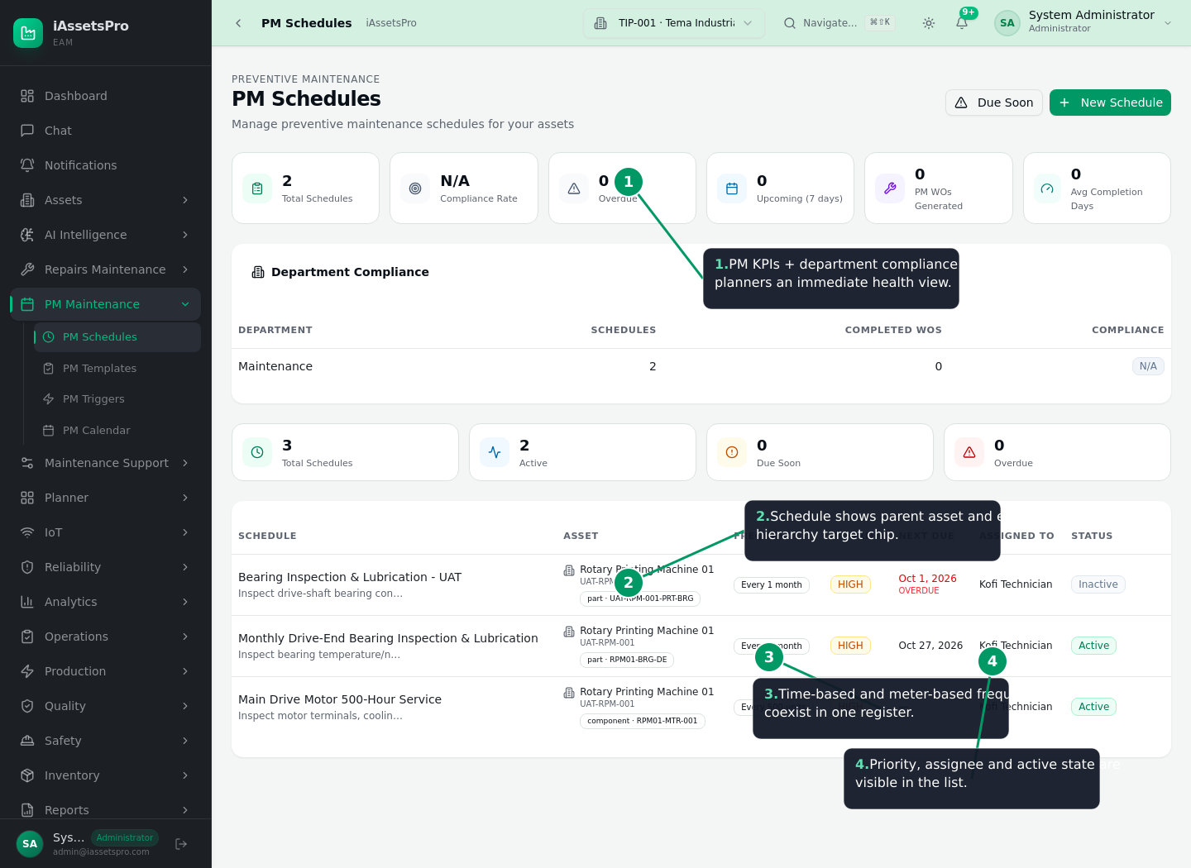
Figure 17 - Annotated PM Schedules register
- PM KPIs expose schedule volume, overdue/upcoming state, generated PM work orders and completion performance.
- Department compliance provides a planner-level health view.
- Each schedule displays the parent asset plus its exact hierarchy target chip.
- Time-based and meter-based PMs coexist in one register.
- Priority, assignee and active/inactive state remain visible and auditable.
- A View action opens fresh read-only schedule details without requiring edit permission.

7.5 PM Triggers and Automatic Work Orders
- Time schedules become due based on their planned cadence and lead window.
- Meter schedules evaluate operating readings against the stored baseline and interval.
- When a threshold is crossed, the runtime generates one preventive work order and prevents duplicate generation at the same reading.
- The generated work order remains linked to the PM schedule, parent asset and exact component target.
- Plant scope/RBAC prevents an unauthorized plant user from generating another plant’s PM work.
- If a trigger-generated work order is cancelled, meter-cycle state is rearmed so the maintenance obligation is not lost.

7.6 PM Execution, Completion and Calendar
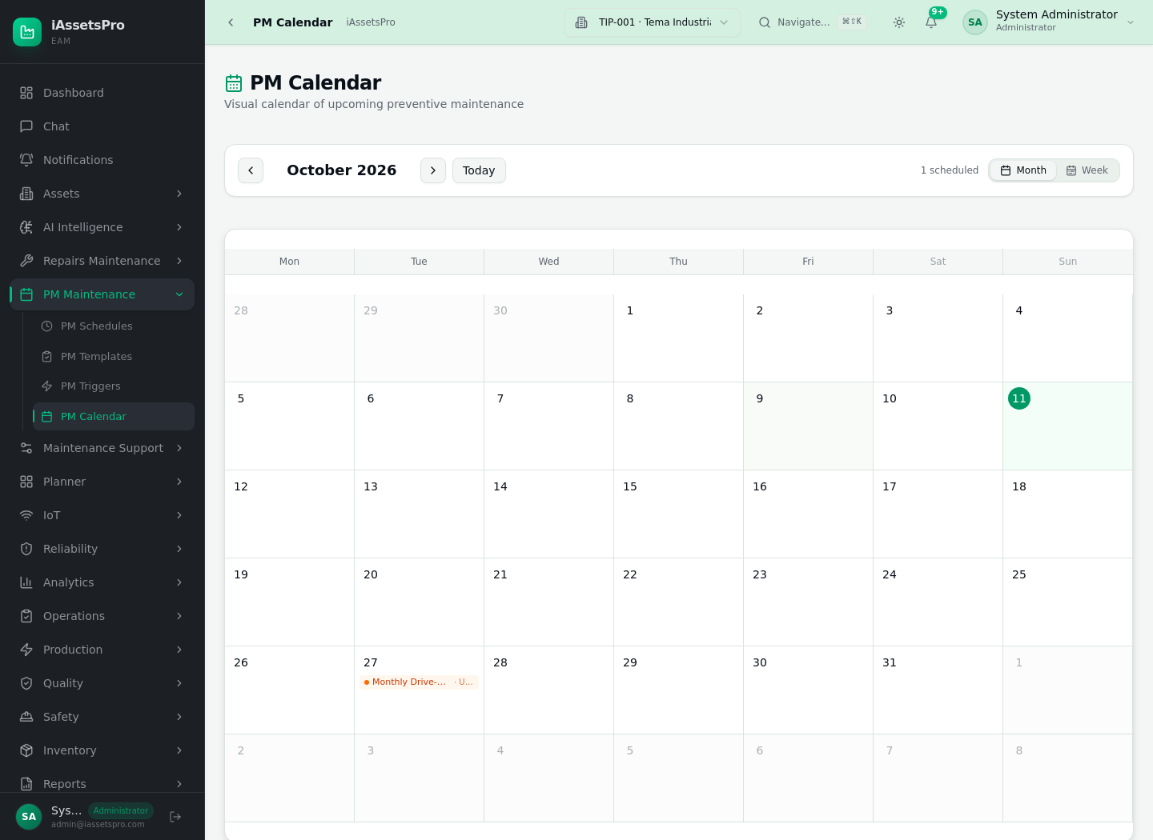
Figure 18 - PM Calendar
- Generated preventive work orders execute through the same controlled work-order workspace as corrective repairs.
- Technicians perform inherited checklist tasks, record time, request materials/tools, add evidence and submit completion.
- Closure updates schedule history and supports compliance reporting/next-due planning.
- The PM Calendar provides a date-oriented planning view for upcoming maintenance load.

8. Roles, Governance and Traceability
Area | Implemented capability | Presentation message
Operator / Requester | Raise defects and operational maintenance requests | Fast structured intake without direct maintenance-control permissions.
Planner | Review requests, plan WOs, PM templates/schedules, resources | Owns work definition and maintenance planning.
Supervisor | Approve/coordinate execution and review completion | Operational control and quality gate.
Technician / Team Leader | Execute tasks, log time/evidence, request resources | Field execution with accountable history.
Store / Inventory | Approve/issue/receive materials and tool custody | Physical inventory accountability.
Administrator | Configuration, RBAC, plant/module governance | Enterprise system administration.
- RBAC limits both visibility and mutations by role and plant scope.
- Work records preserve linkage to the actor and lifecycle state for audit.
- PostgreSQL is used for transactional persistence; Redis/BullMQ supports background job processing and operational queues.
- Offline-first/sync architecture exists for supported workflows so intermittent connectivity can be handled without abandoning controlled data capture.

9. Validation and Current Delivery Status
Release quality evidence: The PM visual-targeting/runtime release passed the complete CI chain: lint, Repairs TypeScript hard gate, full Vitest unit suite, optimized production build, production container build, platform Playwright E2E, Repairs/RWOP Playwright UAT and Required CI Gate. The live production site is responding successfully.

- The production React #130 crash in Production Resource Planning/Bottleneck Analysis was traced to malformed KPI entries and removed with regression protection.
- Responsive dialogs now support form-aware widths and viewport containment; Purchase Order line items no longer force the modal beyond its bounds.
- PM Schedule now searches all accessible assets, reuses the machine Visual Explorer for exact hierarchy target selection, and provides a View details flow.
- No database schema migration was required for the PM visual-targeting upgrade because schedules already persist an exact componentId target.

10. Recommended 12-15 Minute Live Presentation Script
Time | Demonstration | What to say
0:00-1:00 | Open with the business problem | “Industrial maintenance loses value when asset data, breakdowns, spares, tools and PM are in separate systems. iAssetsPro connects them around the physical asset.”
1:00-3:00 | Create/introduce an asset | Open Machines -> Add Asset. Point out identity, criticality, plant/department, parent asset and lifecycle fields.
3:00-5:00 | Show technical hierarchy | Open Rotary Printing Machine 01 -> Visual Explorer. Drill machine -> assembly -> subassembly -> component -> bearing part.
5:00-9:00 | Show corrective Repairs | Maintenance Request -> converted Work Order -> execution -> materials/tools -> completion/closure. Emphasize traceability and custody.
9:00-13:00 | Show PM | Open PM Schedules -> New Schedule -> choose asset -> Choose PM Target -> select exact bearing -> Confirm -> show time/meter frequency, template, auto WO and calendar.
13:00-15:00 | Close with control/analytics | Explain RBAC, audit trail, downtime/cost/KPI visibility, quality-hold returns and validated production release.

11. Demonstration Safety Checklist
- Use a prepared administrator/planner demo account and keep a technician/store account ready in another browser profile if needed.
- Demonstrate on known sample asset “Rotary Printing Machine 01” so the hierarchy and PM examples are populated.
- Do not delete or overwrite production sample records during presentation; create a clearly named DEMO request/schedule if live data entry is required.
- Keep this PDF/PPTX available offline in case internet connectivity becomes unstable.
- For a short presentation, prioritize annotated Figures 4, 8, 9, 10, 11, 12, 17 and 16.

