**Calamansi**

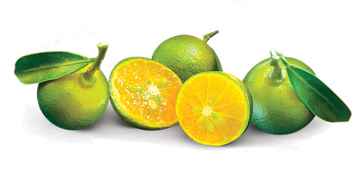

DESCRIPTION:

 a citrus fruit tree also known as Citrfortunella microcarpa or calamondin, grows natively in the Phillipines. Calamansi trees bear small, orange-like fruits, dark green foliage and white flowers.The calamansi tree grows up to about 25 feet tall at maturity, and it is hardy to U.S. Department of Agriculture zone 9 and above.

## **Planting Outdoors**

1.Choose an outdoor site for the calamansi trees when you are ready to plant them in the yard or garden. Calamansi tolerates most soils but will not grow well in heavy clay or light sand. Ideal soil pH ranges from 5.5 to 6.5. Select a site with good drainage and full to part sun.

2.Mix compost or other organic material into the soil, if desired. Apply 3 to 4 inches of compost and mix it into the top 6 inches of soil.

3.Dig a hole about 16 inches deep and 16 inches wide. If planting multiple calamansi trees, space the holes approximately 16 1/2 feet apart.

4.Plant the calamansi tree in the hole. Fill the hole with soil and tamp it down firmly around the tree with a shovel or your hands.

5.Water the calamansi until the soil feels damp. Young trees usually need about 1 inch of water per week. Continue watering whenever the soil feels dry until the calamansi establishes itself, usually within three to five years.

6.Fertilize every four months with about 2 to 3 1/2 ounces of 16-20-0 fertilizer mixed with urea. When the calamansi tree is two years old, increase the amount to about 7 to 10 1/2 ounces every four months.

7.Mulch the calamansi tree with a 4-inch layer of dry leaves, wood chips or other organic material. Spread mulch as far out as the tree's canopy, also called the drip line. Leave a 1- to 2-inch gap between the mulch and the calamansi tree trunk. This conserves moisture and deters weeds.

8.Watch for aphids, citrus bark borers or signs of pest damage. If you see pests or damage caused by them, applying a commercial pesticide usually gets rid of the problem. Signs of pests include eggs on the bottoms of leaves and in bark cavities, unexplained cuts or markings and stunted growth. You might need to apply the pesticide several times, usually every few weeks, to eliminate pests. Cutting off infested branches or introducing predatory insects into the yard might also help.

9.Apply a commercial fungicide if you notice signs of a fungal disease. Signs include a gum-like substance oozing from branches, as well as distorted, crinkled leaves. Proper application of the fungicide depends on the type of fungus. For instance, treat citrus canker when the tree is dormant, but treat citrus scab during the tree's blooming season

**HARVESTING**

Harvest calamansi fruit by cutting it from the tree with scissors. Leave a piece of the stem attached to the fruit to help it stay fresh.

**Upo or Bottle Gourd**

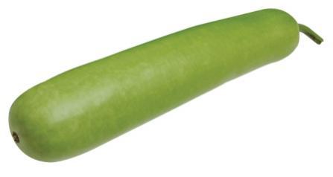

DESCRIPTION

Bottle gourd or calabash (Lagenaria siceraria [Molina] Standley), is commonly called upo among the Tagalogs. Other local names are Tabungaw (Ilocano) and Kandol (Ibanag). This is a herbaceous, annual climbing plant with long strong tendrils and simple leaves. Fruits are globular, bottle- or club-shaped. Its length reaches up to one meter long. When the fruit matures, the rind is hard and durable.

****Seed Preparation****

– A hectare of farm requires 1 to 2 kg of seeds.  
– Soak the seeds in clean water for 24 hours.  
– Pre-germinate the seeds by wrapping in a moist cloth and place in cool and dark place. Incubate until the seed coat breaks.

****Planting****

1.Plant one pre-germinated seeds per hill at a distance of one meter between hills.  
2.Cover the seeds with thin layer of soil.  
3.During wet season, plant in ridges or above furrows to prevent rotting of seedlings due to flooding.

FERTILIZATION

-UREA(46-0-0)

-COMPLETE(14-14-14)

**Ampalaya or Bitter Melon**

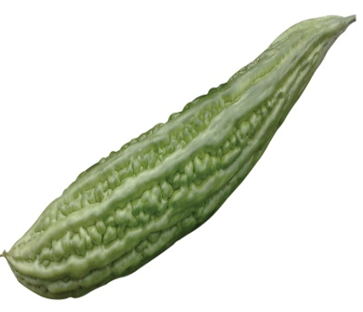

*Ampalaya* is one of the healthiest vegetables in the worlds. Don’t judge it by its rough appearance or its bitter taste. Although notable for its bitter taste, ampalaya works wonders for being who have diabetes.

#### ****Planting****

***Direct Planting***

Plant one seed per hill along the furrows at a distance of 30 to 50 cm between hills. Replant diseased and dead seedlings and missing hills 15 days after emergence.

***Transplanting***

* Use potlets or seedling trays to grow seedlings.
* Prepare and mix thoroughly potting medium of 1:1:1 garden soil, Carbonized Rice Hull (CRH) and compost.
* Fill the container with mix media.
* Plant one seed per potlet or tray hole filled with a prepared planting media.
* When the seedlings emerge, water the plants regularly when needed.
* When the seedlings are grown, harden them by gradually reducing water application and by exposing them under the sun.
* Transplant at 15 days after sowing or when true leaves have developed. Do not delay transplanting because this will result to poor plant growth and high mortality.
* Transplant late in the afternoon for higher percentage recovery of seedlings.
* Apply starter solution by dissolving one tbsp of urea (46-0-0) to 6 liters of water and use as drench for seedlings at transplanting. After drenching, the seedlings should be sprinkled with clean water immediately to avoid burning effects.

**FERTILIZATION**

Apply 10 to 20 tons organic fertilizer per hectare or decomposed [animal manure](https://businessdiary.com.ph/13485/bioorganic-fertilizer-bof-from-coir-dust-and-animal-manures/) or compost before field preparation to supplement inorganic fertilizer. At planting, apply complete fertilizer (14-14-14) at the rate of 20 grams or two tbsp per hill. Sidedress with urea at the rate of 10 grams or one tbsp per hill before hilling up (3 to 4 weeks from planting). Repeat application every 2 weeks for at least 2 to 3 times more. Cover the fertilizer with at least 6 cm of soil after application.

**HARVESTING**

Harvest fresh fruits 18 to 20 days after blooming or when the fruits attain full size but the seeds are still immature. This takes about three weeks after petal fall. Sort harvested fruits according to class.

**Pechay or Chinese cabbage**

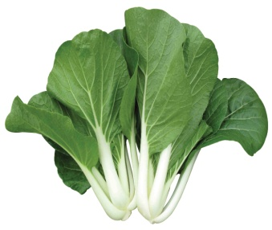

DESCRIPTION

Pechay is used mainly for its immature, but fully expanded tender leaves. The succulent petioles are often the preferred part.

**PLANTING**

A1-ha production area requires kg seeds.

Pechay can either be sown directly in soil or transplanted. Direct seeding is carried out by broadcasting or by sowing in rows. Cover seeds to a depth of about 1 cm by raking or spreading additional topsoil. Water immediately after sowing. Plant spacing should be 10 cm between plants and 20 cm between rows.

If transplanted, sow seeds initially in seedbeds. Transplant seedlings 2-3 weeks after sowing at a distance of 10 cm between plants and 20 cm between rows. Transplant preferably in the afternoon and water immediately. Mulch with grass clippings or rice straw.

FERTILIZATION

Apply seedlings with starter solution using urea (46-0-0) at the rate of 2 tbsp/gal of water. Side-dress along the rows at the rate of 1 tbsp/plant one week after transplanting.

HARVESTING

Harvest as early as three weeks after planting or between 30-40 days after sowing. Harvest preferably in the afternoon to minimize post harvest losses.

**Kangkong or  Water Spinach**

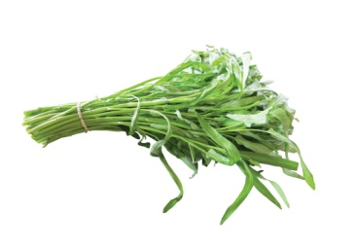

**DESCRIPTION**

Mustard greens should be harvested when the leaves are still young and tender; older leaves will have a bitterer flavor. You can start to pick the leaves after 4 weeks, when they should be about 3 to 6 inches long (7.6-15.2cm). You can harvest greens by snipping off outer leaves from the plant, and then leaving it to continue growing.

PLANTING

The water spinach plants readily roots from cuttings. So planting the cuttings is the easiest way for growing water spinach.

Although you can plant seeds for growing water spinach. Soak the seeds 24 hours before sowing for growing water spinach from seeds. This will help to germinate the seeds faster.

Then scatter the seeds in your prepared bed, and transplant later when the seedlings reach 4-6 inches height.

Planting the seedlings in rows will be good for additional caring. Plant the seedlings to at least 6 inches apart.

FERTILIZATION

The water spinach plants are not among the heavy feeders. They will grow just fine if they have access to enough water. So additional fertilization is not required for growing water spinach plants in home garden.

HARVESTING

The water spinach plants grow very fast. And you can expect to harvest for the first time 4-6 weeks after Planting the seeds. You can harvest either leaves or entire plants. But cutting only a few leaves or entire plant with leaves and stems leaving only 3 inch of growth, will help the plants to grow again.

**Mustasa or Crispy Mustard**

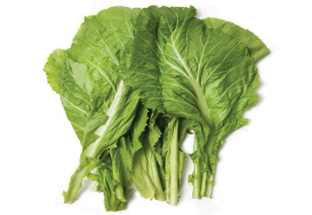

DESCRIPTION

In the Philippines, it was known as Mustasa.  Mustard Greens are indeed one of the most nutritious green-leafy vegetables available around. Mustards are cool season winter crop. Their tender, crispy leaves are more flavorful which last from November until March.

PLANTING

Mustard seed plants are normally grown from seed but can be grown from purchased seedlings as well. Plant the mustard seed about three weeks before your last frost date. Plant your mustard seeds about a 1 inch apart. Once they sprout, thin the seedlings so that they are 6 inches apart.

HARVESTING

Harvesting should be carried out as soon as the pods begin to turn yellow and seed becomes hard. The mustard crop matures in about 110-140 days. Young tender green leaves, which used as green-leafy vegetables, are gathered when the plant reaches about 2 feet tall. If left alone, it continues to grow, reaches about 4-5 feet in height and bears golden yellow flowers which subsequently develop into mustard seed pods.

**Alugbati or Malabar Spinach**

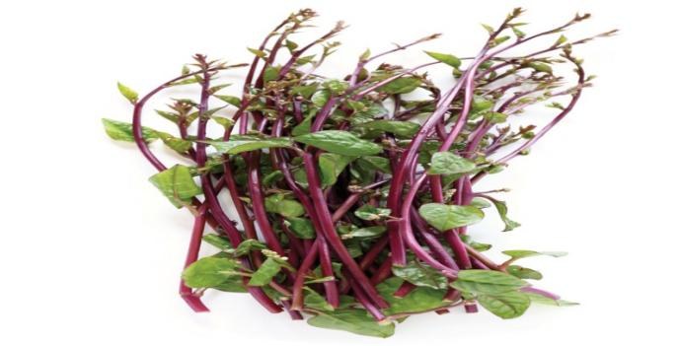

DESCRIPTION

The plant is a succulent branched, smooth, twining, herbaceous vine. The stems are green or purplish. The leaves are fleshy, ovate or heart-shaped, 5-12 centimeters (cm) in length, stalked, tapering toa pointed tip and heart shape at the base. The spikes are axillary, solitary and 5-29 cm in length. The flowers are pink and about 4 millimeters (mm) long. The fruit is fleshy, stalkless, ovoid or nearly spherical, 5-6 mm in length and purple when mature.

**Planting from Cuttings**

The leaves are usually removed before planting to reduce water loss through aspiration. Fresh, healthy tip cuttings of about 20-25 cm lengthare the best planting materials. Soak the cuttings in water overnight or keep them in a dark and damp space for a day or two.  Plant the cuttings on hills or in rows. Space small hills six to eight inches apart and put three or four cuttings on each hill. Alternatively, space rows eight to 12 inches apart, with the cuttings spaced about eight inches apart.  Water the cuttings immediately and continue to keep the soil moist.

**Planting from Seed**

Scarify (to make tiny punctures or superficial incisions) the seeds by using sandpaper or a knife to cut the outer seed coat.  Plant the seeds directly outside after soil temperatures have warmed to the minimum temperature required for germination of 18.33 °C. Plant them about 1/4 inch deep in rows spaced about eight inches apart. Alternatively, spread seeds all across the soil and then thin the seedlings later so that they are spaced about eight inches apart. Keep the soil consistently moist. If the soil dries out, the plants can flower, which makes the leaves taste bitter.

**FERTILIZATION**

Alugbati can grow even under conditions of moderate soil fertility, but production is increased with the application of fertilizers. Soil test is highly recommended to determine available N, P and K.  The fertilizer requirement calculated based on the target yield.  Apply compost or manure at 3-5 tons/ha during plot preparation and sidedress once a month with manure or compost at 20-30 bags/ha.  Tea manure and fermented plant juice (FPJ) may also be used to improve soil fertility.

To prepare tea manure, soak ¾ sack of dried cow or horse manure in a ¾ plastic drum (200 L capacity) of water.  Soak for 5 – 7 days with frequent stirring.  To prepare the FPJ, mix three parts chopped plant shoots or banana trunk with 1 part raw sugar or molasses.  Ferment mixture for 5 -7 days.  Dilute 1 part tea manure or FPJ to 20 parts water and drench on the plots or use as foliar fertilizer.

**HARVESTING**

Alugbati is ready for harvest at 30-45 days after planting.  Plants harvested either once or repeatedly by priming.  In once-over harvest, cut the stems or shoots close to the ground or uproot the entire plant (if grown from seeds), then wash and tie in bundles.  For multiple harvests, pick or cut the shoots at about 15-25 cm long or at a frequency of weekly intervals.  Harvesting is done late in the afternoon to reduce water loss and keep the produce in cool, shaded place.

DESCRIPTION

Patola is closely related to cucumber and modified cultural practices for trellised cucumber production can be used. One must keep in mind, however, that luffa is a tropical plant which requires a long growing season and warm temperature.

PLANTING

****Land Preparation****

Prepare the field as early as possible to give enough time for the weeds and stubbles of previous crops to decompose. Plow and harrow 2 to 3 times alternately at one week interval. Plow at a depth of 15 to 20 cm. Harrow twice to break the clods and level the field. A well-pulverized soil promotes good soil aeration and enhances root formation. Furrows should be set at 2.5 to 3 m distance.

****Trellising****

Provide the plants with trellis to produce fruits of good visual quality. Trellising is also essential during the wet season to minimize fruit rotting and malformation.

Construct overhead trellises at a distance of 2 to 3 m wide and 2 m high using ipil-ipil or bamboo poles. Provide strong roof trellis by intertwining the wire or nylon twine crosswise and lengthwise on top of the trellis. Provide a ladder-like trellis or vertical pole for each upo plant to facilitate the vines to climb up.

****Seed Preparation and Sowing****

Soak the seeds in water overnight before planting to facilitate germination. During dry season, plant 1 to 2seeds per hill at a distance of 2.5 m between hills on the furrows. During wet season, plant 2 to 3 seeds per hill on the ridges of the furrows at a distance of 2.5 m between hills to avoid water logging.

****Thinning and Replanting****

Remove weak and diseased seedlings 3 to 4 weeks after emergence. Retain only one healthy plant per hill. Replant vacant hills.

****Vine Training****

Train the vines to climb the trellis by tying the stem lightly on the vertical pole or ladder-like trellis until it reaches the overhead trellis. Training should be done weekly.

****Fertilizer Application****

The kind and amount of fertilizer to apply depends on soil fertility and soil type. To achieve optimum yield, have your soil analyzed at the Soil Laboratory nearest you to determine the right nutrient requirement of the soil.

**HARVESTING**

Five days after fruit setting, harvest immature fruits using a sharp knife to cut the peduncle. Pack harvested fruits in 10 kg capacity polyethylene bags to maintain freshness. To avoid the damaging effect of sunlight on the fruits (drying of the ridge), harvest early in the morning or late in the afternoon.

**Sigarilyas or Winged beans**

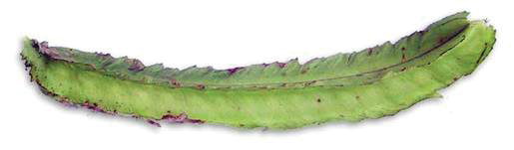

The winged bean plant grows as a vine with climbing stems and leaves, 3-4 m in height. It is an herbaceous perennial, but can be grown as an annual.

PLANTING

the winged bean is often inter-planted with sweet potatoes, taro, bananas, sugar cane or other vegetable crops. For pod and seed production planting is usually on the flat and the seeds are dibbed in holes about 2.5 cm deep, at the beginning of the rainy season. It is usual to provide the winged bean with supports; bamboo poles arranged singly, or in tripods, are often used. When poles are used the plants may grow so tall that picking is difficult and the use of a trellis or wire fence 1-1.5 m high has been recommended.

HARVESTING

The root tubers are normally harvested when they reach 2.5-5 cm in diameter and 7.5-12 cm in length. Lifting is usually by fork, care being taken to avoid damage; the practice of growing the plants on ridges facilitates this operation. Where grown on the flat, the ground is sometimes flooded to make digging easier and to reduce the possibility of injury. There is little information on storage of the root tubers as they are normally eaten immediately after harvest, but it has been found that under normal tropical conditions deterioration is rapid (loss of moisture, loss of vitamin C and long cooking time), but at lower temperatures and higher humidities storage for a few weeks was possible, provided that fungal growth was prevented.

**Banana**

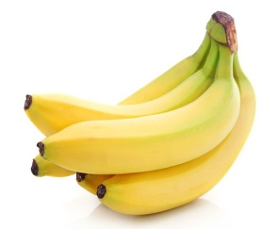DESCRIPTION

The country is one of the top producers of bananas.

Banana is considered the “most economically important fruit” in the country since it is one of the locally-produced fruits available throughout the year. Type such as Cardaba, Abutan, Inabaniko, Turangkog, Sabang puti, Mundo, Gubao, Saba sa Hapon and Bigihan.

PLANTING

Dig holes 50-60 cm deep. Place one sucker in the hole in vertical position and fill it with surface soil. If possible, press down the soil around the base of the sucker to avoid air spaces in the hole. Generally, saba requires a wider spacing. Distance of planting can be 4-7 meters. However, 4m x 4m is the regularly used planting distance, requiring 625 suckers per hectare. If the fruits are to be sold weight, a closer distance of planting will be desirable in order to get a higher yield per unit area. On the other hand, if the fruits are to be sold by counting the fingers, a wider distance of planting is desirable. This will enable the plants to produce bigger bunches.

FERTILIZATION

Large quantities of nutrients are taken up by the banana plant. They consume nitrogen and potassium in big quantities, thus fertilizer application geared to replenish these nutrient must be properly programmed at regular intervals. Therefore, for maximum production, they should be fertilized frequently. The fertilizer recommendations for a hectare of saba banana are the following: On the first year, mix 3.5 bags complete (14-14-14), 3 bags urea (45-0-0) and 10 bags muriate of potash (o-o-60) and apply at a rate of 440 grams per hill every 4 months. Double this rate for the succeeding years

HARVESTING

Harvesting may appear to be simple but it should be done with great care. Usually, Two men are needed in harvesting, namely the cutter and the helper (baker). The cutter nicks the pseudostem in such a way that the bunch is lowered gently. The backer then positions himself below the bunch and takes hold the lower end of the fruit stalks as the bunch is laid on his shoulder. The cutter then cuts the peduncle of the fruit

**Mango**

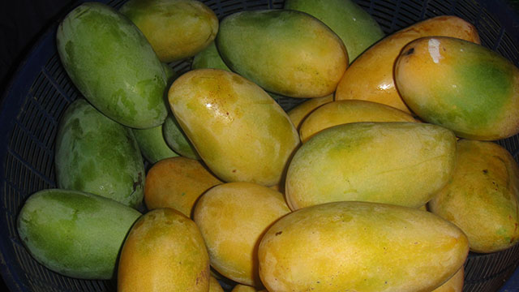

DESCRIPTION

The mango is the national fruit of the country. One of its ripe varieties, the champagne mango, is considered the sweetest mango in the world. It is in season from March to June

PLANTING

**Kinds of planting materials**

1. Grafted mangoes should be purchased from registered nurseries (certified plants). Accredited nursery operators strictly follows the proper nursery management such as selection of seeds for rootstocks, care and maintenance of rootstocks, preparation of soil media, dehusking, germination, transplanting of seedlings, fertilization, watering, insect-pests and diseases control and grafting techniques. Above all, the scions are taken from registered mother trees.
2. b. One-year old vs. 2-year old graft. One-year old grafts are commonly used as planting materials for mango. However, when these are planted in the field, mortality is oftentimes high and replacement of trees would mean uneven growth. Thus, some growers prefer to use older grafts as planting materials. Although more costly, older grafts are easy to establish, mortality is low and trees flower earlier. The choice of planting materials therefore, depends on the capability of growers considering price, size of the farm and equipment available for hauling and planting.
3. Single vs. multiple rootstock.Aside from using single rootstock, growers are inclined to plant mango tree with two (dipod) or three (tripod) rootstocks using approach grafting or inarching. According to proponents of this practice, multiple rootstocks provide better absorption of water and nutrients hence, faster plant growth. In addition, it secures the tree on the ground thus, prevents uprooting by typhoons and strong winds. This method is however, not supported by research findings and is expensive on the part of small growers. Normally, approach grafting (dipod/tripod) is done to assist trees with defective root system especially those infected with disease. This method is also recommended for trees with poor anchorage in the soil. With mango, these problems are not so critical and use of single rootstock is still the best way to propagate the tree.

d. In „situ‟ grafting. In places where availability of grafted mangoes is a problem, it is recommended to plant seedlings in the field following a desired spacing. When seedlings are about two years old, the branches are grafted with selected scions using the cleft method. With this procedure, several scions can be grafted to a tree. The advantages of in „situ‟ grafting are that, management of seedlings in the nursery is omitted and percent of successful grafts is high. However, shading is recommended to prevent death of newly inserted scions.

FERTILIZATION

1. One year old - 100 g Urea (split application start and end at rainy season) or 200 g manure + 100 g Urea. Fertilizer should be placed few inches from the trunk in a shallow canal constructed around.
2. Two years old - 200 g Urea (split application) or 500 g manure + 200 g Urea.
3. Three years old - 300 g triple 14 (split application) or 1.0 to 2.0 kg manure + 300 g triple 14
4. Four years old – 400 to 500 g triple 14 (split application) or 2.0 to 3.0 kg manure + 400 to 500 g Urea

HARVESTING

Mango fruits should be harvested at the proper stage of maturity to avoid problems associated with moisture loss as well as shriveling of fruits. When immature fruits are harvested, these ripen with inferior quality, lacking in aroma and flavor. The skin does not develop into full color and the fruits are susceptible to physiological and pathological disorders.

**Papaya**

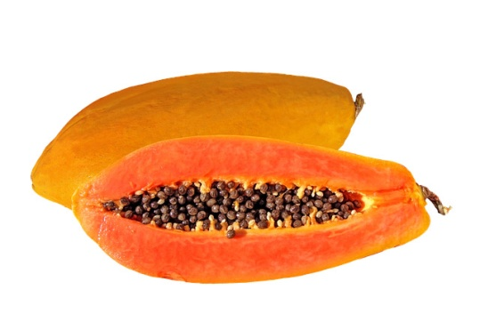

Papaya was purportedly called the “Fruit of the Angels” by explorer Christopher Columbus because of its sweet and soft, butter-like consistency. It is in season throughout the year.

There are several cultivars you can choose from whether for backyard or commercial planting:

****“Cavite Special”**** is a popular semi-dwarf type that blooms 6 to 8 months after planting. The fruit weighs from 3 to 5 kilos each and mainly eaten fresh.  
****“Sunrise Solo”**** is a new improved high quality selection with reddish orange flesh, each fruit weighing half a kilo.  
****“Waimanalo”**** is high quality variety with orange yellow flesh, each fruit weighing from one-half to one kilo.  
****“Sinta”**** is the first Philippine-bred hybrid papaya, semi-dwarf, profile, sweet and flesh and weighs 1.2-2.0 kg./fruit.

PLANTING

Papaya plants are usually planted by direct seedling in the field. Place 5 or more seeds in each hole; then cover with ¼ inch of soil. When fresh seeds are used, seeds will germinate in 10 to 14 days after planting. Seed germination is better and faster if the gelatinous envelope (sarcotestae) surrounding the seed is removed by means of the fingers. In some cases, seedlings are started in the nursery by sowing seeds in seed plots or individual containers such as in cans or plastic bags. Sow 3 to 4 seeds per container. Use sterilized soil to avoid nematode infestation and damping-off. Seedlings in the nursery should be grown under full sunlight to produce vigorous and hardy seedlings. Care should be taken not to disturb the root system. Constant watering is essential until plants are well-established. Seedlings are transplanted when there are 3 to 4 leaves.

FERTILIZATION

Factors such as soil types, rainfall, locations, cultural practices, and age of plant influence fertilization practices. Start fertilizing when seeds are planted or when seedlings are transplanted in the field. Mix a handful (5-10gms.) of complete fertilizer (14-14-14) with the soil at the bottom of the hole before planting. As papaya seedlings grow larger, more fertilizer is applied.

****Guide for papaya fertilization in the Philippines:****

1. Apply 60 grams of ammonium sulfate as soon as plants are well-established and show new growth.  
   2. Apply the same amount at intervals of six weeks until plants are one year old.  
   3. Thereafter, apply 225 grams of ammonium sulfate per plant every three months.  
   4. Apply 450 grams superphosphate per plant at the start of rainy season every year.  
   5. In potassium-deficient soils, complete fertilizer with ratios 2:1:2 or 2:1:3 is recommended.

****Harvesting****

Harvesting is a simple operation when papaya trees are short and the fruit can be reached by hands. The first harvesting starts on the 7th to 8th month after planting. Pick all fruits showing a tinge of yellow at apical end.

Place harvested fruits in picking bags, galvanized containers or pails. Allow fruits to mature more fully to develop better flavor. However, this shortens shelf life and make them more susceptible to fruit fly infestation.

When papaya trees grow older, harvesting is done with the use of ladder. It is a tedious, time-consuming and costly method of harvesting. Farmers in Cavite use a long pole to strike the apical end of the papaya fruit to detach it from the tree while the fruit is caught by hand.

The papaya plant will keep on fruiting for many years but production declines rapidly as it grows older. Old trees grow slower and produce lesser fruits. The productive life span of papaya plantations end after 3-1/2 years. The yield of well-managed papaya plantation is 35 to 40 tons of fruits per hectare which is roughly 4 times the average yield (national) of 10 tons per hectare per year.

**Pineapple**

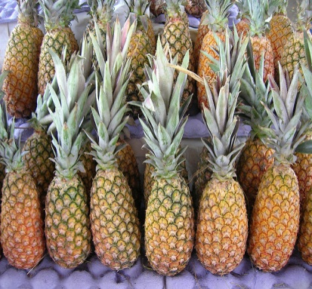

The Philippines is the second largest producer of pineapples next to Thailand. These fruits are exported to other countries as well. Pineapples are in season from May to July.

PLANTING

**Rice**

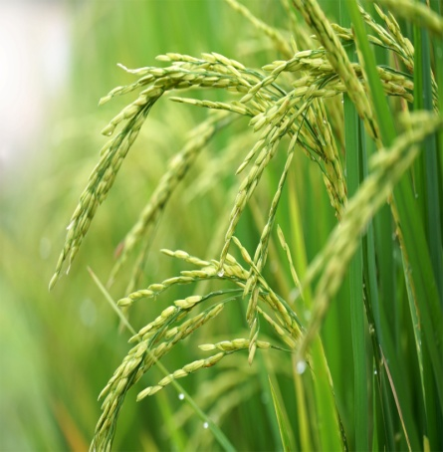

**DESCRIPTION**

Oryza sativa, commonly known as Asian rice, is the plant species most commonly referred to in English as rice. It is the type of farmed rice whose cultivars are most common globally.

There are four main types of rice: Indica, Japonica, aromatic, and glutinous. Rice seeds vary in shape, size, width, length, color and aroma. There are many different varieties of rice: drought-resistant, pest-resistant, flood-resistant, saline-resistant, tall, short, aromatic, sticky, with red, violet, brown, or black; long and slender; or short and round grains.

#### **Seeding and planting rice**

Several seeding and planting methods are practiced:

-Dry seeding with drill.

-Dry seeding by broadcast or air. Most of the rice, in large fields, is sown by aircraft.

-Experienced agricultural pilots use satellite guidance technology to broadcast seed accurately over the fields.

-Water seeding with pre-germinated seed.

-Seedlings are transplanted by hand (Figure 1.11), or by machines (Figure 1.13) to fields which have been flooded by rain or river water.

-Seedlings 25-30 days old, grown in a nursery are usually transplanted at 20 x 15 or 20 x 10 or 15 x 15 cm spacing in a well prepared main field and normally this will have a population of 335,000 to 500,000 hills/ha (33 to 50 hills/m2), whereby each hill contains 2-3 plants.

FERTILIZATION

Most soils provide only limited amount of nutrients to the crop, therefore fertilizers need to be applied to increase grain yield. In some cases, fertilizers are also added to improve the soil’s physical condition. The amount and type of fertilizer applied are determined on the assumption that 1 ton of grain will remove 15 kg nitrogen (N), 2–3 kg phosphorus (P), and 15–20 kg potassium (K). These base rates need to be modified according to the soil type, the season, the crop condition, prevailing weather conditions, and efficiency of application. For efficient fertilizer use:

• Use organic fertilizer (manure, compost, straw, husk, plant leaves) whenever possible, especially in nurseries.

• Apply fertilizer according to soil type and expected yield. As a guide, a 2 t/ha yield on clay loam soil will require 20 kg N and 5 kg P. Sandy soils may require another 10–15 kg K. Double these recommendations for a 3 t/ha expected yield.

• Apply all P, K, and 10% N evenly and incorporate just before seeding or transplanting. For direct seeded broadcast crops, it is okay to apply 10–14 days after establishment when there is water in the field.

• Apply remaining N (urea) in 2 equal portions at 30 days and 50–60 days (panicle initiation) after emergence.

• In established crops, apply chemical fertilizer only in standing water and evenly across the whole field.

• Do not apply high rates of fertilizer for traditional varieties as they may have limited response and cause lodging.

• Do not use chemical fertilizer if you need more than 5 kg paddy to pay for 1 kg of fertilizer.

• Inorganic fertilizers must be stored in a dry and cool place that is out of children’s reach.

**HARVESTING**

The plants grow rapidly, ultimately reaching a height of 90 cm (3 feet). By late summer, the grain begins to appear in long panicles on the top of the plant. By the end of summer, grain heads are mature and ready to be harvested. When still covered by the brown hull rice is known as paddy

**CORN**

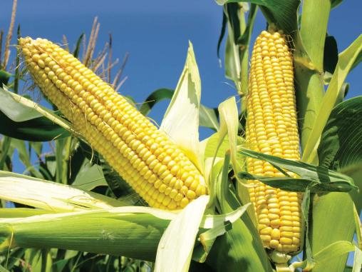

**DESCRIPTION**

**Corn** also known as maize, is a starchy vegetable that comes as kernels on a cob, covered by a husk.

PLANTING

Sow seeds only 1 inch deep; in the hot weather of midsummer, plant them up to 2 inches deep. The average germination rate for sweet corn is about 75 percent, so plant three seeds together every 7 to 15 inches. They should germinate in 7 to 10 days. Thin to one plant every 15 inches. To avoid disturbing remaining plants, remove unwanted seedlings by cutting them off at soil level.

FERTILIZATION

Good starter **fertilizer** might range from a ratio of 1-4-0, 1-3-1, 1-3-3, to 1-1-1, depending on the rate of **fertilizer** required. Do not apply more than 80 to 100 pounds per acre of N + K2O in the starter band. For example, 350 pounds per acre more of 10-20-20 can result in seedling injury.

HARVESTING

Three weeks after corn silks appear, start checking ears for peak ripeness. Pull back part of the husk and pierce a kernel with your thumbnail. If a milky liquid spurts out, the ears are at prime ripeness — rush those ears to the table, refrigerator, or freezer. Ears on the same stalk usually ripen a few days apart. A completely dry silk or a yellow or faded-green sheath means the ear is past its prime.

COCUMBER

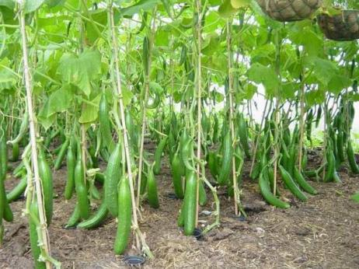

DESCRIPTION

Cocumber (Cucumis sativus) is a widely-cultivated creeping vine plant in the Cucurbitaceae gourd family that bears cucumiform fruits, which are used as vegetables. There are three main varieties of **cucumber :**slicing, pickling, and burpless/seedless,within which several cultivars have been created.

PLANTING

Sow 3-4 seeds/hills and cover with a thin layer of soil. About 2-3 kg of seeds are required for one hectare. Irrigate the field right after sowing. Five to seven days after germination, rogue excess seedlings and maintain only two plants/hill.

### ****Fertilization****

- complete [fertilizer](http://businessdiary.com.ph/tag/fertilizer/" \o "View all articles about fertilizer here) (14-14-14)

 -urea (46-0-0)

 -potash (0-0-60).

WATER MELON

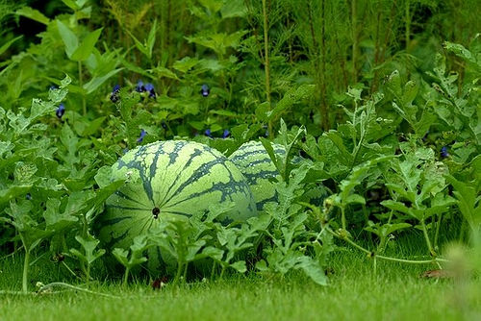

DESCRIPTION

Watermelon is a flowering plant species of the Cucurbitaceae family. A scrambling and trailing vine-like plant,

**Planting and spacing**

Watermelon is grown from seeds directly planted in the field. Plant 3-4 seeds to a hill, 2.5 cm deep. Distance of planting ranges from 1.5 x 1.5 to 2.5 x2.5 meters apart, depending on variety.Planting and spacing- Watermelon is grown from seeds directly planted in the field. Plant 3-4 seeds to a hill, 2.5 cm deep. Distance of planting ranges from 1.5 x 1.5 to 2.5 x2.5 meters apart, depending on variety.

**Months of planting**

Planting season is from October to January. In some parts of the country, planting is done as early as August to [produce an off-season crop](https://businessdiary.com.ph/11450/grafting-effective-producing-off-season-tomato/) which commands better market price.

### ****FERTILIZATION****

Watermelon is generally grown in rotation with other crops. it is necessary to use manure or any soil improving crop to maintain organic matter in the soil. Apply 10 to 15 tons of manure per hectare. Apply complete fertilizer at the rate of 100 to 150 kilograms per hectare at planting time by hand placement 5 to 8 cm below the soil and 5 to 6 cm away to the side where seeds are placed. If plants show signs of yellowing, apply sidedressing of nitrogenous fertilizer.

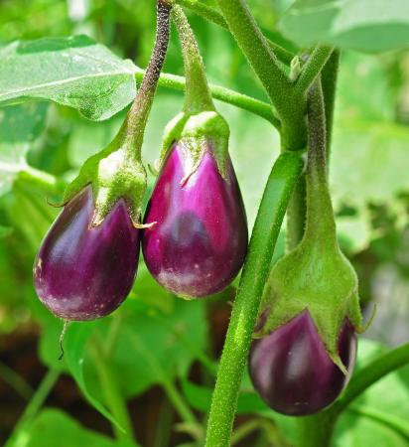

EGGPLANT

DESCRIPTION

Eggplant which is aubergine or brinjal is a plant species in the nightshade family Solanaceae. Solanum melongena is grown worldwide for its edible fruit. Most commonly purple, the spongy, absorbent fruit is used in several cuisines.

#### ****Care of Seedlings****

Protect the seedlings from excessive sunlight and rain by providing a temporary shade using available indigenous materials such as plastic, cogon, talahib or coconut leaves. Construct the shade to 120 cm high on the east side and about 60 cm high on the west side.

Water the seedlings preferably in the morning to minimize damping off. The amount of water to be applied should be just enough to keep the soil moist. Over watering favors damping-off and production of weak seedlings.

**FERTILIZATION**

Apply 0.5 kg fully decomposed chicken manure or any commercial [organic fertilizer](https://businessdiary.com.ph/887/organic-fertilizers-from-farm-waste-adopted-by-farmers-in-the-philippines/) and 0.4 kg ammonium phosphate (16-20-0) for every 10 linear meters of the planting furrows or ridges.

**Harvesting**

Starts 46 to 50 DAT, depending on the variety and intended use of the fruits. Harvest fruits that are still tender and young. Harvest early in the morning and protect the fruits from the sun, rain,and mechanical damage. Harvest all fruits from the plants to prolong the fruiting period of the crop.

Harvesting is usually done two times a week. Use pruning sheer in harvesting to avoid damaging the plants. Remove damaged fruits from the harvest and sort according to market standards. Pack fruits in plastic bags. Prick the bags with a pin for ventilation. Allot two pricks per kilogram of packed fruits. For some varieties, the fruits can be stored up to five days under this condition.

GINGER

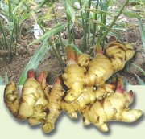

DESCRIPTION

Ginger is a flowering plant that originated in Southeast Asia. It’s among the healthiest (and most delicious) spices

PLANTING

About 800 to 1,500 kg seedpieces are required per hectare. Store ginger roots under shade and cover with banana or coconut leaves. Select healthy rhizomes with sprouts or eyes just before planting. Cut into pieces with 3-4 sprouts each.

The seedpieces may also be pre-germinated for uniform growth. Prepare raised beds of any desired length measuring 1 m wide and 20 cm high. Line sow the seedpieces 2 cm apart and cover with a mixture of compost and coir dust. Water as needed. Transplant when the sprouts are about 1-2 cm long. New varieties can also be propagated by micropropagation or tissue culture to increase the rate of multiplication.

****Fertilization****

Ginger takes up large amounts of nutrients. The general fertilizer requirement is 180 kg/ha N, 180 kg/ha P,05, and 255 kg/ha K.O. The considerably high K requirement makes ginger sensitive to low K supply. A hectare of ginger requires 11.5 bags 14-14-14 and 4 bags 0-0-60 in addition to 5 t/ha chicken or animal manure. Incorporate manure during furrow preparation and apply inorganic fertilizers as sidedress at 30 and 60 days after planting.

****Harvesting****

Harvest ginger when the leaves turn yellow and wither. This is about 8-10 months after planting, depending on the variety used. To harvest, dig each hill with a spading fork or a hoe, pull the entire plant, shake off the soil, lay on top of the bed, and cut off the stem without breaking the rhizomes. Care should be practiced during harvesting to minimize injury that results to faster weight loss and susceptibility to decay.

CABBAGE

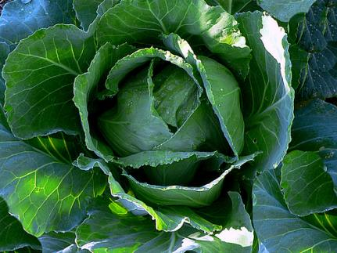

DESCRIPTION

Cabbage is locally known as “repolyo”, grown for its firm, compact, round to flat heads. It belongs to a group of cultivated varieties of the species B. oleracea called “cole crops”. It is the most widely grown crucifer locally.Cabbage ranks as one of the most economically important vegetable crop in the highlands.

PLANTING

From 1/5 to 1/4 kg. of seeds is required per hectare. For limited scale of gardening, seedlings are raised in seed boxes, containing soil rich in humus and free from diseases and other harmful soil organisms. In extensive gardening like in Benguet Province, farmers grow seedlings in variant beds provided with a portable glass or plastic roofing’s. The beds are watered with a solution of ammonium sulphate (3 to 4 tablespoonfuls ammonium sulphate dissolved in one kerosene can of water) to serve as starter. The optimum age of seedlings for transplanting ranges from 25 to 35 days after sowing. “Hardening” is essential to reduce high mortality and cost of replanting. This is achieved by suspending irrigation of the beds a few days before transplanting.

**Fertilization**

Cabbage is a heavy feeder and requires supplemental fertilization in the form of manure or compost, nitrogen, phosphorus and potassium (Animal dung or chicken dung 2-3 tons/ha). Cabbage requires 200 to 250 kg nitrogen per hectare. The first application is made together with phosphorus and potassium. The remainder is side-dressed two to three weeks after transplanting and again three weeks later or applied once at about six weeks. Cabbage also needs micronutrients for proper growth and development.

Harvesting

The crop is harvested when the heads attain their full size and become firm and hard but tender. The color of the head is sometimes used as a maturity index. A fully developed head has a lighter shade of green. If harvesting is delayed, the heads may split and rot while the heads harvested early may be soft.

ONION

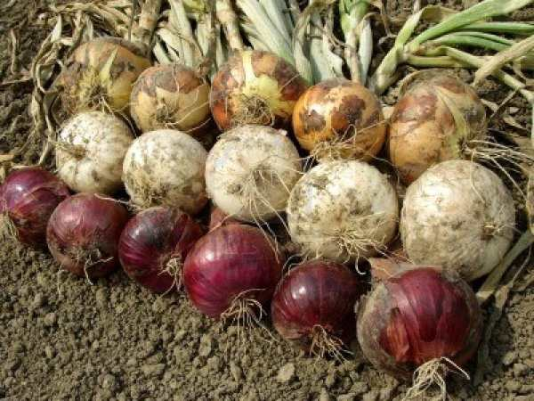

DESCRIPTION

There are two types of [bulb onion](http://businessdiary.com.ph/tag/bulb-onion/" \o "View all articles about bulb onion here) grown in the [Philippines](https://businessdiary.com.ph/tag/philippines/" \o "View all articles about Philippines here); the yellow and the red onion. The yellow varieties grown for the traditional market are either the granex (flat) or the grano (round) type, short day onions.

The red varieties, on the other hand, are produced because of their long storage life. Strains of Red Creole and Red Pinoy are among the popular varieties being grown.

PLANTING

A 1-ha production area requires 5 kg seeds. A 300-500 m2 seedbed produces enough transplants for one ha/ Prepare beds 1 m wide & incorporate animal manure and rice hull.. Line sows 3-5 kg. seeds in rows set across the bed 7-10 cm apart. Distribute seeds thinly and evenly to control damping off. Cover the seeds lightly with compost and mulch with rice straw or grass clippings. Maintain adequate soil moisture. Protect the seedbed against direct sunlight and rain with nylon net or removable plastic tunnels. Reduce watering and expose seedlings to full sunlight one week before transplanting.

Transplant seedlings 4-6 weeks after sowing. Gently uproot the seedlings to prevent root damage. Plant at a distance of 15 cm between rows & 3-5 cm between transplants can also be practiced. Use markers for proper spacing & to facilitate transplanting. After marking, use dibbles to make holes. Plant deep enough but not too deep. Care must be taken so as not to damage the basal portion of the plant. Place the white portion of the plant below the soil surface. Press the soil firmly around the basal portion. Irrigate the field before and after transplanting.

****Fertilization****

In the absence of soil analysis, a 1-ha production area requires 8.5-11.4 [bags](http://businessdiary.com.ph/tag/bags/" \o "View all articles about bags here) of ammonium sulfate (21-0-0), 6.6-26.7 [bags](http://businessdiary.com.ph/tag/bags/" \o "View all articles about bags here) super phosphate (0-18-0) and 2-4 bags muriate of potash (0-0-60).

Apply all of 0-18-0 & half of 21-0-0 & 0-0-60 as basal [fertilizer](http://businessdiary.com.ph/tag/fertilizer/" \o "View all articles about fertilizer here). Side-dress remaining 21-0-0 & 0-0-60 at 30, 45 & 60 days after transplanting. High nitrogen rates tend to shorten storage life of onions. Combine herbicide application with hand weeding to produce a good quality crop.

****Harvesting****

Harvest when the tops begin to fold over. Pull mature plants/bulbs manually from the soil.

****Post harvest****

Cure harvested bulb for 10-14 days in a sunny, well-ventilated area. Align onions so that the leaves of one onion cover the bulb of another. Clip dried leaves 1.5 inches from the stem and remove all roots. Grade bulbs according to size & quality. Pack in jute or net sacks for storage and/or immediate disposal.

**Lettuce**

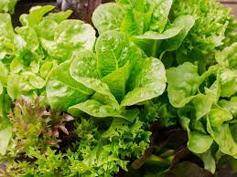

**DESCRIPTION**

Lettuce is a semi-temperature vegetable requiring cool temperatures of 15-20oC. The iceberg varieties will not form heads in hotter areas. It can also be planted in low elevations during November to December. The quality is best in high elevations (1000 m asl).

PLANTING

About 150-200 g of seeds is required per hectare. The best method of seedling production is by line sowing in seed boxes or nursery beds with a soil mixture of 2 parts garden soil, 2 parts manure and 1 part rice hull charcoal. Water before sowing. Make lines 7-10 cm apart. Sow 200-400 seeds/m. Cover with the same mixture and mulch with rice hull of fine rice straw. Water daily and prick to nursery trays with the same soil mix after germination. Maintain under partial shade and harden by exposure to full sunlight one week before transplanting. The seedlings are ready for transplanting 3-4 weeks from sowing.

FERTILIZATION

Apply sufficient animal manure at transplanting. Use tea manure or legume tea once a week, or as needed. Prepare tea manure by soaking manure in plastic drum. After two days, the resulting mixture, tea manure, is used as fertilizer to boost plant growth. Legume tea is prepared by soaking leaves of ipil-ipil or madre de cacao in water. The mixture is ready after 6-10 days.

At transplanting, use 10g 14-14-14/hill as basal fertilizer side-dress with 5-10 g urea (46-0-0)/plant at 2-3 weeks after transplanting.

HARVESTING

Harvest iceberg lettuce at 45-60 days from transplanting, when heads are firm. Harvest loose leaf lettuce as needed, preferably before bolting.

For large-scale planting, sort the heads in the field and pack immediately in perforated carton boxes. If available, vacuum cooling at 1oC is best. Transport at 4oC.

POLE SITAW

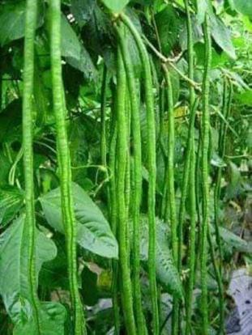

DESCRIPTION

In the Philippines, pole sitao is the most popularly produced vegetable among edible legumes because the pods, young shoots as well as the beans are available throughout the year. It is grown in home gardens, on dikes around paddy fields, under partially shaded areas as a companion crop or commercial crop.

PLANTING

 The seeding rate for pole sitao requires 10-12 kg/ha. For hill method of planting, after basal fertilization with organic and/or inorganic fertilizers, sow 2-3 seeds per hill with a distance of 30 cm between hills and cover lightly with soil. Allow only 2 plants per hill. For drill method of planting, seeds are planted at a depth of 2-3 cm at a rate of 15-18 seeds per linear meter with 100cm spacing between rows.

****Trellising****

In hill and drill methods of planting, provide poles after 14 days from emergence. Vertical trellis is used for single row plot with a distance between rows of one (1) meter. Ipil-ipil, bamboo and kakawate poles are used 3-4 m apart with in the rows and are secured on top with GI wire #16. Tie the top wire to the stakes at the end of e rows to make the poles stable. Plastic straw is used at the bottom portions in every row. Straw lines are tied vertically from top to bottom in every hill. For double row plots, A-type trellis is spaced apart at 0.75 m. Synthetic straw is also used for the pole sitao to cling on for the trellis.

FERTILIZATION

 The general fertilizer recommendation for pole sitao is 135 kg/ha N, 135 kg/ha P205, and 112 kg/ha K20. However, fertilization should be based on soil analysis. Before first plowing, apply 3 tons of well decomposed manure per hectare. Before planting, apply 3 bags/ha of 14-14-14 as basal fertilizer and sidedress wi1-2 bags of urea (46-0-0) at 1 month after planting. Muriate of potash (0-0-60) should be applied at the rate of 1-2 bags during flowering stage. Foliar fertilizers should also be  
applied weekly starting at flowering stage.

HARVESTING

The young and tender pods of pole sitao are ready for harvest 7-10 days after flowering. Harvesting should be done at 2-3 days interval to prolong the productive life of the plants. Harvesting is done manually. Harvest the pod by holding the stem end before twisting it free. To avoid weight loss, harvesting should be done early in the morning or during the cooler times of the day. The pods should be kept in a shaded area after harvest. To prolong the shelf-life, dip the harvested pods in coconut water for 1 minute. In the Philippines, no attempt has been made to mechanize harvesting.

CELERY

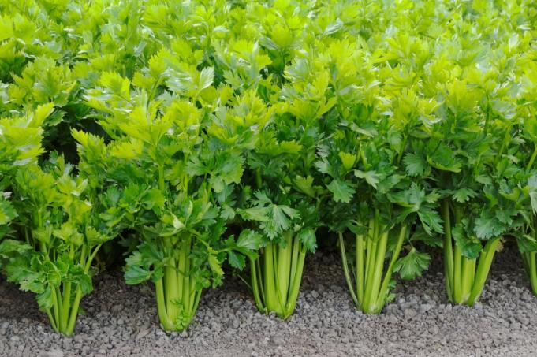DESCRIPTION

Celery is a native to the Mediterranean and adjacent areas. The plant is strong smelling biennial. The thick petioles, curved in cross-section, are long and grooved on the external surface.

PLANTING

To induce quick germination of the seeds, they should be soaked overnight in water. Sowing maybe done early the following morning. As the seed is slow to germinate, soil moisture in the beds should be kept close to field capacity. Pieces of moistened burlap can be spread over the area in which seeds have been sown thinly at a very shallow depth. This aids in preventing washing out of seeds during the watering and also keeps the soil from dying out rapidly.

When the seedlings have attained the height of about 15 cm., they are transplanted in the open field. Beds about 1m. wide are prepared in the field. The usual size is 1m. wide and 15cm high in the dry season and 30 cm in the rainy season. It is quiet common in Trinidad Valley in Benguet Province to make the beds 90 cm. wide with a 30 cm. high furrow between the beds. Two rows of plants are then set on the bed. The rows are about 40 cm. apart and plants are spaced about 20 cm. on the row. It is necessary to prune the seedlings before transplanting them to the field. Recovery from the effects of transplanting would be more rapid with the plants which receives less pruning of the tops or roots. Efforts must be exerted to select only those seedlings of good size for transplanting. Discard small seedlings.

FERTILIZATION

In Baguio and La Trinidad Valley in Benguet, it is customary to mix 100 sacks of chicken manure or compost with 250 kg or 14-14-14 or other complete fertilizer per hectare of beds before transplanting. This is followed with sidedressing from 100-150 kg of ammonium sulfate at 10 to 15 days intervals.

HARVESTING

In harvesting celery, the plants are cut below the soil surface with a large knife before leaving the petioles attached to the base. Tiller or suckers, short and prongy outside the petiole, and diseased or injured leaves are cut off before they are packed in convenient containers.

CARROTS

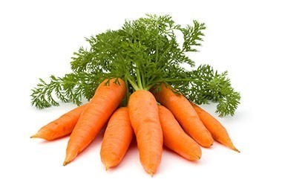DESCRIPTION

Carrot comes in different colors – white, yellow, orange, purple and violet. Several hundred varieties exist, but there are four main types:

****Imperator**** – has long roots (23-25cm), small shoulders and tapered tip;  
****Nantes**** – has medium length roots (15cm), uniform diameter and blunt tip:  
****Danvers**** – is large, with medium length roots (18cm), a processing type used for dicing and slicing; and  
****Chantenay**** – is short (13cm) with large shoulders, and usually a large, distinctly colored core.

PLANTING

The land should be plowed and harrowed several times until a fine filth is attained. Prepare raised beds 20cm high, 0.7-0.8m wide, and 0.3m apart. Pulverize the soil and incorporate fully decomposed chicken at 3-5 t/ha and complete fertilizer at 3-5 bags/ha one week before planting.

Thorough field preparation is very necessary for the plant because it is small- seeded and usually planted direct in the field. Crops planted in a well-prepared field seem to have better well-shaped, marketable roots than plants grown in a poorly prepared soil which tend to have irregularly-shaped roots.

FERTILIZATION

The general fertilizer recommendation is 126 kg/ha N, 71 kg/ha P2O5, and 175 kg/ha K2O. However, fertilization should be based on soil analysis. Apply organic fertilizers such as well decomposed manure or compost at 3-5 t/ha 1-2 weeks before planting to contribute 60-100 kg NPK and micronutrients. The remaining nutrient requirement can be applied at 30 days from sowing, just after weeding and thinning. Cover the fertilizer with soil during hilling up. Tea manure and fermented plant juice (FPJ) may also be used to improve soil fertility.

HARVESTING

Carrots can be harvested 2-3 months after sowing, depending on the variety used. Harvest the carrots if the leaves turn yellowish and the roots are big enough. Loosen the soil using a spading fork then pull the carrot roots carefully. Remove split roots. Haul the roots to the packing house immediately after harvest. Yields are usually 20-30 t/ha under favorable and good management.