ZXA10 C30
En la Imagen se observa la distribución de sus puertos y que hace cada placa
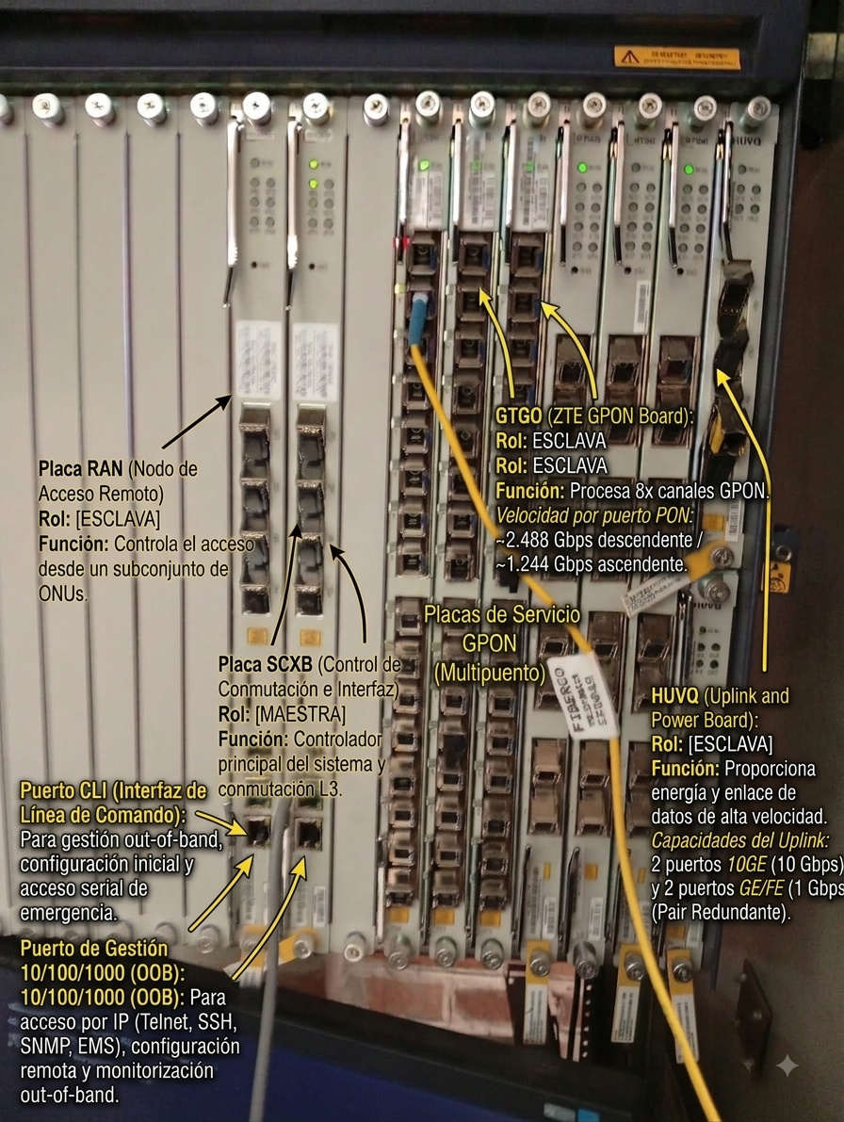

El acceso por CLI es
password: zxr10
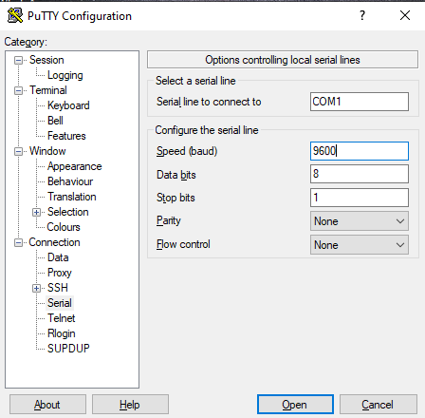
acceso por telnet 10.0.10.100
usuario cidi
contraseña gpon1234
===============================================================================
DOCUMENTACIÓN TÉCNICA DE CONFIGURACIÓN Y DESPLIEGUE - OLT ZTE ZXA10 C300
Firmware: V4.8.35 | Hostname: ZXAN
===============================================================================

1. PARÁMETROS DE ACCESO Y MANTENIMIENTO
-------------------------------------------------------------------------------
• Acceso Consola / Puerto CLI (SCXB/SCTM):
- Velocidad (Baud rate): 9600 bps
- Datos: 8 bits | Paridad: Ninguna | Bits de parada: 1 | Control de flujo: Ninguno
- Contraseña de emergencia modo CLI: zxr10

• Acceso Remoto / Puerto de Gestión Out-of-Band (mng1):
- IP de gestión OOB: 10.0.10.100 /24
- Protocolos habilitados: Telnet / SSH v2
- Usuario: cidi | Contraseña: gpon1234

===============================================================================
2. SECUENCIA CONFIGURATIVA PASO A PASO
===============================================================================

-------------------------------------------------------------------------------
FASE 1: GESTIÓN DE USUARIOS Y ACCESOS ADMINISTRATIVOS
-------------------------------------------------------------------------------
ZXAN> enable
ZXAN# configure terminal

! Configuración de la contraseña cifrada de Enable (Level 15)
ZXAN(config)# enable secret level 15 gpon1234

! Creación de usuario administrador local con restricción de sesiones y vigencia
ZXAN(config)# username cidi password gpon1234 privilege 15
ZXAN(config)# username cidi max-sessions 16
ZXAN(config)# username login-range name cidi login-begin 00:00:00 login-end 23:59:59
ZXAN(config)# username expire-date name cidi datetime 12-31-2099 23:59:59
ZXAN(config)# username password-changed name cidi is-changed false

! Esquema de Autenticación y Autorización Local
ZXAN(config)# user-authentication-type local
ZXAN(config)# user-authorization-type local

-------------------------------------------------------------------------------
FASE 2: INICIALIZACIÓN DEL SISTEMA, HARDWARE Y AJUSTES GLOBALES
-------------------------------------------------------------------------------
! Modo de reenvío global del sistema
ZXAN(config)# system-forwarding-mode normal-mode

! Declaración exacta del Chasis, Fuentes (PRWH), Placas GPON (GTGH/GTGO) y Uplink (HUVQ)
ZXAN(config)# add-rack rackno 1 racktype IEC19
ZXAN(config)# add-shelf rackno 1 shelfno 1 shelftype IEC_SHELF
ZXAN(config)# add-card rackno 1 shelfno 1 slotno 0 PRWH
ZXAN(config)# add-card rackno 1 shelfno 1 slotno 1 PRWH
ZXAN(config)# add-card rackno 1 shelfno 1 slotno 13 GTGH
ZXAN(config)# add-card rackno 1 shelfno 1 slotno 14 GTGH
ZXAN(config)# add-card rackno 1 shelfno 1 slotno 15 GTGH
ZXAN(config)# add-card rackno 1 shelfno 1 slotno 16 GTGO
ZXAN(config)# add-card rackno 1 shelfno 1 slotno 17 GTGO
ZXAN(config)# add-card rackno 1 shelfno 1 slotno 19 HUVQ
ZXAN(config)# add-card rackno 1 shelfno 1 slotno 20 HUVQ

! Ajustes de Socket TCP y Tiempos de Tabla MAC
ZXAN(config)# ip tcp finwait-time 600
ZXAN(config)# ip tcp queuemax 5
ZXAN(config)# ip tcp synwait-time 30
ZXAN(config)# ip tcp window-size 2144
ZXAN(config)# mac aging-time 300
ZXAN(config)# mac monitor-period 10
ZXAN(config)# mac usage-threshold 70
ZXAN(config)# eth-switch max-frame-length 1600

! Sistema de Ventilación (Fans)
ZXAN(config)# fan temp-zone low-threshold -20 high-threshold 90 red-threshold 160 rackno 1 shelfno 1
ZXAN(config)# fan speed-percent-set 23 38 48 58 rackno 1 shelfno 1
ZXAN(config)# fan control fixed-speed rackno 1 shelfno 1
ZXAN(config)# fan speed 1 fanid 1 rackno 1 shelfno 1
ZXAN(config)# fan speed 1 fanid 2 rackno 1 shelfno 1
ZXAN(config)# fan speed 1 fanid 3 rackno 1 shelfno 1
ZXAN(config)# fan speed 1 fanid 4 rackno 1 shelfno 1
ZXAN(config)# fan speed 1 fanid 5 rackno 1 shelfno 1
ZXAN(config)# fan speed 1 fanid 6 rackno 1 shelfno 1
ZXAN(config)# fan speed 1 fanid 7 rackno 1 shelfno 1
ZXAN(config)# fan speed 1 fanid 8 rackno 1 shelfno 1
ZXAN(config)# fan speed 1 fanid 9 rackno 1 shelfno 1
ZXAN(config)# fan speed 1 fanid 10 rackno 1 shelfno 1
ZXAN(config)# fan env-card-device power

! Seguridad de Sistema y Mantenimiento
ZXAN(config)# urpf log off
ZXAN(config)# auto-update backup disable
ZXAN(config)# auto-update activate disable

-------------------------------------------------------------------------------
FASE 3: REDES, VLANS E INTERFACES DE GESTIÓN (OOB / IN-BAND)
-------------------------------------------------------------------------------
! Reservas Internas del Sistema para VoIP y GPON
ZXAN(config)# vlan-reserve 4091 out-voip
ZXAN(config)# vlan-reserve 4092 in-voip
ZXAN(config)# vlan-reserve 4094 gpon

! Base de Datos de VLANs Registradas
ZXAN(config)# vlan database
ZXAN(config-vlan)# vlan 1,200,400,1000
ZXAN(config-vlan)# vlan 4091-4092,4094
ZXAN(config-vlan)# exit

! Interfaz Out-of-Band (mng1 - Puerto Físico Ethernet SCXB)
ZXAN(config)# interface mng1
ZXAN(config-if-mng1)# ip vrf forwarding vpn_mng
ZXAN(config-if-mng1)# ip address 10.0.10.100 255.255.255.0
ZXAN(config-if-mng1)# config-filename startrun.dat
ZXAN(config-if-mng1)# negotiation auto
ZXAN(config-if-mng1)# tag-mode untag
ZXAN(config-if-mng1)# exit

! Interfaz L3 SVI (In-Band Management en VLAN 200)
ZXAN(config)# interface vlan 200
ZXAN(config-if-vlan200)# ip address 10.1.1.2 255.255.255.0
ZXAN(config-if-vlan200)# exit

-------------------------------------------------------------------------------
FASE 4: INTERFACES UPLINK / PUERTOS DE TRANSPORTE ACTIVOS
-------------------------------------------------------------------------------
! Uplink 1: Puerto 10 Gbps Fibra (xgei_1/19/1)
ZXAN(config)# interface xgei_1/19/1
ZXAN(config-if-xgei_1/19/1)# phy-attribute lan
ZXAN(config-if-xgei_1/19/1)# no shutdown
ZXAN(config-if-xgei_1/19/1)# hybrid-attribute fiber
ZXAN(config-if-xgei_1/19/1)# no negotiation auto
ZXAN(config-if-xgei_1/19/1)# speed 10000
ZXAN(config-if-xgei_1/19/1)# duplex full
ZXAN(config-if-xgei_1/19/1)# flowcontrol disable
ZXAN(config-if-xgei_1/19/1)# linktrap enable
ZXAN(config-if-xgei_1/19/1)# als disable
ZXAN(config-if-xgei_1/19/1)# switchport mode trunk
ZXAN(config-if-xgei_1/19/1)# switchport vlan 1 tag
ZXAN(config-if-xgei_1/19/1)# port-protect disable
ZXAN(config-if-xgei_1/19/1)# uplink-isolate disable
ZXAN(config-if-xgei_1/19/1)# exit

! Uplink 2: Puerto 1 Gbps Fibra (gei_1/19/3)
ZXAN(config)# interface gei_1/19/3
ZXAN(config-if-gei_1/19/3)# no shutdown
ZXAN(config-if-gei_1/19/3)# hybrid-attribute fiber
ZXAN(config-if-gei_1/19/3)# negotiation auto
ZXAN(config-if-gei_1/19/3)# flowcontrol disable
ZXAN(config-if-gei_1/19/3)# linktrap enable
ZXAN(config-if-gei_1/19/3)# als disable
ZXAN(config-if-gei_1/19/3)# switchport mode trunk
ZXAN(config-if-gei_1/19/3)# switchport vlan 1,200 tag
ZXAN(config-if-gei_1/19/3)# port-protect disable
ZXAN(config-if-gei_1/19/3)# uplink-isolate disable
ZXAN(config-if-gei_1/19/3)# exit

-------------------------------------------------------------------------------
FASE 5: PLANTILLAS DE ONU Y PERFILES DE TRÁFICO DBA (GPON)
-------------------------------------------------------------------------------
! Definición de Perfiles DBA (Subida / Upstream)
ZXAN(config)# gpon profile tcont INTERNET type 4 maximum 1024000

! Definición de Tipos de ONU (Hardware e Interfaces)
ZXAN(config)# pon onu-type ZTEG-F670 gpon description 4GE,2POTS
ZXAN(config)# pon onu-type ZTEG-F670 gpon max-tcont 7
ZXAN(config)# pon onu-type ZTEG-F670 gpon max-gemport 32
ZXAN(config)# pon onu-type ZTEG-F670 gpon max-switch-perslot 1
ZXAN(config)# pon onu-type ZTEG-F670 gpon max-flow-perswitch 32

ZXAN(config)# pon onu-type generic-F601 gpon description 1GE
ZXAN(config)# pon onu-type generic-F601 gpon max-tcont 8
ZXAN(config)# pon onu-type generic-F601 gpon max-gemport 32
ZXAN(config)# pon onu-type generic-F601 gpon max-switch-perslot 8
ZXAN(config)# pon onu-type generic-F601 gpon max-flow-perswitch 8

ZXAN(config)# pon onu-type generic-F670 gpon description 4GE,2POTS,WIFI
ZXAN(config)# pon onu-type generic-F670 gpon max-tcont 8
ZXAN(config)# pon onu-type generic-F670 gpon max-gemport 32
ZXAN(config)# pon onu-type generic-F670 gpon max-switch-perslot 8
ZXAN(config)# pon onu-type generic-F670 gpon max-flow-perswitch 8

! Asignación de Interfaces Ethernet por Modelo
ZXAN(config)# pon onu-type-if ZTEG-F670 eth_0/1
ZXAN(config)# pon onu-type-if ZTEG-F670 eth_0/2
ZXAN(config)# pon onu-type-if ZTEG-F670 eth_0/3
ZXAN(config)# pon onu-type-if ZTEG-F670 eth_0/4
ZXAN(config)# pon onu-type-if generic-F601 eth_0/1
ZXAN(config)# pon onu-type-if generic-F670 eth_0/1
ZXAN(config)# pon onu-type-if generic-F670 eth_0/2
ZXAN(config)# pon onu-type-if generic-F670 eth_0/3
ZXAN(config)# pon onu-type-if generic-F670 eth_0/4

-------------------------------------------------------------------------------
FASE 6: APROVISIONAMIENTO REAL DE CLIENTES Y SERVICIOS GPON
-------------------------------------------------------------------------------
! --- CASO 1: Registro en Puerto 1/13/1 ---
ZXAN(config)# interface gpon-olt_1/13/1
ZXAN(config-if-gpon-olt_1/13/1)# no shutdown
ZXAN(config-if-gpon-olt_1/13/1)# linktrap disable
ZXAN(config-if-gpon-olt_1/13/1)# onu 1 type generic-F601 sn RTEGCA01096C
ZXAN(config-if-gpon-olt_1/13/1)# exit

ZXAN(config)# interface gpon-onu_1/13/1:1
ZXAN(config-if-gpon-onu_1/13/1:1)# sn-bind enable sn
ZXAN(config-if-gpon-onu_1/13/1:1)# exit

! --- CASO 2: Registro y Servicio de Internet en Puerto 1/13/2 ---
! 1. Alta de ONU en Puerto Físico
ZXAN(config)# interface gpon-olt_1/13/2
ZXAN(config-if-gpon-olt_1/13/2)# no shutdown
ZXAN(config-if-gpon-olt_1/13/2)# linktrap disable
ZXAN(config-if-gpon-olt_1/13/2)# onu 1 type generic-F670 sn ZTEGC826D2E0
ZXAN(config-if-gpon-olt_1/13/2)# exit

! 2. Enlace Lógico de Ancho de Banda y Service-Port
ZXAN(config)# interface gpon-onu_1/13/2:1
ZXAN(config-if-gpon-onu_1/13/2:1)# sn-bind enable sn
ZXAN(config-if-gpon-onu_1/13/2:1)# tcont 1 profile INTERNET
ZXAN(config-if-gpon-onu_1/13/2:1)# gemport 1 tcont 1
ZXAN(config-if-gpon-onu_1/13/2:1)# switchport mode hybrid vport 1
ZXAN(config-if-gpon-onu_1/13/2:1)# service-port 1 vport 1 user-vlan 200 vlan 200
ZXAN(config-if-gpon-onu_1/13/2:1)# exit

! 3. Configuración OMCI de Puertos del Cliente (Gestión PON-ONU-MNG)
ZXAN(config)# pon-onu-mng gpon-onu_1/13/2:1
ZXAN(gpon-onu-mng)# service 1 gemport 1 vlan 200
ZXAN(gpon-onu-mng)# vlan port eth_0/1 mode tag vlan 200
ZXAN(gpon-onu-mng)# exit

-------------------------------------------------------------------------------
FASE 7: COMANDOS DE DIAGNÓSTICO, MONITORIZACIÓN Y SALVAGUARDA
-------------------------------------------------------------------------------
! A. Monitoreo de Hardware y Temperatura
ZXAN# show card
ZXAN# show environment status

! B. Estado de Interfaces de Red y VLANs
ZXAN# show interface xgei_1/19/1
ZXAN# show interface gei_1/19/3
ZXAN# show vlan brief

! C. Diagnóstico GPON y Estado de Óptica
ZXAN# show gpon onu state gpon-olt_1/13/2
ZXAN# show gpon onu optical-power gpon-onu_1/13/2:1
ZXAN# show gpon onu uncfg

! D. Guardado Permanente en Memoria Flash (Guardar Cambios)
ZXAN# write

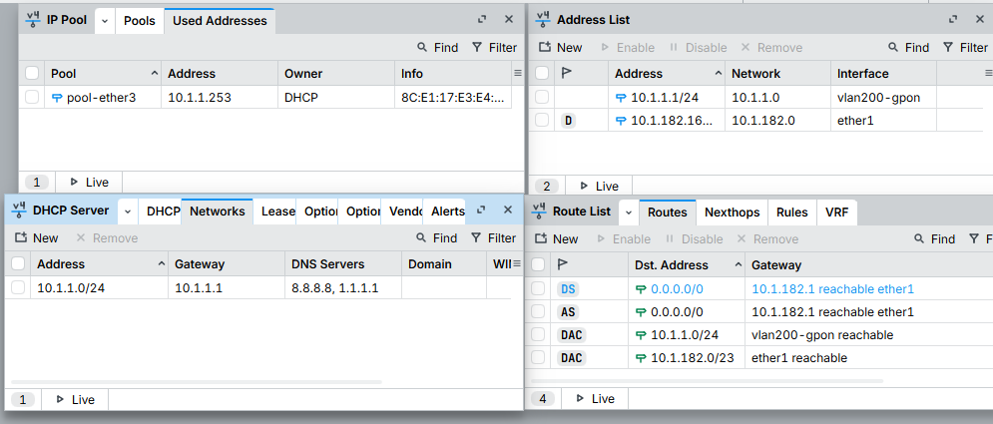

Show Run de la OLT
*************************************************************************
Welcome to ZXAN product of ZTE Corporation
*************************************************************************

Username:cidi
Password:
ZXAN#sh run
Building configuration...
olleh
timestamp_write: 19:45:01 05/06/2026
config-version 2.0
!
system-forwarding-mode normal-mode
!
!
!
set-pnp enable
add-rack rackno 1 racktype IEC19
add-shelf rackno 1 shelfno 1 shelftype IEC_SHELF
add-card rackno 1 shelfno 1 slotno 0 PRWH
add-card rackno 1 shelfno 1 slotno 1 PRWH
add-card rackno 1 shelfno 1 slotno 13 GTGH
add-card rackno 1 shelfno 1 slotno 14 GTGH
add-card rackno 1 shelfno 1 slotno 15 GTGH
add-card rackno 1 shelfno 1 slotno 16 GTGO
add-card rackno 1 shelfno 1 slotno 17 GTGO
add-card rackno 1 shelfno 1 slotno 19 HUVQ
add-card rackno 1 shelfno 1 slotno 20 HUVQ
!
ip tcp finwait-time 600
ip tcp queuemax 5
ip tcp synwait-time 30
ip tcp window-size 2144
!
urpf log off
!
iptv cdr report-interval 240
iptv cdr max-records 65535
gpon
!
!
fan temp-zone low-threshold -20 high-threshold 90 red-threshold 160 rackno 1 she
lfno 1
fan speed-percent-set 23 38 48 58 rackno 1 shelfno 1
fan control fixed-speed rackno 1 shelfno 1
fan speed 1 fanid 1 rackno 1 shelfno 1
fan speed 1 fanid 2 rackno 1 shelfno 1
fan speed 1 fanid 3 rackno 1 shelfno 1
fan speed 1 fanid 4 rackno 1 shelfno 1
fan speed 1 fanid 5 rackno 1 shelfno 1
fan speed 1 fanid 6 rackno 1 shelfno 1
fan speed 1 fanid 7 rackno 1 shelfno 1
fan speed 1 fanid 8 rackno 1 shelfno 1
fan speed 1 fanid 9 rackno 1 shelfno 1
fan speed 1 fanid 10 rackno 1 shelfno 1
fan env-card-device power
!
!
!
!
mac aging-time 300
mac monitor-period 10
mac usage-threshold 70
!
eth-switch max-frame-length 1600
!
auto-update backup disable
auto-update activate disable
!
!
!
gpon
profile tcont INTERNET type 4 maximum 1024000
!
!
epon
!
!
pon
onu-type ZTEG-F670 gpon description 4GE,2POTS
onu-type ZTEG-F670 gpon max-tcont 7
onu-type ZTEG-F670 gpon max-gemport 32
onu-type ZTEG-F670 gpon max-switch-perslot 1
onu-type ZTEG-F670 gpon max-flow-perswitch 32
onu-type generic-F601 gpon description 1GE
onu-type generic-F601 gpon max-tcont 8
onu-type generic-F601 gpon max-gemport 32
onu-type generic-F601 gpon max-switch-perslot 8
onu-type generic-F601 gpon max-flow-perswitch 8
onu-type generic-F670 gpon description 4GE,2POTS,WIFI
onu-type generic-F670 gpon max-tcont 8
onu-type generic-F670 gpon max-gemport 32
onu-type generic-F670 gpon max-switch-perslot 8
onu-type generic-F670 gpon max-flow-perswitch 8
onu-type-if ZTEG-F670 eth_0/1
onu-type-if ZTEG-F670 eth_0/2
onu-type-if ZTEG-F670 eth_0/3
onu-type-if ZTEG-F670 eth_0/4
onu-type-if generic-F601 eth_0/1
onu-type-if generic-F601 eth_0/2
onu-type-if generic-F601 eth_0/3
onu-type-if generic-F601 eth_0/4
onu-type-if generic-F670 eth_0/1
onu-type-if generic-F670 eth_0/2
onu-type-if generic-F670 eth_0/3
onu-type-if generic-F670 eth_0/4
uncfg-onu-display-info model sn pw
!
!
vlan-reserve 4091 out-voip
vlan-reserve 4092 in-voip
vlan-reserve 4094 gpon
!
vlan database
vlan 1,200,400,1000
vlan 4091-4092,4094
!
!
!
his-performance sample enable
his-performance alarm enable
his-performance auto-upload disable
!
!
clock
!
!

!
clock
!
!

!
ptp
!
!
port-identification access-node-id-type inband-mac
port-identification rackno 1 frameno 1
!
igmp enable
mld disable
mib-compatibility iftable v1
!
ip-source-guard ip-spoofing-trap interval 3
ip-source-guard disable
security port-protect enable
!
!
!
vdsl2 vector-bandplan
TransMode:2
ClassMask:7
!
vdsl2 vector-tracking
Mode:1
!
vdsl2 switch-to-tr165
ModeFlag:9
!
!
virtual-mac flexible-syntax-profile MT
add Ctrl-Byte 0 width 6 index 6
exit
virtual-mac access-node-id 0
!
msag

sip capability modify uaid 1 PPRESERVICE 0

!
!
!
interface mng1
ip vrf forwarding vpn_mng
ip address 10.0.10.100 255.255.255.0
config-filename startrun.dat
negotiation auto
tag-mode untag
!
interface vlan 200
ip address 10.1.1.2 255.255.255.0
!
interface null1
!
interface gei_1/10/1
shutdown
hybrid-attribute fiber
no negotiation auto
speed 1000
duplex full
flowcontrol disable
linktrap enable
als disable
switchport mode trunk
switchport vlan 1,200 tag
!
interface gei_1/11/2
shutdown
hybrid-attribute fiber
no negotiation auto
speed 1000
duplex full
flowcontrol disable
linktrap enable
als disable
switchport mode trunk
switchport vlan 1 tag
!
interface gei_1/11/3
shutdown
hybrid-attribute fiber
no negotiation auto
speed 1000
duplex full
flowcontrol disable
linktrap enable
als disable
switchport mode trunk
switchport vlan 1 tag
!
interface gei_1/11/4
shutdown
hybrid-attribute fiber
no negotiation auto
speed 1000
duplex full
flowcontrol disable
linktrap enable
als disable
switchport mode trunk
switchport vlan 1 tag
!
interface gpon-olt_1/13/1
no shutdown
linktrap disable
onu 1 type generic-F601 sn RTEGCA01096C
!
interface gpon-onu_1/13/1:1
sn-bind enable sn
!
interface gpon-olt_1/13/2
no shutdown
linktrap disable
onu 1 type generic-F670 sn ZTEGC826D2E0
!
interface gpon-onu_1/13/2:1
sn-bind enable sn
tcont 1 profile INTERNET
gemport 1 tcont 1
switchport mode hybrid vport 1
service-port 1 vport 1 user-vlan 200 vlan 200
!
interface gpon-olt_1/13/3
shutdown
linktrap disable
!
interface gpon-olt_1/13/4
shutdown
linktrap disable
!
interface gpon-olt_1/13/5
shutdown
linktrap disable
!
interface gpon-olt_1/13/6
shutdown
linktrap disable
!
interface gpon-olt_1/13/7
shutdown
linktrap disable
!
interface gpon-olt_1/13/8
shutdown
linktrap disable
!
interface gpon-olt_1/13/9
shutdown
linktrap disable
!
interface gpon-olt_1/13/10
shutdown
linktrap disable
!
interface gpon-olt_1/13/11
shutdown
linktrap disable
!
interface gpon-olt_1/13/12
shutdown
linktrap disable
!
interface gpon-olt_1/13/13
shutdown
linktrap disable
!
interface gpon-olt_1/13/14
shutdown
linktrap disable
!
interface gpon-olt_1/13/15
shutdown
linktrap disable
!
interface gpon-olt_1/13/16
shutdown
linktrap disable
!
interface gpon-olt_1/14/1
shutdown
linktrap disable
!
interface gpon-olt_1/14/2
shutdown
linktrap disable
!
interface gpon-olt_1/14/3
shutdown
linktrap disable
!
interface gpon-olt_1/14/4
shutdown
linktrap disable
!
interface gpon-olt_1/14/5
shutdown
linktrap disable
!
interface gpon-olt_1/14/6
shutdown
linktrap disable
!
interface gpon-olt_1/14/7
shutdown
linktrap disable
!
interface gpon-olt_1/14/8
shutdown
linktrap disable
!
interface gpon-olt_1/14/9
shutdown
linktrap disable
!
interface gpon-olt_1/14/10
shutdown
linktrap disable
!
interface gpon-olt_1/14/11
shutdown
linktrap disable
!
interface gpon-olt_1/14/12
shutdown
linktrap disable
!
interface gpon-olt_1/14/13
shutdown
linktrap disable
!
interface gpon-olt_1/14/14
shutdown
linktrap disable
!
interface gpon-olt_1/14/15
shutdown
linktrap disable
!
interface gpon-olt_1/14/16
shutdown
linktrap disable
!
interface gpon-olt_1/15/1
shutdown
linktrap disable
!
interface gpon-olt_1/15/2
shutdown
linktrap disable
!
interface gpon-olt_1/15/3
shutdown
linktrap disable
!
interface gpon-olt_1/15/4
shutdown
linktrap disable
!
interface gpon-olt_1/15/5
shutdown
linktrap disable
!
interface gpon-olt_1/15/6
shutdown
linktrap disable
!
interface gpon-olt_1/15/7
shutdown
linktrap disable
!
interface gpon-olt_1/15/8
shutdown
linktrap disable
!
interface gpon-olt_1/15/9
shutdown
linktrap disable
!
interface gpon-olt_1/15/10
shutdown
linktrap disable
!
interface gpon-olt_1/15/11
shutdown
linktrap disable
!
interface gpon-olt_1/15/12
shutdown
linktrap disable
!
interface gpon-olt_1/15/13
shutdown
linktrap disable
!
interface gpon-olt_1/15/14
shutdown
linktrap disable
!
interface gpon-olt_1/15/15
shutdown
linktrap disable
!
interface gpon-olt_1/15/16
shutdown
linktrap disable
!
interface gpon-olt_1/16/1
shutdown
linktrap disable
!
interface gpon-olt_1/16/2
shutdown
linktrap disable
!
interface gpon-olt_1/16/3
shutdown
linktrap disable
!
interface gpon-olt_1/16/4
shutdown
linktrap disable
!
interface gpon-olt_1/16/5
shutdown
linktrap disable
!
interface gpon-olt_1/16/6
shutdown
linktrap disable
!
interface gpon-olt_1/16/7
shutdown
linktrap disable
!
interface gpon-olt_1/16/8
shutdown
linktrap disable
!
interface gpon-olt_1/17/1
shutdown
linktrap disable
!
interface gpon-olt_1/17/2
shutdown
linktrap disable
!
interface gpon-olt_1/17/3
shutdown
linktrap disable
!
interface gpon-olt_1/17/4
shutdown
linktrap disable
!
interface gpon-olt_1/17/5
shutdown
linktrap disable
!
interface gpon-olt_1/17/6
shutdown
linktrap disable
!
interface gpon-olt_1/17/7
shutdown
linktrap disable
!
interface gpon-olt_1/17/8
shutdown
linktrap disable
!
interface xgei_1/19/1
phy-attribute lan
no shutdown
hybrid-attribute fiber
no negotiation auto
speed 10000
duplex full
flowcontrol disable
linktrap enable
als disable
switchport mode trunk
switchport vlan 1 tag
port-protect disable
uplink-isolate disable
!
interface xgei_1/19/2
phy-attribute lan
shutdown
hybrid-attribute fiber
no negotiation auto
speed 10000
duplex full
flowcontrol disable
linktrap enable
als disable
switchport mode trunk
switchport vlan 1 tag
port-protect disable
uplink-isolate disable
!
interface gei_1/19/3
no shutdown
hybrid-attribute fiber
negotiation auto
flowcontrol disable
linktrap enable
als disable
switchport mode trunk
switchport vlan 1,200 tag
port-protect disable
uplink-isolate disable
!
interface gei_1/19/4
shutdown
hybrid-attribute fiber
negotiation auto
flowcontrol disable
linktrap enable
als disable
switchport mode trunk
switchport vlan 1 tag
port-protect disable
uplink-isolate disable
!
interface xgei_1/20/1
phy-attribute lan
shutdown
hybrid-attribute fiber
no negotiation auto
speed 10000
duplex full
flowcontrol disable
linktrap enable
als disable
switchport mode trunk
switchport vlan 1 tag
port-protect disable
uplink-isolate disable
!
interface xgei_1/20/2
phy-attribute lan
shutdown
hybrid-attribute fiber
no negotiation auto
speed 10000
duplex full
flowcontrol disable
linktrap enable
als disable
switchport mode trunk
switchport vlan 1 tag
port-protect disable
uplink-isolate disable
!
interface gei_1/20/3
shutdown
hybrid-attribute fiber
negotiation auto
flowcontrol disable
linktrap enable
als disable
switchport mode trunk
switchport vlan 1 tag
port-protect disable
uplink-isolate disable
!
interface gei_1/20/4
shutdown
hybrid-attribute fiber
negotiation auto
flowcontrol disable
linktrap enable
als disable
switchport mode trunk
switchport vlan 1 tag
port-protect disable
uplink-isolate disable
!
!
set ethernet-oam enable
!
mpls ldp dynamic-capability
!
flow-label para-id 23
!
!
!
!
!
!
!
lldp disable
!
ipoa inatmarp-interval 10
ipoa gateway-arp-interval 10
!
mpnat trans-table aging-time 60
mpnat onu-telnet idle-time 3
mpnat onu-ftp aging-time 5
mpnat onu-snmp aging-time 30
mpnat onu-ftp-data aging-time 5
mpnat onu-mng-port auto-alloc disable
!
pon
!
!
pon-onu-mng gpon-onu_1/13/1:1
!
pon-onu-mng gpon-onu_1/13/2:1
service 1 gemport 1 vlan 200
vlan port eth_0/1 mode tag vlan 200
!
!
pon
!
!
ces
!
!
!
ip-service arp-direct-to-gateway disable
mac vpn ec1d.7f07.75c8
!
!
!
auto-write disable
!
inband-management enable
!
version V4.8.35
!
hostname ZXAN
!
enable secret level 15 5 RcMLuUKvnFZX9kNAV6A/UA==
!
service password-encryption
!
!
username cidi password 7 juZF7ZU68yUOtkJ7B6z7EA== privilege 15
username cidi password 7 juZF7ZU68yUOtkJ7B6z7EA== max-sessions 16
username login-range name cidi login-begin 00:00:00 login-end 23:59:59
username expire-date name cidi datetime 12-31-2099 23:59:59
username password-changed name cidi is-changed false

!
!
!
user-authentication-type local
user-authorization-type local
!
help message full
!
banner incoming @
*************************************************************************
Welcome to ZXAN product of ZTE Corporation
*************************************************************************
@
!
message-of-day @
@
!
!
service timestamps log datetime localtime
service timestamps debug datetime localtime
!
!
!
!
snmp-server location No.889 BiBo Rd.PuDong District, Shanghai, China
snmp-server contact +86-21-68895000
snmp-server packetsize 8192
snmp-server engine-id mode mac
snmp-server group GroupPriv15 v3 priv read AllView write AllView
snmp-server group GroupPriv10 v3 priv read AllView write ViewPriv10
snmp-server group GroupPriv5 v3 priv read AllView write ViewPriv5
snmp-server group GroupPriv0 v3 priv read AllView
snmp-server view AllView 1.2 included
snmp-server view AllView 1.3 included
snmp-server view ViewPriv5 1.2 included
snmp-server view ViewPriv5 1.3 included
snmp-server view ViewPriv5 1.3.6.1.4.1.3902.1082.10.1 excluded
snmp-server view ViewPriv5 1.3.6.1.4.1.3902.1082.10.10 excluded
snmp-server view ViewPriv5 1.3.6.1.4.1.3902.1082.20.1 excluded
snmp-server view ViewPriv5 1.3.6.1.4.1.3902.1082.20.10 excluded
snmp-server view ViewPriv10 1.2 included
snmp-server view ViewPriv10 1.3 included
snmp-server view ViewPriv10 1.3.6.1.4.1.3902.1082.20.10 excluded
!
!
no ftp-server enable listen 21
ftp-server top-directory /flash/
!
logging alarmlog enable
logging level notification
logging snmplog disable
logging igmplog enable
logging cmdlog enable
syslog facility local0
syslog severity 6
line console idle-timeout 15
line console absolute-timeout 1440
line telnet idle-timeout 15
line telnet absolute-timeout 1440
line telnet users 16

no hotkey ctrl_g
no hotkey ctrl_l
no hotkey ctrl_o
no hotkey ctrl_r
no hotkey ctrl_s
no hotkey ctrl_t
!
ssh server authentication mode local
ssh server authentication type pap
no ssh server only
ssh server version 2
!
!
radius attribute vendor-specific vendor-id 3902
!
!
!
radius server-port-check on
!
!
tacacs disable
tacacs-server timeout 5
tacacs-server packet 1024
!
!
alarm enable
alarm confirm
alarm trap-confirm retry 3 timeout 20
nms-hello-trap disable
alarm report-speed 0
alarm anti-jitter 0
alarm filter source-code 11 dest-code 12
ipv6 dhcp snooping disable
!
ipv6 dhcp snooping ifdown-del-entry disable
!
ipv6 nd snooping disable
!
!
control-panel
packet-limit arp 300
packet-limit icmp 250
packet-limit igmp 300
packet-limit dhcp 160
packet-limit snmp 200
packet-limit telnet 300
packet-limit bfd 300
packet-limit stp 500
packet-limit lacp 600
packet-limit lldp 500
packet-limit rip 500
packet-limit bgp 500
packet-limit ospf 400
packet-limit isis 400
packet-limit ldp 600
packet-limit cfm 32
packet-limit ipv6_rs 700
packet-limit ipv6_ra 700
packet-limit ipv6_ns 200
packet-limit ipv6_na 600
packet-limit ipv6_icmp 200
packet-limit ipv6_dhcp 160
packet-limit r-aps 1000
!
!
end
ZXAN#
ZXAN#
ZXAN#

