COURSE CODE: PRAC101 Section: BSIT - 4108
COURSE TITLE: OJT / PRACTICUM 1
TERM: 1st Semester, SY 2024-2025
PROFESSOR: MR. EMERSON GELERA
NAME OF STUDENT: BACAY, CHRISTIAN IRISH

OJT NARRATIVE REPORT

- TOPIC: SECURITY IN CLOUD NETWORK ADMINISTRATION
- SPEAKER: MR. MARC TONIDO
- DURATION: 2:30-3:30
- SCREENSHOT OF DUTY

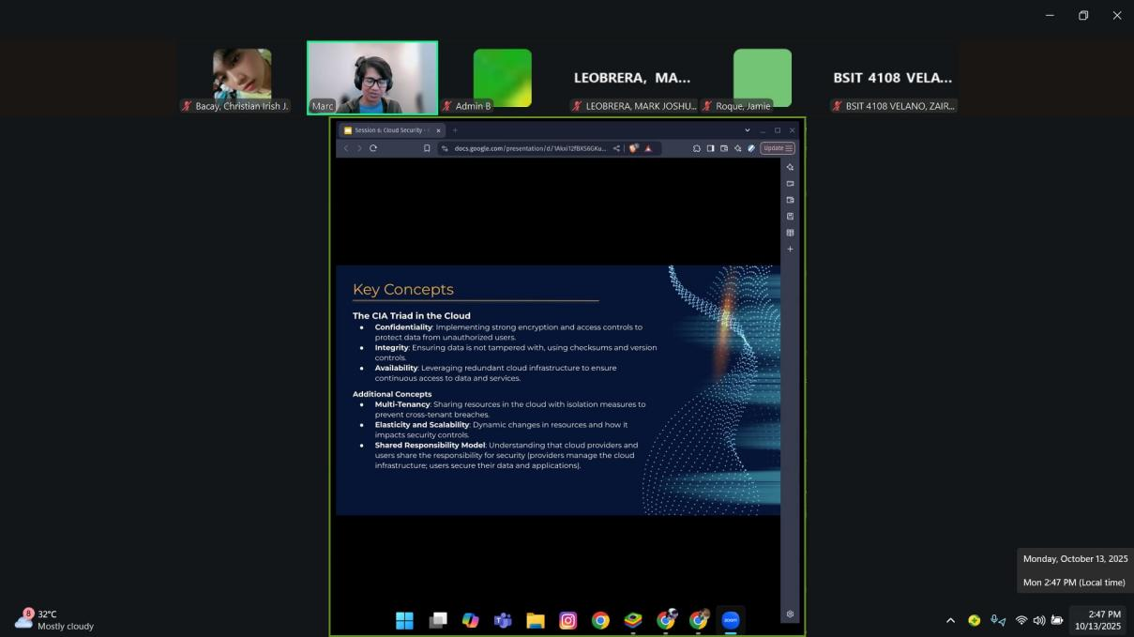

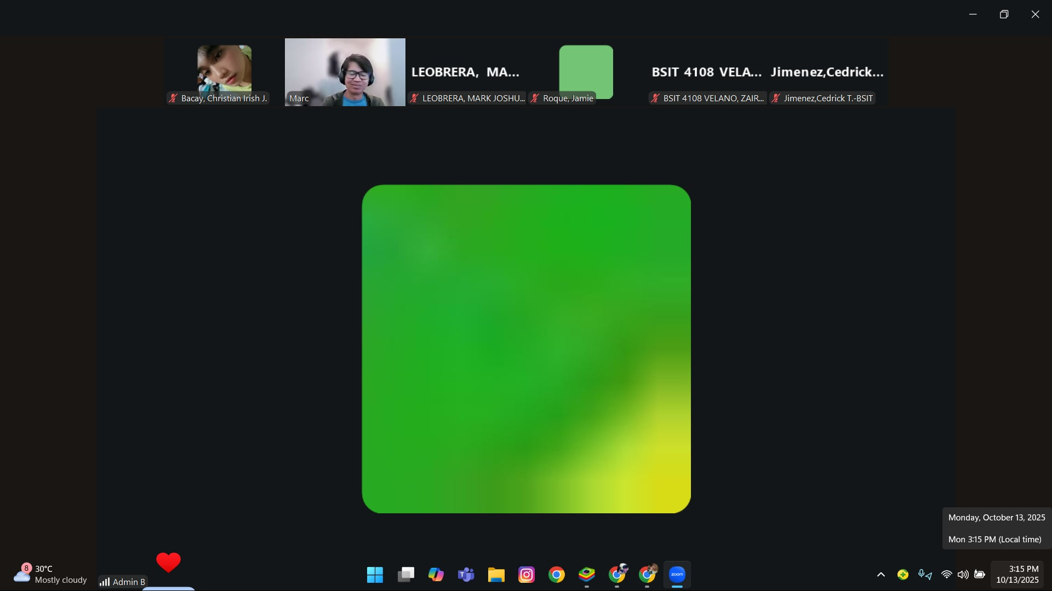

- REFLECTION
The discussion on cloud security provided a comprehensive understanding of how essential it is to safeguard digital infrastructures in modern computing environments. I learned that cloud network security encompasses the combination of technologies, policies, and best practices that protect cloud-based systems from unauthorized access and cyber threats. The session emphasized the importance of the CIA Triad—confidentiality, integrity, and availability—as the foundation of all security measures.
Furthermore, I recognized that threats such as misconfigured cloud storage, insecure APIs, and account hijacking are prevalent in cloud environments and can cause severe data breaches if not properly managed. The tools and techniques explored, including Identity and Access Management (IAM), Multi-Factor Authentication (MFA), and encryption, highlight the need for proactive and layered security strategies.
Lastly, the concept of the Shared Responsibility Model stood out as it clarified that both cloud providers and users have crucial roles in maintaining security. This session reinforced the importance of continuous monitoring, compliance with regulations, and regular audits to ensure data protection. Overall, it deepened my understanding that cloud security is not a one-time setup but an ongoing process that demands awareness, discipline, and technical proficiency.

