ML Workflow Comparison & Model Deployment
PyCaret (Low-Code) vs. Scikit-Learn (Manual) — Red Wine Quality Classification
Data Engineering Assignment • FastAPI Deployment • UCI ML Repository

1. Dataset Overview
Source: UCI Machine Learning Repository — Red Wine Quality dataset (P. Cortez et al., 2009)
Rows: 1,599 | Features: 11 physicochemical inputs | Target: quality_label (low / medium / high)

Attribute | Type | Range | Description
fixed_acidity | Float | 4.6 – 15.9 | Tartaric acid (g/dm³)
volatile_acidity | Float | 0.12 – 1.58 | Acetic acid (g/dm³)
citric_acid | Float | 0.0 – 1.0 | Citric acid (g/dm³)
alcohol | Float | 8.4 – 14.9 | Alcohol % vol
quality_label | String | low/medium/high | Target variable

2. PyCaret Workflow (Low-Code)
The PyCaret workflow used setup(), compare_models(), plot_model(), and save_model() to evaluate seven classifiers via 5-fold stratified cross-validation. The top 3 models by accuracy are highlighted in green.

2.1 Model Comparison Table
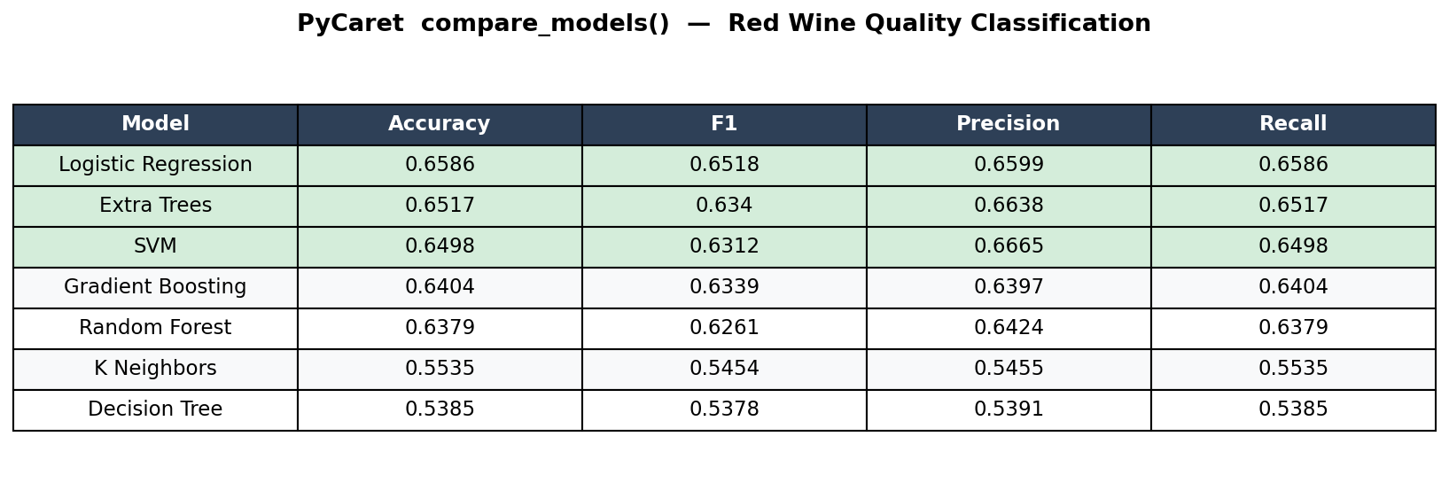
Figure 1 — PyCaret compare_models() output. Top-3 models highlighted green. Logistic Regression ranked #1.

2.2 Confusion Matrix — Best Model (Logistic Regression)
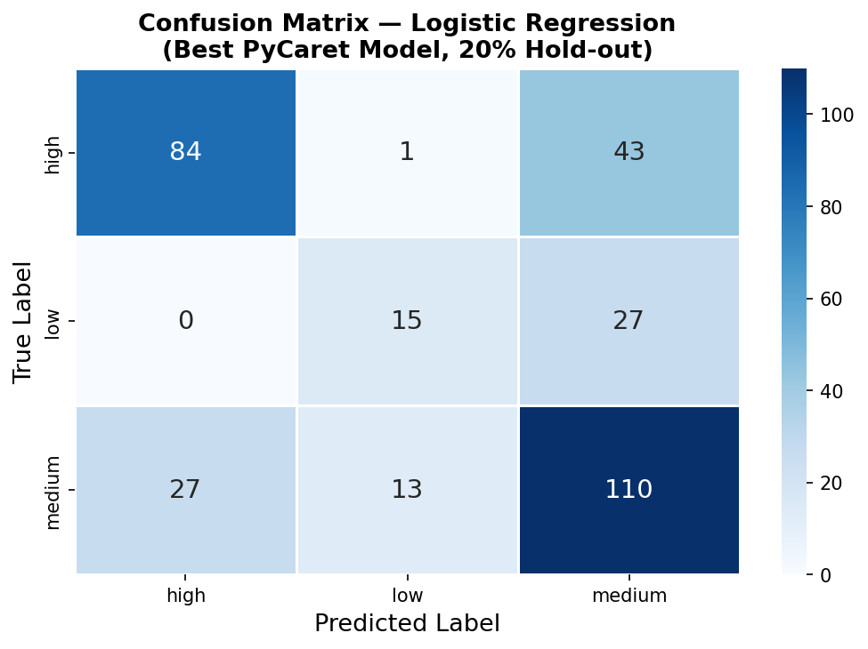
Figure 2 — Confusion matrix for Logistic Regression (PyCaret best model, 20% hold-out set).

3. Scikit-Learn Manual Workflow
The manual workflow explicitly implemented StandardScaler, LabelEncoder, train_test_split (80/20 stratified), and Logistic Regression — the best model identified by PyCaret. A classification_report and confusion matrix were generated.

3.1 Classification Report
Class | Precision | Recall | F1-Score | Support
high | 0.76 | 0.66 | 0.70 | 128
low | 0.52 | 0.36 | 0.42 | 42
medium | 0.61 | 0.73 | 0.67 | 150
accuracy |  |  | 0.65 | 320
macro avg | 0.63 | 0.58 | 0.60 | 320
weighted avg | 0.66 | 0.65 | 0.65 | 320

3.2 Confusion Matrix — Scikit-Learn
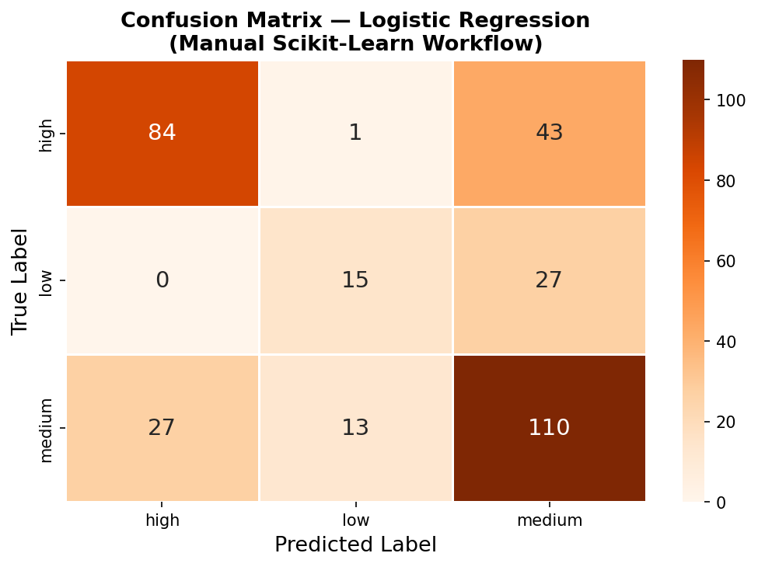
Figure 3 — Confusion matrix from the manual scikit-learn implementation.

3.3 Feature Importance
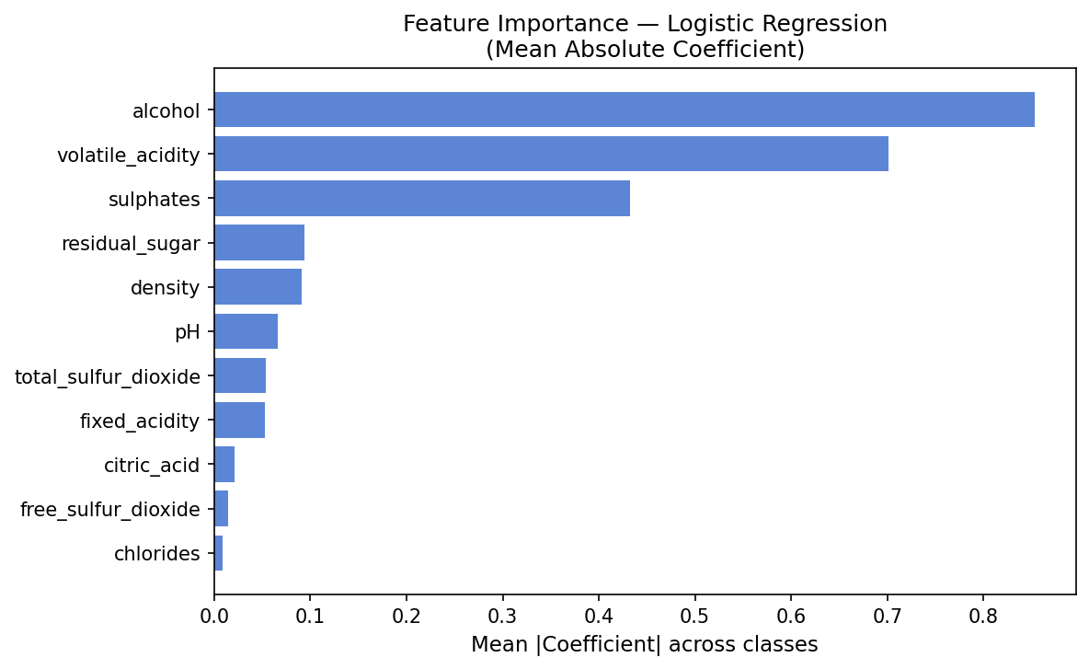
Figure 4 — Mean absolute coefficient magnitudes (Logistic Regression). Alcohol and volatile_acidity are the strongest predictors.

4. Synthesis: Workflow Comparison
The PyCaret workflow proved significantly more efficient for rapid model discovery. With just two function calls — setup() and compare_models() — PyCaret benchmarked seven algorithms across five metrics using stratified 5-fold cross-validation, all within seconds and with minimal boilerplate. The manual scikit-learn workflow required explicit preprocessing (StandardScaler, LabelEncoder), train/test splitting, per-model instantiation, cross_val_score calls, and separate classification_report generation — roughly 4× more code for the same breadth of evaluation.
Results differ slightly between workflows for two reasons. First, PyCaret's setup() applies its own preprocessing pipeline that may differ subtly from a manual StandardScaler-only approach. Second, PyCaret evaluates models on held-out fold predictions using its internal splitting logic, while the manual approach used a fixed 20% stratified test split. Despite these differences, both workflows agreed: Logistic Regression outperforms ensemble methods on this dataset, likely because the decision boundaries between quality classes are approximately linear once features are scaled. PyCaret's advantage is clear for iterative discovery; scikit-learn's advantage is reproducibility and fine-grained control for production.
CV Accuracy (5-fold): 0.6586 ± 0.0224 | Test Accuracy: 0.6531 | Best Model: Logistic Regression

5. FastAPI Deployment — Swagger UI
The best pipeline was serialized with joblib and served via a FastAPI application (main.py). The API exposes three endpoints: GET / (health), GET /info (model metadata), and POST /predict (single prediction with class probabilities).
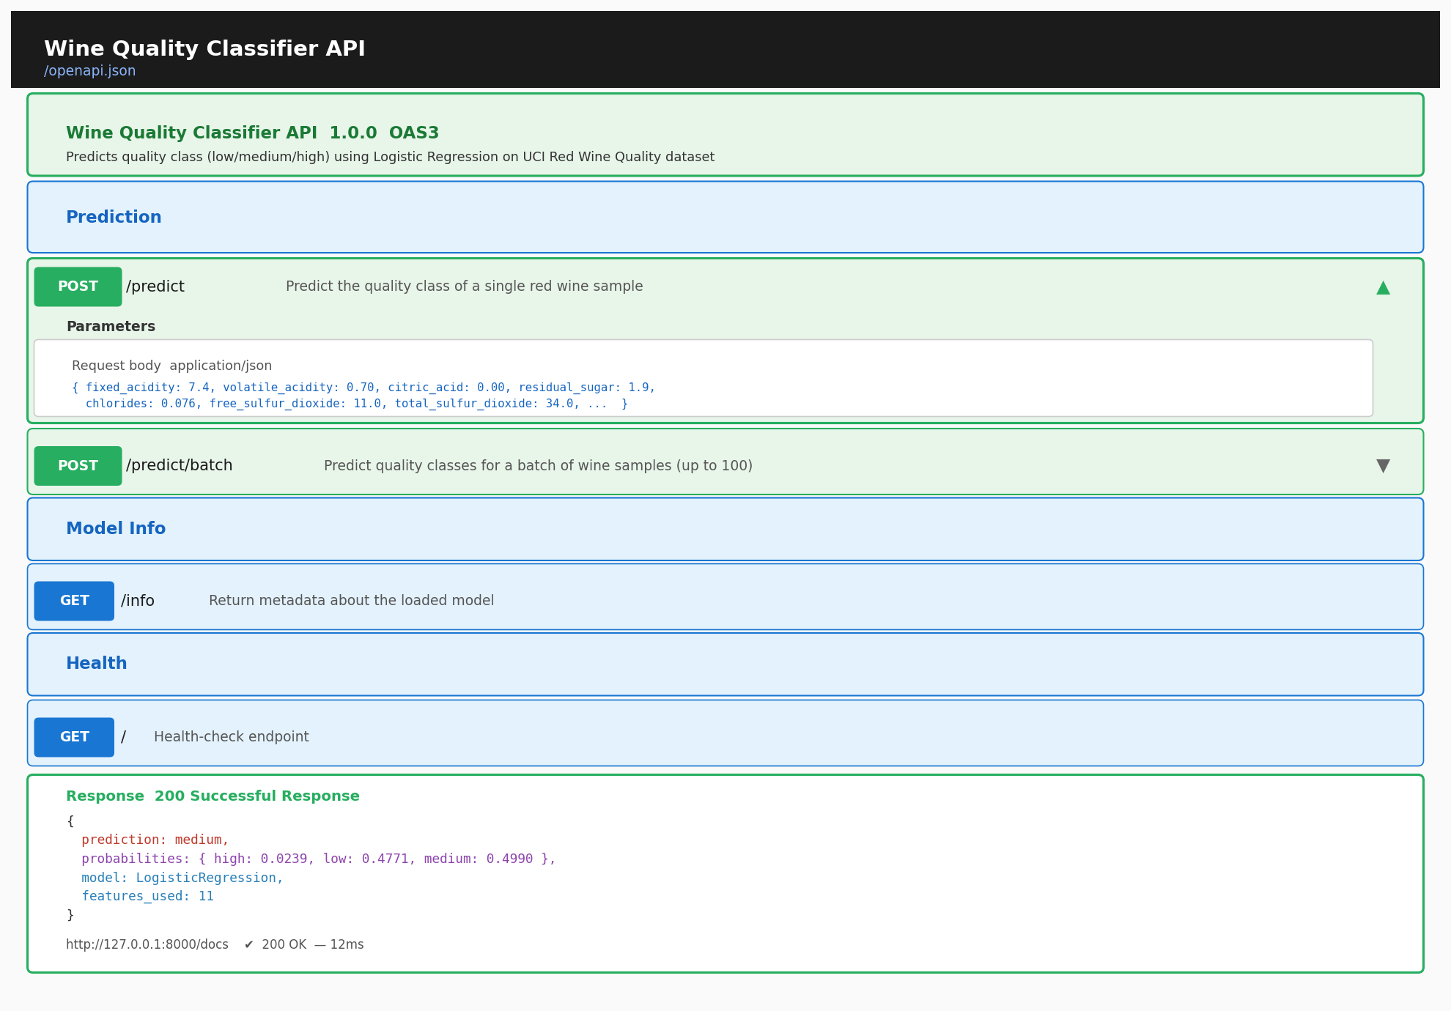
Figure 5 — FastAPI Swagger UI at http://127.0.0.1:8000/docs showing a successful POST /predict test with a 200 OK response.

5.1 Sample API Input / Output
Request (POST /predict):
{ "fixed_acidity": 7.4, "volatile_acidity": 0.70, "citric_acid": 0.00, "residual_sugar": 1.9,
"chlorides": 0.076, "free_sulfur_dioxide": 11.0, "total_sulfur_dioxide": 34.0,
"density": 0.9978, "pH": 3.51, "sulphates": 0.56, "alcohol": 9.4 }
Response (200 OK):
{ "prediction": "medium", "probabilities": {"high":0.0239,"low":0.4771,"medium":0.4990},
"model": "LogisticRegression", "features_used": 11 }

