fixedDana Berg-1000277531

ROP399Y1Y, Summer 2015

Testing for resistance in sea lice (*Lepeoptheirus salmonis*) towards SLICE® between 2012 and 2015 in the Broughton Archipelago

**Abstract:**

High parasitic louse levels on salmon fry in the Broughton Archipelago, British Columbia in 2015 raised concerns over the development of resistance to the pesticide S°LICE® used to kill lice on fish farms. Resistance to SLICE® is seen in the majority of fish farms around the world, including the east coast of Canada. To test for resistance I conducted a bioassay, exposing collected pre-adult stage 2 lice from the Broughton Archipelago to varying concentrations of SLICE®. The response of survival was measured after 24-hour period of submersion. These data were then compared to a bioassay conducted in the Broughton Archipelago in 2012 using similar concentrations. Generalized linear mixed effect models were used to analyze the full data set and averaged to fit the data and visualize the response of survival with the fixed effects of sex, year, and concentration. The effective concentration (EC50) was also calculated for each sex in each year. Results from both analysis showed that no resistance had developed over the three-year period. Although resistance was not detected, continuing studies to test for resistance and effective protocol with SLICE® or other methodology to control sea lice on salmon farms should be investigated.

**Introduction:**

Although a naturally occurring organism, parasitic sea lice (*Lepeoptheirus salmonis*) in high numbers pose a threat to farmed and wild salmon populations. Sea lice are detrimental to salmon health and have negative effects on their mucus biochemistry and tissues and in extreme cases can cause skin removal and death (Costello 2006). These physiological effects result in a loss of productivity on salmon farms with negative economic implications for the aquaculture industry (Costello 2009). Not only are the effects of sea lice felt on salmon existing within the farms but can also be seen in the wild salmon from interaction between the two populations. Specifically, sea lice transmission occurs commonly when juvenile salmon migrate in the spring past salmon farms (Krkošek et al 2005a).

SLICE®, containing the chemical emamectin benzoate (EMB), is a common pesticide administered in in-feed treatments to Atlantic salmon (*Salmo salar*) in farms around the world to combat the infestation of sea lice. When SLICE® is fed to farmed salmon, it becomes concentrated in their tissue. As the sea lice feed on the salmon the pesticide damages the sea lice nervous system (Aaen 2015). Although SLICE® is an effective method to eliminate sea lice, the majority of salmon farms around the world using SLICE® and other chemicals to control sea lice have detected resistance (Aaen 2015). Resistance spreads when all target organisms susceptible to the pesticide are killed off over time and only those organisms that were able to survive reproduce resulting in a resistant generation. This is a major issue because in-feed treatments, like SLICE®, have been found to be the most cost-effective method of sea louse control; therefore, the inability to use it would have negative economic effects on the salmon industry (Costello 2009). Inability to treat for sea lice also has environmental implications, as wild populations would suffer as well. Examples of resistance around the world include Scotland where the efficacy of SLICE® declined between 2002 and 2006 (Lees et al 2008) and in Chile where prolonged exposure to high concentrations has led to a reduced sensitivity to SLICE®(Bravo et al 2008). Almost every area of the world with salmon farms including the east coast of Canada in the Bay of Fundy is affected by resistance, many of these cases of resistance are toward SLICE® (Aaen 2015).

Recent studies that have tested sea lice sensitivity to SLICE® in British Columbia have not shown a decrease in efficacy (Saksida 2013). Some factors linked to causing resistance in other areas may not be present in the British Columbia such as over dosage that occurred in Chile, however, other factors such as repeated use of SLICE® over the past 15 years have been reported (DFO 2014). There is concern that resistance to SLICE® in sea lice in the Broughton Archipelago, British Columbia may have developed. However, no experiments have been reported since to reevaluate sea lice sensitivity in British Columbia.

Spring of 2015 marked some of the highest reports of sea lice on juvenile salmon in that past decade in the Broughton Archipelago with over 90% of fish sampled showing signs of sea lice infection (Hume 2015). The cause of this spike in sea louse numbers is still unknown but could be due to natural causes such as water temperature or possibly as a result of resistance as seen in other areas. Therefore, the goal of this experiment is to test whether sea lice in the Broughton Archipelago have developed resistance to SLICE®.

**Methods**: (Map of the three sites)

To test sea lice sensitivity to SLICE®, I collected pre-adult stage 2 sea lice (*Lepeophtheirus salmonis*) from migrating wild pink (*Oncorhynchus gorbuscha*) and chum (*O. keta*) salmon fry. The sea lice were from three different locations in the Broughton Archipelago in close proximity to salmon farms treating their stock with SLICE®. I visited all three sites on two days and only one site, the Burdwood group, was visited on the other two trips (Map 1). Pre-adult stage 2 lice were used to standardize the age and therefore account for differences in response caused by age (Sevatdal 2003). I collected the salmon by beach seine and I examined each individual in a clear plastic Ziploc bag with seawater and had suspected pre-adult stage 2 lice taken off individually using forceps, taking care to avoid damage to the lice and salmon (Krkošek et al 2005b). Salmon fry were kept in buckets with sea-water and I returned them to the water at the site from which they were collected. The sea lice were kept inside a cooler during collection with an ice pack to keep a constant temperature.

I used the collected sea lice to perform a bioassay within 4-24 hours after collection with the protocol outlined in *Sea lice resistance to chemotherapeutents: A handbook in resistance management* with different concentrations (SEARCH 2006). I identified all of the sea lice under a microscope prior to being put in petri dishes containing SLICE® to assure they were live and active PAL II males and females. In six different petri dishes I placed the sea lice for 24 hours into 40mL of varying EMB concentrations: 0ppb, 15ppb, 30ppb, 60ppb, 90ppb, and 180ppb. Between the four trials on average six sea lice were used for each concentration, four males and two females and they were placed all into the same petri dish. There was some variation in the number of lice used among trials depending on the amount of viable lice collected and the ability to create a balanced design with an equal number of sexes in each concentration. I took the temperature of each concentration every 6 hours; from the time they were placed in the SLICE® until the end of the 24 hours and always testing from the lowest to highest concentration to avoid contamination. Throughout the bioassay the petri dishes were kept in a cooler to keep a constant temperature. I measured the response to the varying concentrations of SLICE® at the end of the 24-hour period through the state of the sea louse: live, moribund, or dead (Sevatdal 2003). I examined each louse under the microscope to determine its response. Live was characterized by normal swimming and the ability to stick to the petri dish. To test for moribund when unsure, the louse was placed in a separate petri dish with fresh seawater and a small pipette was used to create a small current. If the louse floated with the current and did not stick yet still exhibited some motion under the microscope it was categorized as moribund.

**Statistical Analysis**:

My data set consisted of bioassay results from 2012 conducted by other researchers at Salmon Coast Field Station of which I used only the data from the Broughton Archipelago. My response variable, survival, was recorded as binary data with 1 being a surviving louse and 0 being either moribund or dead after the 24 hour period. For my statistical analysis I fit a binomial generalized linear mixed effects model (GLMM) in R with the package lme4 (Bates et al 2014) with a logit-link transformation. Fixed effects included year (2012 or 2015), sex, and concentration and a random effect of trial to account for possible uncontrollable effects that occurred in the field. Uncontrollable effects include environmental factors such as salinity and temperature shared by lice collected on certain days. Based on literature it was predicted that sex would have a significant effect on sensitivity, with females being 3 times more sensitive than males (Wescott 2008). I created 15 models all including trial as a random effect with different combinations of fixed effects being year, sex and concentration and their interactions terms with one another (Table 1). To find and compare the best fitting models, I initially looked at the Akaike Information Criterion values (AIC; Burnham 2002). I then found all of the ∆AICc’s and then calculated Akaike weights, because many of the models had similar weights I used model averaging with Akaike weights that accumulated to 96% model support. To find these weights and average my models I used the package AICcmodavg in R (Mazerolle 2015). I added up all of the models including each factor of year and sex and compared their cumulative weights (Table 2) to see how much weight each held. I then plotted the results for males in 2012 and 2015 together and the results for females in 2012 and 2015 together with their 95% confidence intervals (Fig. 1). To further understand the data, I calculated the proportion of surviving lice compared to total lice at each concentration (Fig. 1).

For each sex in each year I also calculated the EC50, the concentration at which 50% of the lice are affected (moribund or dead), meaning the point on my model averaged prediction at which survival was .5. I included 95% confidence intervals based on my model averaged prediction by multiplying the standard deviations by 1.96 and adding it to the mean to get the upper bound and subtracting it from the mean to get the lower bound.

**Results:**

In total, 184 lice were sampled and used for this experiment in 2012 and 2015, 138 lice from 2015 and 46 from 2012. The best fitting model accounted for sex and concentration and their interaction but did not include the fixed effect of year (Table 1). However, the top model was closely followed by models that did not include sex and also followed by models including year.

The amount of model support for the fixed effects of sex and year when adding up each model including either of those factors resulted in sex having 77% model support whereas year only had 46%.

There is little to no difference between years in each sex, however, the response curve for female is steeper indicating greater sensitivity as concentration increases (Fig. 1). In the visual representation of louse response in males, there is variation at 180ppb concentration. When looking at the proportion of surviving to total lice at each concentration on Fig. 1, there is an outlier in the surviving 2012 males explaining the difference in the two years around 180ppb.

There was a difference in sensitivity between the sexes in each year of at least 20 ppb of SLICE® based on the EC50 values. However, between years the 95% confidence intervals overlap substantially within each sex (Table 3, Fig. 2).

**Discussion:**

**Map 1:** The red dots on this map of the Broughton Archipelago region represent sea louse collection sites. Respectively from left to right: Wicklow, Burdwoods, and Glacier.

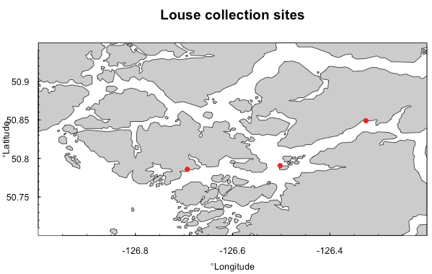

**Table 1**: All models fit to data with fixed factors and their estimated number of parameters, ∆AICc values and Akaike weights. Models that accumulated to ≤96% of Akaike weights were included in the model average and bolded.

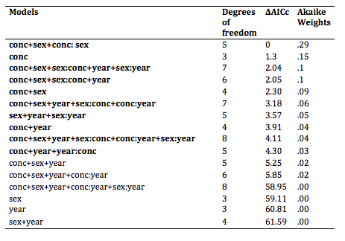

**Table 2**: The amount of model support for the fixed effects of sex and year when adding up each model including either of those factors.



**Table 3:** EC50 values for each sex in each year with 95% confidence intervals.

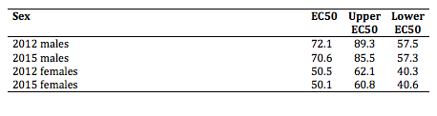

**Figure 1**: Probability of survival of sea lice at different concentrations of SLICE®. Shaded in blue for 2015 and red 2012 are the 95% confidence intervals. (blue=2015 and red=2012). Points represent the proportion of surviving to total lice used at each concentration.

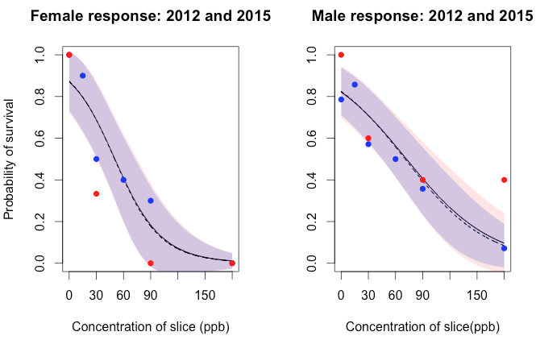

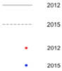

**Figure 2:** EC50 values for males and females in 2012 and 2015.

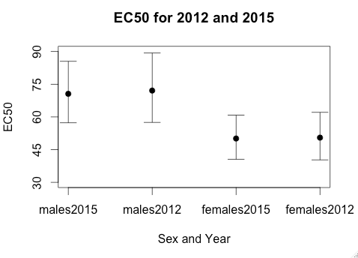

*Acknowledgements: I am grateful to Andrew Bateman and Stephanie Peacock for guiding me through the experimental and written stages of this research process always with helpful comments and endless answers. Credit for 2012 data is given to Zephyr Polk, Brendan Connors, and Scott Rogers. Thank you to those at Salmon Coast Field Station for hosting, assisting in, and supporting this research project and to Melissa Orobko for endless voluntary help and encouragement. I would also like to thank the University of Toronto and Martin Krkošek for funding and providing this research opportunity.*

References:

Aaen, S. M., Helgesen, K. O., Bakke, M. J., Kaur, K., Horsberg, E., (2015) Drug resistance in sea lice: a threat to salmonid aquaculture. *Trends in Parasitology, 31:2*, 72-81.

Bates D, Maechler M, Bolker B and Walker S (2014). _lme4: Linear

mixed-effects models using Eigen and S4_. R package version 1.1-7,

<URL: <http://CRAN.R-project.org/package=lme4>>.

Bravo, S., Sevatdal, S., Horsberg, T. E. (2008). Sensitivity assessment of *Caligus rogercresseyito* emamectin benzoate in Chile. *Aquaculture, 282,* 7–12.

Burnham, K. P. & Anderson, D. R. 2002 Model Selection and Multimodel Inference: A Practical Information-Theoretic Approach. 2nd edn. Springer-Verlag.

Costello (2004, May) A checklist of best practive for sealice control on salmon farms. *Caligus, 8,* 18.

Costello, M. J. (2006). Ecology of sea lice parasitic on farmed and wild fish*. Trends in Parasitology, 22:10*, 475-483.

Costello, M. J. (2009). The global economic cost of sea lice to the salmonid farming industry. *Journal of Fish Diseases, 32*, 115-118.

Department of Fisheries and Oceans Canada (2014, October 10) Use of SLICE®, *Aquculture Management.* Retrieved from

<http://www.pac.dfo-mpo.gc.ca/aquaculture/reporting-rapports/health-sante/slice-eng.html>

Hume, M., (2015, May 7). Sea lice infestation could kill up to ‘millions’ of wild salmon*. The Globe and Mail*. Retrieved from

<http://www.theglobeandmail.com/news/british-columbia/sea-lice-infestation-could-kill-up-to-millions-of-wild-salmon/article24300307/>

Krkošek, M., Lewis, M. A., Volpe, J. P., (2005a). Transmission dynamics of parasitic sea lice from farmed to wild salmon. *Proc. R. Soc. B, 272,* 689-696.

Krkošek, M. Morton, A., Volpe, J.P. (2005b) Nonlethal Assessment of Juvenile Pink and Chum Salmon for Parasitic Sea Lice Infections and Fish Health. *Transactions of the American Fisheries Society, 134*, 711-716.

Lees, F., Baillie, M., Gettinby, G., Revie, C. W. (2008). Factors associated with changing efficacy of emamectin benzoate against infestations of *Lepeophtheirus salmonis* on Scottish salmon farms, *Journal of Fish Disease, 31,* 947-951.

Mazerolle, Marc J. (2015) AICcmodavg: Model selection and multimodel

inference based on (Q)AIC(c). R package version 2.0-3.

<http://CRAN.R-project.org/package=AICcmodavg>.

Peacock, S. J., Krkosek, M., Proboszcz, S., Orr, C., Lewis, M. A., (2013). Cessation of a salmon decline with control of parasites. *Ecological Applications, 23:3*, 606- 620.

Saksida, S.M., et al, (2013). Use of Atlantic salmon, *Salmo salar* L. , farm treatment data and bioassays to assess for resistance of sea lice, Lepeophtheirus salmonis, to emamectin benzoate (SLICE) in British Columbia, Canada, *Journal of Fish Diseases, 36*, 515-520.

SEARCH (Febuary, 2006). Sea lice resistance to chemotherapeutents: A handbook in resistance management, 35-36. Retrieved from <http://www.iacr.bbsrc.ac.uk/pie/search-EU/>

Sevatdal, S., Horsberg, T. E., (2003). Determination of reduced sensitivity in sea lice (Lepeophtheirus salmonis Krøyer) against the pyrethroid deltamethrin using

bioassays and probit modelling, *Aquaculture, 218*, 21-31.

Sevtadal, S., Copley, L., Wallace, C. Jackson, D., Horsberg, T. E. (2005). Monitoring of the sensitivity of sea lice (*Lepeoptheirus salmonis*) to pyrethroids in Norway, Ireland, and Scotland using bioassays and probit modeling. *Aquaculture, 244,* 19-27.

Schnute, J. T., Boers, N., and Haigh, R. (2015). PBSmapping: Mapping Fisheries Data and Spatial Analysis Tools. R package version 2.69.76.

<http://CRAN.R-project.org/package=PBSmapping>

Wescott, J.D., Stryhn, H., Burka, J. F., Hammell, K.L. (2008). Optimization and field use of a bioassay to monitor sea lice *Lepeophtheirus sensitivity* to emamectin benzoate, *Diseases of Aquatic Organisms, 79,* 119-131.

|  |  |  |
| --- | --- | --- |
|  | df | AIC |
| m1 | 7 | 261.2043 |
| model2 | 5 | 268.7583 |
| model3 | 4 | 273.6283 |
| model4 | 3 | 273.3419 |
| model5 | 2 | 287.5162 |
| model6 | 6 | 264.8529 |
| model7 | 4 | 270.5849 |
| model8 | 5 | 268.9442 |
| model9 | 3 | 284.7256 |
| model10 | 6 | 259.7620 |
| model11 | 4 | 267.2849 |
| model12 | 5 | 263.0608 |
| model13 | 3 | 281.2222 |
| model14 | 5 | 268.7103 |
| model15 | 6 | 264.5169 |
| model16 | 4 | 282.6525 |