Table of Contents
1.0 Scope and Purpose 3
2.0 Definitions and Abbreviations 3
3.0 Referenced Documents 3
4.0 Equipment 3
4.1 Hardware 4
4.2 Software 4
4.3 Firmware 5
4.4 Additional 5
5.0 Initialization and Setup 5
5.1 Pre-Assembly Settings 5
5.1.1 PIC Bootloader Initial Setup 5
5.1.2 PIC Bootloader 8
5.1.3 CC1110 11
6.0 Post-Assembly Test 13
6.1 Parameter Programming 13
6.2 Transmit Test 16
6.2.1 Test Setup 16
6.2.2 Test Procedure 17
6.3 Receive Test 19
6.3.1 Test Setup 19
6.3.2 Test Procedure 21
7.0 Record 22
8.0 Troubleshooting 23
9.0 Preventative Maintenance 23
A. Appendix A – Programming Communication Node PIC and CC1110 24

Table of Figures
Figure 1 Communication Node 3
Figure 2 MPLAB X IPE Power Section with Voltage settings 6
Figure 3 MPLAB X IPE Operate Tab 7
Figure 4 Mezzanine and Base Board Assembly 8
Figure 5 CN Board assembly with ICD PIC programmer (J6) and CC Debugger (J3) 8
Figure 6 IPE output window showing automatic installs and successful detection of the PIC. 9
Figure 7 MPLAB Output indicating successful programming 10
Figure 8 Complete Pre-Assembly setup with CC1110 and PIC 11
Figure 9 CC1110 Programming Complete Message 12
Figure 10 CN Programmer Settings 13
Figure 11 CN Programmed after using Set Parameters 15
Figure 12 Transmit Test Setup 16
Figure 13 Transmit Test Waveform with Peak measurement 18
Figure 14 Receive Test with Metal Enclosure Open 20
Figure 15 Full-Length Receive Test Setup 20
Figure 16 Screen Capture of Heartbeats 21
Figure 17 CN Programmer Settings 25
Figure 18 CN Programmer 25

Scope and Purpose
The purpose of this document is to guide the reader through the testing of Strata’s Communication Node during the manufacturing process to determine any potential issues with the RF circuitry, PN: SCT-CN-01
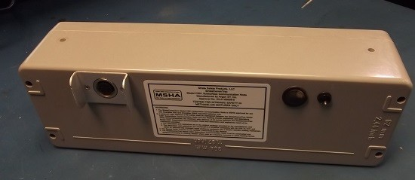
Figure 1 Communication Node

Definitions and Abbreviations
- CN – Communication Node
- UUT – Unit Under Test
- SN – Serial Number

Referenced Documents
- Installation Record
- Test Record
- Software Repository
- CN Gateway Setup Procedure

Equipment
The following hardware and software are necessary to complete this test procedure

Hardware
- Gateway CN
  - See CN Gateway Setup Procedure for further details
- (2) CN Serial cable w/ 5V power supply
- (2) Serial to USB cable
- Spectrum Analyzer
  - Document is based on RIGOL DSA815 Spectrum Analyzer
- Metal enclosure with RF bulkhead SMA ports
- (2) RF coax cables assembly w/ attenuation
  - Sum total of 40 dB attenuation needed for Transmit Test
  - Sum total of 86 dB attenuation needed for Receive Test
  - Recommended to have right-angle cables or right-angle adapters for more convenient setup
  - One RF cable for connection between Gateway Communication Node and Metal enclosure
  - One RF cable that is at least 10 feet in length
    - This document uses a 15-foot SMA cable for testing (P/N: ARF2963-ND)
  - SMA-F to N-M adapter (for spectrum analyzer)
- PC w/ Windows OS, (2) USB ports
- ICD3 or PickIt 3 programmer
- CC Debugger
- Programming Cables
  - CN PIC (with ICD3 or PickIt)
  - CC1110 (with CC Debugger)

Software
- Comm Node Programmer
- MPLAB X IPE
- TI SmartRF Flash Programmer

Firmware
- CN PIC
  - Latest firmware on repository (Transmit and Receive Test)
- CN CC1110
  - Latest firmware on repository (Receive Test)
  - Additionally, custom firmware required for transmit test
    - CC1110_CommunicationNode_CW_5mOn95mOff_Test.hex

Additional
The following are helpful to have when troubleshooting:
- Known good CN
- Schematics

Initialization and Setup

Pre-Assembly Settings
Reference Strata Repository for current versions. The following steps are meant to be performed in order.

PIC Bootloader Initial Setup
1. Open MPLAB X IPE on PC
2. Navigate to the Power Tab
3. Within the Voltage Options section, ensure that VDD is set to 3.25V
4. Within the ICSP Options, ensure that Power Target circuit from Tool is checked.

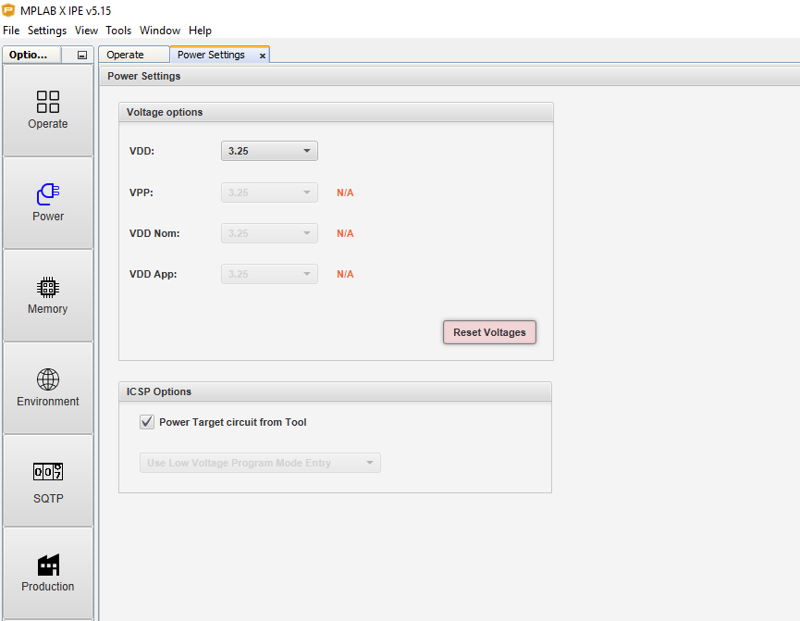
Figure 2 MPLAB X IPE Power Section with Voltage settings
5. Navigate to the Operate Tab on the left side menu

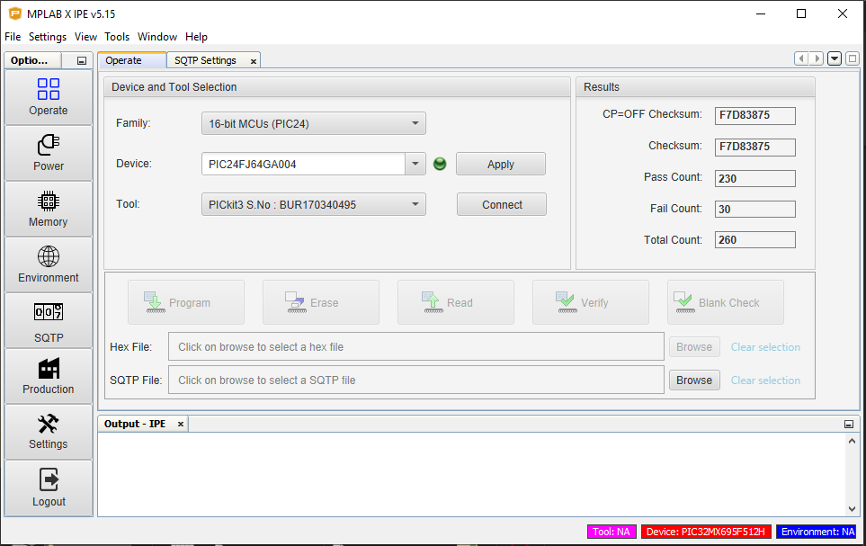
Figure 3 MPLAB X IPE Operate Tab
6. Under Device and Tool Selection, set the following parameters:
  - Family: 16-bit MCUs (PIC24)
  - Device: PIC24FJ64GA004
    - Note: Can also be directly typed in. MPLAB will narrow the drop-down list during typing.
  - Hardware Tool: ICD3 or Pickit3 SN: XXXXX
    - MPLAB will auto-detect if the programmer is connected to the PC

7. Press Apply next to the Device selection.

PIC Bootloader
1. Combine the CN base board and mezzanine board
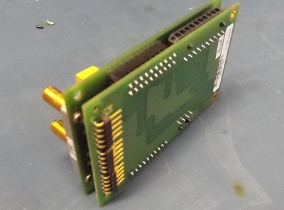
Figure 4 Mezzanine and Base Board Assembly
2. Connect programmer from PC to J6 on the back of the mezzanine board using PIC programming cable
  - Note pin 1 alignment from programming cable to J6 header
3. Connect CC Debugger to PC and to header J3 on CN board using CC1110 programming cable.
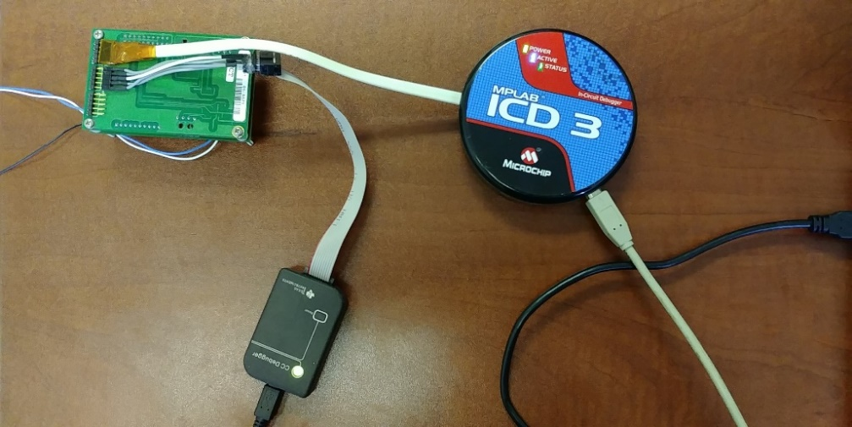
Figure 5 CN Board assembly with ICD PIC programmer (J6) and CC Debugger (J3)

4. On MPLAB X, press Connect next the Tool field and allow the PIC programmer to connect to the CN board.
- MPLAB may start to download new firmware for PIC device and begin to install. Allow it to complete all downloads and installs until it finds and connects to the chip.
- Note: figure 6 below shows connection to PIC32MX695F512H chip, but image applies to PIC24FJ64GA004 as well
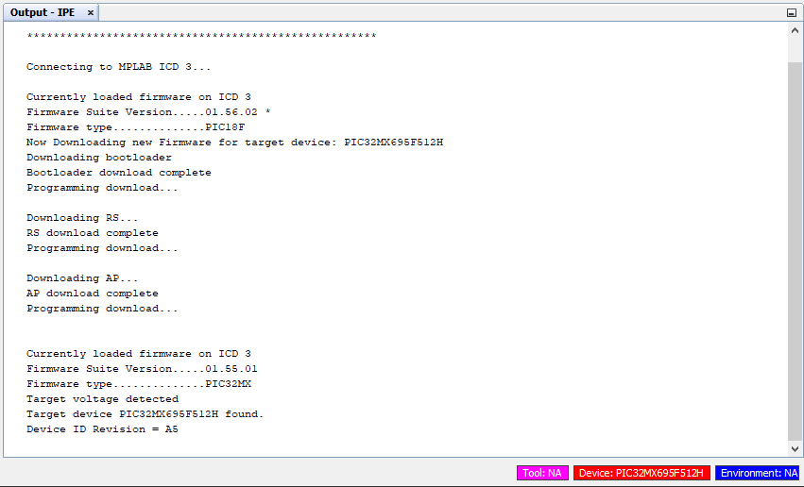
Figure 6 IPE output window showing automatic installs and successful detection of the PIC.
5. Once found, in-between Device and Tool Selection and the Output-IPE window, go to the Hex File box and browse for the PIC firmware file that will be uploaded to the CN.
- The hex file should have both the bootloader and application on it, and it will be in the format of (file version notwithstanding):
- PIC_CommunicationNode_ApplicationAndBootloader2_1_1.hex

6. Click the Program button above the Hex File box and wait for programming to complete.
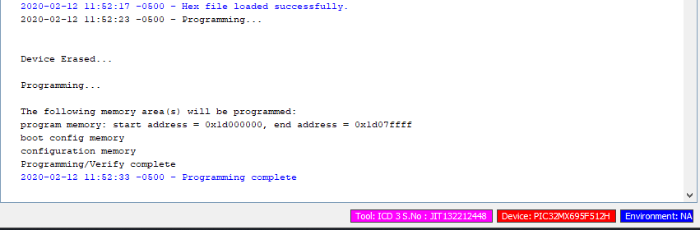
Figure 7 MPLAB Output indicating successful programming

CC1110
1. Open SmartRF Flash Programmer on PC
2. Ensure SmartRF recognizes Debugger
  - Press the reset button if necessary
  - Ensure debugger shows green light
  - Note: The ICD should still be connected to the CN board as it should continue to provide power to CN Board
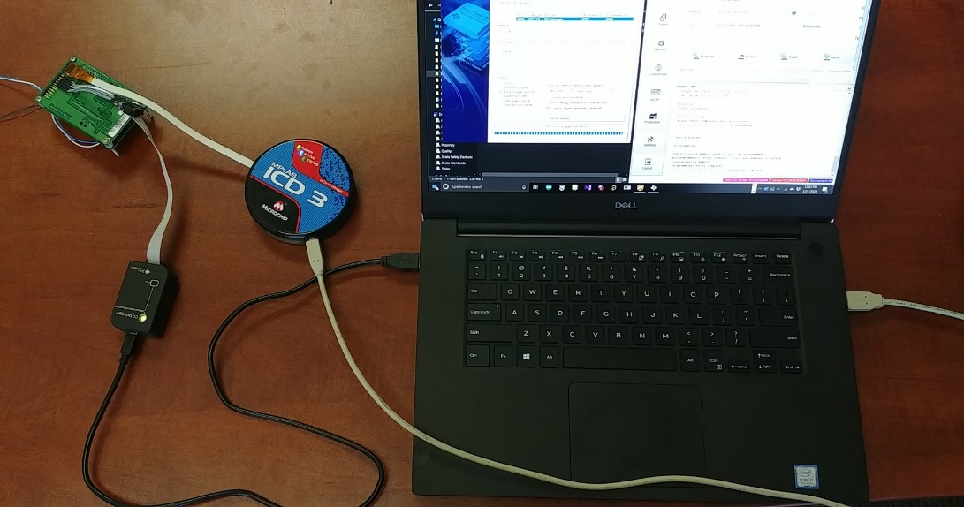
Figure 8 Complete Pre-Assembly setup with CC1110 and PIC
3. Browse for the CC1110 firmware under the Flash image: drop down list
4. Select the Erase, Program, and verify radio button under Actions
5. Program CC1110 firmware into Miner Com board CC1110 by selecting perform actions in the SmartRF
6. Ensure that program shows erase, program and verify OK message
7. Repeat steps 1-6 for the J4 header if populated
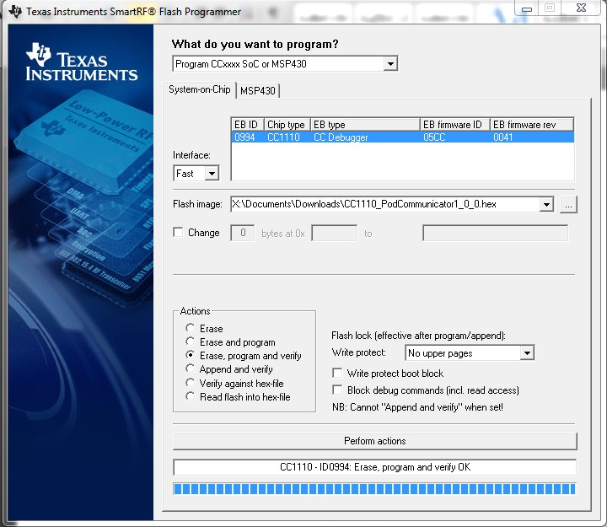
Figure 9 CC1110 Programming Complete Message

Post-Assembly Test

Parameter Programming
Note: The CN must have been programmed previously with a bootloader for the following steps to be applicable.
1. Connect CN test cable to PC USB and to UUT
  - Note the COM Port number assigned
2. Apply 5V power to UUT
  - Green LED on back of unit should flash twice
3. Open CN Programmer software
4. Select the COM Port number assigned to the test cable
5. Ensure the following Serial Settings are correct and then press Apply:
  - Baud Rate: 115200
  - Data Bits: 8
  - Parity: None
  - Stop Bits: 1
6. Navigate to the Serial Programmer tab on the left side menu
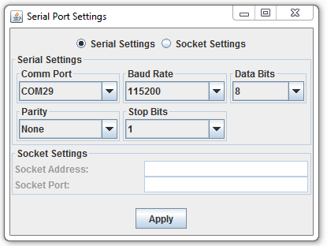
Figure 10 CN Programmer Settings
7. Provided that the PIC and CC1110 has been programmed onto the UUT as described in [Section 5.1 Pre-Assembly Settings], the configuration parameters may be blank.
  - Underneath the Configuration Parameters, ensure that the parameters are as follows:
Parameters | UUT CN
Node Address | UUT’s Serial Number
Heartbeat Interval (seconds) | 5
Output Power | High Power
Node Type | Communication Node
Sensor Type | None
Sensor Interval | 0
Gateway Keep Alive Timeout (seconds) | 0
On Surface | Unchecked
Frequency (MHz) | 918

  - Press the Set Parameters to upload the parameters to the CN
  - Ensure that the progress bar underneath the Set Parameters and Get Parameters button is blue and has the message “Parameters Set”.
8. Confirm that the parameters were saved by clicking the Get Parameters button and seeing that the progress bar underneath Parameters and Get Parameters button is blue and has the message “Parameters Received”.
  - When doing this step immediately after step 7, the parameter values will not change due to the saved parameters and the parameters to program being the same. Otherwise, any values that differ will update to reflect the CN’s saved parameters

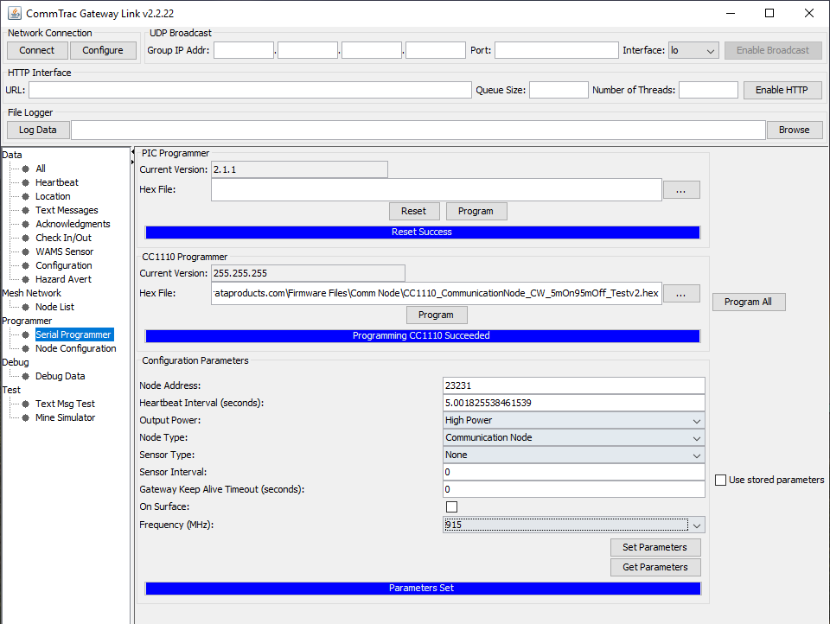
Figure 11 CN Programmed after using Set Parameters

Transmit Test

Test Setup
The following equipment is required for this test:
- UUT Communication Node
- Spectrum Analyzer (Steps based on RIGOL DSA 815 Spectrum Analyzer)
- 40 dB attenuation
- Standard PIC Firmware
- Custom CC1110 Firmware
  - CC1110_CommunicationNode_CW_5mOn95mOff_Test.hex
- Connect CN test cable to PC USB and to UUT
  - Note the COM Port number assigned
- Apply 5V power to UUT
  - Green LED on back of unit should flash twice
- Open CN Programmer software
- Select the COM Port number assigned to the test cable
- Connect 40 dB of attenuation to the negative antenna terminal of the CN
  - The negative terminal is on the button side of the CN (figure 11)
- Connect the CN to the spectrum analyzer input via the attenuators and a compatible RF cable.
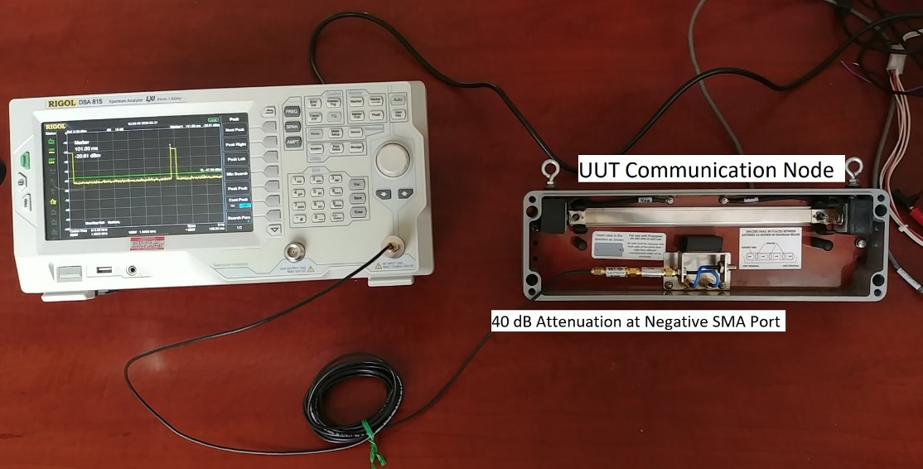
Figure 12 Transmit Test Setup
- Referring to the steps in [Appendix A Programming PIC and CC1110], direct the CC1110 hex file to program to the following custom firmware:
  - CC1110_CommunicationNode_CW_5mOn95mOff_Test.hex
- Under Configuration Parameters, ensure that the following parameters are set as follows:
Parameters | UUT CN
Node Address | UUT’s Serial Number
Heartbeat Interval (seconds) | 5
Output Power | High Power
Node Type | Communication Node
Sensor Type | None
Sensor Interval | 0
Gateway Keep Alive Timeout (seconds) | 0
On Surface | Unchecked
Frequency (MHz) | 918*
- Press Program underneath the CC1110 Programmer Section
  - Note: The file version will appear as 255.255.255 after programming

Test Procedure
- On the Spectrum Analyzer, put the center frequency at 915 MHz*
  - *Note: Despite setting the frequency to 918 MHz in step 6.2.1.8, the custom CC1110 firmware ignores those settings and outputs at 915 MHz always. 918 MHz will be used in the Receive test in section 6.3
- Press the Span key and/or navigate to the Span menu and press the Zero Span softkey
- Within the Control section of the panel, press the Sweep/Trig key
- Press the Time softkey and set the time scale to 150 ms using either the keypad or scroll wheel
- Press the Trig Type soft key and press the Video softkey
- Set the Trig Level to -47 dBm by either directly typing in with the numpad or using the scroll wheel.
- Within the Control section, press the BW/Det key and ensure that the RBW and VBW is set to 1 MHz
- Within the Marker section of the panel, press the Peak key
- In the display menu, ensure that Cont Peak is set to ON
- Verify that the peak measurement is above -21.0 dBm. Record with a checklist that the unit has passed
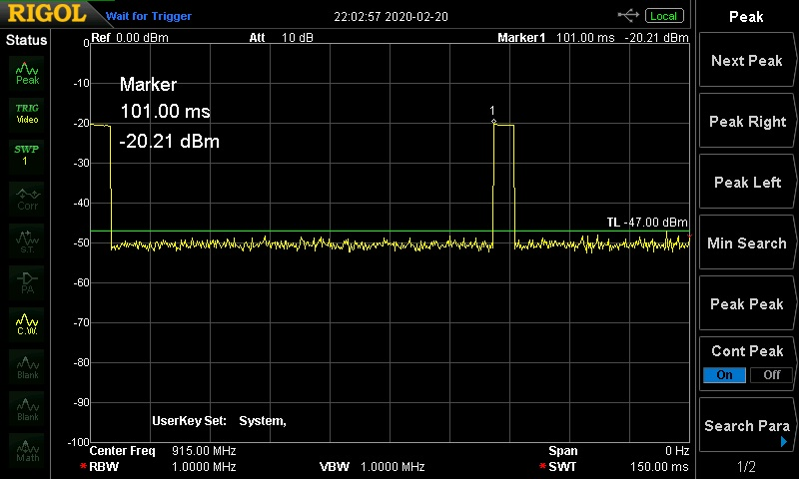
Figure 13 Transmit Test Waveform with Peak measurement

Receive Test

Test Setup
1. The following equipment is required for this test:
- UUT Communication Node
- Gateway Communication Node
- 86 dB attenuation
- Metal Enclosure with RF bulkhead ports
- Standard PIC Firmware
- Standard CC1110 Firmware
- Connect CN test cable to PC USB and to UUT
  - Note the COM Port number assigned
- Apply 5V power to UUT
  - Green LED on back of unit should flash twice
- Open CN Programmer software
- Select the COM Port number assigned to the test cable
- Repeat steps 1-4 for Gateway CN with 2nd CN test cable
- Place 86 dB of attenuation at the Gateway CN’s negative terminal SMA connector (connector on button side of the CN)
- Place the Gateway CN inside the metal enclosure
- Connect a SMA cable from the Gateway CN’s attenuators to the internal SMA bulkhead connector in the enclosure. Then connect a SMA cable from the external bulkhead connector to the UUT’s negative SMA connector. Ensure that the Gateway CN and UUT CN are spaced at least 8 feet apart (figure 15).
  - Note: The RF Cable between the UUT and the enclosure should be at least 10 feet in length. Label the cables (RFCBL-50005) and use the same cables for future tests to maintain consistency.
- Close the metal enclosure.
- Referring to the steps in [Appendix A Programming PIC and CC1110], ensure that the PIC and CC1110 for both the UUT and Gateway CN has the latest firmware from the repository
- Under Configuration Parameters, ensure that the following parameters are set as follows:
Parameters | Gateway CN | UUT CN
Node Address | Gateway’s Serial Number | UUT’s Serial Number
Heartbeat Interval (seconds) | 300 | 5
Output Power | Low Power | High Power
Node Type | Master Gateway | Communication Node
Sensor Type | None | None
Sensor Interval | 0 | 0
Gateway Keep Alive Timeout (seconds) | 0 | 0
On Surface | Unchecked | Unchecked
Frequency (MHz) | 918* | 918*
*Note: 918 MHz is used to minimize the chance of outside, interfering CNs from disrupting the testing procedure as 915 MHz is the default frequency.
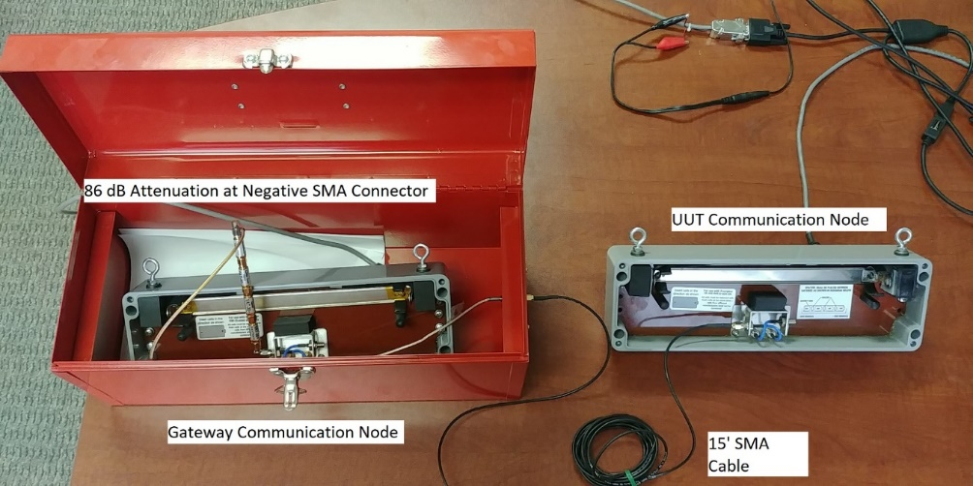
Figure 14 Receive Test with Metal Enclosure Open
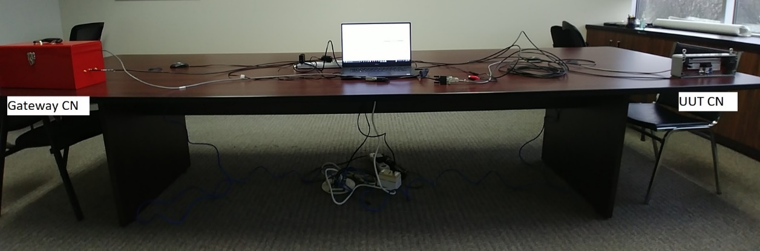
Figure 15 Full-Length Receive Test Setup

Test Procedure
            - In the CommTrac Gateway GUI for the Gateway CN, navigate to Data - > Heartbeat
            - Ensure that heartbeat entries are being filled approximately every 5 seconds from the UUT.
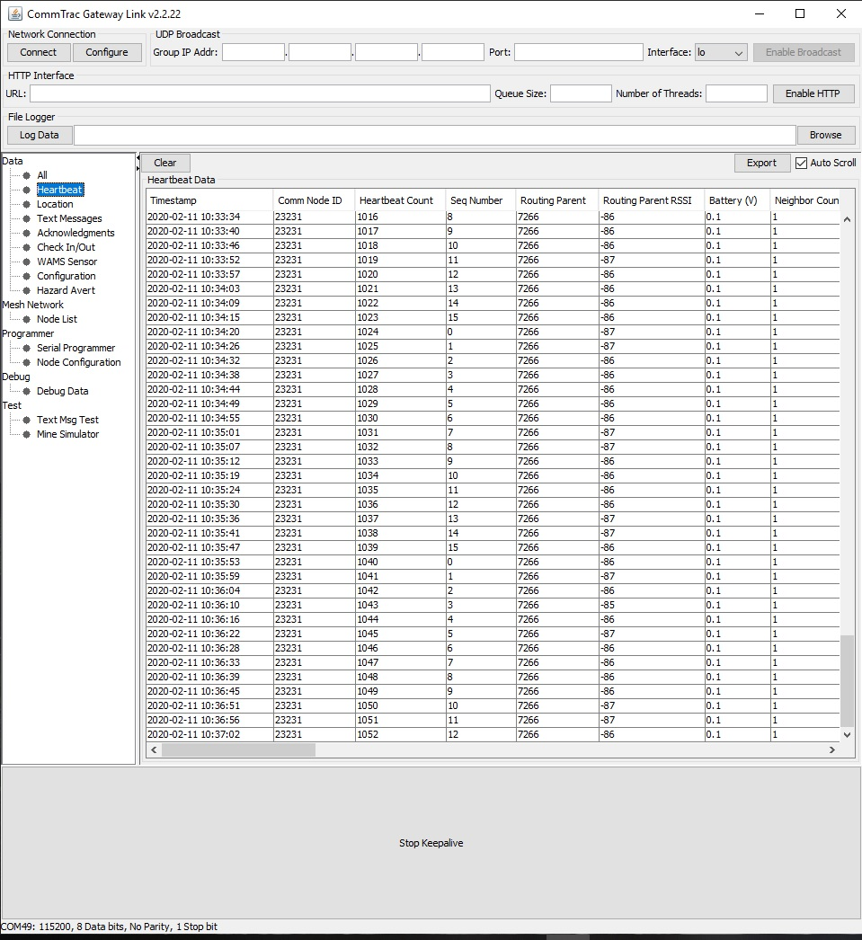
Figure 16 Screen Capture of Heartbeats
            - Allow the heartbeats to accumulate up to 32 times (~ 2 minutes)
            - Verify the following and record with a checklist:
              - Comm Node ID = UUT Serial Number
              - Routing Parent: = Gateway Serial Number
              - Heartbeat Count increments with each message (i.e. up to 32 if starting from 0)
                - May have to scroll window to the right to see heartbeat count
              - Routing Parent RSSI: within range of -84 to -87
            - Before unplugging the UUT, ensure that it has the following parameters:
Parameters | UUT CN
Node Address | UUT’s Serial Number
Heartbeat Interval (seconds) | 300
Output Power | High Power
Node Type | Communication Node
Sensor Type | None
Sensor Interval | 0
Gateway Keep Alive Timeout (seconds) | 0
On Surface | Unchecked
Frequency (MHz) | 915

Record
Each unit undergoing the transmit and receive test described in sections 6.2.2 and 6.3.2 must be recorded using Strata’s Communication Node Test Record.

Troubleshooting
FAILURE MODE | CAUSE | ACTION
Unable to Program Board | Power | Check power supplied to  board
 | Programming Cable | Check programming cable connections
Unable to Program  Functional Unit or Set Parameters | Board not previously  programmed | Reprogram board using  MPLAB and SmartFlash
 | Connection | Check connection between PC and MC test fixture
 | Intermittent | Retry
Not Receiving RSSI or  Wrong RSSI | Gateway | Check Gateway power and  connections
 | Gateway Antenna | Check antenna has correct attenuation and positioning
 | Miner Com Antenna | Check unit antenna is  attached
 | Interference | Check for other RF sources
Message Not Sent/Received | Buttons | Check button functionality
 | Collision | Check other units are not transmitting
 | Check in | Ensure unit is checked into  Gateway under Check in/out tab of CN programmer

Preventative Maintenance
    - Replace test cables yearly
    - Check test fixture contacts yearly

Appendix A – Programming Communication Node PIC and CC1110
Note: The CN must have been programmed previously with a bootloader for the following steps to be applicable.
1. Connect CN test cable to PC USB and to UUT
  - Note the COM Port number assigned
2. Apply 5V power to UUT
  - Green LED on back of unit should flash twice
3. Open CN Programmer software
4. Select the COM Port number assigned to the test cable
5. Ensure the following Serial Settings are correct and then press Apply:
  - Baud Rate: 115200
  - Data Bits: 8
  - Parity: None
  - Stop Bits: 1
6. Navigate to the Serial Programmer tab

Figure 17 CN Programmer Settings
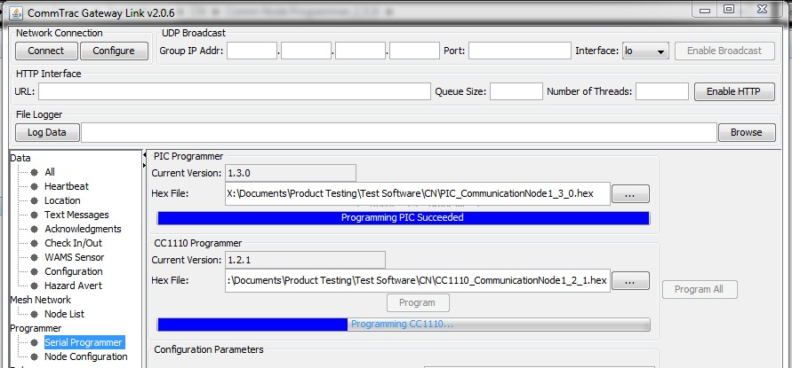
Figure 18 CN Programmer
7. Under the PIC Programmer Hex File field direct the software to the CN PIC firmware then press Program.
  - Ensure firmware is up to date by visiting Strata’s repository
  - Verify the “Programming PIC Succeeded” message is displayed
8. Under the CC1110 Programmer Hex File field direct the software to the CN CC1110 firmware then press Program.
  - Ensure firmware is up to date by visiting Strata’s repository
  - Verify the “Programming CC1110 Succeeded” message is displayed

