Table of Contents
1.0 SCOPE AND PURPOSE 2
2.0 Definitions and Abbreviations 2
3.0 Referenced Documents 2
4.0 Equipment 2
5.0 Hardware 2
6.0 Additional 3
7.0 Procedure 3
7.1 Pre-Test Checklist 3
7.2 Verify Proper Placement and Connections of PM’s, IM, Display and cables 3
7.3 Understanding Zones – ID, Warning and Hazard 3
7.4 Verifying Warning Zone around Vehicle 4
7.5 Verifying Hazard Zone around Vehicle 5
7.6 Verifying SZ area 5
7.7 Moving Vehicle and Stationary PAD 6
8.0 Record 6
9.0 Troubleshooting 6

SCOPE AND PURPOSE
This document is intended to guide the reader through the Site Acceptance Testing (SAT) of the Strata Surface / Hard-Rock Proximity Detection System. This document will help to verify the systems functionality and repeatability prior to commissioning a vehicle equipped with a Strata Surface / Hard-Rock Proximity Detection System. This document assumes that the system has been installed correctly by either a Strata Technician or by persons who have specific training or knowledge of the Strata Surface / Hard-Rock Proximity Detection System and have been authorized to do so.

Definitions and Abbreviations
PDS – Proximity Detection System
HA - HazardAvert
SHR – Surface / Hard-Rock
IM – Interface Module
PAD – Personal Alarm Device
PM – Proximity Module (Magnetic Field Generator)
SAT – Site Acceptance Test
HZ – Hazard Zone
WZ – Warning Zone
SZ – Silent Zone

Referenced Documents
HazardAvert Hard Rock System Operations and Maintenance Manual

Equipment
The following hardware and software are necessary to complete this SAT

Hardware
- 3 x HA-SHR-PAD-01
- Windows based Personal Computer
- USB port
- Bluetooth
- Wi-Fi capability

Additional
The following are helpful to have when troubleshooting:
- Schematics
- Cable Drawings with Signal/Wire Correspondences

Procedure

Pre-Test Checklist
SERIAL NUMBERS
Record the serial numbers of the following items:
Part Number | Description | Serial Number
HA-SHR-IM-01 | Interface Module
HA-SHR-PM-01 (#1) | Proximity Module
HA-SHR-PM-01 (#2) | Proximity Module
HA-SHR-PM-01 (#3) | Proximity Module
HA-SHR-PM-01 (#4) | Proximity Module
HA-SHR-PAD-01 (#1) | Personal Alarm Device
HA-SHR-PAD-01 (#2) | Personal Alarm Device
HA-SHR-PAD-01 (#3) | Personal Alarm Device

Verify Proper Placement and Connections of PM’s, IM, Display and cables
- The IM should be located in a semi-protected area of the CAB
- The PMs should be located such that the field sizes produced are capable of meeting the mine, local or other regional requirements for distances protected from the vehicle
- The Display should be located where it is visible and accessible to the machine operator
- Effort should be taken to ensure that cables are protected and will not be torn off or damaged during operation

Understanding Zones – ID, Warning and Hazard
- The Strata SHR-PDS typically has 3 elliptically shaped zones
  - The ID Zone is an area where the PAD wearing pedestrian and/or other vehicle is registered by the PDS, but no action is taken
  - The Warning Zone is an area where the PAD wearing pedestrian and/or other vehicle and machine operator are notified of each-others presence
  - The Hazard Zone is an area where the PDS can actively engage with the machine to avoid a vehicle collision or pedestrian accident
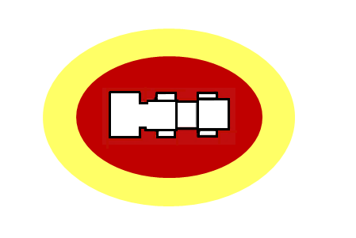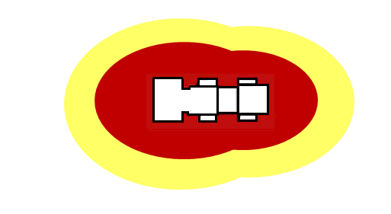
Single Generator Warning Dual Generator Warning (Yellow) & (Yellow) & Hazard (Red) Zones Hazard (Red) Zones

Verifying Warning Zone around Vehicle
Starting outside of the known Warning Zone, walk toward the vehicle from 8 different positions, approximately 45° apart. Measure the distance from the vehicle at the moment the PAD signals the audio/visual “warning alarm” (three audio chirps and visual LED blinks).
The PM “window” LED should also change color from Blue to Yellow/Amber. Repeat this process for the two other PADs and record the distances. The Display should also indicate the status of the system.

Verifying Hazard Zone around Vehicle
Starting outside of the known Warning Zone, walk toward the vehicle, through the Warning Zone and into the Hazard Zone from 8 different positions, approximately 45° apart. Measure the distance from the vehicle at the moment the PAD signals the audio/visual “Hazard Alarm” (constant audio and visual alarms).
The PM “window” LED should also change color from Blue to Yellow/Amber and change to Red when the Hazard Zone is reached. Repeat this process for the two other PADs and record the distances. The Display should also indicate the status of the system.

Verifying SZ area
Starting outside of the known Warning Zone, walk toward the vehicle through the Warning Zone and through the Hazard Zone and into the CAB / SZ Area. Verify that PAD progressed through the Warning and Hazard Alerts and that normal operation mode resumed once the PAD was inside the designated SZ Area.

Verify that PAD and System resume the previous Hazard Alarm once the PAD is removed from the CAB / SZ Area. This can be done from all sides to verify size and shape of the SZ area. Repeat this with PADs 2 and 3.

Moving Vehicle and Stationary PAD
Place PAD on a safety cone or other stable platform in front of the vehicle. Be sure that the PAD is initially placed outside of the known Warning Zone. Start the vehicle and slowly advance toward the stationary PAD. Verify that the PAD and System progress through the Warning Zone and Hazard Zone Alerts as the vehicle approaches the PAD. While in the Hazard Alarm condition, activate the “by-pass” switch and move the vehicle away from the PAD until it is no longer in the Hazard Alarm state. Repeat this for forward and/or backward vehicle movement and with PADs 2 and 3.
- Do not stack the two ends of the PAD device on each other, the two ends should always be separated by at least 100mm to ensure proper PAD functionality
- Do not hold the PAD for this test. The PAD must be placed on an object in the event there is an error in the system.

Record
Use Laptop computer and Wi-Fi capability to verify “event recording”

Troubleshooting
Refer to “HazardAvert User’s Manual for Operation and Maintenance of Surface & Hard Rock Systems” for troubleshooting guidance

