Table of Contents
1.0 Scope and Purpose 2
2.0 Definitions and Abbreviations 2
3.0 Referenced Documents 2
4.0 Equipment 3
4.1 Hardware 3
4.2 Software 3
4.3 Additional 3
5.0 Safety 4
6.0 Procedure 4
6.1 Pre-Assembly Settings 4
6.1.1 Programming 4
6.1.2 Discriminator Voltage 6
6.1.3 Communication Settings 7
6.1.4 Tuning 7
6.2 Post-Assembly Test 8
7.0 Record 10
8.0 Troubleshooting 11
9.0 Preventative Maintenance 11

Table of Figures
Checkout Station 2
Inside Checkout Station 5
Master Cable with ICD3 Programmer 5
HazardAvert Programmer 6
Receiver Board 7
Easy Sync™ Settings 7
COS Tuned Waveform 8
PCS Software 9
PAD in Hazard 10

Scope and Purpose
This document is intended to guide the reader through set up and testing of Strata’s PN: HA-COS-UG24. The HA-COS-UG24 is a 24V underground proximity system designed to test PADs.
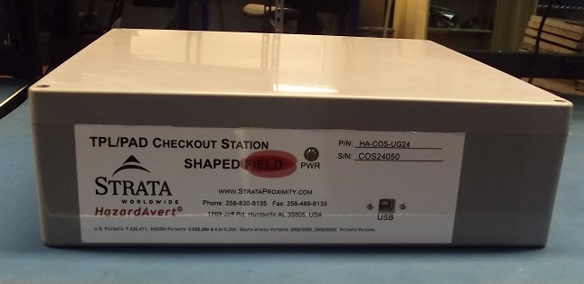
Checkout Station

Definitions and Abbreviations
COS- Checkout Station
PAD- Personal Alarm Device
UUT- Unit under test
PCS- PAD Checkout Station
Control Board- HAE100056
Receiver Board- HAE10042
Amp Board- HAE10041
HV- High Voltage

Referenced Documents
- COS Record
- Strata Software Repository
- Strata Installation Record

Equipment
The following hardware and software is necessary to complete this test procedure:

Hardware
- COS
- Calibrated PAD
- Oscilloscope
- High Voltage Probe, 100x, 1000V CAT II
- Windows Based Personal Computer
- USB A/B Cable
- Pickit or ICD3 or equivalent programmer
- Programming cables: Ping Echo, Data, Master

Software
- PCS
- HazardAvert Programmer
- COS software
  - Master
  - Data
  - Ping/Echo
  - Generator

Additional
The following are helpful to have when troubleshooting:
- Known good COS
- Control board, receiver board, and amp board schematics
- Digital Multimeter
- FAT Data Display software

Safety
Please note, during operation of COS DANGEROUS VOLTAGES are present. It is recommended to make any and all adjustments to COS with the power disengaged. This product should only be serviced by a trained professional.

Procedure

Pre-Assembly Settings
Before securing components within the COS housing perform the following:

Programming
- Reference the Strata Software Repository for the latest software versions and download as needed
- Supply power to the COS
- Connect the Pickit or ICD programmer to the PC
- Open the HazardAvert Programmer software on the PC
- Choose the programmer type.
- Select the tab in the HazardAvert programmer to the corresponding microcontroller to be programmed
  - Provide serial number of unit where applicable
- Select the software file downloaded from the repository for the microcontroller
- Using the correct programming cable insert it into the appropriate header. Match the pin 1 of the cable to the header socket labeled 1
  - Ping/Echo cable is used at J1 on Control board and J1 on Receiver board
  - Data cable is used at J5 on Control board
  - Master cable is used at J5 on Control board
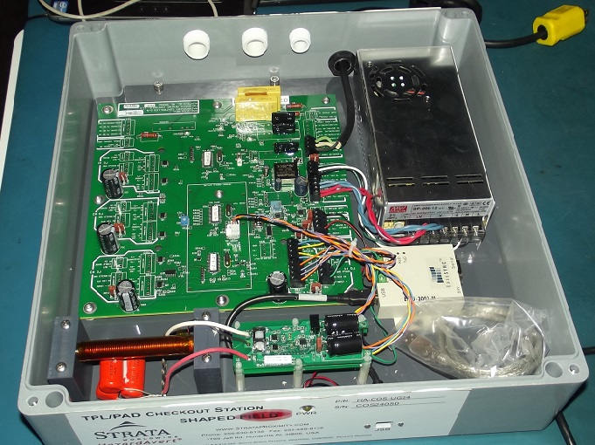
Inside Checkout Station

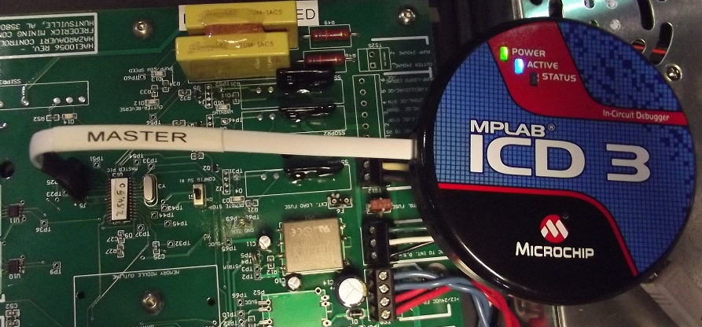
Master Cable with ICD3 Programmer
- Press the program button on the HazardAvert programmer and wait for the “PIC programmed successfully” message
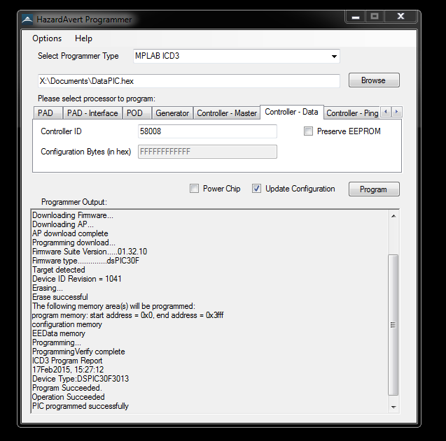
HazardAvert Programmer
- Repeat steps 6-9 for the remaining 3 microcontrollers

Discriminator Voltage
- Place ground clip of oscilloscope probe on TP22/23 of Receiver board
- Power on the board
- Measure the mean voltage at TP 6 of Receiver board
- Adjust the potentiometer at R12 until measurement is equal to 670mV, +/- 10mV
- Mark or seal potentiometer
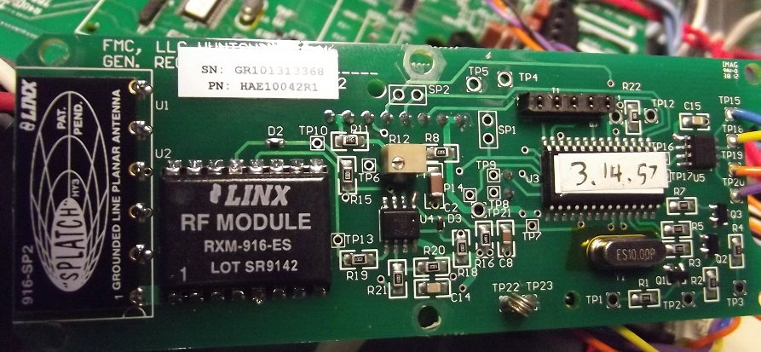
Receiver Board

Communication Settings
- Locate the Easy Sync™ USB to serial converter. PN: ES-3001-M
- Set the DIP switch settings to 1-ON, 2-OFF, 3-OFF, 4-OFF to enable RS-485 half duplex without echo conversion
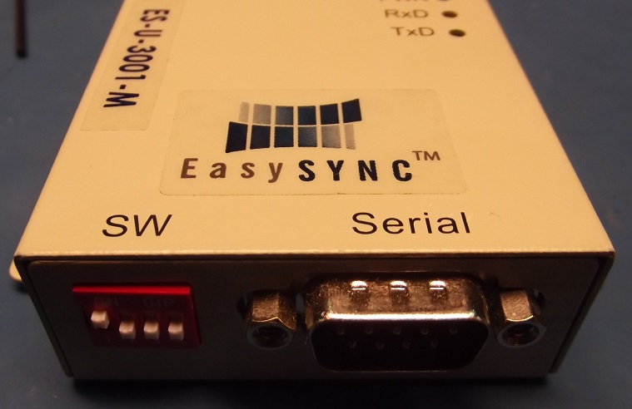
Easy Sync™ Settings

Tuning
- Ensure unit power is off
- Attach ground clip of HV probe to TP12 of amp board
- Attach HV probe to TP15 of amp board
- Set oscilloscope parameters
  - 100x Probe
  - 100V/division
  - 1ms time increments
  - Peak to Peak voltage measurement
  - Trigger at 32V
- Apply power to unit. WARNING: Dangerous voltages may now be present inside of unit
- Turn config sw#2, 1-4 to the ON position
- Turn potentiometer R53 completely clockwise
- Turn switches 1-4 of config sw#2 to the OFF position
- Check waveform shape and Pk-Pk measurement on the oscilloscope
  - Pk-Pk measurement should be above 600V
  - If measurement is below the requirement turn the unit’s power off, then adjust or unwind the coil along the ends of the cylindrical ferrite. Reapply power and check measurement. Repeat as necessary
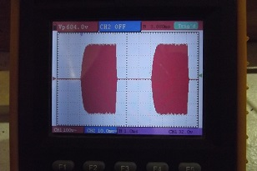
COS Tuned Waveform

Post-Assembly Test
- Place UUT into test location as described by Strata’s installation record
- Connect PC with UUT using USB A/B cable
  - Note the COM port number designated to the UUT
- Open PCS software on PC
- Select the Quick Checkout tab
- Select the UUT under Options/Com Port and select the UUT COM port number from the drop down list
- Connect PCS software to UUT under File/Connect
- Apply power to the UUT
- Ensure power indicator on the front of the UUT is lit
  - Record
- Activate calibrated PAD by removing plug near the UUT
- Ensure the PAD’s serial number and battery voltage appear on the PCS software
  - Record
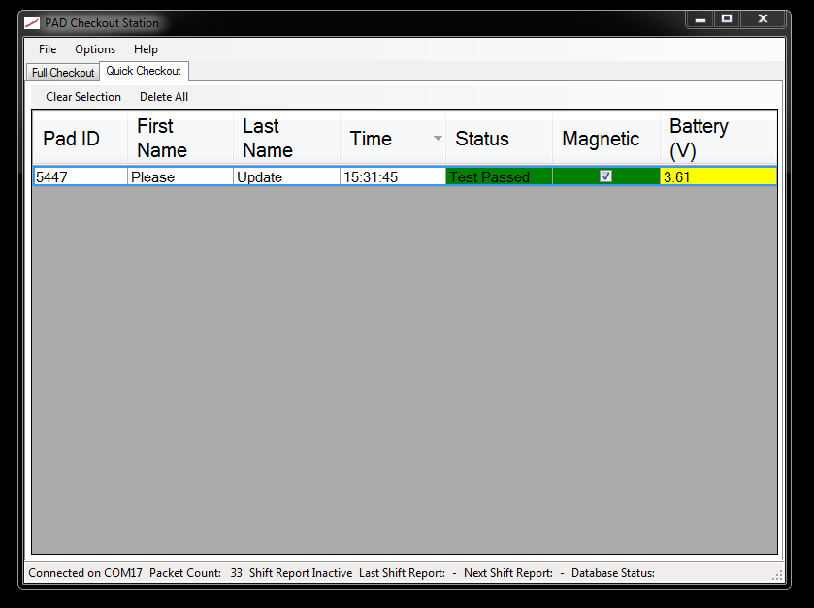
PCS Software
- Place the PAD at hazard zone mark as described in Strata’s installation record
- Ensure PAD is in hazard zone. The PAD will have a constant beep and red light
  - Record
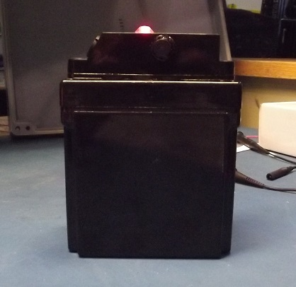
PAD in Hazard

Record
Complete each test using Strata’s COS Record. Save this copy electronically and send to Strata Products Worldwide, LLC

Troubleshooting
Failure Mode | Cause | Action
Unable to program | Incorrect cable | Check cable and orientation
 | Device communication | Unplug and reconnect programming device
No waveform when tuning | Check settings | Check probe and oscilloscope settings
 | No power | Check fuse F1
 | Potentiometer not set | Set R53 as described in tuning procedure
 | Not programmed | Verify software using FAT Data Display software
PCS does not update PAD ID | COM port disconnected | Unplug and reconnect COM device, reconnect with PCS software
 | USB to RS-485 incorrect | Check DIP switch settings on converter
 | J7 connector | Check connection between J7 of control board and converter
PAD not sounding at hazard mark | Parasitic coupling | Remove conductive objects at least 2’ away from the COS
 | Potentiometer set low | Set R53 as described in tuning procedure
 | Detuned signal | Retune coil

Preventative Maintenance
- Calibration of the PAD, oscilloscope, and known good COS should be performed yearly.
- USB A/B cord should be replaced after 10,000 plug/unplug cycles or every two years.
- Test location should be kept free of dirt, and outside objects not present during initial installation.

