 | CAT 246d3 skid steer installation PROCEDURE
 | Prepared By: | Systems & Applications Engineer | Doc No: | SPA-ES-PRO-029
 | Authorised By: | Quality Manager | Revision: | 1.0
 | Functional Area: | Quality Management System | Date Reviewed: | 29.04.25
- 1 TASK OVERVIEW
- 2 SAFETY
  - 2.1 Hazard and Control Measures for Safety and Environment
  - 2.2 Specific “On the Day” Hazards / Simultaneous Operations
  - 2.3 Isolations
- 3 TASK RESOURCES AND PREPARATIONS
  - 3.1 Special Equipment and Special Tools Required
    - 3.1.1 Power Tools
    - 3.1.2 Hand Tools
    - 3.1.3 Other Items
  - 3.2 Reference Documents (OEM Manuals, Drawings and Procedures)
  - 3.3 Preparations
  - 3.4 Job Sign On
- 4 WORK MANAGEMENT TASKS
  - 4.1 Location of System Devices
    - 4.1.1 AIM100 AI Controller
    - 4.1.2 Camera, External Siren and Zone Light
    - 4.1.3 In Cabin Light Strips
    - 4.1.4 Park Brake Interface
    - 4.1.5 Reverse Interface
    - 4.1.6 DC Connection
    - 4.1.7 LTE Modem and Antenna
    - 4.1.8 Level 9 Interface Module
    - 4.1.9 Completion
- 5 COMPLETION OF WORK
  - 5.1 Appendix 1
AREA OWNER OR DELEGATE AUTHORISATION
The responsible individual, under whose authority the machine operates, needs to provide approval for all tasks outlined in this scope of work.

TASK OVERVIEW
Purpose and Scope
The purpose of this document is to describe the installation process of the Mobile AI Personnel Detection system on Downer Skidsteers.
Estimated time to complete is 12 hours for Level 7, 18 hours for Level 9.
This applies to Qualified Technicians, assistant technicians and all support staff directly associated with executing the task.
Equipment and In-Service Testing covered by this Work Instruction
The machine covered by this work instruction is the CAT 246 D3 Skid Steer.

SAFETY

Hazard and Control Measures for Safety and Environment
Safety and Environmental Risks shall be reviewed at the job prior to sign off.
Common Hazards associated with working on construction machinery typically include:
- Electrical Power, of which the appropriate control is Electrical energy isolation.
- Crushing Hazard, of which the appropriate control is ensuring that chocks are in place before commencing work.
- Fluid Power, of which the appropriate control is ensuring that the hydraulic, air water and gas systems are depressurised before starting work on the system at hand. Under no circumstance may the pressure hoses be replaced with hoses not rated for the job.
- Biomechanical Hazard, ensure the area for ascending and descending is clear of trip hazards. Ensure the surrounding work area is free of trip hazards and tools.
- Ascending & Descending Hazard, ensure 3 points of contact are possible and use best platform or steps to match the path.

Specific “On the Day” Hazards / Simultaneous Operations
Ensure that a JSA is completed on the day of installation to ensure that and additional hazards are accounted for and adequately controlled around the machine that is being installed.

Isolations
Ensure adequate isolation is completed that is in line with the relevant work conducted on the Haul Truck.

TASK RESOURCES AND PREPARATIONS

Special Equipment and Special Tools Required

Power Tools
- Power Drill
- Impact Driver
- Heat Gun (battery or AC)
- Grinder
- Soldering Iron

Hand Tools
- Cable Strippers
- Cutters (Black Panthers)
- Stanly Knife
- Screw Drivers
- Allen Keys
- Shifter
- Hammer
- Terminal Crimper
- Boot Lace Crimper

Other Items
- Laptop & Interface Cables (for commissioning)
- Wesa Tape
- Impact Drivers Bits
- Drill Bits
- Drill Set
- Hand Tap
- Muiltimeter
- Head Lamp
- Measuring Wheel (SAT Test)
- Cones (SAT Test would be Onsite)
- Tape Measure
- Lead Free Solder

Reference Documents (OEM Manuals, Drawings and Procedures)
The electrical red line drawings and the OEM specification manual for the specific machine are to be considered during the installation of the machine.
See Appendix 1 for installation drawings.

Preparations
Supervisor Consultation: Before drilling into the vehicle or machine, always consult with the fleet supervisor.
Structural Integrity: Under no circumstances should modifications be made to the ROPs (Roll Over Protection structure) or FOPs (Falling object Protective structures).
Cable Routing: Adhere to existing OEM cable routes. Do not attach cables to or follow the fire suppression system on the machine. Avoid routing or securing to hydraulic hoses. Keep cable routes clear from potential impact areas, rubbing points, and moving parts. Ensure cable is protected from rubbing and impact by using appropriate mechanical protection.
Use of Magnets & Sticky backs: Using magnets and sticky backs for cable securing is acceptable where necessary eg on ROPS.
Connection Sealing: Apply Densyl tape to all connections outside of the cab for protection. All cabin or IP rated entries should be adequately sealed using compression glanding or existing entry methods. Under no circumstances should your work decrease the moisture and dust protection of the cabin or enclosure.
External Cabling: All external cables must be housed in corrugated conduit (no split conduit). Use adhesive heat shrink on the cables to prevent water ingress at the conduit start and end points. All external cabling should maintain an OEM new machine level of finish.
Internal Cabling: Inside the cab, all cables must be run inside finger trap/guard flex. All internal cables should be hidden where possible to maintain high level of finish.
Cable Labeling: All cables must be labeled to allow adequate identification of wire at source and destination.
Bracketry Preparation: Ensure all bracketry is prepared prior to installation. External bracketry should be painted to match the OEM colour scheme or black. Brackets should be fit for purpose and be professionally finished.
Driver's Vision: Avoid placing screens in a way that impedes the driver's vision.

Job Sign On
Each individual who is engaged in tasks as specified under the guidelines of this Operational Protocol is required to provide their signature on the SAT/Commissioning document as a testament to the fact that they have duly read and comprehended this written material. If any part of the instructions enclosed herein seem unclear or not entirely understood, it is crucial that the supervisor overseeing the work operations be consulted without hesitation. No work activities should be initiated or resumed until any existing doubts or concerns have been thoroughly resolved to the satisfaction of both the employee and supervisor.
In the event that modifications, corrections, or alterations are necessary within the document, the required procedure for reporting such is outlined meticulously in the designated feedback segment of this document. This ensures that any suggestions for improvements or observations of discrepancies are adequately communicated and subsequently addressed in a systematic and effective manner.

WORK MANAGEMENT TASKS

Location of System Devices

AIM100 AI Controller
The AIM controller is the primary control module for the AIM100 system. All system connections feed to and from this module.
A Perspex mount plate is used to fix the controller in it’s position. This plate uses existing threaded inserts in the vertical surface of the pillar and attaches to the aluminium surround of the window frame. | 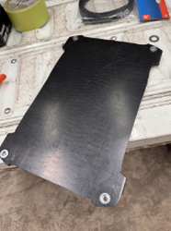 | 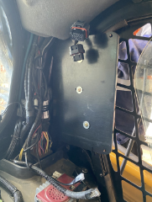
Due to the limited space in the CAT skidsteer we have elected to place the controller on either. the left or right B pillar. Note the preference for consistency is the left B pillar and care must be taken to ensure the controller is located as far back as possible. | 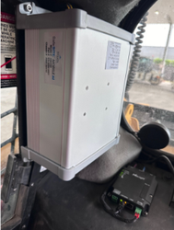 | 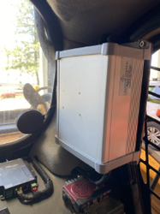
The B pillar trim must be trimmed and refit once the controller has been installed.

Camera, External Siren and Zone Light
The Camera must be installed in the same position and orientation on every CAT machine. If the position must be changed the camera calibration and configuration will need to be updated.
Camera orientation angle is setup during the commissioning process.
The zone light must be installed on the side of the camera as per the following pictures. All cabling must be installed with mechanical protection and appropriate water proofing must be applied to the cable connections. | 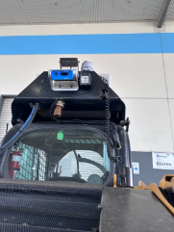 | 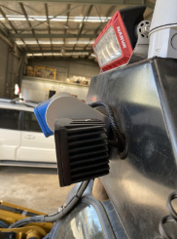
All fixings should be stainless steel and either Nylock nuts used or a threadlocker

In Cabin Light Strips
The operator LED indicators must be installed using the supplied mounting clips. All cabling should be installed behind the cabin lining and secured in place to prevent vibration of the cable. | 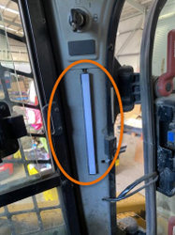 | 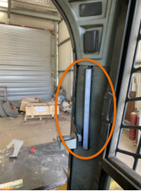
Indicator orientation should be as per the pictures above. It is important that the indicators are located so that they are easily seen in the operator’s peripheral vision while operating.

Park Brake Interface
Required for Level 7 & Level 9
We interface with the machine park brake switch in order for the AIM100 controller and L9 controller to activate or deactivate the park brake. The Park Brake status signal (Parking Brake solenoid HIGH or LOW), is from vehicle ECU to the AIM100.  Figure 8 shows the park brake switch to ECU connection that is located in the machine harness on the left hand B pillar. We splice into this and install the interfacing Relay box as seen in Figure 9. See interconnection drawing at appendix 1 for the CAT wire numbers to splice into. | 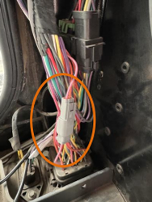 | 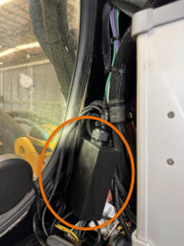
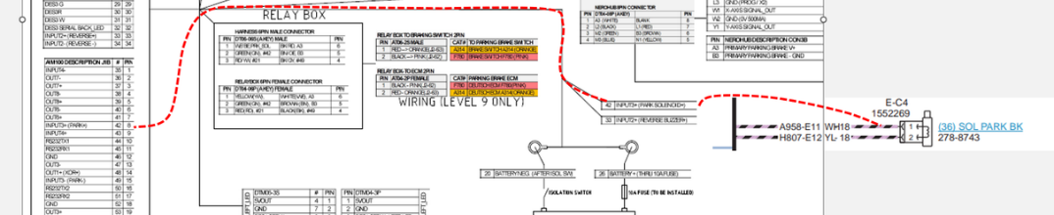
Depending on whether the machine is L9 or L7 will determine the interface box configuration.
See appendix 1 for the system interconnection drawing.

Reverse Interface
Required for Level 7 & Level 9 to help the system determine which direction the machine is travelling in.
We take a parallel connection with the reverse buzzer feed. This cable is run back to the AIM100 in the cabin.  All cabling must be installed with mechanical protection and secured with existing harness. Care must be taken to ensure the cable doesn’t impede the operation of any machine systems and stay away from heat sources. | 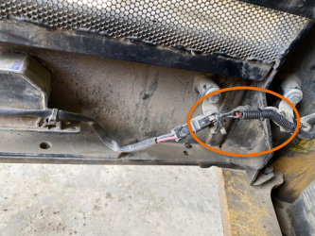

DC Connection
The system requires a +12Vdc connection to both the battery (via isolator) and to the machine switched ignition.
The CAT skidsteer uses a switches ground. The AIM100 battery positive feed should run directly to the machine battery “+” terminal via a fuse located as close to the battery as possible. The AIM100 ground connection should be to the isolated side of the machine main isolator.  The AIM100 also uses an ignition sense input to enable some advanced power management features and this connection must be run to a circuit that activates when the machine ignition is switched on. | 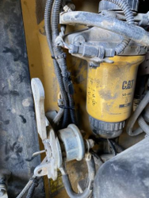 | 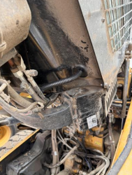

LTE Modem and Antenna
The LTE modem must be installed as close to the antenna position as possible. The SIM tray slot must be easily accessible and orientated so that the diagnostics LED’s are easily seen.  The LTE modem and GPS antenna must be placed on rear window glass and care taken with the coaxial leads as they can be damaged if stretched or kinked. | 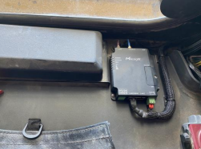 | 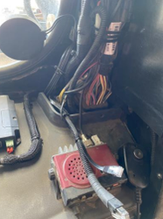

Level 9 Interface Module
The level 9 controller should be installed on the firewall either on the left or right of the operator chair. Preference is to install on the same side as the AIM100 controller so that the harnessing can be easily installed. | 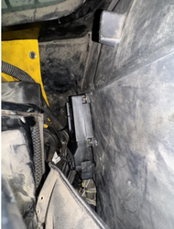

Completion
- Reassemble the control area.
- Follow the isolation procedure to safely reintegrate the system.
- Conduct a series of operational tests:
- Ensure the system starts up properly when power is turned on, ensuring there are no error messages and system is connected to wireless network or LTE.
- Validate that the AIM system does not affect the operation of the machine or impeded the operator controls in any way.
- Utilize the diagnostics indicator to ensure the system is starting up correctly.
- Carry out a shutdown test to confirm the control device shuts down properly when power is cut.
- Conduct a restart test, verifying that all systems correctly restart upon powering on.
- Carry out Configuration upload for this type of machine.
- Conduct the Camera calibration process.
- Conduct a Site Acceptance Test (SAT) of the Haul Truck and capture the relevant information in the 2IB system
- Complete SAT and Commissioning, update documentation.
- Securely fasten all fittings, ensuring cabling is properly routed and protected.

COMPLETION OF WORK
Upon the culmination of the work process, there are several critical actions that need to be meticulously carried out in order to ensure the comprehensiveness, accuracy, and continuity of the work done. This process not only contributes to maintaining the professional integrity of the work but also aids in streamlining subsequent tasks and improving overall productivity. These actions are listed as follows:
The initiation and completion of Site Acceptance Tests (SAT) are paramount. These documents serve as verifiable records of the measurements undertaken during the work process, providing valuable insight into the operations and enhancing the traceability of the work done.
Feedback is an integral part of continuous improvement. Therefore, any observations, suggestions, or analysis should be recorded in the Strata Jira system or emailed to the product manager for Analysis and Improvement. This process aids in the identification and elimination of defects, fostering a culture of continuous improvement and enhancing the overall quality of work.

Appendix 1


