
A-Node
Site Configuration Procedure

Table of Contents
1.0 Scope and Purpose 3
2.0 Definitions and Abbreviations 3
3.0 Referenced Documents 4
4.0 Equipment 4
4.1 Hardware 4
4.2 Software 4
4.3 Firmware 4
4.4 Additional 4
5.0 Procedure 5
5.1 Site Configuration 5
5.1.1 Programming 5
5.1.2 Update configuration on A-node radio 1 7
5.2 Radio 1 (SXT board) configuration update 9
5.2.1 Connect to A-node Radio1 9
5.2.1 Update configuration on A-node radio 2 11
5.2.2 Update configuration on A-node RB960 Board 12
5.2.3 Update configuration on A-node RB960 12
5.3 Radio RB960 configuration update 13
5.3.1 Connect to A-node RB960 13
6.0 Commtrac board Configuration 17
6.1 Configuration 17
6.1.1 RB960 Setup 17
6.1.2 Comm Node Programming 19
7.0 Pre-Installation Test 22
7.1 Configure a Backhauler in the StrataConnect Server 22
8.0 Underground Installation 23
9.0 Record and Testing 23
9.1 WiFi Functional Testing 23
9.2 CommTrac Functional Testing 24
9.3 Updating CommTrac Server 24

Table of Figures
Access Point Node (A-Node) 3
Winbox window 6
SXT Radio Reset Configuration 7
RB960 Ether5 DISABLE 8
RB960 Radio Reset Configuration 12
Comm Node Programmer 20
Serial Programmer 20
Get Parameters 21
Add Backhauler 22
New Node 25
Add Wifi 25
Add Wifi Settings 26

Scope and Purpose
The purpose of this document is to guide the reader through the configuration of Strata’s Access Point A-Node, PN:
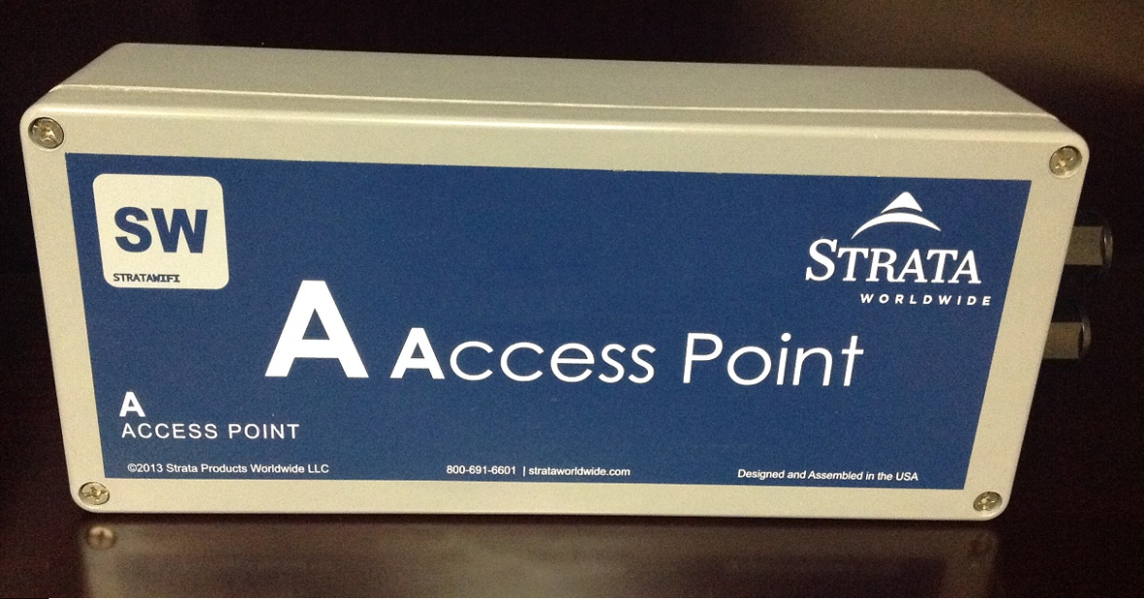
Access Point Node (A-Node)

Definitions and Abbreviations
A-Node – Fiber/WiFi Access Point Node
UUT- Unit Under Test
SN- Serial Number

Referenced Documents
- Installation Record
- Test Record
- Software Repository

Equipment
The following hardware and software are necessary to complete this test procedure:

Hardware
- 48V-DC power Supply
- (1) Poe Injector
- (1) Ethernet Cable
- PC w/ Windows OS, (1) Ethernet port

Software
- Winbox
- Comm Node Programmer

Firmware
- CN PIC (Commtrac Board – If necessary)
- CN CC1110 (Commtrac Board – If necessary)

Additional
The following are helpful to have when troubleshooting:
- Known good A-Node

Procedure

Site Configuration

Programming
Note: The programming and initial Testing shall be completed on a test network away from the mine site active communication system. Refer to the site operational readiness procedure for configuration of Site Network Infrastructure prior to installing Node underground.

Note: All the A-Node interfaces must have been factory reset before continuing with this procedure (IP Address will be 192.168.88.1).
- Connect the A-node (ether2 port) to the PC using Ethernet cable and Poe injector provided
  - Caution: Make sure the Poe injector is installed so DC voltage is applied to the a-Node. Wrong connection could damage your PC
- Apply 48V to the Poe injector
  - Green LED on back of unit should turn ON
- Open Winbox software
- On Winbox, press neighbors and refresh in order to display A-node (under test) interfaces
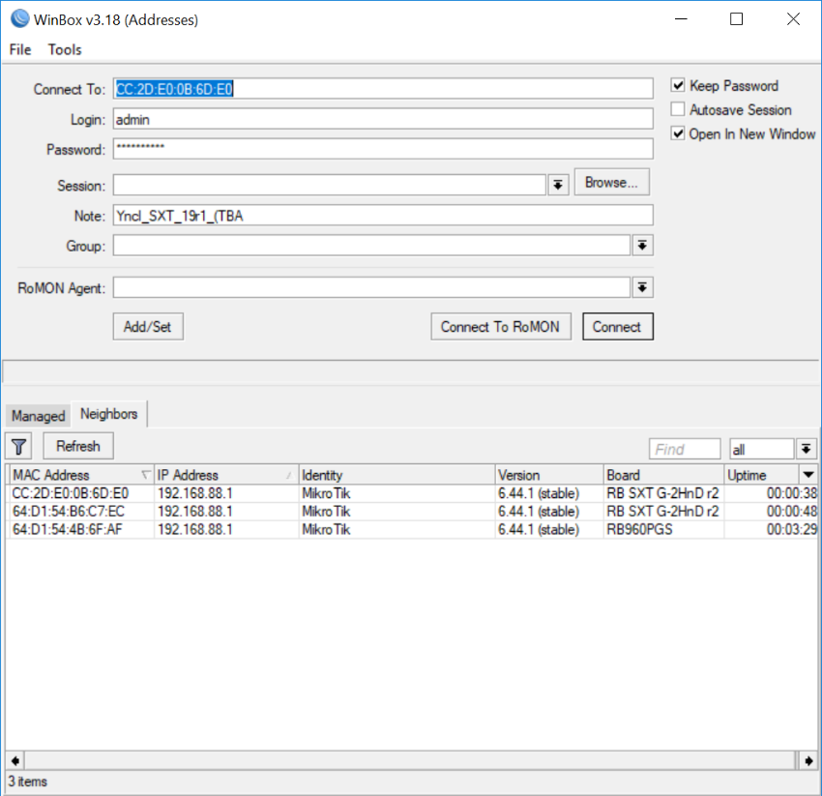
Winbox window

  - Note: Make sure the Interfaces have the latest mikrotik firmware Version. Update to current Version if necessary
- Select any SXT2 radio interface and press connect. Login credential are:
User: Admin
Password: (blank)

- Reset Configuration on the A-Node SXT radio boards
- On Winbox (Left Menu) Select System/Reset configuration
- Tick “No Default Configuration”
- Tick “Do Not Backup”
- Press Reset Configuration

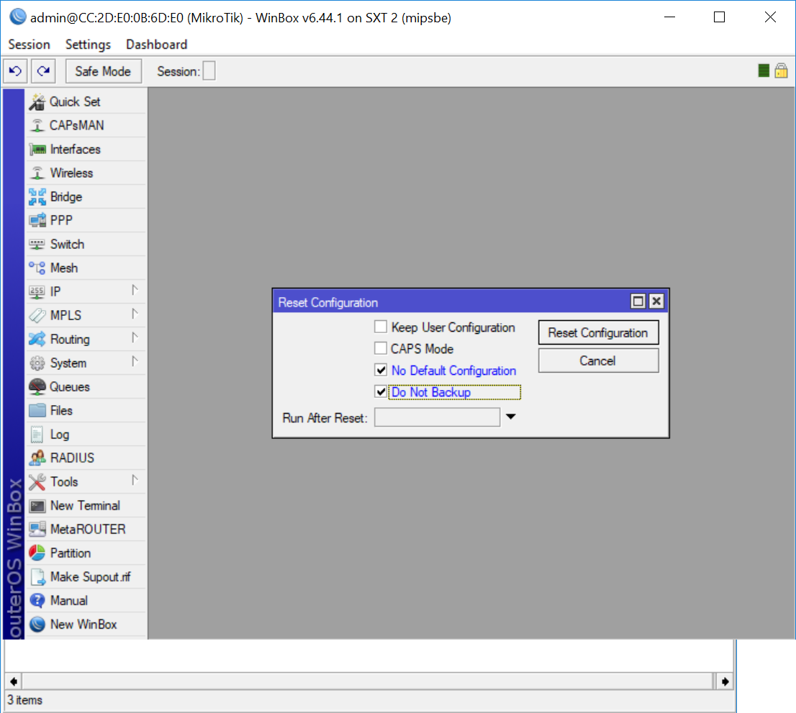
SXT Radio Reset Configuration

- Reset Configuration on 2nd SXT interface board.
  - Repeat the Instructions on Step 5 for the 2nd SXT interface

Update configuration on A-node radio 1
- On Winbox connect to RB960 Interface, to disable radio 2 from been broadcasted.
Note: Ether4 interface on RB960 is connected to SXT radio 1
Note: Ether5 interface on RB960 is connected to SXT radio 2
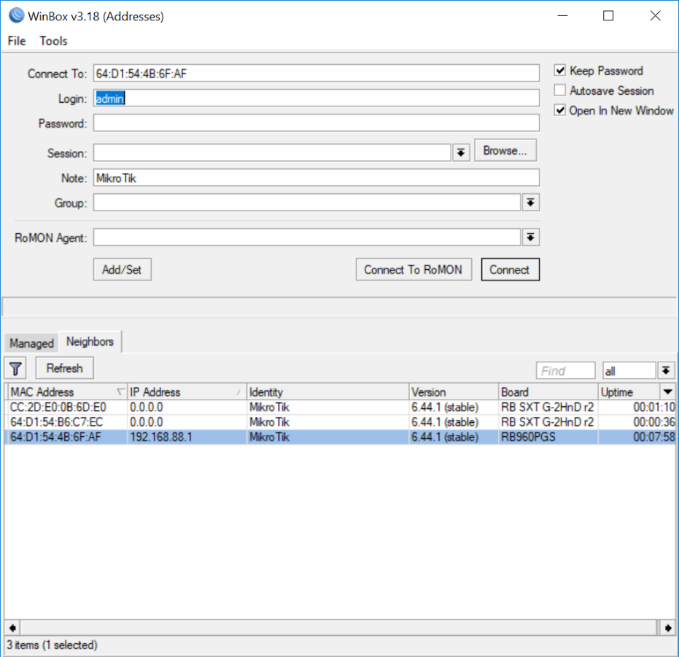
Winbox – Connect to RB960
- On Winbox Interfaces/
- Select Ether 5
- Disable Ether5 interface (Press red X to disable)
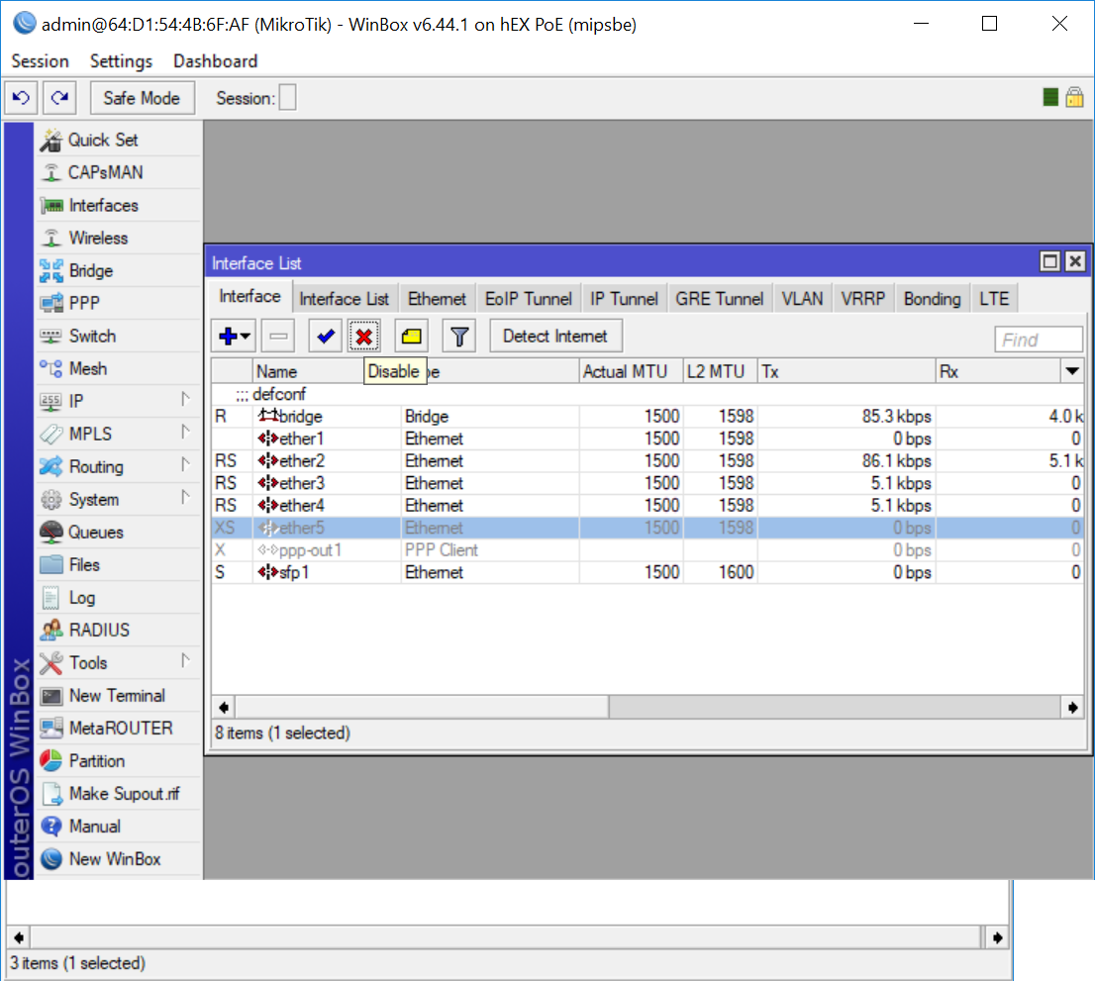
RB960 Ether5 DISABLE

Radio 1 (SXT board) configuration update

Connect to A-node Radio1
- On Winbox/ Neighbors/ press refresh to show available interfaces.
Note: make sure only one (1) SXT2 board is displayed on the search window
Connect to SXT2 board selecting its MAC address, then press connect
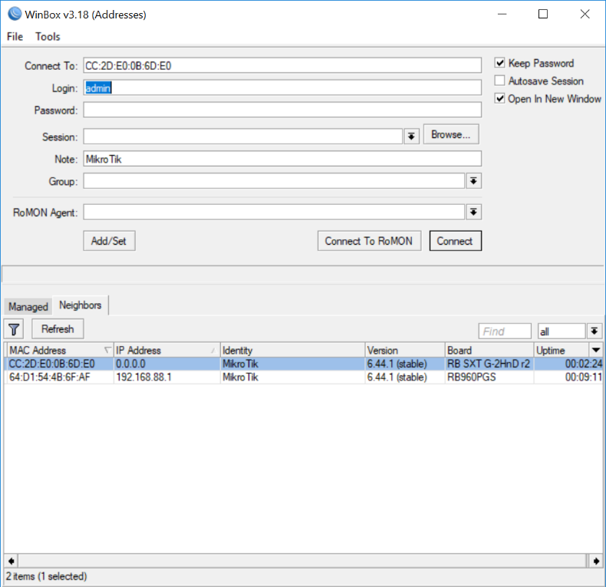
Winbox – Connect to SXT2 radio 1
- On Winbox, left menu select New Terminal
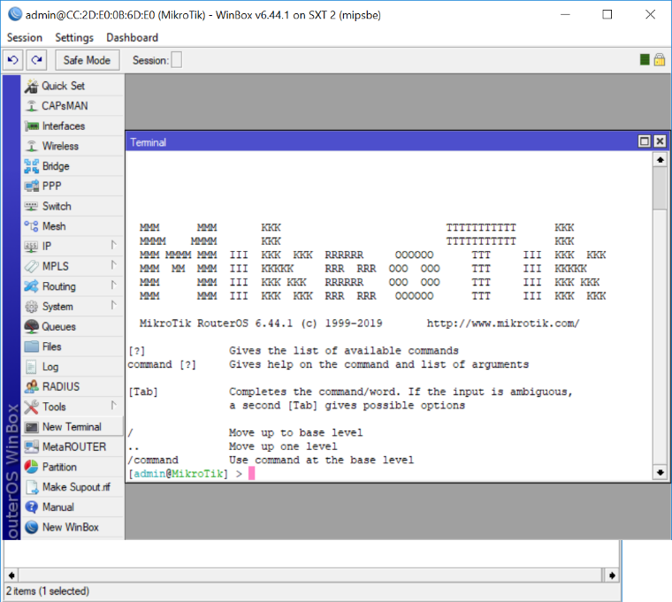
Winbox – New terminal
- On your PC, find and open the script to be used on the A-node radio 1 (open script with any text editor). Highlight the whole script then select “copy”
Note: Make sure there are no MAC addresses on the script before to use it. Delete any MAC address on the script.
- Paste the selected script on Winbox new terminal
Note: Reconnect to the SXt radio under programing if the connection drops out)

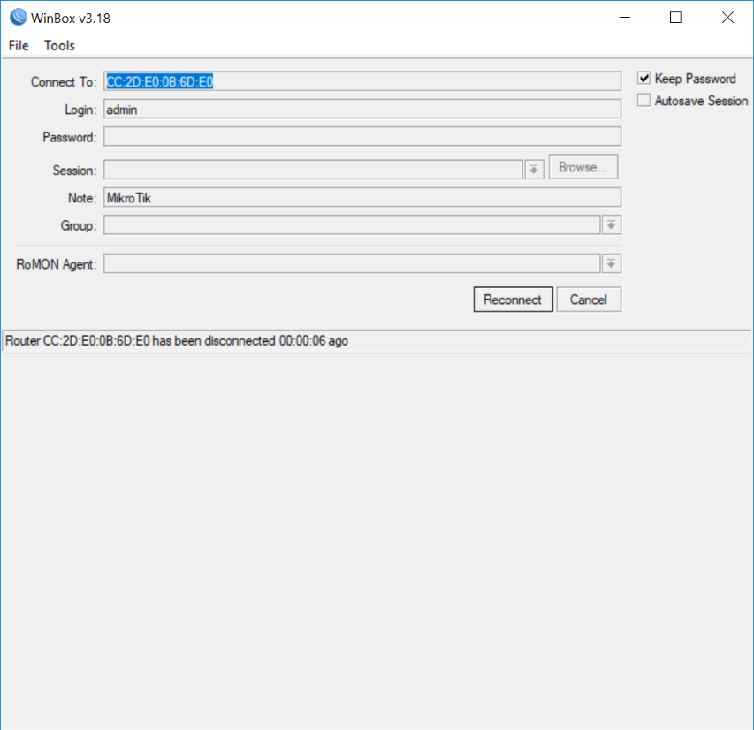
Winbox – Reconnect

- Copy and paste the whole script again to finish uploading the script
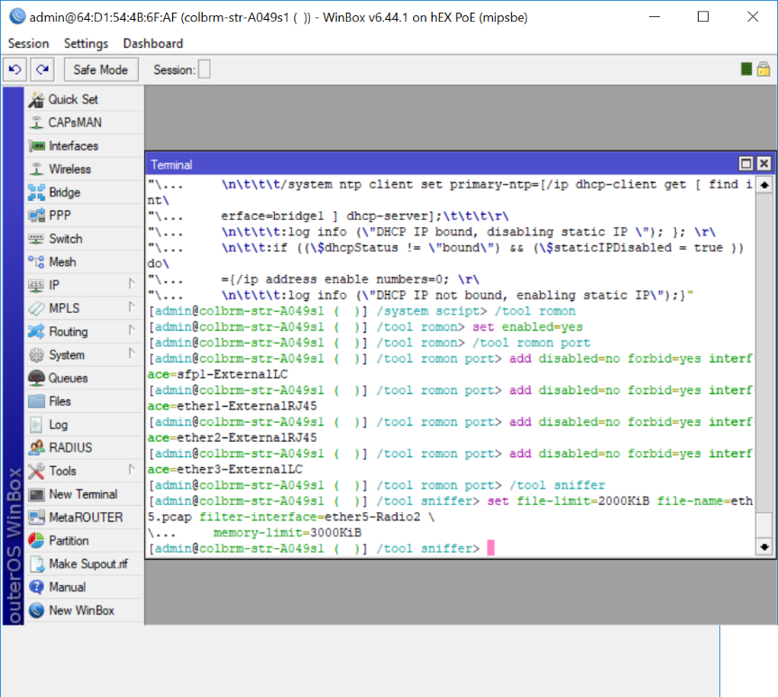
Winbox – Upload Script

- Once the script has been uploaded. Make sure all settings have been changed and no errors are shown on interface, wireless, or bridge configurations
- Select System/Identity to change the Radio Description
- Select IP/Address to change the unit to the desired IP address
- Select System/Password to add unit password (Pass: stratawifi)

Update configuration on A-node radio 2
- Repeats step 5.1.2 and 5.2 to Update configuration on Radio 2
Note: On Winbox RB960 Make sure that ether5 has been enabled and ether4 has been disabled, in order to update configuration on radio2

Update configuration on A-node RB960 Board
- Reset Configuration om the A-Node RB960 radio boards
- On Winbox select RB960 then press connect. User: Admin (leave password blank)
- On Winbox (Left Menu) Select System/Reset configuration
- Tick “No Default Configuration”
- Tick “Do Not Backup”
- Press Reset Configuration

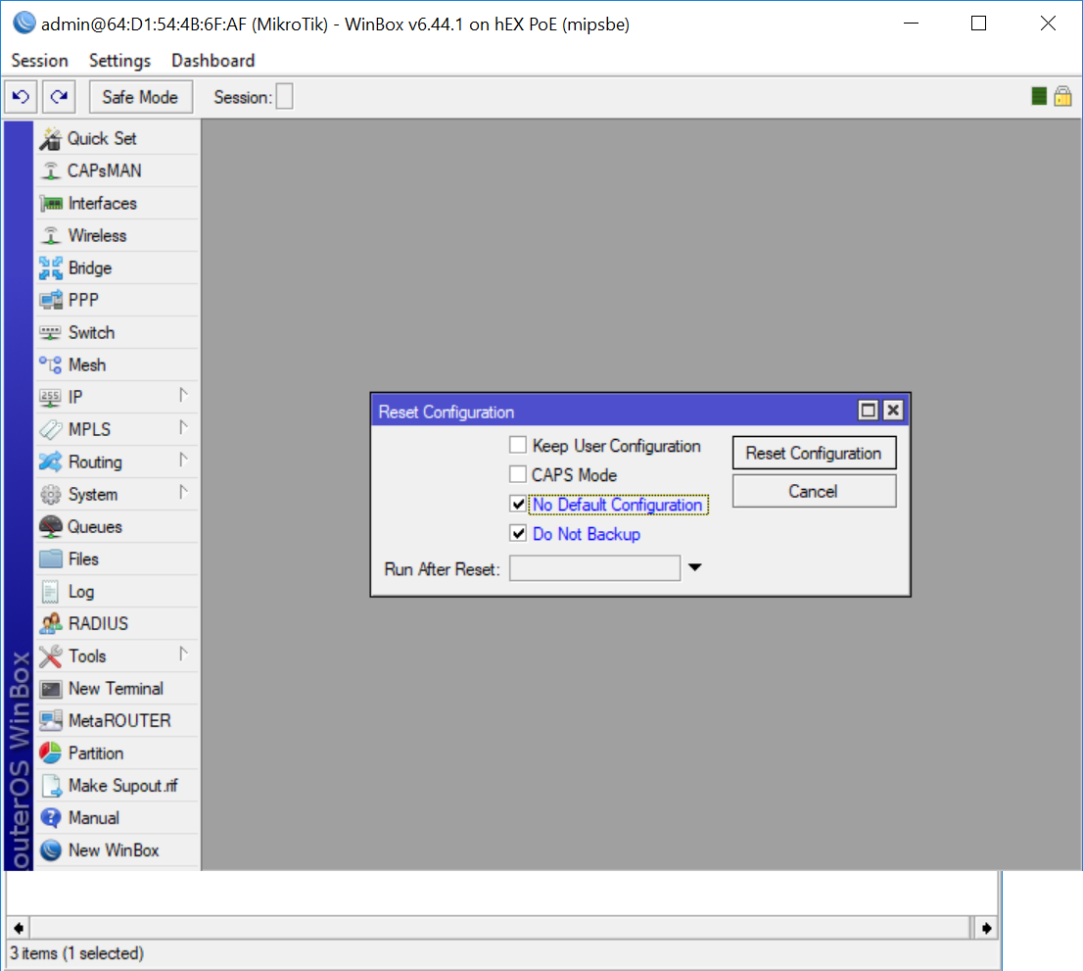
RB960 Radio Reset Configuration

Update configuration on A-node RB960
- On Winbox connect to RB960 Interface.
Note: Make sure the RB960 IP displayed on Winbox is 0.0.0.0.
- Select and connect to RB960
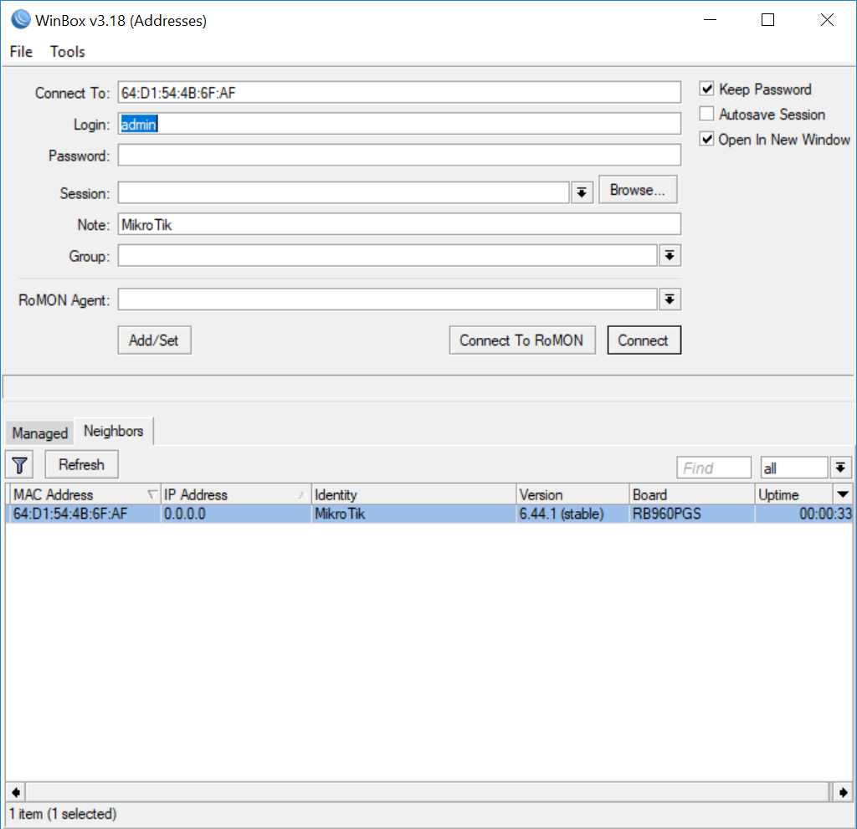
Winbox – CONNECT TO RB960

Radio RB960 configuration update

Connect to A-node RB960
- On Winbox/ Neighbors/ press refresh to show available interfaces.
Note: make sure only one (1) RB960 board is displayed on the search window
Connect to RB960 board selecting its MAC address, then press connect
- On Winbox, left menu select New Terminal
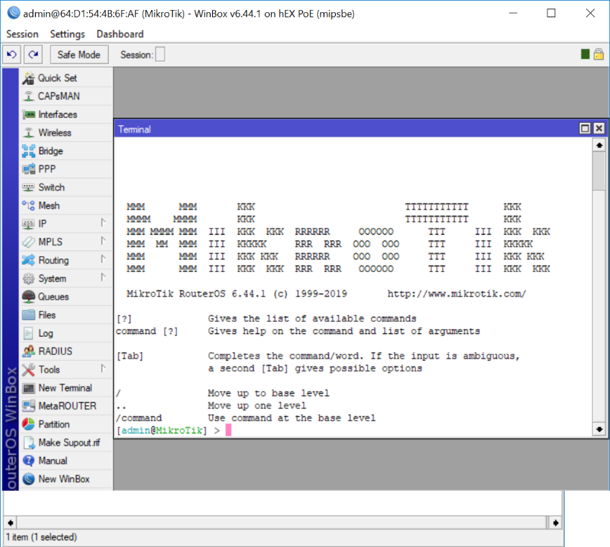
Winbox – New Terminal
- On your PC, find and open the script to be used on the A-node radio 1 (open script with any text editor). Highlight the whole script then select “copy”
Note: Make sure there are no MAC addresses on the script before to use it. Delete any MAC address on the script.
- Paste the selected script on Winbox new terminal
Note: Reconnect to the RB960 radio under programing if the connection drops out)

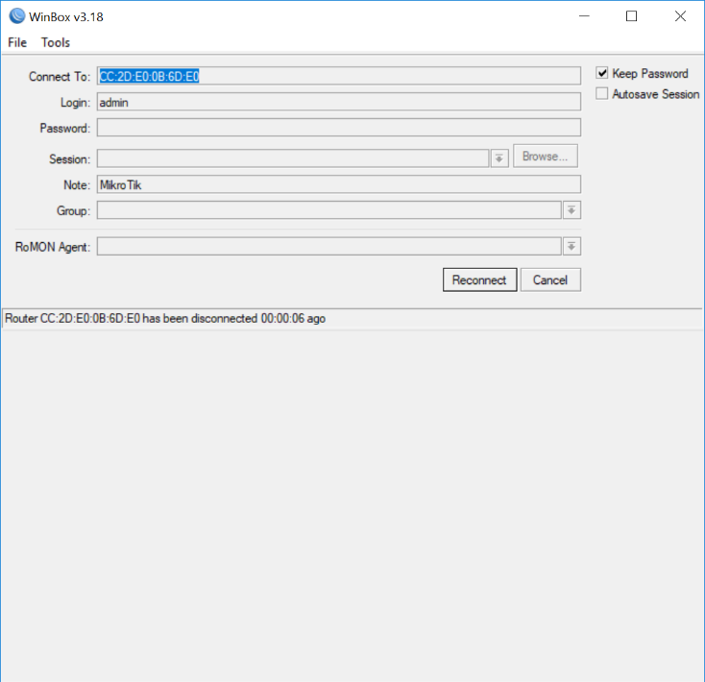
Winbox – Reconnect

- Copy and paste the whole script again to finish uploading the script
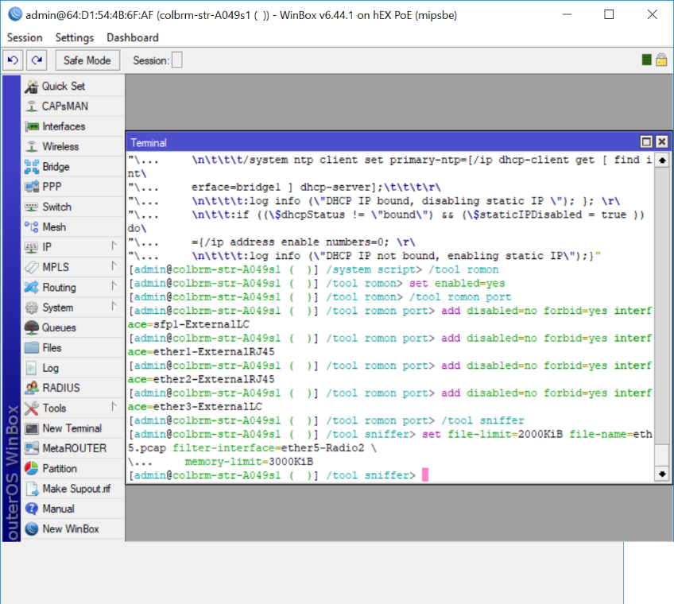
Winbox – Upload Script

- Once the script has been uploaded. Make sure all settings have been changed and no errors are shown on interface, wireless, or bridge configurations
- Select System/Identity to change the Radio Description
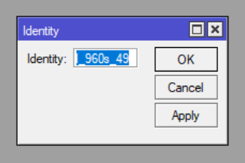
Winbox – Update identity

- Select IP/Address to change the unit to the desired IP address
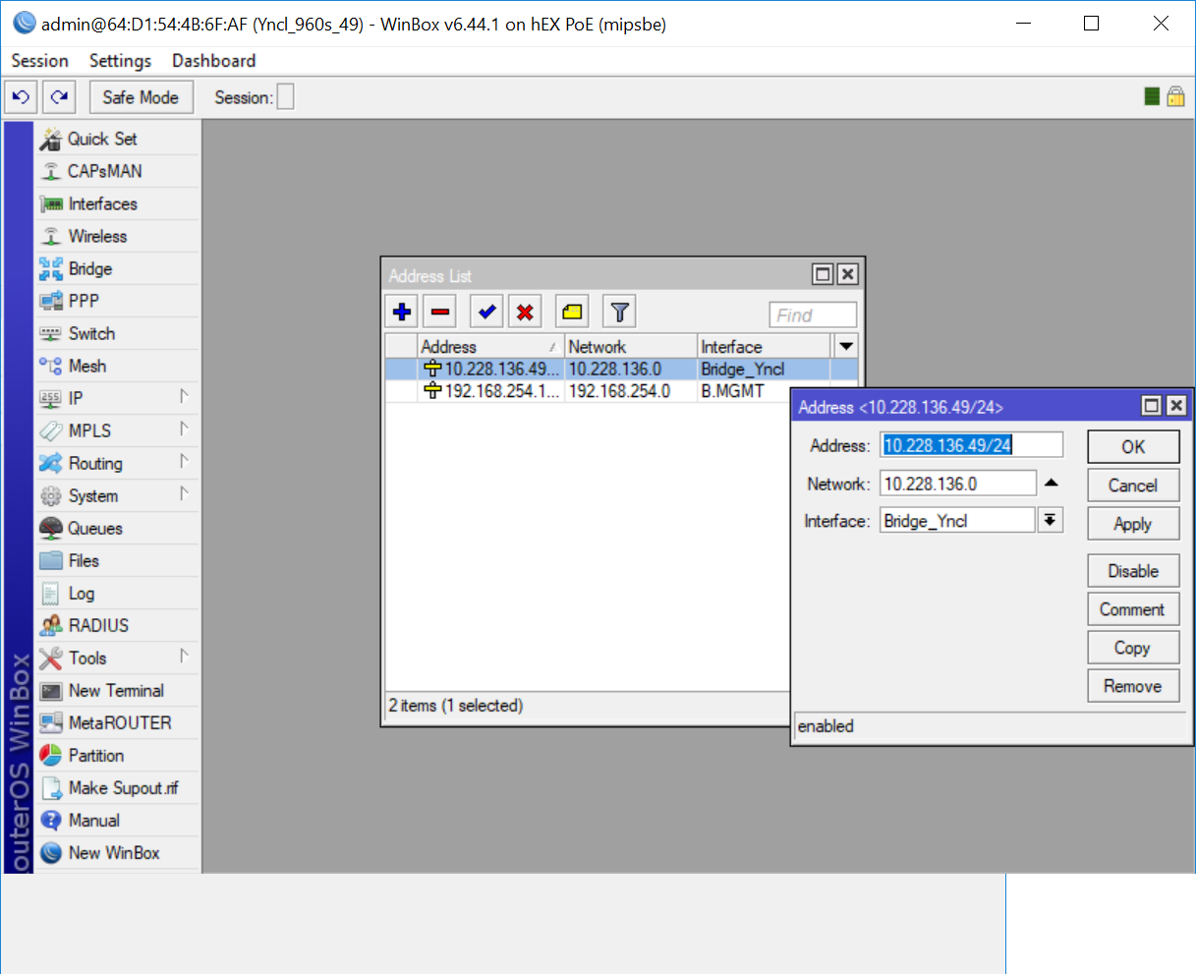
Winbox – Update IP address

- Select System/Password to add unit password (Pass: stratawifi)
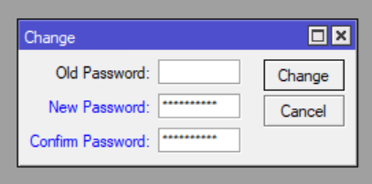
Winbox – Update Password

Commtrac board Configuration

Configuration

RB960 Setup
- Using Winbox connect to the Target RB960
- On Winbox Select system/Port
  - Change the USB baud rate port to 115200
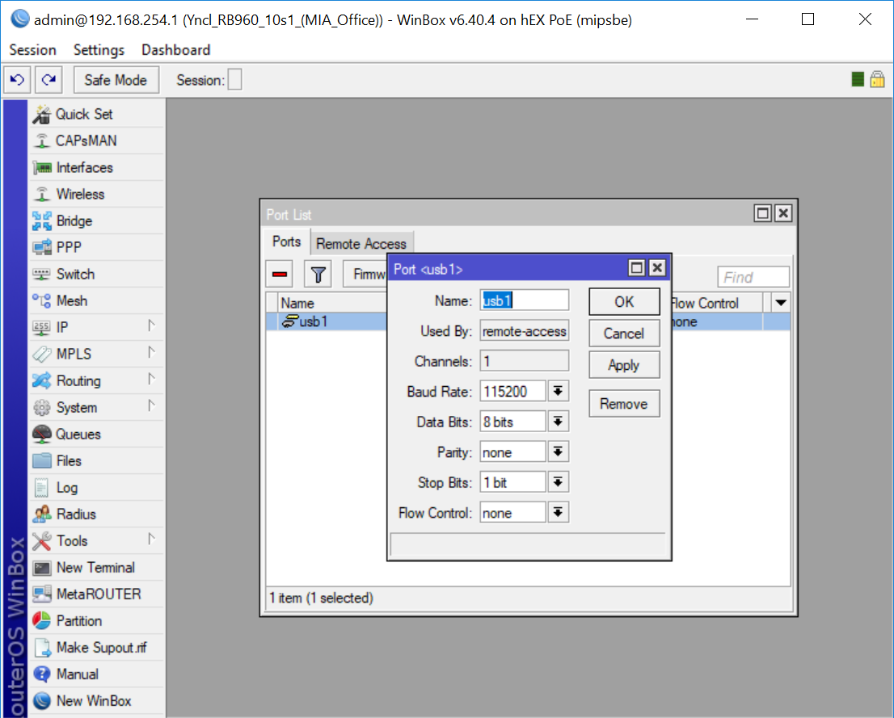
Winbox – USB port settings

- Select remote access tab
- Add TCP Port 2101
- Change Protocol to “raw”, then press apply
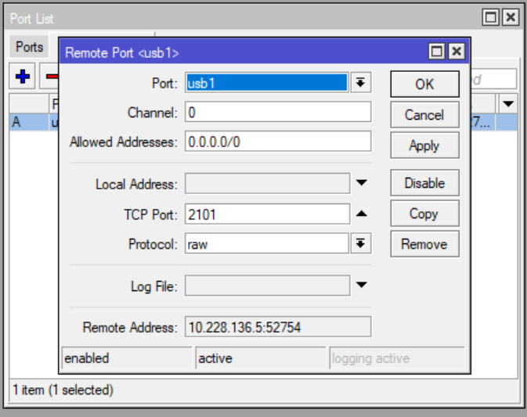
Winbox – Remote Port Settings

Comm Node Programming
            - Launch the Comm Node Programmer Software
            - Select ‘Socket Settings’ and enter the ‘IP Address’ and ‘port’ as configured in section 5.3.1 and section 6.1
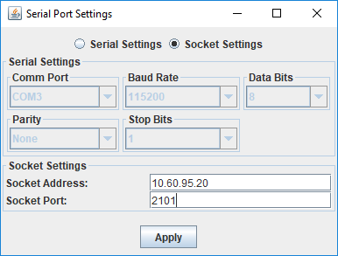
Comm Node Programmer
            - Select ‘Serial Programmer’
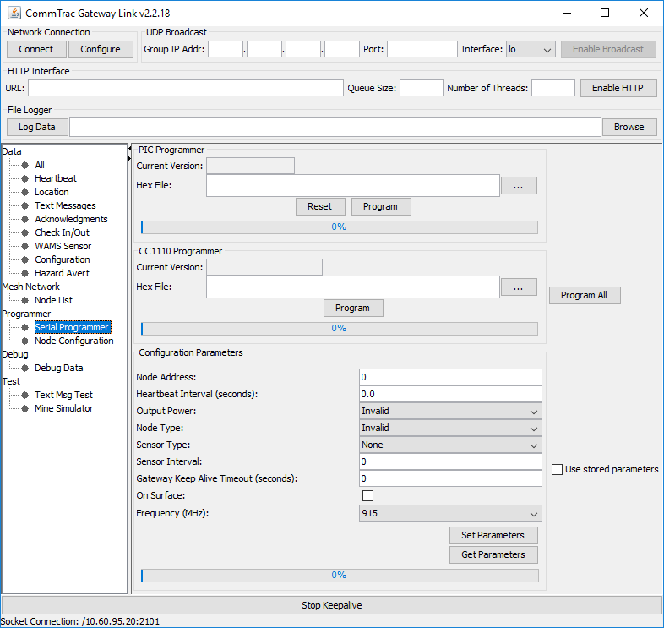
Serial Programmer
            - Select ‘Get Parameters’
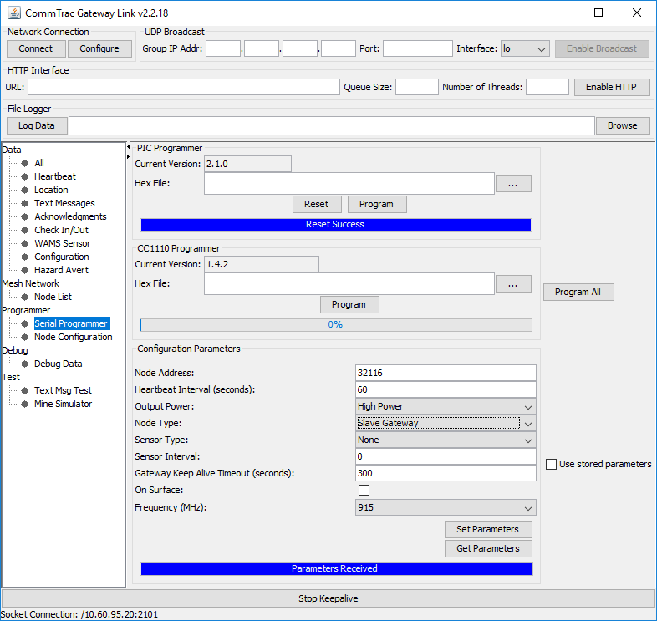
Get Parameters
            - Confirm Settings
              - PIC and CC1110 versions are latest
              - Node Address is equal to Serial Number of UUT
              - Heartbeat Interval = 60
              - Output Power = High Power
              - Node Type = Slave Gateway (unless Master is required)
              - Sensor Type = none
              - Sensor Interval = 0
              - Gateway Keepalive Timeout = 300
              - On Surface = (As Required)
              - Frequency = (as per site allocation) default = 915
            - Press ‘Set Parameters’

Pre-Installation Test
Connect the UUT to the network on the surface for server configuration

Configure a Backhauler in the StrataConnect Server
            - Login to the StrataConnect Server as a SuperUser
            - Press ‘StrataAdmin/CommTrac/BackHaulers/Add’
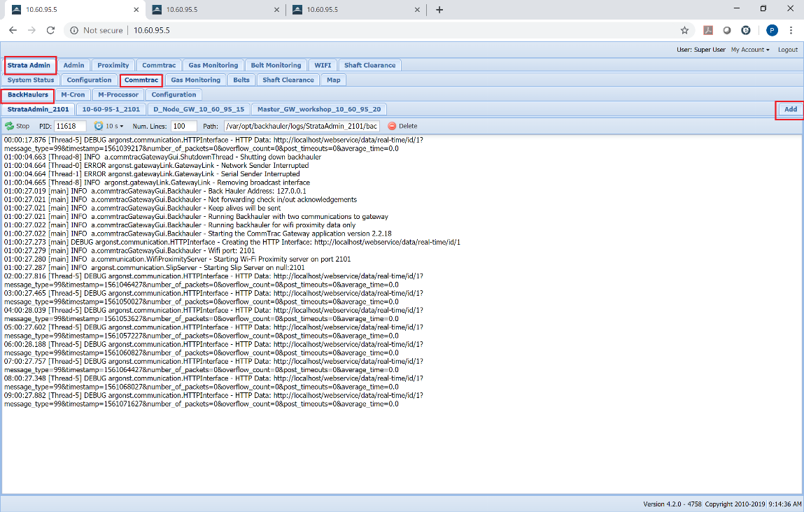
Add Backhauler

            - Change the following settings
              - Name = Meaningful Description of Gateway (usually location followed by IP Address, i.e. “UG_D_Node_10_60_95_20”
              - Digi IP Address = IP Address of UUT
              - Gigi Port = Port Number of UUT
            - Press Save
            - Wait for Backhauler to Start

Underground Installation
Refer the D Node Installation manual for any ‘conditions of use’. Ensure the D Node Antennas are installed in a location unobstructed by metallic objects for best range and performance.
D Nodes are supplied with a pre-terminated Ethernet cable with a potted Ex d Gland at both ends.
- One End is terminated inside the D Node
- The second end is to be installed inside the device providing power and data to the D Node; for example
  - Sub-Station
  - Belt Starter
  - Longwall TMU
  - Shuttle Car Main Control Box
  - DCB
  - Etc.…
Connect the D Node to 48V DC via the POE Injector, and then plug the Ethernet RJ45 connector into a pre-configured site network Switch.

Record and Testing

WiFi Functional Testing
            - Ensure the D Node is powered and connected to the site network
            - Using a handheld VOIP Phone, connect to the WiFi SSID associated to the phone system.
            - Initiate a call to a surface phone on the same phone system.
            - Ensure phone calls can be maintained for a minimum of 50m from the D Node
            - Record the location on a map where the phone call drops out.

CommTrac Functional Testing
            - Using a Miner Communicator, Enter the receive signal strength menu
To enter receive signal strength Menu-
- Press "1" & down arrow at the same time. Information will display including the number nodes heard.
- Press the "2" button to get more information. Serial numbers will be displayed with the corresponding signal strength (receive signal strength) adjacent to them.
- Press "2" again to see more or "3" to back.
Signal strength should be measured to obtain the desired receive signal strength

            - Send a test message to the surface indicating the Node Address and the Install location. For Example (33333. DCB MG15)

Updating CommTrac Server
Each Node must be updated on the Commtrac Server after installation.
            - Select “Admin/Communication Nodes”
            - Find the “New Node xxxxx” with the correct Serial ID
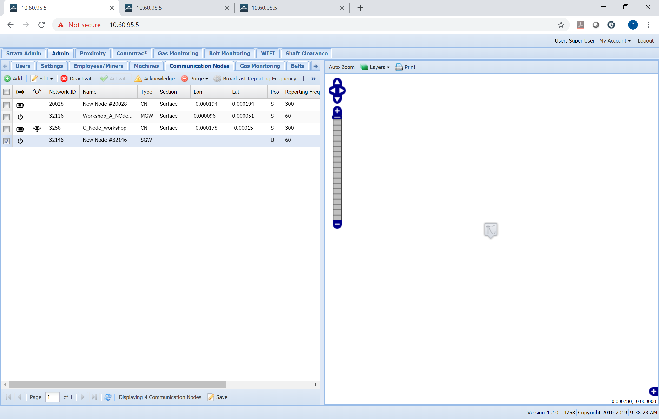
New Node
            - Press “Acknowledge” and change the following settings
              - Name = Meaningful Name
              - Section = Select as required
              - Latitude/Longitude = Click on map physical location of installed node
            - Press Save
            - Press “Admin/WiFi/Add”
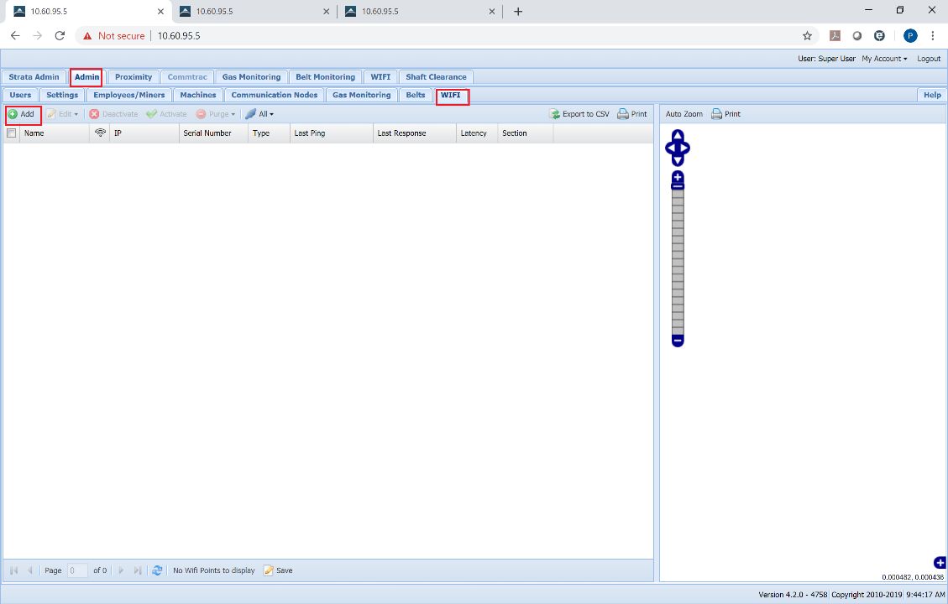
Add Wifi
            - Complete the settings as follows
              - Name = Meaningful Name
              - IP = IP Address
              - Type = Access Point
              - Serial Number = As labelled on D Node
              - Latitude/Longitude = “Click on map”
              - Section = As required
            - Press “Save”
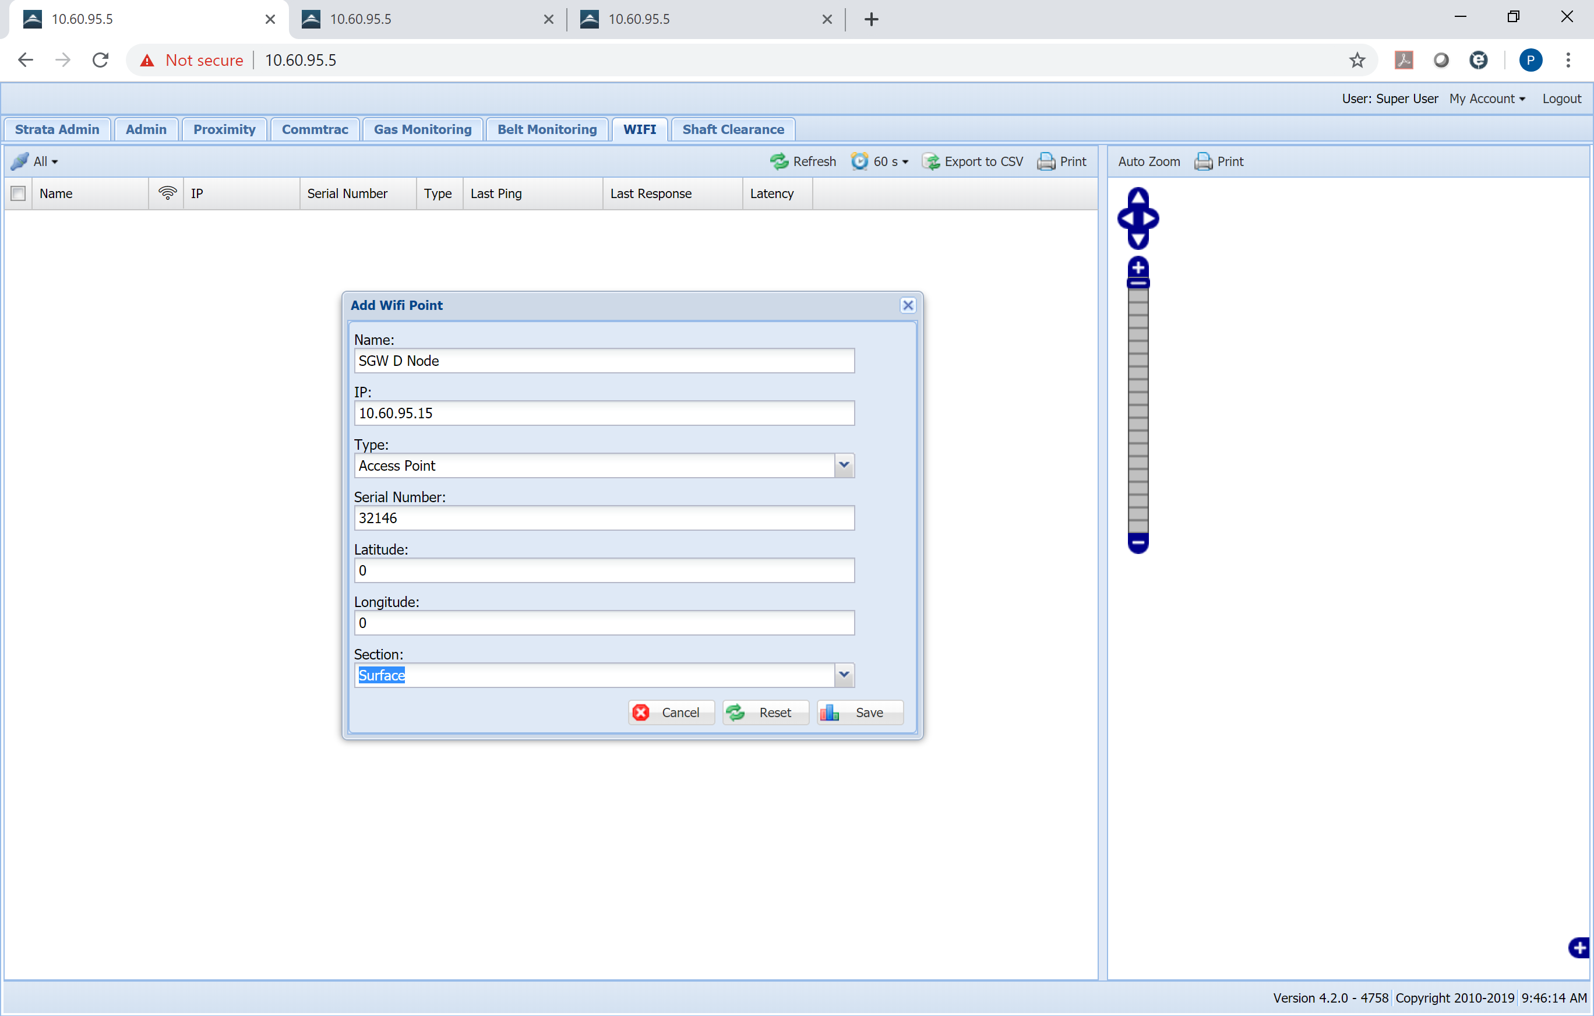
Add Wifi Settings

