STRATA COMMTRAC WIRELESS TRACKING AND COMMUNICATION SYSTEM VERSION 2.5

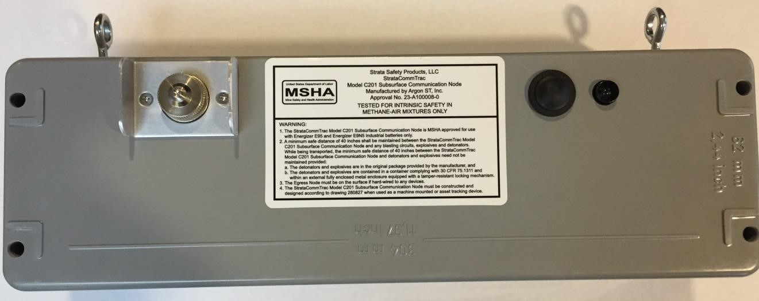
Table of Contents
1. Overview 3
1. 1. Theory of Operation 3
1. 2. Frequency of Operation 3
1. 3. Approvals 3
1.3.1. IECEx 3
1.3.2. ATEX 3
1.3.3. MSHA Approval 3
1.3.4. Pennsylvania Approval 3
1.3.5. EAC (Russia) Approval 3
1. 4. Label Information 3
1.4.1. Approved Blasting Distances 4
1. 5. FCC Information 4
1. 6. SCT-CN Equipment Parameters 5
2. Installation Information 5
2. 1. Gateway Node 5
2. 2. Surface network 6
2. 3. Underground Installation 6
2. 4. Preliminary Plan 7
2. 5. Physical Installation 7
2. 6. Placement Considerations and Conditions of Use 8
2. 7. Placement Example: 9
2. 8. CommTrac SCT-CN Gain Pattern 9
2. 9. Parallel Entries 10
2. 10. Determining Placement Location 10
2. 11. Record Placement Location 11
2. 12. Powering on SCT-CN 11
2. 13. Maintenance, Overhaul, and Repair 11
3. Battery Installation 11
3. 1. Battery Installation Process. 12
4. Reset Button 15
4. 1. Samples Signal Strength 16
4. 2. Reset 16
5. LED 16
6. External Connectors 17
6. 1. RS232 Pin Out 18
6. 2. RS422 Pin Out 19
6. 3. Power 19
7. Warranty 19

1. Overview

1. 1. Theory of Operation

Strata CommTrac is a completely wireless mesh tracking and communication network which has been specifically designed for use in underground mining operations. the mesh network is composed of underground CommTrac communication nodes which facilitate the passing of location information and communication from wireless mobile devices to the surface or aboveground environment.

1. 2. Frequency of Operation

The CommTrac Communication Node model SCT-CN utilizes 500kHz bandwidth with a command able centre frequency between 900-930MHz MHz. The factory default centre frequency is 915MHz.

1. 3. Approvals

1.3.1. IECEx

The IECEx certificate number is IECEx TRA 16.0003X issued 2017-07-20. The equipment has been certified to the IECEx Ex ia I 150°C Ma standards.

1.3.2. ATEX

The ATEX certificate number is BKI15ATEX0009X issued 2015-5-5. The equipment has been certified to the ATEX I M1 Ex ia I 150°C Ma standards.

1.3.3. MSHA Approval

The MSHA Approval number is 23-A100008-0 as of July 22, 2010.

1.3.4. Pennsylvania Approval

The Pennsylvania approval number is BFE 28-11

1.3.5. EAC (Russia) Approval

The EAC approval number is ТС RU C-US.МЮ62.В.04951

1. 4. Label Information

The CommTrac SCT-CN label is located on the front centre of the unit.

Label Summary:
Defines battery requirements.
Defines MSHA determinate minimum safe blast distance.
Designates a surface location if hardwired.

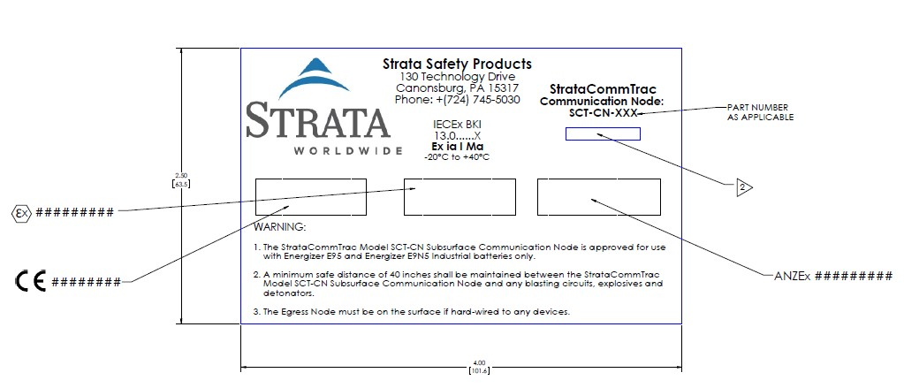

1.4.1. Approved Blasting Distances

MSHA
MSHA approval requires that a minimum of 40 inches shall be maintained between the CommTrac Model SCT-CN Communication Node and any blasting circuits, explosives or detonators.

Pennsylvania
Pennsylvania approval requires that the CommTrac Model SCT-CN must be installed at a minimum safe distance of 17 feet from blasting circuits, explosives, and detonators.

Note: Pennsylvania generates such requirements by multiplying the MSHA determined minimum distance of 40" by a factor of 5.

1. 5. FCC Information

The FCC ID for the SCT-CN is Y68C201 as of July 11, 2011. When configured by Strata for above-ground use, the device complies with Part 15 of the FCC Rules. Operation is subject to the following conditions: (1) This device may not cause harmful interference. (2) This device must accept any interference received including interference that may cause undesired operation.

Any intentional or unintentional changes or modifications to the configuration of the
Communication Node not specifically detailed in this document, could void the user’s authority to operate the equipment.

NOTE: This equipment has been tested and found to comply with the limits for a Class B digital device, pursuant to Part 15 of the FCC Rules. These limits are designed to provide reasonable protection against harmful interference in a residential installation. This equipment generates, uses and can radiate radio frequency energy and, if not installed and used in accordance with the instructions, may cause harmful interference to radio communications. However, there is no guarantee that interference will not occur in a particular installation. If this equipment does cause harmful interference to radio or television reception, which can be determined by turning the equipment off and on, the user is encouraged to try to correct the interference by one or more of the following measures:
-- Reorient or relocate the receiving antenna.
-- Increase the separation between the equipment and receiver.
-- Connect the equipment into an outlet on a circuit different from that to which the receiver is connected. -- Consult the dealer or an experienced radio/TV technician for help.

1. 6. SCT-CN Equipment Parameters

Transmit Power
The transmit power for the SCT-CN Communication Node is +24dBm.

Supply Voltage
The supply voltage for the SCT-CN Communication Node is 6v DC from internal batteries for the IS/XP product.

Protection Classification
The protection classification for the SCT-CN Communication Node is IP65.

Operating Temperature Range
The operating temperature range for the SCT-CN Communication Node is -20ºC to +40ºC.

2. Installation Information

2. 1. Gateway Node

A SCT-CN functions as a gateway node on the surface. This gateway node is the link between the SCT-CN wireless communication node network underground and the system server at the surface.

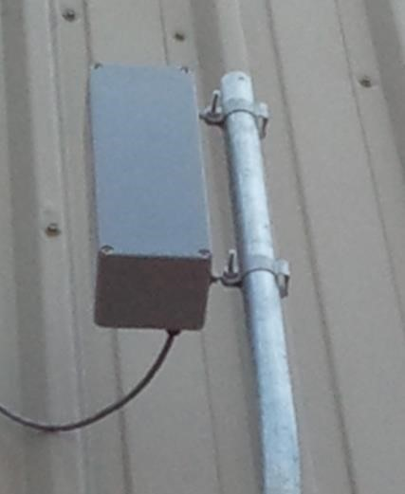

2. 2. Surface network

CommTrac SCT-CN Communication nodes can function on the surface to relay information between a portal and the gateway node when configured for FCC compliant operation.

2. 3. Underground Installation

The SCT-CN is intrinsically safe for methane environments. It is recommended that the underground SCT-CN installation occur after the surface installation is complete and gateway node is operational. This enables the wireless network to be established as the installation progresses. Installers should be aware of and maintain approved blast distances defined in Sec.1.4.1 of this document.

Mine characteristics dictate distance that will be attainable between the SCT-CN units. Larger distances are generally achieved in entries that are straight and open versus entries that lack line of sight, are partially obstructed, or contain equipment such as belt structure. Other factor which will impact distance between nodes are width of entry, seam height, entry dips and rises and existence of standing water. In a typical 6ft (1.8m) height coal seam, the distance between Communication Nodes is approximately 800 to 1500ft (250m to 450m). In low coal or entries with many dips and rises, the distance is reduced to approximately 500-1000ft (150m to 300m).

Distance is also reduced when signal SCT-CN nodes are on opposite sides of barriers or stoppings.

**Typical signal attenuation through material;

Hollow block wall | 5 - 10 dB signal loss
Metal doors and stoppings | 25+ dB signal loss
Metal stoppings with doors open or plexiglass inserts | 10 dB signal loss

2. 4. Preliminary Plan

Prior to beginning installation, a preliminary installation plan should be realized/developed.

Installers should have with them:
Knowledge of mine and preliminary placement plan
SCT-CN Communication Nodes
Batteries
Screw Driver
Map of mine or paper to record placement
Pen
SCT-CN installation bags

All required safety equipment
Be qualified to be in the environment.
May need stepladder

2. 5. Physical Installation

Strata CommTrac installation bags are available to hold and suspend the SCT-CN communication nodes from the entry roof. The bags have adjustable straps and clips to attach them to hardware present in the mine. The bags include a clear window to enable visibility of SCT-CN LED while installed. Bag opening must be confirmed closed properly upon installation.
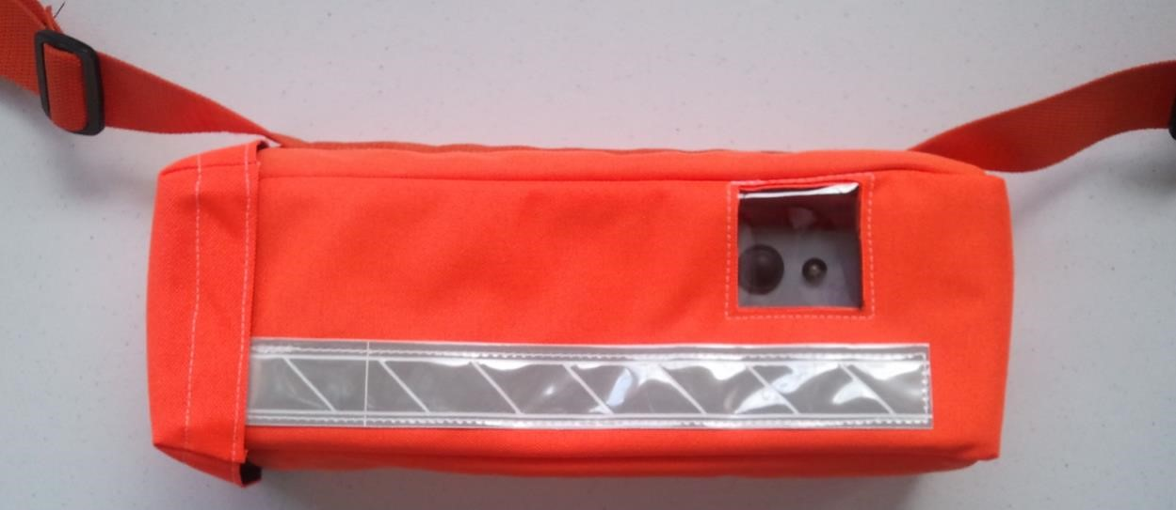


2. 6. Placement Considerations and Conditions of Use

Each SCT-CN should hang at least 6" (150mm) from the roof and from metal surfaces in the centre of the entry and be placed to avoid being struck by passing personnel or equipment.

The SCT-CN communication node should be oriented with its long axis perpendicular to the entry to achieve greatest communication distance.

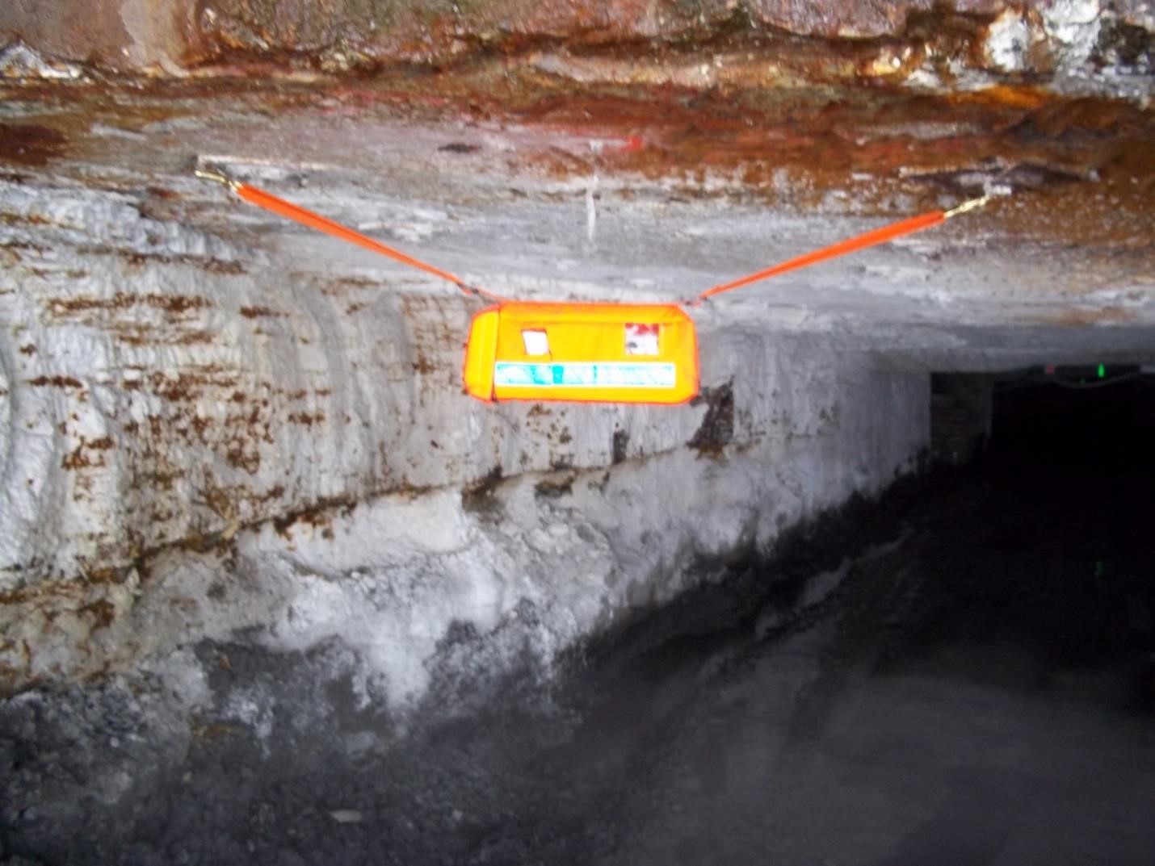

2. 7. Placement Example:
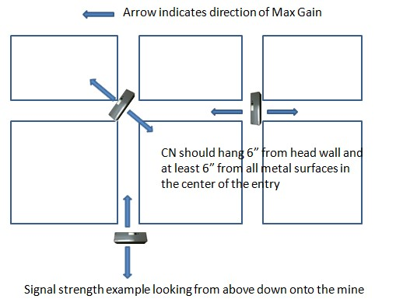

2. 8. CommTrac SCT-CN Gain Pattern

Signal gain pattern is approximately 15dB less from the short axis of the SCT-CN versus from the long axis of the unit.
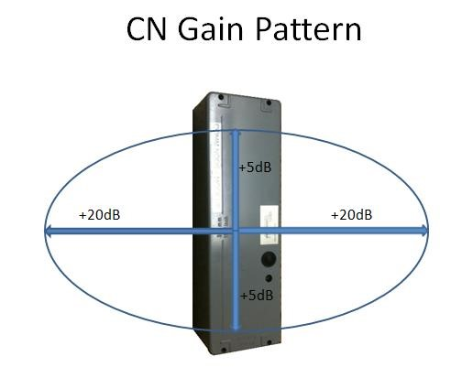

2. 9. Parallel Entries

If SCT-CN nodes are being installed in parallel entries, a laddered method is suggested. Therefore, when SCT-CN nodes are placed in parallel entries, it is desirable to have them positioned adjacent to each other or in the same cross, while in each respected entry. This, in most cases, provides additional redundancy in routing data from the mine.

2. 10. Determining Placement Location

The suggested technique is to utilize a SCT-MC Miner Communicator to sample signal strengths between a proposed SCT-CN installation location and the SCT-CN communication nodes already installed.

The SCT-MC Miner Communicator will display the serial number and signal strength of each SCT-CN communication node it hears.

The installer should maintain awareness of the next outby installed SCT-CN's serial number. The next SCT-CN should be placed, based on signal strength between the proposed installation location and the next outby communication node.

To use a SCT-MC Miner Communicator for this SCT-CN placement enter the receive signal strength Menu.

To enter receive signal strength Menu-

- Press "1" & down arrow at the same time. Information will display including the number nodes heard.

- Press the "2" button to get more information. Serial numbers will be displayed with the corresponding signal strength (receive signal strength) adjacent to them.

- Press "2" again to see more or "3" to back.

Signal strength should be measured to obtain the desired receive signal strength signal strength level to the next outby SCT-CN. Signal Strength (receive signal strength) guideline for node placement is below.

Desired signal | -60 to -75
Placement is too close | -0 to -60
Placement is too far apart | -75 to -99

2. 11. Record Placement Location

As each SCT-CN node is deployed, its serial number and exact location must be recorded on a map or other hard copy document. This will be used to place the SCT-CN on the map within the Strata CommTrac system when back on the surface.

2. 12. Powering on SCT-CN

Each SCT-CN should not be powered on until it has reached its installation location. Insertion of batteries powers on the SCT-CN. (Refer to Sec. 3 Battery Installation)

2. 13. Maintenance, Overhaul, and Repair

The only maintenance required of the SCT-CN node upon installation is to maintain a battery voltage level above 4.5v. If the battery voltage level drops below 4.5v, then the batteries should be replaced immediately.

Beyond battery replacement, there is no other repair work that should be performed. If a problem is encountered with a SCT-CN node, then a Strata service technician should be contacted or the node should be replaced with a new node and returned to Strata.

If the SCT-CN node requires cleaning in a Hazardous environment it is only to be cleaned with a damp cloth. The SCT-CN node is to be removed from its protective bag only when cleaning or replacing batteries.

3. Battery Installation

Batteries authorized for use in the SCT-CN by MSHA are Energizer E-95 (Retail Store Product) and EN95 (Industrial Product) only. The batteries have been determined by themselves to be intrinsically safe. The SCT-CN has been determined to also be intrinsically safe even with the battery exterior cover removed. Therefore, batteries can be changed in the area where the SCTCN is installed. In Hazardous environments, the SCT-CN is only to be removed from its protective bag temporarily. Once the batteries are replaced the SCT-CN is to be placed into its protective bag.

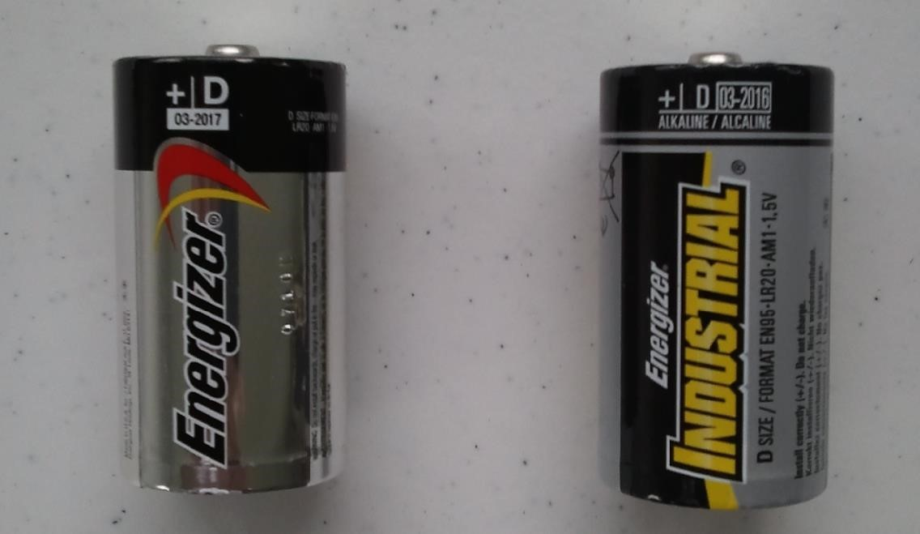

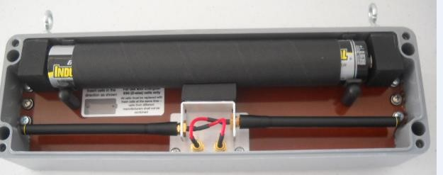

3. 1. Battery Installation Process.

Place the SCT-CN on a safe surface.

Remove the four Screws from the cover.
Note: The screws will not fall out of the lid by design.



A small no conductive tool is within the SCT-CN enclosure to ease insertion of batteries.

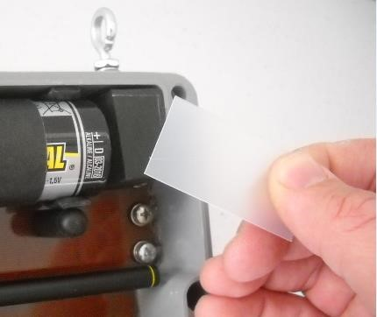

Grasp the battery tube and pull outward.

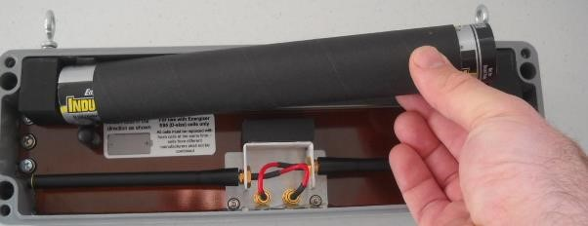
Remove the four (4) D cell batteries from the tube, if present, and dispose of properly.

Insert four new EN95 or E95 D-cell batteries into the tube, orient all in the same direction.

A label is in the unit to indicate battery direction.
Note: E95 and EN95 are equivalent and acceptable

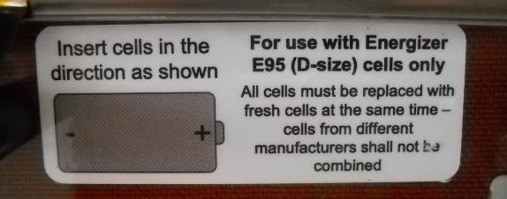

Place the Negative side of the battery tube into the battery compartment.



Use the supplied non-conductive tool to guide the positive end of the battery tube into position.

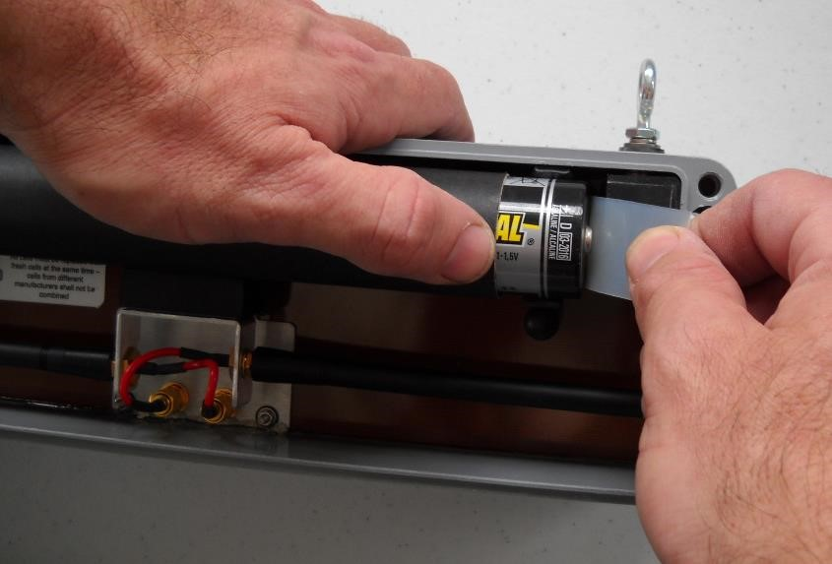
Remove the guide tool from between the battery and contact. This powers on the SCT-CN.
If batteries are being installed in a storage or staging area, leave the guide tool in place so that the SCT-CN is not powered on. The SCT-CN is not to be powered on until it is at its installation location.

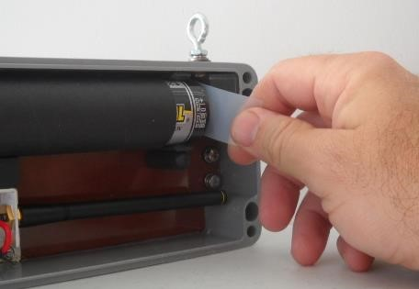

The guide tool should remain within the SCT-CN enclosure for future use.

Replace the cover with the dense battery support pad located on the inner surface of the cover over the battery side of the SCT-CN.

Hand tighten the screws with a screw driver. Do not over tighten.



4. Reset Button

A button is located on the front of the SCT-CN and has two functions, Reset and Signal Sample.

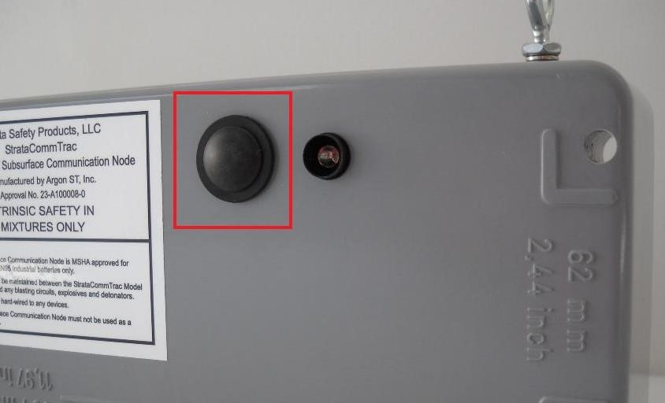

4. 1. Samples Signal Strength

To utilize this feature, press the button and release it, without holding the button in.
The LED light near the button will then indicate signal strength to its parent node. (See Sec.5 LED) A parent node is the SCT-CN communication node that a particular SCT-CN is communicating with to send data out of the mine.

This feature is not the recommended method to utilize for SCT-CN placement, as the SCT-CN does not indicate which specific SCT-CN it is communicating with. It may not always be an indication of the next outby SCT-CN. It is recommended that a SCT-MC Miner Communicator is utilized for communication node placement purposes. (See installation section 2)

4. 2. Reset

This feature enables resetting the SCT-CN by pressing and holding the reset button for at least 6 seconds. The SCT-CN will then reset and join the network if functioning and placed properly.

The Communication Node is designed to never need to be reset. There may exist a need to reset the Communication Node if the LED is on constantly or the has failed to send in reports.

5. LED

The LED is located on the front of the SCT-CN near the reset button. The LED activity is an indication of signal strength or lack thereof. The LED is activated by pressing and releasing the reset button (Refer to Sec 4.)

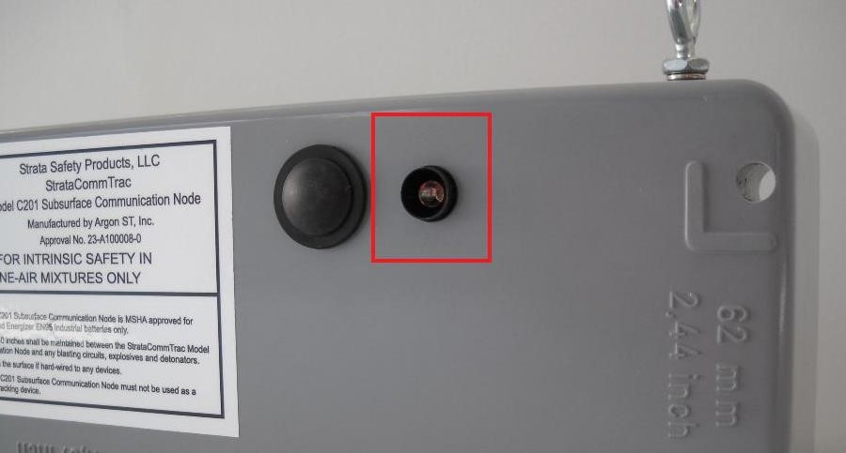

LED Activity description:

- Solid for 60 seconds:
  - No Parent found. This indicates that the SCT-CN is not communicating with any other SCT-CN.

- One Flash:
o This indicates a signal strength receive signal strength of less than -82.
  - Signal is weak and indicates SCT-CN is too far from its parent.

- Two Flashes:
  - This indicates a signal strength receive signal strength of between -82 and -60.
  - Signal is in the desirable range. Position is adequate

- Three Flashes:
  - This indicates a signal strength receive signal strength of greater than -60.
  - Signal strength is too strong. The SCT-CN is too close to its parent.

This is not the recommended method to utilize for SCT-CN placement, as the SCT-CN does not indicate which SCT-CN it is communicating with. It may not always be an indication of the next outby SCT-CN. It is recommended that a SCT-MC Miner Communicator is utilized for placement purposes. (See installation section 2)

6. External Connectors

The SCT-CN provides a connectivity port on the front of the unit. It enables communication with other components such as a Strata CommTrac transponder on the surface. It provides a connection for external power (surface) or for alternative network connectivity. This port also may be used for software updates.

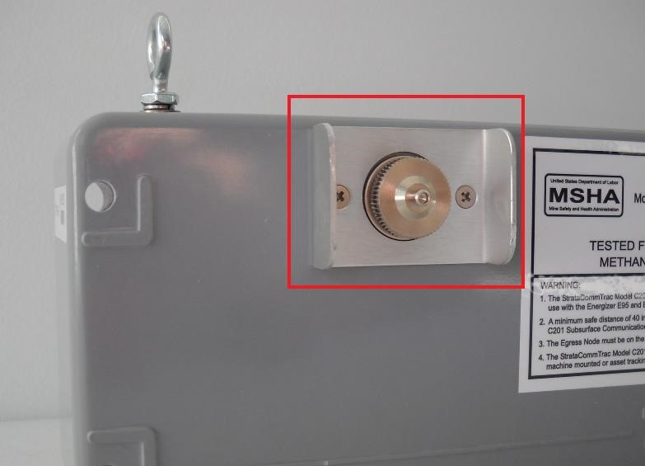

6. 1. RS232 Pin Out

The pin out for the Communication Node connector is presented below. Note that the pin out is as viewed from the solder side of the connector

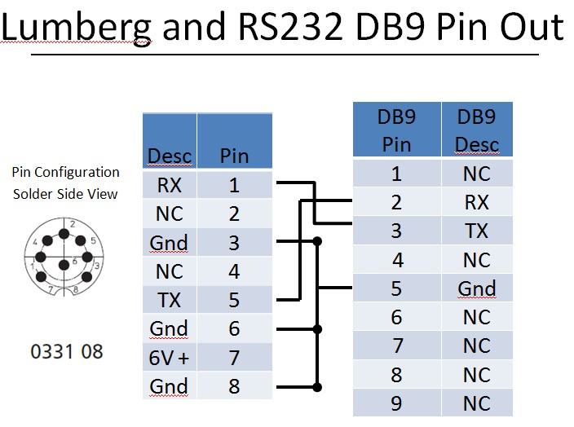

6. 2. RS422 Pin Out
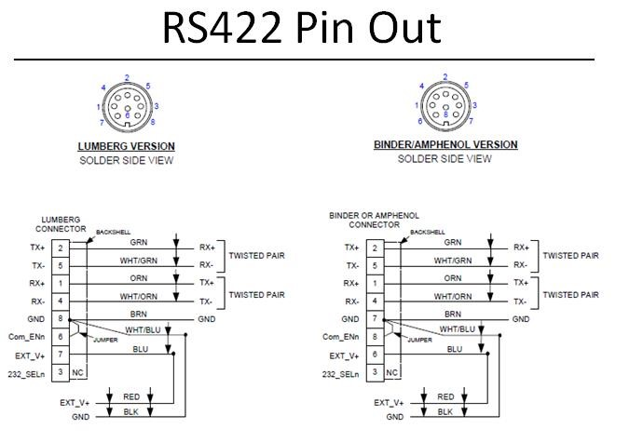

6. 3. Power

The SCT-CN operates on 4 D Cell batteries. Batteries authorized for use in the SCT-CN by MSHA are Energizer E-95 (Retail Store Product) and EN95 (Industrial Product) only. The batteries have been determined by themselves to be intrinsically safe.

The SCT-CN can be powered from an external source when on the surface. This is accomplished via a wired connection between the SCT-CN and another Strata CommTrac device such as a transponder box. Some Transponder boxes contain a battery backup, should line power fail. If the SCT-CN is powered externally, D Cell batteries in the SCT-CN will also serve as a redundant source of power as needed.

The SCT-CN will operator with battery voltage down to 4.5v. If the battery voltage ever drops below 4.5v, the batteries should immediately be replaced.

7. Warranty

Initial system hardware components will be warranted to be free of defects for a period of one (1) year from in service date. Subsequent component purchases will be warranted one year from receipt acknowledgement. Warranted replacement or repair is not applicable in cases of physical damage or abuse as determined at the time of return or inspection.

