
Machine Type & Model |  | Machine No. | SCA |  | System | Gen1 | Gen2
Mine Name |  | Mine Section & No. |  | Timesheet Ref.

INSTRUCTIONS |  | ACCEPTABLE LIMITS | COMMENTS |  |  |  |  | STATUS |  | INITIALS
 | GENERAL INSPECTION OF PDS BYPASS SWITCH |  |  |  |  | Circle (✓) if completed, or (✗) if outstanding.
 | Inspect certification label. | - Note Serial # & Date  - Note Certificate No. | Serial:  Date:  Certificate: |  |  |  |  |   ✓  | ✗
 | Check bolts on enclosure cover to ensure tight. | - Check bolts are firm |  |  |  |  |  | ✓ | ✗
 | Check mounting bolts to ensure tight. | - Check bolts are firm |  |  |  |  |  | ✓ | ✗
 | Check Cable Entries and Glands | - Correct Certification  - Hose Clamps Fitted and Secure |  |  |  |  |  | ✓ | ✗
 | Inspect PDS Bypass Push Button | - Operates Freely  - Locked in ‘ON’ Position |  |  |  |  |  | ✓ | ✗
 | GENERAL INSPECTION OF MAIN ENCLOSURE |  |  |  |  | Circle (✓) if completed, or (✗) if outstanding.
 | Inspect certification label. | - Note Serial # & Date  - Note Certificate No. | Serial:  Date:  Certificate: |  |  |  |  | ✓ | ✗
 | Check all Cable markers, Traffolyte labels fitted | - Refer Drawing |  |  |  |  |  | ✓ | ✗
 | Check Relay Retaining Clips are secure | - Clips fitted |  |  |  |  |  | ✓ | ✗
 | Check bolts on enclosure cover to ensure tight. | 1. Check bolts are firm |  |  |  |  |  | ✓ | ✗
 | Check mounting bolts to ensure tight. | 1. Check bolts are firm |  |  |  |  |  | ✓ | ✗
 | Check Cable Entries and Glands | - Correct Certification  - Hose Clamps Fitted and Secure |  |  |  |  |  | ✓ | ✗
 | GENERAL INSPECTION OF DISPLAY POD |  |  |  |  | Circle (✓) if completed, or (✗) if outstanding.
 | Inspect certification label. | - Note Serial # & Date  - Note Certificate No. | Serial:  Date:  Certificate: |  |  |  |  | ✓ | ✗
 | Inspect Display POD location | - LED’s Visible by Operator |  |  |  |  |  | ✓ | ✗
 | Check mounting bolts to ensure tight. | - Check bolts are firm |  |  |  |  |  | ✓ | ✗
 | Check Cable Entry and Gland | - Correct Certification  - Hose Clamps Fitted and Secure |  |  |  |  |  | ✓ | ✗
 | GENERAL INSPECTION OF FLASHER/SIREN COMBO |  |  |  |  | Circle (✓) if completed, or (✗) if outstanding.
 | Inspect certification label. | - Note Serial # & Date  - Note Certificate No. | Serial:  Date:  Certificate: |  |  |  |  | ✓ | ✗
 | Inspect Flasher/Siren Location | - LED’s not obstructed from view |  |  |  |  |  | ✓ | ✗
 | Check mounting bolts to ensure tight. | - Check bolts are firm |  |  |  |  |  | ✓ | ✗
 | Check Cable Entry and Gland | - Correct Certification  - Hose Clamps Fitted and Secure |  |  |  |  |  | ✓ | ✗
 | GENERAL INSPECTION OF PROXIMITY MODULE A1 |  |  |  |  | Circle (✓) if completed, or (✗) if outstanding.
 | Inspect certification label. | - Note Serial # & Date  - Note Certificate No. | Serial:  Date:  Certificate: |  |  |  |  | ✓ | ✗
 | Inspect Proximity Module Location | - Check Clearances around Generator >90mm  - Check LED Window Visible |  |  |  |  |  | ✓ | ✗
 | Check mounting bolts to ensure tight. | - Check bolts are firm |  |  |  |  |  | ✓ | ✗
 | Check Cable Entry and Gland | - Correct Certification  - Hose Clamps Fitted and Secure |  |  |  |  |  | ✓ | ✗
 | GENERAL INSPECTION OF PROXIMITY MODULE A2 |  |  |  |  | Circle (✓) if completed, or (✗) if outstanding.
 | Inspect certification label. | - Note Serial # & Date  - Note Certificate No. | Serial:  Date:  Certificate: |  |  |  |  | ✓ | ✗
 | Inspect Proximity Module Location | - Check Clearances around Generator >90mm  - Check LED Window Visible |  |  |  |  |  | ✓ | ✗
 | Check mounting bolts to ensure tight. | - Check bolts are firm |  |  |  |  |  | ✓ | ✗
 | Check Cable Entry and Gland | - Correct Certification  - Hose Clamps Fitted and Secure |  |  |  |  |  | ✓ | ✗
 | GENERAL INSPECTION OF PROXIMITY MODULE B1 |  |  |  |  | Circle (✓) if completed, or (✗) if outstanding.
 | Inspect certification label. | - Note Serial # & Date  - Note Certificate No. | Serial:  Date:  Certificate: |  |  |  |  | ✓ | ✗
 | Inspect Proximity Module Location | - Check Clearances around Generator >90mm  - Check LED Window Visible |  |  |  |  |  | ✓ | ✗
 | Check mounting bolts to ensure tight. | - Check bolts are firm |  |  |  |  |  | ✓ | ✗
 | Check Cable Entry and Gland | - Correct Certification  - Hose Clamps Fitted and Secure |  |  |  |  |  | ✓ | ✗
 | GENERAL INSPECTION OF PROXIMITY MODULE B2 |  |  |  |  | Circle (✓) if completed, or (✗) if outstanding.
 | Inspect certification label. | - Note Serial # & Date  - Note Certificate No. | Serial:  Date:  Certificate: |  |  |  |  | ✓ | ✗
 | Inspect Proximity Module Location | - Check Clearances around Generator >90mm  - Check LED Window Visible |  |  |  |  |  | ✓ | ✗
 | Check mounting bolts to ensure tight. | - Check bolts are firm |  |  |  |  |  | ✓ | ✗
 | GENERAL INSPECTION OF JUNCTIONBOX A (Front) |  |  |  |  | Circle (✓) if completed, or (✗) if outstanding.
 | Inspect certification label. | - Note Serial # & Date  - Note Certificate No. | Serial:  Date:  Certificate: |  |  |  |  | ✓ | ✗
 | Check mounting bolts to ensure tight. | - Check bolts are firm |  |  |  |  |  | ✓ | ✗
 | Check Cable Entry and Gland | - Correct Certification  - Hose Clamps Fitted and Secure |  |  |  |  |  | ✓ | ✗
 | GENERAL INSPECTION OF JUNCTION BOX B (Rear) |  |  |  |  | Circle (✓) if completed, or (✗) if outstanding.
 | Inspect certification label. | - Note Serial # & Date  - Note Certificate No. | Serial:  Date:  Certificate: |  |  |  |  | ✓ | ✗
 | Check mounting bolts to ensure tight. | - Check bolts are firm |  |  |  |  |  | ✓ | ✗
 | Check Cable Entry and Gland | - Correct Certification  - Hose Clamps Fitted and Secure |  |  |  |  |  | ✓ | ✗
 | HAZARDAVERT FUNCTION TESTS
 | Ensure System is Powered ‘On’ | - PDS Bypass Switch Set to ‘On’ Mode.  - Park Brake Engaged  - POD + Proximity Modules Display as per right  - Flasher/Siren shows steady white LED indication (indicates PDS in not bypassed) | 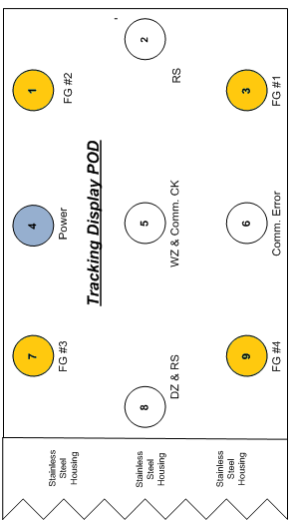 |  |  |  | 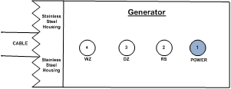 | ✓ | ✗
 | Check releasing Park Brake activates fields | - Release Park Brake  - POD + Proximity Modules Display as per right  - PFER LED in Operator control station indicates fields enabled  - Flasher/Siren shows no indication | 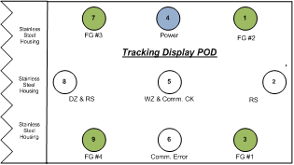 |  |  |  |  | ✓ | ✗
 | Check “fields enabled relay” (PFER) prevents Shuttle car from moving if relay it does not operate.  - Check by disconnecting wire 243  - 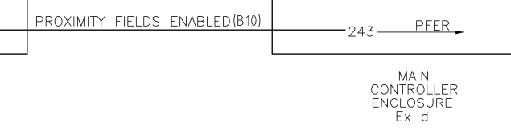 | - Remove wire 243 from terminals in PDS Main Controller box  - Release Park Brake  - POD + Proximity Modules Display as per right  - PFER LED in Operator control station indicates fields disabled  - Attempt to drive shuttle car. Shuttle car should not move  - Replace wire 243 in terminals in PDS Main Controller box |  |  |  |  |  | ✓ | ✗
 | Simulate park brake input failure.  If one or both park brake inputs fail then:  - PFER relay should prevent car from moving  - PDS fields should turn to ‘ON’. i.e. PDS fields ‘ON’ is a failsafe condition. Note: the PDS requires a ‘low’ signal input condition from the park brake feedback to turn fields ‘ON’  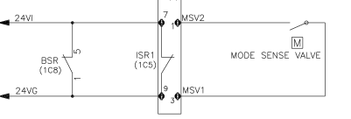 | - Place a PDS cap lamp in the Shuttle car PDS Stop Zone  - Unplug Park Status J80 phoenix plug from Strata main controller board  - Release Park Brake  - POD + Proximity Modules Display as per right  - PFER LED in Operator control station indicates fields enabled  - Attempt to drive shuttle car. Shuttle car should not move  - Replace wire 24VI in terminals in PDS Main Controller box |  |  | 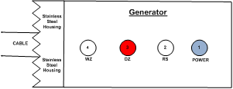 |  |  | ✓ | ✗
 | Simulate mode sense valve failure  If one or both park brake inputs fail then:  - PFER relay should prevent car from moving  - PDS fields should turn to ‘ON’. i.e. PDS fields ‘ON’ is a failsafe condition. Note: the PDS requires a ‘low’ signal input condition from the park brake feedback to turn fields ‘ON’  -  | - Place a PDS cap lamp in the Shuttle car PDS Stop Zone  - Remove wire MSV2 from the mode sense valve  - Release Park Brake  - POD + Proximity Modules Display as per right  - PFER LED in Operator control station indicates fields enabled  - Attempt to drive shuttle car. Shuttle car should not move  - Replace wire MSV2 on the mode sense valve switch. |  |  |  |  |  | ✓ | ✗
 | Check Silent Zone is Active in Operators Cabin | - Place PAD inside Operators Cabin  - Machine does not trip on Hazard Event |  |  |  |  |  | ✓ | ✗
 | Check Warning Zone is Operational | - Place PAD on a Traffic Cone at 15m in front of shuttle car.  - Release park brake & Drive slowly towards the PAD  - POD + Proximity Modules Display as per right  - Flasher/Siren shows Yellow Flashing Light (No Siren)  - SC Slows to Warning Speed  - Repeat Check at Rear of Shuttle Car | 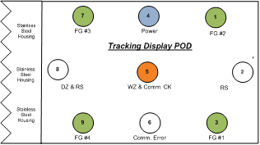 |  |  |  | 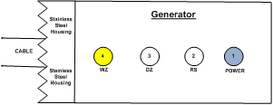 | ✓ | ✗
 | Check Hazard Zone is Operational | - Continue driving slowly towards PAD.  - POD + Proximity Modules Display as per right  - Flasher/Siren shows Red + Yellow Flashing Light  - Flasher/Siren Sounds the Siren  - SC Stops  - Repeat Check at Rear of Shuttle Car | 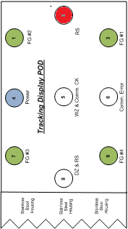 |  |  |  |  | ✓ | ✗
 | Check 2nd Stop Feature is Operational | - Remove K1 Relay in Main Enclosure.  - Place PAD on a Traffic Cone at 15m in front of shuttle car.  - Release park brake & Drive slowly towards the PAD  - POD + Proximity Modules Display as per right  - Flasher/Siren shows Red + Yellow Flashing Light  - Flasher/Siren Sounds the Siren  - SC trips the pilot | 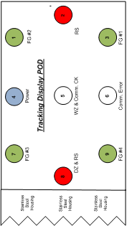 |  |  |  |  | ✓ | ✗
 | Check Hard Wired Bypass Switch is Operational | - Place PDS Bypass Switch into Bypass Mode  - Place PAD on a Traffic Cone at 15m in front of shuttle car.  - Release park brake and drive towards the PAD  - POD + Proximity Modules Display as per right (System Off)  - Flasher/Siren shows no indication  - SC does not provide any intervention  - Ensure shuttle car can move away from PAD. | 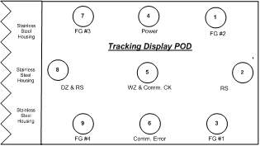 |  |  |  |  | ✓ | ✗
 | Place PDS back into ‘On’ Condition and ensure PDS returns to Normal State | - PDS Bypass Switch Set to ‘On’ Mode.  - POD + Proximity Modules Display as per right  - Flasher/Siren shows no indication |  |  |  |  |  | ✓ | ✗
 | Check Remote Stop Function is operational | - Press any 2 buttons on test PAD whilst standing outside of the hazard zone  - Cap lamp should alarm in hazard  - POD + Proximity Modules Display as per right  - Flasher/Siren shows Red + Yellow Flashing Light  - Flasher/Siren Sounds the Siren  - UV to shuttle car trips  - SC Stops | No lights on POD |  |  |  | No lights on Generators | ✓ | ✗
 | Check Communication Check Operational | - Press S1 on Test PAD  - POD + Proximity Modules Display as per right  - Flasher/Siren shows no indication | 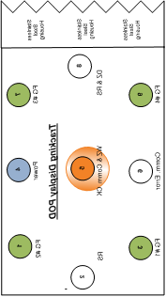  FLASH TWICE |  |  |  | 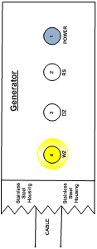  FLASH TWICE | ✓ | ✗
 | Check Shrink Fields are Disabled | - With PAD in Warning Zone, Press S1 button  - Zone Sizes do not change |  |  |  |  |  | ✓ | ✗
 | Check System Bypass is operational | - With PAD in Hazard Condition, press buttons in sequence S1, S2, Menu  - POD lights alternate in Ping/Pong Mode  - PAD Continues to Alarm  - SC Stops Alarming  - SC can move | 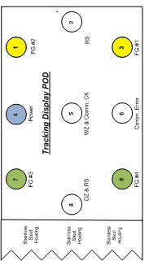  PING | 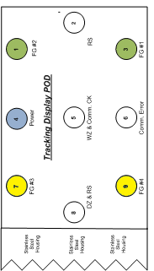PONG |  |  |  | ✓ | ✗
 | Check POD Communication Error is operational | - Disconnect Comms cables from POD  - POD Displays as per right | 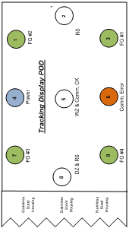 |  |  |  |  | ✓ | ✗
 | Check PM A1 Failure Detect is Operational | - Disconnect the Comms Line to PM A1  - POD + Proximity Modules Display as per right  - Flasher/Siren shows Red + Yellow Flashing Light  - Flasher/Siren Sounds the Siren  - SC Cannot be moved | 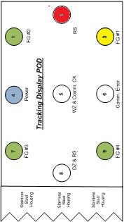 |  |  |  | 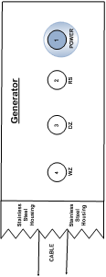  BLINKING  Note: you made need to cycle power to get generator LEDs to faults | ✓ | ✗
 | Check PM A2 Failure Detect is Operational | - Disconnect the Comms Line to PM A2  - POD + Proximity Modules Display as per right  - Flasher/Siren shows Red + Yellow Flashing Light  - Flasher/Siren Sounds the Siren  - SC Cannot be moved | 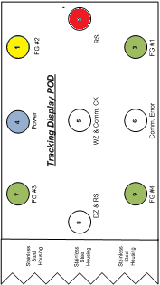 |  |  |  |   BLINKING  Note: you made need to cycle power to get generator LEDs to faults | ✓ | ✗
 | Check PM B1 Failure Detect is Operational | - Disconnect the Comms Line to PM B1  - POD + Proximity Modules Display as per right  - Flasher/Siren shows Red + Yellow Flashing Light  - Flasher/Siren Sounds the Siren  - SC Cannot be moved | 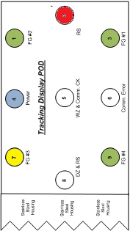 |  |  |  |   BLINKING  Note: you made need to cycle power to get generator LEDs to faults | ✓ | ✗
 | Check PM B2 Failure Detect is Operational | - Disconnect the Comms Line to PM B2  - POD + Proximity Modules Display as per right  - Flasher/Siren shows Red + Yellow Flashing Light  - Flasher/Siren Sounds the Siren  - SC Cannot be moved | 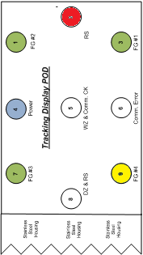 |  |  |  |   BLINKING  Note: you made need to cycle power to get generator LEDs to faults | ✓ | ✗

SHUTTLE CAR SAT FORM (Site Acceptance Test) – 3-Monthly & Commissioning

SC MEASURED FIELDS - WARNING ZONE |  |  | SC MEASURED FIELDS - DANGER ZONE |  |  | EQUIPMENT VERSIONS
Position | Min / Max Field Size | Measured Field | Position | Min / Max Field Size | Measured Field | Equipment | Serial # | Firmware
AA | 6.0-9.0 |  | A | 3.0 – 6.0 |  | PM A1
PP | 6.0-9.0 |  | P | 3.0 – 6.0 |  | PM A2
OO | 6.0-9.0 |  | O | 3.0 – 6.0 |  | PM B1
BB | <8 |  | B | 1.0 – 3.0 |  | PM B2
CC | <8 |  | C | 0.5 – 3.0 |  | Display POD
DD | <8 |  | D | 0.5 – 3.0 |  | Flasher | N/A
EE | <8 |  | E | 0.5 – 3.0 |  | Bypass Switch | N/A
FF | <8 |  | F | 0.5 – 3.0 |  | Controller Box (IM)
GG | 6.0-9.0 |  | G | 3.0 – 6.0 |  | Controller WiFi
HH | 6.0-9.0 |  | H | 3.0 – 6.0 |  | IP Address
II | 6.0-9.0 |  | I | 3.0 – 6.0 |  | Visible on Server?
JJ | <8 |  | J | 0.5 – 3.0
KK | <8 |  | K | 0.5 – 3.0
LL | <8 |  | L | 0.5 – 3.0
MM | <8 |  | M | 0.5 – 3.0 |  | Test PAD ID
NN | <8 |  | N | 1.0 – 2.5 |  | Test PAD SW

FIELD MEASURE POSITIONS

Controller Box

Generator

K-Box

Display POD

Flasher
Warning Zone
Danger Zone
Legend

Note:
- The MAXIMUM field can be exceeded in order to satisfy the minimum of all required fields.
- The danger zone takes PRIORITY in terms of field setup; the warning zone will be determined by the danger zone.
Acceptance by Mine | Name |  |  | Position |  | Signed |  | Date
Acceptance by Mine | Name |  |  | Position |  | Signed |  | Date
Acceptance by Strata | Name |  |  | Position |  | Signed |  | Date
Are Field Sizes Correct? | YES | NO

